Professore Presente

System security & Web Programming Report

Academic Submission For:
Web Programming
System Security

Student Name: Ermiyas Alemu Dagne
Student ID: 559995
Date: 02/05/2026

Table of Contents
1. Introduction
2. System Architecture & Tech Stack
3. System Security Implementations
3.1. Authentication using JSON Web Tokens (JWT)
3.2. Password Cryptography with Bcrypt
3.3. Mitigation of SQL Injection vulnerabilities
3.4. Role-Based Access Control (RBAC)
3.5. Brute Force & Rate Limiting Controls
4. Web Programming & Implementation
4.1. RESTful API Backend Paradigm
4.2. Database Design & Relational Schema
4.3. Frontend Client Architecture & DOM Manipulation
4.4. State Management and Asynchronous Operations

1. Introduction
The 'Professore Presente' project is a robust, asynchronous web application designed to streamline the management of exam queues within a university setting. Bridging the gap between faculty and students, the platform provides an intuitive interface for professors to establish course rosters, schedule examination sessions, and manage live queues. Concurrently, it empowers students to enroll in courses, monitor their queue status in real-time, and manage their academic interactions efficiently.
This technical report details the full-stack implementation of the system, uniquely tailored to fulfill the requirements of both the Web Programming and System Security courses. The document dissects the architectural choices, frontend and backend paradigms, and the rigorous security measures implemented to protect sensitive academic data against modern cyber threats.

2. System Architecture & Tech Stack
The application follows a decoupled client-server architecture, cleanly separating the user interface from the underlying business logic and data persistence layers. This separation of concerns ensures scalability, easier maintenance, and clearer boundaries for security enforcement.
The backend is developed using PHP 8.2, operating on an Apache web server. It functions entirely as a RESTful API, exposing structured endpoints that consume and return JSON payloads. The persistence layer utilizes PostgreSQL 15, chosen for its robust relational integrity and advanced querying capabilities. To ensure environment consistency across development and production, the entire backend infrastructure is containerized using Docker and orchestrated via Docker Compose.
The frontend is a lightweight, high-performance client built with HTML5, CSS3, and Vanilla JavaScript. By avoiding heavy frameworks, the project demonstrates a fundamental mastery of the Document Object Model (DOM), asynchronous HTTP requests (Fetch API), and browser-side state management using LocalStorage.

3. System Security Implementations
Security is treated as a foundational element of the Professore Presente architecture, not as an afterthought. Because the system handles academic records, student identities, and examination schedules, protecting data integrity and user authorization is paramount. This section outlines the primary defenses integrated into the system, focusing specifically on JWT, Bcrypt, and defenses against SQL Injection.

3.1. Authentication using JSON Web Tokens (JWT)
Traditional session-based authentication relies on the server maintaining a stateful session file or database record for every active user. To optimize scalability and create a stateless RESTful architecture, Professore Presente implements JSON Web Tokens (JWT) for authentication and authorization.
Instead of relying on external libraries, the system includes a custom, deeply integrated JWTHandler class. A JWT consists of three parts: a Header, a Payload, and a Signature. The header specifies the algorithm (HS256). The payload contains the user's non-sensitive identity claims (user_id, username, email, role) and an expiration timestamp (exp). The signature is generated by applying the HMAC-SHA256 algorithm to the base64-url-encoded header and payload, hashed against a cryptographic secret key stored on the server.
Below is the core implementation of the JWT generation within the system:
// src/security/JWTHandler.php (Token Generation)
public function create($payload) {
$payload['iat'] = time();
$payload['exp'] = time() + $this->expiration;
$header = ['alg' => 'HS256', 'typ' => 'JWT'];
$header_encoded = $this->base64UrlEncode(json_encode($header));
$payload_encoded = $this->base64UrlEncode(json_encode($payload));
// Generating the HMAC-SHA256 signature
$signature = hash_hmac(
'sha256',
$header_encoded . '.' . $payload_encoded,
$this->secret_key,
true
);
$signature_encoded = $this->base64UrlEncode($signature);
return $header_encoded . '.' . $payload_encoded . '.' . $signature_encoded;
}
When a client makes a subsequent API request, it passes this token in the HTTP 'Authorization' header. The server verifies the integrity of the token by recalculating the signature. If the calculated signature matches the provided signature, the server knows the payload was not tampered with. If an attacker attempts to modify the role claim in the payload (e.g., changing 'student' to 'admin'), the signature will invalidate the token.
// src/security/JWTHandler.php (Token Verification)
$signature_calculated = hash_hmac(
'sha256',
$header_encoded . '.' . $payload_encoded,
$this->secret_key,
true
);
$signature_calculated_encoded = $this->base64UrlEncode($signature_calculated);
if (!hash_equals($signature_provided, $signature_calculated_encoded)) {
return null; // Token has been tampered with
}

3.2. Password Cryptography with Bcrypt
Storing passwords in plaintext is a catastrophic security vulnerability. Even standard hashing algorithms like MD5 or SHA-256 are no longer sufficient because they are optimized for speed, allowing attackers to rapidly compute billions of hashes per second using GPUs (facilitating brute-force or dictionary attacks). Furthermore, without 'salting', identically hashed passwords can be reversed using pre-computed Rainbow Tables.
To mitigate this, Professore Presente uses the Bcrypt algorithm via PHP's native password hashing API. Bcrypt is specifically designed to be computationally slow and memory-intensive (key derivation function). It also automatically generates a cryptographically secure random salt for every password, ensuring that two users with the exact same password will have completely different stored hash strings.
During user registration, the password is encrypted as follows:
// src/api/auth/register.php
// The PASSWORD_BCRYPT flag enforces the use of the bcrypt algorithm.
$password_hash = password_hash($password, PASSWORD_BCRYPT);
$stmt = $conn->prepare("INSERT INTO users (username, email, password_hash, role) ...");
$stmt->execute([...]);
During authentication, the system retrieves the full hash string from the database (which contains the algorithm identifier, cost factor, salt, and the actual hash) and securely compares it against the user's input. The `password_verify` function is immune to timing attacks.
// src/api/auth/login.php
$stmt = $conn->prepare("SELECT id, password_hash, role FROM users WHERE email = :email");
$stmt->execute([':email' => $email]);
$user = $stmt->fetch(PDO::FETCH_ASSOC);
if (!password_verify($password, $user['password_hash'])) {
http_response_code(401);
echo json_encode(['error' => 'Invalid email or password']);
exit;
}

3.3. Mitigation of SQL Injection (SQLi) Vulnerabilities
SQL Injection occurs when untrusted user input is directly concatenated into a database query string. This allows an attacker to manipulate the structure of the SQL statement, potentially bypassing authentication or extracting sensitive data from other tables.
The system completely neutralizes SQL Injection vectors by exclusively using PHP Data Objects (PDO) with Prepared Statements. When a statement is prepared, the database engine compiles the SQL query structure before any user data is inserted. The user data is then sent to the database separately as bound parameters.
Because the query plan is pre-compiled, the database treats the bound parameters strictly as literal values (strings or integers), not as executable SQL commands. Even if a user inputs a malicious string such as `' OR 1=1 --`, it will simply be treated as a literal search string.
Example implementation from the student course enrollment API:
// src/api/student/courses.php
// VULNERABLE APPROACH (Avoided):
// $conn->query("SELECT id FROM courses WHERE code = '" . $_POST['code'] . "'");
// SECURE APPROACH (Implemented):
$verify_stmt = $conn->prepare("SELECT id FROM courses WHERE LOWER(code) = LOWER(:course_code)");
// The parameter is bound upon execution, securely bridging the data layer.
$verify_stmt->execute([':course_code' => $course_code]);

3.4. Role-Based Access Control (RBAC)
Authentication confirms identity, but Authorization determines privileges. The application implements a centralized Role-Based Access Control (RBAC) middleware class. This matrix explicitly defines which roles ('admin', 'professor', 'student') have access to specific controller actions.
// src/security/RBAC.php
private static $permissions = [
'professor' => [
'professor.create_exam',
'professor.manage_queue',
'auth.profile'
],
'student' => [
'student.join_queue',
'student.view_queue',
]
];
public static function enforce($role, $permission) {
if (!in_array($permission, self::$permissions[$role])) {
http_response_code(403);
echo json_encode(['error' => 'Access denied.']);
exit;
}
}

3.5. Brute Force & Rate Limiting Controls
To protect against automated credential stuffing and brute-force attacks on the authentication endpoints, the system implements IP-based rate limiting. A `login_attempts` table tracks failed authentication requests originating from specific IP addresses.
If a user exceeds 5 failed login attempts, the system imposes a temporary 15-minute lockout constraint. During this window, any authentication attempt from that IP address is rejected immediately with an HTTP 429 Too Many Requests status, before the database even attempts to query the user tables or perform the expensive Bcrypt verification.
// src/api/auth/login.php (Rate Limiting logic snippet)
$rate_limit_stmt = $conn->prepare("SELECT failed_attempts, locked_until FROM login_attempts WHERE ip_address = :ip");
$rate_limit_stmt->execute([':ip' => $client_ip]);
if ($rate_limit_stmt->rowCount() > 0) {
$attempt = $rate_limit_stmt->fetch();
if ($attempt['locked_until'] && strtotime($attempt['locked_until']) > time()) {
http_response_code(429);
echo json_encode(['error' => 'Too many failed login attempts. Try again later.']);
exit;
}
}

4. Web Programming & Implementation
From a Web Programming perspective, the project demonstrates a modern approach to web architecture, bypassing legacy monolithic designs in favor of an API-driven frontend.

4.1. RESTful API Backend Paradigm
The backend endpoints strictly adhere to REST (Representational State Transfer) principles. Resources are logically grouped by user domain (e.g., `/api/professor/queue.php`, `/api/student/courses.php`). Appropriate HTTP methods are used to reflect the action being performed:
- POST: Used for resource creation (e.g., creating an exam, joining a queue).
- GET: Used for idempotent data retrieval (e.g., viewing a queue).
- PATCH: Used for partial resource updates (e.g., marking a student's status as 'attended').
All responses are returned as structured JSON, accompanied by accurate HTTP status codes (200 OK, 201 Created, 400 Bad Request, 401 Unauthorized, 403 Forbidden, 404 Not Found, 409 Conflict, 500 Internal Server Error).
$verify_stmt = $conn->prepare("
SELECT e.id FROM exams e
JOIN courses c ON e.course_id = c.id
WHERE e.id = :exam_id AND c.professor_id = :professor_id
");
$verify_stmt->execute([
':exam_id' => $exam_id,
':professor_id' => $professor_id
]);
if ($verify_stmt->rowCount() === 0) {
http_response_code(403);
echo json_encode(['error' => 'Exam does not belong to you']);
exit;
}

4.2. Database Design & Relational Schema
The PostgreSQL schema employs robust normalization. The core `users` table handles authentication credentials and global roles. Specialized tables (`professors`, `students`) extend the user entity through one-to-one foreign key relationships, allowing role-specific metadata without polluting the primary user table.
The database relies heavily on `ON DELETE CASCADE` constraints to maintain referential integrity. If a course is deleted, all associated exams, exam rosters, and active queue entries tied to that course are automatically expunged, preventing orphaned data records.
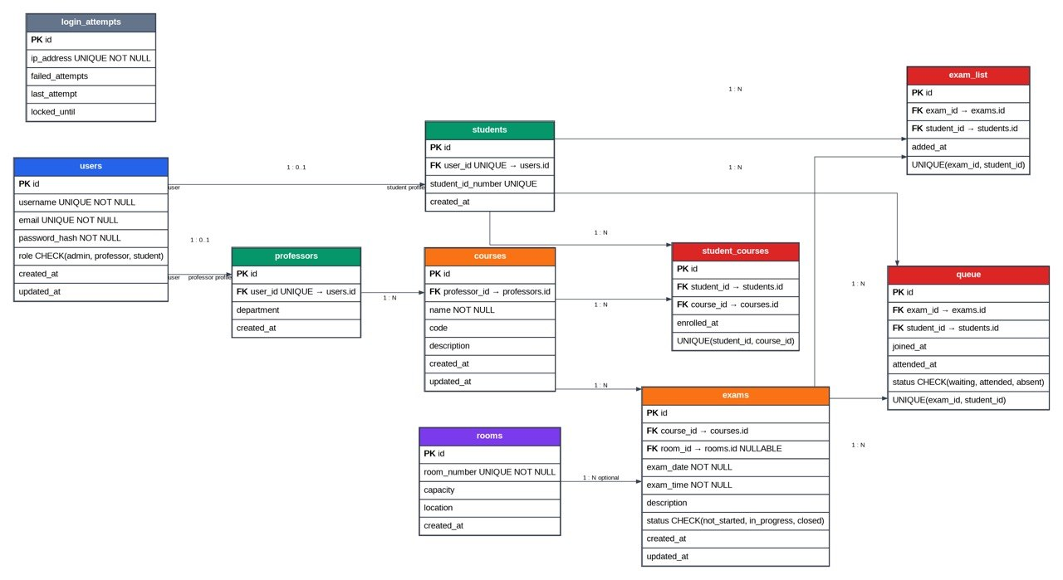

4.3. Frontend Client Architecture & DOM Manipulation
The frontend operates as a pseudo-Single Page Application (SPA). Instead of fully reloading the browser to navigate between the 'Courses', 'Exams', and 'Queue' tabs, the JavaScript dynamically toggles the CSS `display` properties of various `<section>` containers within the DOM.
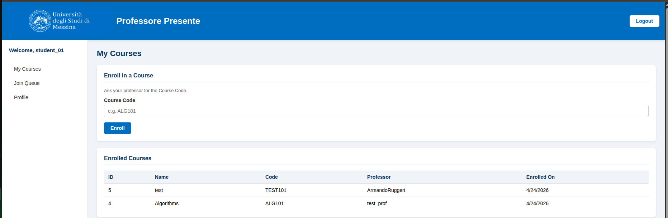
When data needs to be presented, the client-side JavaScript constructs HTML strings dynamically and injects them into the DOM using `innerHTML`. While this is highly performant for lightweight tasks, careful consideration was given to ensure data retrieved from the backend is structurally safe.

4.4. State Management and Asynchronous Operations
All communication between the frontend and the backend is handled asynchronously using the modern JavaScript `Fetch API`. This ensures the UI remains responsive while data is being transmitted. Authentication state is persisted on the client side using the browser's `LocalStorage` API, where the JWT is securely housed.
A centralized utility script (`common.js`) intercepts all outgoing API requests, automatically appending the JWT as an HTTP Authorization Bearer token.
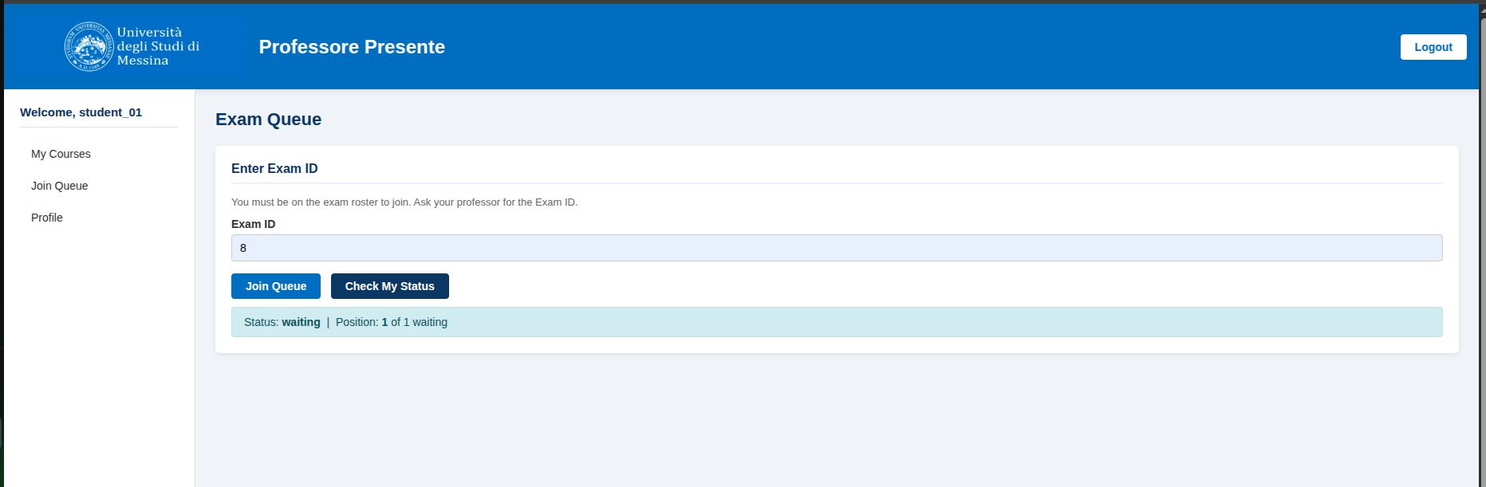

5. Conclusion
The Professore Presente project successfully synthesizes the core learning objectives of both Web Programming and System Security. By utilizing a decoupled, RESTful architecture backed by a highly normalized relational database, the system is engineered for scalability and maintainability.
More importantly, the proactive integration of security controls ensures that the application is resilient. Custom JWT handling provides stateless, tamper-proof authentication. Bcrypt guarantees cryptographic resilience for user credentials, while strict adherence to prepared statements closes the door on SQL injection vectors. Through this multi-layered defense-in-depth approach, the application stands as a secure and functional academic utility.

Referenced Project Files
Key files used in this report: src/config/schema.sql, src/config/Database.php, src/security/JWTHandler.php, src/security/RBAC.php, src/api/auth/login.php, src/api/admin/professors.php, src/api/professor/queue.php, src/api/student/queue.php, src/js/common.js, src/js/admin.js, Dockerfile, docker-compose.yml, and README (1).md.

