

**Bahir Dar University**

**Bahir Dar Institute of Technology**

**Faculty of Computing**

**Department of Software Engineering**

Course Title: software testing and quality assurance

Name ID

Ermias Desalegn ……………………………………….1404196

**Submitted to: Dr. Mequanint**

**BAHIR DAR, ETHIOPIA**

**Run the load test for a website with a link**: -

*https://www.plex.tv/watch-free/*

Summary report :

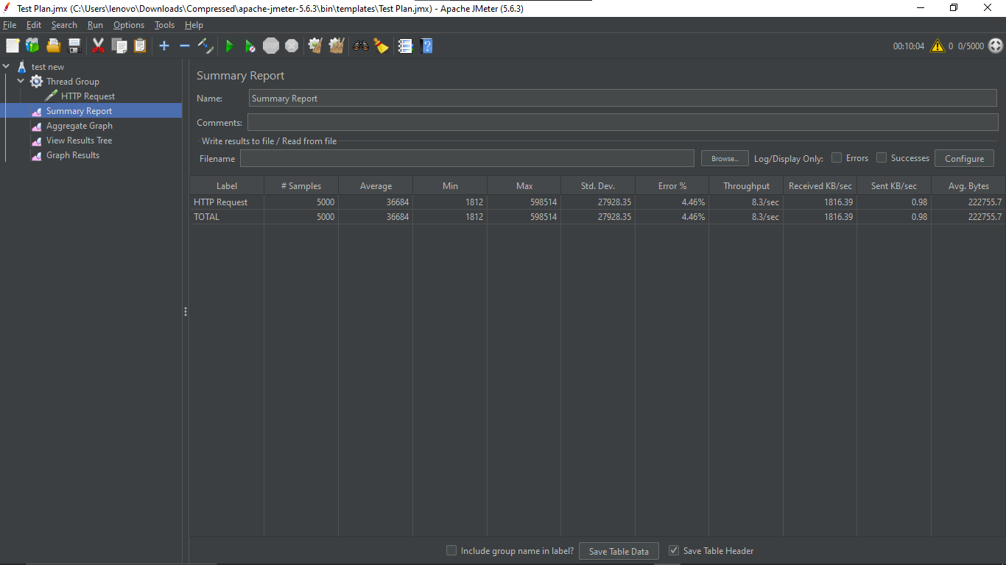

Result tree:

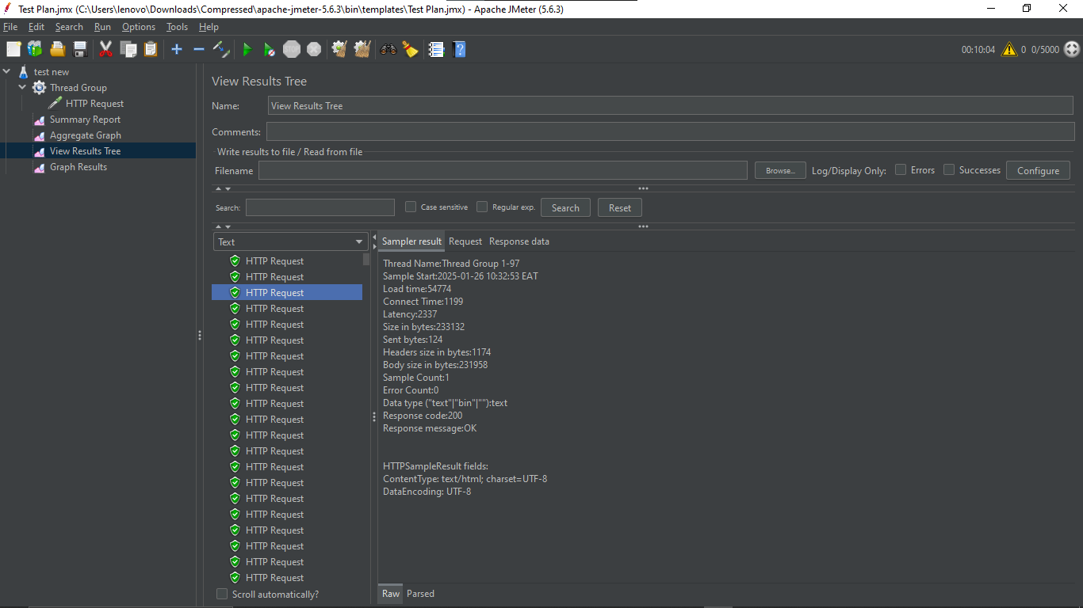

Graph Results

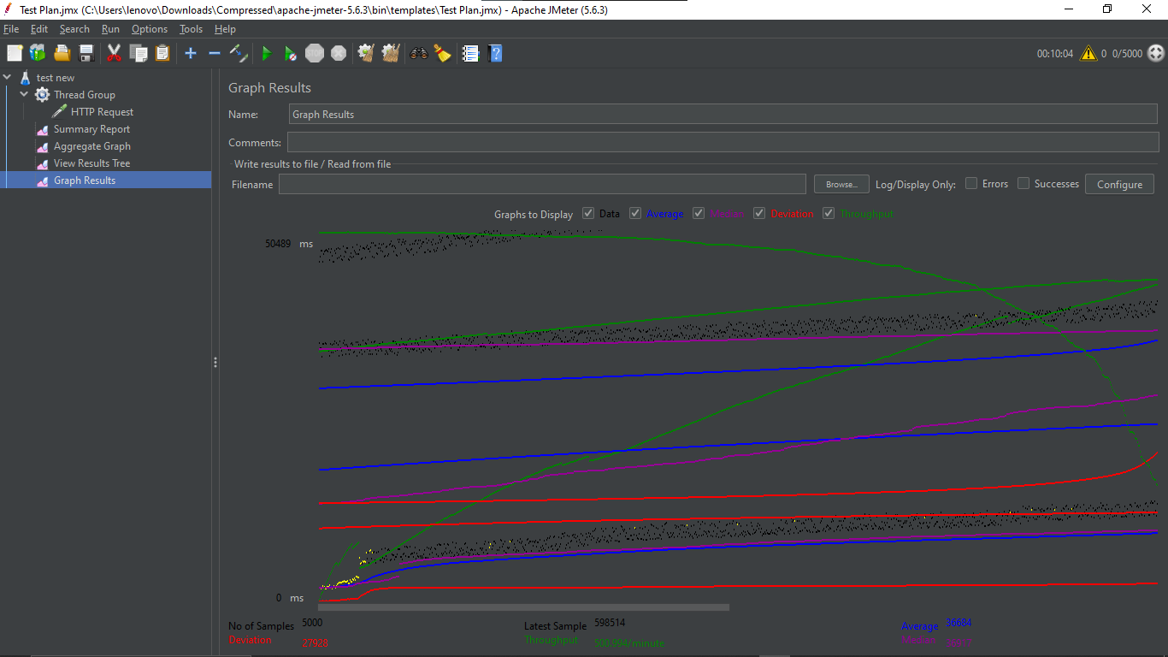

Aggregate Graph view:

