seller's app has small texts which may be bad for user experience

I reviewed the customer app has some UX issues which has avibration which might makes users uncomfortable when we add a quantity or use the minus sign and also when adding to cart

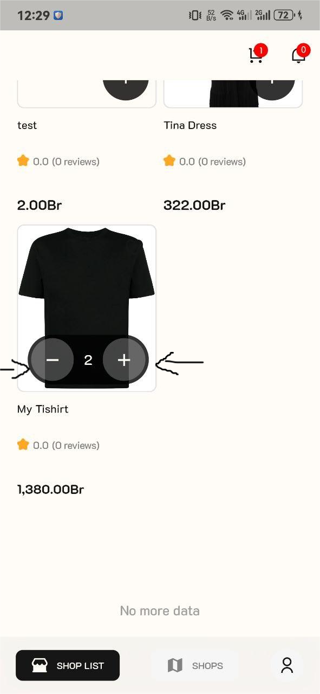  
  
in the images after we opened an item and click it the X button to navigate back or close the existing image is somehow covered and the image is always on the top of our screen this may not be good for UI too. We can see its effect in the new arrivals caagory in the test image or in the tshirt part also make it smaller or idk.  
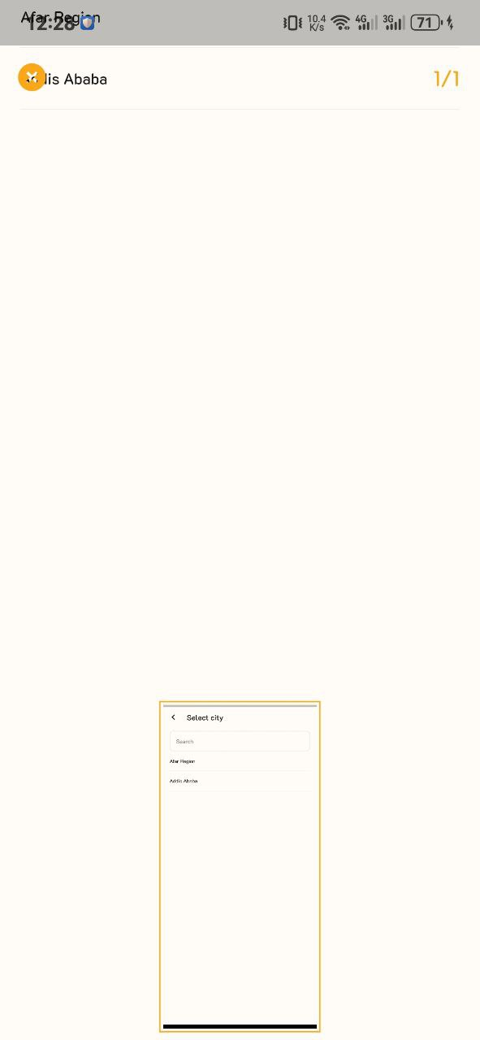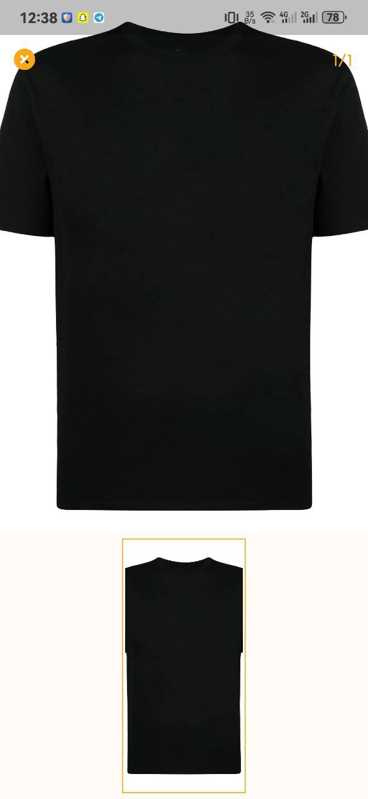  
see its covering the whole screen even my top screen above the app.