Access the demo insurance project at demo guru99.com (<http://demo.guru99.com>)

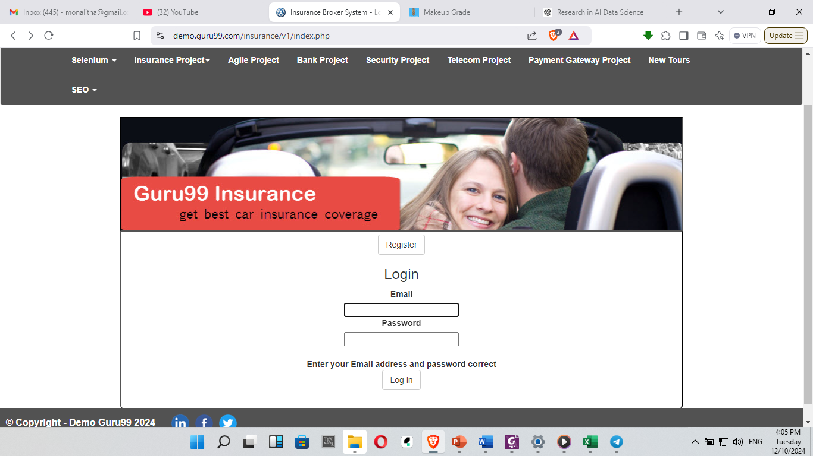

Testable features or test scenarios

* 1. Login page (using email address)
  2. Register as a new user

Prepare all possible test cases from the above test scenarios as follows:

|  |  |  |  |  |  |  |
| --- | --- | --- | --- | --- | --- | --- |
| **Test Scenario** | **Test Case** | **Test Step** | **Test Data** | **Expected Result** | **Actual Result** | **Status (P/F)** |
| TS1-Check yyy yyy yyy yyy | TC1- aaa aaa aaa |  |  |  |  |  |
| TC2- bbb bbb |  |  |  |  |  |
| TC3- ccc ccc ccc |  |  |  |  |  |
| TS2-Check yyy yyy yyy yyy | TC4- ddd ddd |  |  |  |  |  |
| TC5- eee eee eee |  |  |  |  |  |
| TC6- fff fff fff fff |  |  |  |  |  |
| TC7- ggg ggg ggg |  |  |  |  |  |
|  |  |  |  |  |  |  |
|  |  |  |  |  |  |  |

Execute test cases and compute test

1. Ran rate
2. Pass rate

Prepare defect report based on the following format:

|  |  |  |  |  |  |  |  |  |  |  |  |
| --- | --- | --- | --- | --- | --- | --- | --- | --- | --- | --- | --- |
| **Defect_ID** | **Defect Description** | **Version** | **Steps** | **Date Raised** | **Reference** | **Detected By** | **Status** | **Fixed by** | **Date Closed** | **Severity** | **Priority** |
|  |  |  |  |  |  |  |  |  |  |  |  |
|  |  |  |  |  |  |  |  |  |  |  |  |
|  |  |  |  |  |  |  |  |  |  |  |  |

While reporting the defect to developers, your defect report should contain the following data.

* 1. **Defect_ID** - Unique identification number for the defect.
  2. **Defect Description** - Detailed description of the defect including information about the module in which the defect was found.
  3. **Version** - Version of the application in which defect was found.
  4. **Steps** - Detailed steps along with screenshots with which the developer can rectify the defects.
  5. **Date Raised** - Date when the defect is raised
  6. **Reference**- Provide reference to the documents such as requirements, design, architecture or maybe even screenshots of the error to help understand the defect
  7. **Detected By** - Name/ID of the tester who raised the defect
  8. **Status** - Status of the defect
  9. **Fixed by** - Name/ID of the developer who fixed it
  10. **Date Closed** - Date when the defect is closed
  11. **Severity -** which describes the impact of the defect on the application
  12. **Priority -** which is related to defect fixing urgency.

Group members:

1.

2.

Submission date: December 15, 2024

Submission email address: [monalitha@gmail.com](mailto:monalitha@gmail.com)