SOFTWARE REQUIREMENTS & SOLUTION DESIGN SPECIFICATION
PropPulse AI — Autonomous Multi-Estate Brokerage & LangGraph Sales Engine
Target Role: Independent Real Estate Super-Broker & Sales Executive | Industry: PropTech & Multi-Developer Brokerage
Author: Ermias Desalegn | Core Stack: Next.js 14, FastAPI, LangGraph, Supabase pgvector, Gemini 2.5 Flash, Mapbox
Infrastructure Guarantee: 100% Free-Tier Compliant (Google AI Studio, GCP Cloud Run & Cloud Scheduler, Telegram, Resend)

1. Executive Summary & Brokerage Business Model
In high-growth property markets (such as Addis Ababa and major global urban centers), top-performing real estate sales professionals operate as Independent Multi-Estate Super-Brokers—representing buyers across dozens of competing real estate developers (e.g., Ayat Real Estate, Noah Real Estate, Gift Real Estate, Flintstone Homes, Ovid, and luxury boutique developments). However, independent brokers lose over 70% of their productive selling hours to fragmented operational bottlenecks: manually monitoring dozens of developer websites and channels for price-per-sqm updates, answering repetitive inquiries via text and voice notes, manually calculating cross-developer payment plans, cross-referencing calendars for site visits, and following up with buyers post-tour.
PropPulse AI is an enterprise-grade, autonomous Multi-Estate Brokerage & Market Aggregation Platform that serves as a 24/7 digital workforce for the independent broker. It establishes an end-to-end, full-stack ecosystem: automated multi-developer web scraping and floor-plan vision parsing, natural language buyer qualification across text and voice notes, stateful LangGraph orchestration with self-correcting constraint relaxation, multi-stop site tour routing via Mapbox, and proactive automated follow-ups.
Commission Business Model (No In-App Payment Processing Required)
In real estate brokerage, buyers never pay the broker directly, nor do they transact online prior to physically inspecting a property. Instead: (1) PropPulse AI autonomously sources inventory across multiple developers, qualifies the buyer via Telegram (text/voice), compares options across developers, and schedules a physical multi-site tour on the broker's Google Calendar. (2) Simultaneously, the agent dispatches a timestamped 'Official Lead Registration Notice' via Resend Email to the target real estate developer's sales office—legally locking in the broker as the originating agent. (3) The human broker guides the physical site visit and assists the buyer in signing the purchase contract directly with the developer. (4) Once the buyer executes the contract with the developer, the developer pays the broker's commission (typically 2%–5%), which is tracked through to final disbursement inside PropPulse AI's Commission & Deal Ledger.

2. System Capabilities & Core Workstream Matrix
PropPulse AI automates the complete operational lifecycle of an independent super-broker through six specialized workstreams, delivering high technical complexity and real-world commercial defensibility:
Workstream / Capability | Business & Product Value | Technical Execution Mechanism | Priority
1. Autonomous Market Ingestion | Eliminates manual market research; aggregates fragmented developer portals & announcements into one index. | Playwright & BeautifulSoup4 headless crawlers extract listings, pricing tables, and floor plans. Gemini 2.5 Flash Vision extracts spatial attributes from floor plans into structured JSON + 768-d vectors. | P0 (Core)
2. LangGraph Agentic Search | Converts natural buyer inquiries (text/voice) into cross-developer recommendations with self-correction. | Stateful LangGraph StateGraph routes buyer intent to Hybrid pgvector search. If strict constraints return 0 hits, a self-correcting graph edge widens budget bounds by ±12% automatically. | P0 (Core)
3. Smart Phonebook CRM | Captures structured lead profiles without forms and tracks deals from first contact to commission clearance. | Extracts buyer identity, budget, down-payment liquidity, and preference vectors into Supabase PostgreSQL; manages pipeline stages with automated commission calculation. | P0 (Core)
4. Multi-Site Tour & Protection | Secures physical viewing appointments on broker's calendar and legally protects broker commission. | Google Calendar API books multi-site viewing blocks; Mapbox Directions API sequences stops efficiently; Resend API dispatches buyer itineraries and legal Developer Lead Registration notices. | P1 (Core)
5. Channel Ad Publishing & Reverse-RAG | Drives organic inbound buyer acquisition and re-engages past dormant leads when prices drop. | Publishes persuasive property listings with inline inquiry keyboards to the public Telegram Channel; executes reverse vector cosine matching against CRM buyers for targeted DMs. | P1 (Proactive)
6. Proactive Crons & Milestones | Eliminates tour no-shows and tracks post-sale contract installments so broker commission clears. | GCP Cloud Scheduler dispatches 24h site-visit reminders with location pins and tracks post-sale developer contract installment schedules to ensure timely commission payout. | P1 (Proactive)

3. Deep-Dive Technical Architecture & AI Engineering
3.1 Stateful Multi-Agent Orchestration with LangGraph (StateGraph)
Rather than relying on a fragile, single-prompt linear tool loop, the FastAPI backend orchestrates buyer interactions using a compiled LangGraph StateGraph backed by Supabase PostgreSQL checkpointing (PostgresSaver). Every conversation thread maintains a strictly typed BrokerAgentState containing conversation history, extracted buyer profile fields, active property matches, comparison matrices, and human-override flags.
Node 1 — Multimodal Intake & Transcription Node: Detects whether the incoming Telegram payload is text or a voice note (.ogg). If audio, it fetches the binary stream via the Telegram File API and passes it directly to Gemini 2.5 Flash native audio processing to transcribe and extract tone, urgency, and spoken requirements (including English and Amharic/local neighborhood terms like 'Bole', 'CMC', 'Kazanchis', 'Ayat').
Node 2 — Supervisor Router & CRM Extraction Node: Evaluates the buyer's message, updates newly discovered entities (name, phone, email, budget ceiling, down-payment readiness, preferred sub-cities) into the Smart Phonebook CRM, and routes execution to the appropriate specialist node.
Node 3A — Hybrid RAG Discovery Node & Self-Correction Loop: Generates a 768-dimensional embedding of the buyer's semantic query using text-embedding-004 and invokes the Supabase RPC function match_properties_hybrid(). Crucially, if strict SQL filters yield zero results, a conditional graph edge (should_relax_constraints) automatically loops to the Constraint Relaxer Node, widening the budget tolerance by ±12% or expanding to adjacent sub-cities, and transparently explains the trade-off to the buyer.
Node 3B — Cross-Developer Financial Analyst Node: When a buyer evaluates options across multiple developers, this node computes a structured side-by-side matrix: Price per Sqm, Initial Down Payment (ETB), Construction Stage %, Expected Delivery Date, and Estimated Rental Yield.
Node 3C — Multi-Site Tour & Lead Registration Node: Queries Google Calendar availability, schedules single or multi-property viewing blocks, computes Mapbox driving routes between sites, sends buyer confirmations, and dispatches the legal Lead Registration Email to the developer.
Node 4 — Human-in-the-Loop Gate & SSE Broadcaster: Streams live node transitions to the Next.js Command Center UI via Server-Sent Events (SSE) / Supabase Realtime. If a lead's deal value exceeds a high-value threshold or the broker clicks 'Take Over Chat' in the UI, the LangGraph thread pauses autonomous replies and routes messages directly to the human broker's console.

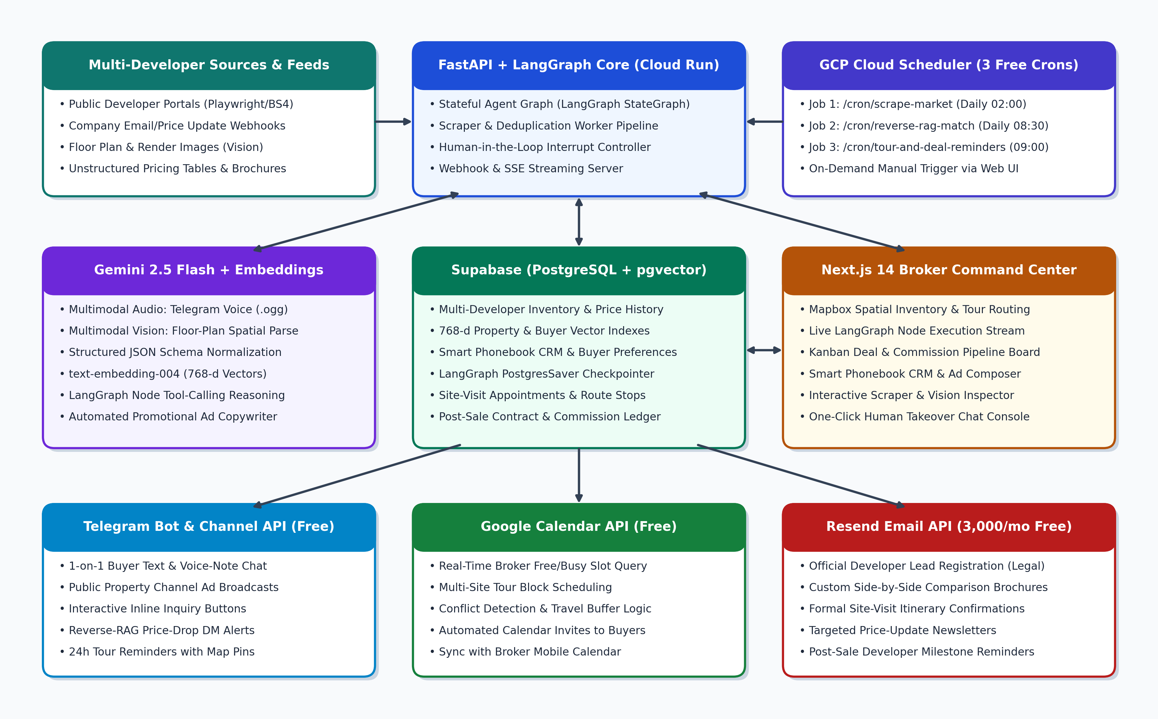
Figure 1: Stateful LangGraph Multi-Agent Architecture with Self-Correcting Discovery Loop
3.2 Multimodal Web Scraping, AI Vision Floor-Plan Parsing & Announcement Ingestion
Real estate inventory originates from two sources: (1) public developer websites and listing portals, and (2) direct company announcements (price-per-sqm updates, promotional discounts, or new building launches). PropPulse AI automates both pathways:
Automated Headless Web Scraper (Playwright + BS4): Crawls configured multi-developer listing pages, extracting raw HTML text, pricing tables, unit availability, and floor-plan image URLs.
Gemini Vision Spatial Extraction: Developer websites frequently omit key layout details from text descriptions and bury them inside architectural drawings. The ingestion pipeline passes floor-plan images to Gemini 2.5 Flash Vision, automatically extracting structured tags ('Open-concept kitchen', 'Maid room + bath', 'Corner wrap-around balcony', 'Net vs. Gross area ratio') and indexing them into the property's semantic profile.
Deduplication & Price-Change Detection: Computes a deterministic hash (developer_slug + project_name + unit_type + sqm). If a unit already exists in Supabase but the newly scraped price differs, the pipeline logs a price_history record and flags the unit as a PRICE_DROP or PRICE_INCREASE to trigger targeted buyer alerts.
3.3 Hybrid Agentic RAG & Reverse-RAG Vector Matchmaking (Supabase pgvector)
Pure vector search struggles with strict numeric bounds, while pure SQL fails on subjective lifestyle preferences. PropPulse AI implements bidirectional vector intelligence in Supabase PostgreSQL:
Forward Hybrid RAG (Buyer -> Properties): Combines relational WHERE clauses (status = 'AVAILABLE', price_etb <= buyer_max_budget, bedrooms >= min_beds) with pgvector cosine distance (1 - (property.embedding <=> query_embedding) >= 0.65) to retrieve the highest-scoring cross-developer units.
Reverse-RAG Matchmaking (New Property / Price Drop -> Buyers): Every buyer in the Smart Phonebook CRM maintains a 768-dimensional preference_embedding generated from their cumulative chat history. Whenever a new listing or price drop is ingested, the backend executes a reverse cosine similarity query against the buyers table to identify high-affinity leads and notify them automatically via Telegram DM or Resend Email.
4. Complete End-to-End Operational Workflows
Workflow 1: Multi-Developer Scraping, Announcement Ingestion & Telegram Channel Ad Publishing
Trigger: Daily GCP Cloud Scheduler job (POST /api/cron/scrape-market), inbound developer announcement email webhook, or manual trigger from the Next.js Scraper Playground.
• Step 1 (Parse & Vision Enrich): Scrapes target developer pages or parses raw announcement text; Gemini 2.5 Flash extracts structured JSON attributes and analyzes attached floor-plan images via Gemini Vision.
• Step 2 (Vectorize & Upsert): Generates a 768-d embedding via text-embedding-004 and upserts the property into Supabase PostgreSQL, recording any price delta.
• Step 3 (Autonomous Telegram Channel Broadcast): Gemini generates persuasive promotional ad copy (highlighting developer name, neighborhood, down payment %, and key floor-plan perks) and publishes it to the broker's public Telegram Property Channel complete with interactive inline buttons ('Ask AI About This Unit', 'Compare With Similar', 'Book Site Visit').
Workflow 2: Multimodal Conversational Qualification, Hybrid RAG & Cross-Developer Comparison
Trigger: A buyer clicks an inline button on a Telegram Channel ad, sends a text/voice note to the Telegram Bot, or messages via the Web Chat Simulator.
• Step 1 (State Load & Multimodal Decode): FastAPI loads the buyer's LangGraph checkpoint and Phonebook CRM record. Voice notes (.ogg) are decoded natively by Gemini 2.5 Flash.
• Step 2 (Hybrid RAG & Self-Correction): The LangGraph Discovery Node queries Supabase across all developers. If exact matches exist, it returns the top 3 units; if zero exact matches exist, the Constraint Relaxer Node widens parameters and presents the closest viable alternatives.
• Step 3 (Cross-Developer Comparison & CRM Upsert): The Financial Analyst Node synthesizes a transparent comparison across developers (e.g., comparing Ayat vs. Noah vs. Gift on price/sqm, installment schedule, and delivery timeline) while silently updating the buyer's Phonebook CRM profile and AI Lead Score (0–100).
Workflow 3: Multi-Site Tour Booking, Mapbox Routing & Developer Lead Registration (Commission Protection)
Trigger: The buyer expresses intent to visit one or more properties (or schedule an in-depth consultation).
• Step 1 (Calendar Availability & Conflict Guardrails): The LangGraph Scheduler Node calls Google Calendar API to verify the human broker's free slots, automatically accounting for travel buffer time between properties.
• Step 2 (Mapbox Multi-Stop Route Generation): For physical tours covering 2–3 properties, the backend queries the Mapbox Directions/Matrix API to sequence stops in the most efficient driving order and calculates travel times.
• Step 3 (Multi-Party Dispatch — Buyer + Developer + Broker): Upon confirmation, the agent executes three automated actions: (a) Creates the Google Calendar event; (b) Sends the buyer a formal itinerary and custom comparative brochure via Resend Email and Telegram; (c) Dispatches an official timestamped 'Lead Registration & Commission Protection Notice' via Resend Email to each respective developer's sales office registering the buyer under the broker's representation.
• Step 4 (Broker Pre-Tour Closing Dossier): Generates an executive briefing card on the Next.js dashboard detailing the buyer's budget, objections raised during chat, preferred units, Mapbox route map, and estimated commission value (ETB) so the broker can close the deal in person.
Workflow 4: Proactive Reverse-RAG Price-Drop Alerts, Tour Reminders & Post-Sale Milestone Tracking
Trigger: GCP Cloud Scheduler invokes POST /api/cron/daily-proactive-run every morning (also triggerable on-demand from the Next.js Command Center UI).
• Action A (Reverse-RAG Price-Drop & New Launch Re-Engagement): Queries newly scraped properties or price reductions from the past 24 hours, runs reverse vector similarity against saved buyer preference vectors in the Phonebook CRM, and sends personalized Telegram DMs and Resend emails to matching leads.
• Action B (24-Hour Site-Visit & Call Reminders): Scans upcoming Google Calendar tours within the next 24 hours and dispatches Telegram reminders with exact meeting times and Google Maps/Mapbox location pins.
• Action C (Post-Sale Developer Installment & Commission Milestone Reminders): For buyers who have signed a contract with a developer (status = CONTRACT_SIGNED), developers release the broker's commission once the buyer completes their initial down-payment or 2nd installment milestone. The cron job monitors these contract milestone dates and sends friendly, personalized Telegram/Email reminders to the buyer to pay the developer on schedule—protecting the deal from defaulting and notifying the broker when their commission is ready for collection.
5. High-Level Architecture & 100% Free-Tier Strategy
Every component of PropPulse AI is engineered to operate within Always Free Tier limits without requiring credit cards, paid API keys, or restricted sandboxes:
Architectural Layer | Technology / Service | Free Tier Allocation & Architectural Role
Frontend UI & Geospatial | Next.js 14 (App Router), Tailwind CSS, Mapbox GL JS | Mapbox Free Tier (50,000 map loads + 100,000 routing requests/mo free). Hosts Broker Command Center, Mapbox cluster map, and Live LangGraph Inspector.
Backend & Orchestrator | Python FastAPI, LangGraph, Playwright / BS4 on Cloud Run | GCP Cloud Run Always Free Tier (2M requests / 180,000 vCPU-seconds per month). Runs the stateful LangGraph agent, web scrapers, and webhook endpoints.
Multimodal AI & Embeddings | Google Gemini 2.5 Flash + text-embedding-004 | Google AI Studio Free Tier (15 RPM / 1,500 RPD, $0 cost). Handles text reasoning, native .ogg voice understanding, floor-plan Vision parsing, and 768-d vector embeddings.
Database & Vector Store | Supabase PostgreSQL + pgvector + Realtime | Supabase Free Tier (500MB DB, unlimited API requests). Stores multi-developer inventory, 768-d embeddings, LangGraph checkpoints, Phonebook CRM, and Commission Ledger.
Conversational & Broadcast | Telegram Bot API & Public Channel API | 100% Free & Unlimited. Powers 1-on-1 multimodal buyer chat, inline interactive keyboards, proactive reminders, and automated public channel ad posts.
Calendar Scheduling API | Google Calendar API (GCP Service Account) | 100% Free. Reads real-time broker free/busy availability and books single or multi-site property tour appointments.
Transactional Email API | Resend Email API | Free Tier (3,000 emails/month). Sends buyer tour itineraries, comparative brochures, and legal Developer Lead Registration notices.
Proactive Automation | GCP Cloud Scheduler | Always Free Tier (3 free cron jobs/month). Triggers daily multi-developer scraping, reverse-RAG matchmaking, and tour/milestone reminders.

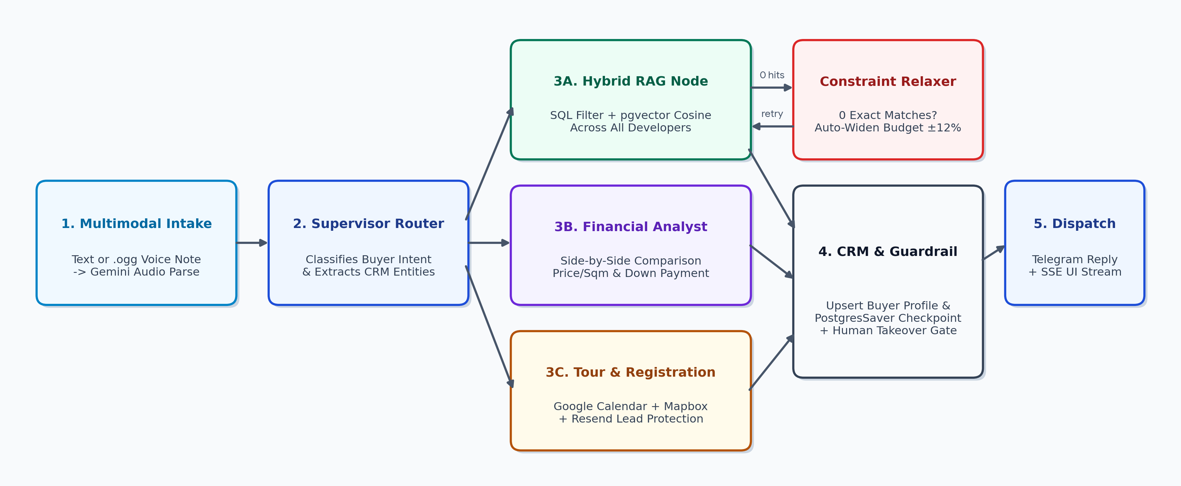
Figure 2: End-to-End System Architecture across Free-Tier Cloud, AI Services, APIs, and Webhook Layers
6. Core Relational & Vector Schema Design (Supabase PostgreSQL)
The relational and vector database schema is architected to support multi-developer aggregation, bidirectional vector search, stateful LangGraph checkpointing, and full-lifecycle commission tracking:
Table / RPC Name | Key Columns & Data Types | Architectural Purpose in System
developers | id (UUID), name, slug, sales_email, commission_rate_pct, reliability_score, website_url | Stores profiles of competing real estate companies (e.g., Ayat, Noah, Gift, Flintstone) and their sales office contacts for automated lead registration.
properties | id (UUID), developer_id (FK), title, sub_city, lat, lng, price_etb, bedrooms, sqm, down_payment_pct, delivery_date, vision_amenities (JSONB), content_hash, embedding (VECTOR(768)) | Multi-tenant property catalog indexed with HNSW pgvector for fast hybrid semantic search and Mapbox coordinate clustering.
price_history | id (UUID), property_id (FK), old_price_etb, new_price_etb, change_pct, detected_at | Logs price drops or increases detected by the scraper to trigger Reverse-RAG buyer alerts and Telegram channel broadcasts.
buyers_crm (Phonebook) | id (UUID), telegram_id, full_name, phone, email, max_budget_etb, min_bedrooms, preferred_sub_cities, lead_score, deal_stage, human_takeover (BOOL), preference_embedding (VECTOR(768)) | Smart Phonebook CRM storing extracted buyer entities, conversation stage, human-override state, and cumulative preference vectors.
tours_and_appointments | id (UUID), buyer_id (FK), property_ids (UUID[]), scheduled_start, calendar_event_id, mapbox_route_json, reminder_sent (BOOL) | Tracks booked phone consultations and multi-stop physical site visits along with optimized Mapbox driving routes.
commission_ledger | id (UUID), buyer_id (FK), developer_id (FK), property_id (FK), lead_reg_email_id, contract_value_etb, expected_commission_etb, next_buyer_milestone_date, status | Tracks legal lead registration proof, post-sale buyer installment milestones with the developer, and broker commission payout status.
match_properties_hybrid() | PostgreSQL RPC Function (max_budget, min_beds, sub_city_filter, query_embedding, match_count) | Executes single-pass Hybrid RAG: filters by hard SQL constraints and ranks by 1 - (embedding <=> query_embedding) cosine similarity.

7. Frontend Broker Command Center & Evaluator Demo Suite (Next.js 14)
To ensure a balanced full-stack implementation and allow evaluators to test every autonomous workflow immediately without waiting for overnight cron jobs, the Next.js 14 dashboard is designed as a 6-module Broker Command Center:
1. Mapbox Geospatial Inventory & Multi-Site Tour Router: Interactive dark/light Mapbox canvas displaying custom price-pill markers across Addis Ababa sub-cities (Bole, CMC, Kazanchis, Ayat, Sarbet) color-coded by developer. Clicking a booked tour overlays the optimized driving route, distance, and stop sequence.
2. Live LangGraph Brain Inspector & Activity Stream: Real-time SSE panel visualizing the active LangGraph state machine as a buyer chats—highlighting node transitions (Intake -> Router -> Hybrid RAG -> Constraint Relaxer -> Financial Analyst -> Scheduler), raw tool arguments, and latency metrics.
3. Interactive Multi-Developer Scraper, Vision & Ad Publisher Studio: Allows the user or evaluator to trigger a live scrape of sample developer portals or paste a raw company price announcement + floor-plan image. Shows live HTML-to-JSON extraction, Gemini Vision floor-plan tags, vector generation, and one-click publishing to the public Telegram Channel.
4. Smart Phonebook CRM & One-Click Human Takeover Console: Displays live buyer profiles, extracted budgets, AI Lead Readiness Scores, and full chat transcripts (including playable voice notes and transcriptions). Includes a 'Take Over Chat' toggle that pauses the LangGraph agent and lets the broker message the buyer on Telegram directly from the web UI.
5. Kanban Deal & Commission Protection Board: Drag-and-drop pipeline tracking deals across six real-world brokerage stages: Lead Qualified -> Site Visit Booked (Lead Registered with Developer) -> Tour Completed -> Contract Signed with Developer -> Commission Pending -> Commission Paid.
6. Manual Cron & Proactive Simulation Control Bar: Dedicated top-bar buttons allowing evaluators to fire all three GCP Cloud Scheduler jobs on demand ('Run Market Scraper', 'Trigger Reverse-RAG Price-Drop Alerts', 'Send 24h Tour & Milestone Reminders') and observe the resulting Telegram messages and Resend emails live.

