Integrate it in your application

Remove Migration file

Change ur Database Path

Using appsettings.js

Create Database- go to packageManager console

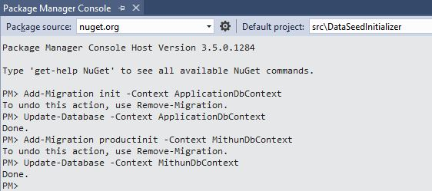

**Requirement for seed Data configuration**

Change Made in Startup.cs

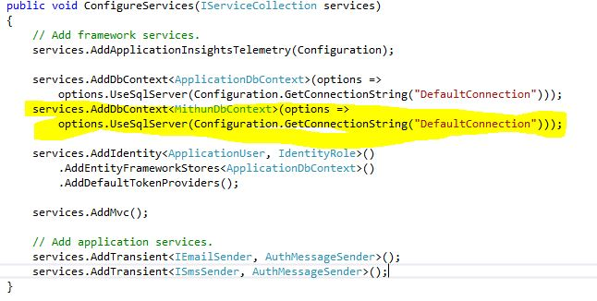

public void Configure(IApplicationBuilder app, IHostingEnvironment env, ILoggerFactory loggerFactory)

{

….

…..

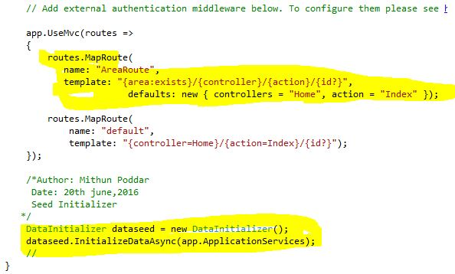

}

Now Add DataInitializer.cs file

Here, in this file I have created seed Data for User as well as for Product

Please Go thorugh this repository accordingly

Thank you

Author: Mithun Poddar

Date:21st june,2016

Summary-Seed Data Configuration in Mvc Core 1.0 RC2