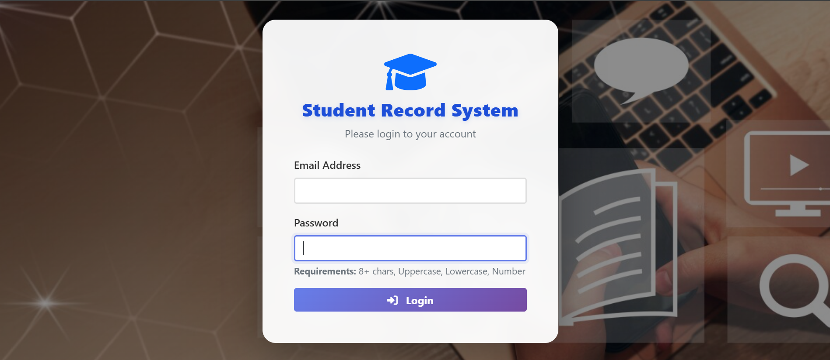 STUDENT RECORD MANAGEMENT SYSTEM-(SRMS)

A Web-Based Platform for Managing University Student Academic Records
3rd-year final Project — Wolkite University (WKU)
Built with the Laravel PHP Framework

Summited date 6/21/2026

Summited to Abraham G/m
GROUP MEMBER

Group Name ID-No

Ermiyas : Ashenafi…………………………………………………….. nsr\0284\16
Biruk :Getu………………………………………………………………nsr\0197\16
Debele :Denboba……………………………………………………….nsr\0233\16
Dagemawit :Negash……………………………………………………nsr\0217\16
Dawit :Tariku…………………………………………………………….nsr\2882c\16
Elili: T/mariyam…………………………………………………………nsr\0272\16

Table of Contents
Table of Contents 2
1. Introduction 3
1.1 Problem Being Solved 3
2. System Objectives 3
3. Technology Stack 3
4. System Architecture 4
4.1 Request Flow 4
5. User Roles and Access Control 5
6. Database Design 5
6.1 Core Entities 5
6.2 Key Relationships 6
7. Core Modules and Features 6
7.1 Administrator Module 6
7.2 Registrar Module 7
7.3 Teacher Module 7
7.4 Student Module 7
8. Authentication and Security 7
9. How the System Works — End-to-End Workflow 8
10. Demo / Test Accounts 8
11. Project Folder Structure 9
12. Possible Future Enhancements 9

1. Introduction
The Student Record Management System (SRMS) is a web-based application built to digitize and centralize the academic record-keeping process at a university. It replaces manual, paper-based or spreadsheet-driven processes for managing students, courses, grades, attendance, and enrollment with a single, role-based online platform.
The system was developed as a 3rd_year project (Wolkite University, WKU) using the Laravel PHP framework, and is organized around four distinct user roles — Administrator, Registrar, Teacher, and Student — each of whom interacts with a tailored dashboard and permission set suited to their responsibilities.

1.1 Problem Being Solved
Universities typically manage large volumes of student data: personal information, course enrollment, grades across multiple semesters, and attendance records. When this is handled manually or through disconnected spreadsheets, it commonly leads to:
- Data duplication and inconsistent records across departments
- Slow, error-prone grade and attendance entry
- Difficulty producing accurate, up-to-date reports for administrators
- No single source of truth that students, teachers, and staff can all rely on
SRMS addresses these problems by giving every stakeholder a focused, secure, web-based interface to the same underlying database.

2. System Objectives
The system is designed to achieve the following goals:
- Provide secure, role-based access so each user only sees and manages what is relevant to them.
- Allow registrars to register new students and manage their enrollment in courses each semester.
- Allow teachers to record and submit grades, and track attendance, only for the students they are responsible for.
- Allow students to view their own academic records (profile, grades, attendance) without needing staff assistance.
- Give administrators an overview of the institution (student/teacher counts, reports) and the ability to manage user accounts.
- Maintain a normalized, relational database structure so academic data stays accurate and consistent.

3. Technology Stack
SRMS follows the Model-View-Controller (MVC) pattern provided by Laravel. The table below summarizes the technologies used in the project.
Layer | Technology | Purpose
Backend Framework | Laravel 12 (PHP 8.2) | Routing, MVC structure, authentication, ORM
Database | SQLite (via Eloquent ORM) | Relational storage for all academic records
Templating | Blade | Server-rendered HTML views per role
Frontend Styling | Bootstrap 5 + Tailwind CSS + Sass | Responsive dashboard and form UI
Build Tooling | Vite | Compiling and bundling CSS/JS assets
Data Export | Maatwebsite/Excel | Exporting records to Excel format
Testing | PHPUnit | Feature and unit test scaffolding

The project uses Laravel's built-in Eloquent ORM to model relationships between users, courses, departments, grades, attendance, and enrollment records, and Laravel's session-based authentication guard for login.

4. System Architecture
SRMS follows a layered MVC architecture with an added role-based access layer:
- Routes (routes/web.php) — define every URL endpoint, grouped by role prefix (/admin, /teacher, /student, /registrar).
- Middleware — every role-prefixed route group requires authentication (auth); the Registrar section additionally requires the registrar middleware. Dedicated middleware classes also exist for Admin, Teacher, and Student roles to enforce per-role access at the controller level.
- Controllers — one controller per role (AdminController, TeacherController, StudentController, RegistrarController) plus an Auth namespace handling login, registration, and password reset.
- Models (Eloquent) — User, Student, Course, Department, SubField, Enrollment, Grade, Attendance, and AcademicPeriod, each mapped to a database table with defined relationships.
- Views (Blade templates) — one set of views per role under resources/views/admin, /teacher, /student, /registrar, sharing a common layout (layouts/app.blade.php).

4.1 Request Flow
A typical request flows as follows: the browser submits a request to a named route → Laravel checks the auth (and role) middleware → the matching controller method runs business logic and queries the database through Eloquent models → the controller returns a Blade view (or redirects back with a success/error message) → the rendered HTML is sent back to the browser.

5. User Roles and Access Control
Every account in the system has a single role stored on the users table: admin, teacher, student, or registrar. After login, the user is redirected to the dashboard that matches their role, and route-level middleware prevents users from accessing dashboards or actions outside their role.
Role | Primary Responsibilities
Administrator | Oversees the whole system: manages student and teacher accounts, views institution-wide reports, and can correct/manage grade records.
Registrar | Owns the student lifecycle: registers new students, edits or archives student records, and manages course enrollment per semester.
Teacher | Manages academic delivery: views assigned/department students, records and submits grades, and logs attendance for their classes.
Student | Self-service access: views and updates their own profile, and reviews their grades and attendance history.

Login is handled by a single, unified login form. After Laravel validates the e-mail and password (via Auth::attempt), the AuthController inspects the authenticated user's role field and redirects them to the corresponding dashboard route — admin.dashboard, teacher.dashboard, student.dashboard, or registrar.dashboard.

6. Database Design
The database is relational and was refactored during development to follow Third Normal Form (3NF) — for example, a student's department and course sub-field are stored as foreign keys referencing dedicated Department and SubField tables, rather than as repeated free-text values on every record.

6.1 Core Entities
Table | Key Fields | Purpose
users | list_no, first_name, last_name, email, role, department, year | Stores every account (admin, teacher, student, registrar). list_no is an auto-generated ID such as STU20260001.
departments | name, department_code, description | Academic departments/colleges (e.g. Computer Science).
sub_fields | name, department_id | Specializations within a department, linked via foreign key.
courses | course_code, course_name, sub_field_id, credits | Course catalog; linked to a sub-field/department.
enrollments | student_id, course_id, academic_period_id | Records which student is enrolled in which course, per term.
grades | student_id, course_id, teacher_id, grade, status | A student's grade in a course; status is draft or submitted.
attendances | student_id, course_id, teacher_id, date, status | Daily attendance entries; status is present, absent, late, or excused.
academic_periods | semester, academic_year, start_date, end_date, status | Defines each academic term and which one is currently active.
teacher_courses | teacher_id, course_id | Pivot table assigning teachers to the courses they teach.
student_teacher_assignments | student_id, teacher_id, assigned_by | Pivot table assigning students to a specific teacher when not grouped purely by department.

6.2 Key Relationships
- A Department has many SubFields; a SubField has many Courses (Department → SubField → Course).
- A Course belongs to many Teachers, and a Teacher is assigned to many Courses (many-to-many via teacher_courses).
- A Student (User) has many Grades, Attendances, and Enrollments.
- Every Grade, Attendance, and Enrollment record belongs to an AcademicPeriod, so records are always tied to a specific semester/year.
- A Teacher may be linked to specific Students directly (student_teacher_assignments) in addition to department-wide access.

7. Core Modules and Features

7.1 Administrator Module
The admin dashboard summarizes total students, teachers, courses, and users. From there, the administrator can:
- View, create, edit, and delete student accounts, with filtering by department, freshman category, or college group.
- View, create, edit, and delete teacher accounts.
- View and correct grade records (edit/delete) across the system.
- Access an institution-wide reports page.
- Look up courses dynamically by department (used to populate dependent dropdowns).

7.2 Registrar Module
The registrar module focuses on the student lifecycle and enrollment:
- Register new students through a dedicated registration form.
- View, edit, update, and delete student records.
- Archive a student (e.g. on graduation or withdrawal) without permanently deleting their history.
- Manage course enrollment — add a student to a course for a given academic period, or remove an enrollment.
- View grade records across students for verification purposes.

7.3 Teacher Module
The teacher dashboard shows the number of students under the teacher's responsibility, total courses, and how many grades have been entered versus submitted. Teachers can only act on students within their own department, or students specifically assigned to them — this is enforced in the controller, not just the UI.
- Search and filter their list of students by name, ID, or year.
- Add or update a grade for a student/course/semester combination (grades start in draft status).
- Submit one or more draft grades to the registrar, locking them as submitted (a submitted grade can no longer be edited or deleted by the teacher).
- Record daily attendance per student/course as present, absent, late, or excused, with optional remarks.
- Delete a grade or attendance entry they created, as long as it has not yet been submitted/finalized.

7.4 Student Module
Students have a read-mostly, self-service dashboard:
- View and update their own profile information.
- View their grades across courses and semesters.
- View their attendance history.

8. Authentication and Security
- Authentication uses Laravel's session-based Auth guard; passwords are hashed automatically via the password cast on the User model.
- Login requires a valid e-mail and a password meeting a minimum-complexity rule (at least one uppercase letter, one lowercase letter, and one digit).
- On every login, the session is regenerated to prevent session-fixation attacks.
- Each role-prefixed route group is wrapped in the auth middleware, and the Registrar section adds a second registrar middleware layer; dedicated Admin/Teacher/Student middleware classes are also registered as named aliases for role enforcement.
- Authorization is checked again at the controller level — for example, a teacher's grade/attendance actions are validated against the specific students that teacher is permitted to manage, not just against their role.
- CSRF protection is enabled across all web routes via Laravel's standard CSRF middleware (with a custom CSRF verifier class for any excluded routes).

9. How the System Works — End-to-End Workflow
A typical academic cycle moves through the system as follows:
- Setup: An Administrator or Registrar ensures the relevant Department, SubField, Course, and AcademicPeriod records exist for the term.
- Student Registration: The Registrar registers a new student, which creates a User record with the role student and an auto-generated list number (e.g. STU20260012).
- Enrollment: The Registrar enrolls the student into one or more courses for the active academic period, creating Enrollment records.
- Course Delivery: Throughout the term, the assigned Teacher records attendance for each class session and enters grades as coursework is completed.
- Grade Submission: Once finalized, the Teacher submits the grades; their status changes from draft to submitted, after which the Teacher can no longer alter them.
- Review: The Registrar and Administrator can review submitted grades and, if necessary, the Administrator can correct a record.
- Self-Service: At any point, the Student can log in to view their own profile, grades, and attendance — always scoped to their own account only.

10. Demo / Test Accounts
The project ships with seeded demonstration accounts (one per role) for local testing. These are development credentials only and should be changed before any real deployment.
Role | Email | Password
Administrator | admin@example.com | Admin123
Teacher | teacher@example.com | Teacher123
Student | student@example.com | Student123
Registrar | registrar@example.com | Registrar123

The application is run locally with the Laravel built-in server using the command: php artisan serve

11. Project Folder Structure
The codebase follows the standard Laravel directory layout:
Path | Contents
app/Models/ | Eloquent models: User, Student, Course, Department, SubField, Enrollment, Grade, Attendance, AcademicPeriod
app/Http/Controllers/ | Role controllers (Admin, Teacher, Student, Registrar) and the Auth namespace
app/Http/Middleware/ | Role-guard middleware classes (Admin, Teacher, Student, Registrar)
routes/web.php | All application routes, grouped by role prefix
database/migrations/ | Schema definitions, including the later 3NF normalization migration
database/seeders/ | Seed data for departments, sub-fields, courses, and academic periods
resources/views/ | Blade templates, one subfolder per role plus shared auth/layout views
public/ | Web server entry point (index.php) and compiled front-end assets

12. Possible Future Enhancements
- Wire up the already-installed Maatwebsite/Excel package to export student lists, grade sheets, or attendance reports directly to Excel.
- Build out the admin Reports page with charts/summaries (e.g. pass rates, attendance trends per department).
- Add e-mail notifications when grades are submitted or a student is enrolled/archived.
- Add automated test coverage for grade-submission and enrollment workflows using the existing PHPUnit setup.
- Introduce API endpoints so a future mobile app could reuse the same backend.

