Customer Support Ticket Analysis
Exploratory Data Analysis & Insights Report

Dataset: output.xlxs | Period: 2020–2021 | Total Tickets: 8,469

1. Executive Summary
This report presents a comprehensive exploratory data analysis of 8,469 customer support tickets spanning 2020–2021. The analysis covers ticket volume trends, priority distribution, channel usage, product categories, customer demographics, and satisfaction ratings. Key findings point to a high open-ticket backlog and first-response time as the primary bottlenecks in the support workflow.

1.1 Key Performance Indicators

8,469  Total Tickets | 19.35 hrs  Avg Response Time | 9.61 hrs  Avg Resolution Time
0.33%  Resolved TTs % | 2.99 / 5  Average Rating | 0.50%  Priority TTs %

2. Data Overview & Preparation
The dataset was loaded from customer_support_tickets.csv and contained the following key columns after standardization:

- ticket_id, ticket_type, ticket_subject, ticket_status, ticket_priority, ticket_channel
- product_purchased → mapped to product_category (Electronics, Computers, Gaming, Home Appliances, Cameras, Other)
- date_of_purchase, first_response_time, time_to_resolution — converted to datetime
- customer_age, customer_gender, customer_satisfaction_rating

Derived fields created during EDA:
- resolution_time_hours: (time_to_resolution − first_response_time) in hours
- Status_Group: Closed vs In Progress (consolidating Pending & Open)
- age_group: 18–25, 26–35, 36–46, 47–59, 60+
- product_category: grouped from 30+ individual product names

3. Dashboard Overview
The following dashboard was created in Power BI / Matplotlib and visualises the core KPIs and distributions at a glance.

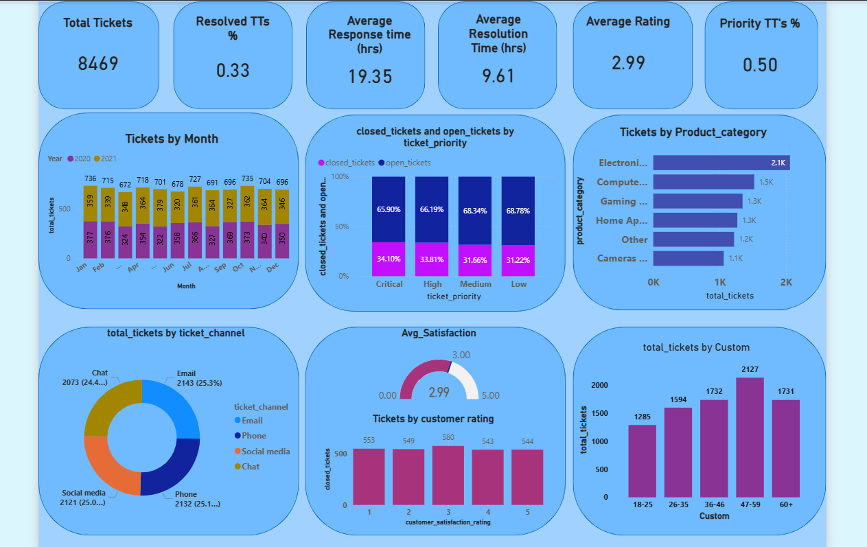
Figure 1: Customer Support Ticket Dashboard (2020–2021)

4. Detailed Analysis

4.1 Monthly Ticket Volume
Ticket volumes remain relatively stable across all twelve months of both years, ranging from approximately 320 to 736 per month. There is no strong seasonal spike, indicating a consistently high support demand year-round. A slight dip is observed in mid-year months (June–July) in 2021, potentially corresponding to fewer purchases during non-peak retail periods.

4.2 Ticket Priority Distribution
Across all four priority levels — Critical, High, Medium, and Low — the proportion of open tickets consistently exceeds 65%. This is a significant red flag:
- Critical: 34.1% closed vs 65.9% open
- High: 33.8% closed vs 66.2% open
- Medium: 31.7% closed vs 68.3% open
- Low: 31.2% closed vs 68.8% open

The lack of meaningful differentiation in closure rates between Critical and Low priority tickets suggests that priority-based SLA enforcement is either absent or poorly implemented.

4.3 Product Category Analysis
Electronics & Gadgets is the dominant category with ~2,100 tickets, followed by Computers & Software (1,500), Gaming & Entertainment (1,300), Home Appliances (1,300), Other (1,200), and Cameras & Accessories (1,100). This distribution reflects the popularity and complexity of consumer electronics, which tend to generate more support queries due to setup issues, connectivity problems, and firmware updates.

4.4 Ticket Channel Distribution
The four support channels — Email (25.3%), Phone (25.1%), Social Media (25.0%), and Chat (24.4%) — are strikingly balanced, each handling approximately one quarter of all tickets. This multi-channel equilibrium suggests customers do not have a strong preference for one channel, or that the organisation actively redistributes load across channels.

4.5 Customer Satisfaction Ratings
The average satisfaction rating is 2.99 out of 5.0, suggesting moderate customer satisfaction. The distribution of ratings among closed tickets is nearly uniform across all five rating levels (553–580 per rating), indicating that resolution alone does not strongly determine how satisfied customers feel. Other factors such as agent behaviour, communication quality, and resolution time likely play larger roles.

4.6 Age Group Analysis
The 47–59 age group generates the highest number of tickets (2,127), followed closely by 36–46 (1,732) and 60+ (1,731). The 18–25 bracket contributes the fewest (1,285). Older customers may be less tech-savvy or have higher-value products requiring more support, making them an important demographic to serve well.

5. Key Insights & Recommendations

High Open-Ticket Rate Across All Priorities
65–69% of all tickets remain unresolved regardless of priority. Implement strict SLA tiers with automated escalation for Critical and High priority tickets to drive resolution rates up.
Electronics Dominates Support Volume
Electronics & Gadgets accounts for the largest category (~2.1K tickets). Invest in self-service knowledge bases, FAQs, and video tutorials for common Electronics issues to deflect routine queries.
Balanced Multi-Channel Model
All four channels handle approximately 25% of traffic — an impressive balance. Maintain this by monitoring channel-specific response KPIs and rebalancing agent allocation when drift occurs.
Older Customers Are the Primary Users
The 47–59 segment generates the most tickets. Consider dedicated senior support queues with extended hours, simplified IVR, and patient-style communication guidelines.
First Response Is the Key Bottleneck
Average response time (19.35 hrs) is more than double the resolution time (9.61 hrs). Reducing first-response lag through chatbot triage or auto-acknowledgement would have the highest impact on satisfaction.
Satisfaction Not Driven by Resolution Alone
Uniform rating distribution across resolved tickets (1–5 stars) suggests soft skills matter. Agent training in empathy, communication, and follow-up may lift average ratings above 3.0.

6. Methodology
The analysis was conducted using Python in a Jupyter Notebook environment with the following libraries:
- pandas — data loading, cleaning, grouping, and feature engineering
- numpy — numerical operations
- matplotlib — base plotting
- seaborn — statistical visualisations (countplot, histplot, barplot, boxplot)

Key data preprocessing steps included: column name standardisation (lowercase, underscore-separated), datetime parsing for date_of_purchase, first_response_time, and time_to_resolution, derivation of resolution_time_hours, product categorisation, and age group binning.

7. Conclusion
This EDA reveals a support ecosystem that is high-volume, balanced across channels, and demographically diverse. The primary challenges are a persistently high backlog of open tickets and slow initial response times. Priority-based SLA differentiation appears to be ineffective in its current form.

Addressing first-response lag through automation, reducing ticket backlog for Critical issues, and improving self-service resources for Electronics & Gadgets should be the immediate priorities. Longer-term, improving the average satisfaction score above 3.0 will require investment in agent communication skills and structured follow-up processes.

All code for this analysis is available in the accompanying Jupyter Notebook (capstone_proj.ipynb).

