Curriculum Vitae

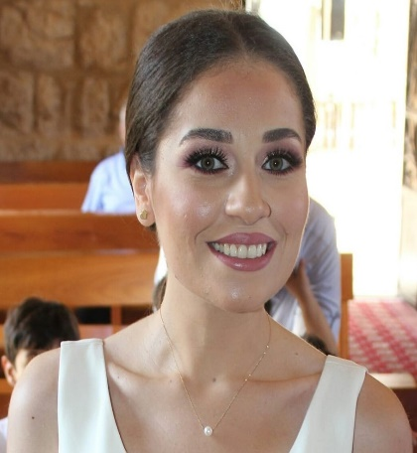 | ROULA KHATTAR  Lebanon- Beirut  phone: 00961-71-786513  Email: khattaroula@gmail.com  Date of birth: 6 MAY 1993  Sex: Female  Nationality: Lebanese  Status: single

education  Professionnel Experiences  LANGUAGE  COMPUTER and INTERNET  TALENTS | - 2015-2016: Master in political and administrative science at the Lebanese university - JAL EL DIB.  - 2011-2012: Certificate of literature and humanities at Laure Moughaizel Public high school – Achrafieh.  - 2015 till now: French teacher for primary classes at Antonines sisters school – Rechmaya.  - 2016 till now: Science teacher for primary classes at Antonines sisters school – Rechmaya.  - 2016 till 2019: Working at the secretary office at the Antonines sisters school – Rechmaya.  Arabic, French and English.  Word, Excel.  - Music : Piano learning.  - Traveling : ITALY – TURKEY.  - Other : Reading - Sport.

