Penetrating Damp
Older properties in Gloucester are often built without a cavity and have solid walls and if they are affected by water ingress from driving rain, gutter leaks etc they can become damp which can affect walls inside leading to damage to plaster and possible decay of timber.
Gloucester Damp & Mould Control offer a complete service for weatherproofing your home which includes roof and gutter repairs, repointing walls and replace defective render with a waterproof coating.
The properties that have solid walls lose about 45% of their actual heat through the solid walls. They are also known as ‘hard to treat’ because insulating them is very expensive. Insulating them through expensive external cladding alters the appearance of the walls and fitting insulated plaster boards internally reduces the room dimensions.
Gloucester Damp & Mould Control has a solution to prevent penetrating dampness and also prevent heat loss through walls. We provide external waterproofing treatment with STORMDRY. This treatment prevents any moisture ingress and penetrating damp but also reduces heat loss and is also less disruptive to the appearance than solid wall insulation. Stormdry is a unique, cost-effective method of improving the water-proofing and insulation qualities of buildings without changing their appearance.
The Stormdry water-proofing and insulation treatment can be best explained by using the following analogy: Imagine you have been caught in a heavy rain shower with no umbrella. Your clothes are soaked through and very quickly you begin to feel cold. When you get home, your first instinct will be to remove your wet clothes, as you know that they are making you colder.
The reason behind this is that wet materials lose heat more readily than dry materials. In the case of typical building materials, a completely saturated brick will transfer approximately twice as much heat as an identical dry brick.
By keeping a building’s walls drier, it is therefore possible to significantly reduce the heat that is lost through them. Stormdry has been developed over the last five years to achieve this by creating a high-performance hydrophobic zone in treated properties.
Stormdry is unique cream formulation of silanes and siloxanes, a single coat of Stormdry waterproofing and insulating cream is applied externally to masonry using a brush or roller . When applied, the cream is white so that it is easy to see if any areas have been missed. Within 48 hours the Stormdry will have penetrated deeply into the walls leaving no visible sign of application on the surface; this means no discolouration, no sheen and no residue.
Any rainwater that comes into contact with the treated walls is deflected away from the building and is seen to bead down the brickwork like water off a ducks back
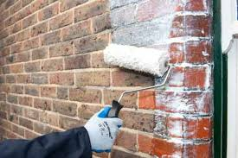
Stormdry is applied by brush or roller and penetrates deep into the brickwork forming and impermeable barrier to water.
Prevents water ingress and heat loss
.

The Benefits of using Stormdry
- Protects your home against penetrating damp (rain penetration)
- Improves thermal performance of masonry by keeping it dry (energy saving)
- Improves the performance of cavity wall insulation by protecting it from moisture
- Retains the original appearance of the wall
- Saves up to 29% on energy bills for energy loss through brick surfaces.
- Deep penetration compared to conventional coatings
- Single coat application
- Retains wall breathability
- BBA approved for 25 years

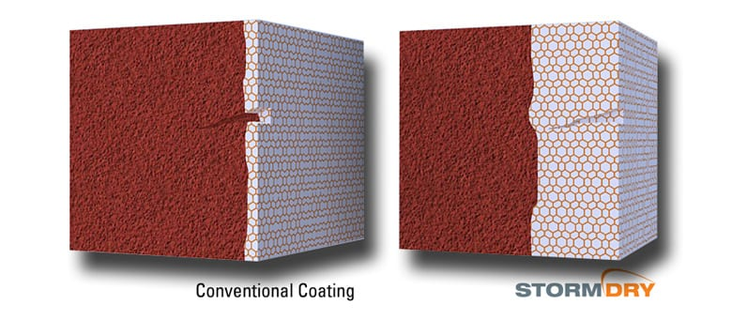
Applied externally as a single-coat of cream that will last for 20 years, Stormdry is a specially formulated cream that penetrates deeply into the walls and reduces the amount of moisture they can absorb. A dry wall conducts much less heat than a saturated (wet) wall does, therefore more heat will be retained within the property as less is transferred out through the walls
The cream has been formulated to line the pores of the masonry rather than block them, so vapours can still pass through the building fabric allowing it to "breathe."
When applied the cream is white, however within 48 hours it will have penetrated deeply into the walls leaving no discolouration, residue or sheen.
Tests carried out at two leading UK universities have revealed that as well as preventing penetrating damp the treatment can save a large amount of a property's annual heating energy that would normally be lost
If you feel that your property is affected by penetrating dampness or poor thermal efficiency then please feel free to call us on 01452 890707 for free, impartial advice.
At Gloucester Damp & Mould Control we are happy to discuss any damp related problems that may be having an adverse effect on your house and offer over the phone advice or arrange an inspection if required. Initial inspections are also free and we will offer you the most cost effective and beneficial advice and solutions to your rising dampness problems
Alternatively contact us through the form on the Contact Us page to request a free survey or to learn more information about our services.

