1. The blue entries are uneditible, because this is the content from Flipit.com. They are intended to help you with inspiration for creating new content.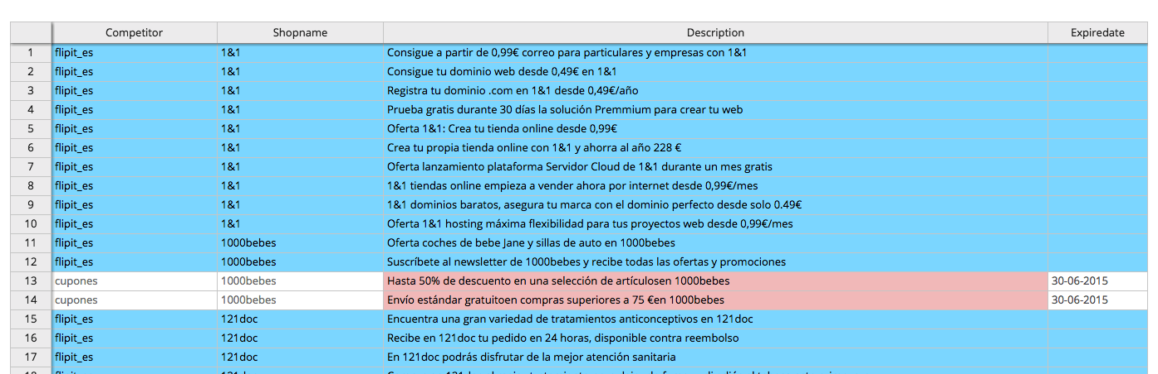
2. The entries in red, means that the content is not edited. You can edit the content by clicking the cell and add some content. When the content is edited, the bar will be green. **Please note that the content must be between 15 and 150 characters. Otherwise you get an error message.**
3. When you press show, you can see the edited, unedited and all content. 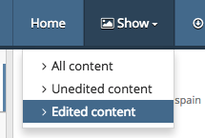
4. When you press Export, you can export the format to MS Excel, CSV or JSON. 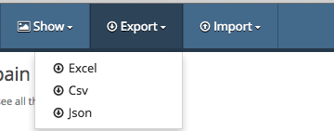
5. When you press Import, you can renew the offers per competitor. Refreshing the content takes about 1 -2 minutes. When you refresh the page you can see the new offers. 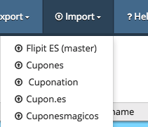
6. **Questions / bugs / suggestions? Please mail them to** [**Erwin@imbull.com**](mailto:Erwin@imbull.com)