Exploring Wigets:

1.Container Widget

import 'package:flutter/material.dart';

class Home extends StatelessWidget {
@override
Widget build(BuildContext context) {
return Container(
alignment: Alignment.center,
color: Colors.deepPurple,
width: 200.0,
height: 100.0,
child: Text('Flight',textDirection: TextDirection.ltr),
);
}
}

import 'package:flutter/material.dart';

import 'app_screens/home.dart';

void main() {
runApp(MaterialApp(
title: 'Exploring UI Widgets',

home: Home(),
));
}

Output:

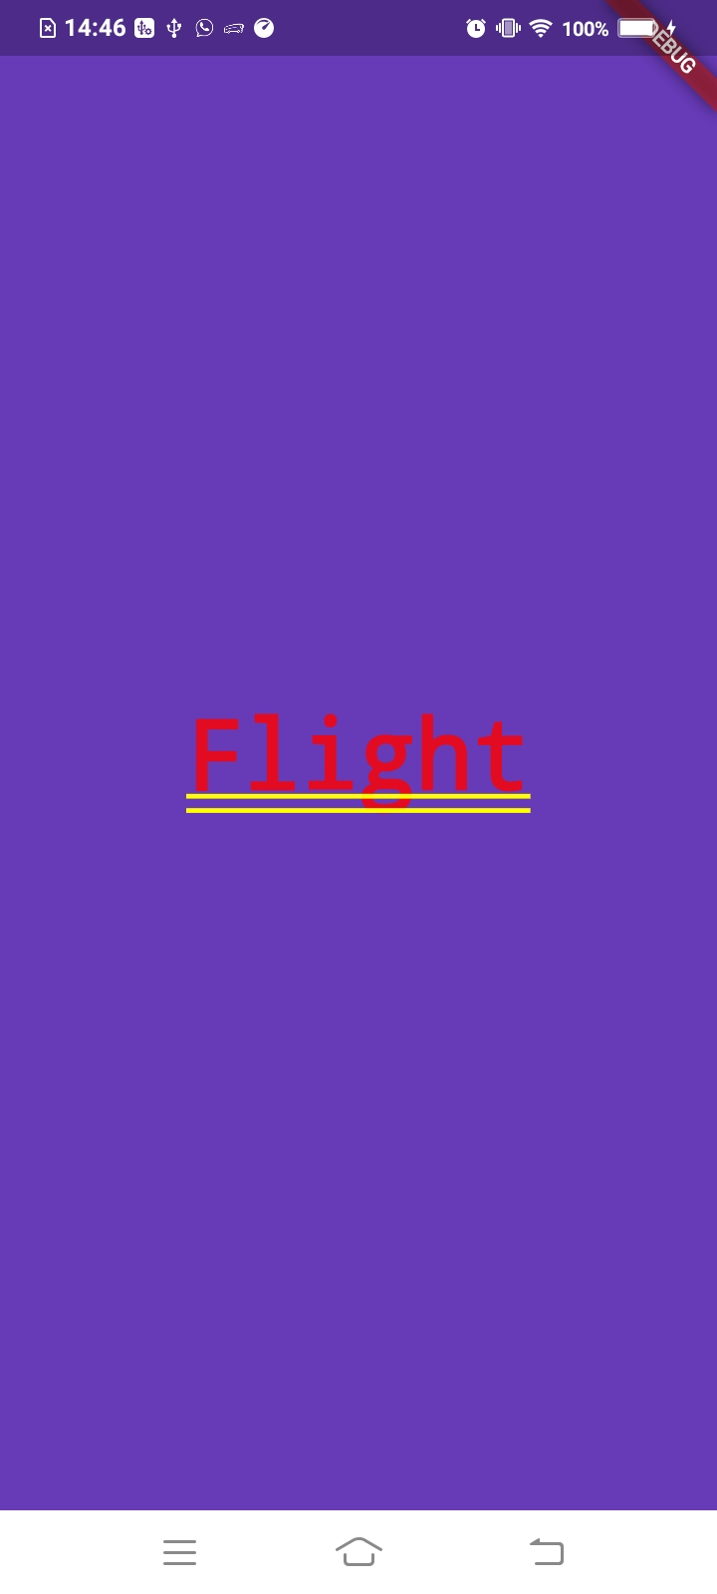

Add Width and Height:

import 'package:flutter/material.dart';

class Home extends StatelessWidget {
@override
Widget build(BuildContext context) {
return Center(
child: Container(
alignment: Alignment.center,
color: Colors.deepPurple,
width: 200.0,
height: 100.0,
child: Text('Flight',textDirection: TextDirection.ltr),
),
);
}
}

Output:
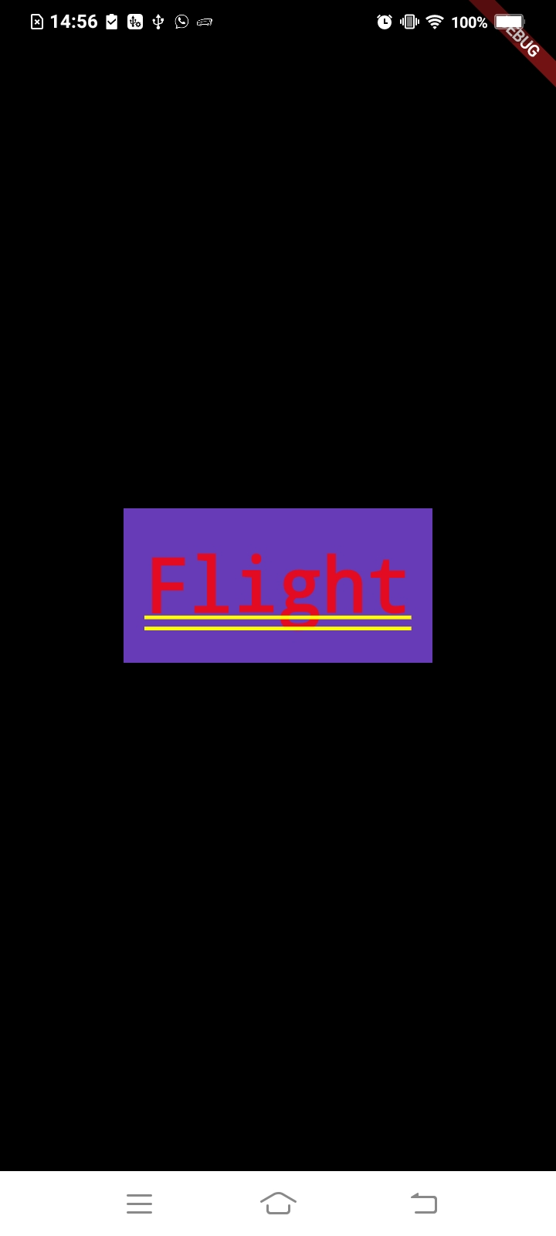

Add Margin:
import 'package:flutter/material.dart';

class Home extends StatelessWidget {
@override
Widget build(BuildContext context) {
return Center(
child: Container(
alignment: Alignment.center,
color: Colors.deepPurple,
/* width: 200.0,
height: 100.0,*/
margin: EdgeInsets.all(15.0),
child: Text('Flight',textDirection: TextDirection.ltr),
),
);
}
}

Output:
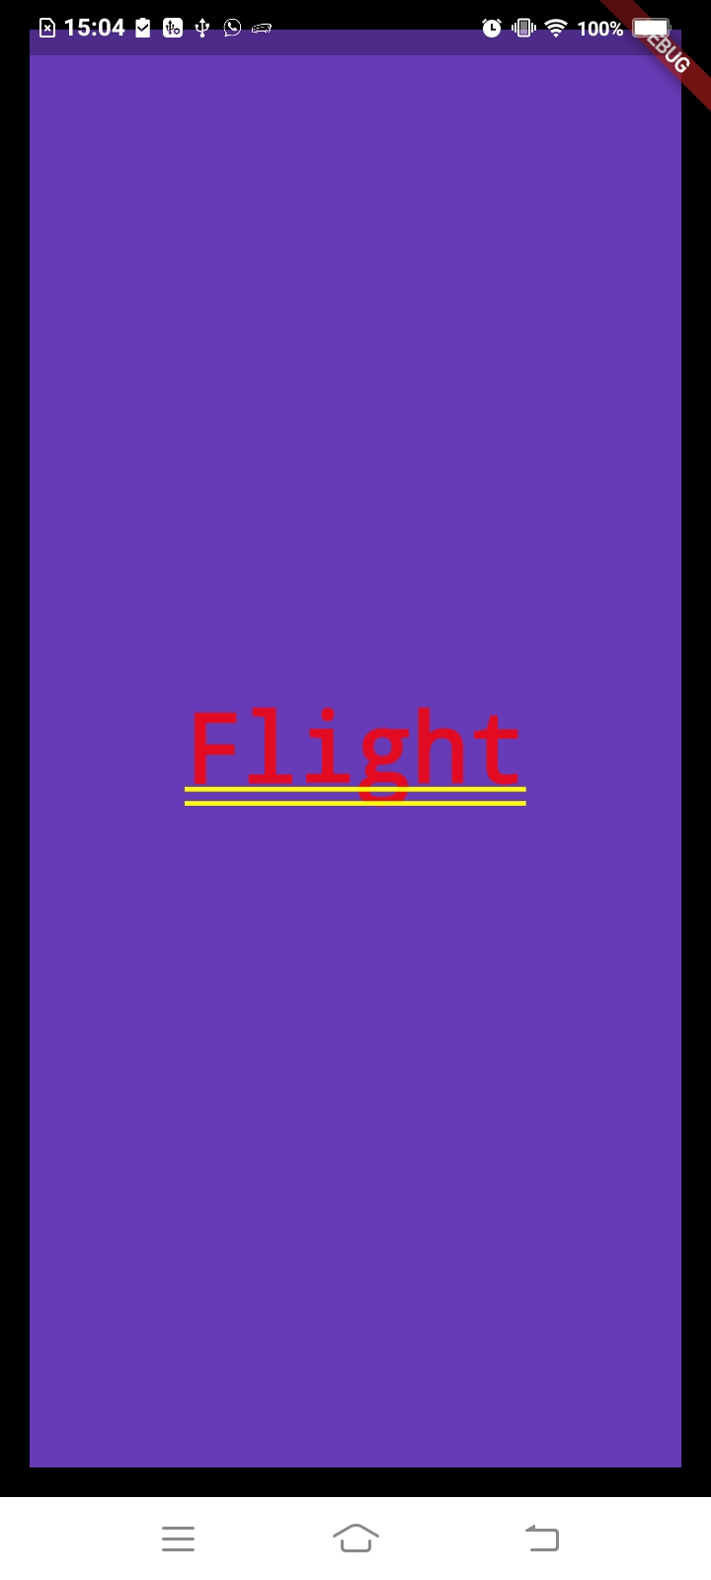

Styling Text Widget and add custom font:

Remove Underline in Text

import 'package:flutter/material.dart';

class Home extends StatelessWidget {
@override
Widget build(BuildContext context) {
return Center(
child: Container(
alignment: Alignment.center,
color: Colors.deepPurple,
/* width: 200.0,
height: 100.0,*/
margin: EdgeInsets.all(15.0),
child: Text(
'Flight',
textDirection: TextDirection.ltr,
style: TextStyle(
decoration: TextDecoration.none //remove underline
),),
),
);
}
}

Output:
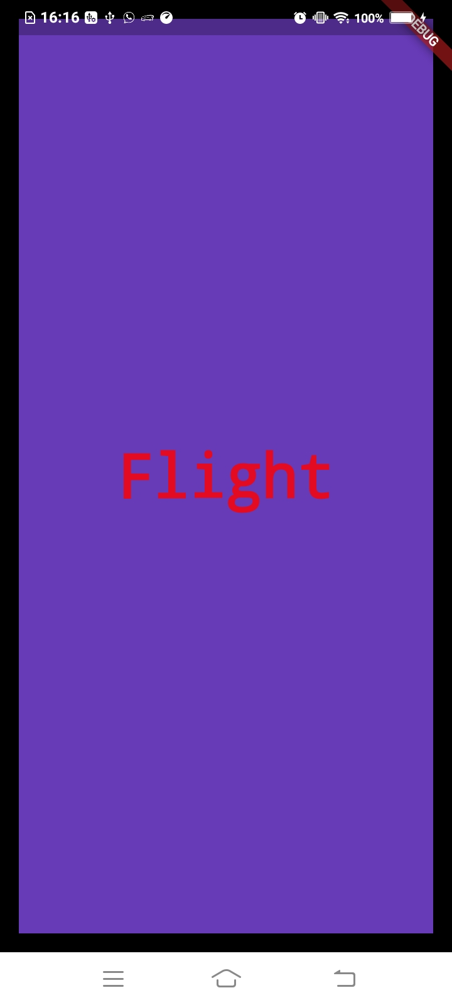

Custom Font:
1.Download and import font file
2.Declare it in pubspec.yaml
3.Use it in Text widget

2.Declare it in pubspec.yaml

fonts:
- family: Raleway
fonts:
- asset: fonts/Raleway-Regular.ttf
- asset: fonts/Raleway-Bold.ttf
weight: 700
- asset: fonts/Raleway-LightItalic.ttf
weight: 300

- family: Roboto
fonts:
- asset: fonts/Roboto-Regular.ttf

3. Use it in Text widget

class Home extends StatelessWidget {
@override
Widget build(BuildContext context) {
return Center(
child: Container(
alignment: Alignment.center,
color: Colors.deepPurple,
/* width: 200.0,
height: 100.0,*/
margin: EdgeInsets.all(15.0),
child: Text(
'Flight',
textDirection: TextDirection.ltr,
style: TextStyle(
decoration: TextDecoration.none ,//remove underline
fontFamily: 'Raleway',
fontWeight: FontWeight.w700,
color: Colors.white
),),
),
);
}
}

Output:

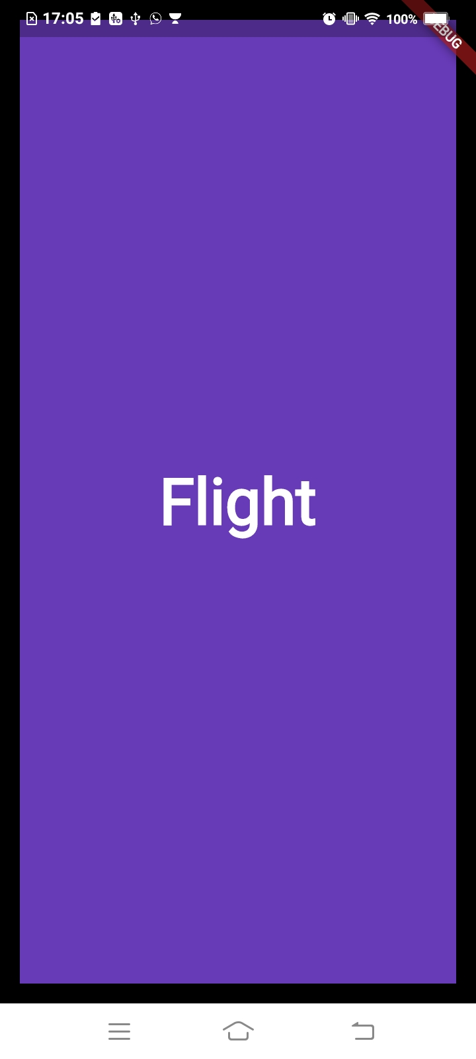

2.Row and Column Widget

Row Widget: ( Show Elements in Vertical)

import 'package:flutter/material.dart';

class Home extends StatelessWidget {
@override
Widget build(BuildContext context) {
return Center(
child: Container(
alignment: Alignment.center,
color: Colors.deepPurple,
child: Row(
children: <Widget>[
Text(
'Spice Jet',
textDirection: TextDirection.ltr,
style: TextStyle(
decoration: TextDecoration.none, //remove underline
fontSize: 35.0,
fontFamily: 'Raleway',
fontWeight: FontWeight.w700,
color: Colors.white),
),
Text(
'From Mumbai to Bangalore via New Delhi',
textDirection: TextDirection.ltr,
style: TextStyle(
decoration: TextDecoration.none, //remove underline
fontSize: 35.0,
fontFamily: 'Raleway',
fontWeight: FontWeight.w700,
color: Colors.white),
)
],
),
),
);
}
}

Output:
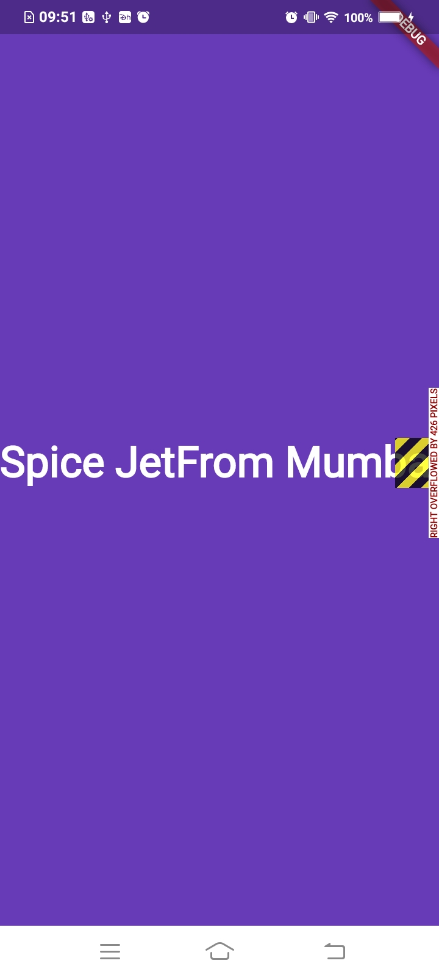

Expanded Widget (Contents to big for screen)

import 'package:flutter/material.dart';

class Home extends StatelessWidget {
@override
Widget build(BuildContext context) {
return Center(
child: Container(
alignment: Alignment.center,
color: Colors.deepPurple,
child: Row(
children: <Widget>[
Text(
'Spice Jet',
textDirection: TextDirection.ltr,
style: TextStyle(
decoration: TextDecoration.none, //remove underline
fontSize: 35.0,
fontFamily: 'Raleway',
fontWeight: FontWeight.w700,
color: Colors.white),
),

Expanded(child:
Text(
'From Mumbai to Bangalore via New Delhi',
textDirection: TextDirection.ltr,
style: TextStyle(
decoration: TextDecoration.none, //remove underline
fontSize: 35.0,
fontFamily: 'Raleway',
fontWeight: FontWeight.w700,
color: Colors.white),
)
)
],
),
),
);
}
}

Output:
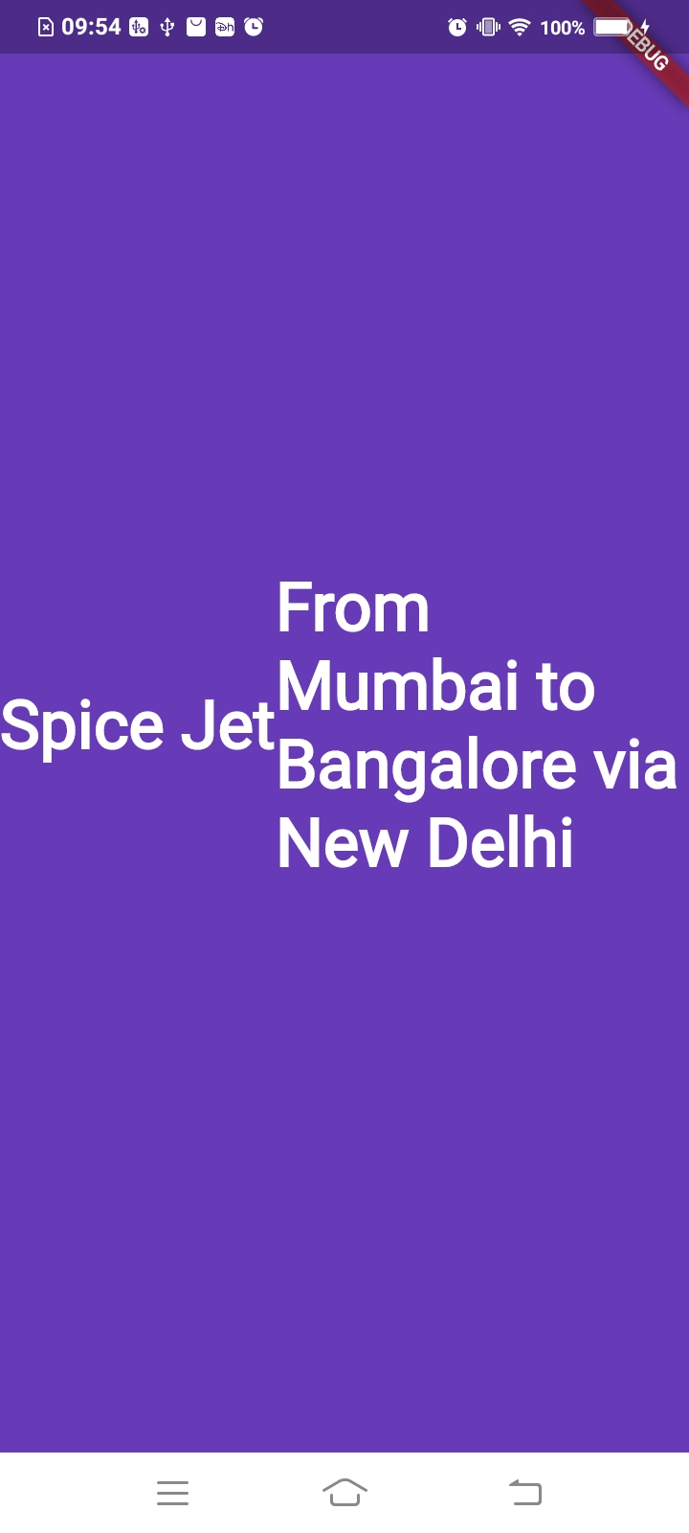

2. Add Expand Widget to first Text

import 'package:flutter/material.dart';

class Home extends StatelessWidget {
@override
Widget build(BuildContext context) {
return Center(
child: Container(
alignment: Alignment.center,
color: Colors.deepPurple,
child: Row(
children: <Widget>[
Expanded(
child: Text(
'Spice Jet',
textDirection: TextDirection.ltr,
style: TextStyle(
decoration: TextDecoration.none,
//remove underline
fontSize: 35.0,
fontFamily: 'Raleway',
fontWeight: FontWeight.w700,
color: Colors.white),
)),
Expanded(
child: Text(
'From Mumbai to Bangalore via New Delhi',
textDirection: TextDirection.ltr,
style: TextStyle(
decoration: TextDecoration.none,
//remove underline
fontSize: 35.0,
fontFamily: 'Raleway',
fontWeight: FontWeight.w700,
color: Colors.white),
))
],
),
),
);
}
}

Output:
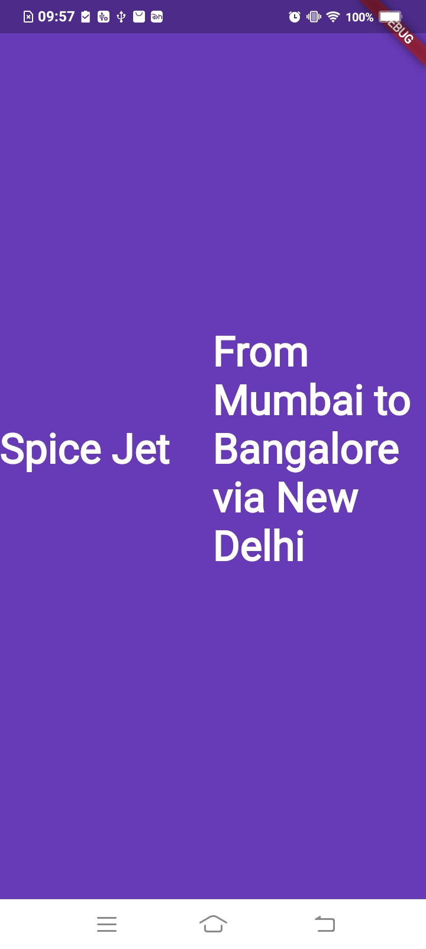

3.Update Font in second Text

import 'package:flutter/material.dart';

class Home extends StatelessWidget {
@override
Widget build(BuildContext context) {
return Center(
child: Container(
alignment: Alignment.center,
color: Colors.deepPurple,
child: Row(
children: <Widget>[
Expanded(
child: Text(
'Spice Jet',
textDirection: TextDirection.ltr,
style: TextStyle(
decoration: TextDecoration.none,
//remove underline
fontSize: 35.0,
fontFamily: 'Raleway',
fontWeight: FontWeight.w700,
color: Colors.white),
)),
Expanded(
child: Text(
'From Mumbai to Bangalore via New Delhi',
textDirection: TextDirection.ltr,
style: TextStyle(
decoration: TextDecoration.none,
//remove underline
fontSize: 20.0,
fontFamily: 'Raleway',
fontWeight: FontWeight.w700,
color: Colors.white),
))
],
),
),
);
}
}

Output:

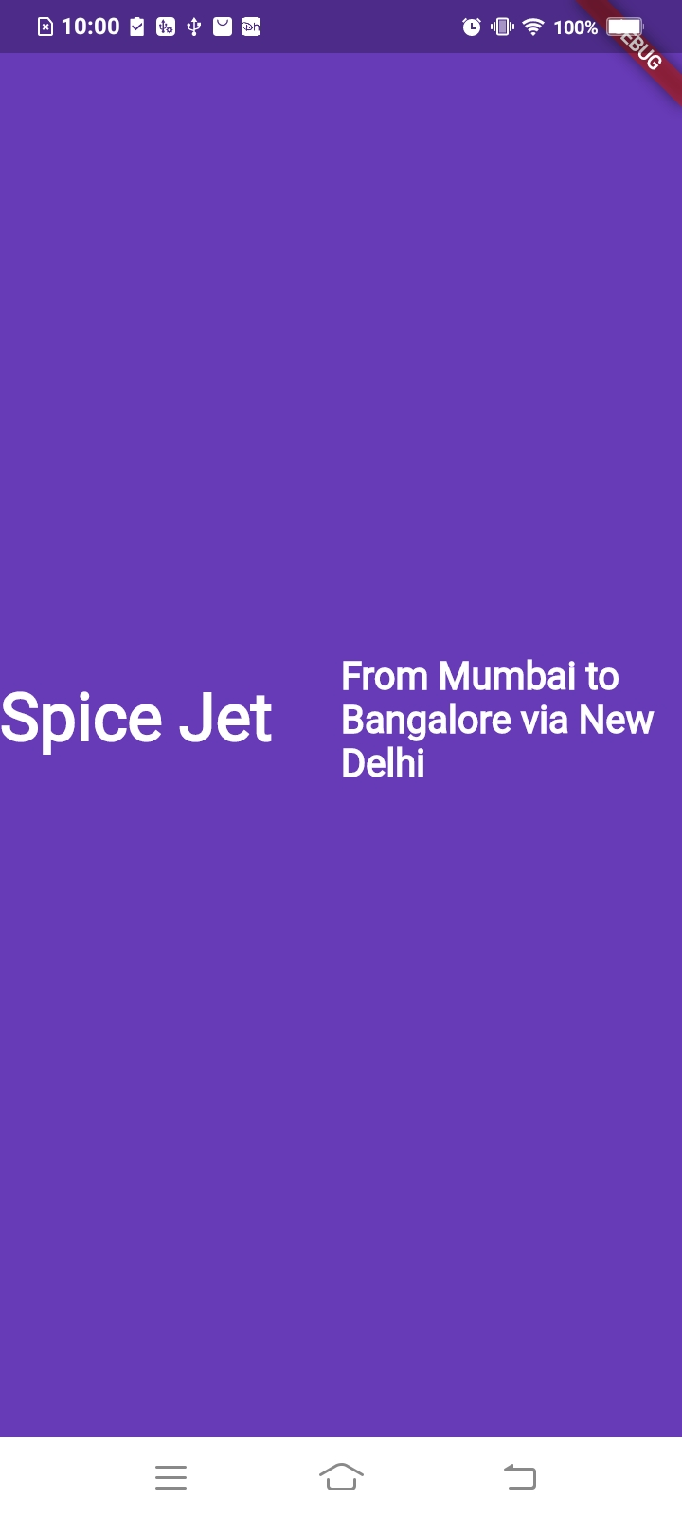

Column Widget: ( Show Elements in Horizontal)

Single Column

import 'package:flutter/material.dart';

class Home extends StatelessWidget {
@override
Widget build(BuildContext context) {
return Center(
child: Container(
alignment: Alignment.center,
color: Colors.deepPurple,
child: Column(
children: [
Row(
children: <Widget>[
Expanded(
child: Text(
'Spice Jet',
textDirection: TextDirection.ltr,
style: TextStyle(
decoration: TextDecoration.none,
//remove underline
fontSize: 35.0,
fontFamily: 'Raleway',
fontWeight: FontWeight.w700,
color: Colors.white),
)),
Expanded(
child: Text(
'From Mumbai to Bangalore via New Delhi',
textDirection: TextDirection.ltr,
style: TextStyle(
decoration: TextDecoration.none,
//remove underline
fontSize: 20.0,
fontFamily: 'Raleway',
fontWeight: FontWeight.w700,
color: Colors.white),
))
],
)
],
),
),
);
}
}

Output:

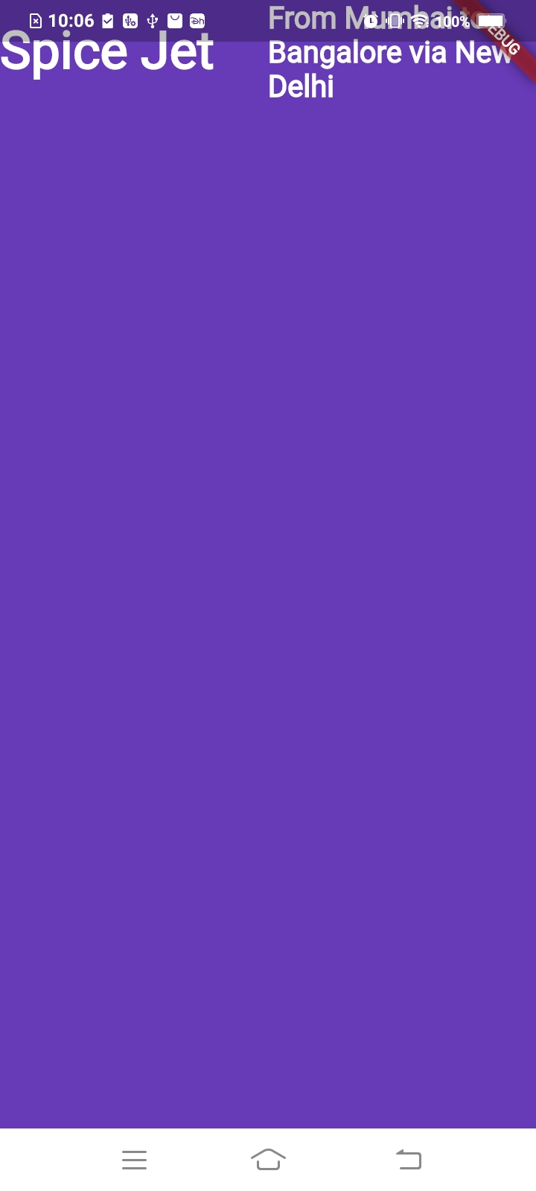

Add More than One Column

import 'package:flutter/material.dart';

class Home extends StatelessWidget {
@override
Widget build(BuildContext context) {
return Center(
child: Container(
alignment: Alignment.center,
color: Colors.deepPurple,
child: Column(
children: [
Row(
children: <Widget>[
Expanded(
child: Text(
'Spice Jet',
textDirection: TextDirection.ltr,
style: TextStyle(
decoration: TextDecoration.none,
//remove underline
fontSize: 35.0,
fontFamily: 'Raleway',
fontWeight: FontWeight.w700,
color: Colors.white),
)),
Expanded(
child: Text(
'From Mumbai to Bangalore via New Delhi',
textDirection: TextDirection.ltr,
style: TextStyle(
decoration: TextDecoration.none,
//remove underline
fontSize: 20.0,
fontFamily: 'Raleway',
fontWeight: FontWeight.w700,
color: Colors.white),
))
],
),
Row(
children: <Widget>[
Expanded(
child: Text(
'Air India',
textDirection: TextDirection.ltr,
style: TextStyle(
decoration: TextDecoration.none,
//remove underline
fontSize: 35.0,
fontFamily: 'Raleway',
fontWeight: FontWeight.w700,
color: Colors.white),
)),
Expanded(
child: Text(
'From Jaipur to Goa',
textDirection: TextDirection.ltr,
style: TextStyle(
decoration: TextDecoration.none,
//remove underline
fontSize: 20.0,
fontFamily: 'Raleway',
fontWeight: FontWeight.w700,
color: Colors.white),
))
],
)
],
),
),
);
}
}

Output:
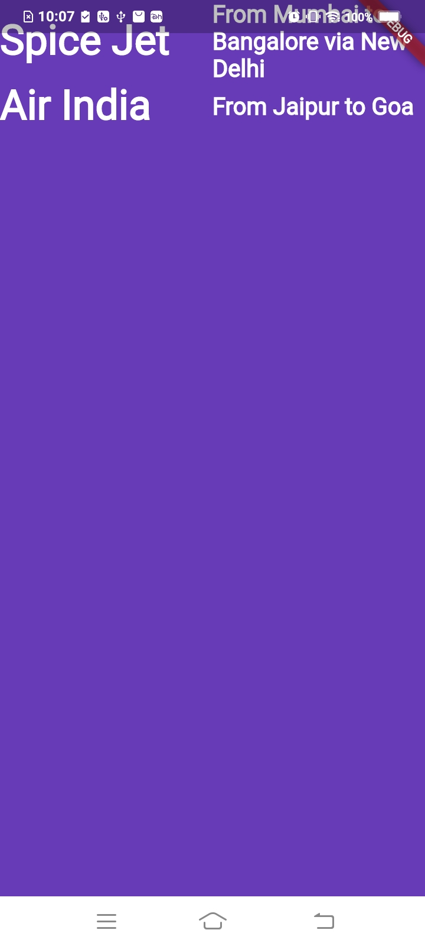

Add Padding to container:

import 'package:flutter/material.dart';

class Home extends StatelessWidget {
@override
Widget build(BuildContext context) {
return Center(
child: Container(
padding: EdgeInsets.only(left: 10.0,top: 40.0),
alignment: Alignment.center,
color: Colors.deepPurple,
child: Column(
children: [
Row(
children: <Widget>[
Expanded(
child: Text(
'Spice Jet',
textDirection: TextDirection.ltr,
style: TextStyle(
decoration: TextDecoration.none,
//remove underline
fontSize: 35.0,
fontFamily: 'Raleway',
fontWeight: FontWeight.w700,
color: Colors.white),
)),
Expanded(
child: Text(
'From Mumbai to Bangalore via New Delhi',
textDirection: TextDirection.ltr,
style: TextStyle(
decoration: TextDecoration.none,
//remove underline
fontSize: 20.0,
fontFamily: 'Raleway',
fontWeight: FontWeight.w700,
color: Colors.white),
))
],
),
Row(
children: <Widget>[
Expanded(
child: Text(
'Air India',
textDirection: TextDirection.ltr,
style: TextStyle(
decoration: TextDecoration.none,
//remove underline
fontSize: 35.0,
fontFamily: 'Raleway',
fontWeight: FontWeight.w700,
color: Colors.white),
)),
Expanded(
child: Text(
'From Jaipur to Goa',
textDirection: TextDirection.ltr,
style: TextStyle(
decoration: TextDecoration.none,
//remove underline
fontSize: 20.0,
fontFamily: 'Raleway',
fontWeight: FontWeight.w700,
color: Colors.white),
))
],
)
],
),
),
);
}
}

Output:

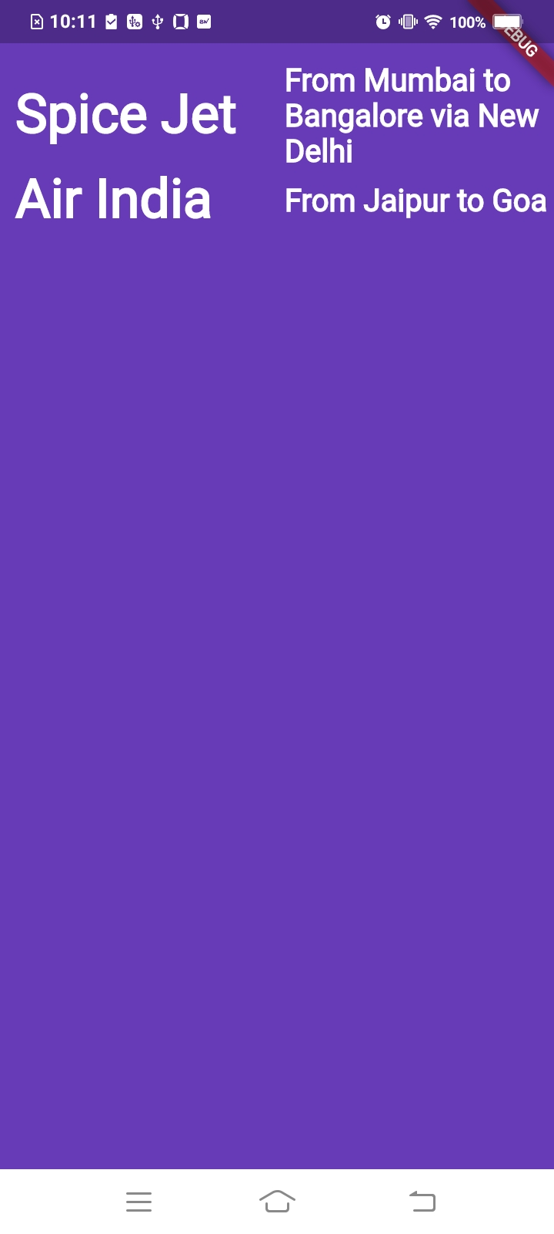

3.AssetImage

Add Image

1.Create image folder
2.Add image from external resource tothat folder
3.Update pubspec.yaml
4.Used to your widget

3.Update pubspec.yaml

assets:
- images/flight.png

4.Used to your widget

import 'package:flutter/material.dart';

class Home extends StatelessWidget {
@override
Widget build(BuildContext context) {
return Center(
child: Container(
padding: EdgeInsets.only(left: 10.0,top: 40.0),
alignment: Alignment.center,
color: Colors.deepPurple,
child: Column(
children: [
Row(
children: <Widget>[
Expanded(
child: Text(
'Spice Jet',
textDirection: TextDirection.ltr,
style: TextStyle(
decoration: TextDecoration.none,
//remove underline
fontSize: 35.0,
fontFamily: 'Raleway',
fontWeight: FontWeight.w700,
color: Colors.white),
)),
Expanded(
child: Text(
'From Mumbai to Bangalore via New Delhi',
textDirection: TextDirection.ltr,
style: TextStyle(
decoration: TextDecoration.none,
//remove underline
fontSize: 20.0,
fontFamily: 'Raleway',
fontWeight: FontWeight.w700,
color: Colors.white),
))
],
),
Row(
children: <Widget>[
Expanded(
child: Text(
'Air India',
textDirection: TextDirection.ltr,
style: TextStyle(
decoration: TextDecoration.none,
//remove underline
fontSize: 35.0,
fontFamily: 'Raleway',
fontWeight: FontWeight.w700,
color: Colors.white),
)),
Expanded(
child: Text(
'From Jaipur to Goa',
textDirection: TextDirection.ltr,
style: TextStyle(
decoration: TextDecoration.none,
//remove underline
fontSize: 20.0,
fontFamily: 'Raleway',
fontWeight: FontWeight.w700,
color: Colors.white),
)
)
],
),
FlightImageAsset()
],
),
),
);
}
}

class FlightImageAsset extends StatelessWidget {
@override
Widget build(BuildContext context) {
AssetImage assetImage = AssetImage('images/flight.png');
Image image= Image(image: assetImage,width: 250.0,height: 250.0);
return Container(child: image);
}
}

Output:
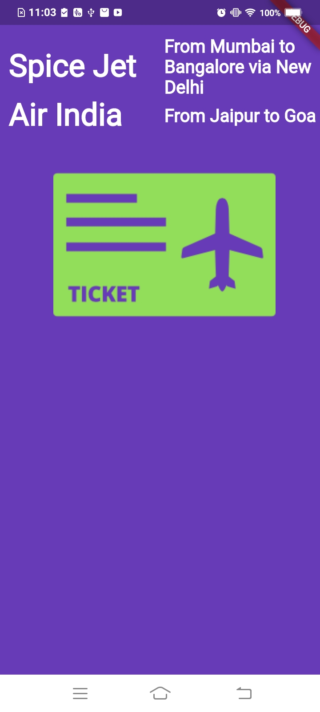

4.Raised Button

Without onPressed: event

import 'package:flutter/material.dart';

class Home extends StatelessWidget {
@override
Widget build(BuildContext context) {
return Center(
child: Container(
padding: EdgeInsets.only(left: 10.0,top: 40.0),
alignment: Alignment.center,
color: Colors.deepPurple,
child: Column(
children: [
Row(
children: <Widget>[
Expanded(
child: Text(
'Spice Jet',
textDirection: TextDirection.ltr,
style: TextStyle(
decoration: TextDecoration.none,
//remove underline
fontSize: 35.0,
fontFamily: 'Raleway',
fontWeight: FontWeight.w700,
color: Colors.white),
)),
Expanded(
child: Text(
'From Mumbai to Bangalore via New Delhi',
textDirection: TextDirection.ltr,
style: TextStyle(
decoration: TextDecoration.none,
//remove underline
fontSize: 20.0,
fontFamily: 'Raleway',
fontWeight: FontWeight.w700,
color: Colors.white),
))
],
),
Row(
children: <Widget>[
Expanded(
child: Text(
'Air India',
textDirection: TextDirection.ltr,
style: TextStyle(
decoration: TextDecoration.none,
//remove underline
fontSize: 35.0,
fontFamily: 'Raleway',
fontWeight: FontWeight.w700,
color: Colors.white),
)),
Expanded(
child: Text(
'From Jaipur to Goa',
textDirection: TextDirection.ltr,
style: TextStyle(
decoration: TextDecoration.none,
//remove underline
fontSize: 20.0,
fontFamily: 'Raleway',
fontWeight: FontWeight.w700,
color: Colors.white),
)
)
],
),
FlightImageAsset(),
FlightBookButton()
],
),
),
);
}
}

class FlightImageAsset extends StatelessWidget {
@override
Widget build(BuildContext context) {
AssetImage assetImage = AssetImage('images/flight.png');
Image image= Image(image: assetImage,width: 250.0,height: 250.0);
return Container(child: image);
}
}

class FlightBookButton extends StatelessWidget {
@override
Widget build(BuildContext context) {
return Container(
child: RaisedButton(
color: Colors.deepOrange,
child: Text('Book your Flight'),
onPressed: null
),
);
}
}

Output:
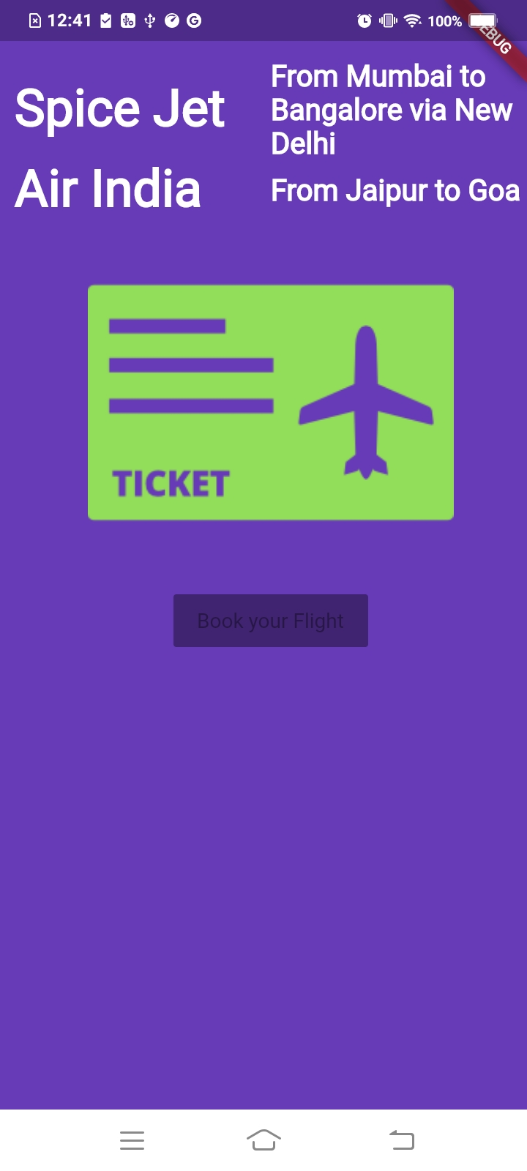

2.With onPressed: event

import 'package:flutter/material.dart';

class Home extends StatelessWidget {
@override
Widget build(BuildContext context) {
return Center(
child: Container(
padding: EdgeInsets.only(left: 10.0,top: 40.0),
alignment: Alignment.center,
color: Colors.deepPurple,
child: Column(
children: [
Row(
children: <Widget>[
Expanded(
child: Text(
'Spice Jet',
textDirection: TextDirection.ltr,
style: TextStyle(
decoration: TextDecoration.none,
//remove underline
fontSize: 35.0,
fontFamily: 'Raleway',
fontWeight: FontWeight.w700,
color: Colors.white),
)),
Expanded(
child: Text(
'From Mumbai to Bangalore via New Delhi',
textDirection: TextDirection.ltr,
style: TextStyle(
decoration: TextDecoration.none,
//remove underline
fontSize: 20.0,
fontFamily: 'Raleway',
fontWeight: FontWeight.w700,
color: Colors.white),
))
],
),
Row(
children: <Widget>[
Expanded(
child: Text(
'Air India',
textDirection: TextDirection.ltr,
style: TextStyle(
decoration: TextDecoration.none,
//remove underline
fontSize: 35.0,
fontFamily: 'Raleway',
fontWeight: FontWeight.w700,
color: Colors.white),
)),
Expanded(
child: Text(
'From Jaipur to Goa',
textDirection: TextDirection.ltr,
style: TextStyle(
decoration: TextDecoration.none,
//remove underline
fontSize: 20.0,
fontFamily: 'Raleway',
fontWeight: FontWeight.w700,
color: Colors.white),
)
)
],
),
FlightImageAsset(),
FlightBookButton()
],
),
),
);
}
}

class FlightImageAsset extends StatelessWidget {
@override
Widget build(BuildContext context) {
AssetImage assetImage = AssetImage('images/flight.png');
Image image= Image(image: assetImage,width: 250.0,height: 250.0);
return Container(child: image);
}
}

class FlightBookButton extends StatelessWidget {
@override
Widget build(BuildContext context) {
return Container(
child: RaisedButton(
color: Colors.deepOrange,
child: Text('Book your Flight'),
onPressed: (){
//Action
}
),
);
}
}

Output:
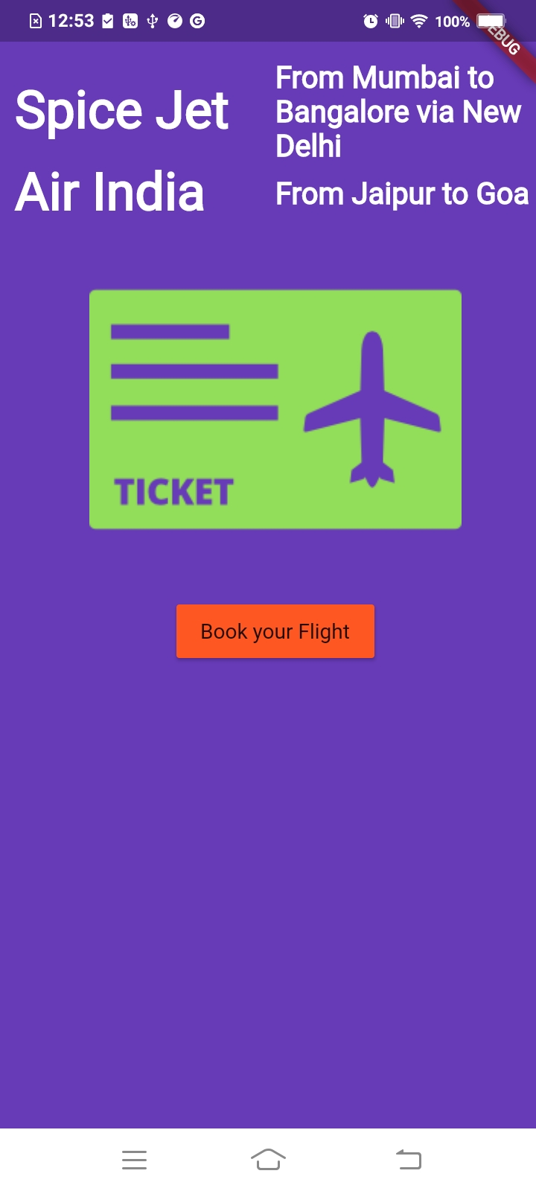

3.Style Button:

import 'package:flutter/material.dart';

class Home extends StatelessWidget {
@override
Widget build(BuildContext context) {
return Center(
child: Container(
padding: EdgeInsets.only(left: 10.0,top: 40.0),
alignment: Alignment.center,
color: Colors.deepPurple,
child: Column(
children: [
Row(
children: <Widget>[
Expanded(
child: Text(
'Spice Jet',
textDirection: TextDirection.ltr,
style: TextStyle(
decoration: TextDecoration.none,
//remove underline
fontSize: 35.0,
fontFamily: 'Raleway',
fontWeight: FontWeight.w700,
color: Colors.white),
)),
Expanded(
child: Text(
'From Mumbai to Bangalore via New Delhi',
textDirection: TextDirection.ltr,
style: TextStyle(
decoration: TextDecoration.none,
//remove underline
fontSize: 20.0,
fontFamily: 'Raleway',
fontWeight: FontWeight.w700,
color: Colors.white),
))
],
),
Row(
children: <Widget>[
Expanded(
child: Text(
'Air India',
textDirection: TextDirection.ltr,
style: TextStyle(
decoration: TextDecoration.none,
//remove underline
fontSize: 35.0,
fontFamily: 'Raleway',
fontWeight: FontWeight.w700,
color: Colors.white),
)),
Expanded(
child: Text(
'From Jaipur to Goa',
textDirection: TextDirection.ltr,
style: TextStyle(
decoration: TextDecoration.none,
//remove underline
fontSize: 20.0,
fontFamily: 'Raleway',
fontWeight: FontWeight.w700,
color: Colors.white),
)
)
],
),
FlightImageAsset(),
FlightBookButton()
],
),
),
);
}
}

class FlightImageAsset extends StatelessWidget {
@override
Widget build(BuildContext context) {
AssetImage assetImage = AssetImage('images/flight.png');
Image image= Image(image: assetImage,width: 250.0,height: 250.0);
return Container(child: image);
}
}

class FlightBookButton extends StatelessWidget {
@override
Widget build(BuildContext context) {
return Container(
margin: EdgeInsets.all(30.0),
width: 250.0,
height: 50.0,
child: RaisedButton(
color: Colors.deepOrange,
child: Text(
'Book your Flight',
style: TextStyle(
fontSize: 20.0,
color: Colors.white,
fontFamily: 'Raleway',
fontWeight: FontWeight.w700
),),
onPressed: (){
//Action
}
),
);
}
}

Output:
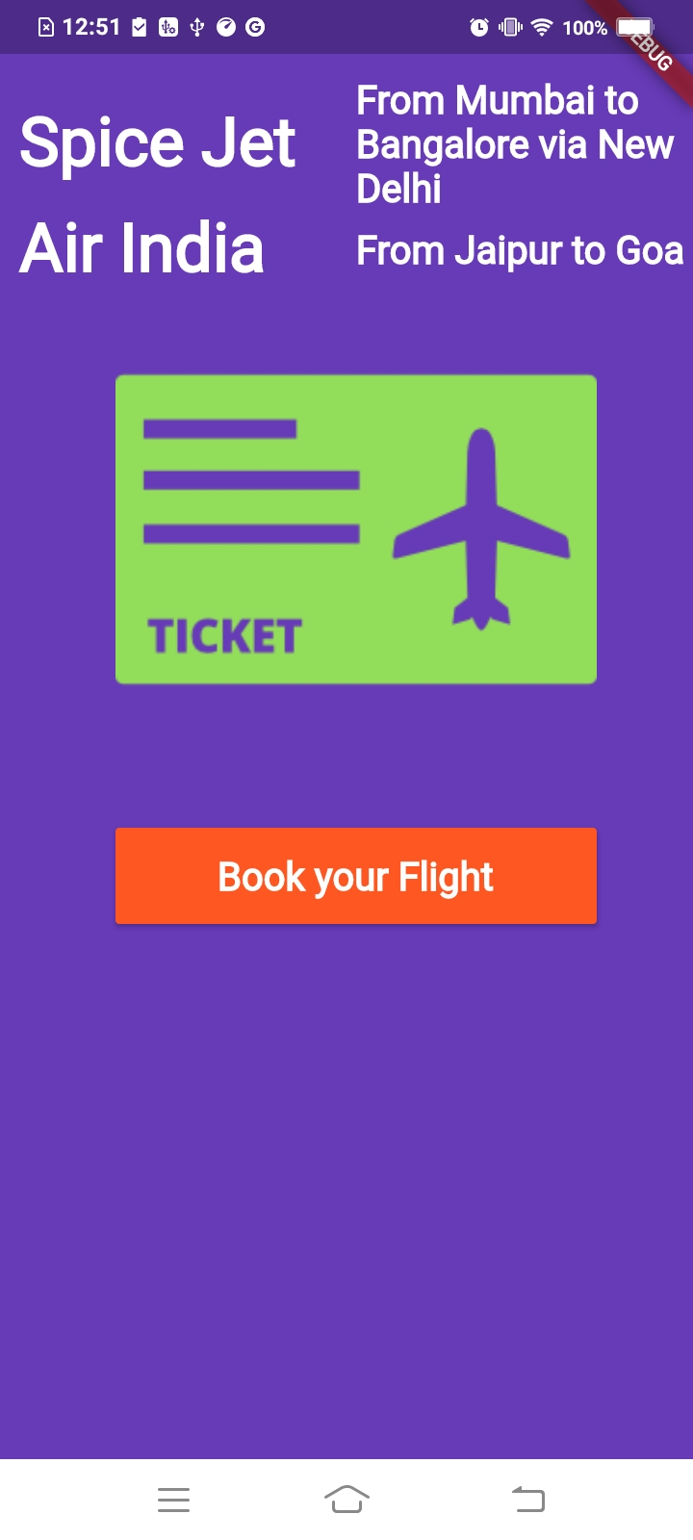

5.AlertDialog

import 'package:flutter/material.dart';

class Home extends StatelessWidget {
@override
Widget build(BuildContext context) {
return Center(
child: Container(
padding: EdgeInsets.only(left: 10.0,top: 40.0),
alignment: Alignment.center,
color: Colors.deepPurple,
child: Column(
children: [
Row(
children: <Widget>[
Expanded(
child: Text(
'Spice Jet',
textDirection: TextDirection.ltr,
style: TextStyle(
decoration: TextDecoration.none,
//remove underline
fontSize: 35.0,
fontFamily: 'Raleway',
fontWeight: FontWeight.w700,
color: Colors.white),
)),
Expanded(
child: Text(
'From Mumbai to Bangalore via New Delhi',
textDirection: TextDirection.ltr,
style: TextStyle(
decoration: TextDecoration.none,
//remove underline
fontSize: 20.0,
fontFamily: 'Raleway',
fontWeight: FontWeight.w700,
color: Colors.white),
))
],
),
Row(
children: <Widget>[
Expanded(
child: Text(
'Air India',
textDirection: TextDirection.ltr,
style: TextStyle(
decoration: TextDecoration.none,
//remove underline
fontSize: 35.0,
fontFamily: 'Raleway',
fontWeight: FontWeight.w700,
color: Colors.white),
)),
Expanded(
child: Text(
'From Jaipur to Goa',
textDirection: TextDirection.ltr,
style: TextStyle(
decoration: TextDecoration.none,
//remove underline
fontSize: 20.0,
fontFamily: 'Raleway',
fontWeight: FontWeight.w700,
color: Colors.white),
)
)
],
),
FlightImageAsset(),
FlightBookButton()
],
),
),
);
}
}

class FlightImageAsset extends StatelessWidget {
@override
Widget build(BuildContext context) {
AssetImage assetImage = AssetImage('images/flight.png');
Image image= Image(image: assetImage,width: 250.0,height: 250.0);
return Container(child: image);
}
}

class FlightBookButton extends StatelessWidget {
@override
Widget build(BuildContext context) {
return Container(
margin: EdgeInsets.all(30.0),
width: 250.0,
height: 50.0,
child: RaisedButton(
color: Colors.deepOrange,
child: Text(
'Book your Flight',
style: TextStyle(
fontSize: 20.0,
color: Colors.white,
fontFamily: 'Raleway',
fontWeight: FontWeight.w700
),),
onPressed : () => bookFlight(context)
),
);
}

void bookFlight(BuildContext context) {
var alertDialog = AlertDialog(
title: Text('Flight Booked successfully'),
content: Text('Have a pleasant flight'),
);

showDialog(
context: context,
builder: (BuildContext context) => alertDialog
);
}
}

Output:

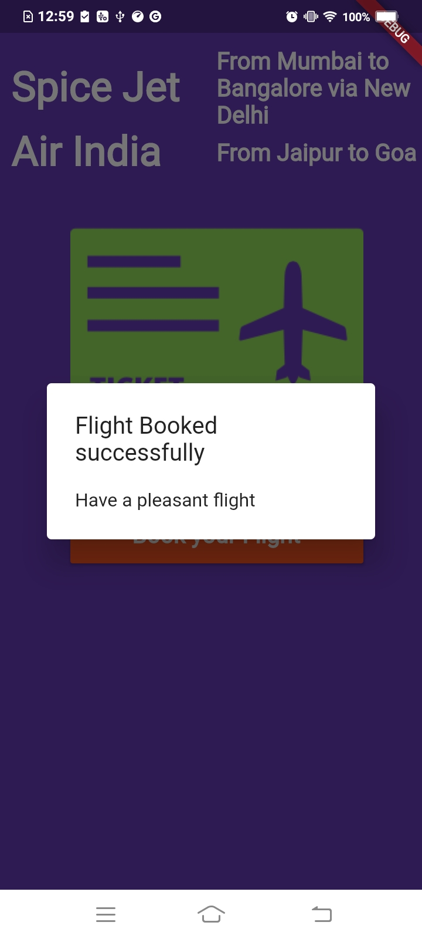

6.ListView Widget

Scrollable Widgets without Scaffold Widget

import 'package:flutter/material.dart';

void main(){
runApp(MaterialApp(
title: 'Exploring Ui Widgets',
home: getListView(),
));
}

Widget getListView(){
var listView = ListView(
children: [
ListTile(
leading: Icon(Icons.landscape),
title: Text('LandScape'),
subtitle: Text('Beautiful View!'),
trailing: Icon(Icons.wb_sunny),
)
],
);
return listView;
}

Output: (Exception)

To introduce a Material widget, you can either directly include one, or use a widget that contains Material itself, such as a Card, Dialog, Drawer, or Scaffold.
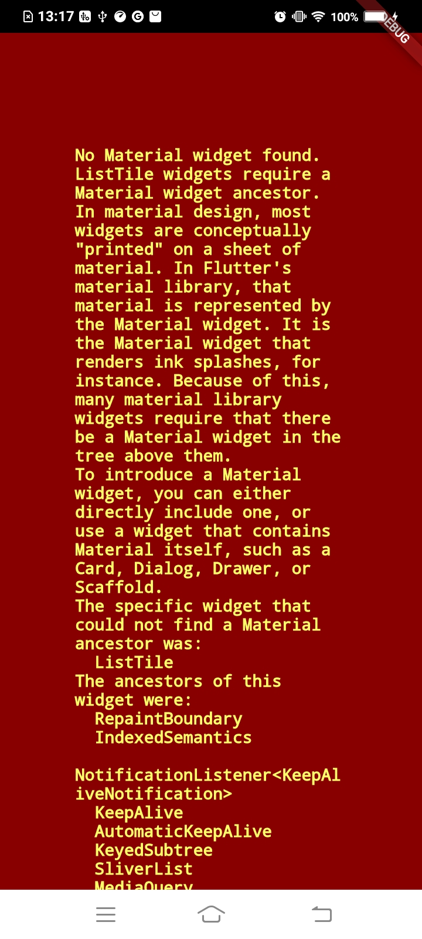

Scrollable Widgets with Scaffold Widget

import 'package:flutter/material.dart';

void main(){
runApp(MaterialApp(
title: 'Exploring Ui Widgets',
home: Scaffold(
body: getListView()
)
));
}

Widget getListView(){
var listView = ListView(
children: [
ListTile(
leading: Icon(Icons.landscape),
title: Text('LandScape'),
subtitle: Text('Beautiful View!'),
trailing: Icon(Icons.wb_sunny),
)
],
);
return listView;
}

Output:
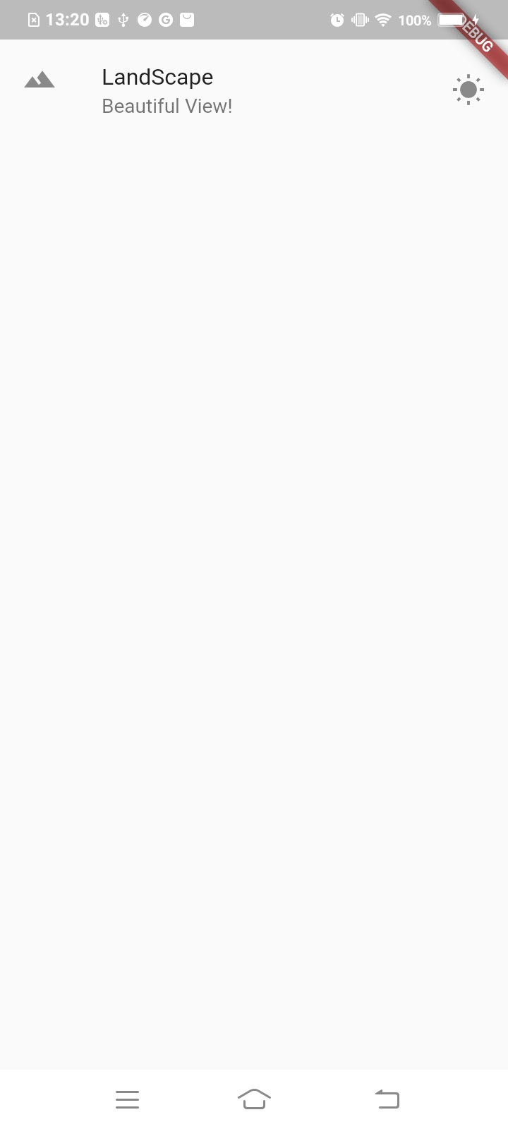

Multi Row in ListView

import 'package:flutter/material.dart';

void main(){
runApp(MaterialApp(
title: 'Exploring Ui Widgets',
home: Scaffold(
body: getListView()
)
));
}

Widget getListView(){
var listView = ListView(
children: [
ListTile(
leading: Icon(Icons.landscape),
title: Text('LandScape'),
subtitle: Text('Beautiful View!'),
trailing: Icon(Icons.wb_sunny),
),
ListTile(
leading: Icon(Icons.laptop_chromebook),
title: Text('Windows'),
),
ListTile(
leading: Icon(Icons.phone),
title: Text('Phone'),
)
],
);
return listView;
}

Output:
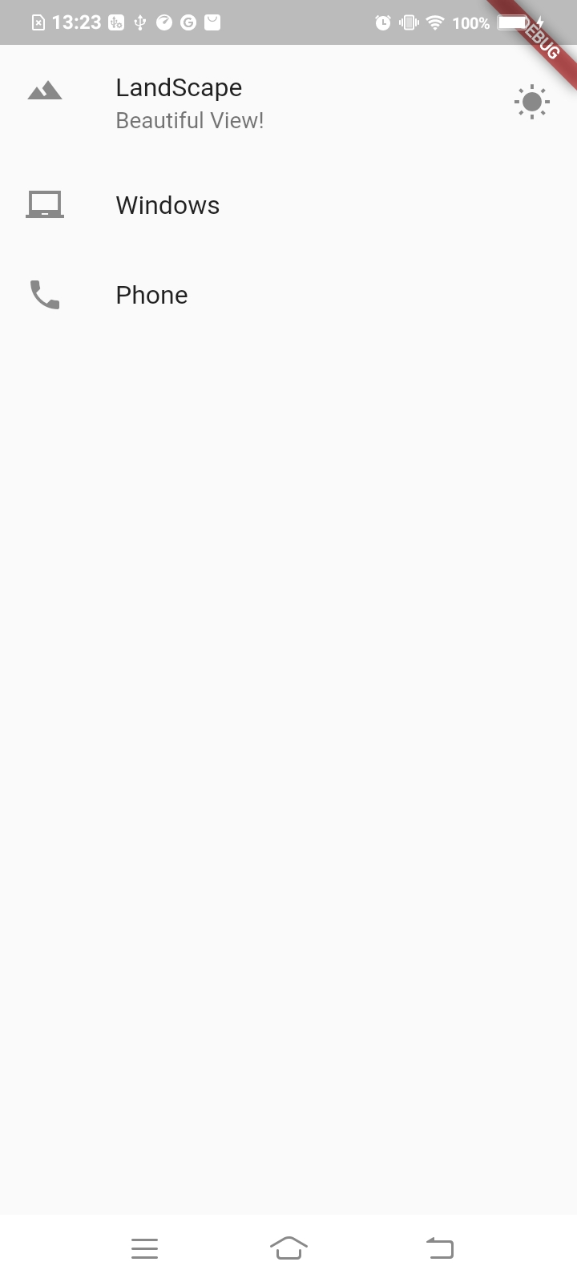

Any Widget in ListView

import 'package:flutter/material.dart';

void main(){
runApp(MaterialApp(
title: 'Exploring Ui Widgets',
home: Scaffold(
body: getListView()
)
));
}

Widget getListView(){
var listView = ListView(
children: [
ListTile(
leading: Icon(Icons.landscape),
title: Text('LandScape'),
subtitle: Text('Beautiful View!'),
trailing: Icon(Icons.wb_sunny),
),
ListTile(
leading: Icon(Icons.laptop_chromebook),
title: Text('Windows'),
),
ListTile(
leading: Icon(Icons.phone),
title: Text('Phone'),
),
Text('Yet another element in List'),
Container(
color:Colors.red,height: 50.0
)
],
);
return listView;
}

Output:

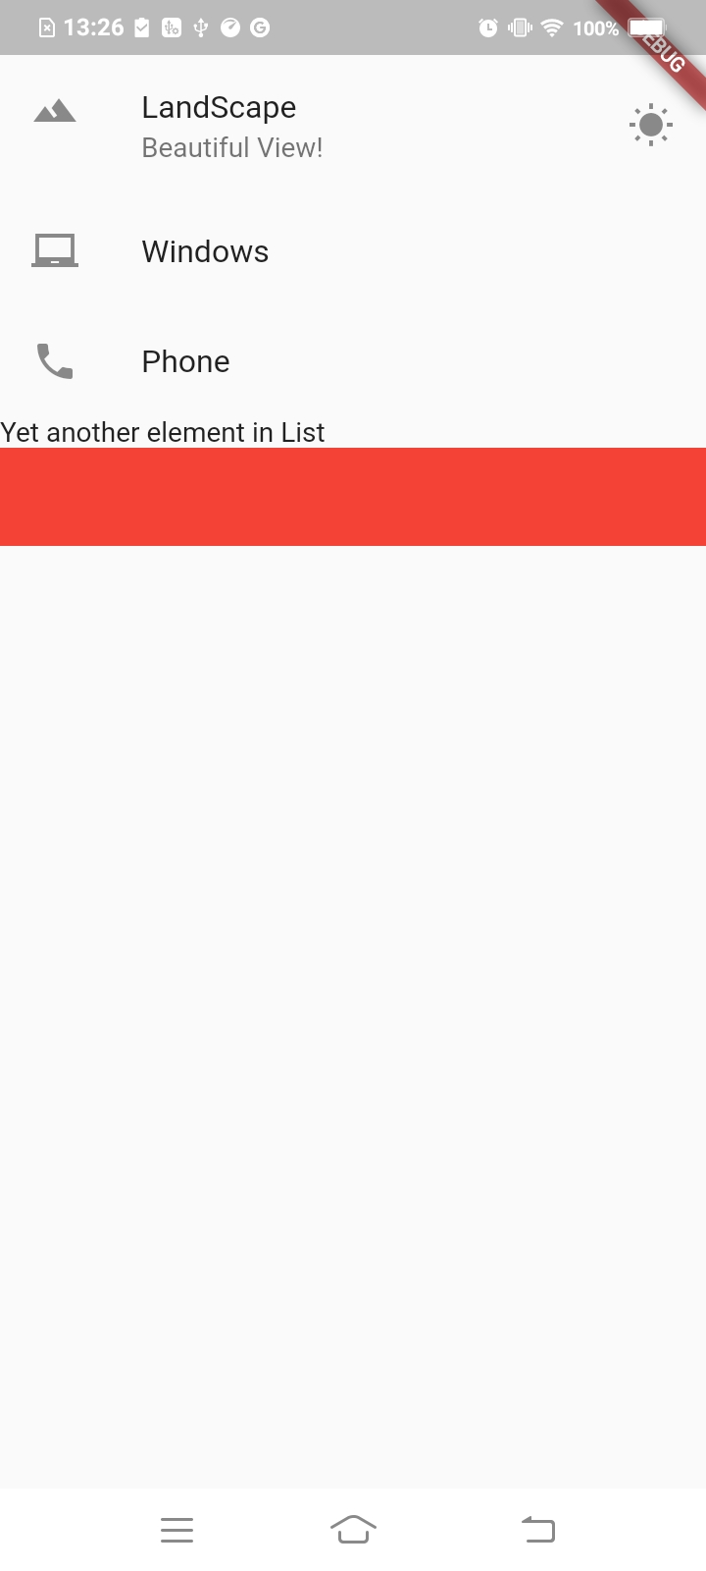

Add Appbar

import 'package:flutter/material.dart';

void main(){
runApp(MaterialApp(
title: 'Exploring Ui Widgets',
home: Scaffold(
appBar: AppBar(title: Text('Basic List View'),),
body: getListView()
)
));
}

Widget getListView(){
var listView = ListView(
children: [
ListTile(
leading: Icon(Icons.landscape),
title: Text('LandScape'),
subtitle: Text('Beautiful View!'),
trailing: Icon(Icons.wb_sunny),
),
ListTile(
leading: Icon(Icons.laptop_chromebook),
title: Text('Windows'),
),
ListTile(
leading: Icon(Icons.phone),
title: Text('Phone'),
),
Text('Yet another element in List'),
Container(
color:Colors.red,height: 50.0
)
],
);
return listView;
}

Output:
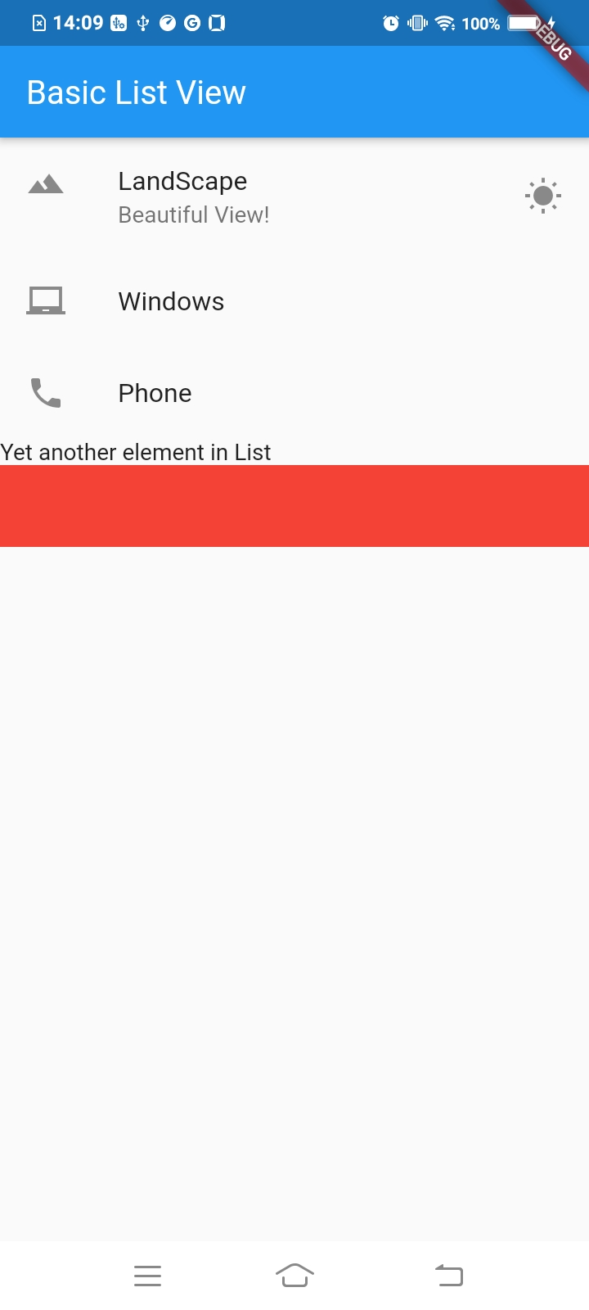

ListView Clickable

import 'package:flutter/material.dart';

void main(){
runApp(MaterialApp(
title: 'Exploring Ui Widgets',
home: Scaffold(
appBar: AppBar(title: Text('Basic List View'),),
body: getListView()
)
));
}

Widget getListView(){
var listView = ListView(
children: [
ListTile(
leading: Icon(Icons.landscape),
title: Text('LandScape'),
subtitle: Text('Beautiful View!'),
trailing: Icon(Icons.wb_sunny),
onTap: (){
debugPrint('Landscape tapped');
},
),
ListTile(
leading: Icon(Icons.laptop_chromebook),
title: Text('Windows'),
),
ListTile(
leading: Icon(Icons.phone),
title: Text('Phone'),
),
Text('Yet another element in List'),
Container(
color:Colors.red,height: 50.0
)
],
);
return listView;
}

Output:
Same as above output but give ‘Landscape tapped’ in Logcat

Listview Generic way

1. Prepare Datasource
2.Convert Datasource to widget
3.Use Widget as children of listview

import 'package:flutter/material.dart';

void main(){
runApp(MaterialApp(
title: 'Exploring Ui Widgets',
home: Scaffold(
appBar: AppBar(title: Text('Basic List View'),),
body: getListView(), //3
)
));
}

List<String> getListElements() => List<String>.generate(1000, (index) => "Item $index"); //2

Widget getListView(){
var listItems = getListElements();
var listView = ListView.builder(
itemBuilder: (context,index){
return ListTile(
title: Text(listItems[index]),
onTap: (){
debugPrint('${listItems[index]} was tapped');
},
);
});

return listView;
}

Output:
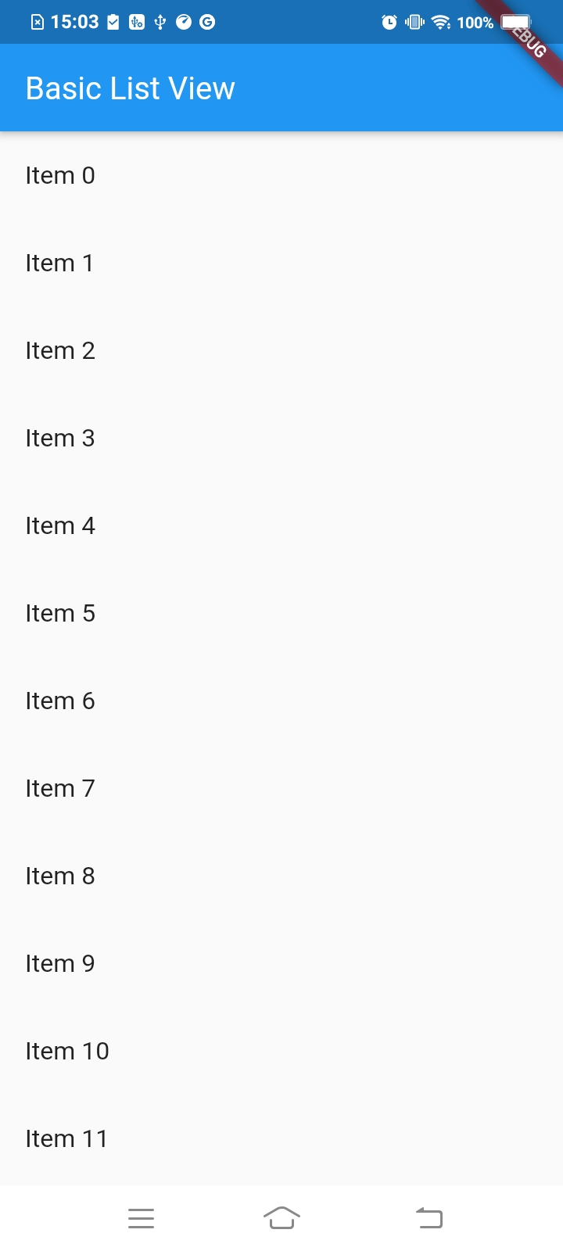

7.FloatingActionButton Widget

import 'package:flutter/material.dart';

void main(){
runApp(MaterialApp(
title: 'Exploring Ui Widgets',
home: Scaffold(
appBar: AppBar(title: Text('Basic List View'),),
body: getListView(),
floatingActionButton: FloatingActionButton(
onPressed: (){
debugPrint('FAB Clicked');
},
child: Icon(Icons.add),
tooltip: 'Add One More Item',
),
)
));
}

List<String> getListElements() => List<String>.generate(1000, (index) => "Item $index");

Widget getListView(){
var listItems = getListElements();
var listView = ListView.builder(
itemBuilder: (context,index){
return ListTile(
title: Text(listItems[index]),
onTap: (){
debugPrint('${listItems[index]} was tapped');
},
);
});

return listView;
}

Output:
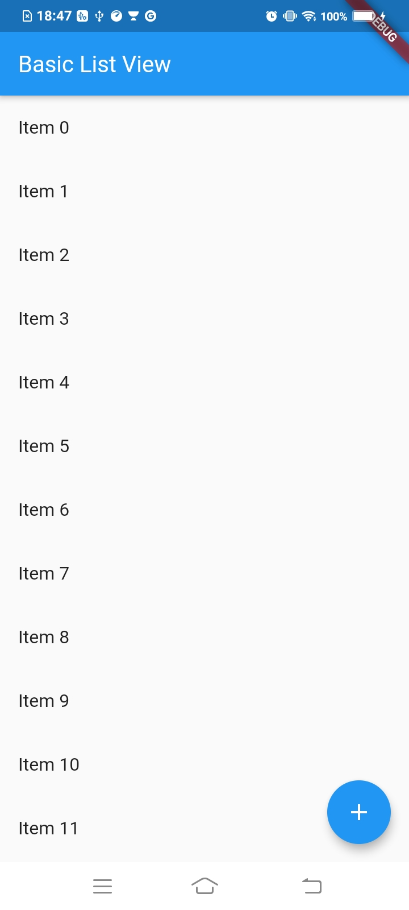

8.SnackBar

import 'package:flutter/material.dart';

void main(){
runApp(MaterialApp(
title: 'Exploring Ui Widgets',
home: Scaffold(
appBar: AppBar(title: Text('Basic List View'),),
body: getListView(),
floatingActionButton: FloatingActionButton(
onPressed: (){
debugPrint('FAB Clicked');
},
child: Icon(Icons.add),
tooltip: 'Add One More Item',
),
)
));
}

List<String> getListElements() => List<String>.generate(1000, (index) => "Item $index");

Widget getListView(){
var listItems = getListElements();
var listView = ListView.builder(
itemBuilder: (context,index){
return ListTile(
title: Text(listItems[index]),
onTap: (){
showSnackBar(context,'${listItems[index]}');
},
);
});

return listView;
}

void showSnackBar(BuildContext context,String item){
var snackBar = SnackBar(
content: Text('You just tapped $item')
);

Scaffold.of(context).showSnackBar(snackBar);
}

Output:

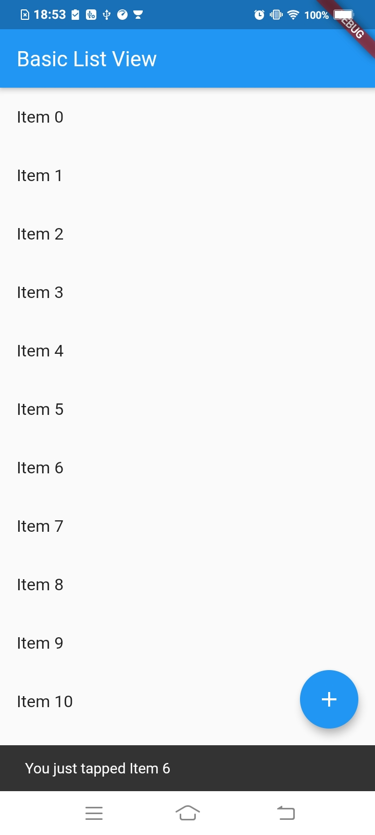

2.Add Button in Snackbar

import 'package:flutter/material.dart';

void main() {
runApp(MaterialApp(
title: 'Exploring Ui Widgets',
home: Scaffold(
appBar: AppBar(
title: Text('Basic List View'),
),
body: getListView(),
floatingActionButton: FloatingActionButton(
onPressed: () {
debugPrint('FAB Clicked');
},
child: Icon(Icons.add),
tooltip: 'Add One More Item',
),
)));
}

List<String> getListElements() =>
List<String>.generate(1000, (index) => "Item $index");

Widget getListView() {
var listItems = getListElements();
var listView = ListView.builder(itemBuilder: (context, index) {
return ListTile(
title: Text(listItems[index]),
onTap: () {
showSnackBar(context, '${listItems[index]}');
},
);
});

return listView;
}

void showSnackBar(BuildContext context, String item) {
var snackBar = SnackBar(
content: Text('You just tapped $item'),
action: SnackBarAction(
label: 'UNDO',
onPressed: (){
debugPrint('Performing dummy undo operation');
},
),
);

Scaffold.of(context).showSnackBar(snackBar);
}

Output:
