1.TextField Widget

1.State Change after click Button(i.e. Normal EditText)

import 'package:flutter/cupertino.dart';
import 'package:flutter/material.dart';

void main() {
runApp(MaterialApp(
title: 'Stateful App Example',
home: FavouriteCity(),
));
}

class FavouriteCity extends StatefulWidget {
@override
_FavouriteCityState createState() => _FavouriteCityState();
}

class _FavouriteCityState extends State<FavouriteCity> {
String nameCity = "";

@override
Widget build(BuildContext context) {
return Scaffold(
appBar: AppBar(
title: Text('Stateful App Example'),
),
body: Container(
margin: EdgeInsets.all(20.0),
child: Column(
children: [
TextField(
onSubmitted: (String userInput) {
setState(() {
nameCity = userInput;
});
},
),
Padding(
padding: EdgeInsets.all(30.0),
child: Text(
"Your best city is $nameCity",
style: TextStyle(fontSize: 20.0),
))
],
)));
}
}

Output:
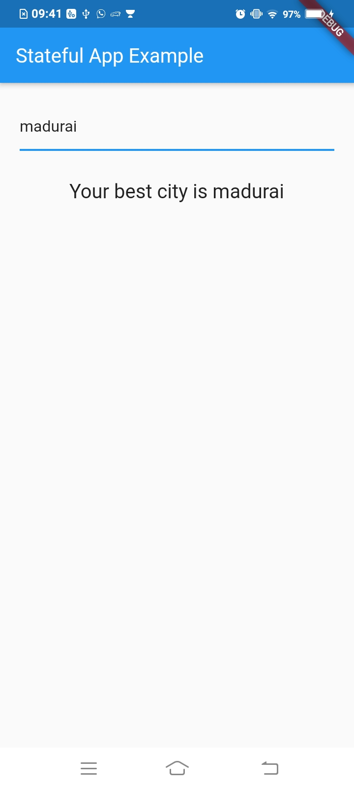

2.State Change at time of give input(i.e. Normal EditText.TextWatcher)

import 'package:flutter/cupertino.dart';
import 'package:flutter/material.dart';

void main() {
runApp(MaterialApp(
title: 'Stateful App Example',
home: FavouriteCity(),
));
}

class FavouriteCity extends StatefulWidget {
@override
_FavouriteCityState createState() => _FavouriteCityState();
}

class _FavouriteCityState extends State<FavouriteCity> {
String nameCity = "";

@override
Widget build(BuildContext context) {

debugPrint('Favourite City Widget is created');

return Scaffold(
appBar: AppBar(
title: Text('Stateful App Example'),
),
body: Container(
margin: EdgeInsets.all(20.0),
child: Column(
children: [
TextField(
onChanged: (String userInput) {
setState(() {
debugPrint('setState is called');
nameCity = userInput;
});
},
),
Padding(
padding: EdgeInsets.all(30.0),
child: Text(
"Your best city is $nameCity",
style: TextStyle(fontSize: 20.0),
))
],
)));
}
}
Output: Same as above output
2.Dropdown Button Widget

import 'package:flutter/material.dart';

void main() {
runApp(MaterialApp(
title: 'Stateful App Example',
home: FavouriteCity(),
));
}

class FavouriteCity extends StatefulWidget {
@override
_FavouriteCityState createState() => _FavouriteCityState();
}

class _FavouriteCityState extends State<FavouriteCity> {
String nameCity = "";
var _currencies = ['Rupees', 'Dollar', 'Pounds'];
var _currentItemSelected = 'Rupees';

@override
Widget build(BuildContext context) {
debugPrint('Favourite City Widget is created');

return Scaffold(
appBar: AppBar(
title: Text('Stateful App Example'),
),
body: Container(
margin: EdgeInsets.all(20.0),
child: Column(
children: [
TextField(
onChanged: (String userInput) {
setState(() {
debugPrint('setState is called');
nameCity = userInput;
});
},
),

DropdownButton<String>(
items: _currencies.map((String dropDownStringItem) {
return DropdownMenuItem<String>(
value: dropDownStringItem,
child: Text(dropDownStringItem));
}).toList(),
onChanged: (String newValueSelected) {
_onDropDownItemSelected(newValueSelected)
},
value: _currentItemSelected,),

Padding(
padding: EdgeInsets.all(30.0),
child: Text(
"Your best city is $nameCity",
style: TextStyle(fontSize: 20.0),
))
],
)
)
);
}

void _onDropDownItemSelected(String newValueSelected){
setState(() {
this._currentItemSelected = newValueSelected;
});
}
}

Output:

