1.HelloWorld
import 'package:flutter/material.dart';

void main() {
runApp(Text('Hello World', textDirection: TextDirection.ltr));
}

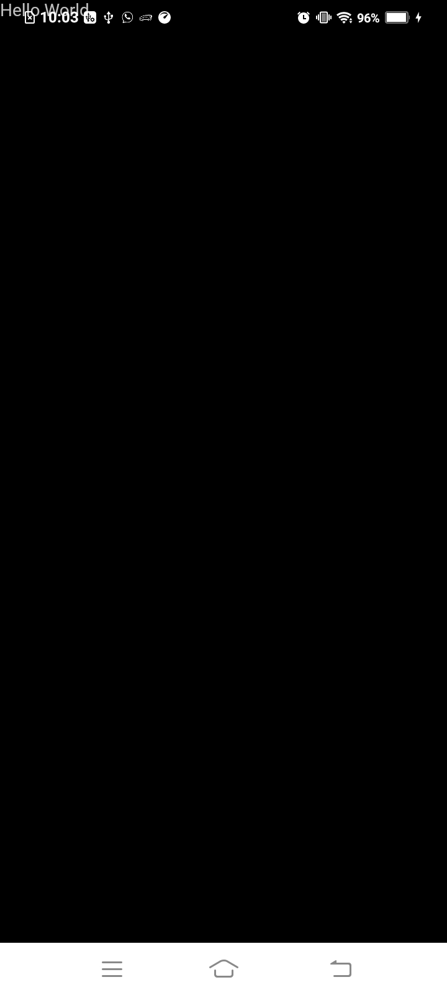
Output:

Place Text in Center:(Use Center Widget)

import 'package:flutter/material.dart';

void main() {
runApp(
Center(
child: Text(
'Hello World',
textDirection: TextDirection.ltr
)
)
);
}

Output:

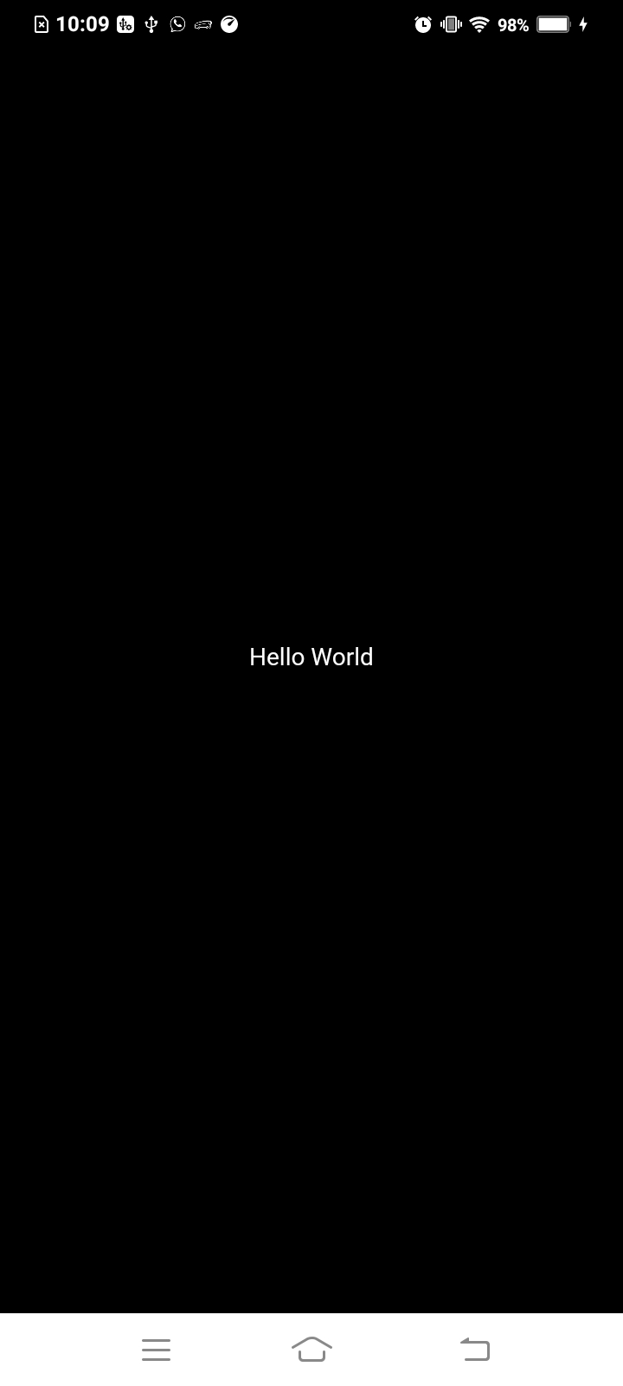

2.Designing UI:

import 'package:flutter/material.dart';

void main() {
runApp(
MaterialApp(
title: "My App",
home: Material(
color: Colors.lightBlueAccent,
child:Center(
child: Text(
'Hello World',
textDirection: TextDirection.ltr
)
) ,
),
)
);
}

Output:

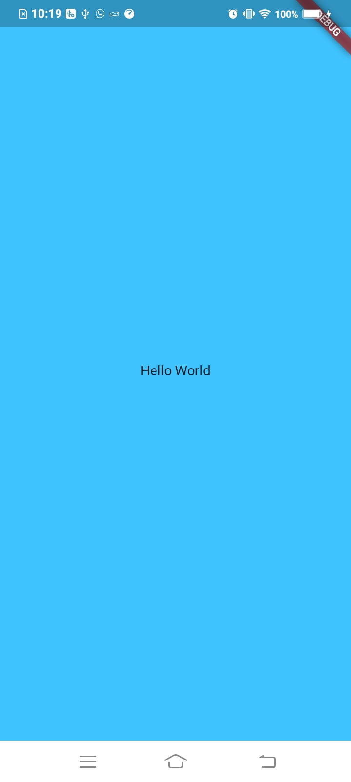

Style Text:

import 'package:flutter/material.dart';

void main() {
runApp(
MaterialApp(
title: "My App",
home: Material(
color: Colors.lightBlueAccent,
child:Center(
child: Text(
'Hello World',
textDirection: TextDirection.ltr,
style: TextStyle(color:Colors.white,fontSize: 48.0),
)
) ,
),
)
);
}

Output:

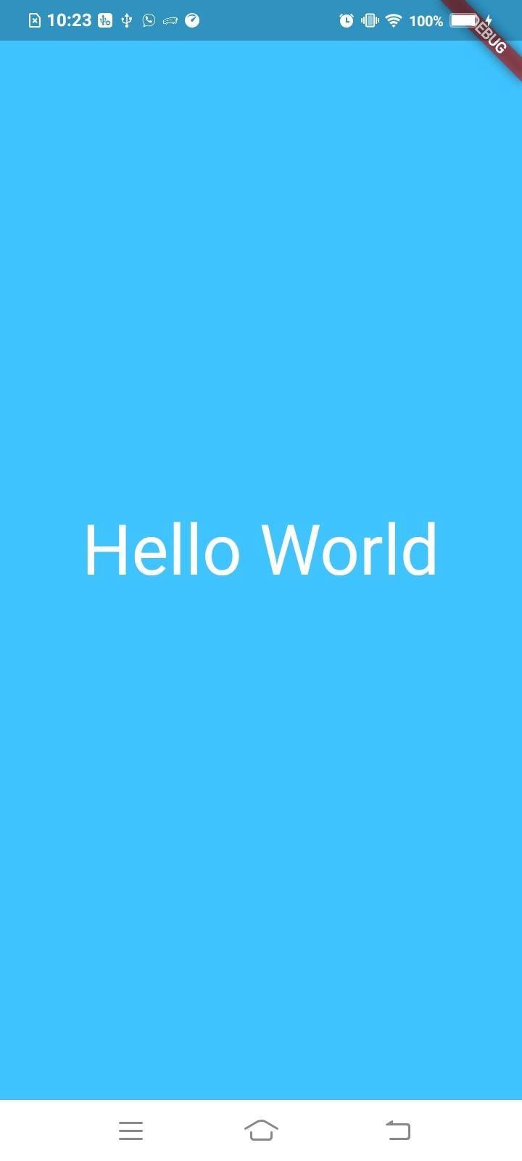

Scaffold Widget: Add appbar

import 'package:flutter/material.dart';

void main() {
runApp(MaterialApp(
title: "My App",
home: Scaffold(
appBar: AppBar(title: Text('My App Screen')),
body: Material(
color: Colors.lightBlueAccent,
child: Center(
child: Text(
'Hello World',
textDirection: TextDirection.ltr,
style: TextStyle(color: Colors.white, fontSize: 48.0),
)),
),
),
));
}

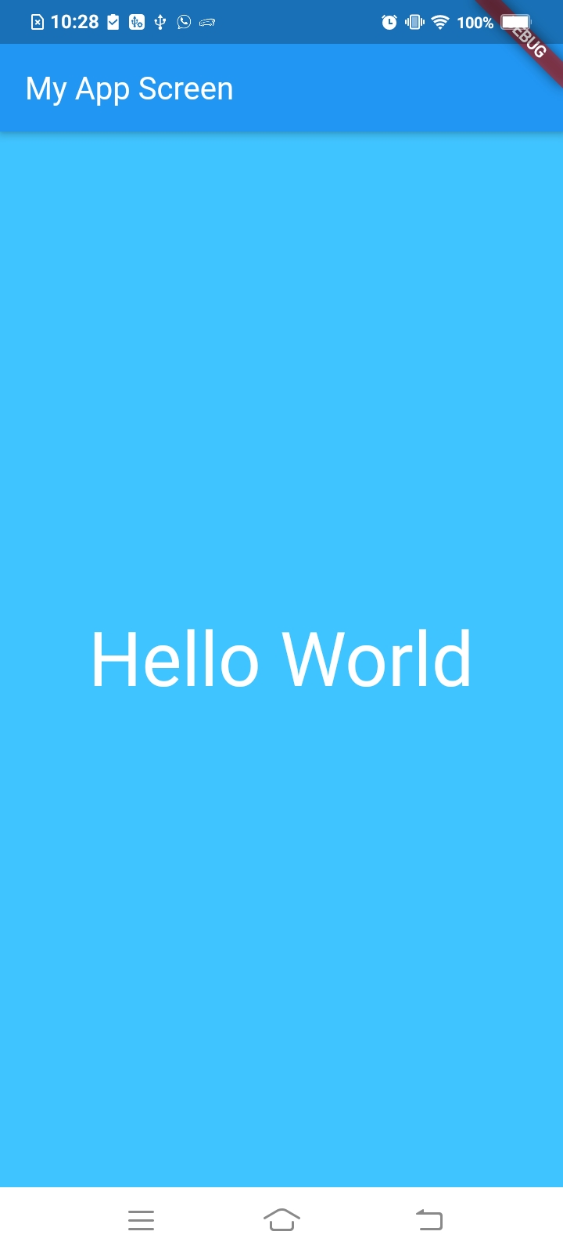
Output:

Remove debug banner present right top:

import 'package:flutter/material.dart';

void main() {
runApp(MaterialApp(
debugShowCheckedModeBanner: false,
title: "My App",
home: Scaffold(
appBar: AppBar(title: Text('My App Screen')),
body: Material(
color: Colors.lightBlueAccent,
child: Center(
child: Text(
'Hello World',
textDirection: TextDirection.ltr,
style: TextStyle(color: Colors.white, fontSize: 48.0),
)),
),
),
));
}

Output:

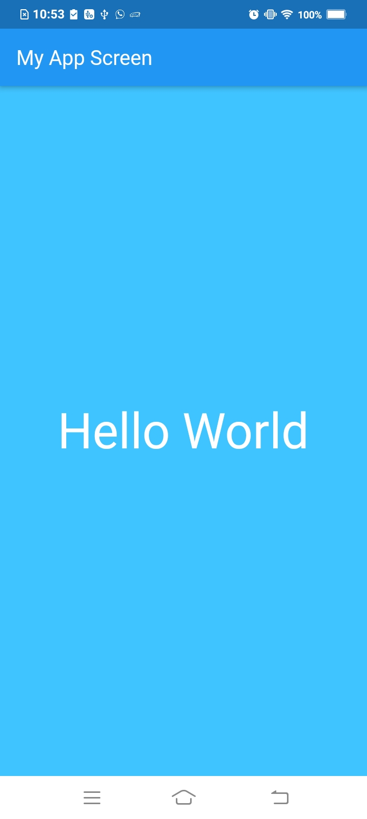

3.Organizing Flutter App:

import 'package:flutter/material.dart';

void main() {
runApp(MyApp());
}

class MyApp extends StatelessWidget{
@override
Widget build(BuildContext context) {
return MaterialApp(
debugShowCheckedModeBanner: false,
title: "My App",
home: Scaffold(
appBar: AppBar(title: Text('My App Screen')),
body: Material(
color: Colors.lightBlueAccent,
child: Center(
child: Text(
'Hello World',
textDirection: TextDirection.ltr,
style: TextStyle(color: Colors.white, fontSize: 48.0),
)),
),
),
);
}
}

Output:
Same output as above

Use Function expression in main

import 'package:flutter/material.dart';

void main() => runApp(MyApp());

class MyApp extends StatelessWidget{
@override
Widget build(BuildContext context) {
return MaterialApp(
debugShowCheckedModeBanner: false,
title: "My App",
home: Scaffold(
appBar: AppBar(title: Text('My App Screen')),
body: Material(
color: Colors.lightBlueAccent,
child: Center(
child: Text(
'Hello World',
textDirection: TextDirection.ltr,
style: TextStyle(color: Colors.white, fontSize: 48.0),
)),
),
),
);
}
}

Output:
Same output as above

Create Seperate Files:

first_screen.dart

import 'package:flutter/material.dart';

class FirstScreen extends StatelessWidget{
@override
Widget build(BuildContext context) {
// TODO: implement build
return Material(
color: Colors.lightBlueAccent,
child: Center(
child: Text(
'Hello World',
textDirection: TextDirection.ltr,
style: TextStyle(color: Colors.white, fontSize: 48.0),
)
),
);
}
}

main.dart

import 'package:flutter/material.dart';
import 'package:organizing_flutter_app/app_screens/first_screen.dart';

void main() => runApp(MyApp());

class MyApp extends StatelessWidget {
@override
Widget build(BuildContext context) {
return MaterialApp(
debugShowCheckedModeBanner: false,
title: "My App",
home: Scaffold(
appBar: AppBar(title: Text('My App Screen')),
body: FirstScreen())
);
}
}

Output:
Same output as above

Add Code Logic:

first_screen.dart

import 'dart:math';

import 'package:flutter/material.dart';

class FirstScreen extends StatelessWidget{
@override
Widget build(BuildContext context) {
// TODO: implement build
return Material(
color: Colors.lightBlueAccent,
child: Center(
child: Text(
generateLuckyNumber(),
textDirection: TextDirection.ltr,
style: TextStyle(color: Colors.white, fontSize: 48.0),
)
),
);
}

String generateLuckyNumber(){
var random = Random();
int luckyNumber = random.nextInt(10);
return "Your lucky number is $luckyNumber";
}
}

main.dart:

import 'package:flutter/material.dart';
import 'package:logic_code_flutter_app/app_screens/first_screen.dart';

void main() => runApp(MyApp());

class MyApp extends StatelessWidget {
@override
Widget build(BuildContext context) {
return MaterialApp(
debugShowCheckedModeBanner: false,
title: "My App",
home: Scaffold(
appBar: AppBar(title: Text('My App Screen')),
body: FirstScreen())
);
}
}

Output:
