Applying Styles and Themes
1.Application Wide
2.Small Part of the app

1.Application Wide

1. Apply Theme

import 'package:flutter/material.dart';

void main() {
runApp(
MaterialApp(
debugShowCheckedModeBanner: false,
title: 'Simple Calculator', home: SIForm(),
theme:ThemeData(
primaryColor: Colors.indigo,
accentColor: Colors.indigoAccent
)),
);
}

class SIForm extends StatefulWidget {
@override
_SIFormState createState() => _SIFormState();
}

class _SIFormState extends State<SIForm> {
final _minimumPadding = 5.0;
var _currencies = ['Rupees', 'Dollars', 'Pounds'];

@override
Widget build(BuildContext context) {
return Scaffold(
//resizeToAvoidBottomPadding: false,
appBar: AppBar(
title: Text('Simple Interest Calculator'),
),
body: Container(
padding: EdgeInsets.all(_minimumPadding * 2),
child: ListView(
children: [
getImageAsset(),
Padding(
padding: EdgeInsets.only(
top: _minimumPadding, bottom: _minimumPadding),
child: TextField(
keyboardType: TextInputType.number,
decoration: InputDecoration(
labelText: 'Principal',
hintText: 'Enter Principal eg.12000',
border: OutlineInputBorder(
borderRadius: BorderRadius.circular(5.0))),
)),
Padding(
padding: EdgeInsets.only(
top: _minimumPadding, bottom: _minimumPadding),
child: TextField(
keyboardType: TextInputType.number,
decoration: InputDecoration(
labelText: 'Rate of Interest',
hintText: 'In Percent',
border: OutlineInputBorder(
borderRadius: BorderRadius.circular(5.0))),
)),
Padding(
padding: EdgeInsets.only(top: _minimumPadding,bottom: _minimumPadding),
child: Row(
children: [
Expanded(
child: TextField(
keyboardType: TextInputType.number,
decoration: InputDecoration(
labelText: 'Rate of Interest',
hintText: 'In Percent',
border: OutlineInputBorder(
borderRadius: BorderRadius.circular(5.0))),
)),
Container(
width: _minimumPadding * 5,
),
Expanded(
child: DropdownButton<String>(
items: _currencies.map((String value) {
return DropdownMenuItem<String>(
value: value,
child: Text(value),
);
}).toList(),
value: 'Rupees',
onChanged: (String newValueSelected) {}))
],
),
),
Padding(
padding: EdgeInsets.only(top: _minimumPadding,bottom: _minimumPadding),
child:Row(
children: [
Expanded(child: RaisedButton(
child: Text('Calcualte'),
onPressed: (){

},
)),
Expanded(child: RaisedButton(
child: Text('Reset'),
onPressed: (){

},
))
],
) ,
),
Padding(padding: EdgeInsets.all(_minimumPadding * 2),
child: Text('Todo Text'),)
],
),
));
}

Widget getImageAsset() {
AssetImage assetImage = AssetImage('images/money.png');
Image image = Image(image: assetImage,width: 125.0,height: 125.0);
return Container(
child: image,
padding: EdgeInsets.all(_minimumPadding * 10),
);
}
}

Output:

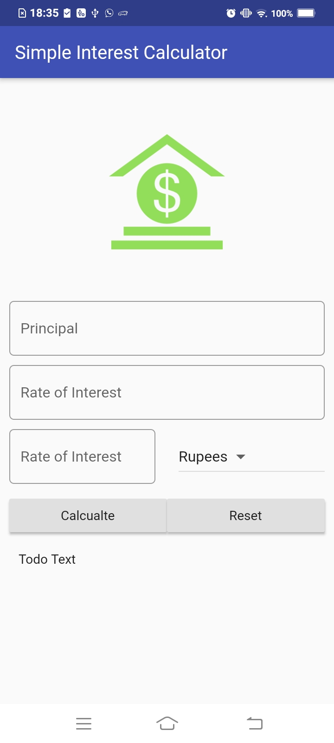

2. Add Style

import 'package:flutter/material.dart';

void main() {
runApp(
MaterialApp(
debugShowCheckedModeBanner: false,
title: 'Simple Calculator', home: SIForm(),
theme:ThemeData(
brightness: Brightness.dark,
primaryColor: Colors.indigo,
accentColor: Colors.indigoAccent
)),
);
}

class SIForm extends StatefulWidget {
@override
_SIFormState createState() => _SIFormState();
}

class _SIFormState extends State<SIForm> {
final _minimumPadding = 5.0;
var _currencies = ['Rupees', 'Dollars', 'Pounds'];

@override
Widget build(BuildContext context) {

TextStyle textStyle = Theme.of(context).textTheme.title;

return Scaffold(
//resizeToAvoidBottomPadding: false,
appBar: AppBar(
title: Text('Simple Interest Calculator'),
),
body: Container(
padding: EdgeInsets.all(_minimumPadding * 2),
child: ListView(
children: [
getImageAsset(),
Padding(
padding: EdgeInsets.only(
top: _minimumPadding, bottom: _minimumPadding),
child: TextField(
style: textStyle,
keyboardType: TextInputType.number,
decoration: InputDecoration(
labelText: 'Principal',
labelStyle: textStyle,
hintText: 'Enter Principal eg.12000',
border: OutlineInputBorder(
borderRadius: BorderRadius.circular(5.0))),
)),
Padding(
padding: EdgeInsets.only(
top: _minimumPadding, bottom: _minimumPadding),
child: TextField(
style: textStyle,
keyboardType: TextInputType.number,
decoration: InputDecoration(
labelText: 'Rate of Interest',
labelStyle: textStyle,
hintText: 'In Percent',
border: OutlineInputBorder(
borderRadius: BorderRadius.circular(5.0))),
)),
Padding(
padding: EdgeInsets.only(top: _minimumPadding,bottom: _minimumPadding),
child: Row(
children: [
Expanded(
child: TextField(
style: textStyle,
keyboardType: TextInputType.number,
decoration: InputDecoration(
labelText: 'Rate of Interest',
hintText: 'In Percent',
labelStyle: textStyle,
border: OutlineInputBorder(
borderRadius: BorderRadius.circular(5.0))),
)),
Container(
width: _minimumPadding * 5,
),
Expanded(
child: DropdownButton<String>(
items: _currencies.map((String value) {
return DropdownMenuItem<String>(
value: value,
child: Text(value),
);
}).toList(),
value: 'Rupees',
onChanged: (String newValueSelected) {}))
],
),
),
Padding(
padding: EdgeInsets.only(top: _minimumPadding,bottom: _minimumPadding),
child:Row(
children: [
Expanded(child: RaisedButton(
color: Theme.of(context).accentColor,
textColor: Theme.of(context).primaryColorDark,
child: Text('Calculate',textScaleFactor: 1.5,),
onPressed: (){

},
)),
Expanded(child: RaisedButton(
color: Theme.of(context).primaryColorDark,
textColor: Theme.of(context).primaryColorLight,
child: Text('Reset',textScaleFactor: 1.5),
onPressed: (){

},
))
],
) ,
),
Padding(padding: EdgeInsets.all(_minimumPadding * 2),
child: Text('Todo Text',style: textStyle))
],
),
));
}

Widget getImageAsset() {
AssetImage assetImage = AssetImage('images/money.png');
Image image = Image(image: assetImage,width: 125.0,height: 125.0);
return Container(
child: image,
padding: EdgeInsets.all(_minimumPadding * 10),
);
}
}

Output:
