Dataflow Programming
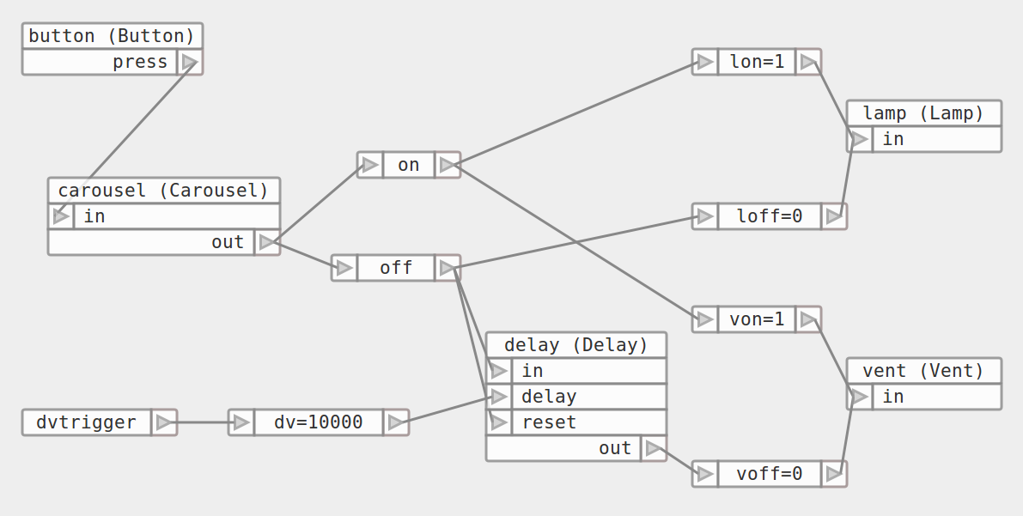

ern0 – http://linkbroker.hu

V4 – 2015.09.26

Basics | Advanced
Definition  Component & Port  Data Types  Source, Processor, Sink | Component: Native vs Composite  Scheduling: Synchronous vs Asynchronous  Triggering: Push vs Pull  Execution: Parallel, Multi Host

Dataflow Systems
Unix Pipe, Spreadsheet, Make etc.
Practice
App Creating vs Programming, Component Programming, Application Building

Benefits
Rapid Prototyping, Reusability, Transparency

Basics | Advanced
Definition  Component & Port  Data Types  Source, Processor, Sink | Component: Native vs Composite  Scheduling: Synchronous vs Asynchronous  Triggering: Push vs Pull  Execution: Parallel, Multi Host

Dataflow Systems
Unix Pipe, Spreadsheet, Make etc.
Practice
App Creating vs Programming, Component Programming, Application Building

Benefits
Rapid Prototyping, Reusability, Transparency

Definition


Programming paradigm / software architecture: computation is modelled as a directed graph.

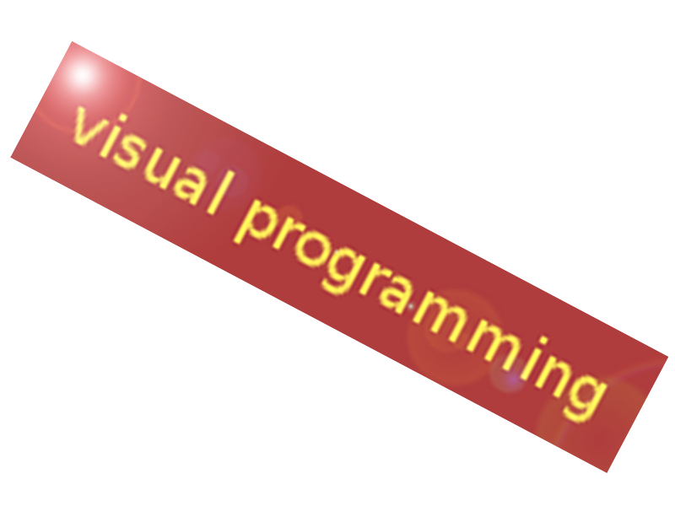
Applications is a network of "black box" processes, which exchange data across predefined connections by message passing, where the connections are specified externally to the processes.
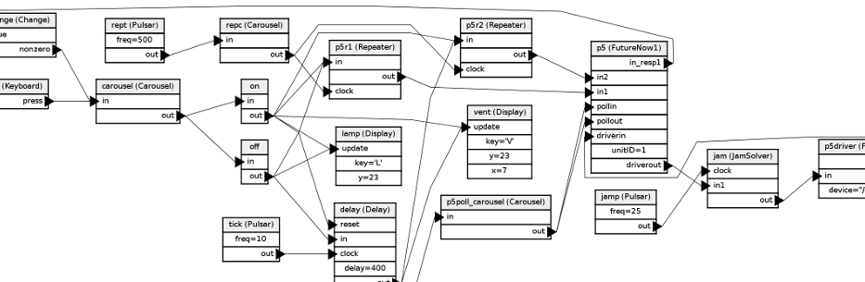

Domains

- Synth/sampler/workstation
- Audio/video processing
- Animation rendering
- Industrial/home automation
- Spreadsheet
- Task automation
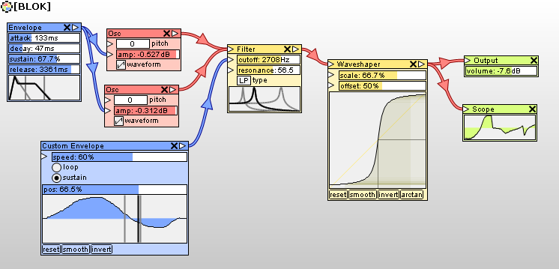
Similar, See Also...

Flow Based Programming
Reactive Programming
Functional Programming
Event-Driven Programming
PLC (Ladder Logic, Functional Block Diagram)
Microservices
Kahn Process Networks, Petri Net
Electricity
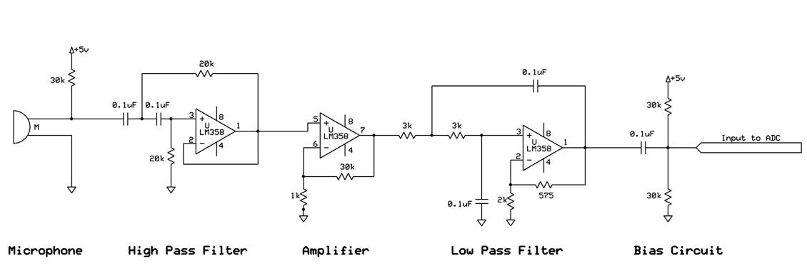
etc.

Basics | Advanced
Definition  Component & Port  Data Types  Source, Processor, Sink | Component: Native vs Composite  Scheduling: Synchronous vs Asynchronous  Triggering: Push vs Pull  Execution: Parallel, Multi Host

Dataflow Systems
Unix Pipe, Spreadsheet, Make etc.
Practice
App Creating vs Programming, Component Programming, Application Building

Benefits
Rapid Prototyping, Reusability, Transparency

Component & Port
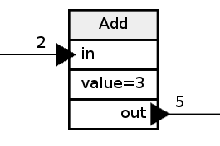
- consumer (input)
- property / parameter
- producer (output)

Component library:
platform, “language”


stateful components

Basics | Advanced
Definition  Component & Port  Data Types  Source, Processor, Sink | Component: Native vs Composite  Scheduling: Synchronous vs Asynchronous  Triggering: Push vs Pull  Execution: Parallel, Multi Host

Dataflow Systems
Unix Pipe, Spreadsheet, Make etc.
Practice
App Creating vs Programming, Component Programming, Application Building

Benefits
Rapid Prototyping, Reusability, Transparency

Data Types

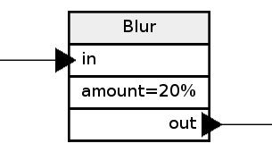
- Trigger
- Integer
- Packet (some bytes)

- Image, video stream
- Audio stream
- Lines of text (Unix pipe)
- Composite packet

Basics | Advanced
Definition  Component & Port  Data Types  Source, Processor, Sink | Component: Native vs Composite  Scheduling: Synchronous vs Asynchronous  Triggering: Push vs Pull  Execution: Parallel, Multi Host

Dataflow Systems
Unix Pipe, Spreadsheet, Make etc.
Practice
App Creating vs Programming, Component Programming, Application Building

Benefits
Rapid Prototyping, Reusability, Transparency

Component Function Types
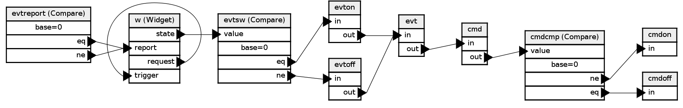

source | processor | sink
external input  import, feed  network receive | data process  transform  path select  process control | result presentation  export  network send
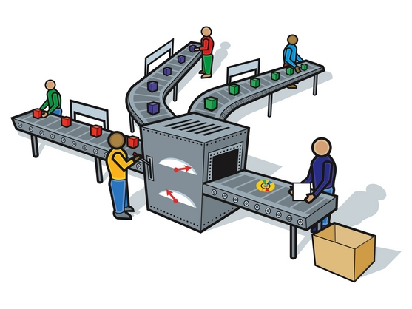

Basics | Advanced
Definition  Component & Port  Data Types  Source, Processor, Sink | Component: Native vs Composite  Scheduling: Synchronous vs Asynchronous  Triggering: Push vs Pull  Execution: Parallel, Multi Host

Dataflow Systems
Unix Pipe, Spreadsheet, Make etc.
Practice
App Creating vs Programming, Component Programming, Application Building

Benefits
Rapid Prototyping, Reusability, Transparency

Component Implementation Modes

Native | Composite
class ChangeComponent {  void messageHandler(Msg* message) {  int v = message->getValue();  int l = last->getValue();  if (v == l) return;  last->setValue(v);  changePort->fire(v);  if (v == 0) {  zeroPort->fire(v);  } else {  nonzeroPort->fire(v);  }  } // messageHandler()  } // class | 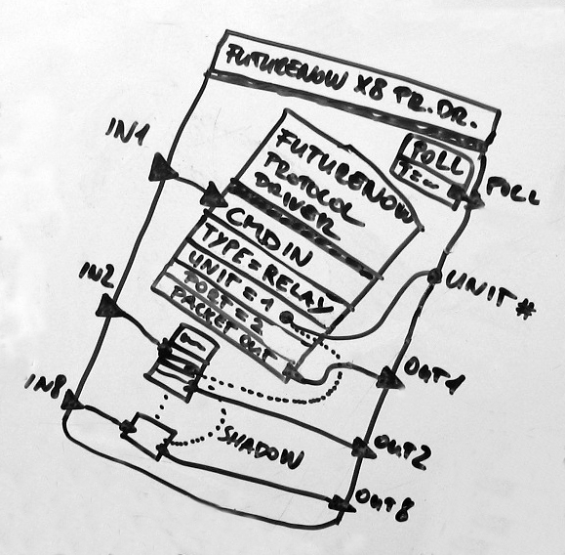
unlimited depth

Basics | Advanced
Definition  Component & Port  Data Types  Source, Processor, Sink | Component: Native vs Composite  Scheduling: Synchronous vs Asynchronous  Triggering: Push vs Pull  Execution: Parallel, Multi Host

Dataflow Systems
Unix Pipe, Spreadsheet, Make etc.
Practice
App Creating vs Programming, Component Programming, Application Building

Benefits
Rapid Prototyping, Reusability, Transparency

Scheduling Modes

Synchronous | Asynchronous
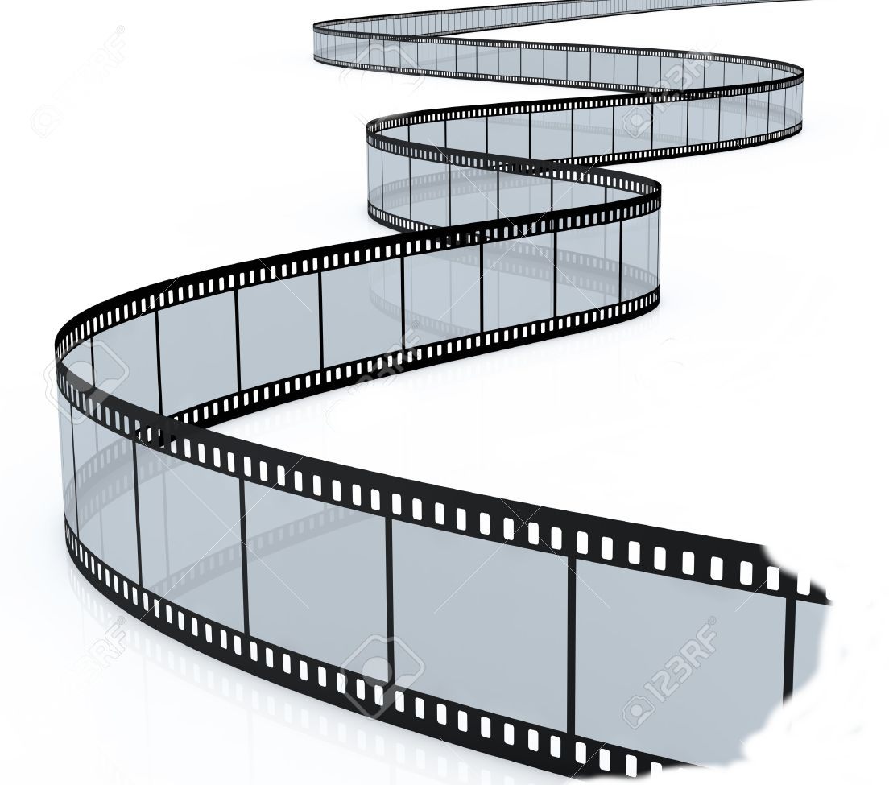  system clock | trigger      --------
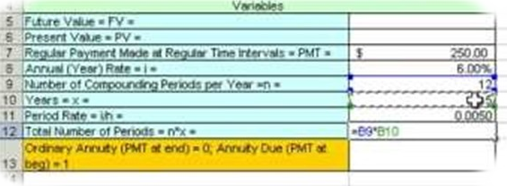

Basics | Advanced
Definition  Component & Port  Data Types  Source, Processor, Sink | Component: Native vs Composite  Scheduling: Synchronous vs Asynchronous  Triggering: Push vs Pull  Execution: Parallel, Multi Host

Dataflow Systems
Unix Pipe, Spreadsheet, Make etc.
Practice
App Creating vs Programming, Component Programming, Application Building

Benefits
Rapid Prototyping, Reusability, Transparency

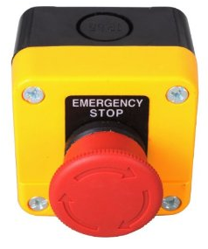
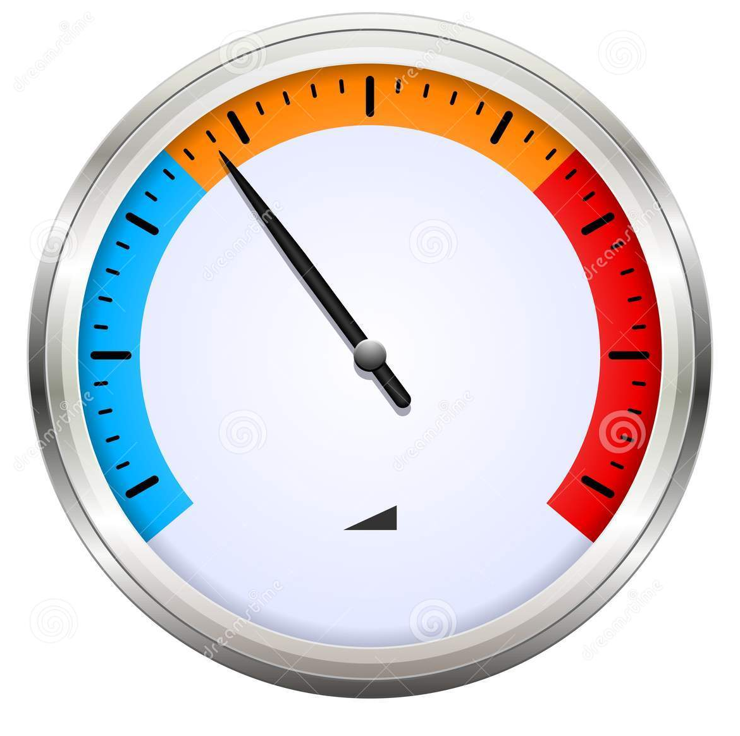
Triggering Modes

Push | Pull
data/event driven  active  source component  overload,  unneeded messages | demand driven  passive  source component  response delay,  improper sampling

buffering

Basics | Advanced
Definition  Component & Port  Data Types  Source, Processor, Sink | Component: Native vs Composite  Scheduling: Synchronous vs Asynchronous  Triggering: Push vs Pull  Execution: Parallel, Multi Host

Dataflow Systems
Unix Pipe, Spreadsheet, Make etc.
Practice
App Creating vs Programming, Component Programming, Application Building

Benefits
Rapid Prototyping, Reusability, Transparency

Parallel Execution

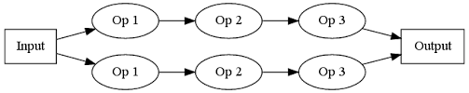

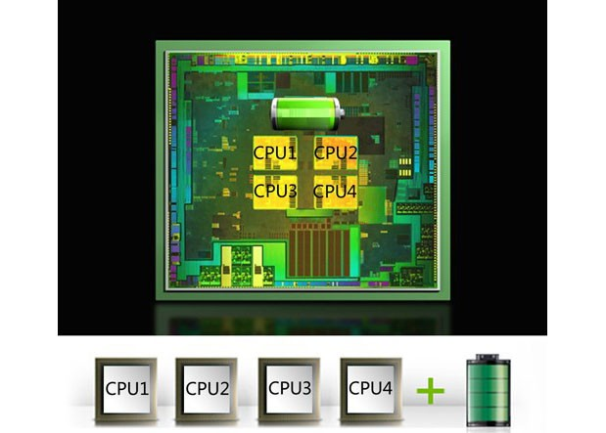
Converts single-threaded
algorythms to multi-threaded

Load balancing, merging problems

Utilizes multi-core CPUs

Multi-host Application
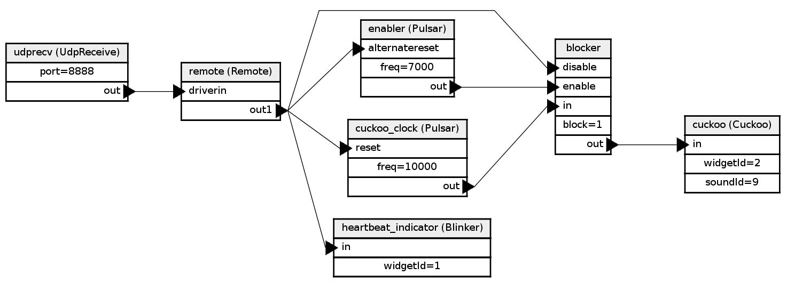
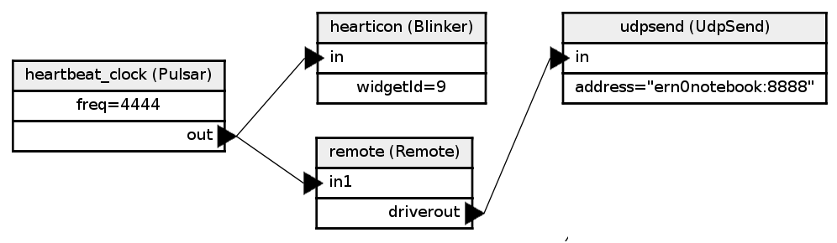
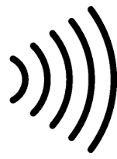


Basics | Advanced
Definition  Component & Port  Data Types  Source, Processor, Sink | Component: Native vs Composite  Scheduling: Synchronous vs Asynchronous  Triggering: Push vs Pull  Execution: Parallel, Multi Host

Dataflow Systems
Unix Pipe, Spreadsheet, Make etc.
Practice
App Creating vs Programming, Component Programming, Application Building

Benefits
Rapid Prototyping, Reusability, Transparency

Unix Pipe

- All the commands are components by default
- One, universal data type: lines of text
- Restricted graph: 1-in-1-out (+ files)
- No editor required, CLI syntax (c1 | c2 | c3)
- Parallel execution (check it: ps)
(MS-DOS: single, using tmp files)
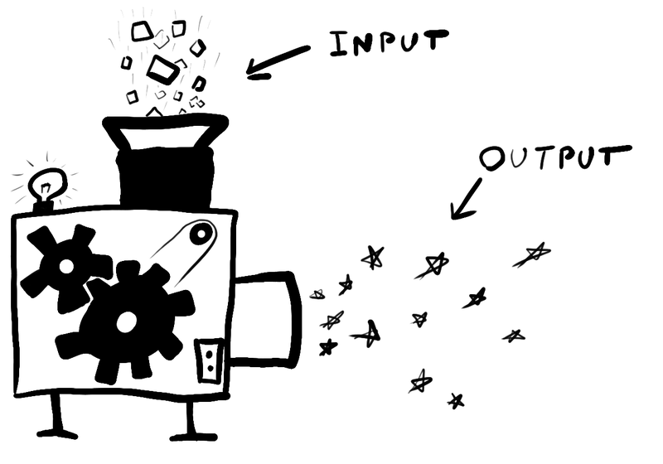
/bin/cat
/usr/bin/tee

simple architecture

Basics | Advanced
Definition  Component & Port  Data Types  Source, Processor, Sink | Component: Native vs Composite  Scheduling: Synchronous vs Asynchronous  Triggering: Push vs Pull  Execution: Parallel, Multi Host

Dataflow Systems
Unix Pipe, Spreadsheet, Make etc.
Practice
App Creating vs Programming, Component Programming, Application Building

Benefits
Rapid Prototyping, Reusability, Transparency

Spreadsheet

- Formula components (issue: no repository)
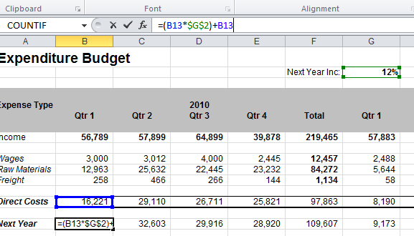
- Data types: numeric, date, string
- Graph defined by 2D/3D cell coordinate references

Basics | Advanced
Definition  Component & Port  Data Types  Source, Processor, Sink | Component: Native vs Composite  Scheduling: Synchronous vs Asynchronous  Triggering: Push vs Pull  Execution: Parallel, Multi Host

Dataflow Systems
Unix Pipe, Spreadsheet, Make etc.
Practice
App Creating vs Programming, Component Programming, Application Building

Benefits
Rapid Prototyping, Reusability, Transparency

Make

- Component: job (compiler script)
- Data: file (sources, objects, executable)
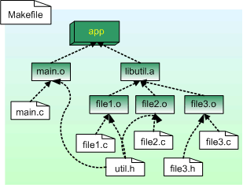
- Dependency tree
- Parallel execution
make -j

Basics | Advanced
Definition  Component & Port  Data Types  Source, Processor, Sink | Component: Native vs Composite  Scheduling: Synchronous vs Asynchronous  Triggering: Push vs Pull  Execution: Parallel, Multi Host

Dataflow Systems
Unix Pipe, Spreadsheet, Make etc.
Practice
App Creating vs Programming, Component Programming, Application Building

Benefits
Rapid Prototyping, Reusability, Transparency

Quartz Composer

- Graphics purpose
- Comes with Mac OS X
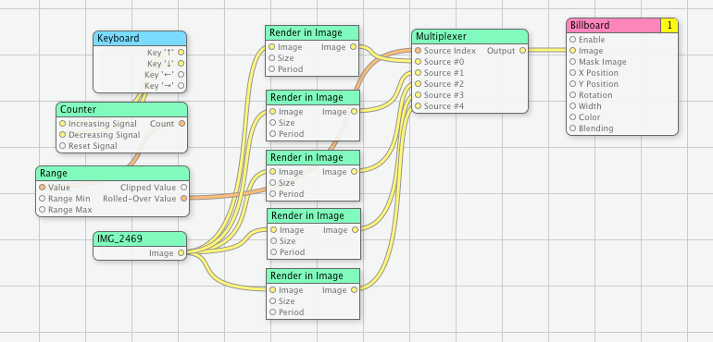

Rane DragNet

Audio system

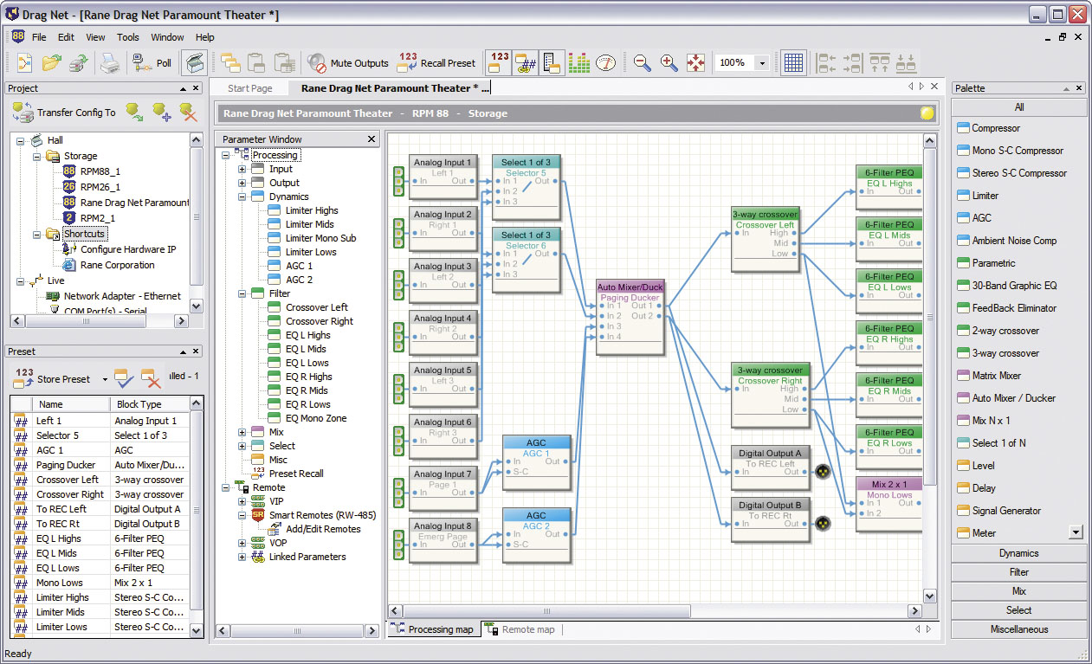


Blender

- Video system
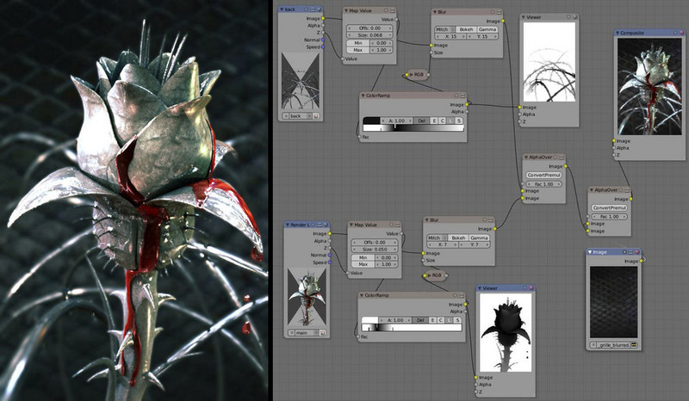
- Open source

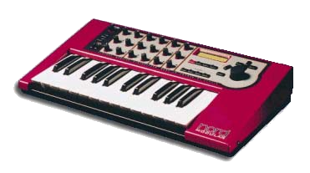
Clavia Nord Modular

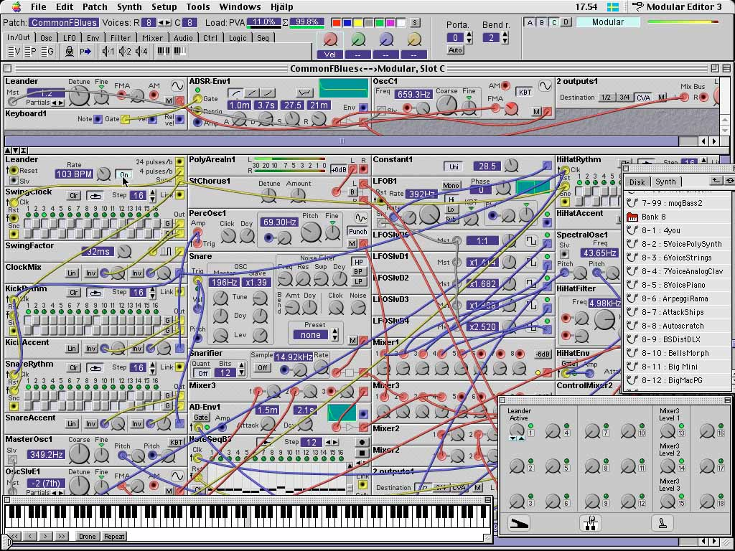
- Music
- Win32
editor


Propellerhead Reason

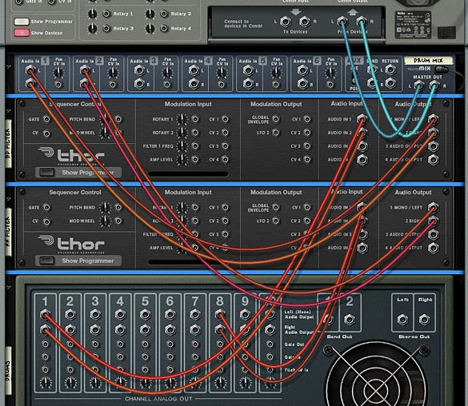

- Audio workstation
- Rack+wire metaphor


MaxMSP
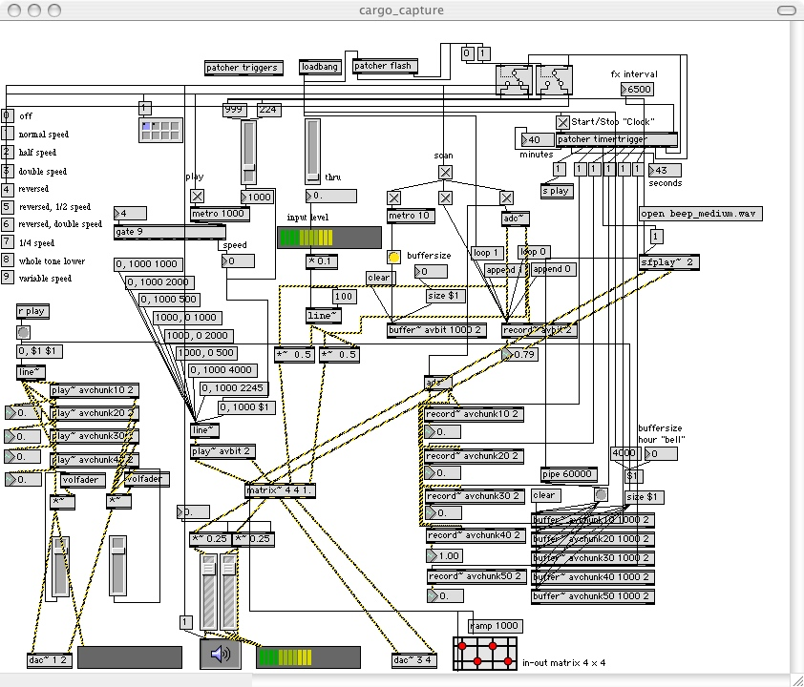
Audio/video
magic

Houdini

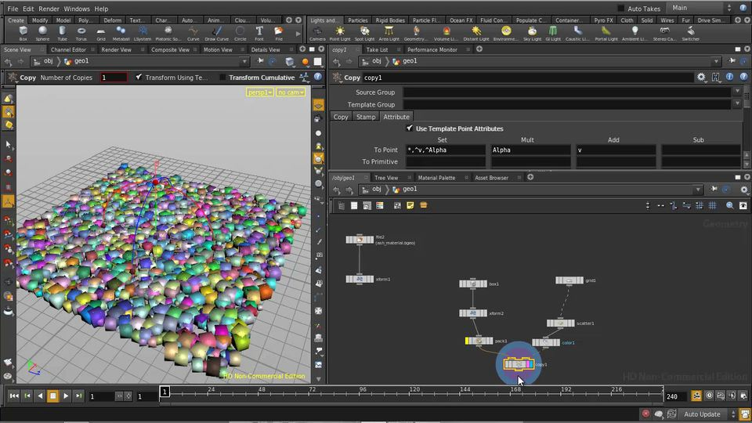
3D Animation
TinyOS


Embedded Systems

// CounterSounder
Main.StdControl -> CounterSounderM.StdControl;

// TimerC
CounterSounderM.Timer -> TimerC.Timer[unique("Timer")];
Main.StdControl -> TimerC.StdControl;

// LedsC
CounterSounderM.Leds -> LedsC.Leds;

// Sounder
CounterSounderM.SounderControl -> Sounder.StdControl;


LabView

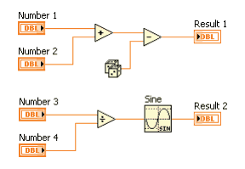
Math magic


MatLab & SimuLink

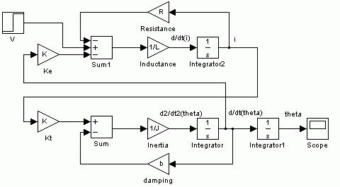
Math magic

Basics | Advanced
Definition  Component & Port  Data Types  Source, Processor, Sink | Component: Native vs Composite  Scheduling: Synchronous vs Asynchronous  Triggering: Push vs Pull  Execution: Parallel, Multi Host

Dataflow Systems
Unix Pipe, Spreadsheet, Make etc.
Practice
App Creating vs Programming, Component Programming, Application Building

Benefits
Rapid Prototyping, Reusability, Transparency

Good News


creating application programming

People Are Different

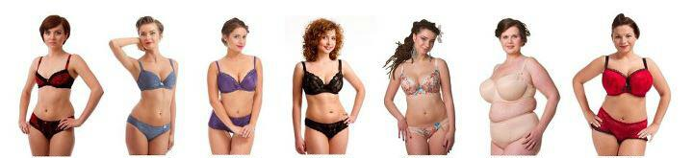

another image, pls
People Are Different


creating application programming

application builder | programmer
domain knowledge    user contact  customization  integration  maintenance | programming    supporting app builder

separating roles

Basics | Advanced
Definition  Component & Port  Data Types  Source, Processor, Sink | Component: Native vs Composite  Scheduling: Synchronous vs Asynchronous  Triggering: Push vs Pull  Execution: Parallel, Multi Host

Dataflow Systems
Unix Pipe, Spreadsheet, Make etc.
Practice
App Creating vs Programming, Component Programming, Application Building

Benefits
Rapid Prototyping, Reusability, Transparency

Component Programming

- Simple, small code (100 – 1000 lines)
Homeaut.com component sizes (C++, w/o headers):
JamSolver: 497 lines
Scheduler: 628 lines
SimpleSequencer: 815 lines
- Loose coupling: default (Hollywood principle etc.)

- Ready for unit testing
- No customer demands
- No legacy code to learn and modify

Basics | Advanced
Definition  Component & Port  Data Types  Source, Processor, Sink | Component: Native vs Composite  Scheduling: Synchronous vs Asynchronous  Triggering: Push vs Pull  Execution: Parallel, Multi Host

Dataflow Systems
Unix Pipe, Spreadsheet, Make etc.
Practice
App Creating vs Programming, Component Programming, Application Building

Benefits
Rapid Prototyping, Reusability, Transparency

Application Building

- No programming skills required
- Even the user can create apps
- Visual programming

- Convert patterns to composite components
- Focusing on the problem
- Different world

Basics | Advanced
Definition  Component & Port  Data Types  Source, Processor, Sink | Component: Native vs Composite  Scheduling: Synchronous vs Asynchronous  Triggering: Push vs Pull  Execution: Parallel, Multi Host

Dataflow Systems
Unix Pipe, Spreadsheet, Make etc.
Practice
App Creating vs Programming, Component Programming, Application Building

Benefits
Rapid Prototyping, Reusability, Transparency

Rapid Prototyping

- No programming required
- Mock missing components
- Mock missing resources (data source, user input etc.)
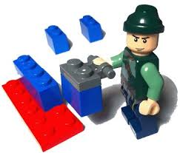
- Discover missing components to be implemented

Basics | Advanced
Definition  Component & Port  Data Types  Source, Processor, Sink | Component: Native vs Composite  Scheduling: Synchronous vs Asynchronous  Triggering: Push vs Pull  Execution: Parallel, Multi Host

Dataflow Systems
Unix Pipe, Spreadsheet, Make etc.
Practice
App Creating vs Programming, Component Programming, Application Building

Benefits
Rapid Prototyping, Reusability, Transparency

Reuse. Really.

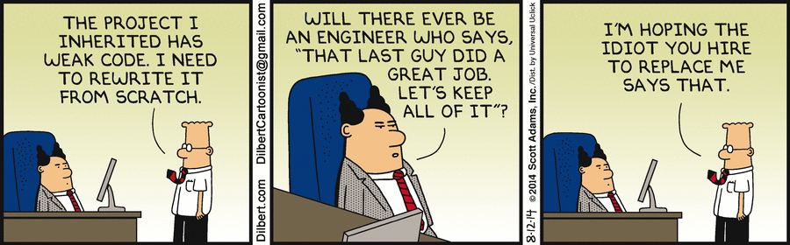
OOP promised reusability.
It was a lie.

Reusability Example

Serial sniffer with home automation components
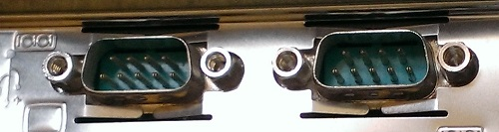
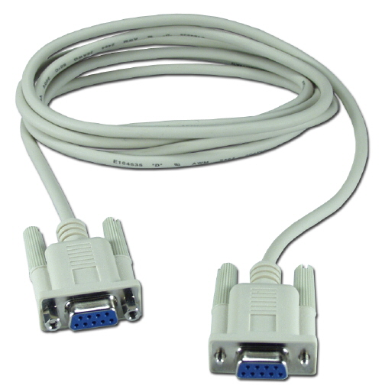
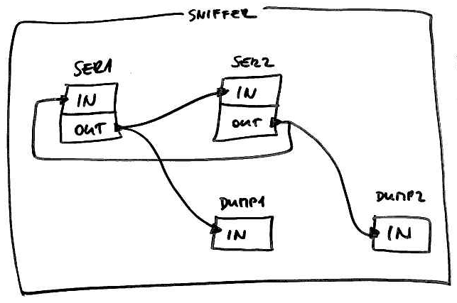

Basics | Advanced
Definition  Component & Port  Data Types  Source, Processor, Sink | Component: Native vs Composite  Scheduling: Synchronous vs Asynchronous  Triggering: Push vs Pull  Execution: Parallel, Multi Host

Dataflow Systems
Unix Pipe, Spreadsheet, Make etc.
Practice
App Creating vs Programming, Component Programming, Application Building

Benefits
Rapid Prototyping, Reusability, Transparency

Transparency

- Automatic documentation of the application
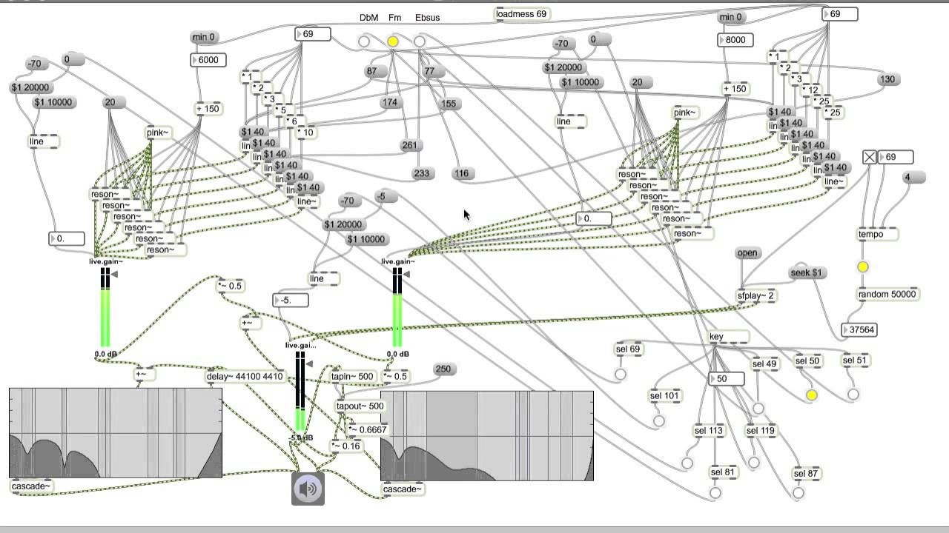
- Well-separated layers
THE END

My favourite application. Can you find the bug?

