GIT is not a VCS.
That’s why GIT is a great VCS




ern0@linkbroker.hu
2018.05.01

This is not a GIT course.
This is not a GIT course.

• Definiton of VCS
• Living without VCS
• Version controlling concepts
• How GIT works
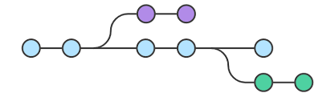
• GIT commands, tips’n’tricks
Version Control System (VCS)

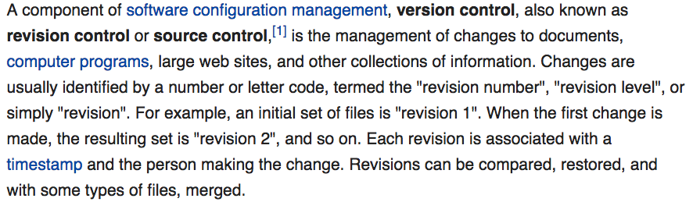
(Wikipedia)

VCS features:

• Central file repository
• Store all changes
• Recall any snapshot
• Organize snapshots
• Teamwork support
• Side effect: backup

Thank you, Captain Obvious!

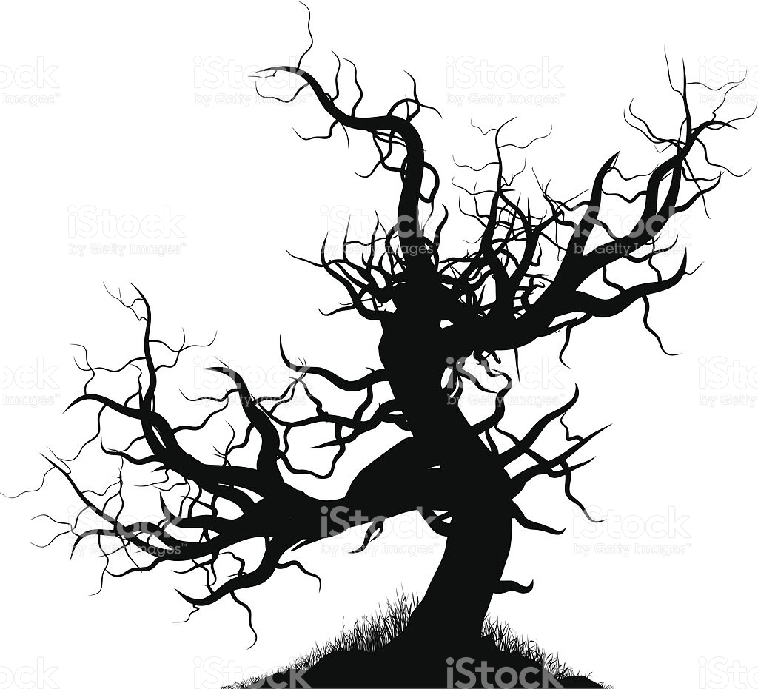
w/o VCS
Without VCS: editor backup

• myprg.bak
• myprogram.pas.bak
• myprogram.pas~

• myprg.pa~
Without VCS: naming convention

• Logo2.psd
• Logo3b.psd
• Logo4-palettefix-veryfinal2.psd

Without VCS: manual snapshot

• app_old_2/
• app_1.3rc/
• app_1.4_20180402/
• app_bak_20180402.zip
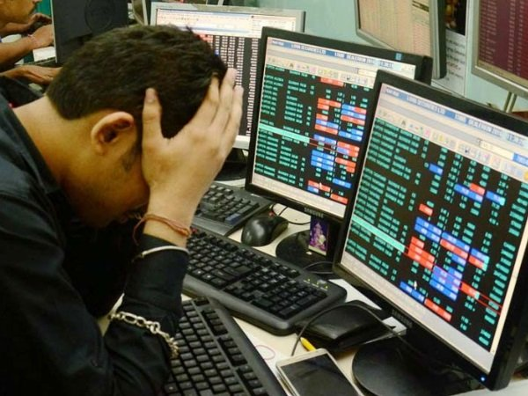
Without VCS: automatic backup

• local media
• network

Almost VCS:

• file versioning (VAX / VMS)
• journaling filesystem (AIX JFS)
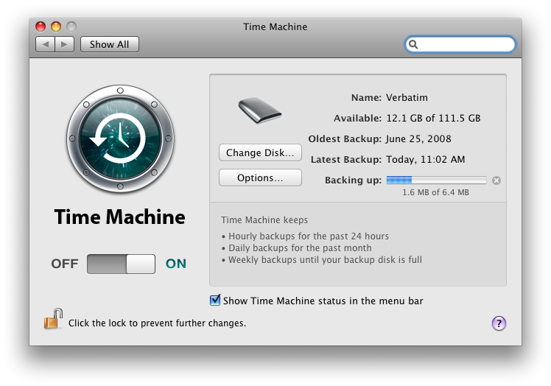
• Time Machine (Mac OS)

Poor man’s VCS: Dropbox

• cloud sync (repo)
• file history (revert)

• pause sync (commit)

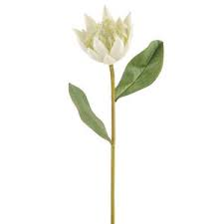
VCS
VCS infrastructure

• server

• repository
• client
VCS terms (basic)

• checkout
• working copy
• file is under version control
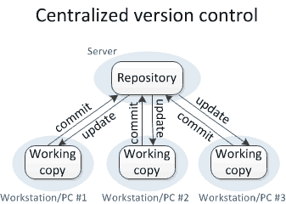
• commit, commit message
• revert
• changelog
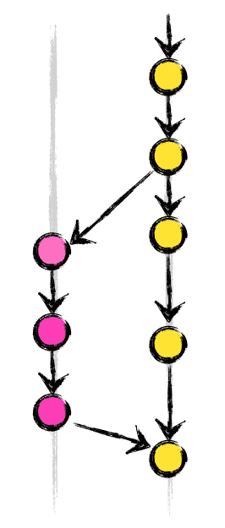
VCS terms (advanced)

• branch, head
• locking / shared checkout
• merge
• merge conflict
• diff (change, delta)
• merge conflict resolve


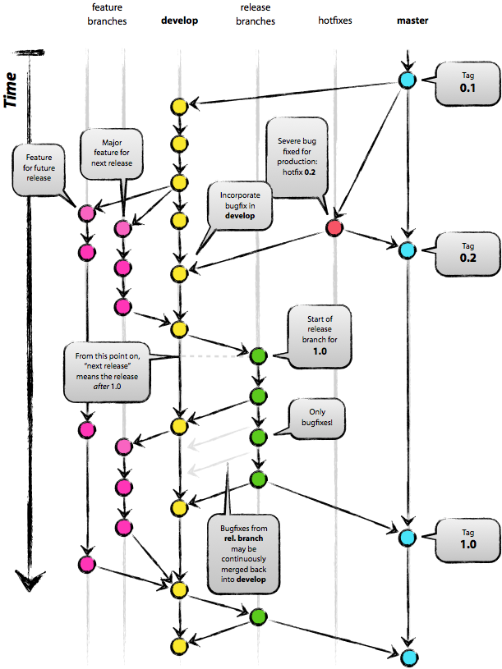
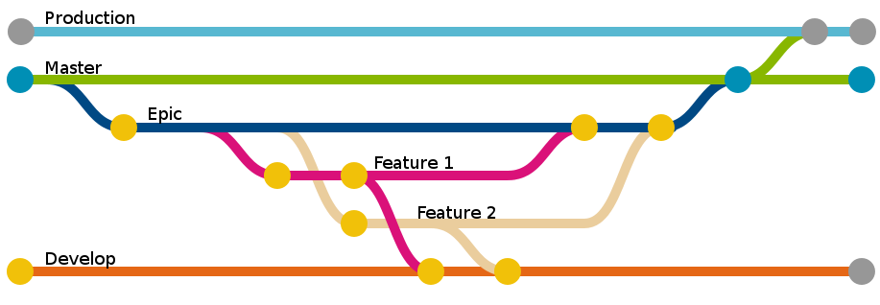
VCS is about branching
Development is about branching

GIT

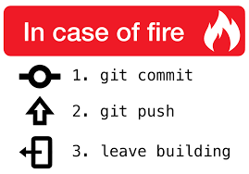
GIT

Three states

• Working Directory
• Staging Area (a.k.a. Index)
• Local Repository .git/

• Remote Repository

Three states

• Working Directory
• Staging Area (a.k.a. Index)
• Local Repository .git/

• Remote Repository
(GitHub, GitLab etc.)
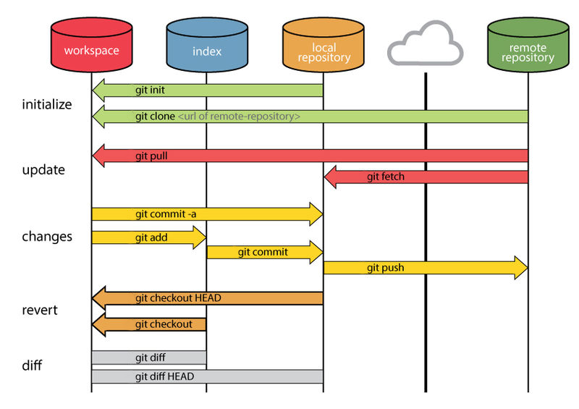
diff

One two three four
Can I have a little cake
Five six seven eight nine ten
I love you
A B C D
Can I bring my friend to coffee
One two three four
Can I have a little more
Five six seven eight nine ten
I love you
A B C D
Can I bring my friend to tea
E F G H I J
I love you
--- a2018-04-23 21:35:37.000000000 +0200
+++ b2018-04-23 21:35:10.000000000 +0200
@@ -1,6 +1,8 @@
One two three four
-Can I have a little cake
+Can I have a little more
Five six seven eight nine ten
I love you
A B C D
-Can I bring my friend to coffee
+Can I bring my friend to tea
+E F G H I J
+I love you
colordiff
One two three four
Can I have a little cake
Five six seven eight nine ten
I love you
A B C D
Can I bring my friend to coffee
One two three four
Can I have a little more
Five six seven eight nine ten
I love you
A B C D
Can I bring my friend to tea
E F G H I J
I love you
--- a2018-04-23 21:35:37.000000000 +0200
+++ b2018-04-23 21:35:10.000000000 +0200
@@ -1,6 +1,8 @@
One two three four
-Can I have a little cake
+Can I have a little more
Five six seven eight nine ten
I love you
A B C D
-Can I bring my friend to coffee
+Can I bring my friend to tea
+E F G H I J
+I love you

(The Beatles: All Together Now)
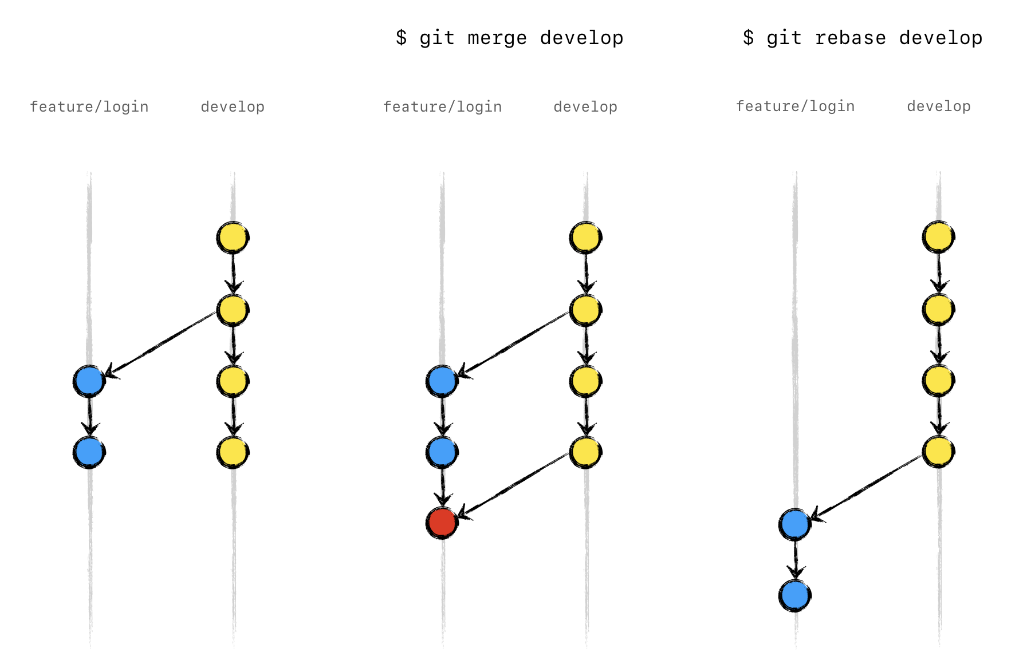
The repository

• series of snapshots
• diff to previous
• commit: new node
based on selected one

(stay tuned)
hash (md1)
$ echo "We Build Robots" | sha1sum
0b19fb7e8ad55d5b0fc5bf27411c63a4c0b182fe -

$ echo "We Build Robots." | sha1sum
99d7c75c3cf51f3712058a3eba56837314b35156 -

$ echo "We build robots" | sha1sum
fc3504b54ff836e66d956b1056c6549b991d01fa -

$ echo "We Build Robots" | sha1sum
0b19fb7e8ad55d5b0fc5bf27411c63a4c0b182fe -

hash (md1)
commit 029978ed2767be597f159b5e0eb29f754b410379
Author: ern0 <ern0@linkbroker.hu>
Date: Fri Apr 20 00:00:24 2018 +0200

fmt stub added

commit f705e402ceb518011bea3d8a813e45233101ed27
Author: ern0 <ern0@linkbroker.hu>
Date: Thu Apr 19 22:46:03 2018 +0200

added universal hash check function
git log

029978e 2018-04-20 00:00 ern0 o fmt stub added
f705e40 2018-04-19 22:46 ern0 o added universal hash check function

tig
The repository element (commit)
• commit ID (hash)
• previous commit ID
• snapshot (diff...)
• merged commit ID (opt.)
• timestamp
• author
• commit message

Working with commits


• pick a base commit
• apply changes
• add new commit
to the repository

GIT logo
Referring to commits


• commit ID (0.00%)
• tag (0.01%)
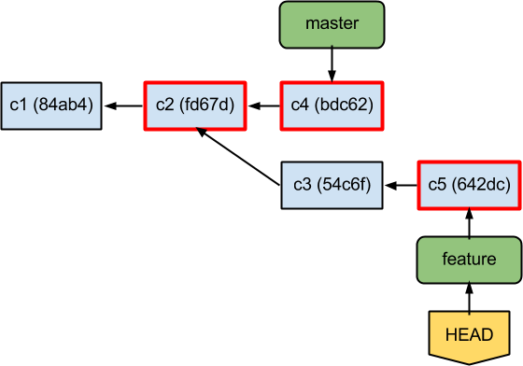
• relative to HEAD (1%)
• branch (99%)

Referring by commit ID
$ git checkout fb154891753699fa38beb4525412ed7b1995ed4e
HEAD is now at fb15489 html file created

$ echo “</html>” >> index.html # workspace
$ git add index.html # staging

$ git commit -m "closing tag added to html file"
[detached HEAD bbbd55a] closing tag added to html file
1 file changed, 1 insertion(+)

$ git log
commit bbbd55a86a6a54a360bc830700c720fb6b65edde (HEAD)
Author: ern0 <ern0@linkbroker.hu>
closing tag added to html file

commit fb154891753699fa38beb4525412ed7b1995ed4e
Author: ern0 <ern0@linkbroker.hu>
html file created
Referring by commit ID
$ git checkout fb154891753699fa38beb4525412ed7b1995ed4e
HEAD is now at fb15489 html file created

$ echo “</html>” >> index.html # workspace
$ git add index.html # staging

$ git commit -m "closing tag added to html file"
[detached HEAD bbbd55a] closing tag added to html file
1 file changed, 1 insertion(+)

$ git log
commit bbbd55a86a6a54a360bc830700c720fb6b65edde (HEAD)
Author: ern0 <ern0@linkbroker.hu>
closing tag added to html file

commit fb154891753699fa38beb4525412ed7b1995ed4e
Author: ern0 <ern0@linkbroker.hu>
html file created
Referring by tag

• named reference to a node
• once set, never changes
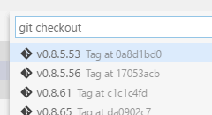
• git checkout v1.8.1
Referring relative to HEAD

• using previuos commit ID refs
• git diff HEAD^
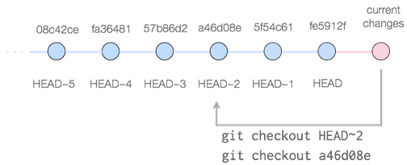
• git checkout HEAD~2

Referring by branch (99%)

• named reference to a node
• actual branch follows HEAD
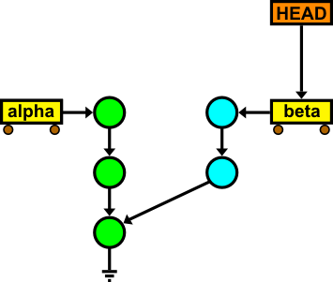
• repository: tree, branch: leaf
• detached HEAD:
no branch,
GC will delete it

Branch
Creating a commit
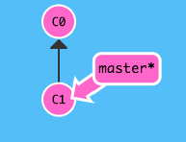
git commit ...
Creating a branch
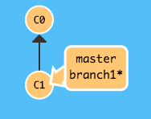
git checkout-b branch1

Commit on the new branch
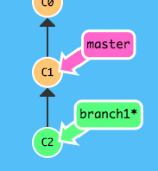
git commit ...

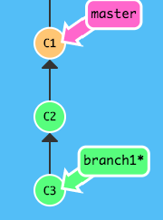
Another commit

git commit ...

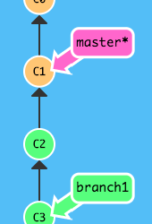
Back to master

git checkout master

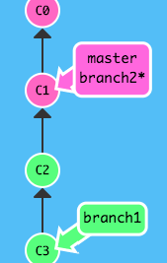
Another new branch

git checkout \
-b branch2
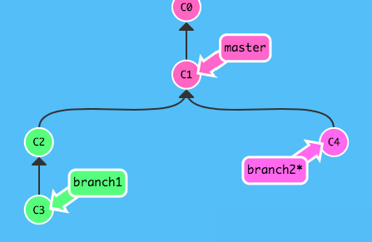
Commit on new branch

git commit ...
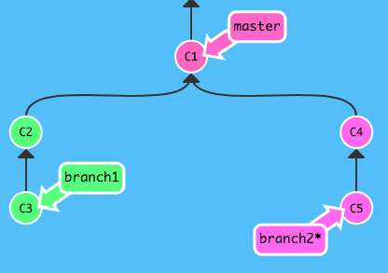
Another commit on new branch

git commit ...
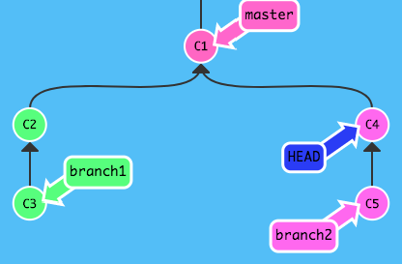
Step back

git checkout HEAD^
detached
HEAD
Commit on detached HEAD
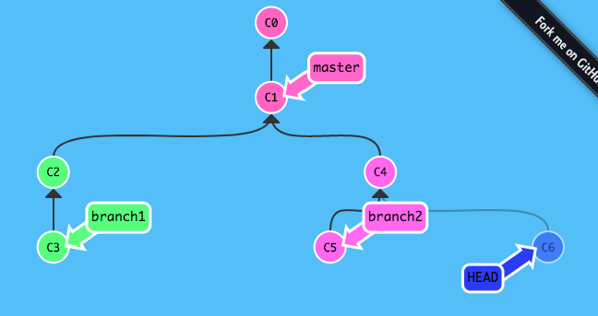

Give name to child
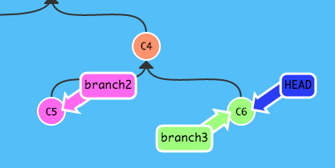
git branch branch3

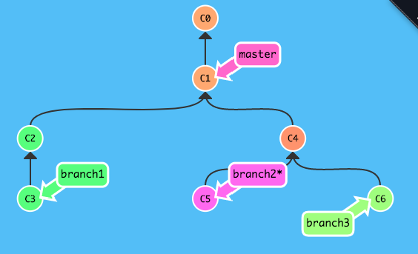
Merge 1/2.

git checkout branch2

Merge 2/2.
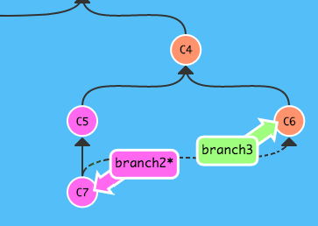
git merge branch3

Merge ffwd 1/2.
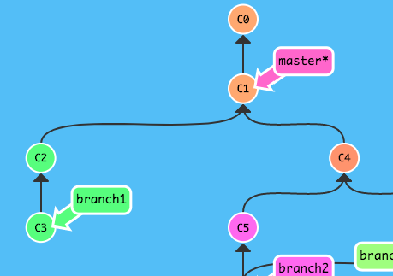
git checkout master
Merge ffwd 2/2.
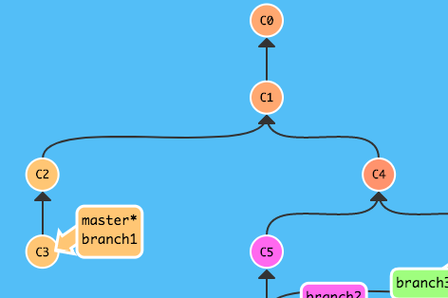
git merge branch1
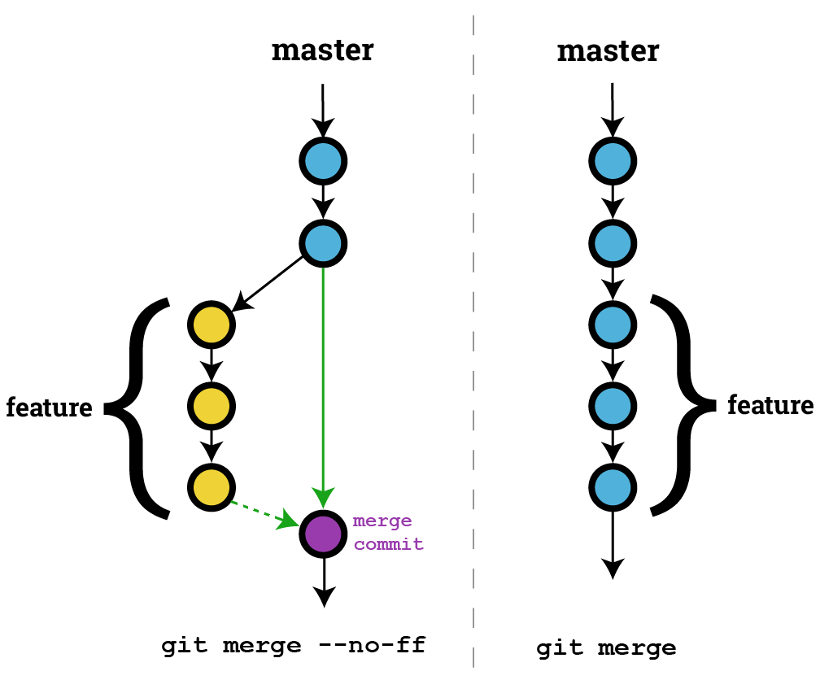
Merge fast forward

Basic branching strategy
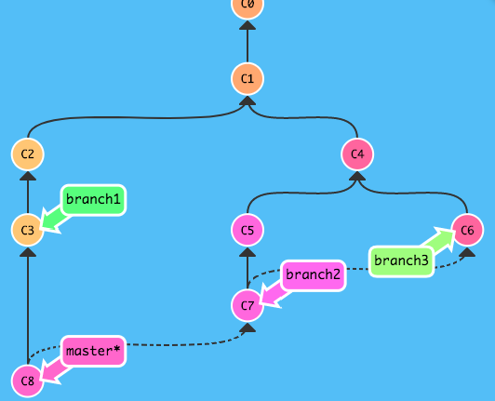
git merge branch2

• merge to
master
• pls delete
merged
branches

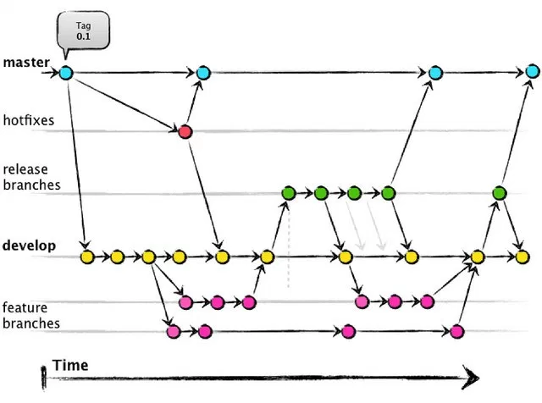

Gitflow

Cherry-pick 1/3.
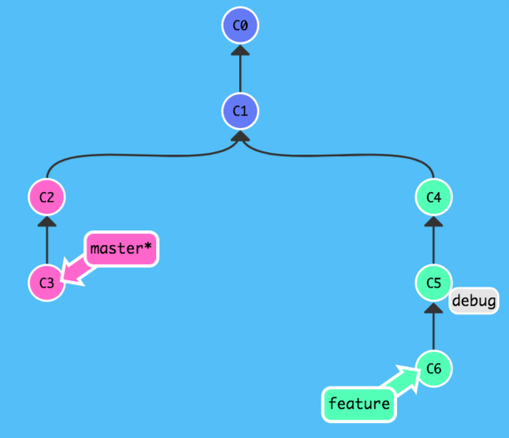

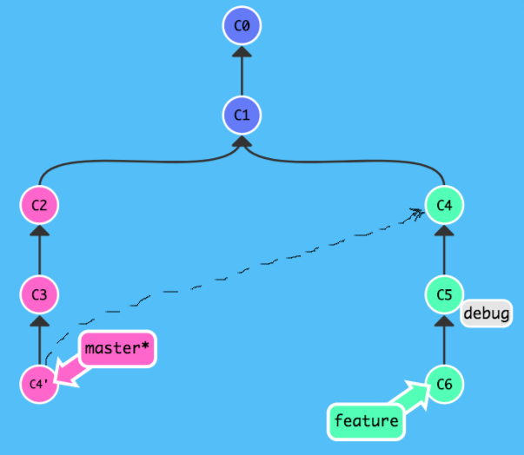
Cherry-pick 2/3.

git cherry-pick C4
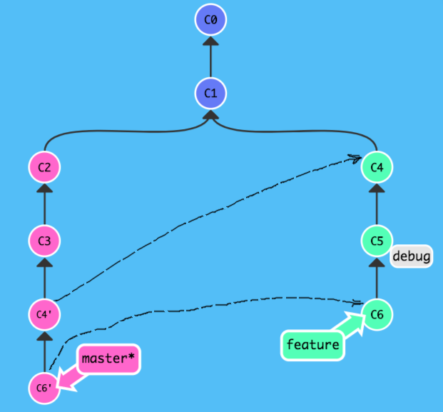
Cherry-pick 3/3.

git cherry-pick C6

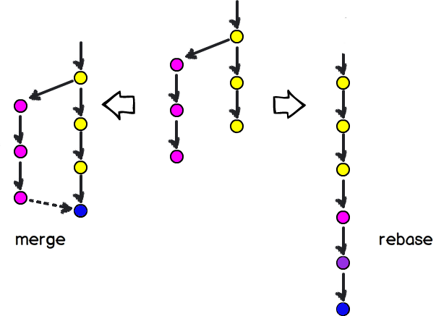
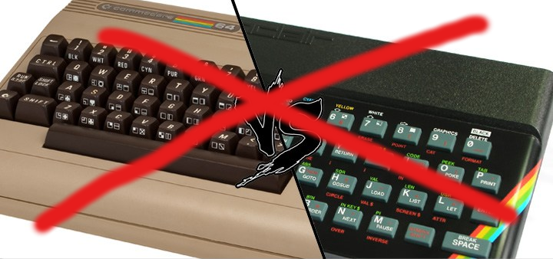
Merge vs Rebase
For more information: see internet




Survival pack

git status use often (it’s free)


learngitbranching.js.org

sudo apt install git \
tig gitk gitg ... meld



Start now

cd myprj ; git init



Start now

cd myprj ; git init

git status



