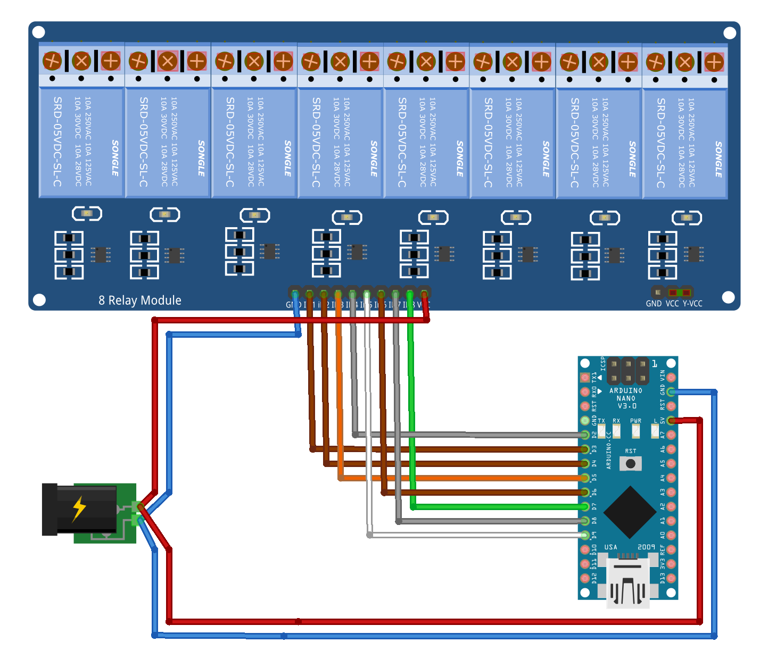
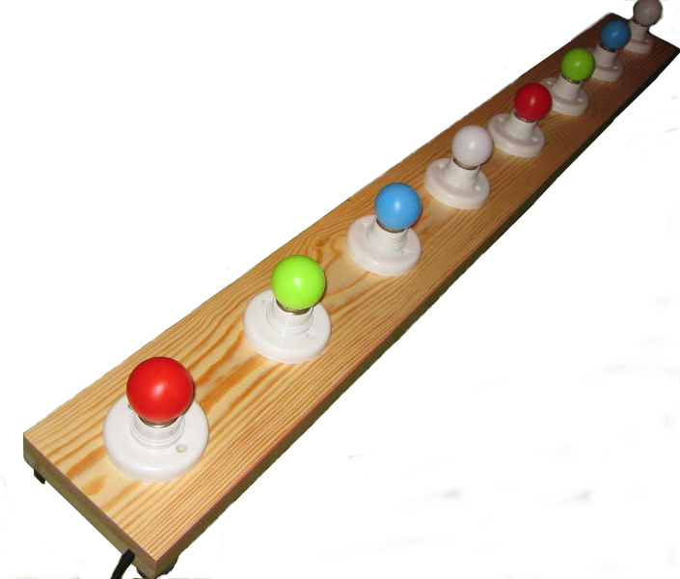
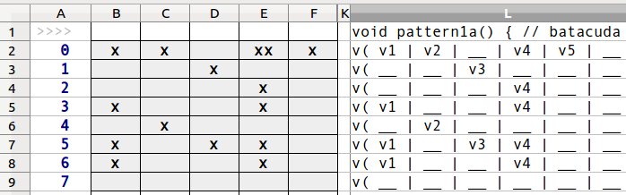
Light Organ – Batacuda
• Arduino Nano
• 8-relay module
• charger
• 8x led lamp
mut(w1);
m(0,0,0,r1|g1|b1|r2|g2|b2,w1|w2,0,0,0); upbeat1();
m(0,0,0,r1|g1|b1|r2|g2|b2,w1|w2,0,0,0); pattern1a();
m(0,0,0,r1|g1|b1|r2|g2|b2,w1|w2,0,0,0); pattern1a();
m(0,0,0,r1|g1|b1|r2|g2|b2,w1|w2,0,0,0); pattern1a();
m(0,0,0,r1|g1|b1|r2|g2|b2,w1|w2,0,0,0); pattern1b();
delay(600);
https://github.com/ern0/lightorgan-batacuda

spreadsheet-as-pattern-editor

texteditor-as-sequencer

