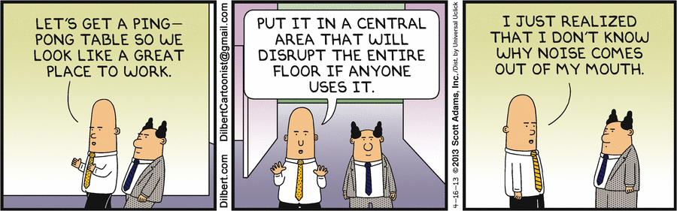
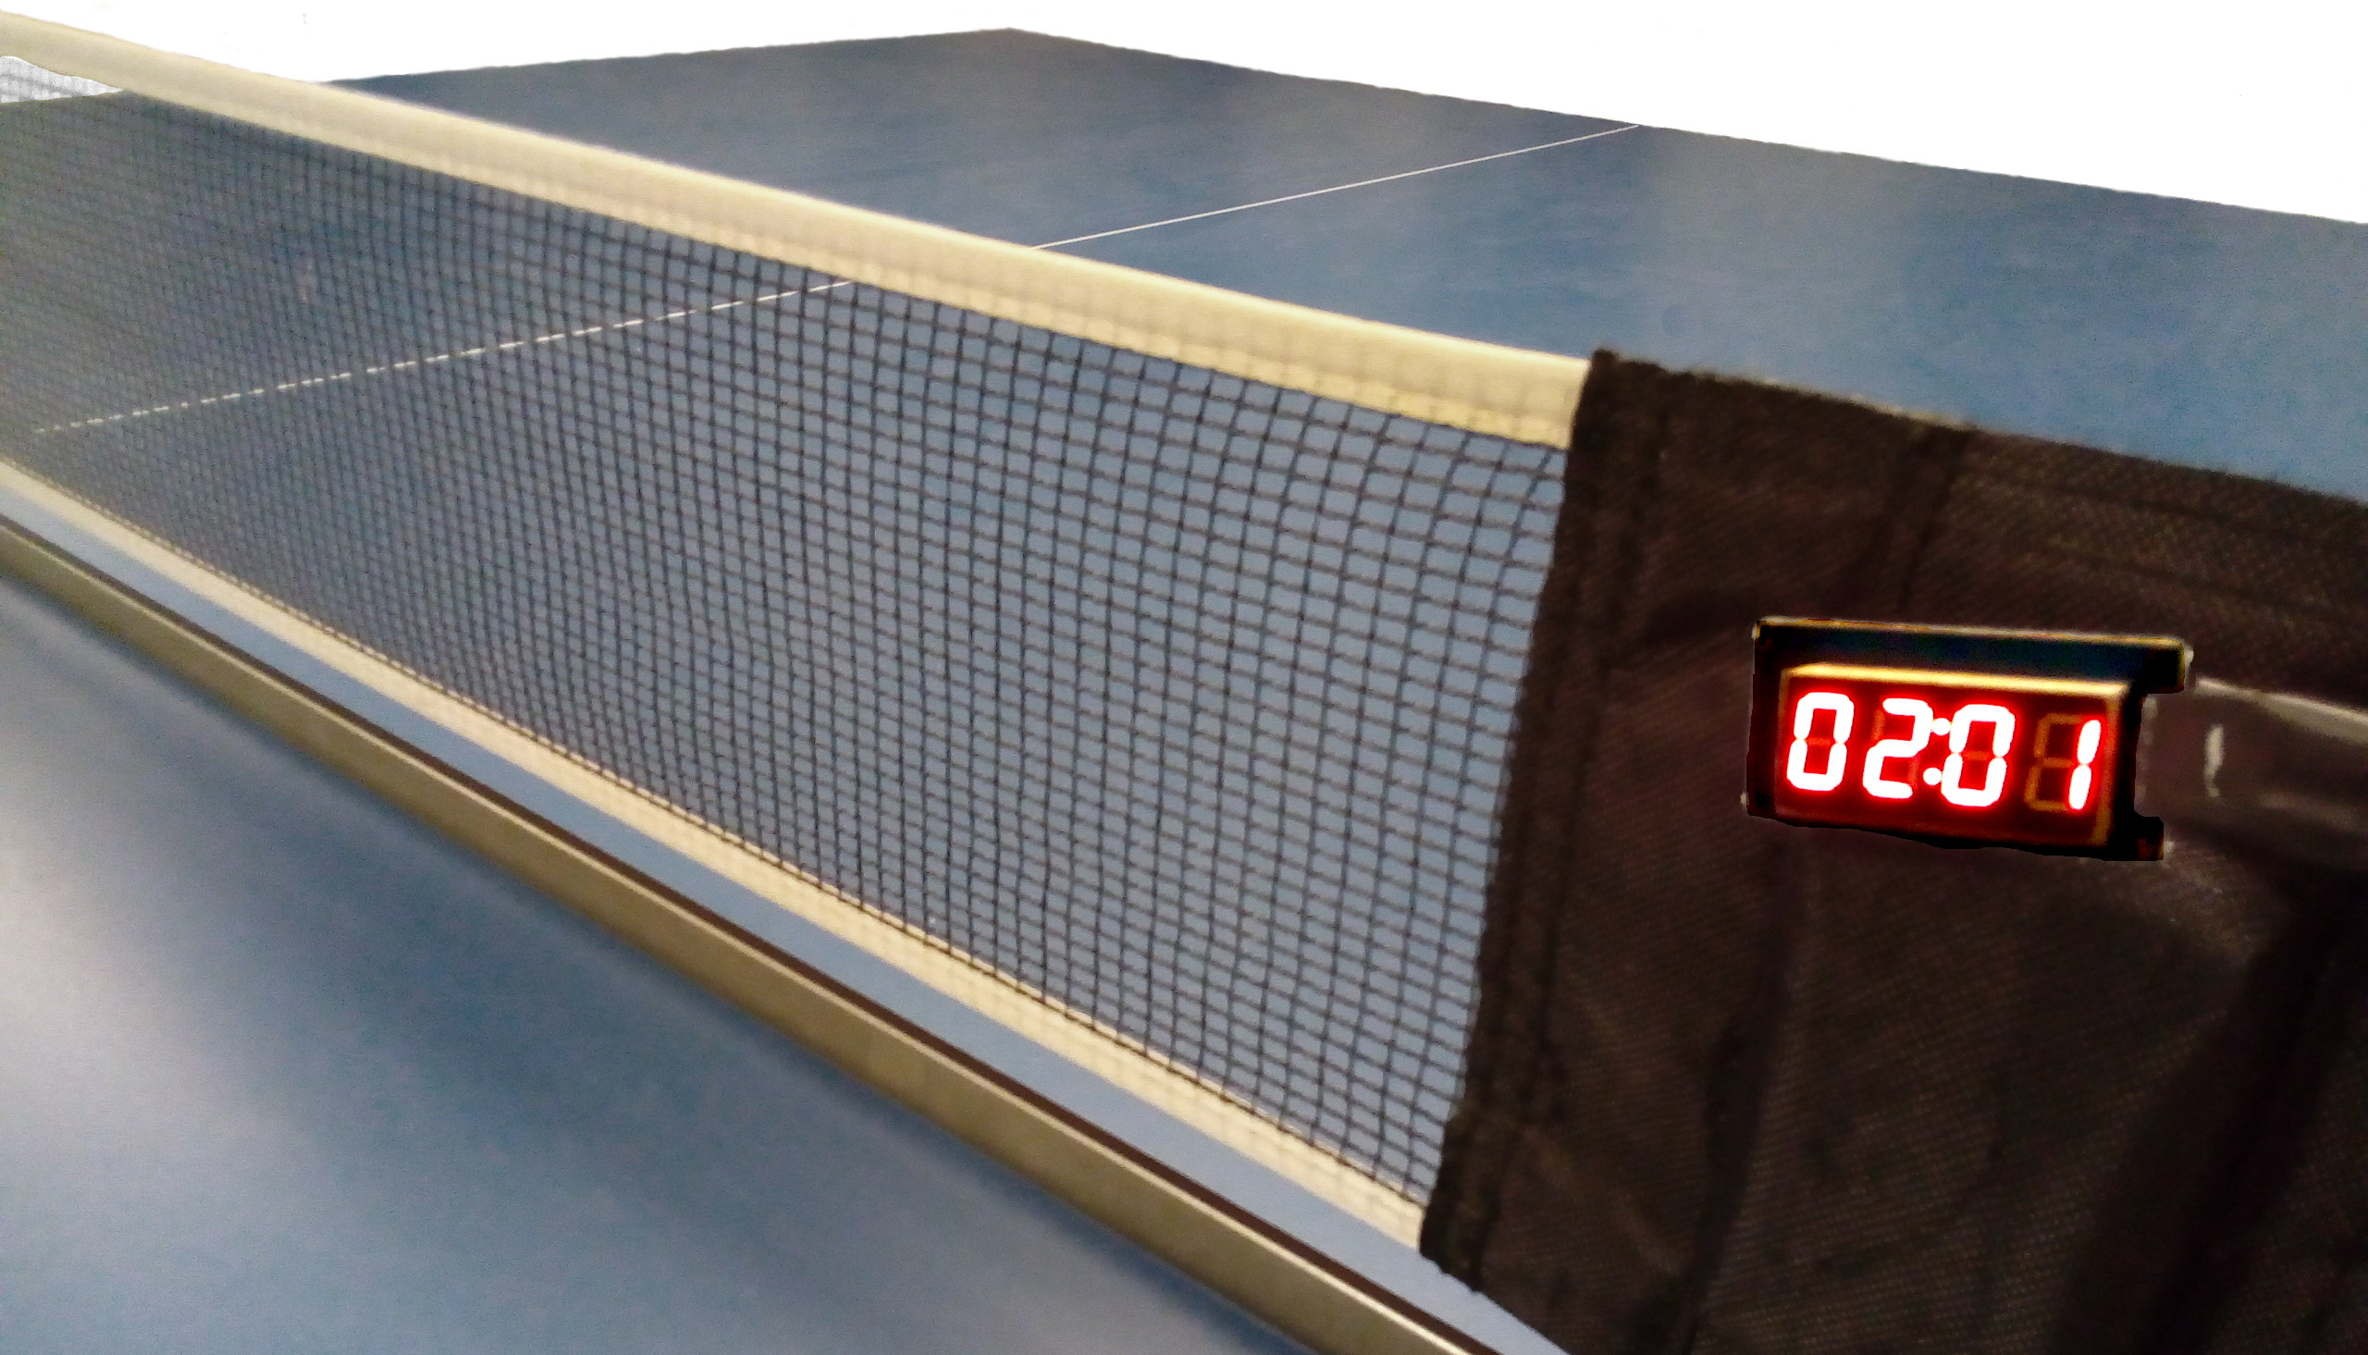
Table Tennis Counter
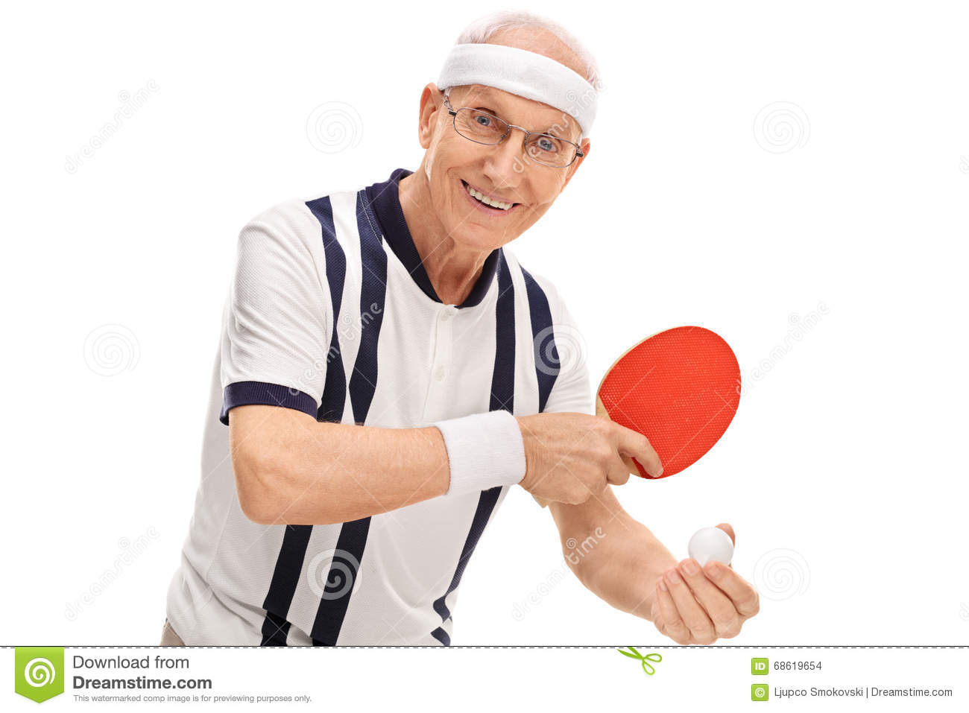
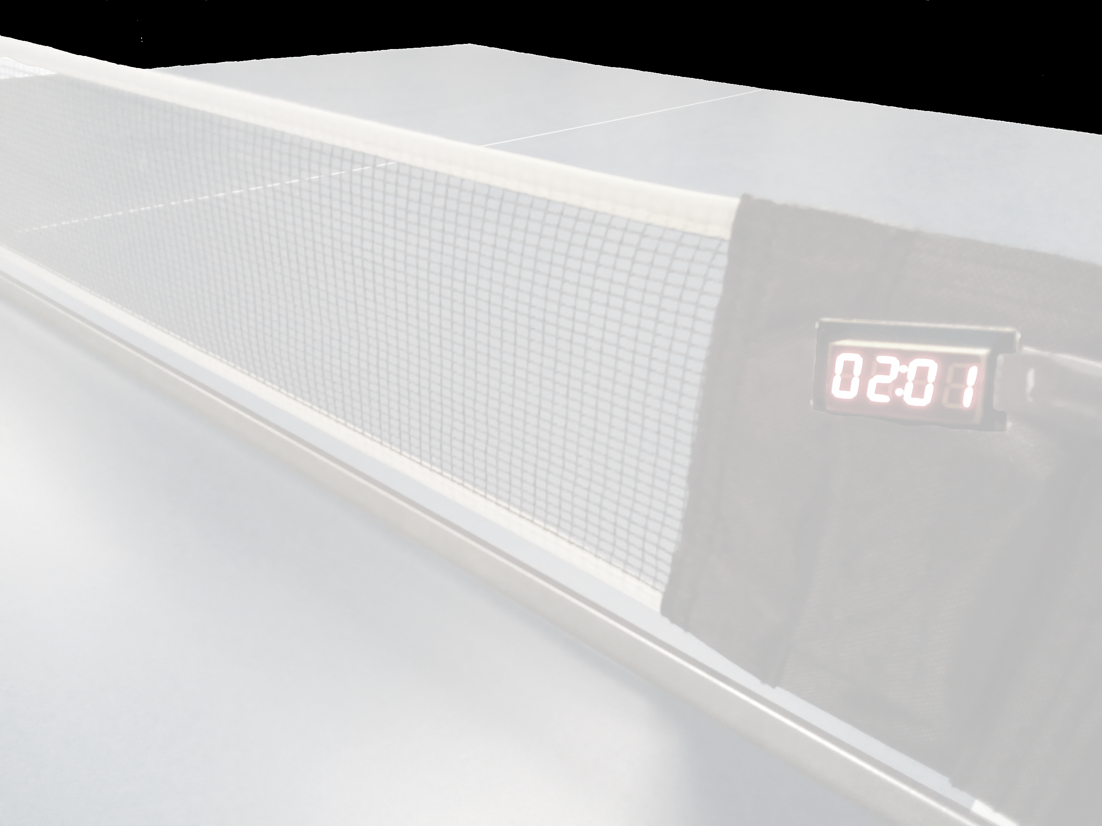
Problem



playing

counting


playing

counting

#firstworldproblems
Solution
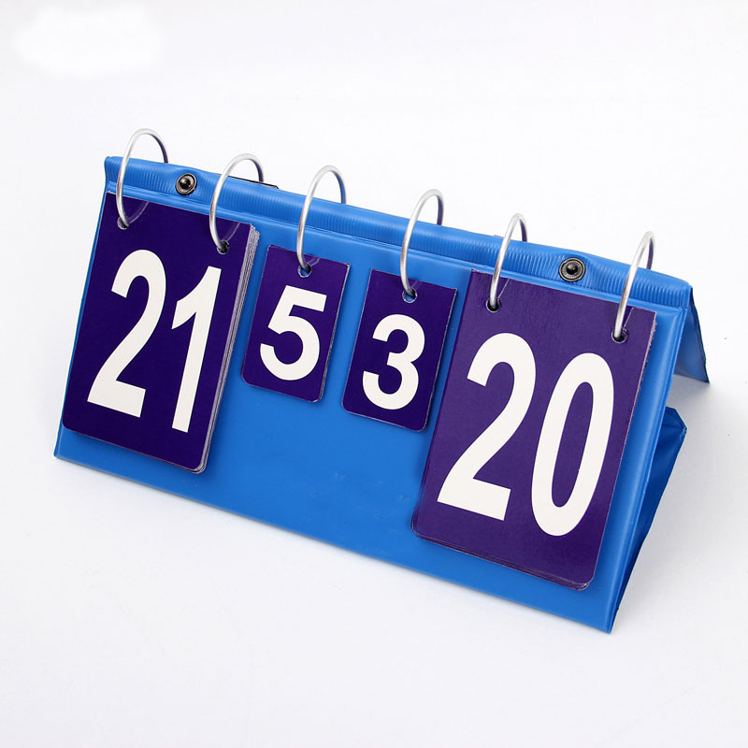

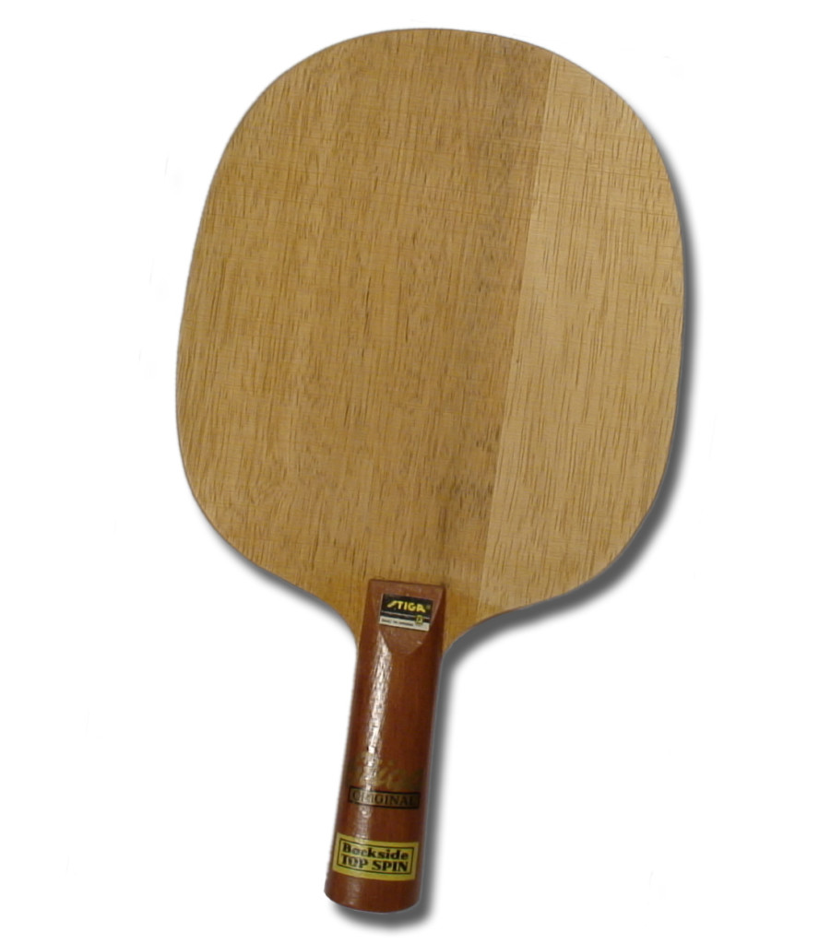
so 1922
Requirements
Requirements:

- hands free
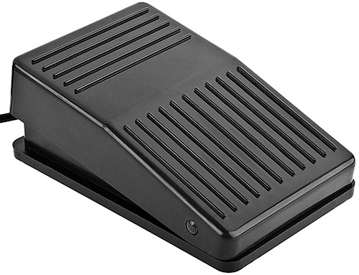
Requirements:

- hands free
Requirements:

- hands free
- serve change alert
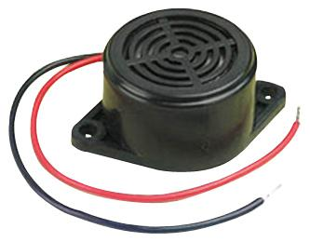
Requirements:

- hands free
- serve change alert
Requirements:

- hands free
- serve change alert
- display
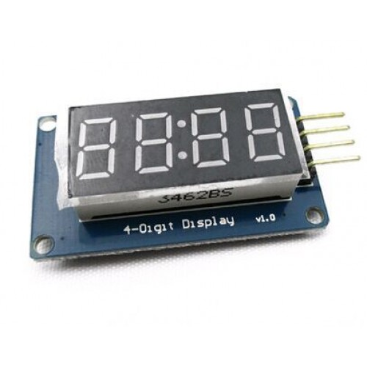
Requirements:

- hands free
- serve change alert
- display
Requirements:

- hands free
- serve change alert
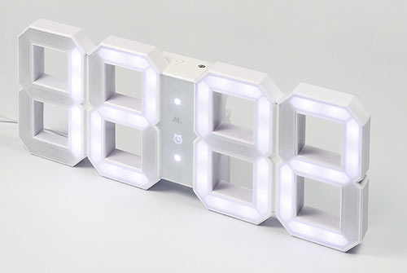
- display
Requirements:

- hands free
- serve change alert

- display
Requirements:

- hands free
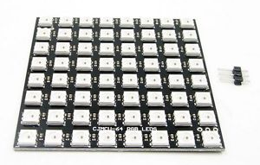
- serve change alert
- display
Installation
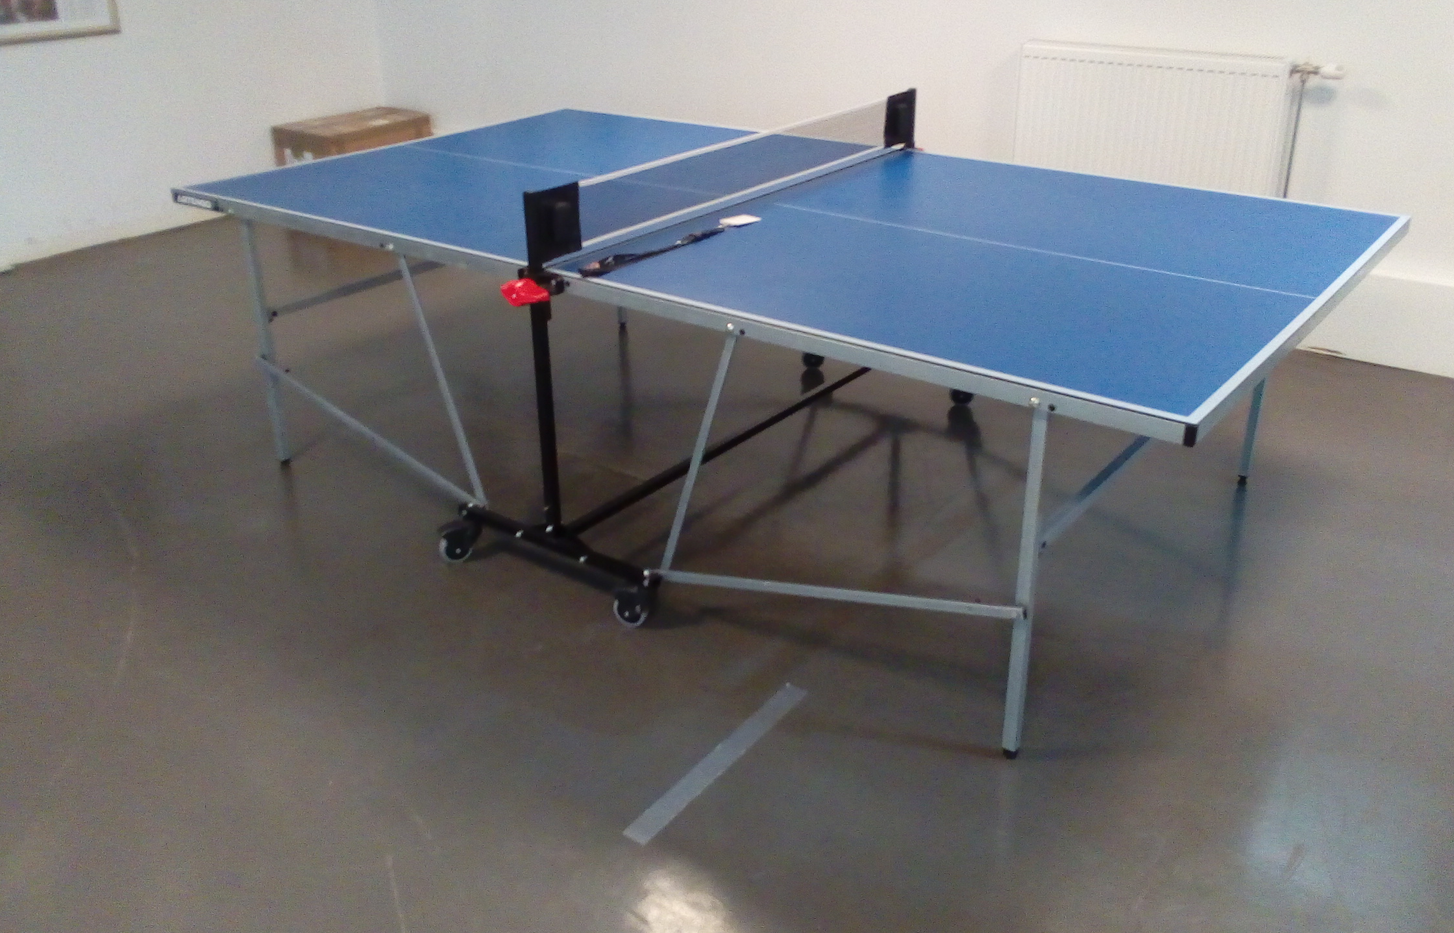
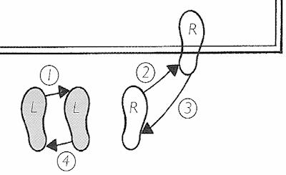
Installation
Installation – planning
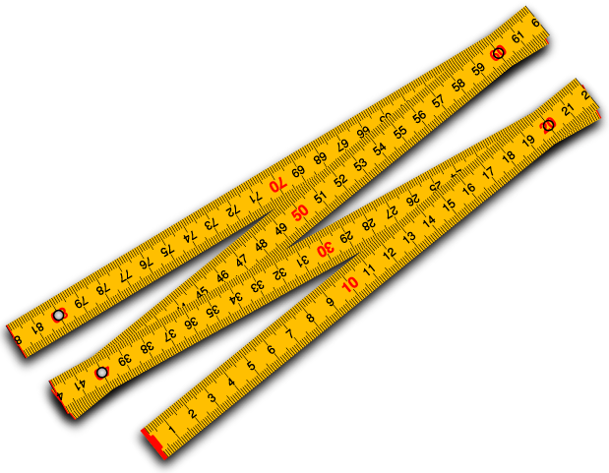
Installation
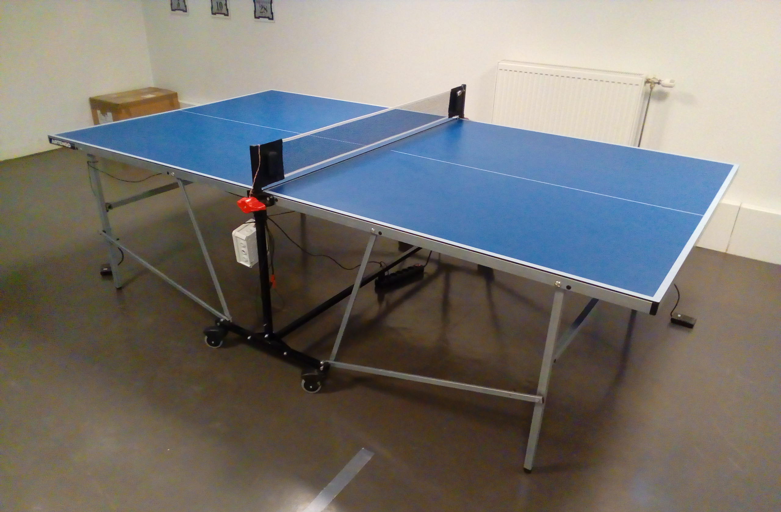
1. main unit
2. pedals
3
3
3. displays
1
2
2
Installation
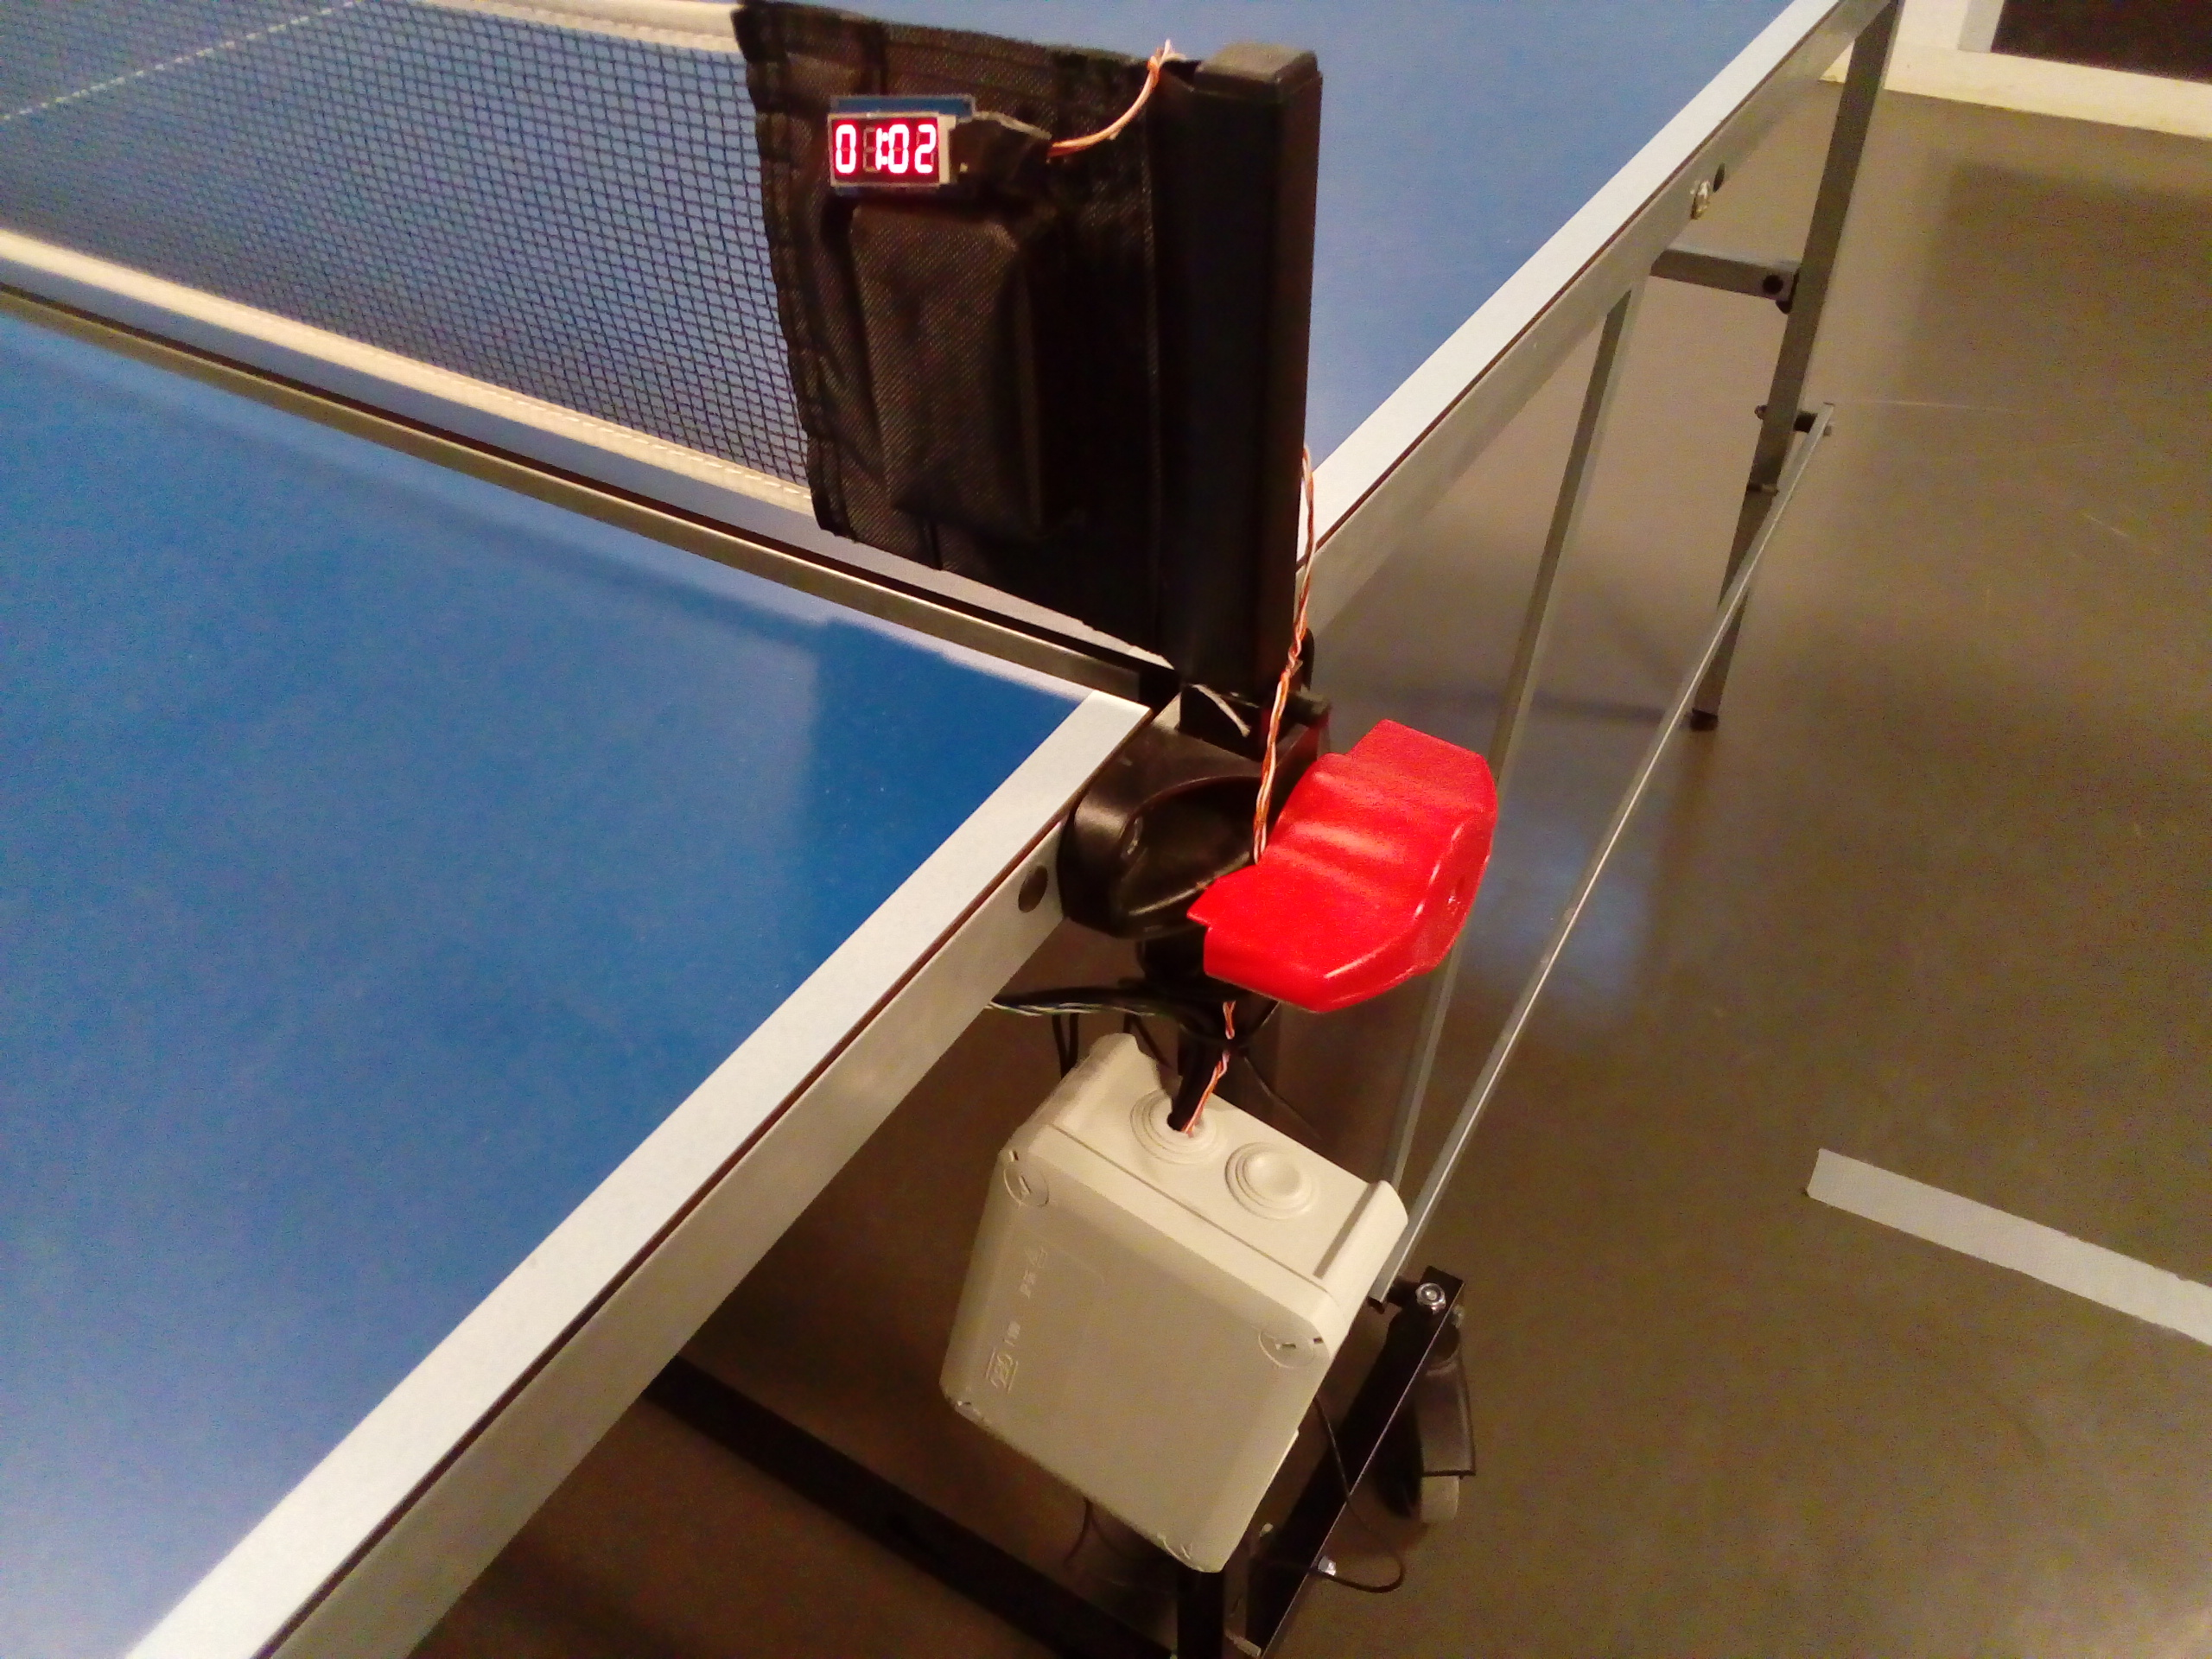
1. main unit
3
2. pedals
3. displays
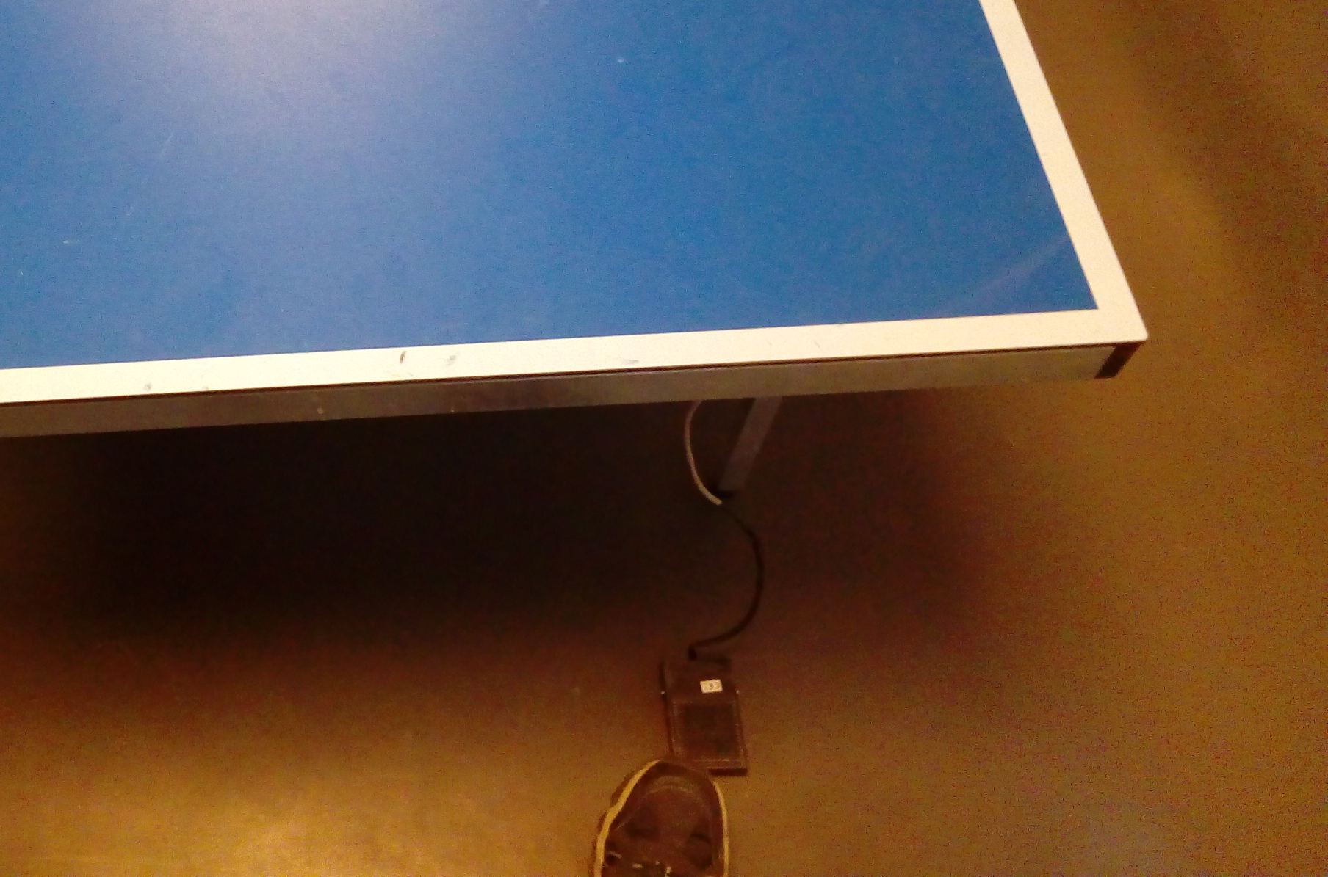
2
1
Hardware
Hardware – boxing

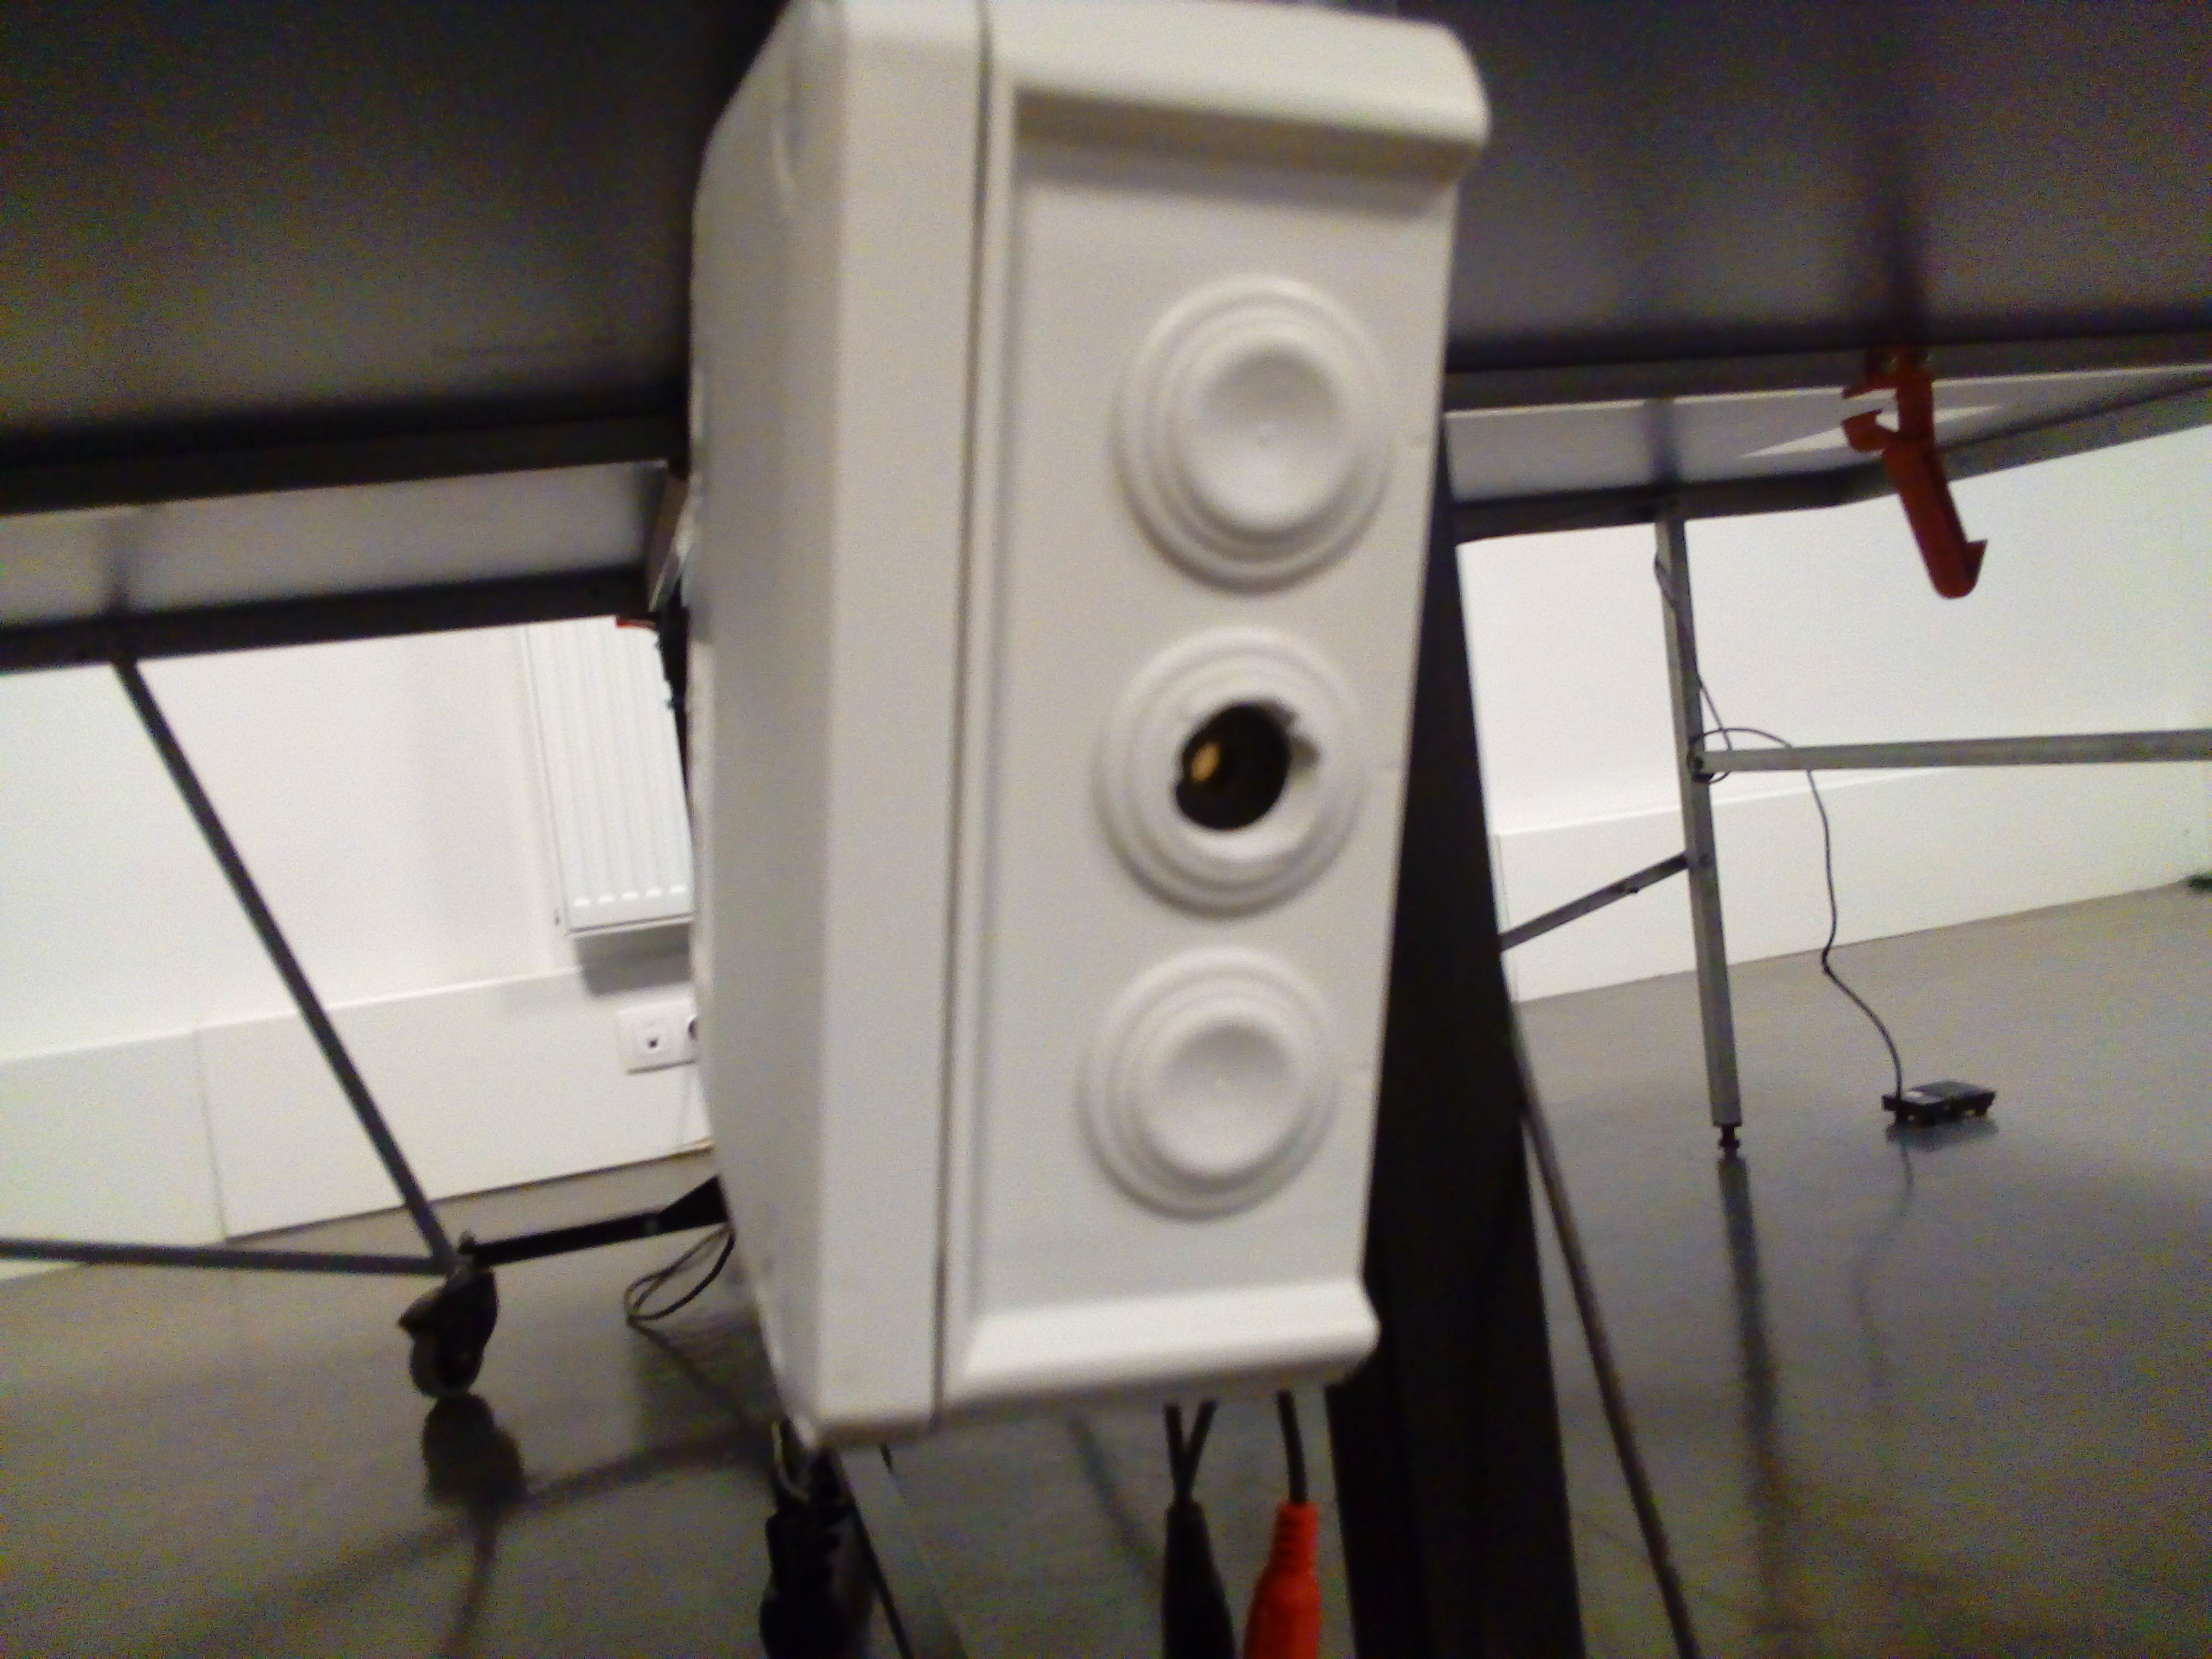
- std box
- power: micro USB
- pedals: 2x RCA
buzzer
Hardware – boxing

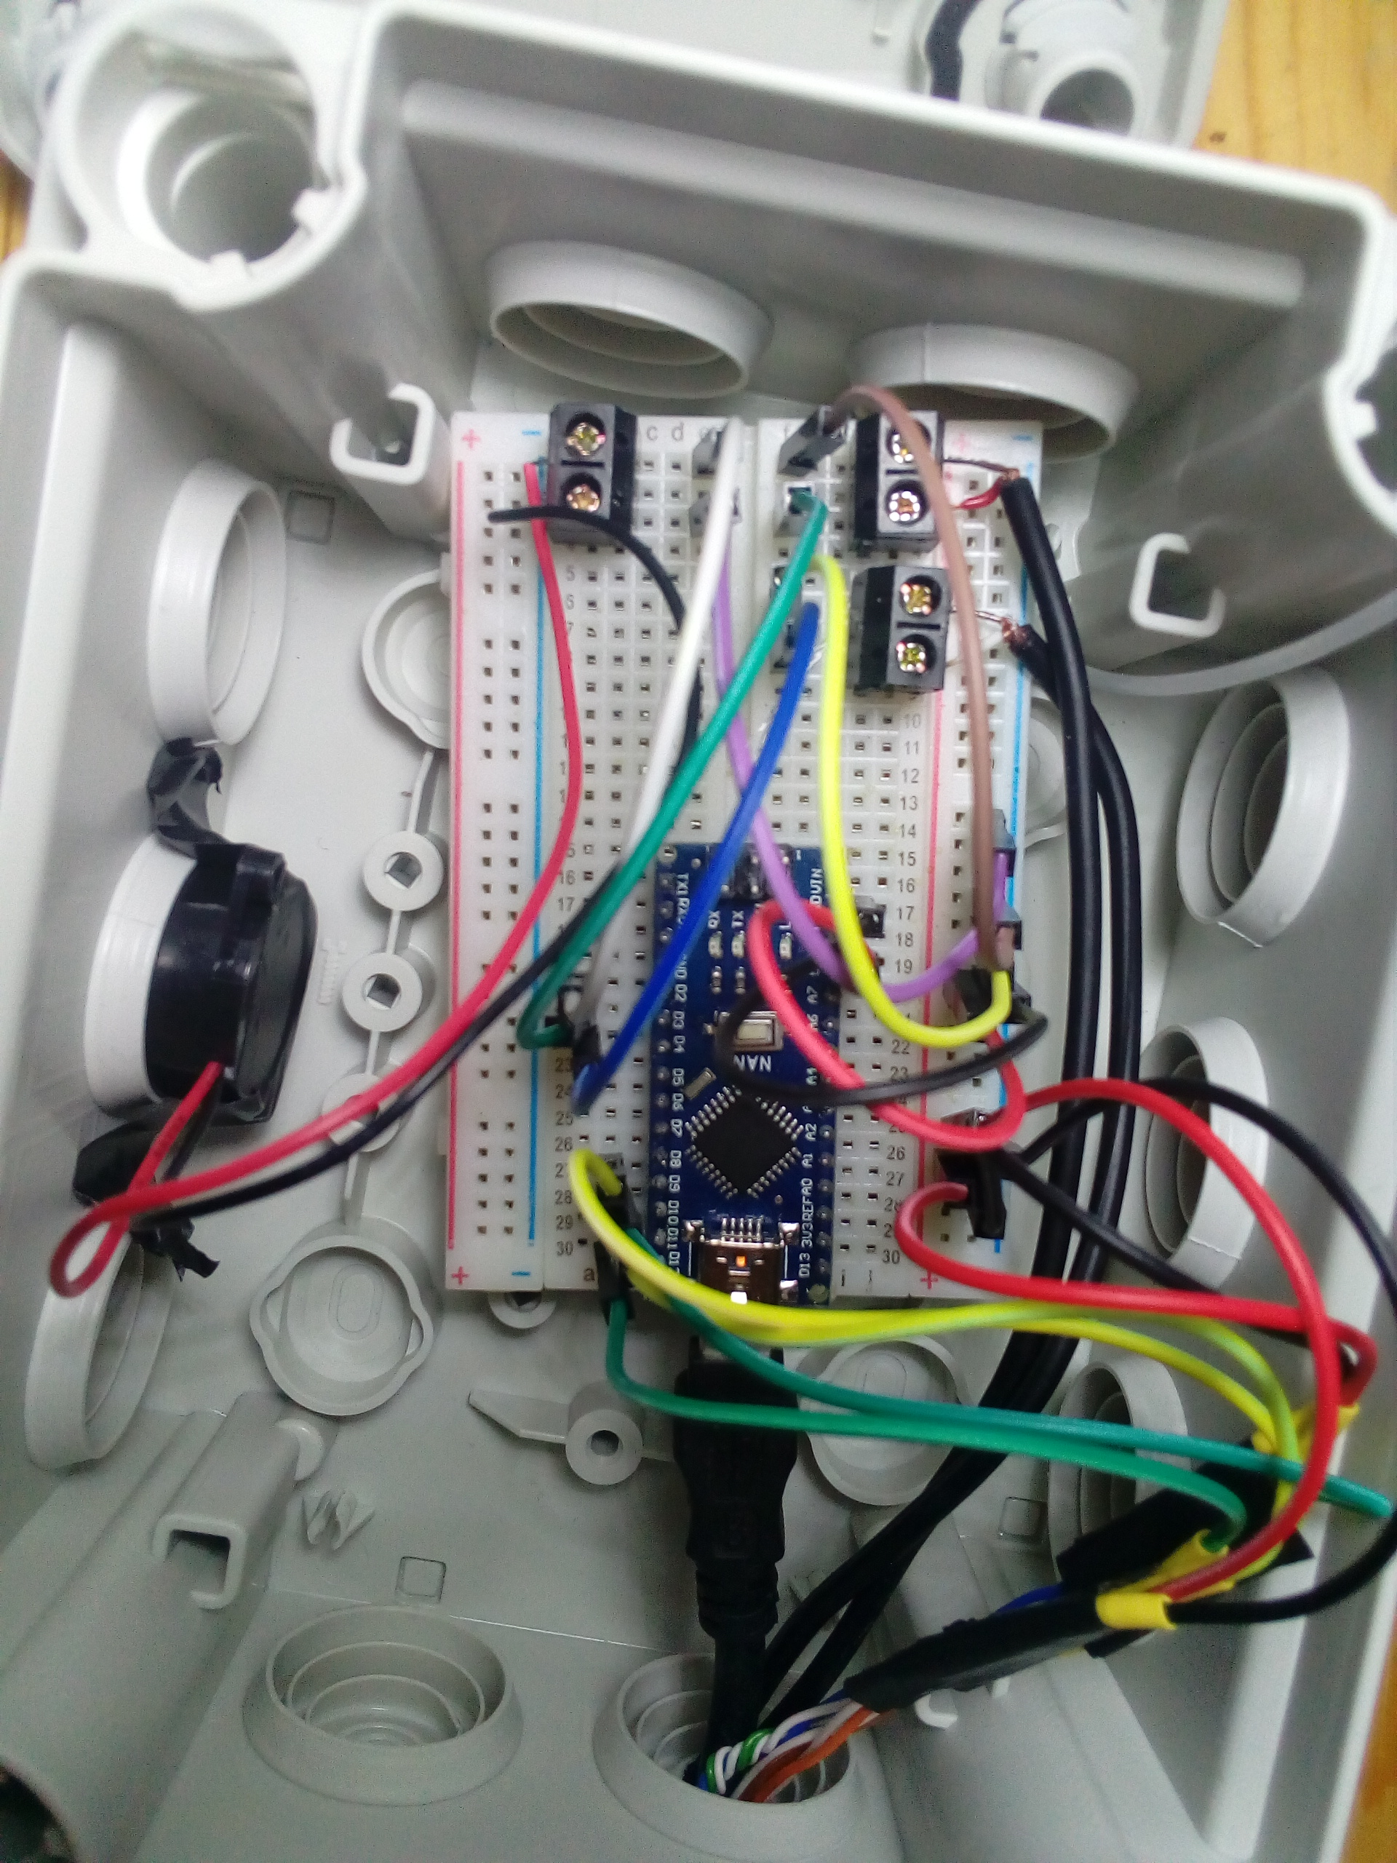
- Arduino Nano
Arduino Nano
- Internal pullup
resistors
buzzer
Hardware – schematics
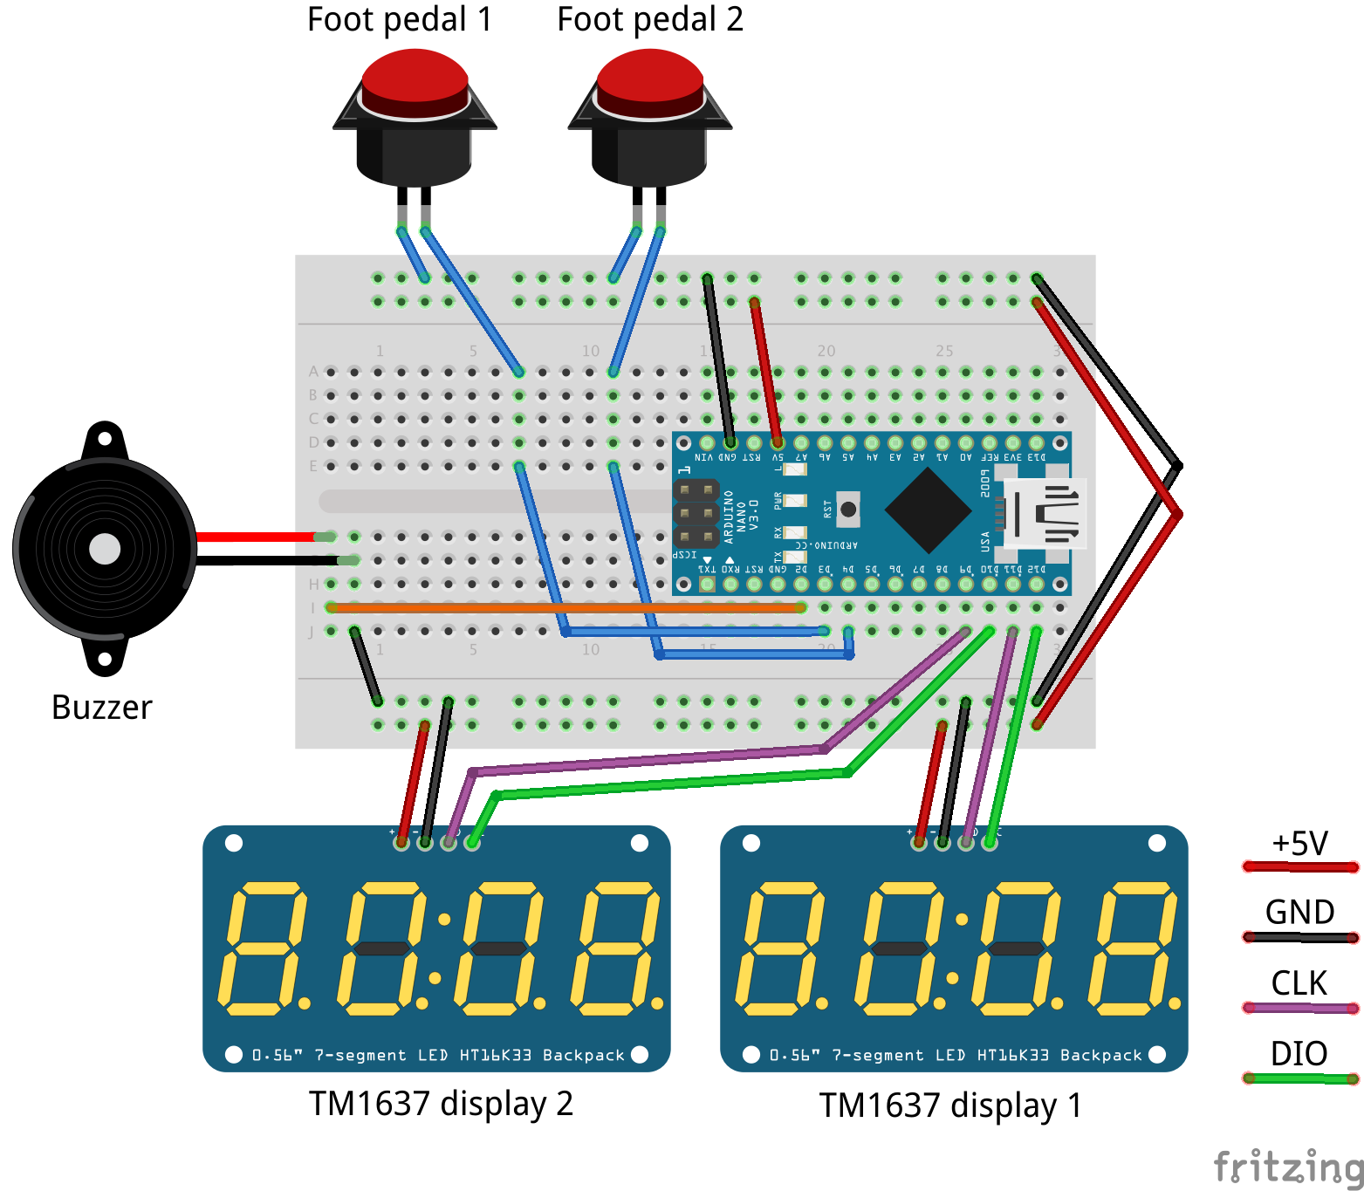
Software – UX


Control
Software – UX

Control:

- full functionality on single side

Software – UX

Control:

- full functionality on single side
- double click timing for foot
Software – UX

Control:

- full functionality on single side
- double click timing for foot
- restart match any time

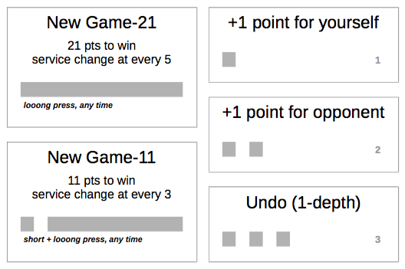
Software – UX
Software – UX

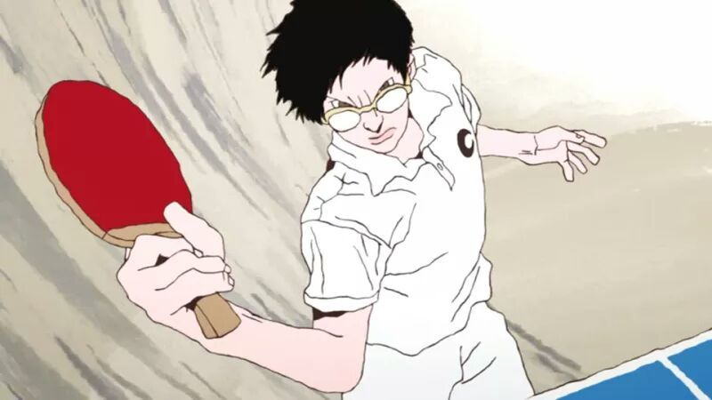
Display
Software – UX

Display:

- score only, no anim, no graphics

Software – UX

Display:

- score only, no anim, no graphics
- dim while setting score

Software – UX

Display:

- score only, no anim, no graphics
- dim while setting score
- end-of-match flashing

Software – UX

Buzzer

Software – UX

Buzzer:

- confirm pedal action
Software – UX

Buzzer:

- confirm pedal action
- serve side, serve change
Software – UX

Buzzer:

- confirm pedal action
- serve side, serve change
- end-of-match song

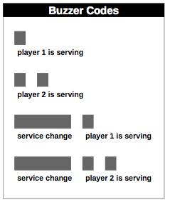
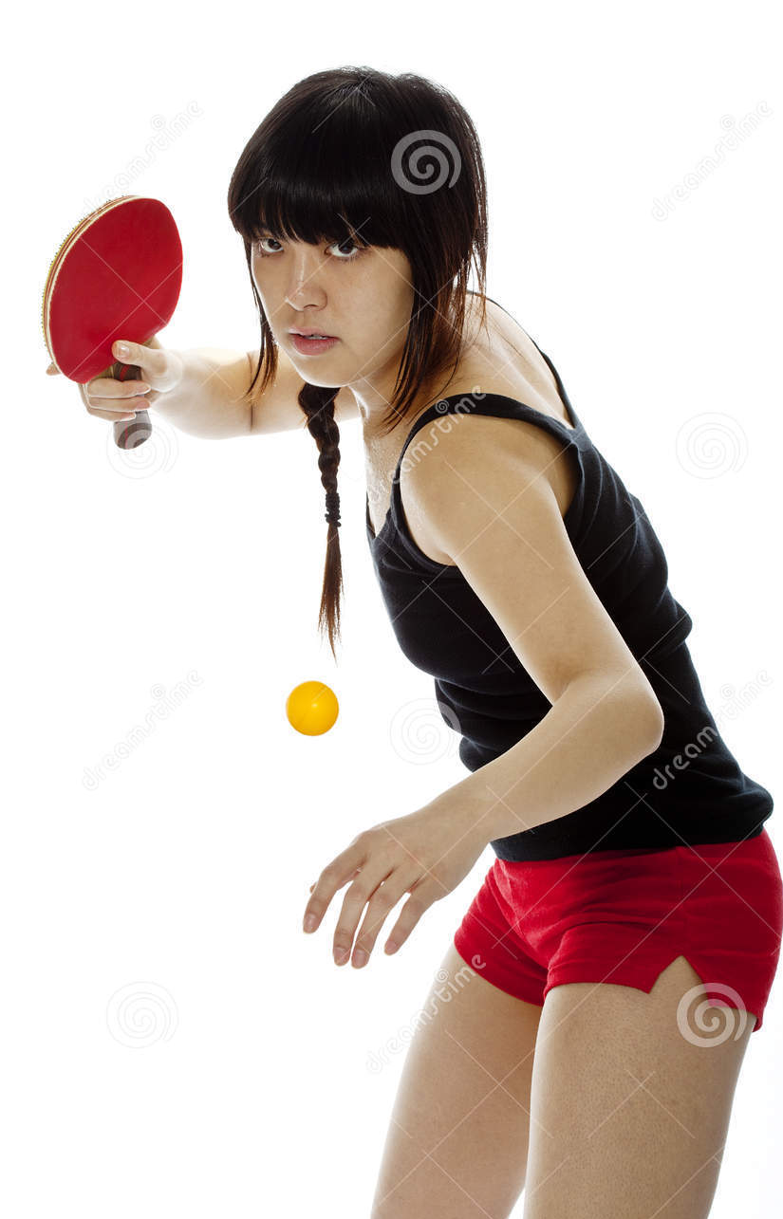
Software – UX
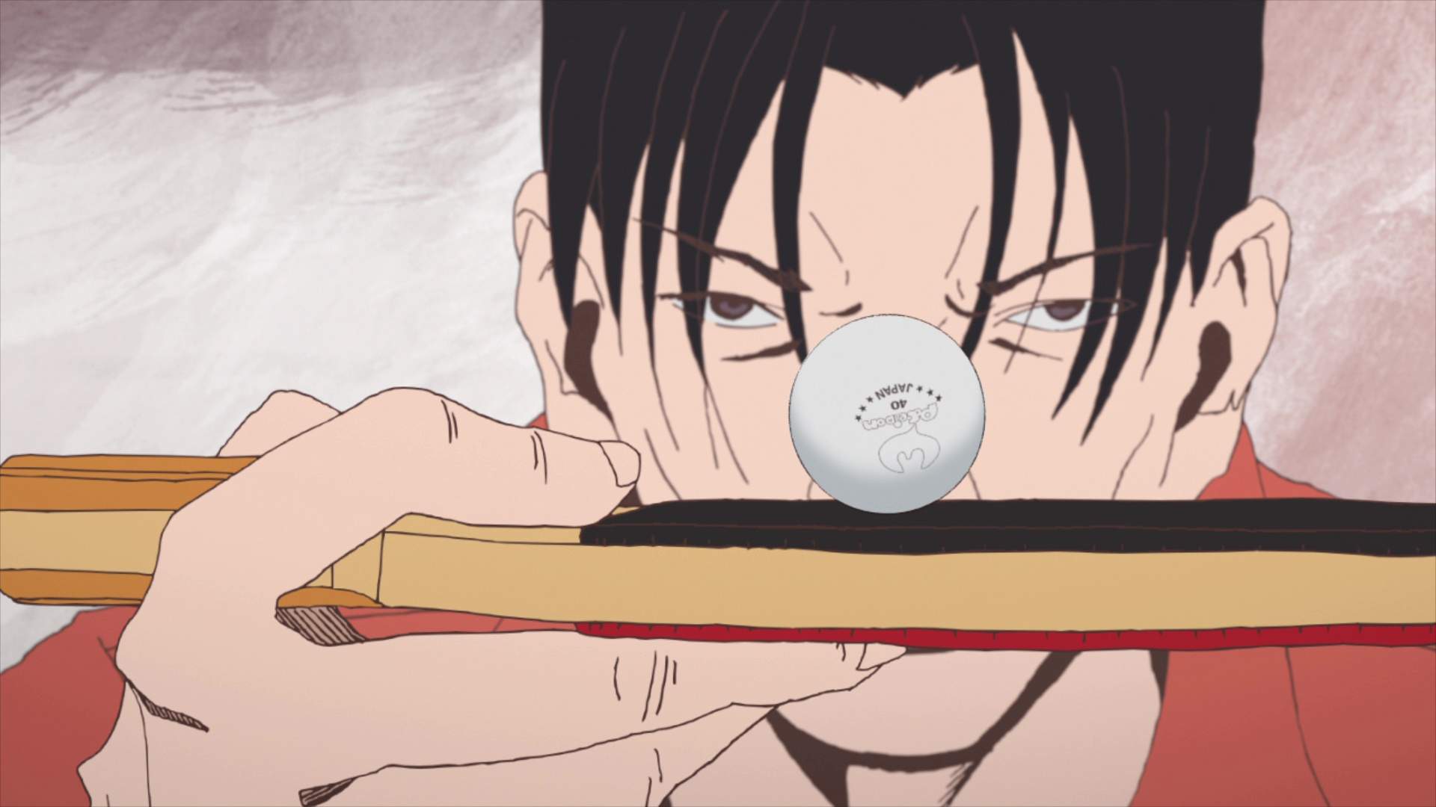
Questions
https://github.com/ern0/tabletenniscounter

- schematics
- gallery
- source code
- manual
https://github.com/ern0/tabletenniscounter
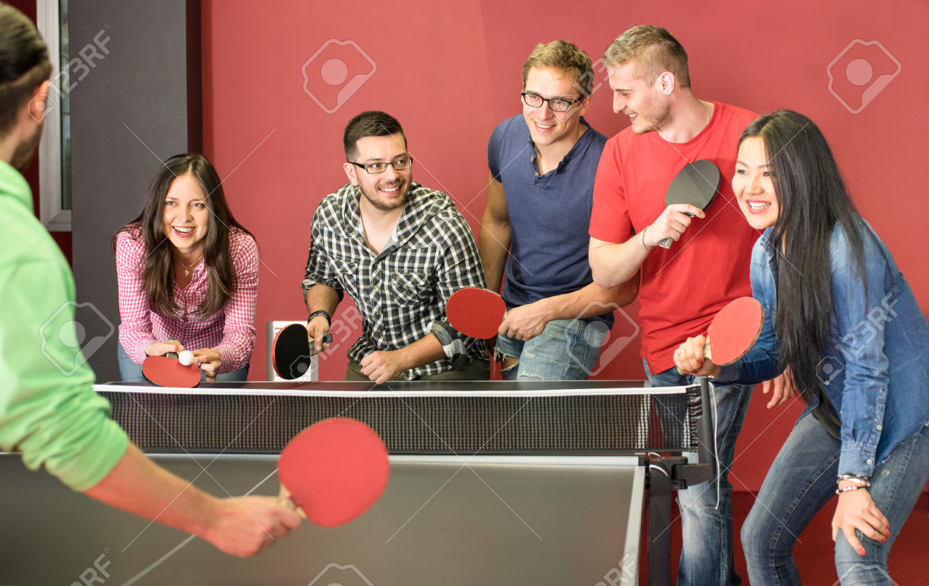
https://github.com/ern0/tabletenniscounter

