Freescale MQX RTOS Example Guide
Usb Audio Microphone Host Example
This document explains the USB Audio Microphone host example, what to expect from the example and a brief introduction to the USB audio host class.
The Example
The Demo application is used to control and communicate with USB Audio Microphone devices. It has the following main features:
- Identify the USB Audio Microphone device attached to it: The device belong to Class, sub class, number of interfaces it has, the audio characteristic the device supports …
- Control the USB Audio Microphone device: mute control.
- Record audio data received from USB audio microphone devices and store the data in a SD card in WAV format.
- The user controls the USB Audio Microphone host by commands. The commands are received from a terminal window console. The terminal window is also used to display message from the application.
Running the example

Application Connection
The following figure describes the topology of the application
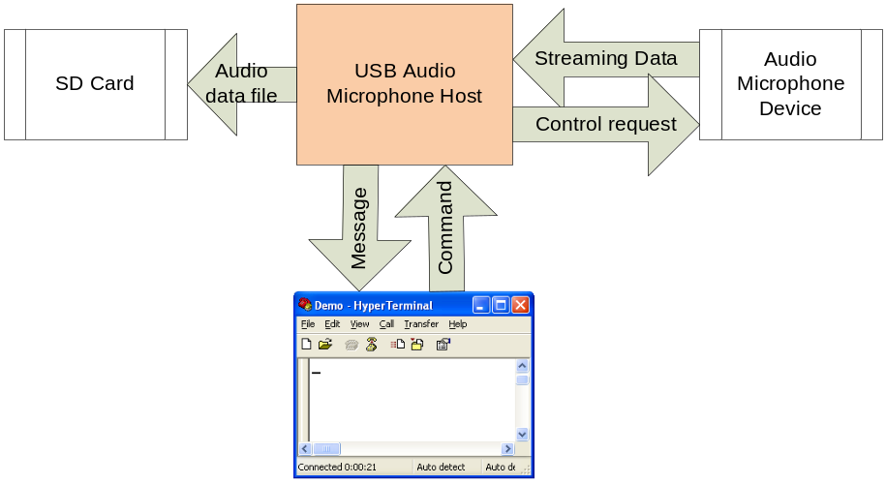

Application Topology
- The SD card is used to store wav audio files.
- The hyper terminal window is used to receive commands and display messages of the application. The USB Audio Microphone host communicates with the hyper terminal windows by a serial cable that connects the com port of the board with the PC.
- The USB Audio Microphone device is connected to the host by an USB cable. We can use a board and downloads the USB Audio Microphone project to the board to have the USB Audio Microphone.
- After the audio device is connected to the host, and successfully enumerated. The host can control the device and receive audio data stream from it.

Shell command
The Shell command module distribues a console to receive commands from users. After each command is received, the Shell command module calls the function correspond to the command.
List of commands used by the application :
Command | Syntax | Description
cd | cd directory | Change the working directory on the current drive to directory.
del | del filename | This command is used to delete a particular or more files.
dir | dir [drive:][path][filename] | List the contents of a directory.  If the dir command has no parameter, it will list the contents of current directory.
help | help 'command' | Help about a command.  If the help command has no parameter, it will list all the supported command and details of them.
mkdir | mkdir directory | Make a new directory
ren | ren filename newname | Rename a file
rmdir | rmdir directory | Remove a directory (delete a directory), by default the directories must be empty of files for the command to succeed
record | record [drive:][path][filename] [length] | Record an audio file with specified file name and length  - Drive : the drive used, this application uses drive « a »  - Path : path of the file  - File name : file name extension with « .wav »  - Length : length of the file in seconds
mute | mute | Switch between Mute on and Mute off state
? | ? | List of command supported

Command List of the Application
Example records an audio file named “song.wav” with 5s length:
Type this command to the terminal window
record a:\song.wav 5
Note that the song will have characteristics that suits with the USB Audio Microphone device connected to the host.
When you turn on the board these message are displayed
USB Host Audio Demo
Waiting for USB Audio Microphone Device to be attached...

Shell (build: Oct 19 2011)
Copyright (c) 2008 Freescale Semiconductor;
shell>
shell> SD card installed to a:
When you connect the Usb audio microphone device to the host, these messages are displayed
----- Audio control interface: attach event -----
State = attached Class = 1 SubClass = 1 Protocol = 0
----- Audio stream interface: attach event -----
State = attached Class = 1 SubClass = 2 Protocol = 0
----- Audio control interface: interface event -----
----- Audio stream interface: interface event-----
Audio device information:
- Device type : Microphone
- Frequency : 8000 Hz
- Bit resolution : 8 bits
- Number of channels : 1 channels
- Transfer type : Isochronous
- Sync type : No synchronization
- Usage type : Data endpoint
This audio device supports record audio files with these properties:
- Sample rate : 8000 Hz
- Sample size : 8 bits
- Number of channels : 1 channels
Type "record a:\filename.wav 5" to record the file with 5s length
When you type “record a:\filename.wav 5” command to record the song

shell> record a:\filename.wav 5
Audio file properties:
- Sample rate : 8000 Hz
- Sample size : 8 bits
- Number of channels : 1 channels
Recording...
When record has finished
Recording...done
Example connecting unsupported devices
Speaker:
----- Audio control interface: attach event -----
State = attached Class = 1 SubClass = 1 Protocol = 0
----- Audio stream interface: attach event -----
State = attached Class = 1 SubClass = 2 Protocol = 0
----- Audio control interface: interface event -----
----- Audio stream interface: interface event-----
Audio device information:
- Device type : Speaker
- Frequency : 8000 Hz
- Bit resolution : 8 bits
- Number of channels : 1 channels
- Transfer type : Isochronous
- Sync type : No synchronization
- Usage type : Data endpoint
The device is unsupported!

