
1.0
May 17, 2012
USB Audio Speaker Host Specification
Abstract:
Provide a one-sentence summary of the contents of this document and indicate the customer if requested
USB Audio Speaker Host for MQX OS or Bare Metal.
Keywords:
Keyword 1, keyword 2, …, keyword n
USB, Host, PHDC, MQX, SDS
© Copyright 2011, Freescale Semiconductor, Inc.
All rights reserved. Presence of a copyright notice is not an acknowledgement of publication.

APPROVED:
Author | Sign-off Signature 1 | Sign-off Signature 2 | Sign-off Signature 3
Nguyen Quoc Minh
Sign-off Signature 4 | Sign-off Signature 5 | Sign-off Signature 6
The required sign-off signatures will be determined on a per project basis. The author will be required to modify the title page to include signatures necessary for sign-off.

REVISION HISTORY
Version | Date | Author | Change Description
1.0 | May 17, 2012 | Nguyen Quoc Minh | Initial Creation

Table of Contents
1 Introduction 1
1.1 Purpose 1
1.2 Scope 1
1.3 Demo Overview 1
1.4 Audience Description 1
1.5 Definitions, Acronyms, and Abbreviations 1
1.6 References 2
2 Demo Application Functionalities 3
3 Application Architecture 4
3.1 Application layer 4
3.2 Application Library layer 5
3.3 MQX Core Layer 5
3.4 Hardware Layer 5
4 Application Block Diagram 6
4.1 Shell command 6
4.2 File Manipulation 7
4.3 Audio Data Manipulation 8
4.4 USB Audio Host Service 8
5 Operation Description 10
5.1 Play and Pause Command 10
5.2 Mute,Up and Down Command 11
5.3 Audio Characteristics 12
5.4 Application Topology 12

Introduction

Purpose
This section shall identify the overall purpose of this document.
For design, it is usually to describe a specific portion of the software structure.
For example: If you are designing the caller id feature from ground-up, then the purpose of your document is to describe the caller id feature design. Likewise, if you are making changes to the existing caller id feature, then your purpose is to describe the changes (either all or ones of major consequence) to the caller id feature because of whatever reason.
This document describes the software specification for the USB Audio Speaker Host Demo.

Scope
This document is written for the MQX environment, covers the audio class design for the KHCI Host controller interface.
The USB Audio Speaker Host Demo supports identifying and communicating with the USB Audio Speaker.

Demo Overview
The Demo application is used to control and communicate with USB Audio Speaker. It has the following main features:
- Identify the USB Audio Speaker device attached to it: The device belong to Class, sub class, number of interfaces it has …
- Control the USB Audio Speaker device: Mute, volume.
- Play audio wav files in SD card and transfer audio data to the USB Audio Speaker device, the sound then can be head from the device.
This section shall identify the scope of this document.
The scope reflects what will be included in the design and what will not be included. This is generally a one or two sentence description which may be bullet points for specific understanding.
For example: If you are describing design changes of major consequence to the caller id feature, then an example of a scope statement is:
“This document addresses the xyz change to the caller id feature and how it affects the inputs and outputs, entry and exit criteria, of the caller id feature and the initialization and shutdown, etc... of the handset.....”
Elaborating on what is not included is also a good idea.

Audience Description
The audience for this document is all people involved in developing, testing and integrating the low level hardware driver, including Developers, Integrators, Testers.

Definitions, Acronyms, and Abbreviations
All non-standard terms, acronyms and abbreviations that are unique to this document should be included in this section. References to other appendices or reference documents may be included. Index information should be in bold.
IEEE – Institute of Electrical and Electronics Engineers
FRD – Feature Requirements Document
SRD – System Requirements Document
PRD – Product Requirements Document
MRS – Marketing Requirements Specification
Also see IEEE Std 1002-1987, IEEE Standard Taxonomy for Software Engineering Standards

Term / Acronym | Definition
API | Application Programming Interface
COM | Communication
KHCI | Host Controller Interface
PC | Personal Computer
PCM | Pulse-Code Modulation
PWM | Pulse-Width Modulation
ROM | Read-Only Memory
RTOS | Real Time Operating System
SDS | Software Document Specification
USB | Universal Serial Bus

References
Serial No | Document Name | Version
1 | Universal Serial Bus specification | 2.0
2 | Universal Serial Bus Device Class Definition for Audio Device | 1.0
3 | FSL_USB_HOST_AUDIO_CLASS_DEVELOPMENT API function reference v1.0 | 1.0

Demo Application Functionalities
The Demo application is used to control and communicate with USB Audio Speaker devices.
USB Audio Speaker devices are supported in this demo have following characteristics:
- Basic topology:
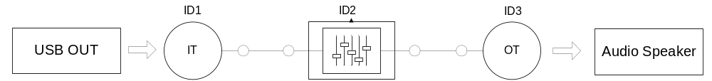
Figure 2-1: Supported Device Topology
- Support audio data resolution: 8 bits, 16 bits.
- Sampling frequency: 48kHz, 44kHz, 32 kHz, 22kHz, 16kHz, 11 kHz and 8 kHz.
- Support HID interface to provide functionality for the associated HID controls.
The demo has the following main features:
- Identify the USB Audio Speaker device attached to it: The device belong to Class, sub class, number of interfaces it has, the audio characteristic the device supports …
- Control the USB Audio Speaker device: mute and adjust volume.
- Play audio wav files stored in SD card and transfer audio data to the USB Audio Speaker device, the sound then can be head from the device.
- The audio files are stored in SD card and in wav format.
- The user controls the USB Audio speaker host by commands. The commands are received from a terminal window console. The terminal window is also used to display message from the application. If the audio speaker has HID interface, the user can control USB Audio speaker host by this interface, too.

Application Architecture
The architecture of the application is in the following figure.
USB Audio Speaker Application

USB Host library
MQX library
USB Hardware Controller
Hardware
Application Libraries
Application
MFS Library
Shell Library
Audio Class
USB Audio Host Service
Files Manipulation
Shell Commands
Audio Data Manipulation
MQX Core
HID class
Figure 3-1: Architecture of the USB Audio Speaker Application
The following sessions describe the layers of the application stack.

Application layer
The application layer has the following module:
- Audio data manipulation:
This module parses the wav audio data file and manipulates the audio data. The application supports wav files with the characteristics:
  - Support sample frequencies: 48kHz, 44kHz, 32 kHz, 22kHz, 16kHz, 11 kHz, 8 kHz
  - Support stereo and mono audio
  - Support sample bit number: 8, 16
- USB Audio host service:
The USB Audio host service supports detect the USB Audio speaker, get the device information and communicate with the device through USB protocol.
The USB Audio host service also supports detect the HID interface, get the HID interface information and get control commands from the device through USB protocol.
- File manipulation:
This module reads and gets information of audio files stored in SD card; the audio data file then can be send to the Audio data manipulation module for further processing.
- Shell command:
This module reserves commands from user. The user type commands to console terminal to control the device.
The USB audio speaker host uses following commands:
“cd”, “del”, “dir”, “help”, “mkdir”, “ren”, “rmdir”, “play”, “pause”, “mute”, “up”, “down” and “?” .

Application Library layer
This layer distributes some libraries that are available in MQX. This application uses following application libraries:
- USB host library:
The USB audio speaker host uses audio class in USB host library to communicate with the audio speaker device. The Audio class implements USB API functions that are specified for the audio devices.
The USB audio speaker host uses USB host library to get requests from USB audio speaker device if the device has HID interface.
- MFS library:
The MFS library distributes functions to read and write files. The MFS library supports formatting the volume to FAT format and operates in that format.
- Shell library:
This library support processing commands from user, the user types command to the console terminal to control the device. The shell library distributes some standard commands and prototype commands for extension specific application commands.

MQX Core Layer
- The MQX core has the role to access and control the hardware, the MQX core impliment RTOS task such as manager tasks, memory, initialize the MQX kernel, ...

Hardware Layer
- This is the physical layer that impliment tasks of the application. This layer is the hardware resources that can run the MQX RTOS.

Application Block Diagram
The following figure describes block diagram of the application
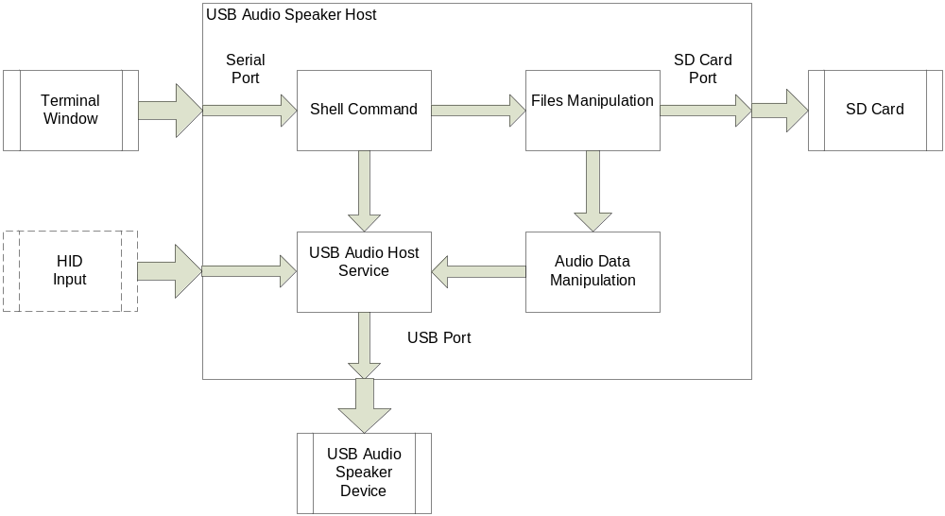
Figure 4-2 Application Block Diagram
The following subsection will describe details about each module.

Shell command
The Shell command module distribues a console to receive commands from users. After each command is received, the Shell command module calls the function correspond to the command.
List of commands used by the application :
Command | Syntax | Description
cd | cd directory | Change the working directory on the current drive to directory.
del | del filename | This command is used to delete a particular or more files.
dir | dir [drive:][path][filename] | List the contents of a directory.  If the dir command has no parameter, it will list the contents of current directory.
help | help 'command' | Help about a command.  If the help command has no parameter, it will list all the supported command and details of them.
mkdir | mkdir directory | Make a new directory
ren | ren filename newname | Rename a file
rmdir | rmdir directory | Remove a directory (delete a directory), by default the directories must be empty of files for the command to succeed
play | Play filename | Play an audio file with a file name
pause | pause | Switch between playing and pausing state
mute | mute | Switch between Mute on and Mute off state
up | up | Increase volume
down | down | Descrease volume
? | ? | List of command supported

Table 4-1 Command List of the Application

File Manipulation
The MFS library distributes functions to read and write files. The MFS library supports formatting the volume to FAT format and operates in that format.
The file manipulation module uses MFS libraries to manipulate audio files stored in SD card. After an audio file is read, the data of audio file then can be sent to the audio data manipulation module for further processing.
The file manipulation module also implements SD card tasks to manage the SD card such as detecting the SD card plugged in, installing the file system …
When and SD card is inserted in, the SD card tasks do the following:
- Open the lower-layer device.
- Optionally install the partition manager on the device.
- If the partition manager is installed, open the partition manager.
- Install MFS on the device (or on the partition manager if the partition manager is installed)
- Open the MFS device.
After the SD card is successfully installed, file manipulation module is ready to access data files in SD card.
When the application detects that the media has been removed, it must do the following:
- Close all files that are open on the device.
- Close the MFS device.
- Uninstall the MFS device.
- If the partition manager is installed, close it.
- If the partition manager is installed, uninstall it.
- Close the lower-layer device.

Audio Data Manipulation
This module parses the wav audio data file and manipulates the audio data. The application supports wav files with the characteristics:
- Support sample frequencies: 48kHz, 44kHz, 32 kHz, 22kHz, 16kHz, 11 kHz and 8 kHz
- Support stereo and mono audio
- Support sample bit number: 8, 16
The wav files are stored in storage Medias with the file extension “.wav”. The wav file contains the header that has information about the audio file, and the audio data. The audio data is PCM samples and non-compressed.
The header contains information about the audio file such as:
- Audio Format: PCM = 1 (i.e. Linear quantization). Values other than 1 indicate some form of compression.
- Number of channels: Mono = 1, Stereo = 2, etc.
- Sample rate: 8000, 44100, etc.
- Bits per sample: 8 bits, 16 bits, etc.
After the module gets information about the audio file; the audio data is extracted and sent to the USB audio host service module.

USB Audio Host Service
The USB Audio host service supports detect the USB Audio speaker, get the device information and communicate with the device through USB protocol.
The USB Audio Class provides an interface to the USB Host controller, allowing the application layer to handle the data exchange with Audio Speaker devices.
The application is responsible for handling Isochronous/interrupt data transfer with the connected device using send/receive functions of USB Audio Class driver:
- usb_class_audio_send_data: This function is used for sending audio streaming data through isochronous OUT pipe.
- usb_class_audio_recv_data: This function is used for receiving audio streaming data on isochronous IN pipe.
The application sends requests to the audio connected device using following USB Audio Class driver functions:
- usb_class_audio_set_cur_mute: Set new current mute value to the audio device.
- usb_class_audio_get_cur_mute: Get new current mute value to the audio device.
- usb_class_audio_set_cur_volume: Set new current volume value to the audio device.
- usb_class_audio_get_cur_volume: Get new current volume value to the audio device.
The USB Audio host service also supports detect the HID interface, get the HID interface information and get control commands from the device through USB protocol. If USB audio speaker device has HID interface, the USB Audio host will receive data on interrupt IN pipe.
When an USB Audio speaker device is plugged in the host, the host does following processes, sequentially:
- Attachment
- Configuration
- Interface selection
Once interfaces are selected, communication pipes are established. The device is ready to transfer data.
After each state, the Host also sends a message to PC via COM port to notify users.
The Host also gets the information about the audio data that the audio device supports: frequency, bit solution …

Operation Description
This session will describe the sequent tasks that the applicttion does when the user type a command.
The following figure describes the machanism of the play, pause and mute commands
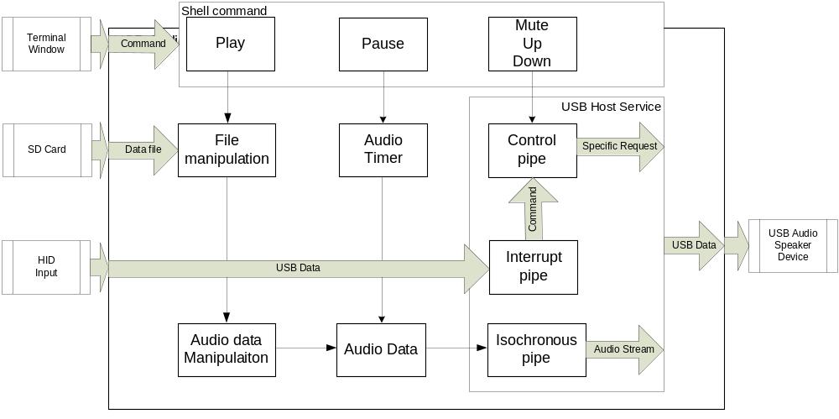
Table 5-2 Command Mechanism

Play and Pause Command
- The play command is used to play an audio file with a specified file name or switch USB Audio Speaker host from Pausing state to Playing state.
When the user types the play command to the Terminal window with file name parameter, the application search for the file in SD card, get the data of the file through the file manipulation module, after the module gets information about the audio file; the data file then is sent to the audio data manipulation module for further processing.
The audio data manipulation module then parses the data file to get the file header and the audio data, this module also checks the audio device whether it supports that type of audio data or not, then if the device supports, the audio data is then sent to the USB host service module. The audio timer call send data function with the period of 1mms, the audio data is sent to the Audio device via the isochronous pipe. When the data packet is sent completely, the Audio data is prepared for the next transfer.
When the user types the play command to the Terminal window without file name parameter, the application check the state of USB Audio Speaker host. If the state is Pausing, the application will change the state to Playing.
- The pause command is used to set the state of USB Audio Speaker Host to Pausing
The Audio timer stops and the sending data proccess is stopped.
The following sequent diagram describe the chain of funcitons call between objects
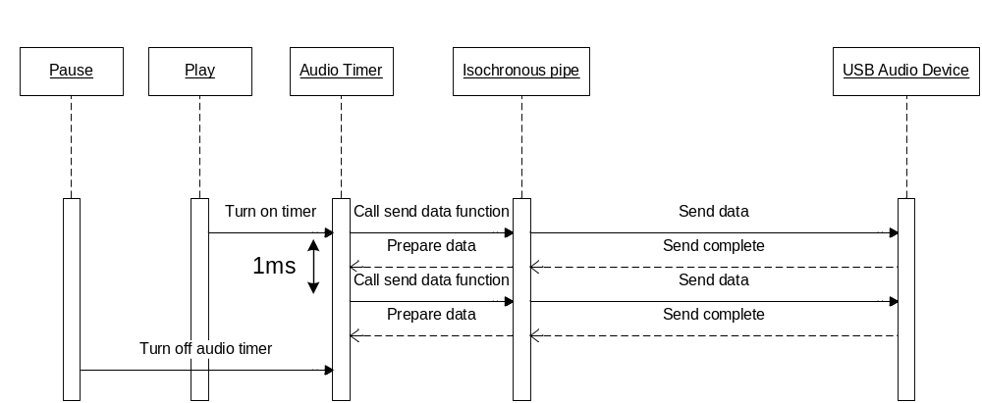
Figure 5-3 Play and Pause Sequence Diagram

Mute,Up and Down Command
- The mute command is used to switch between Mute ON and OFF state of the USB Audio speaker device.
  - Mute ON : The application sends Mute ON control request to the device.
  - Mute OFF : The application sends Mute OFF control request to the device..
- The up/down command is used to increase/descrease volume of the USB Audio speaker device. The application will set new level of volume and calcutate the real volume of the USB Audio speaker device. After that, the application sends Set current volume request to the device.
- All requests are sent to the Audio device via the control pipe.
The following sequent diagram describe the chain of funciton call between objects
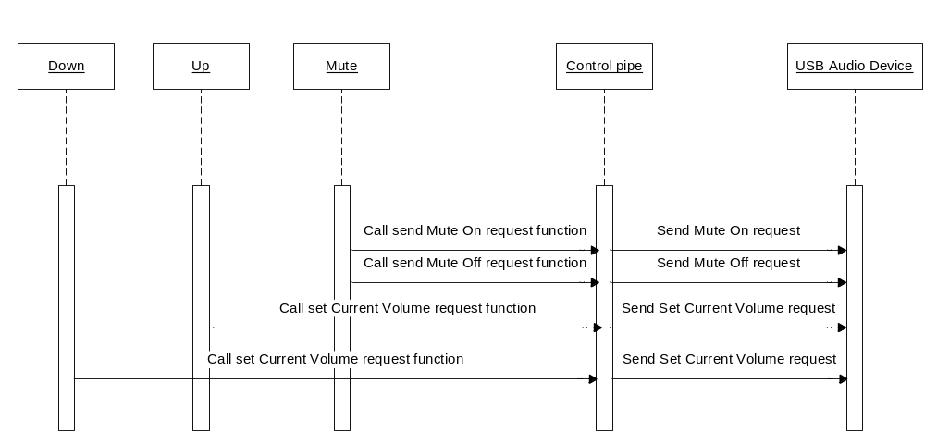
Figure 5-4 Up, Down and Mute Sequence Diagram

Audio Characteristics
In this application, audio data used to transfer between the Host and Device has following characteristics:
- Supported Audio data formats: PCM non-compressed, stereo/mono
- Supported Audio data resolution: 8 bits, 16 bits
- Supported Sampling frequency: 48kHz, 44kHz, 32 kHz, 22kHz, 16kHz, 11 kHz and 8 kHz

Application Topology
The following figure describes the topology of the application

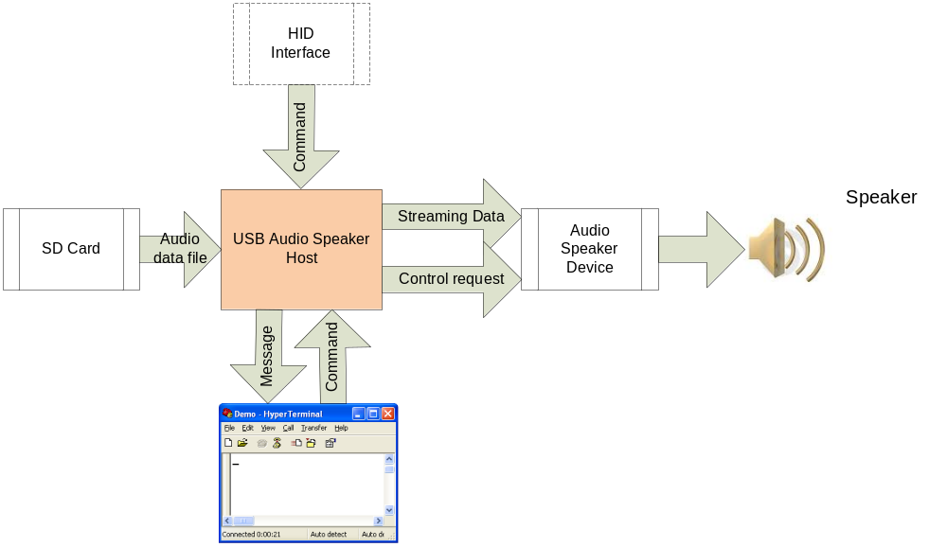
Figure 5-5: Application Topology
The SD card is used to store wav audio files.
The hyper terminal window is used to receive commands and display messages of the application.
If the audio device has HID interface, it can send command to USB Audio host through the interface.
After the audio device is connected to the host, and successfully enumerated. The host can control the device and send audio data stream to it.
Briefly state the system decompositions that are involved and give the names by which you will refer to these throughout the rest of your design document.

Function Name(s): <Give the names of the functions. (If the same change is being made to several functions, list all of the function names here.) >
File(s) to change: <This is an optional field. You need only give the names of the files to be changed if the names are not obvious from the function names.>
Description of Change: <Refer to the guidelines in this section for instructions on the format to be used when describing changes to existing functions.>

