W % dS %dP Sfac R Zpos

0 42.6487 -77.2324 -0.5203 0.0416 0.0800
0.1000 41.7836 -71.9388 -0.5127 0.0412 0.0800
0.5000 23.5698 -40.2287 -0.7563 0.0333 0.0800
0.8000 13.9001 -19.8994 -0.8486 0.0313 0.0802
1.0000 9.2191 -9.3676 -0.8590 0.0306 0.0808
1.5000 -3.0893 7.3972 0.0202 0.0800 0.0873
2.0000 -10.3929 26.7969 0.0649 0.0800 0.0800
3.0000 -21.2194 63.7570 0.3682 0.0593 0.0800
4.0000 -28.4955 97.5913 0.8407 0.0568 0.0800
5.0000 -33.8981 130.3444 1.8211 0.0555 0.0800
8.0000 -43.5503 215.2834 3.0000 0.0631 0.0800
10.0000 -47.6384 265.8693 3.0000 0.0689 0.0800

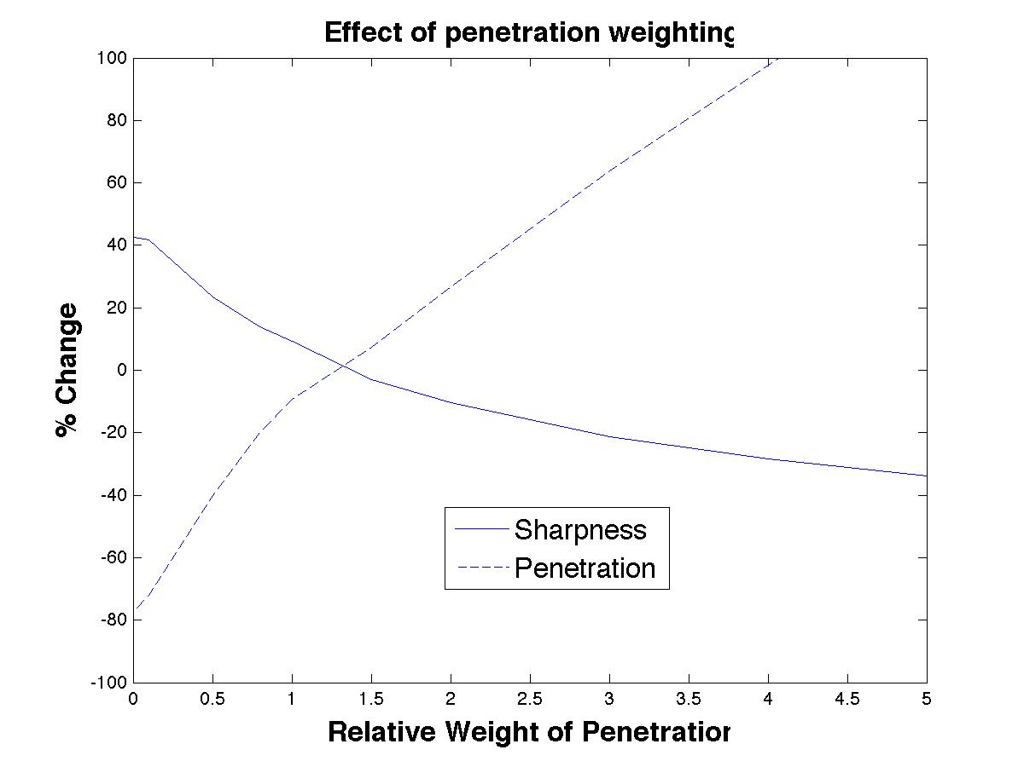
No shield
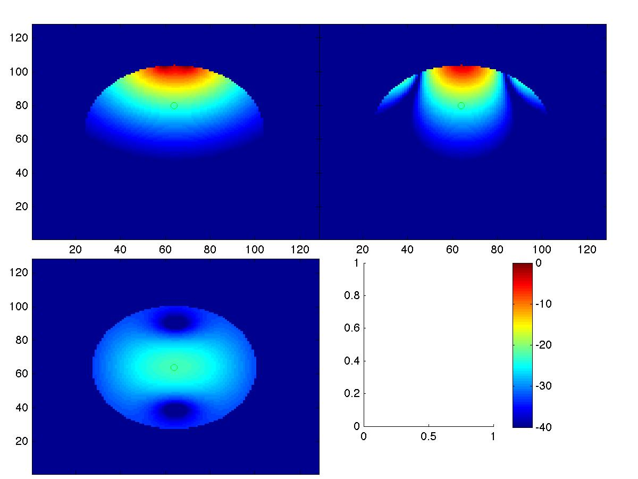

optimized with W = 0.5:
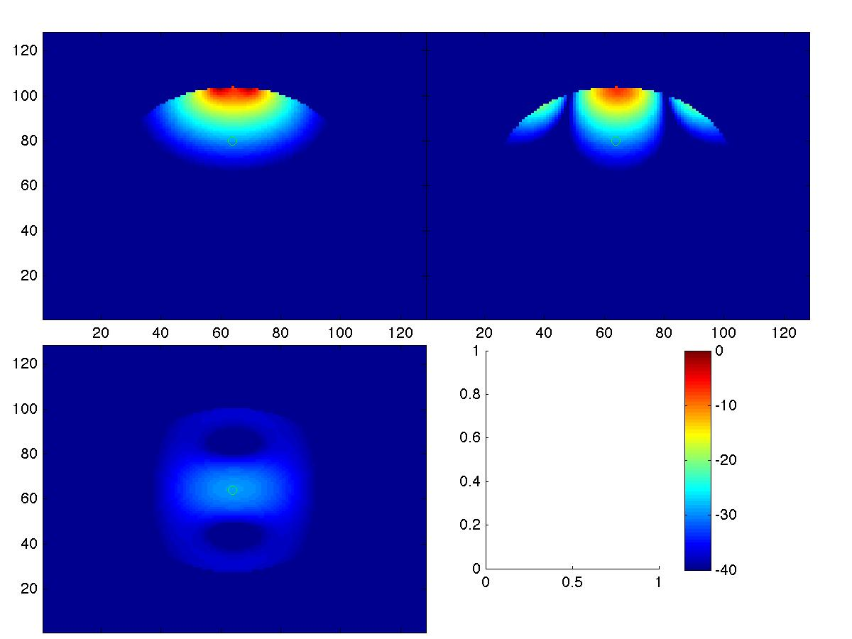

optimized with W = 0.8:
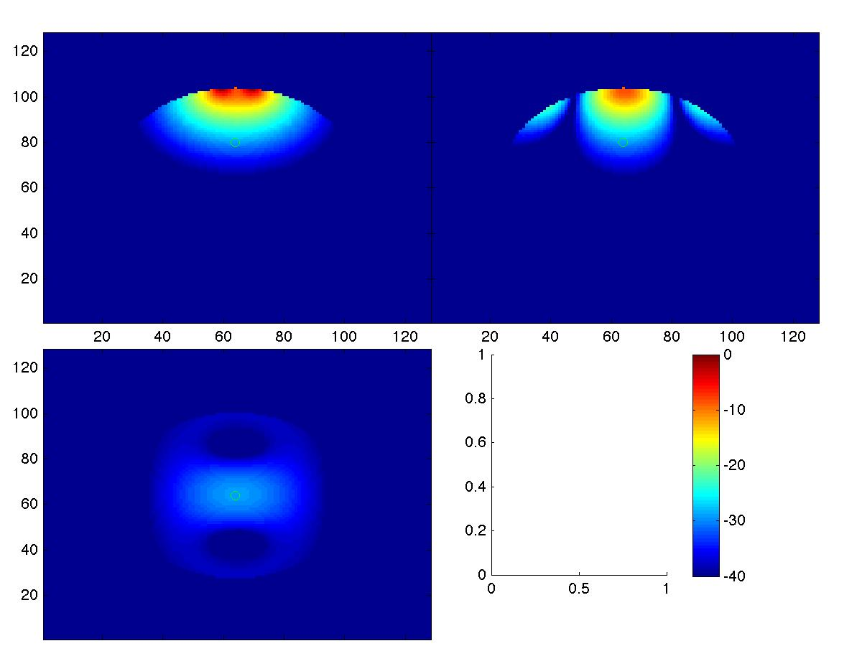

optimized with W = 3:
