Ernest Vallebuona
Just put comments in the comments on canvas,
Problem 1
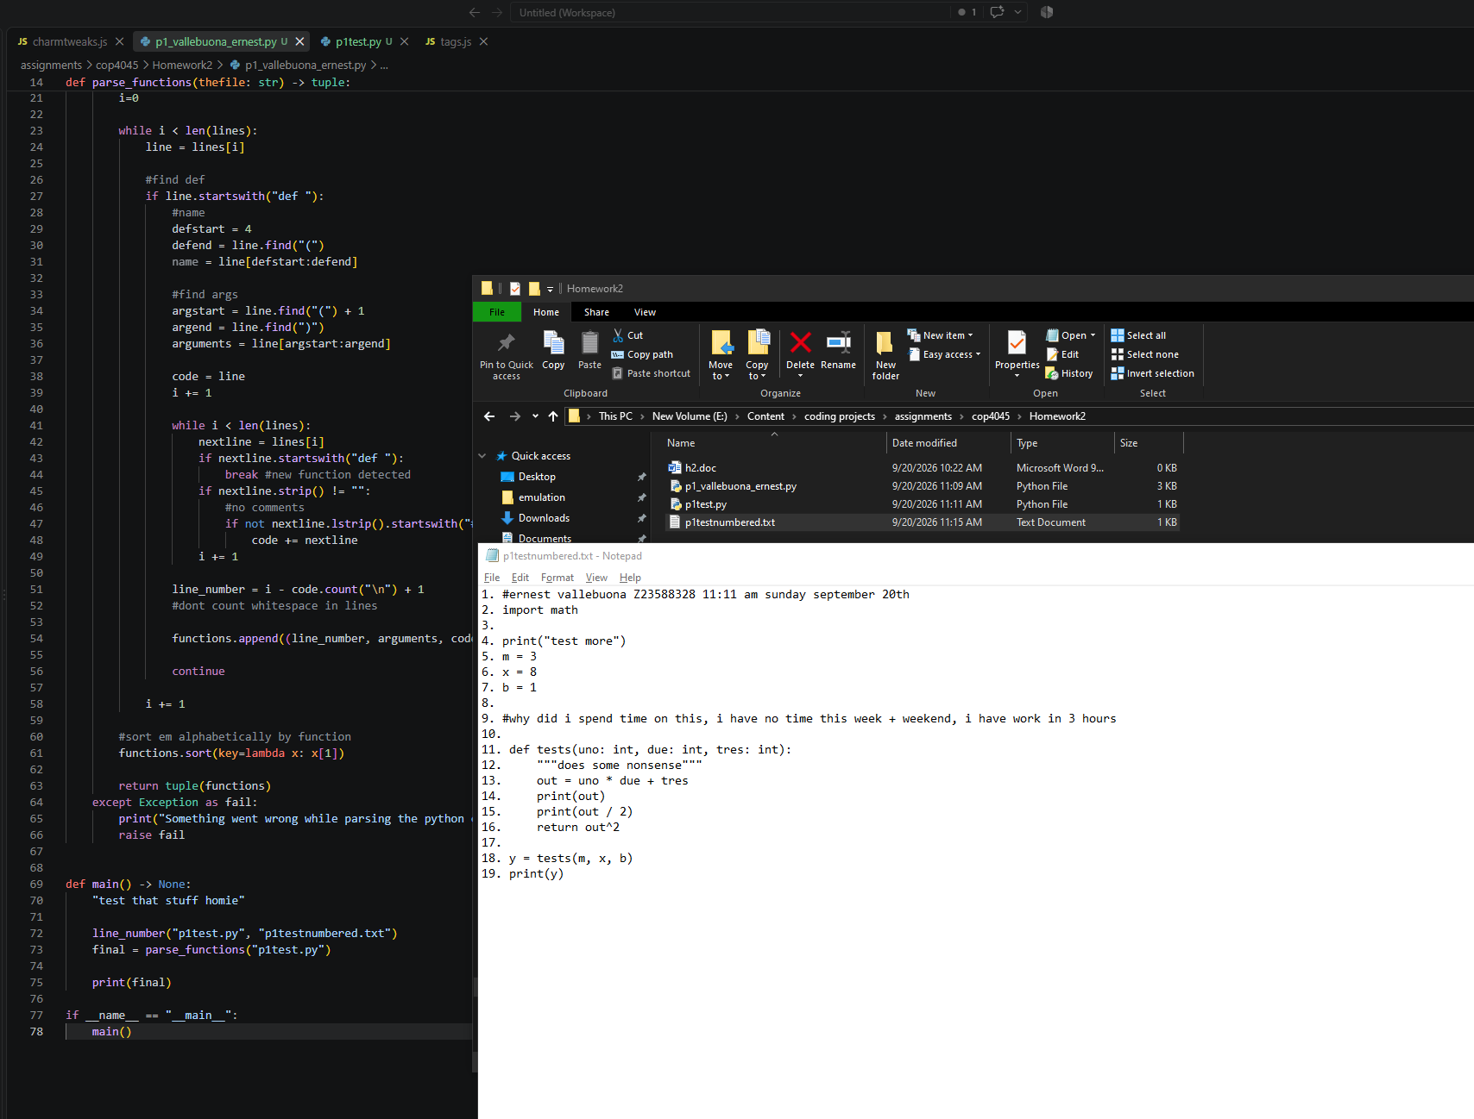

def line_number(input_file: str, output_file: str )-> None:
"""read a text file and record each line alongside a line number"""
try:
with open(input_file, "r") as fin:
with open(output_file, "w") as fout:
num = 1
for line in fin:
fout.write(str(num) + ". " + line)
num += 1
except Exception as fail:
print("Something went wrong while numbering the lines: ")
raise fail

def parse_functions(thefile: str) -> tuple:
"""read a Python file and give information about functions within it"""
try:
with open(thefile, "r") as file:
lines = file.readlines()

functions = []
i=0

while i < len(lines):
line = lines[i]

#find def
if line.startswith("def "):
#name
defstart = 4
defend = line.find("(")
name = line[defstart:defend]

#find args
argstart = line.find("(") + 1
argend = line.find(")")
arguments = line[argstart:argend]

code = line
i += 1

while i < len(lines):
nextline = lines[i]
if nextline.startswith("def "):
break #new function detected
if nextline.strip() != "":
#no comments
if not nextline.lstrip().startswith("#"):
code += nextline
i += 1

line_number = i - code.count("\n") + 1
#dont count whitespace in lines

functions.append((line_number, arguments, code))

continue

i += 1

#sort em alphabetically by function
functions.sort(key=lambda x: x[1])

return tuple(functions)
except Exception as fail:
print("Something went wrong while parsing the python code")
raise fail

def main() -> None:
"test that stuff homie"

line_number("p1test.py", "p1testnumbered.txt")
final = parse_functions("p1test.py")

print(final)

if __name__ == "__main__":
main()

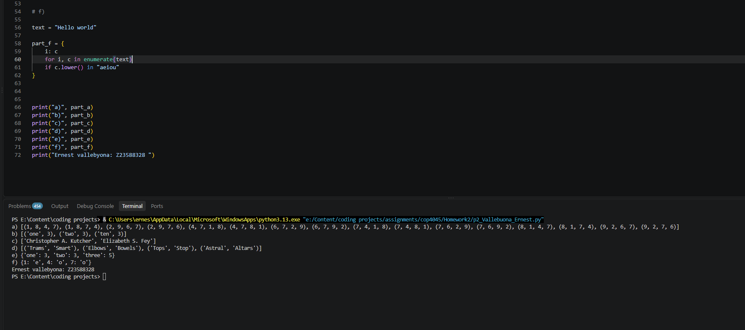
Problem 2

# a)
part_a = [
(a, b, c, d)
for a in range(1, 11)
for b in range(1, 11)
for c in range(1, 11)
for d in range(1, 11)
if len({a, b, c, d}) == 4
and a**2 + b**2 == c**2 + d**2
]

# b)
strings = ['One', 'SEVEN', 'three', 'two', 'Ten']

part_b = [
(word.lower(), len(word))
for word in strings
if len(word) < 5
]

# c)

names = ['Christopher Ashton Kutcher', 'Elizabeth Stamatina Fey']

part_c = [
f"{first} {middle[0]}. {last}"
for first, middle, last in (name.split() for name in names)
]

# d)
lst1 = ["Spam", "Trams", "Elbows", "Tops", "Astral"]
lst2 = ["Bowels", "Sample", "Altars", "Stop", "Course", "Smart"]

part_d = [
(w1, w2)
for w1 in lst1
for w2 in lst2
if sorted(w1.lower()) == sorted(w2.lower())
]

# e)
s = ['one', 'two', 'three']

part_e = {
word: len(word)
for word in s
}

# f)

text = "Hello world"

part_f = {
i: c
for i, c in enumerate(text)
if c.lower() in "aeiou"
}

print("a)", part_a)
print("b)", part_b)
print("c)", part_c)
print("d)", part_d)
print("e)", part_e)
print("f)", part_f)
print("Ernest vallebyona: Z23588328 ")

Problem 3

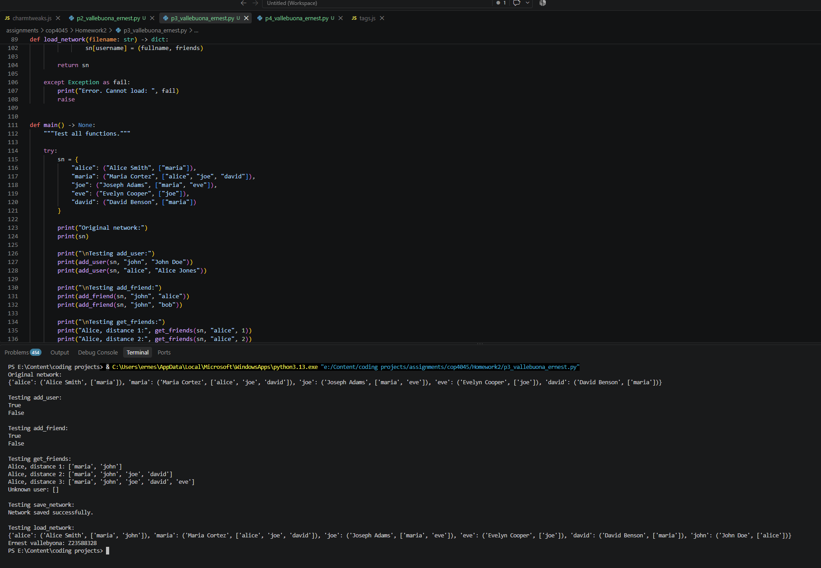

import csv

def add_user(sn: dict, username: str, fullname: str) -> bool:
"""Add a new user to the network."""
try:
if username in sn:
return False

sn[username] = (fullname, [])
return True

except Exception as fail:
print("Error. cannot add user: ", fail)
raise

def add_friend(sn: dict, user1: str, user2: str) -> bool:
"""Add a friendship between two users <3."""
try:
if user1 not in sn or user2 not in sn:
return False

if user1 == user2:
return False

if user2 not in sn[user1][1]:
sn[user1][1].append(user2)

if user1 not in sn[user2][1]:
sn[user2][1].append(user1)

return True

except Exception as fail:
print("Error. Cannot Friend: ", fail)
raise

def get_friends(sn: dict, user1: str, distance: int) -> list:
"""Return all friends within a distance."""
try:
if user1 not in sn or distance <= 0:
return []

visited = {user1}
current = [user1]
result = []

for i in range(distance):
next_level = []

for user in current:
for friend in sn[user][1]:
if friend not in visited:
visited.add(friend)
result.append(friend)
next_level.append(friend)

current = next_level

if len(current) == 0:
break

return result

except Exception as fail:
print("You have no friends, or less likely, an error occurred:", fail)
raise

def save_network(filename: str, sn: dict) -> None:
"""Save the social network to disk."""
try:
with open(filename, "w", newline="") as file:
writer = csv.writer(file)

for username in sn:
fullname = sn[username][0]
friends = sn[username][1]

writer.writerow([username, fullname] + friends)

except Exception as fail:
print("Error. Cannot save: ", fail)
raise

def load_network(filename: str) -> dict:
"""Load a social network from disk."""
try:
sn = {}

with open(filename, "r", newline="") as file:
reader = csv.reader(file)

for row in reader:
username = row[0]
fullname = row[1]
friends = row[2:]

sn[username] = (fullname, friends)

return sn

except Exception as fail:
print("Error. Cannot load: ", fail)
raise

def main() -> None:
"""Test all functions."""

try:
sn = {
"alice": ("Alice Smith", ["maria"]),
"maria": ("Maria Cortez", ["alice", "joe", "david"]),
"joe": ("Joseph Adams", ["maria", "eve"]),
"eve": ("Evelyn Cooper", ["joe"]),
"david": ("David Benson", ["maria"])
}

print("Original network:")
print(sn)

print("\nTesting add_user:")
print(add_user(sn, "john", "John Doe"))
print(add_user(sn, "alice", "Alice Jones"))

print("\nTesting add_friend:")
print(add_friend(sn, "john", "alice"))
print(add_friend(sn, "john", "bob"))

print("\nTesting get_friends:")
print("Alice, distance 1:", get_friends(sn, "alice", 1))
print("Alice, distance 2:", get_friends(sn, "alice", 2))
print("Alice, distance 3:", get_friends(sn, "alice", 3))

print("Unknown user:", get_friends(sn, "bob", 2))

print("\nTesting save_network:")
save_network("social_network.csv", sn)
print("Network saved successfully.")

print("\nTesting load_network:")
new_sn = load_network("social_network.csv")
print(new_sn)

except Exception as fail:
print("Something went wrong: ", fail)
raise

print("Ernest vallebyona: Z23588328 ")
if __name__ == "__main__":
main()

Problem 4
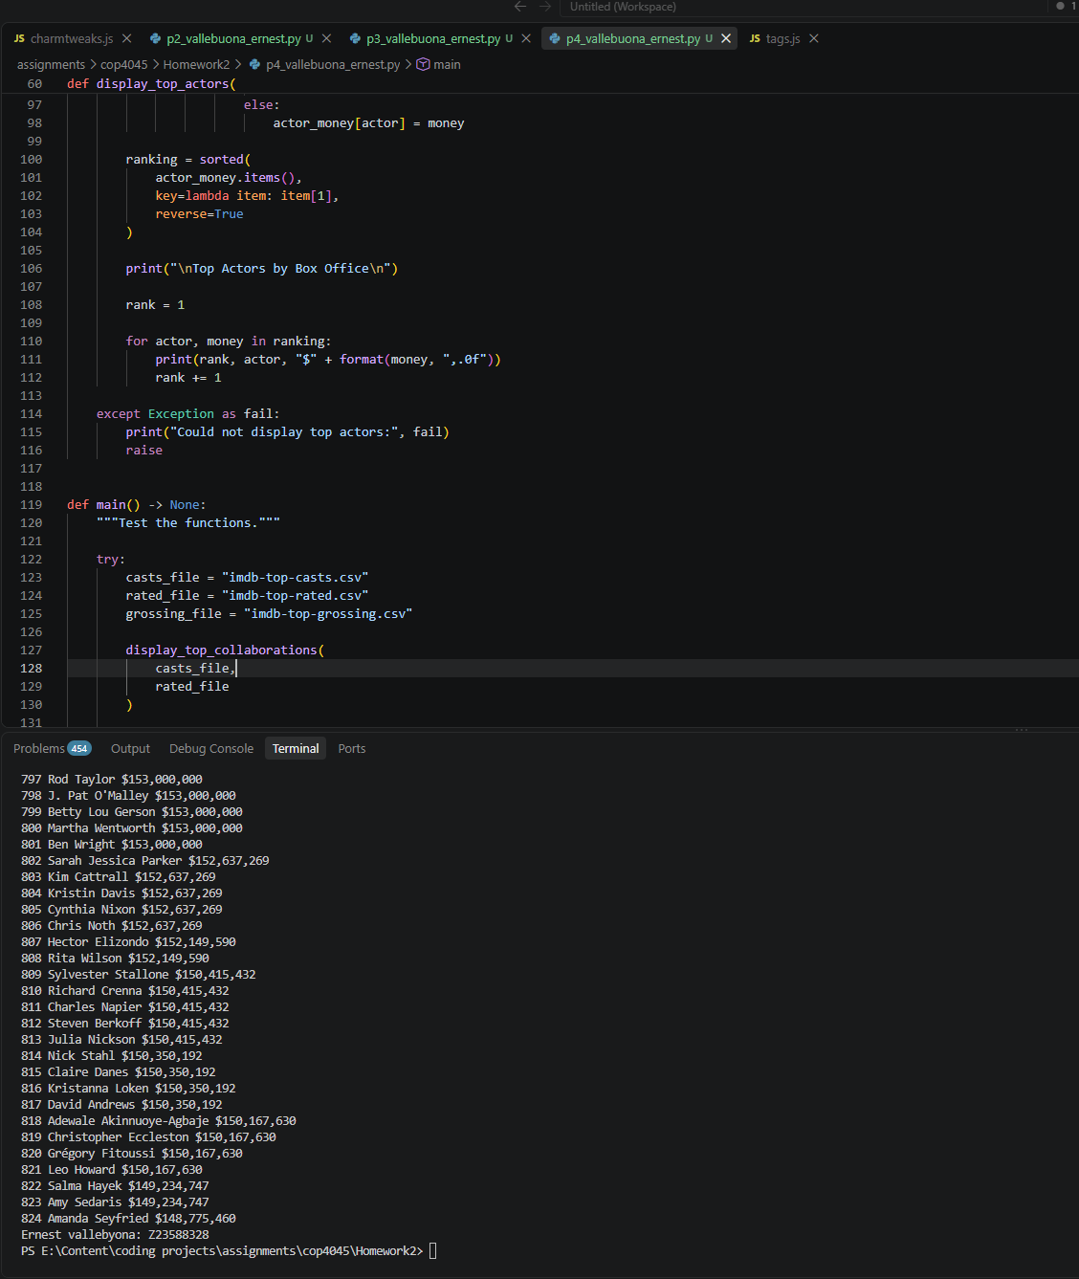

import csv

def display_top_collaborations(
casts_filename: str, rated_filename: str
) -> None:
"""Display director-actor collaborations for top-rated movies."""

try:
rated_movies = set()

with open(rated_filename, "r", encoding="utf-8") as file:
reader = csv.DictReader(file)

for row in reader:
title = row["Title"]
year = row["Year"]
rated_movies.add((title, year))

collaborations = {}

with open(casts_filename, "r", encoding="utf-8") as file:
reader = csv.reader(file)

for row in reader:
title = row[0]
year = row[1]
director = row[2]

if (title, year) in rated_movies:
actors = row[3:]

for actor in actors:
pair = (director, actor)

if pair in collaborations:
collaborations[pair] += 1
else:
collaborations[pair] = 1

ranking = sorted(
collaborations.items(),
key=lambda item: item[1],
reverse=True
)

print("\nTop Director-Actor Collaborations\n")

rank = 1

for (director, actor), number in ranking:
print(rank, director, actor, number)
rank += 1

except Exception as fail:
print("Error displaying collaborations:", fail)
raise

def display_top_actors(
casts_filename: str, grossing_filename: str
) -> None:
"""Display actors ranked by total box office from top-grossing movies."""

try:
grossing_movies = {}

with open(grossing_filename, "r", encoding="utf-8") as file:
reader = csv.DictReader(file)

for row in reader:
title = row["Title"]
year = row["Year"]
box_office = row["USA Box Office"]

box_office = box_office.replace("$", "").replace(",", "")

grossing_movies[(title, year)] = float(box_office)

actor_money = {}

with open(casts_filename, "r", encoding="utf-8") as file:
reader = csv.reader(file)

for row in reader:
title = row[0]
year = row[1]

if (title, year) in grossing_movies:
money = grossing_movies[(title, year)]

actors = row[3:]

for actor in actors:
if actor in actor_money:
actor_money[actor] += money
else:
actor_money[actor] = money

ranking = sorted(
actor_money.items(),
key=lambda item: item[1],
reverse=True
)

print("\nTop Actors by Box Office\n")

rank = 1

for actor, money in ranking:
print(rank, actor, "$" + format(money, ",.0f"))
rank += 1

except Exception as fail:
print("Could not display top actors:", fail)
raise

def main() -> None:
"""Test the functions."""

try:
casts_file = "imdb-top-casts.csv"
rated_file = "imdb-top-rated.csv"
grossing_file = "imdb-top-grossing.csv"

display_top_collaborations(
casts_file,
rated_file
)

display_top_actors(
casts_file,
grossing_file
)

except Exception as fail:
print("An error occurred during testing:", fail)
raise

print("Ernest vallebyona: Z23588328 ")

if __name__ == "__main__":
main()

Ran outta time, womp womp for me

