Bike-share case study

By Ernestas Garjonis

Overview

Cyclistic is a bike-share program that features more than 5800 bicycles an 600 docking stations. Company has two types of members: “casual riders” – customers who purchase single-ride or full-day pass and “members” – customers who purchased annual membership.

Objectives

The business goal for this project is to find opportunities to increase membership sales by converting casual riders to full members.

Questions to be answered:

1. **How do annual members and casual riders use Cyclistic bikes differently?**
2. Why would casual riders buy Cyclistic annual memberships?
3. How can Cyclistic use digital media to influence casual riders to become members?

In this report I will be focusing on the 1st question.

Data

For this project I will use Cyclistic’s historical trip data to identify trends.

The dataset is presented in CSV format. Data is organized in rows and columns. The dataset is delivered by 1st party so it should be credible. Dataset does not contain any private customer information and is under open license. Upon inspection I did not find any data to be biased in this dataset. Dataset contains of 12 CSV files each containing data for a month from 2020-04 to 2021-04. These datasets will be combined into one.

Datasets between 2020-04 and 2021-04 were downloaded from https://divvy-tripdata.s3.amazonaws.com/index.html

Processing

For this project I will be using a R programming to manipulate data because of large dataset.

Data integrity is good, data is consistent across columns. Data cleaning process will be done in Google Sheets and documented in a *changelog.txt* file. The analysis will be done in R notebook.

Analysis

Casual-riders vs Members

Casual-riders make up for 40.9% of all customers, members make up to 59.1% of all customers. 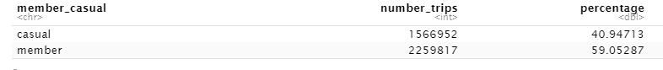

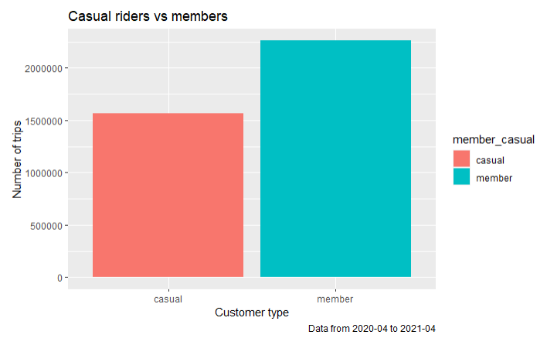

Ride length

During my analysis I found that casual-riders average ride length is ~45min., whereas members average ride length is 15min.

Ride type

Docked bike is the most popular with ~67.5% share, followed by electric bike with ~18.5% and classic bike with ~14%. Classic bike is more popular among members with ~73.5% of all classic bike rides being members. 

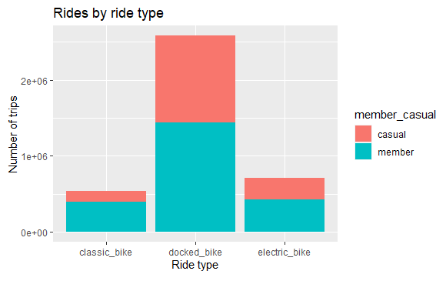

Ride month

Customer activity positively correlates with outside temperature. Most active month is August with ~16.3% of all rides in a year, followed by July with ~14.4%. Members dominate the share, especially during lower activity months.

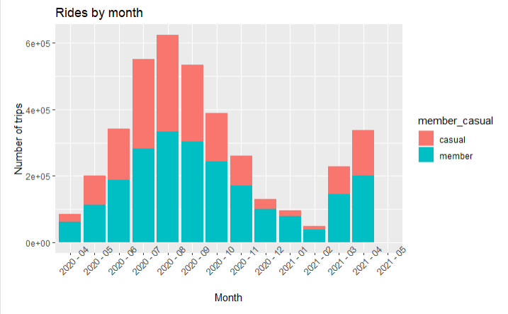

Ride week days

Customers are most active during weekends with ~34.4% of all rides happening during weekends. Members dominate with 60-65% share on work days, however, on weekends members to casuals ratio is very close to 1:1.

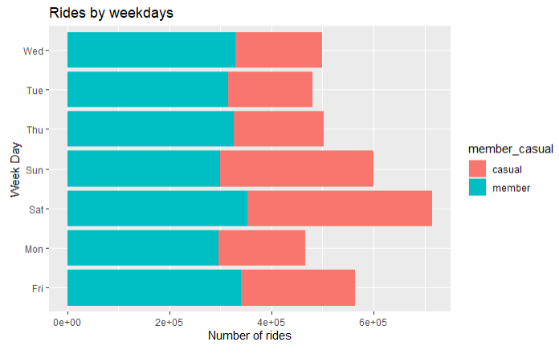

Customers are most active in the evening (7PM-9PM)

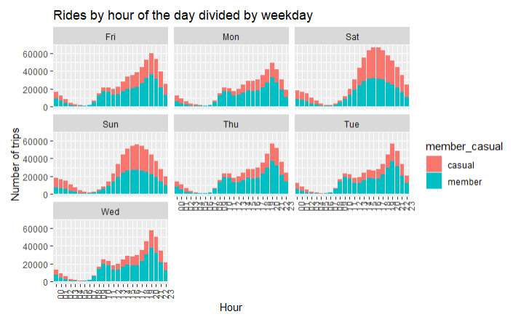

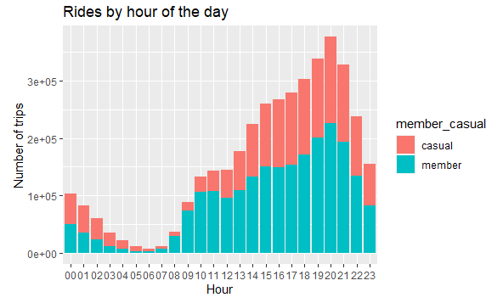

Recommendations

* The company could offer discounts for annual subscriptions at a discount during winter months.
* Because rides are most popular during weekends a company can create a marketing campaign targeted at weekend riders.