Software Design
J-OBS
June 2016

Introduction

The Joint Observation System (J-OBS) is designed for manually submitting meteorological and oceanographic observations through the SIPR and NIPR internet systems. It is a thin-client application that utilizes a web browser using HTML and JavaScript to accept input. CGI Perl scripts are used on the server side to create the HTML files and create output files. The output files fall into two groups, encoded which will be accessed by DPS for transfer and archive which will be kept for later analysis and historical review.

The accepted data type input fall into three observational platforms, ship, land and aircraft. In most cases, the submitter will need to compose the observational report using the format found in the United States Navy Manual for Ship's Surface Weather Observations – 3144.1E which is based on the WMO document No. 306, Part A. For diagnostic purposes submission checking, encoded report decoders are used, alerting users to format errors.

The ship platform submissions include the data types of a surface report from a sea station, an upper level pressure, temperature, humidity and wind report from a sea station, a bathythermal (BATHY) report and a temperature, salinity and current (TESAC) report from a sea station. One more type is TAF which is not an observation but an aerodrome forecast, in the this case from a ship. The surface reports and BATHY reports can be submitted in two manners, one where the user has already encoded the observations and the other where the user enters the actual observational data.

Contact
Cary McGregor
phone: 831-657-1588
FNMOC
7 Grace Hopper Ave.
Monterey, CA 93943-5501

Basic Layout

The purpose of the Joint Observation Submission (J-OBS) project is to allow deployed USN/USMC assets to submit meteorological and oceanographic observation data to FNMOC via a web GUI interface which allows for inclusion of the data into numerical weather prediction models without the use of standard communications paths (i.e.: Message Traffic)
J-OBS functionality includes the ability to submit:

1 Coded Ship Surface Observations:
2 Ship Surface Observations via Entry Form:
3 Coded Upper Air Observations:
4 Coded Bathythermograph Observations
5 Bathythermograph Observations via Entry Form:
6 Coded TESAC Observations:
7 Coded TAF:
8 Coded Suface Mobile Land observations:
9 Coded Aicraft (AMDAR) observations:
10 Classification Markings:

These observations in turn are either placed directly or encoded into files specially designed for DPS handling. These files are in turn given to to the MODS decoders to be made available for later weather model ingest or FNMOC customers. The same observations are also recorded together with submission details into archival files.

Observer Input
via J-OBS
DPS
transfer
MODS
decoders

Climate
archive
Job script
File transfer

The subdirectory layout is basically standard, dynamic, css, js, static, html, cgi-bin and lib. Generated files are placed under dynamic into encoded, archive, activity_logs or usage_survey. DPS transfer occurs under encoded within three subdirectories called unclas, confid, and secret, depending on the security classification determined by the user. Those files are in turn moved by DPS into the following locations for MODS processing, again depending on the user classification selection.

/u/ops/etc/dynamic/odr2app/mods/unclas/j_obs
/c/ops/etc/dynamic/odr2app/mods/confid/j_obs
/s/ops/etc/dynamic/odr2app/mods/secret/j_obs

The NIPR version is limited to only unclassified submissions; however, on the SIPR side, unclassified reports can be submitted depending on the situation.

The static subdirectory contains the ship reference library file that links call signs to ship names for both the US Navy and US Coast Guard. The CSS subdirectory contains the Cascading Style Sheets file that uses the FNMOC Webservices standards. The activity logs subdirectory contains logs of user submissions. And the usage survey contains the record of any user's feedback.

The html subdirectory contains html files directly used by the web browser or template html files that are read by Perl cgi scripts which make substitutions and appends them into one standard output fed to the user's web browser. The cgi subdirectory contains the CGI Perl scripts that are initially called use Perl modules contained under the lib subdirectory. Finally, the js subdirectory contain JavaScript functions that are either called directly from the generated html files or by functions used by other JavaScript functions.

Software Paradigm

Identical software is used for either operational or training purposes, used under SIPR or NIPR control, and allows distinctions between functional levels of alpha. Beta and ops. Even though this paradigm makes for more complicated code, updates and changes to data entry and processing can be consitant.

The initial web page is cgi-bin/index.cgi uses html/index.html_template as the common start whether it's under SIPR or NIPR, or the operational or training version type. See the following code
#!/usr/bin/perl -wT

use strict;
use warnings;

use lib "/opt/global/webservices/apache/app/common/lib";
use lib "/opt/global/perllib";
use lib "../lib";
use CGI;
# remove before promotion
#use CGI::Carp "fatalsToBrowser";

use sys_info qw(getDevLevel getHostClass getAppName);
use web_routines qw(getClasBnr);

#
# Set ENV to needed directories and remove uncessary variables for
# security reasons
#
$ENV{PATH} = "/bin:/usr/bin";
delete @ENV{ 'IFS', 'CDPATH', 'BASH_ENV'};

use vars qw($clas_banner);

#
# Limit file upload size
#
use constant MAX_FILE_SIZE => 5_000;

$clas_banner = getClasBnr();
print "Content-type: text/html; charset=utf-8\n\n";
open (IN, "<../html/index.html_template") or die " Can't open ../html/index.html_template";
while (<IN>)
{
#
# skip line
#
if(index($_,'//') == 0)
{
next;
}
s/#CLAS_BANNER#/$clas_banner/g;
print;
}
close IN;
1;

The techniques used here are the simplest but are also use in more sophisticated ways in other CGI scripts. This CGI script first determines the machine classification and version type through the function, getClasBnr, found in the Perl module, lib/web_routines.pm. More about this and other Perl modules later, but suffice it to say that the colored classification banner variable is spliced or substituted as the index.html_template file is read and then redirected as standard output used by the web browser. That substituted line of generated code will indicate the classification (UNCLASSIFIFIED, CONFIDENTAIL or SECRET), version type (operational or training) and functional level (ALPHA, BETA or OPS). An example of generated HTML code.

<html>
<head>
<title>J-OBS Home Page</title>
</head>

<body>

<center>
<link rel="stylesheet" type="text/css" href="/common/css/common.css" />
<link rel="stylesheet" type="text/css" href="../css/util.css" />
<div class='sec-unclass-bnr'>UNCLASSIFIED --- ALPHA</div>
<br>
<!--
<input type="button" value="640x480" onclick="window.resizeTo(640,480)">
<input type="button" value="600x800" onclick="window.resizeTo(800,600)">
<input type="button" value="1024x768" onclick="window.resizeTo(1024,768)">
-->
<br>
<br>
Welcome to the <b>Joint Observations Submission (J-OBS)</b>
web user interface.
<br>
<br>
<table width="80%">
<tr>
<td>
This site is maintained by Fleet Numerical Meteorology
and Oceanography Center (FNMOC). J-OBS web
applications enable Joint military assets to submit
meteorological and oceanographic observational data with
specific classifications to a central site for assimilation
and distribution.
<br>
<br>
Individuals who wish to receive copies of their observations
can do so via a Spot Observations data request by visiting
https://portal.fnmoc.navy.mil/spout_cgi/cgi-bin/spout.cgi</a>
or by contacting the Fleet Numerical CDO at (831) 656-4326/
fnmoc.cdo@navy.smil.mil.
<br>
<br>
</td>
</tr>
</table>
<br>
<br>
<br>
<br>

<table width="60%">
<center>
<tr>

<td valign="top" align="left">
<center>
SHIP APPLICATIONS
<br>
<a href='ship_sfc_form.cgi' target="SHIP_SFC">Ship's Surface Weather Observation</a>
<br>
<a href='ship_sfc.cgi' target="SHIP_SFC_ENC">Encoded Ship's Synopt</a>
<br>
<a href='ship_raob.cgi' target="SHIP_RAOB">Encoded Upper Air Sounding</a>
<br>
<a href='bathy_form.cgi' target="BATHY">Bathy</a>
<br>
<a href='bathy.cgi' target="BATHY_ENC">Encoded Bathy</a>
<br>
<a href='tesac.cgi' target="TESAC_ENC">Encoded Tesac</a>
<br>
<a href='ship_taf.cgi' target="SHIP_TAF">TAF</a>
</center>
</td>
<td>
</td>
<td valign="top" align="center">
<center>
LAND MOBILE APLICATIONS
<br>
<a href='lnd_mo_sfc.cgi' target="LND_MO_SFC">Encoded Surface Weather Observation</a>
<br>
<a href='lnd_mo_raob.cgi' target="LND_MO_RAOB">Encoded Upper Air Sounding</a>
<br>
<!--
MOBOB
-->
</center>
</td>

<!--
<td>
</td>
<td valign="top">
<center>
FIXED LAND STATION
<br>
<a href='lnd_fx_sfc.cgi'>Hourly/Synoptic</a>
<br>
<a href='lnd_fx_raob.cgi'>Upperair</a>
<br>
<a href='metar.cgi'>METAR</a>
<br>
<a href='taf.cgi'>TAF</a>
</center>
</td>
-->

<td>
</td>

<td valign="top" align="right">
<center>
AIRCRAFT APPLICATIONS
<br>
<a href='acft_amdar.cgi' target="AMDAR">Encoded AMDAR</a>
</center>
</td>

<!--
<td>
<center>
PIREP
</center>
</td>
-->

</tr>
</center>
</table>

<a href='counts.cgi' target="COUNTS">Counts Listing</a>
<br>
<a href='data_display.cgi' target="DATA_DISPLAY">Data Display</a>
<br>
<br>
<a href='usage_survey.cgi' target="FEEDBACK">Feedback</a>
<br>
<br>
<br>
<a href='updates.cgi' target="UPDATES">Update History</a>
<br>
<br>
Version 1.0.18 --- June 2015
<br>
<br>
<div class='sec-unclass-bnr'>UNCLASSIFIED --- ALPHA</div>

</center>
</body>

</html>
<!--
-->

That banner line of code in the above example is <div class='sec-unclass-bnr'>UNCLASSIFIED --- ALPHA</div> which calls upon the CSS file, css/util.css to display the classification banner in a color according to classification (green –unclassified, blue - confidential and red – secret). See the following as displayed in a web browser.

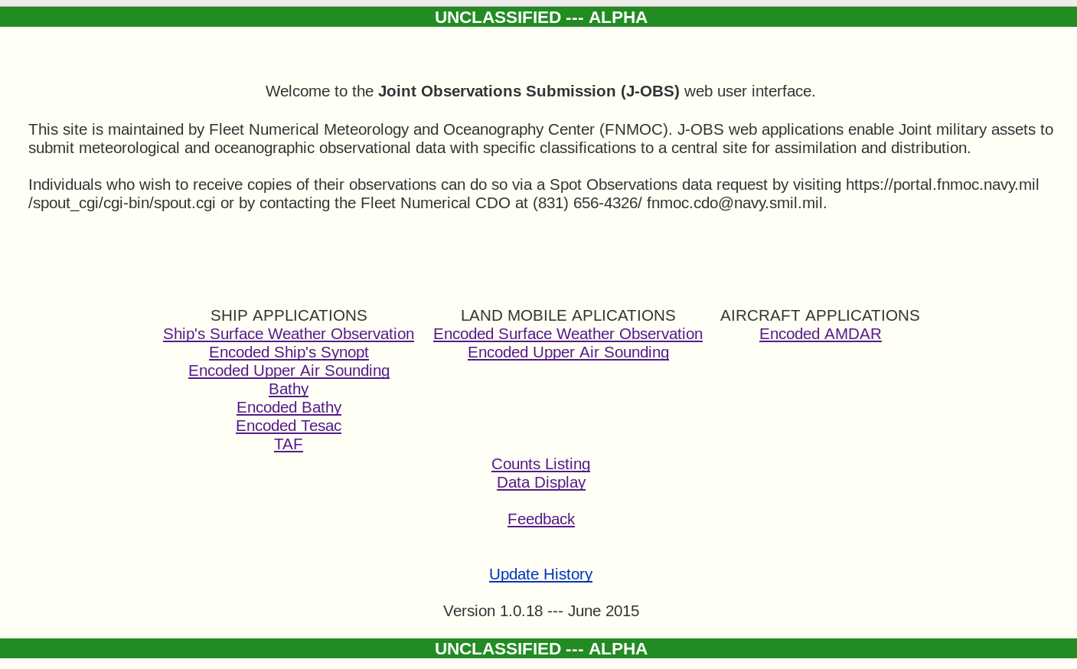
The web page allows the selection of different report submittal selections which can be placed into two groups, short and long forms. The short form allows the user to submit an observation that has been enocded into a WMO report. The long form used in Ship's Surface Weather Observation and Bathy where weather and oceanographic data are directly entered. Additional selections will allow display of report submission counts during the last two weeks, review of submitted reports and feedback. For details on each web pages and data entry or WMO encoded report submission see J-OBS User's Guide.

The Encoded Ship's Synopt is an exmaple of how encoded WMO reports are submitted. The calling CGI script, ship_sfc.cgi, is as followers.

#!/usr/bin/perl -wT
use strict;

#----------------------------------------------------------
# Following variables define html type
#
my $title="Encoded Ship's Synopt";
my $data_type="ship_sfc";
my $wmo_id="BBXX";
#----------------------------------------------------------

use lib "../lib";
use wmo_routines;

wmo_routines::setup();

wmo_routines::initialize();
wmo_routines::main($title, $data_type, $wmo_id);

This script calls three functions, setup, initialize and main from the Perl module, lib/wmo_routines.pm. The setup function associates the Perl library, /opt/global/perlib and sets the maximum file size that can be uploaded. The initialize module sets up the variables used in the main function. The main function has three arguments that sets the title displayed on the corresponding web page, the data type and the WMO report id. As with the index web page, the banner is based on of a NIPR or SIPR access, opertional or training, and function level. The HTML file templates, origin_insert.html_template, security_insert.html_tmeplate and wmo_insert.html_template, are used to form the final web display as shown below.

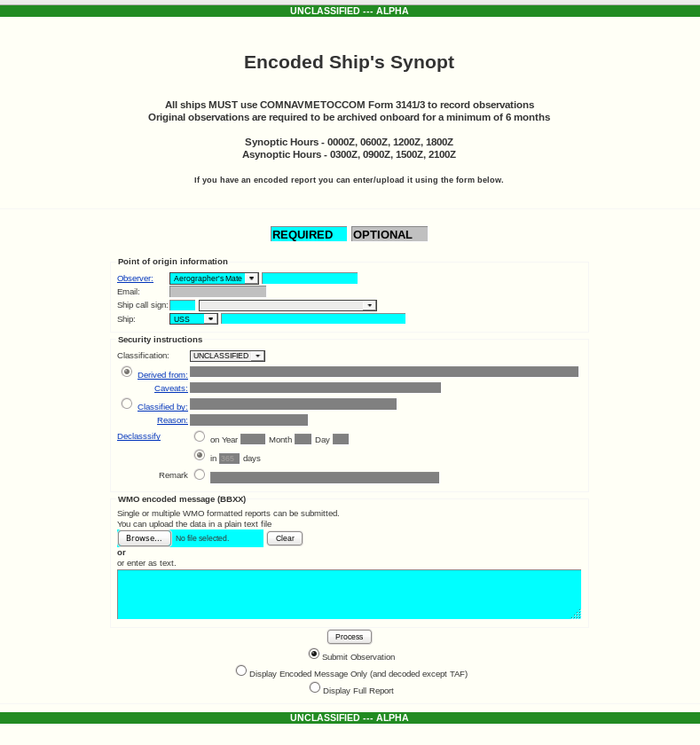

Each input box has a color that indicates that data entry is required (cyan) or optional (dark grey). These colors and hence input are monitored by JavaScript functions, which check on basic input requirements (such as numeric versus alpha) or left unfilled. Once the user has made the necessary entries, he has there options, submit the report (Submit Observation), the WMO encoded report (Display Encoded Message Only) and show submitted entries (Display Full Report).

Further summarized explanation of the three process options is needed. The last one displays what the user has entered, origin input, security entries and the WMO encoded report. The decoding of the encoded WMO report allows the user to see what was encoded and gives an error if there is an error. The observation submission will first run the encoded report through a decoder and not accept if there is an error. This is an important update in that a number of reports have been submitted only to be “kicked out” later by the MODS decoders.

Software Details
CGI Perl Scripts

Data entry links from the main index web page (index.cgi) corresponds to the following CGI Perl scripts. These scripts call Perl modules that do the actual processing. The scripts that allow direct submission of encoded WMO ship reports rely on wmo_routines.pm; whereas, the long form entries of ship_sfc_for.cgi and bath_form.cgi rely on form_routines.pm. The surface land and AMDAR entry scripts rely on wmo_lnd_routines.pm and wmo_acft_routines.pm respectively.

ship_sfc_form.cgi
ship_sfc.cgi
ship_raob.cgi
bathy_form.cgi
bathy.cgi
tesac.cgi
ship_taf.cgi

lnd_mo_sfc.cgi
lnd_mo_raob.cgi

acft_amdar.cgi

The example of ship_sfc.cgi shown earlier illustrates how the other scripts function in the previous list and will be examined in detail in the next section.

The counts.cgi script shows the users a summary of submitted reports during the past two weeks. data_display.cgi allows the user to access submitted reports during the past two using three options, encoded, raw and decoded.

usage_survey.cgi provides the user to submit comments that will be emailed to the CDO of FNMOC. The updates.cgi script summarizes software updates.

Perl Modules

The following Perl modules are called by the CGI Perl scripts mentioned on the previous section

wmo_routines.pm
wmo_acft_routines.pm
wmo_lnd_routines.pm
form_routines.pm

The following Perl modules are used by counts.cgi, data_display.cgi, index.cgi, updates.cgi and usages_survey.cgi

sys_info.pm
web_routines.pm

Decoder Software

The following executable binaries for WMO enocoded reports from ship, bathy, TESAC, mobile surface land observation, mobile surface upper air sounding, and AMDAR aircraft. These were built from NCEP FORTRAN code. They are accessed through Perl module functions.

Dcmsfc --- surface ship and land
scbthy --- bathy and TESAC
dcusnd --- upper air sounding
dcacft --- AMDAR aircraft

HTML Templates

The following HTML template files are used by specific Perl module functions that generate standard output for web browser display. Certain words within these template files are upper case and bracketed by #'s. The Perl function reads that template and makes a substitution before output.

This template is for the initial index web pages

index.html_template

The following templates are inserted for collection of the user's name, title, email, ship callsign and name, land station id and aircraft flight number.

:qorigin_acft_insert.html_template
origin_insert.html_template
origin_lnd_insert.html_template

Obsolete inserts.

time_insert.html_template
time_ship_sfc_form_insert.html_template

The security insert template allows classification selection, unclassified, confidential or secret, and corresponding justifications.

security_insert.html_template
location_insert.html_template

This insert templates display the meanings behind the cyan, yellow and silver colors.

color_insert_all.html_template
color_insert.html_template

These inserts allow the submission of encoded WMO reports.

wmo_acft_form.html_template
wmo_form.html_template
wmo_form_taf.html_template
wmo_insert.html_template
wmo_lnd_form.html_template

These inserts are specifically designed a particular platform and observations entry.

ship_sfc_form_insert.html_template
bathy_form_insert.html_template

These inserts are for the report displays collected during the past two weeks.

data_display.html_template
data_type_form.html_template

These are for the ancillary abitility of displaying saftware updates and collecting user feedback.

updates.html_template
usage_survey.html_template

CSS

The following CSS file sets the font size for the classification banner.

util.css

JavaScript Functions

The JavaScript functions utilized in the displayed HTML code essentially checks the validity of data submitted in input boxes and keeps track of the required input. Red is displayed as the background color in the input box if the submitted value is not acceptable or is vacant (if the original color is cyan) when the Submit Observation button is clicked. If the original color is silver:q, then it is an optional input box.

basic_acft_lists_clas.js
basic_acft_lists_unclas.js
basic_lists_clas.js
basic_lists_clas_taf.js
basic_lists.js
basic_lists_taf.js
basic_lists_unclas.js
basic_lists_unclas_taf.js
basic_lnd_lists_clas.js
basic_lnd_lists_unclas.js
bathy_form_lists.js
bckgrd_set.js
functions.js
functions_sec.js
ship_sfc_form_lists.js
wmo_lists.js

