User's Guide for J-OBS
Classified Observation Handling Version

June, 2016

Cary McGregor 381-657-1588

Fleet Numerical Meteorology and Oceanography Center

7 Grace Ave.

Monterey, CA 93943-5501

I. Name: J-OBS (web application)

II. Description:

Joint Observation Submission (J-OBS) is a web user interface that allows USN and USMC units to submit unclassified, confidential and secret observational data to a central site for assimilation and distribution. These data are ship surface, upperair, bathymetric, TESAC observations and TAF, and land surface, upperair and AMDAR aircraft observations.

III. User's Procedures:

This user's guide applies to both the SIPR and NIPR versions of operational and training J-OBS.

For unclassified applications use a NIPR PC and for classified applications use a SIPR PC.

1) Computer Access

Through a SIPR computer, access the URLs, http://portal.fnmoc.navy.smil.mil/j-obs/index.html (submission) and http://portal.fnmoc.navy.smil.mil/j-obs_training/index.html (training). Through an unclassified NIPR PC, access the URLs, http://portal.fnmoc.navy.mil/j-obs/index.html (submission) and http://portal.fnmoc.navy.mil/j-obs_training/index.html (training).

The web page begins with “Welcome to the Joint Observations Submission (J-OBS) Web User Interface.” The SIPR J-OBS web pages will have the following classification banner

The NIPR J-OBS web pages will have the following classification banner

Both the SIPR and NIPR training J-OBS web pages will have the following classification banner.

2) Example Data Input

a) SHIP APPLICATIONS - Ship's Surface Weather Observation

Click on the Ship's Surface Weather Observation link under the SHIP APPLICATIONS column.

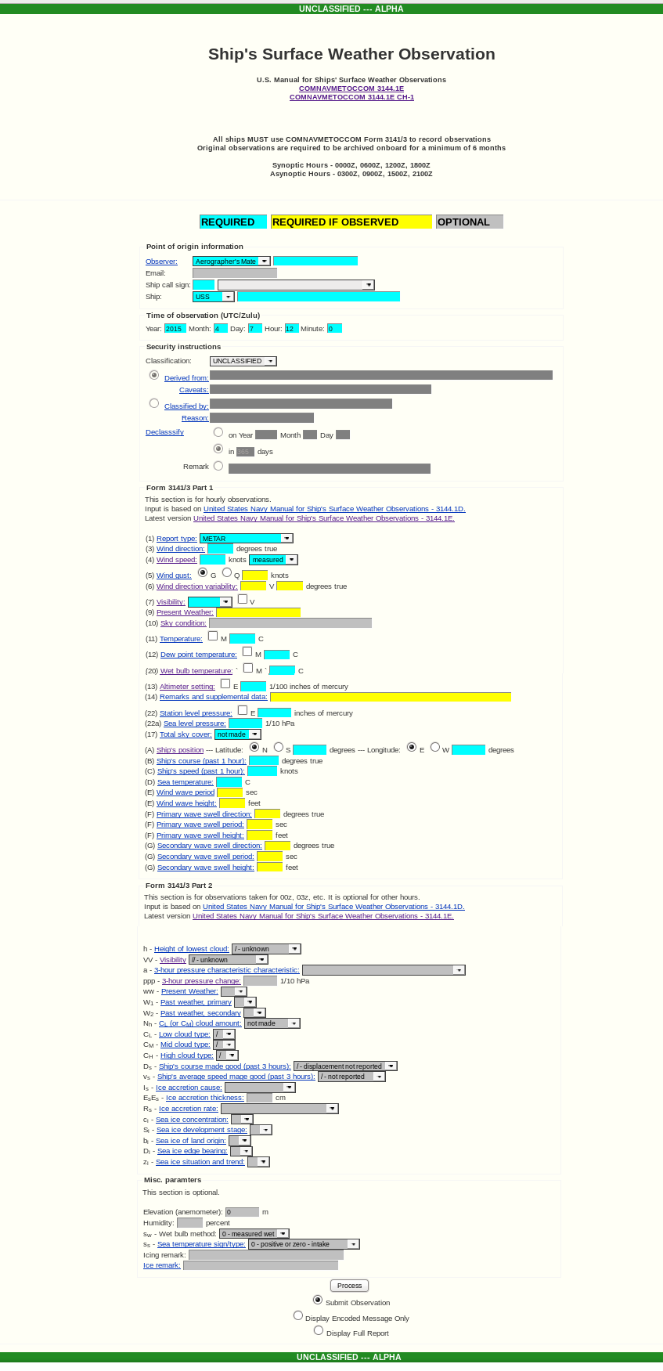

The following are example entries.

Point of origin information
Observer: Smith Ship call sign: TEST Ship: USS Test
Time of observation (UTC/Zulu)
Year: yyyy Month: mm Day: dd Hour: hh Minute:00
Security instructions
Classification:SECRET
Derived from: this is a test
Classified by: Reason:

Caveats: Declassify on Year Month Day in days

Form 3141/3 Part 1 This section is for hourly observations.
Input is based on United Staes Navy Manual for Ship's Surface Weather Observations - 3144.1D.

(1) Report type:METAR
(3) Wind direction:180 degrees true
(4) Wind speed: 5 knots measured
(5) Wind gust: G Q 15 knots
(6) Wind direction variability: 160 V 200 degrees true
(7) Visibility: 10 nm V
(9) Present Weather: DZ
(10) Sky condition: OVC010
(11) Temperature: 12.5 C
(12) Dew point temperature: 11 C
(20) Wet bulb temperature: 10.5 C
(13) Altimeter setting: 2950 1/100 inches of mercury
(14) Remarks and supplemental data: THN FG NW
(22) Station level pressure: 29.30 inches of mercury
(22a) Sea level pressure: 990 1/10 hPa
(17) Total sky cover: 6/8
(A) Ship's position -- Latitude: N 33.3 degrees -- Longitude: E 133.3 degrees
(B) Ship's course (past 1 hour): 90 degrees true
(C) Ship's speed (past 1 hour): 7 knots
(D) Sea temperature: 10.0 C
(E) Wind wave period 20 sec
(E) Wind wave height: 3 feet
(F) Primary wave swell direction; 145 degrees true
(F) Primary wave swell height: 5 feet
(F) Primary wave swell period: 60 sec
(G) Secondary wave swell direction: degrees true
(G) Secondary wave swell height: feet
(G) Secondary wave swell period: sec
Form 3141/3 Part 2 This section is for observations taken for 00z, 03z, etc. It is optional for other hours.
Input is based on United Staes Navy Manual for Ship's Surface Weather Observations - 3144.1D.

h - Height of lowest cloud: 4 – 1000-1999 ft
VV – Visibility 99-not reported
a - 3-hour pressure characteristic characteristic: Dcrs-steadily/unsteadily
ppp - 3-hour pressure change: 005 1/10 hPa
ww - Present Weather: 58
W1 - Past weather, primary 5
W2 - Past weather, secondary 5
Nh - CL (or CM) cloud amount: 6-6/8
CL - Low cloud type: 6
CM - Mid cloud type:
CH - High cloud type:
Ds - Ship's course made good (past 3 hours): 2 - E
vs - Ship's average speed mage good (past 3 hours): 2- 6-10
Is - Ice accretion cause:
EsEs - Ice accretion thickness: cm
Rs - Ice accretion rate:
ci - Sea ice concentration:
Si - Sea ice development stage:
bi - Sea ice of land origin:
Di - Sea ice edge bearing:
zi - Sea ice situation and trend:
Misc. paramters This section is optional.

Elevation (anemometer): 15 m
Humidity: percent 75
sw - Wet bulb method: 0 – measured wet
ss - Sea temperature sign/type: 0 – positive or zero - intake
Icing remark:
Ice remark:

Click Submit observation. A new window will appear with the following information. Remember dd is for the day and hh is for the hour.

Generated WMO encoded message
BBXX TEST ddhh4 99333 11333
41499 61805 10125 2011/ 40990 70234 866// 90000
22222 00100 23002 314// 46003 80105

b) SHIP APPLICATION Encoded Ship's Synopt

Return main index web page and click on the Encoded Ship's Synopt link.

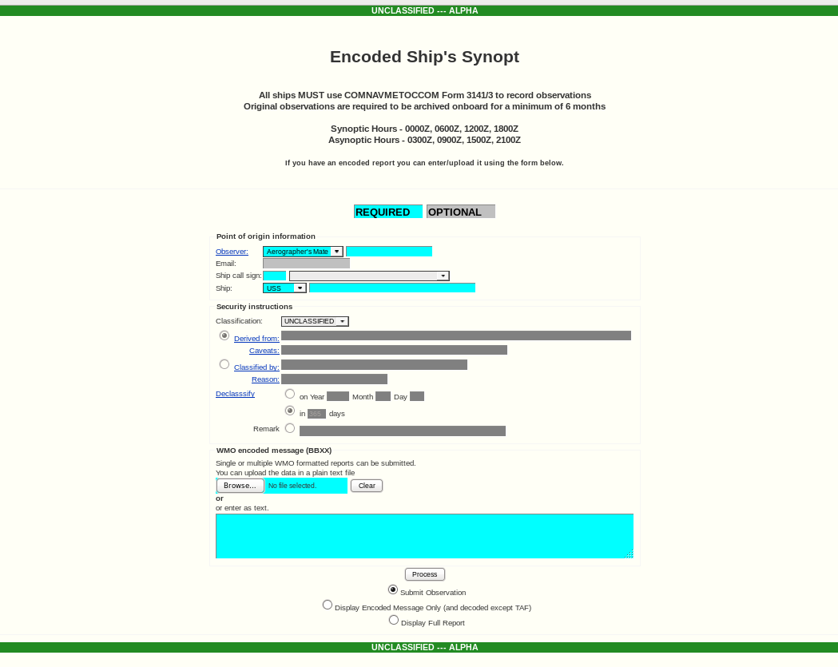

The following are example entries

Point of origin information
Observer: Smith Ship call sign: TEST Ship: USS Test
Time of observation (UTC/Zulu)
Year: yyyy Month: mm Day: dd Hour: hh Minute:00
Security instructions
Classification:SECRET
Derived from: this is a test
Classified by: Reason:

Caveats: Declassify on Year Month Day in days

WMO encoded message (BBXX)
enter as text
BBXX TEST 19004 99333 11433
41499 61805 10125 2011/ 40990 70234 866// 90000
22222 00100 23002 314// 46003 80105

Click the Display Encoded Message Only (and decoded except TAF). A new window similar to the following will appear.

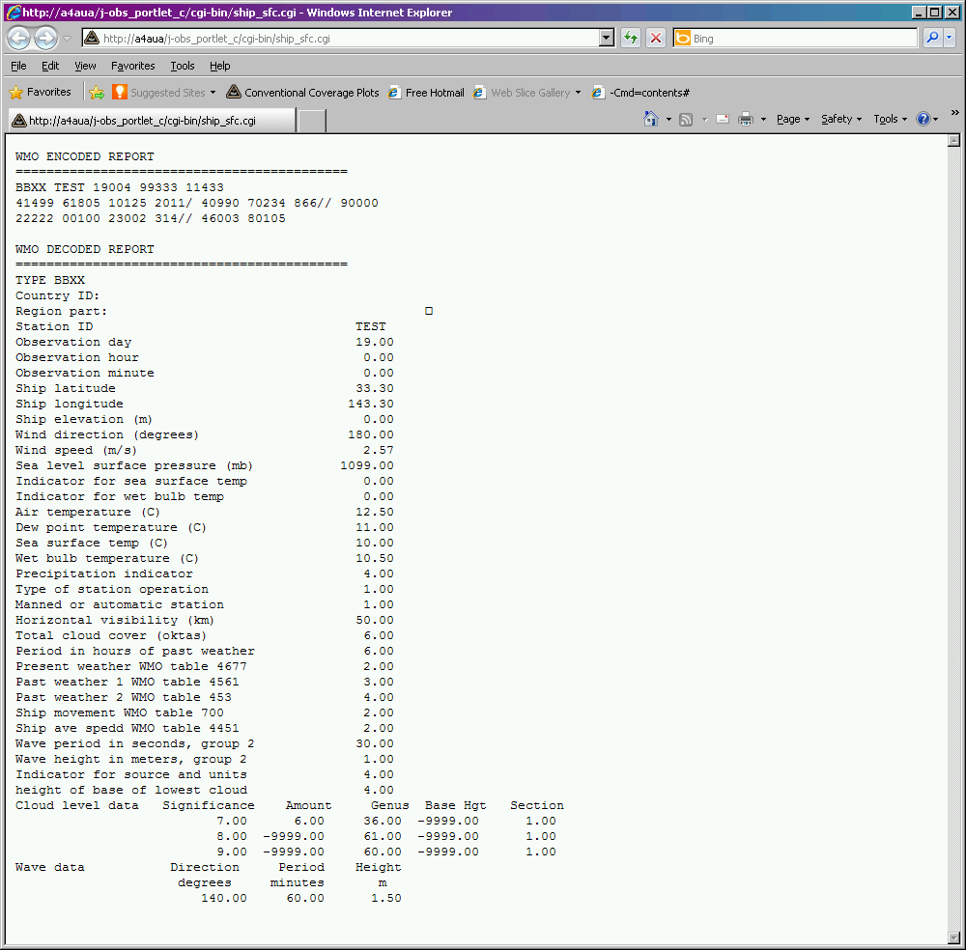

Click Submit observation. A new window will appear with the following similar information.

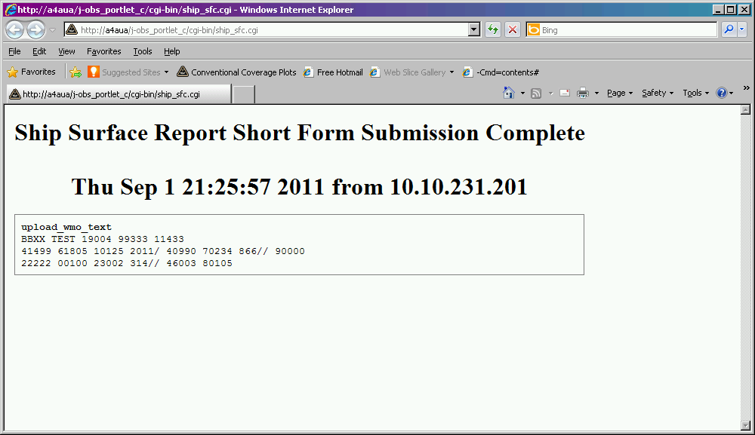

c) SHIP APLICATIONS Encoded Upper Air Sounding

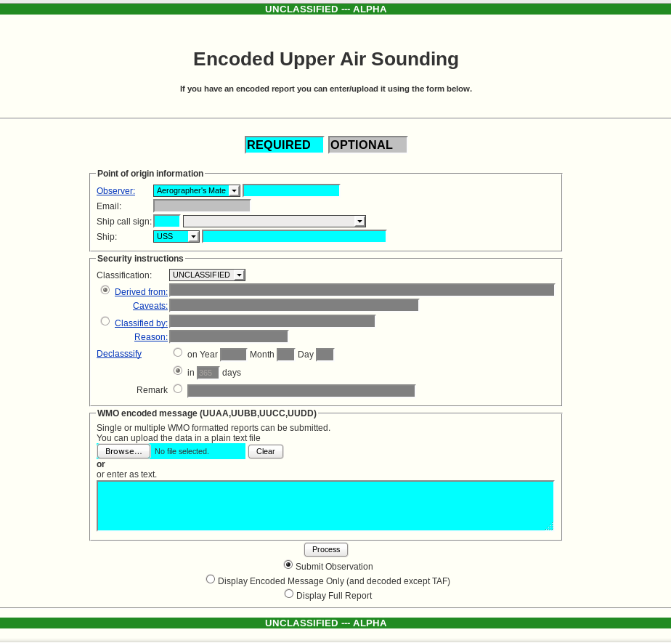

Point of origin information
Observer: Smith Ship call sign: TEST Ship: USS Test
Time of observation (UTC/Zulu)
Year: yyyy Month: mm Day: dd Hour: hh Minute:00
Security instructions
Classification:SECRET
Derived from: this is a test
Classified by: Reason:

Caveats: Declassify on Year Month Day in days

WMO encoded message (UUAA,UUBB,UUCC,UUDD)
enter as text
UUAA SHIP 19001 99137 70169 03836
99009 34462 30503 00085 28659 35001 92776 26067 08505
85516 22066 10006 70162 08857 13007 50585 07567 25009
40755 18939 23519 30964 32547 21524 25090 427// 24026
20237 557// 25031 15413 701// 26543 10651 757// 24523
88109 767// 24025
77149 26543 41618
31313 48008 81555 90301
UUBB SHIP 19008 99137 70169 03836
00008 32860 11005 30461 22002 30262 33001 31066 44987
31072 55859 23276 66664 05258 77623 01459 88601 01145
99589 02350 11578 03365 22573 02982 33555 03788 44507
06987 55458 10947 66450 10962 77448 10958 88443 11160
99411 15372 11363 23361 22321 29167 33297 33367 44237
473// 55174 631// 66174 635//
21212 00008 13002 11005 17001 22961 12005 33936 09005
44881 12507 55860 14005 66682 17003 77650 16005 88535
23002 99510 26504 11497 27006 22483 26509 33471 24514
44434 24521 55408 24017 66382 25519 77292 25026 88223
27032 99187 26533 11174 25529
31313 48008 81550 90301
41414 10901
51515 11901 11006 22800 16503 33600 27001
UUCC SHIP 1900/ 99137 70169 03836 NIL
UUDD SHIP 1900/ 99137 70169 03836
11870 779// 22576 679//
21212 11841 26519 22785 22013 33704 23508 44671 29005
55659 24002 66643 16006 77610 20006 88577 19004
31313 48008 81555 90301

Next click the Display Encoded Message Only (and decoded except TAF). Text similar to the following will appear in a new window.

WMO ENCODED REPORT
===========================================
UUAA SHIP 19001 99137 70169 03836
99009 34462 30503 00085 28659 35001 92776 26067 08505
85516 22066 10006 70162 08857 13007 50585 07567 25009
40755 18939 23519 30964 32547 21524 25090 427// 24026
20237 557// 25031 15413 701// 26543 10651 757// 24523
88109 767// 24025
77149 26543 41618
31313 48008 81555 90301
UUBB SHIP 19008 99137 70169 03836
00008 32860 11005 30461 22002 30262 33001 31066 44987
31072 55859 23276 66664 05258 77623 01459 88601 01145
99589 02350 11578 03365 22573 02982 33555 03788 44507
06987 55458 10947 66450 10962 77448 10958 88443 11160
99411 15372 11363 23361 22321 29167 33297 33367 44237
473// 55174 631// 66174 635//
21212 00008 13002 11005 17001 22961 12005 33936 09005
44881 12507 55860 14005 66682 17003 77650 16005 88535
23002 99510 26504 11497 27006 22483 26509 33471 24514
44434 24521 55408 24017 66382 25519 77292 25026 88223
27032 99187 26533 11174 25529
31313 48008 81550 90301
41414 10901
51515 11901 11006 22800 16503 33600 27001
UUCC SHIP 1900/ 99137 70169 03836 NIL
UUDD SHIP 1900/ 99137 70169 03836
11870 779// 22576 679//
21212 11841 26519 22785 22013 33704 23508 44671 29005
55659 24002 66643 16006 77610 20006 88577 19004
31313 48008 81555 90301

WMO DECODED REPORT
===========================================
Ship/mobil ID: SHIP
Country ID:
Region part: UUAA
Latitude: 13.70
Longitude: -16.90
Report Intrument type WMO table C-2: 80.00
Marsden square WMO table 2590: 38.00
Launch hour: 15.00
Launch minute: 55.00
Solar/infrared corr. WMO table 3849: 4.00
Tracking tech. WMO table 3872: 8.00
Sea surface temp. (C): 30.10
Day: 19.00
Hour: 0.00
Wind intru. type, BUFR talbe 002002: 0.00

Number of sounding levels: 14.00
Significance pressure height temperature dew point wind dir wind speed
(mb) (m) (C) (C) (degrees) (m/s)
64. 1009.0 -9999. 34.4 22.4 305. 3.0
32. 1000.0 85. 28.6 19.6 350. 1.0
32. 925.0 776. 26.0 9.0 85. 5.0
32. 850.0 1516. 22.0 6.0 100. 6.0
32. 700.0 3162. 8.8 1.8 130. 7.0
32. 500.0 5850. -7.5 -24.5 250. 9.0
32. 400.0 7550. -18.9 -22.8 235. 19.0
32. 300.0 9640. -32.5 -37.2 215. 24.0
32. 250.0 10900. -42.7 -9999.0 240. 26.0
32. 200.0 12370. -55.7 -9999.0 250. 31.0
32. 150.0 14130. -70.1 -9999.0 265. 43.0
32. 100.0 16510. -75.7 -9999.0 245. 23.0
16. 109.0 -9999. -76.7 -9999.0 240. 25.0
8. 149.0 -9999. -9999.0 -9999.0 265. 43.0
===========================================
Ship/mobil ID: SHIP
Country ID:
Region part: UUBB
Latitude: 13.70
Longitude: -16.90
Report Intrument type WMO table C-2: 80.00
Mearsuring equip. WMO 0285: 8.00
Marsden square WMO table 2590: 38.00
Launch hour: 15.00
Launch minute: 50.00
Solar/infrared corr. WMO table 3849: 4.00
Tracking tech. WMO table 3872: 8.00
Sea surface temp. (C): 30.10
Day: 19.00
Hour: 0.00
Wind intru. type, BUFR talbe 002002: 0.00
Cloud amount, BUFR table 020011: 1.00
Height of lowest cloud: 9.00
Cloud type, BUFR table 020012
Number of cloud types: 3.00
30.00
20.00
11.00

Number of sounding levels: 44.00
Significance pressure height temperature dew point wind dir wind speed
(mb) (m) (C) (C) (degrees) (m/s)
64. 1008.0 -9999. 32.8 22.8 -9999. -9999.0
4. 1005.0 -9999. 30.4 19.4 -9999. -9999.0
4. 1002.0 -9999. 30.2 18.2 -9999. -9999.0
4. 1001.0 -9999. 31.0 15.0 -9999. -9999.0
4. 987.0 -9999. 31.0 9.0 -9999. -9999.0
4. 859.0 -9999. 23.2 -2.8 -9999. -9999.0
4. 664.0 -9999. 5.2 -2.8 -9999. -9999.0
4. 623.0 -9999. 1.4 -7.6 -9999. -9999.0
4. 601.0 -9999. -1.1 -5.6 -9999. -9999.0
4. 589.0 -9999. -2.3 -7.3 -9999. -9999.0
4. 578.0 -9999. -3.3 -18.3 -9999. -9999.0
4. 573.0 -9999. -2.9 -34.9 -9999. -9999.0
4. 555.0 -9999. -3.7 -41.7 -9999. -9999.0
4. 507.0 -9999. -6.9 -43.9 -9999. -9999.0
4. 458.0 -9999. -10.9 -15.6 -9999. -9999.0
4. 450.0 -9999. -10.9 -22.9 -9999. -9999.0
4. 448.0 -9999. -10.9 -18.9 -9999. -9999.0
4. 443.0 -9999. -11.1 -21.1 -9999. -9999.0
4. 411.0 -9999. -15.3 -37.3 -9999. -9999.0
4. 363.0 -9999. -23.3 -34.3 -9999. -9999.0
4. 321.0 -9999. -29.1 -46.1 -9999. -9999.0
4. 297.0 -9999. -33.3 -50.3 -9999. -9999.0
4. 237.0 -9999. -47.3 -9999.0 -9999. -9999.0
4. 174.0 -9999. -63.1 -9999.0 -9999. -9999.0
64. 1008.0 -9999. -9999.0 -9999.0 130. 2.0
2. 1005.0 -9999. -9999.0 -9999.0 170. 1.0
2. 961.0 -9999. -9999.0 -9999.0 120. 5.0
2. 936.0 -9999. -9999.0 -9999.0 90. 5.0
2. 881.0 -9999. -9999.0 -9999.0 125. 7.0
2. 860.0 -9999. -9999.0 -9999.0 140. 5.0
2. 682.0 -9999. -9999.0 -9999.0 170. 3.0
2. 650.0 -9999. -9999.0 -9999.0 160. 5.0
2. 535.0 -9999. -9999.0 -9999.0 230. 2.0
2. 510.0 -9999. -9999.0 -9999.0 265. 4.0
2. 497.0 -9999. -9999.0 -9999.0 270. 6.0
2. 483.0 -9999. -9999.0 -9999.0 265. 9.0
2. 471.0 -9999. -9999.0 -9999.0 245. 14.0
2. 434.0 -9999. -9999.0 -9999.0 245. 21.0
2. 408.0 -9999. -9999.0 -9999.0 240. 17.0
2. 382.0 -9999. -9999.0 -9999.0 255. 19.0
2. 292.0 -9999. -9999.0 -9999.0 250. 26.0
2. 223.0 -9999. -9999.0 -9999.0 270. 32.0
2. 187.0 -9999. -9999.0 -9999.0 265. 33.0
2. 174.0 -9999. -9999.0 -9999.0 255. 29.0
Number of diagonstic codes: 1.00
115.00
===========================================
===========================================
Ship/mobil ID: SHIP
Country ID:
Region part: UUDD
Latitude: 13.70
Longitude: -16.90
Report Intrument type WMO table C-2: 80.00
Marsden square WMO table 2590: 38.00
Launch hour: 15.00
Launch minute: 55.00
Solar/infrared corr. WMO table 3849: 4.00
Tracking tech. WMO table 3872: 8.00
Sea surface temp. (C): 30.10
Day: 19.00
Hour: 0.00
Wind intru. type, BUFR talbe 002002: 0.00

Number of sounding levels: 10.00
Significance pressure height temperature dew point wind dir wind speed
(mb) (m) (C) (C) (degrees) (m/s)
4. 87.0 -9999. -77.9 -9999.0 -9999. -9999.0
4. 57.6 -9999. -67.9 -9999.0 -9999. -9999.0
2. 84.1 -9999. -9999.0 -9999.0 265. 19.0
2. 78.5 -9999. -9999.0 -9999.0 220. 13.0
2. 70.4 -9999. -9999.0 -9999.0 235. 8.0
2. 67.1 -9999. -9999.0 -9999.0 290. 5.0
2. 65.9 -9999. -9999.0 -9999.0 240. 2.0
2. 64.3 -9999. -9999.0 -9999.0 160. 6.0
2. 61.0 -9999. -9999.0 -9999.0 200. 6.0
2. 57.7 -9999. -9999.0 -9999.0 190. 4.0

Click Submit observation. A new window will appear with the following information.

upload_wmo text
UUAA SHIP 19001 99137 70169 03836
99009 34462 30503 00085 28659 35001 92776 26067 08505
85516 22066 10006 70162 08857 13007 50585 07567 25009
40755 18939 23519 30964 32547 21524 25090 427// 24026
20237 557// 25031 15413 701// 26543 10651 757// 24523
88109 767// 24025
77149 26543 41618
31313 48008 81555 90301
UUBB SHIP 19008 99137 70169 03836
00008 32860 11005 30461 22002 30262 33001 31066 44987
31072 55859 23276 66664 05258 77623 01459 88601 01145
99589 02350 11578 03365 22573 02982 33555 03788 44507
06987 55458 10947 66450 10962 77448 10958 88443 11160
99411 15372 11363 23361 22321 29167 33297 33367 44237
473// 55174 631// 66174 635//
21212 00008 13002 11005 17001 22961 12005 33936 09005
44881 12507 55860 14005 66682 17003 77650 16005 88535
23002 99510 26504 11497 27006 22483 26509 33471 24514
44434 24521 55408 24017 66382 25519 77292 25026 88223
27032 99187 26533 11174 25529
31313 48008 81550 90301
41414 10901
51515 11901 11006 22800 16503 33600 27001
UUCC SHIP 1900/ 99137 70169 03836 NIL
UUDD SHIP 1900/ 99137 70169 03836
11870 779// 22576 679//
21212 11841 26519 22785 22013 33704 23508 44671 29005
55659 24002 66643 16006 77610 20006 88577 19004
31313 48008 81555 90301

d) SHIP APPLICATIONS Bathy

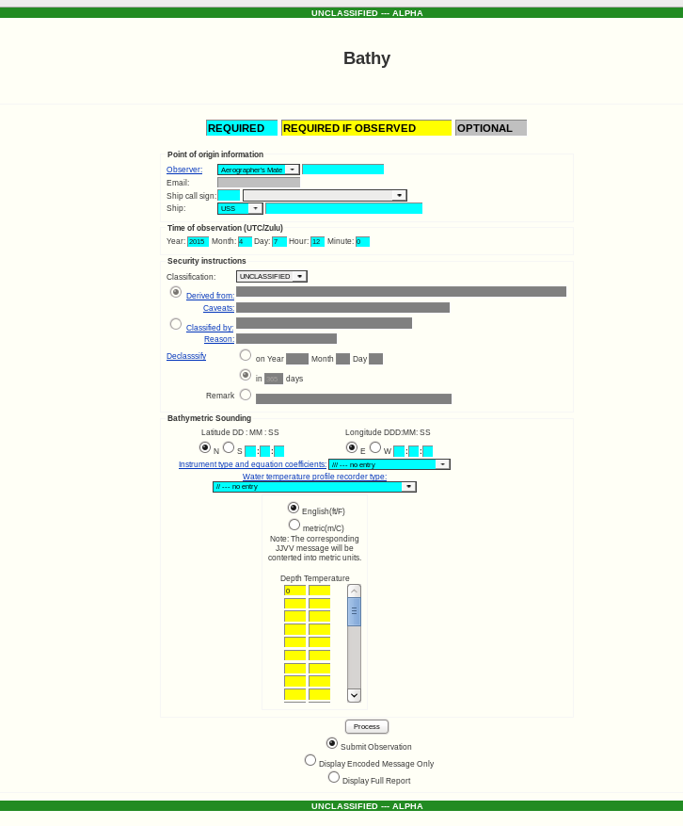

Point of origin information
Observer: Smith Ship call sign: TEST Ship: USS Test
Time of observation (UTC/Zulu)
Year: yyyy Month: mm Day: dd Hour: hh Minute:00
Security instructions
Classification:SECRET
Derived from: this is a test
Classified by: Reason:

Caveats: Declasssify on Year Month Day in days

Latitude N DD:MM:SS 33:33:33
Longitude D DDD:MM:SS 133:33:33

Instument type and equation coefficients: /// --- no entry
Water temperature profile recorder type: // --- no entry

Metric (m/C)
Depth Temperature
- 13.5
- 12.0
- 11.5
- 10.0
- 8.5
- 9.0

Click Submit observation. A new window will appear with the following information. Remember dd is the day, mm the month, hh is the hour and MM is the minute

Generated WMO encoded message
JJVV ddmm6 hhMM/ 133559 133559
88888 00000 00135 99901 00120 99902 00115
99903 00100 99904 00085 99905 00090 TEST

e) SHIP STATION Encoded Bathy

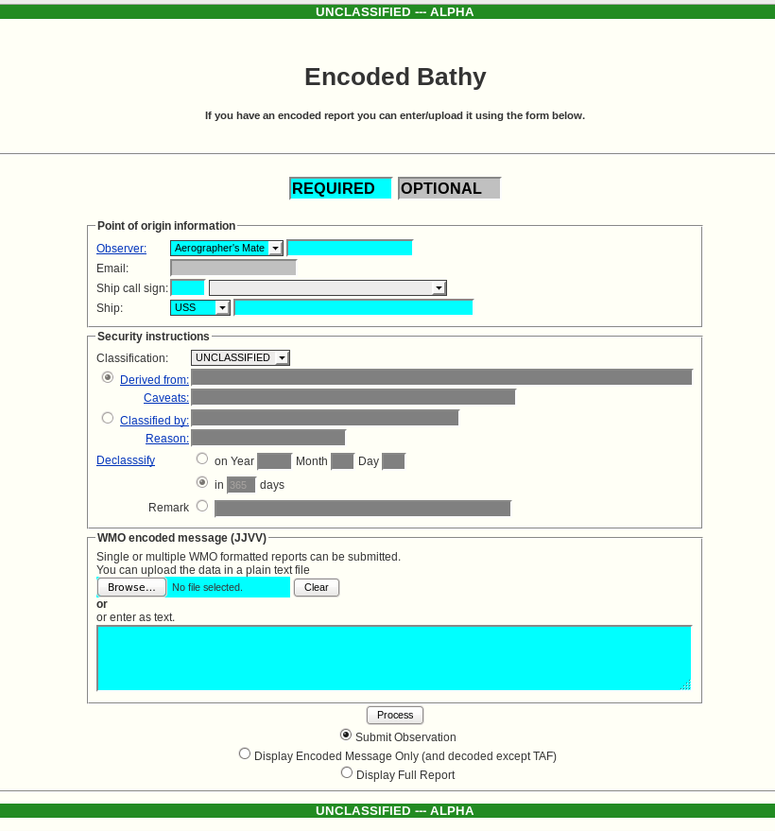

i) Metric units

Point of origin information
Observer: Smith Ship call sign: TEST Ship: USS Test
Time of observation (UTC/Zulu)
Year: yyyy Month: mm Day: dd Hour: hh Minute:00
Security instructions
Classification:SECRET
Derived from: this is a test
Classified by: Reason:

Caveats: Declasssify on Year Month Day in days

WMO encoded message (JJVV)
enter as text
JJVV 19126 1400/ 133559 133559
88888 00000 00135 99901 00120 99902 00115
99903 00100 99904 00085 99905 00090 TEST

Next click the Display Encoded Message Only (and decoded except TAF). A new window similar to the following will appear.

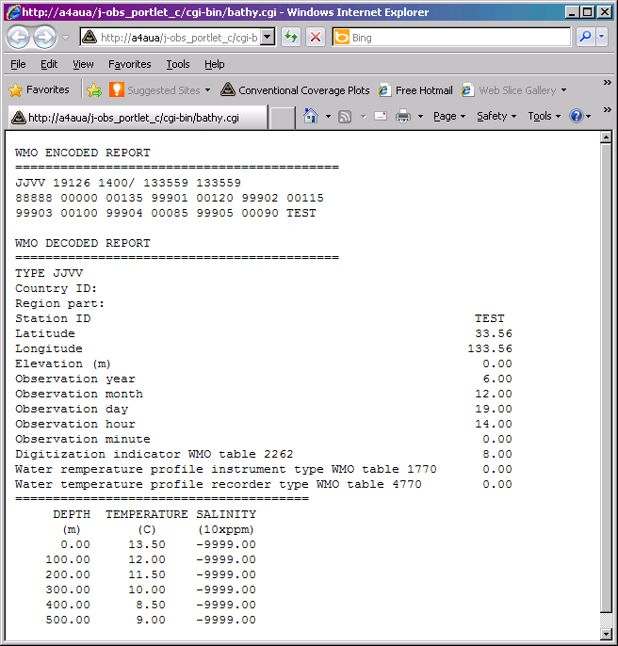
Click Submit observation. A new window will appear with the following information.

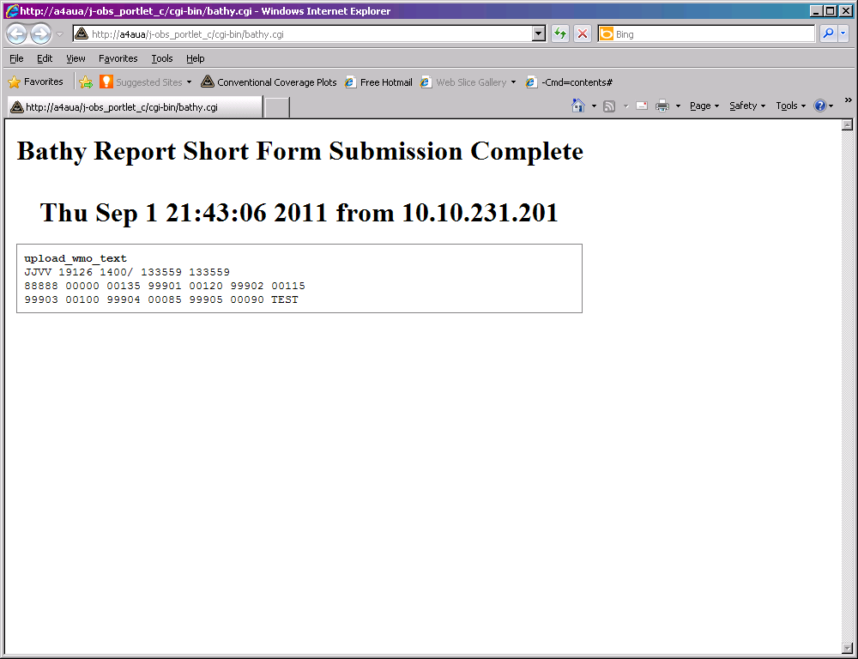

ii) English units

Point of origin information
Observer: Smith Ship call sign: TEST Ship: USS Test
Time of observation (UTC/Zulu)
Year: yyyy Month: mm Day: dd Hour: hh Minute:00
Security instructions
Classification:SECRET
Derived from: this is a test

WMO encoded message (JJVV)
enter as text
JJVV 19126 14009 133559 133559
88888 00000 00175 99901 00700 99902 00600
99903 00550 99904 00500 99905 00450 TEST

Next click the Display Encoded Message Only (and decoded except TAF). A new window similar to the following will appear.

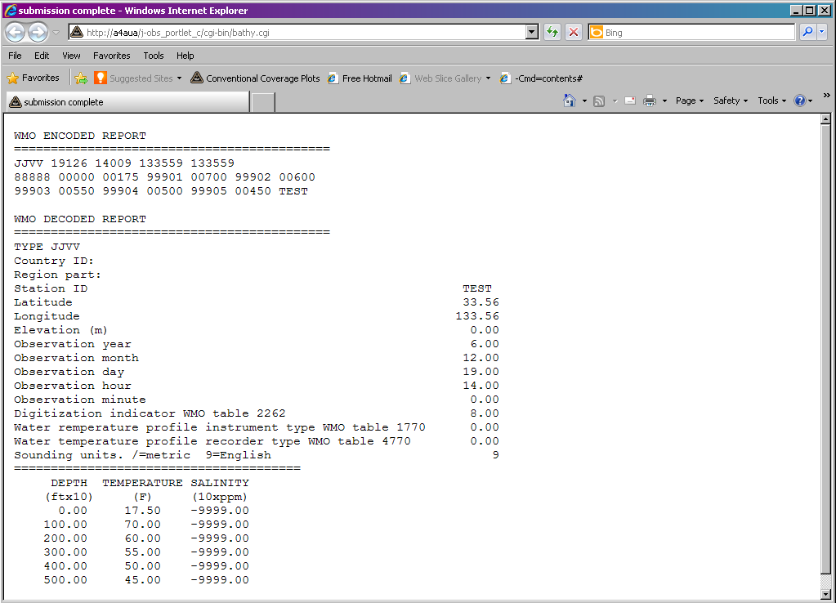
Click Submit observation. A new window will appear with the following information.

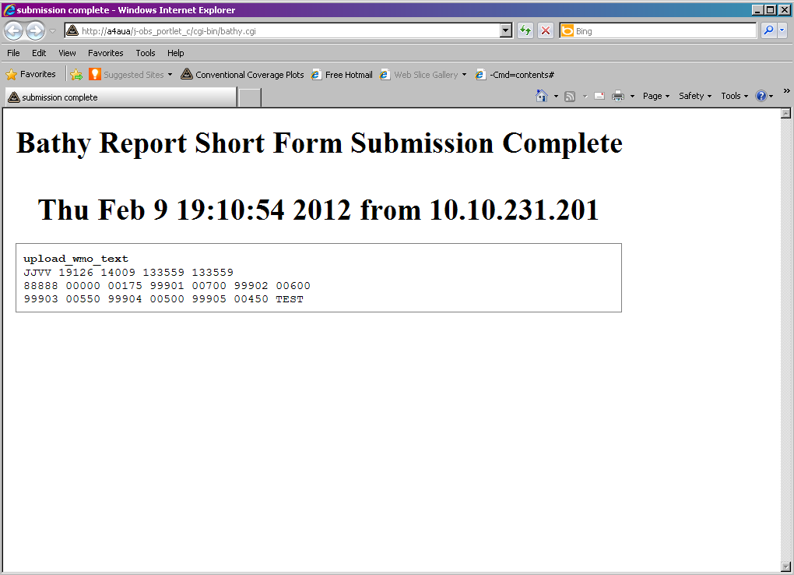

f) SHIP APPLICATIONS TAF

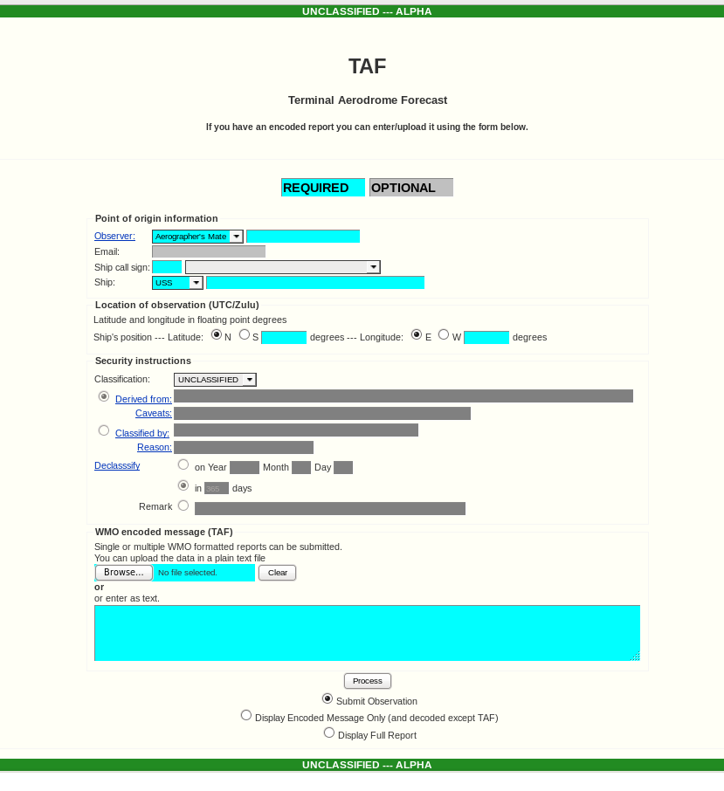

Point of origin information
Observer: Smith Ship call sign: TEST Ship: USS Test
Time of observation (UTC/Zulu)
Year: yyyy Month: mm Day: dd Hour: hh Minute:00
Security instructions
Classification:SECRET
Derived from: this is a test
Classified by: Reason:

Caveats: Declasssify on Year Month Day in days

WMO encoded message (TAF)
enter as text
TAF TEST 19003 99369 70338 41498 81812 10260 2023/ 40260 56010
78182 886// 22264 0//// 202// 3//// 406// 5//// 6//// 80235 ICE

Click Submit observation. A new window will appear with the following information.

upload_wmo text
TAF TEST 19003 99369 70338 41498 81812 10260 2023/ 40260 56010
78182 886// 22264 0//// 202// 3//// 406// 5//// 6//// 80235 ICE

g) LAND MOBILE APPLICATIONS Encoded Surface Weather Observation

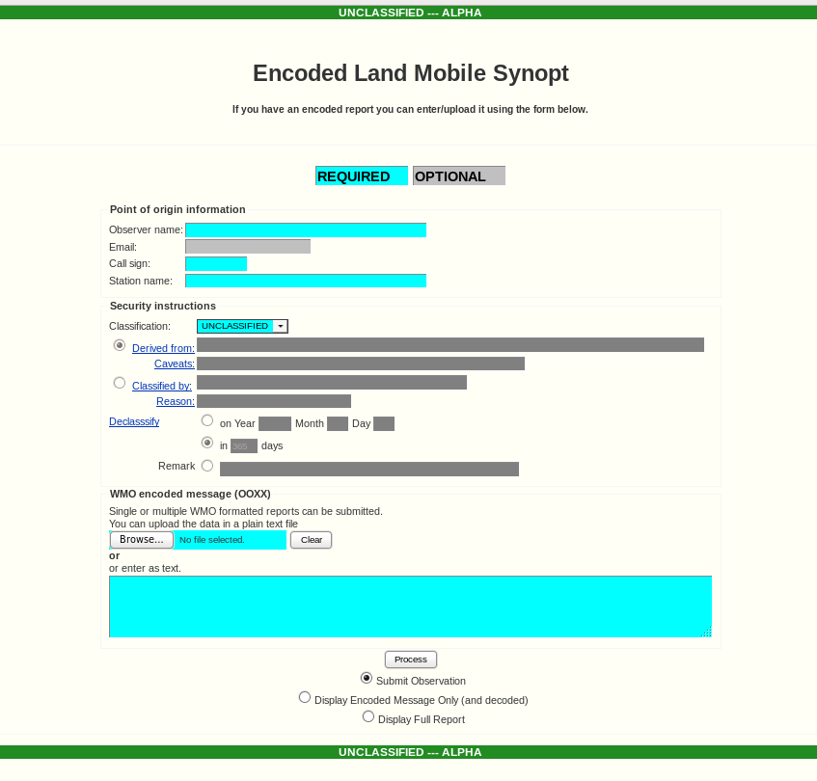

Point of origin information
Observer: Smith Call sign: LAND Station name: Land
Time of observation (UTC/Zulu)
Year: yyyy Month: mm Day: dd Hour: hh Minute:00
Security instructions
Classification:SECRET
Derived from: this is a test
Classified by: Reason:

Caveats: Declasssify on Year Month Day in days

WMO encoded message (TAF)
enter as text
OOXX LAND 19003 99369 70338 11263 00102
41498 81812 10260 2023/ 40260 56010 78182 886//
22264 0//// 202// 3//// 406// 5//// 6//// 80235

Click Submit observation. A new window will appear with the following information.

upload_wmo text
OOXX LAND 19003 99369 70338 11263 00102
41498 81812 10260 2023/ 40260 56010 78182 886//
22264 0//// 202// 3//// 406// 5//// 6//// 80235

h) LAND MOBILE APPLICATIONS Encoded Upper Air

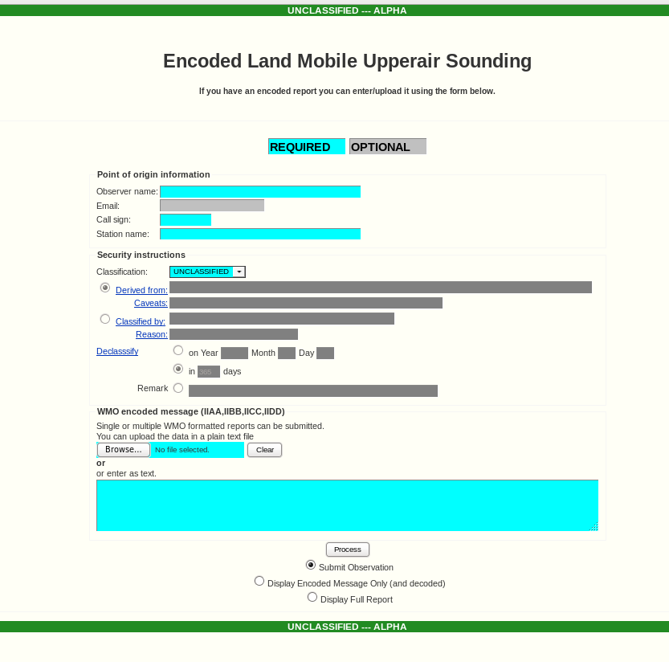

Point of origin information
Observer: Smith Call sign: LAND Station name: Land
Time of observation (UTC/Zulu)
Year: yyyy Month: mm Day: dd Hour: hh Minute:00
Security instructions
Classification:SECRET
Derived from: this is a test
Classified by: Reason:

Caveats: Declasssify on Year Month Day in days

WMO encoded message (IIAA,IIBB,IICC,IIDD)
enter as text
IIAA LAND 19004 99140 70170 03837 00051
99009 28865 05007 00087 28472 05508 92776 26877 07010
85513 20871 09507 70154 08459 12005 50584 06921 23512
40755 17517 23523
88999
77999
IIBB LAND 19008 99140 70170 03837 00051
00009 28865 11991 27672 22979 29080 33922 26877 44631
01636 55568 04157 66561 04930 77526 07717 88518 05909
99483 07930 11375 20313 22327 277//
21212 00009 05007 11977 06008 22928 07010 33913 08008
44873 10009 55825 10006 66791 14006 77765 13503 88702
11505 99692 13005 11675 12005 22659 14005 33608 13506
44542 22004 55506 23012 66464 24516 77404 23523 88369
21521 99327 22021

Click Submit observation. A new window will appear with the following information.

upload_wmo text
IIAA LAND 19004 99140 70170 03837 00051
99009 28865 05007 00087 28472 05508 92776 26877 07010
85513 20871 09507 70154 08459 12005 50584 06921 23512
40755 17517 23523
88999
77999
IIBB LAND 19008 99140 70170 03837 00051
00009 28865 11991 27672 22979 29080 33922 26877 44631
01636 55568 04157 66561 04930 77526 07717 88518 05909
99483 07930 11375 20313 22327 277//
21212 00009 05007 11977 06008 22928 07010 33913 08008
44873 10009 55825 10006 66791 14006 77765 13503 88702
11505 99692 13005 11675 12005 22659 14005 33608 13506
44542 22004 55506 23012 66464 24516 77404 23523 88369
21521 99327 22021

i) AIRCRAFT APPLICATIONS Encoded AMDAR

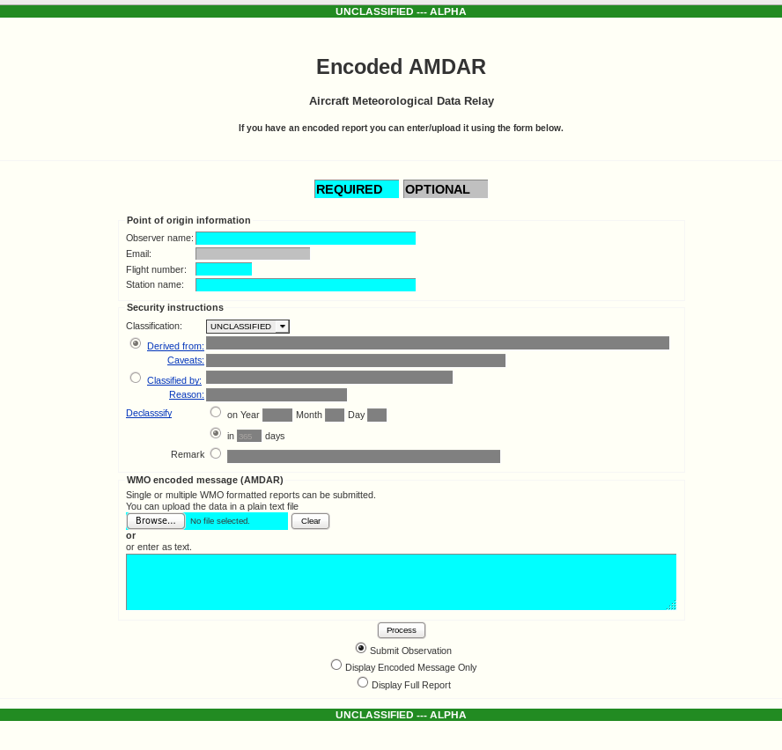

Observer name : Smith
Flight number: 12345
Station name: Anywhere
Hour: 12
Minute: 00
Classification: UNCLAS

Enter the following in the text box within the encoded message section.

AMDAR 1409
LVR EU2276 5514N 01320W 140930 F379 MS517 231/066 TB0 S031=
LVR EU2276 5528N 01449W 140937 F379 MS505 228/057 TB0 S031=
LVR EU2276 5554N 01616W 140944 F379 MS480 225/045 TB0 S031=
LVR EU2276 5622N 01745W 140951 F379 MS452 212/033 TB0 S031=
LVR EU2276 5648N 01919W 140958 F379 MS440 206/026 TB0 S031=
LVR EU2276 5713N 02055W 141005 F379 MS440 188/027 TB0 S031=
LVR EU2276 5737N 02236W 141012 F379 MS420 182/021 TB0 S031=
LVR EU2276 5759N 02420W 141019 F379 MS430 164/022 TB0 S031=
LVR EU2276 5820N 02606W 141026 F379 MS420 172/023 TB0 S031=
LVR EU2276 5839N 02754W 141033 F379 MS417 158/017 TB0 S031=

Then click the “Display Encoded Message Only” button and submit. The following should appear.

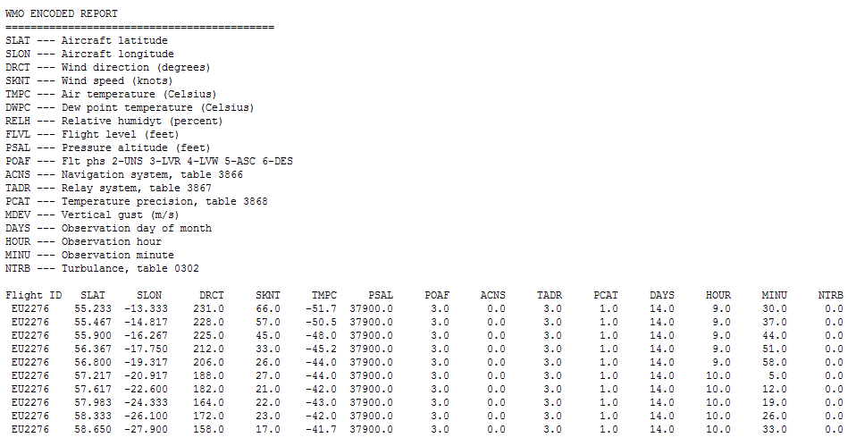

Next, click the “Display Full Report” and the following should appear.

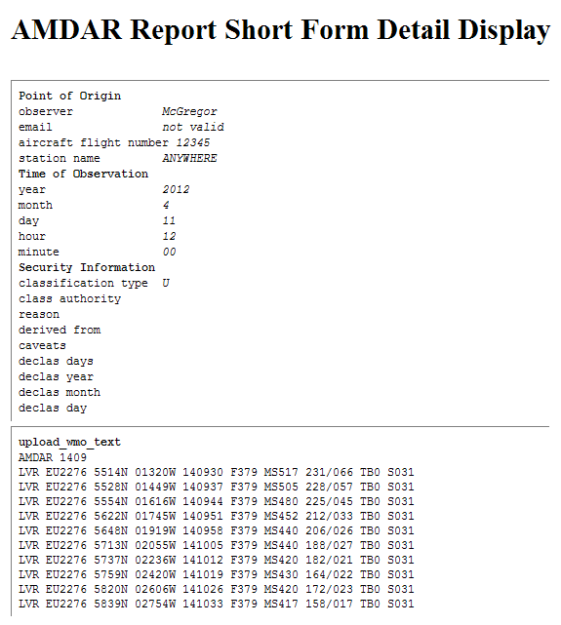

Finally click on “Submit Observation: and submit. Something similar to the following should appear.

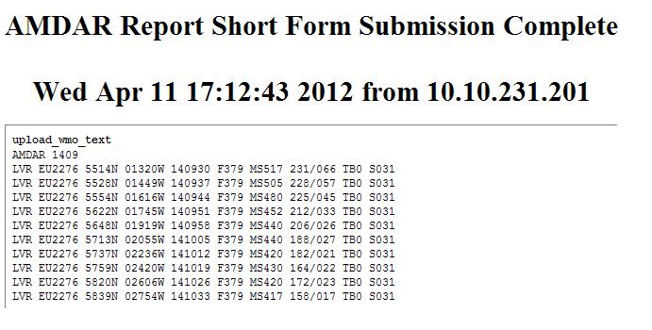

3) Data Inspection

a) Counts Web Page

Go back to the main web page and click on the “Counts” link. You will
See a web page similar to the following but with more listings.

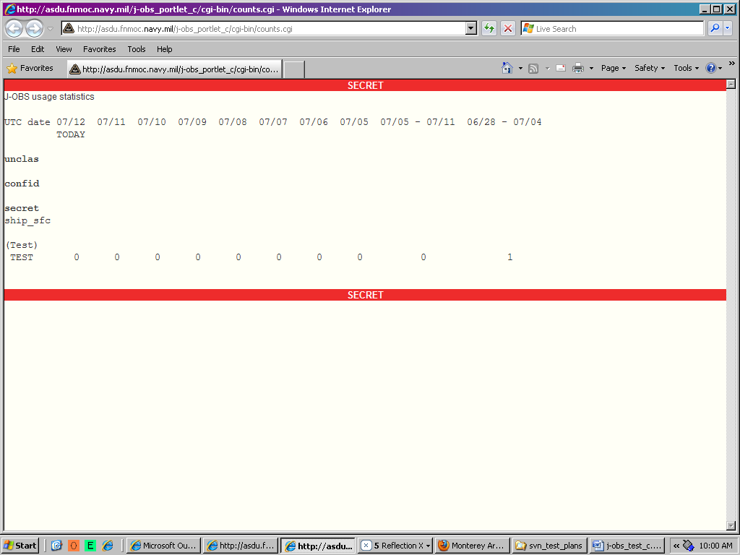

b) Data Display Web Page

Go back to the main web page and click on the “Data Display” link. You will see a web page similar to the following but with more listings.

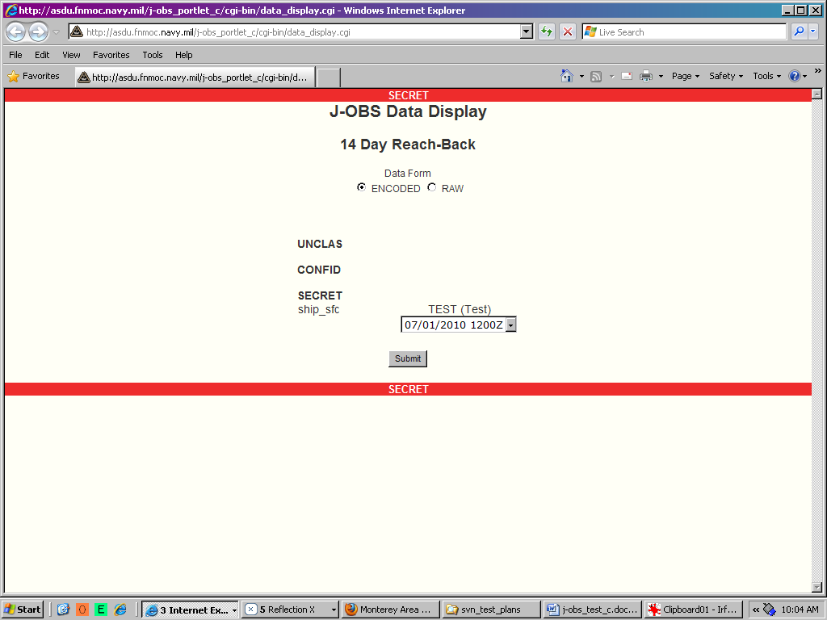

Click on any of the input boxes that contain a data and time and a web page similar to following will appear.

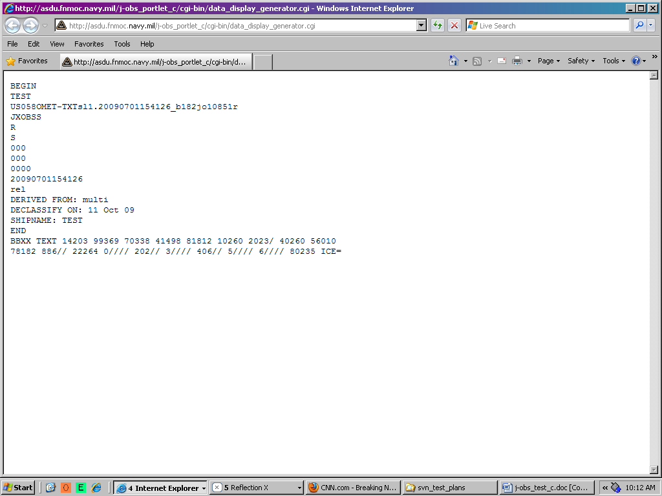

Delete that page and go back to click on the “raw” radio button and the click on any of the input boxes that contain a data and time and a web page similar to following will appear.

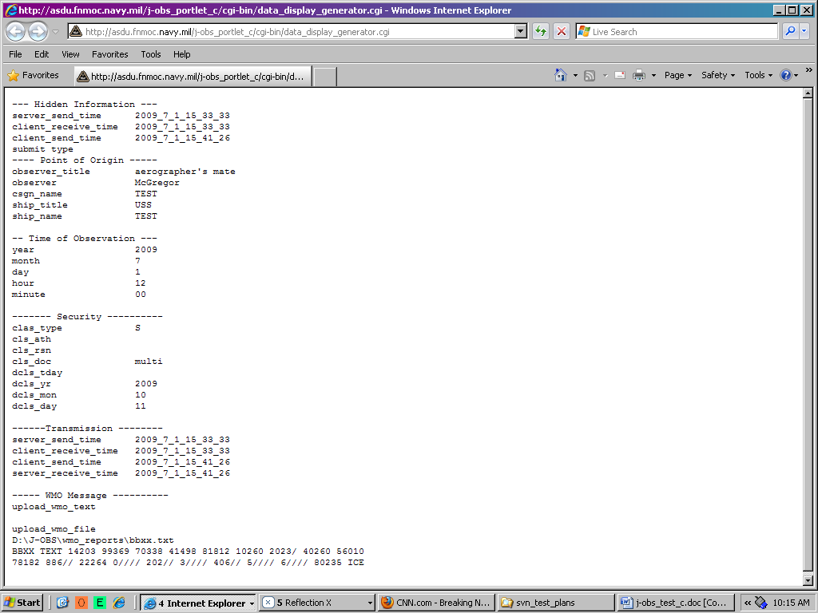

Next click DECODED for a ship_sfc observation and new window similar to the following will appear.

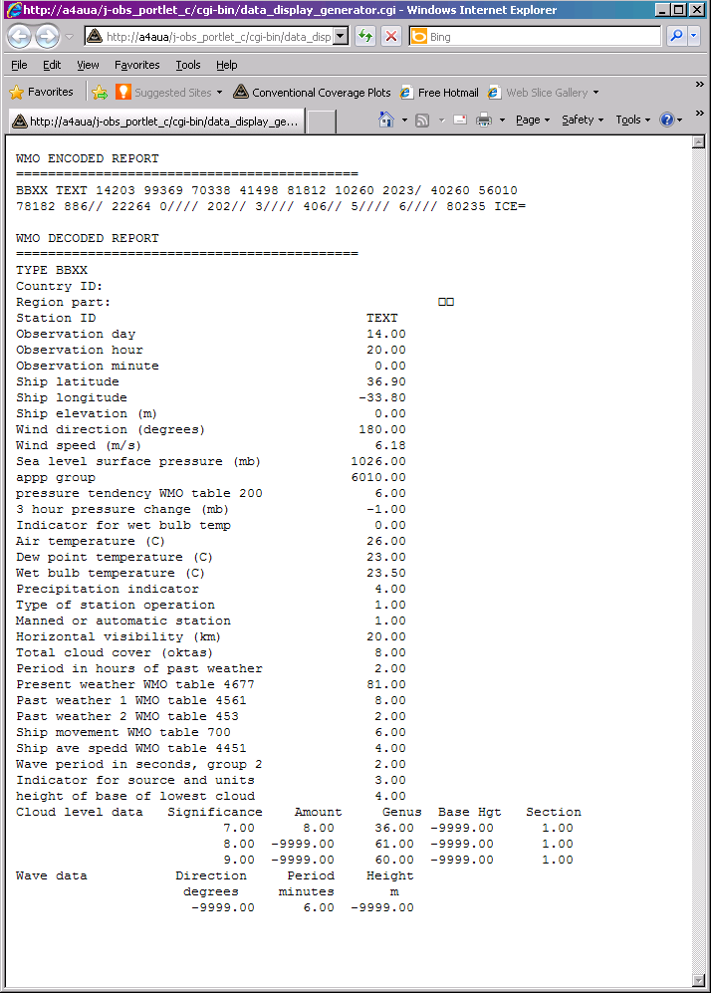
Next click DECODED for a ship_raob observation and new window with following similar text will appear.

WMO ENCODED REPORT
===========================================
UUAA HEALY 79001 99847 71672 91747
99011 02513 18001 00119 03306 17003 92738 00162 22005
85413 02359 23004 70933 12334 19512 50544 25163 19524
40703 36165 18024 30896 49561 18033 25015 49174 17532
20163 46584 19018 15354 46985 20509 10622 47385 20008
88294 50561 18034
77999
31313 41308 82344 9////
51515 10164 00006 10194 22003 20010=
UUBB HEALY 79008 99847 71672 91747
00011 02513 11014 00930 22008 02513 33006 00112 44006
02916 55005 00912 66005 02716 77977 04701 88968 03141
99964 02503 11954 01901 22943 00902 33938 00534 44935
00561 55929 00366 66923 00165 77921 00159 88919 00063
99910 00065 11907 00157 22898 00365 33892 00558 44839
02760 55837 02738 66835 02757 77808 03320 88800 02956
99784 04358 11623 19902 22616 15513 33609 14156 44608
14138 55607 14560 66606 14362 77524 23959 88450 30566
99388 36967 11337 45360 22301 49361 33294 50561 44258
49772 55167 45986 66162 45386 77100 47385 88163 44787
99227 45985 11289 50768 22350 43560 33394 36763 44491
26562 55514 25157 66614 14767 77621 19756 88624 19944
99628 19719 11653 17501 22790 04350 33913 00748 44935
01314 55943 01349 66977 04708 77996 03701
31313 41308 82344 9////
41414 /////=

WMO DECODED REPORT
===========================================
Ship/mobil ID: HEALY
Country ID:
Region part: UUAA
Latitude: 84.70
Longitude: -167.20
Report Intrument type WMO table C-2: 13.00
Marsden square WMO table 2590: 917.00
Launch hour: 23.00
Launch minute: 44.00
Solar/infrared corr. WMO table 3849: 4.00
Tracking tech. WMO table 3872: 8.00
Day: 29.00
Hour: 0.00
Wind intru. type, BUFR talbe 002002: 4.00

Number of sounding levels: 13.00
Significance pressure height temperature dew point wind dir wind speed
(mb) (m) (C) (C) (degrees) (m/s)
64. 1011.0 -9999. -2.5 -3.8 180. 0.5
32. 1000.0 119. -3.3 -3.9 170. 1.5
32. 925.0 738. -0.1 -12.1 220. 2.6
32. 850.0 1413. -2.3 -11.3 230. 2.1
32. 700.0 2933. -12.3 -15.7 195. 6.2
32. 500.0 5440. -25.1 -38.1 195. 12.4
32. 400.0 7030. -36.1 -51.1 180. 12.4
32. 300.0 8960. -49.5 -60.5 180. 17.0
32. 250.0 10150. -49.1 -73.1 175. 16.5
32. 200.0 11630. -46.5 -80.5 190. 9.3
32. 150.0 13540. -46.9 -81.9 205. 4.6
32. 100.0 16220. -47.3 -82.3 200. 4.1
16. 294.0 -9999. -50.5 -61.5 180. 17.5
===========================================
Ship/mobil ID: HEALY
Country ID:
Region part: UUBB
Latitude: 84.70
Longitude: -167.20
Mearsuring equip. WMO 0285: 8.00
Marsden square WMO table 2590: 917.00
Day: 29.00
Hour: 0.00
Wind intru. type, BUFR talbe 002002: 4.00

Number of sounding levels: 41.00
Significance pressure height temperature dew point wind dir wind speed
(mb) (m) (C) (C) (degrees) (m/s)
64. 1011.0 -9999. -2.5 -3.8 -9999. -9999.0
4. 1008.0 -9999. -2.5 -3.8 -9999. -9999.0
4. 1006.0 -9999. -0.1 -1.3 -9999. -9999.0
4. 1005.0 -9999. -0.9 -2.1 -9999. -9999.0
4. 977.0 -9999. -4.7 -4.8 -9999. -9999.0
4. 968.0 -9999. -3.1 -7.2 -9999. -9999.0
4. 964.0 -9999. -2.5 -2.8 -9999. -9999.0
4. 954.0 -9999. -1.9 -2.0 -9999. -9999.0
4. 943.0 -9999. -0.9 -1.1 -9999. -9999.0
4. 938.0 -9999. -0.5 -3.9 -9999. -9999.0
4. 935.0 -9999. -0.5 -11.5 -9999. -9999.0
4. 929.0 -9999. -0.3 -16.3 -9999. -9999.0
4. 923.0 -9999. -0.1 -15.1 -9999. -9999.0
4. 921.0 -9999. -0.1 -9.1 -9999. -9999.0
4. 919.0 -9999. 0.0 -13.0 -9999. -9999.0
4. 910.0 -9999. 0.0 -15.0 -9999. -9999.0
4. 907.0 -9999. -0.1 -7.1 -9999. -9999.0
4. 898.0 -9999. -0.3 -15.3 -9999. -9999.0
4. 892.0 -9999. -0.5 -8.5 -9999. -9999.0
4. 839.0 -9999. -2.7 -12.7 -9999. -9999.0
4. 837.0 -9999. -2.7 -6.5 -9999. -9999.0
4. 835.0 -9999. -2.7 -9.7 -9999. -9999.0
4. 808.0 -9999. -3.3 -5.3 -9999. -9999.0
4. 800.0 -9999. -2.9 -8.9 -9999. -9999.0
4. 784.0 -9999. -4.3 -12.3 -9999. -9999.0
4. 623.0 -9999. -19.9 -20.1 -9999. -9999.0
4. 616.0 -9999. -15.5 -16.8 -9999. -9999.0
4. 609.0 -9999. -14.1 -20.1 -9999. -9999.0
4. 608.0 -9999. -14.1 -17.9 -9999. -9999.0
4. 607.0 -9999. -14.5 -24.5 -9999. -9999.0
4. 606.0 -9999. -14.3 -26.3 -9999. -9999.0
4. 524.0 -9999. -23.9 -32.9 -9999. -9999.0
4. 450.0 -9999. -30.5 -46.5 -9999. -9999.0
4. 388.0 -9999. -36.9 -53.9 -9999. -9999.0
4. 337.0 -9999. -45.3 -55.3 -9999. -9999.0
4. 301.0 -9999. -49.3 -60.3 -9999. -9999.0
4. 294.0 -9999. -50.5 -61.5 -9999. -9999.0
4. 258.0 -9999. -49.7 -71.7 -9999. -9999.0
4. 167.0 -9999. -45.9 -81.9 -9999. -9999.0
4. 162.0 -9999. -45.3 -81.3 -9999. -9999.0
4. 100.0 -9999. -47.3 -82.3 -9999. -9999.0
Number of diagonstic codes: 1.00
115.00

