General j-obs test plan

We will be utilizing data from the tag’s test directory. Go to tag#/test/upload_files.

On and FSL box, go to website “http://a8(a|b|o)(u|s)-a002/j-obs_training/cgi-bin/index.cgi”.

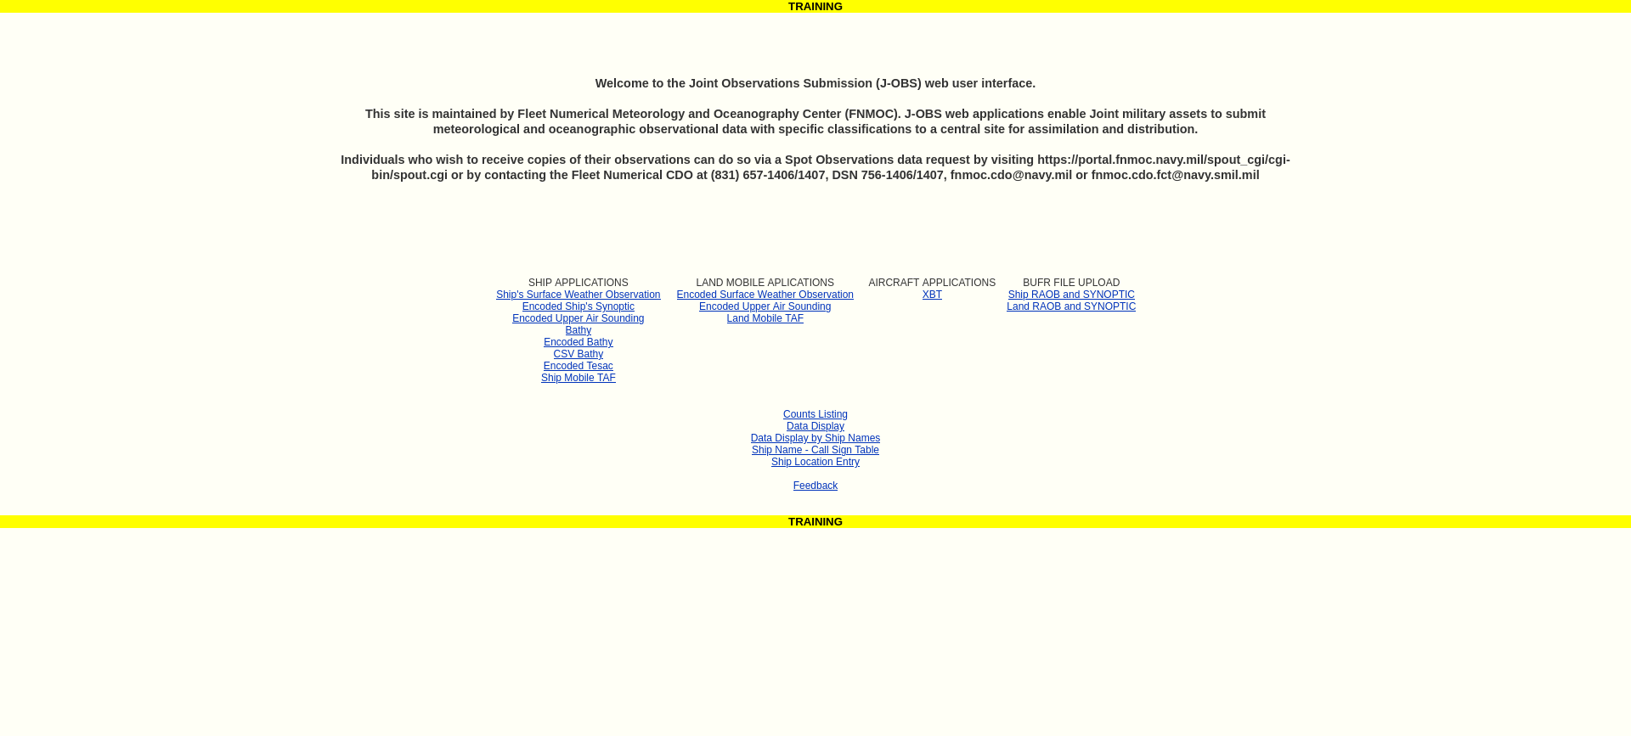

TEST 1) “Testing Encoded Ship’s Synoptic”

Under SHIP APPLICATIONS, select Encoded Ship’s Synoptic.

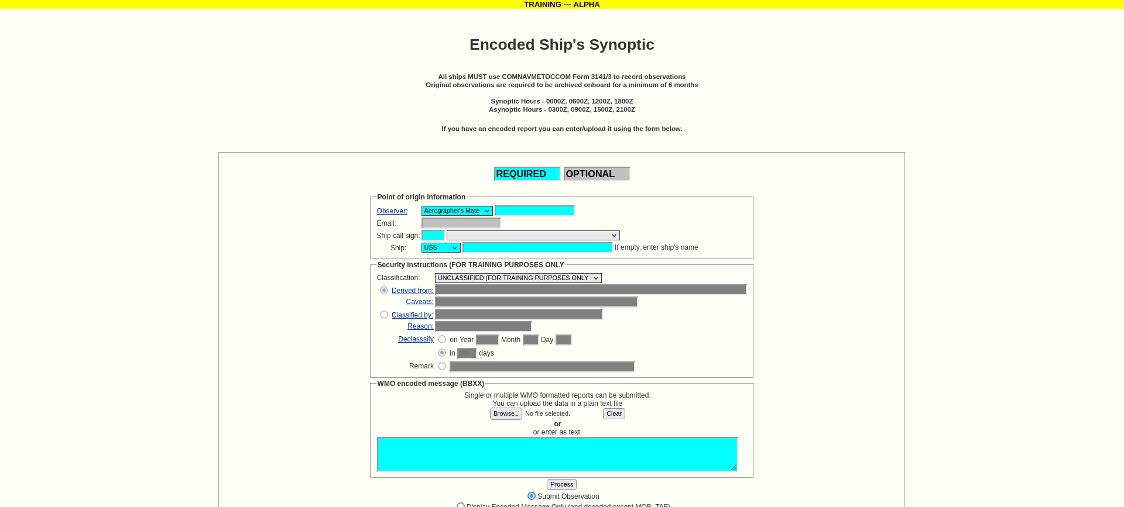

Open test/upload_files/bbxx_nwsw.txt. Fill out the form using the file’s info.

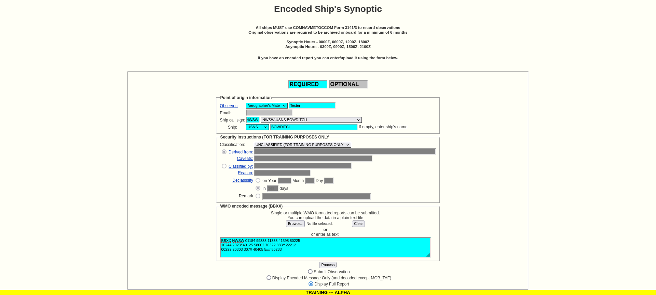

Select “Display Full Report” the the “Process” button. You should see the following;

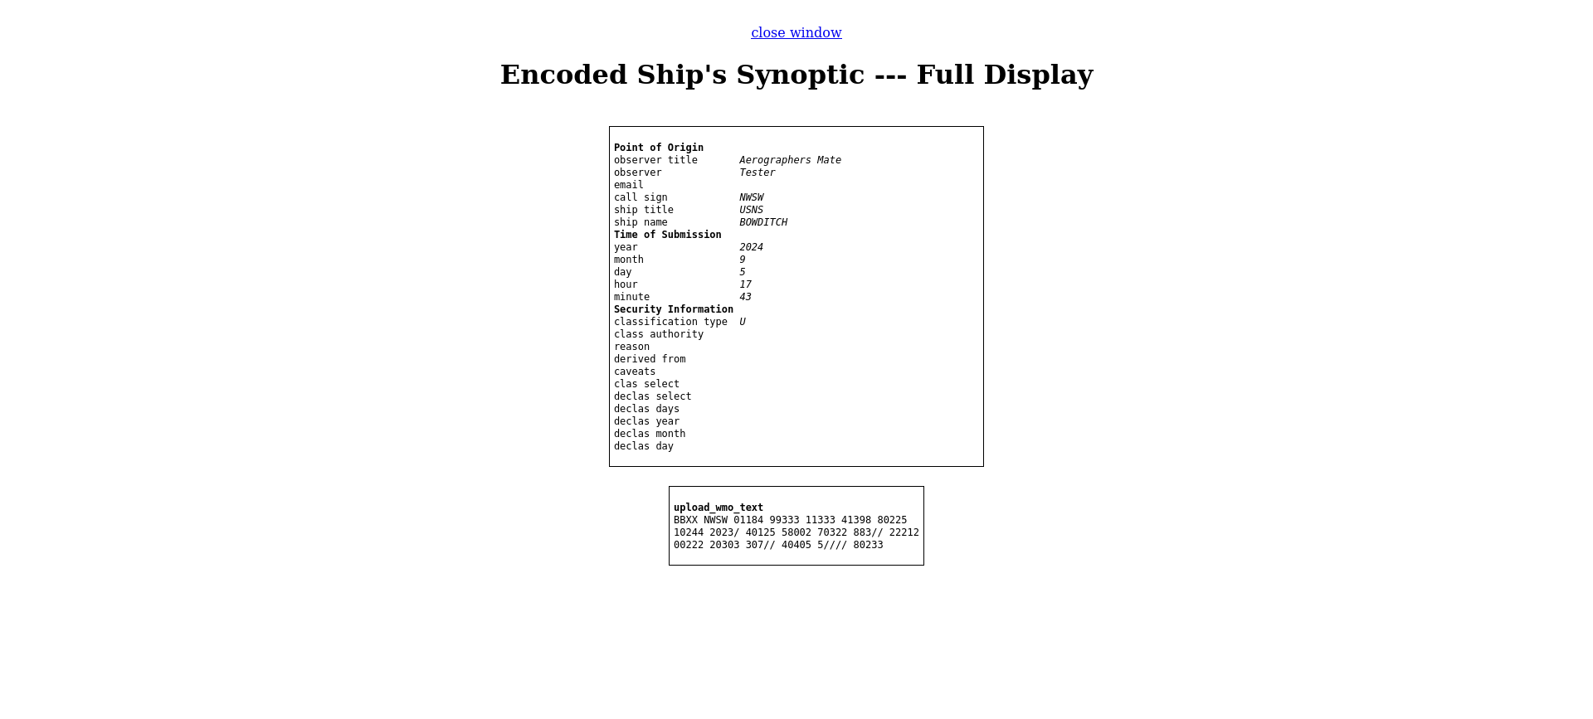

Close this window, then select “Display Encoded Message”, then select the “Process” button. You should see the following;

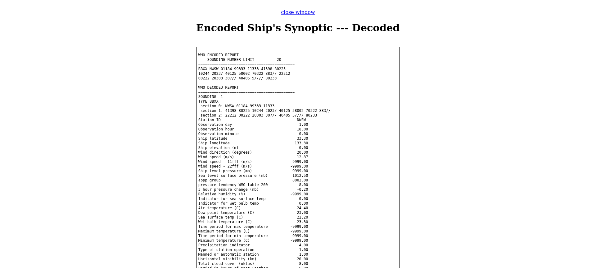

Next, select “Submit Observation”, then the “Process” button. You should see the following;

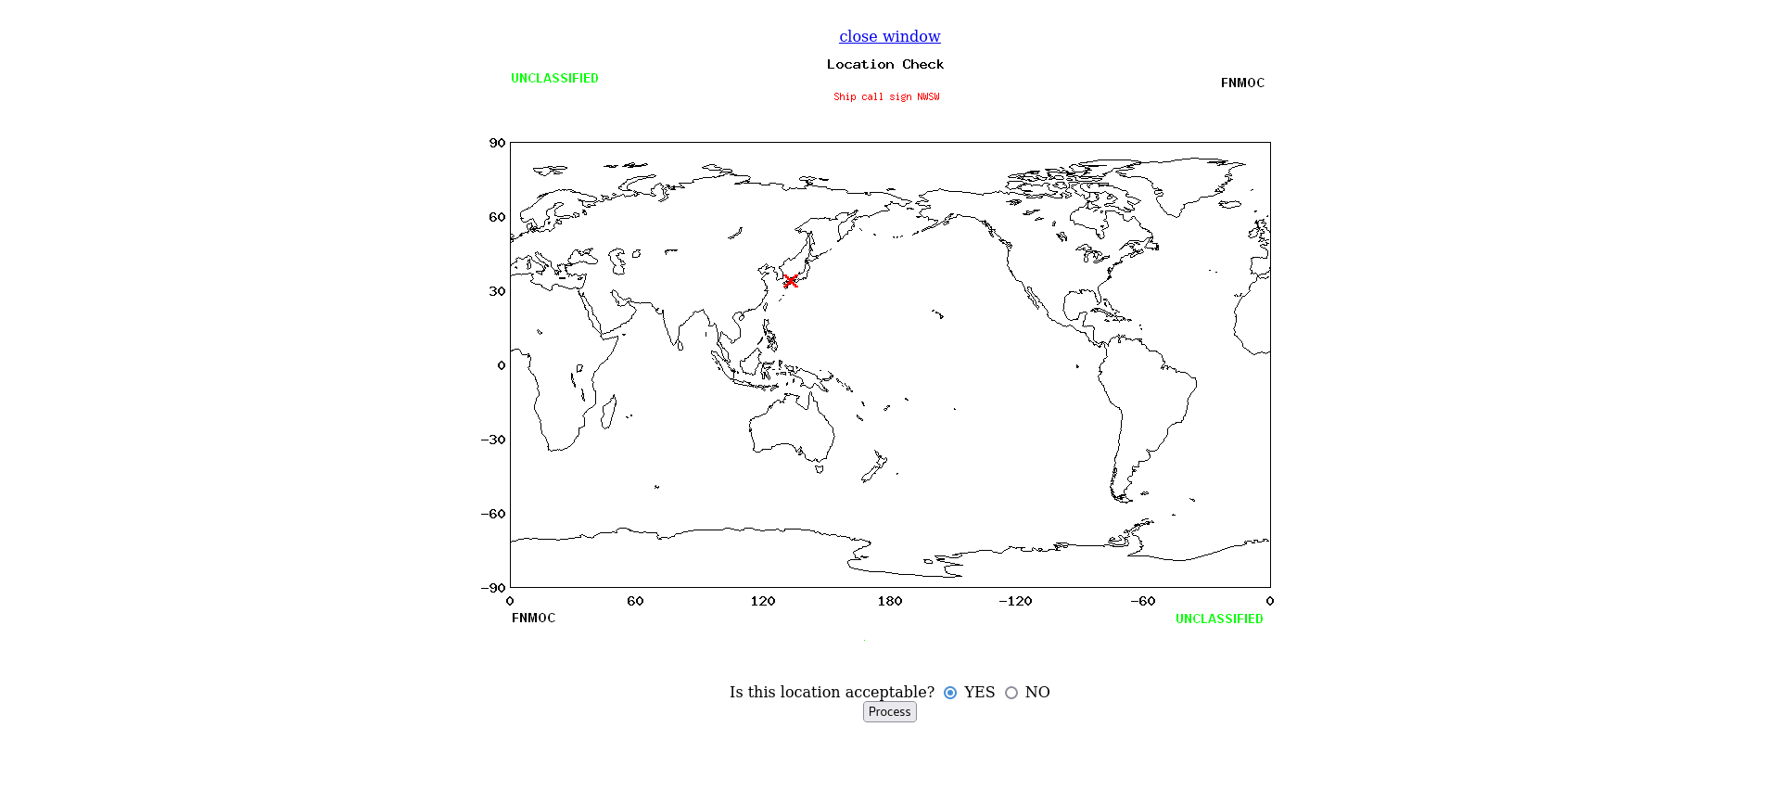

Select the “YES” bullet, then the “Process” button. You should see the following;

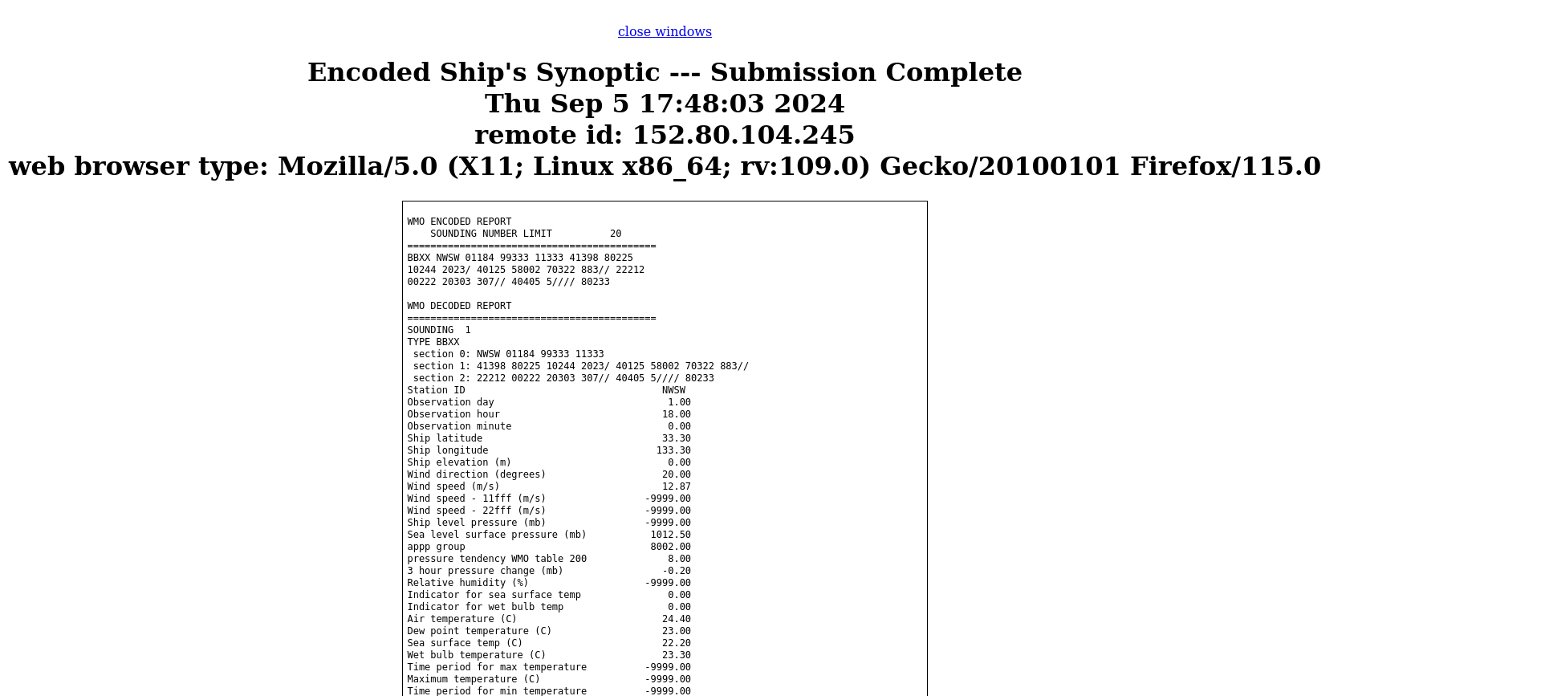

This concludes “Testing Encoded Ship’s Synoptic”

TEST 2) “Encoded Upper Air Sounding”

From the homepage select “Encoded Upper Air Sounding”.

Open the file, “uuxx_ship.txt” and fill out the form. Whatever call sign you use, you will need to modify the report by replacing “SHIP” with the call sign (upper case).

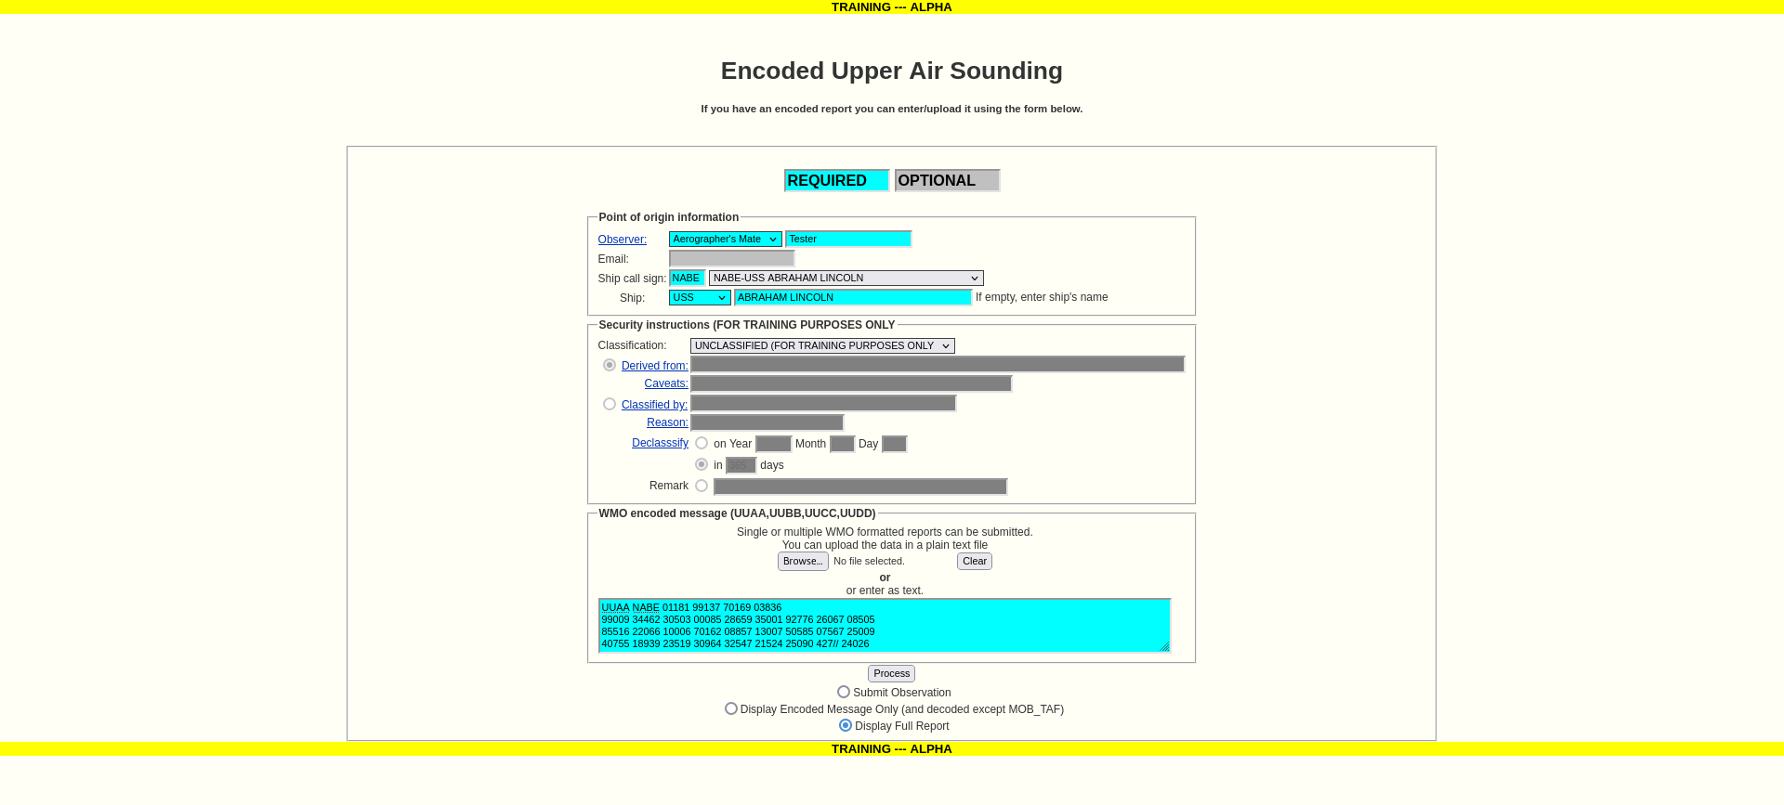

Select “Display Full Report”, the click the “Process” button. You should see the following;

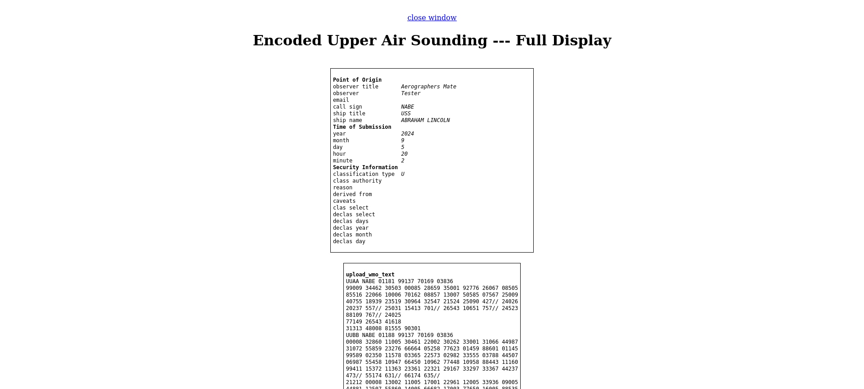

Select “Display Encoded Message”, then click the “Process” button. You should see the following;

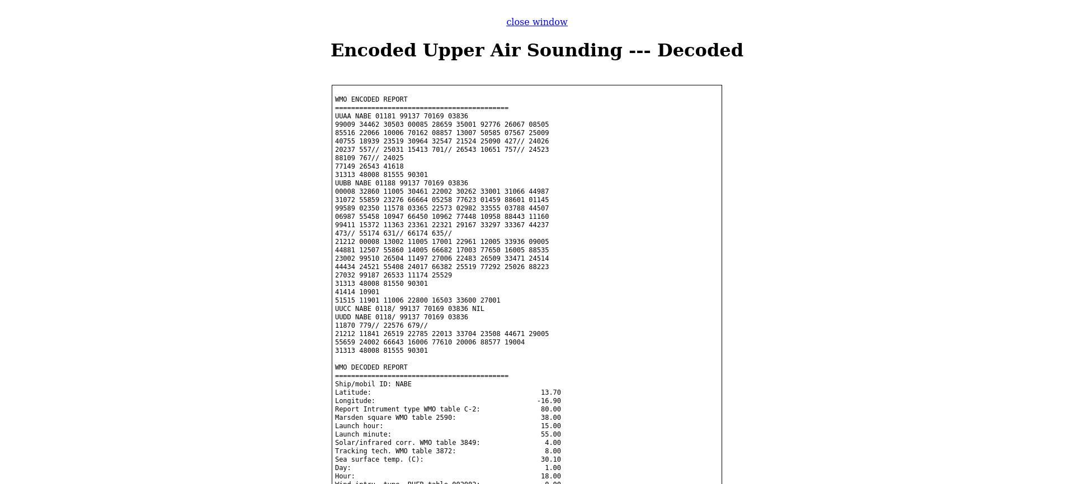

Select “Submit Observation”, then click the “Process” button. You should see the following;

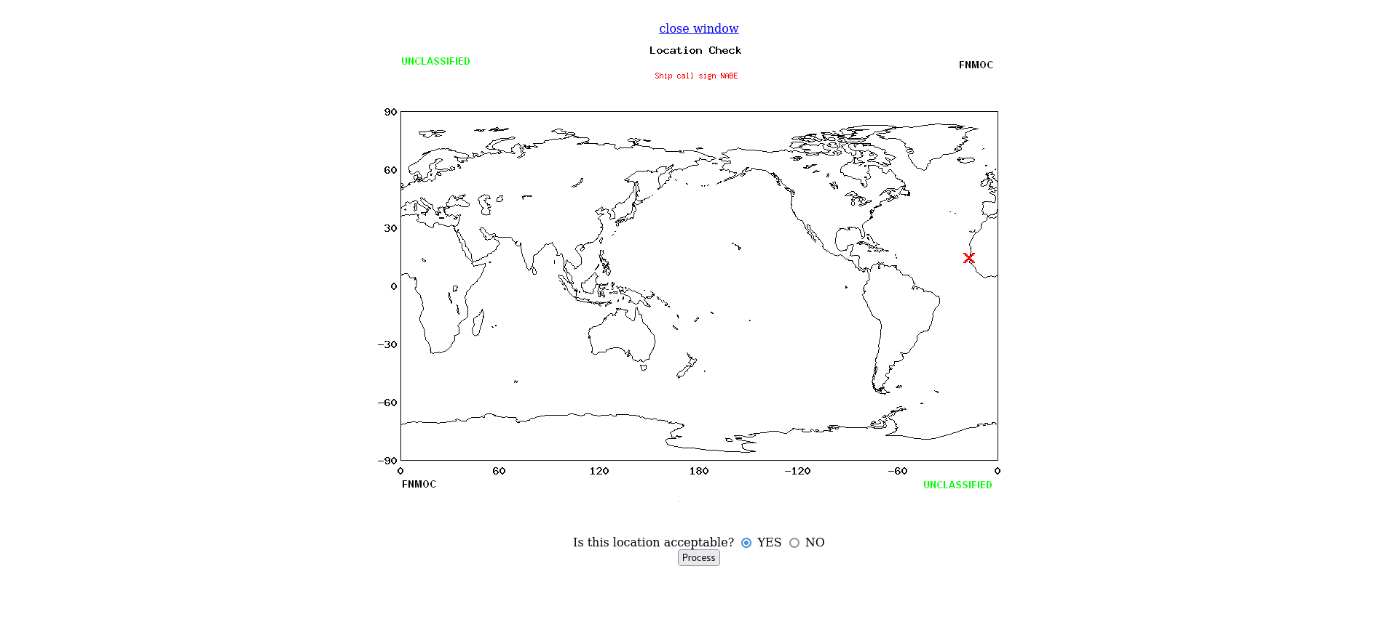

Select “YES”, then click the “Process” button. You should see the following;

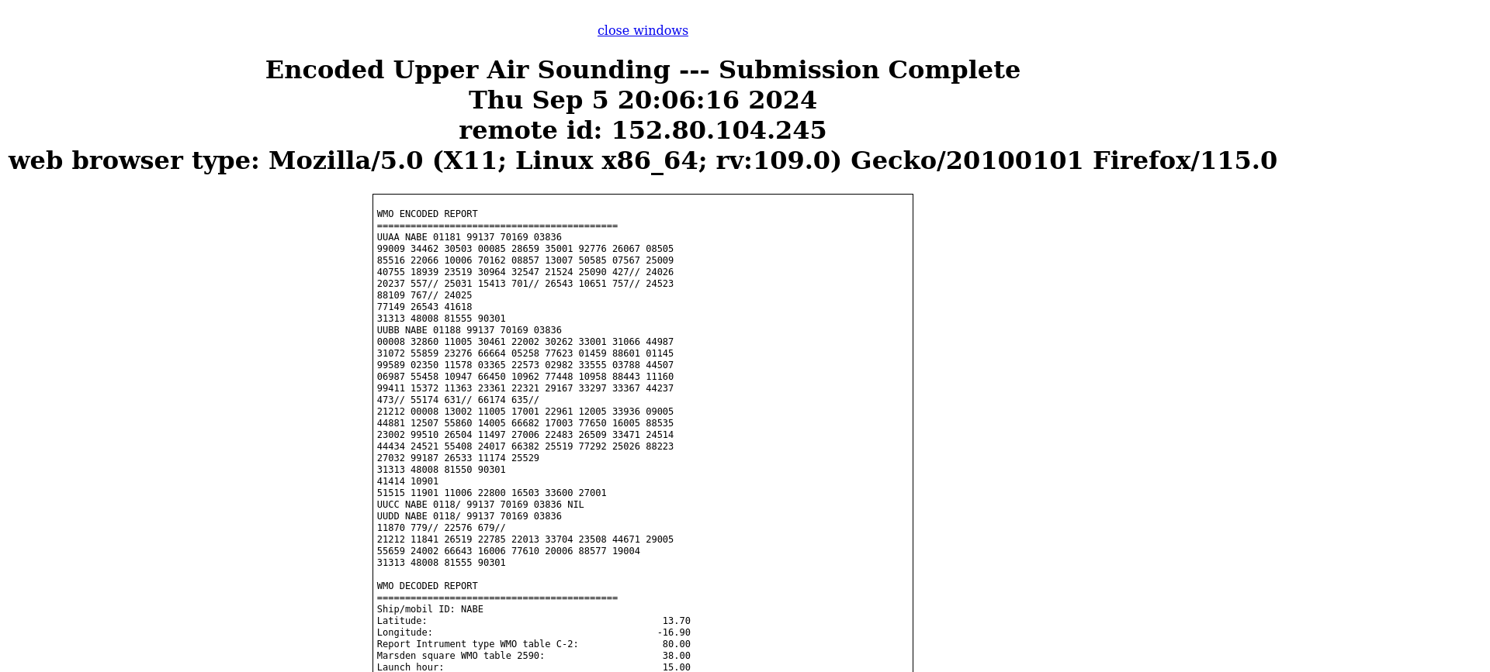

This concludes testing “Encoded Upper Air Sounding”.

TEST 3) “Encoded Bathy”

Select “Encoded Bathy” from the homepage, then open file jjvv_ncpn.txt and place it’s content into the form.

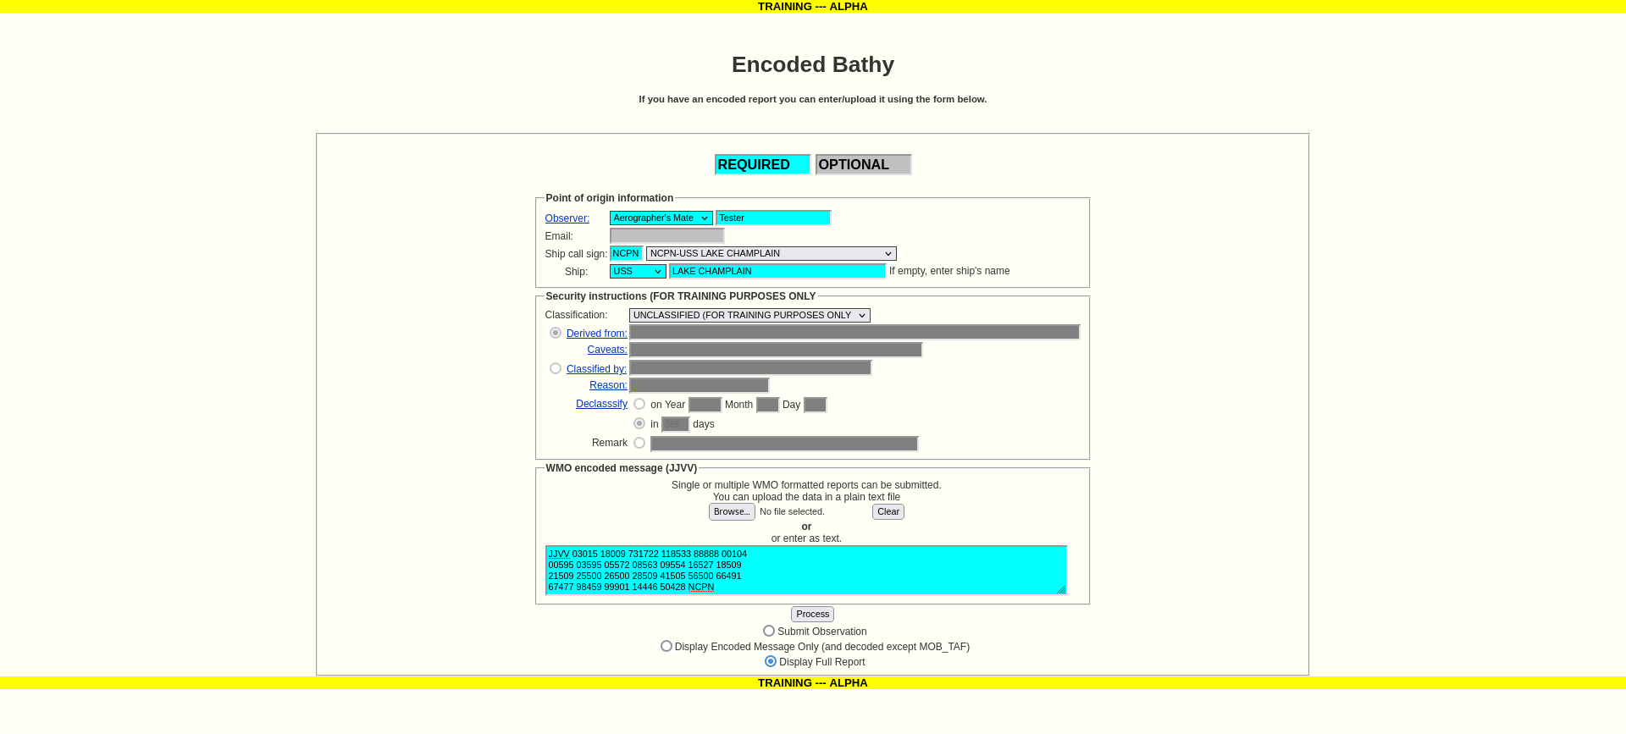

Note that we utilize the call sign at the end of the encoded report, “NCPN”. Select “Display Full Report”, then click the “Process” button. You should see the following;

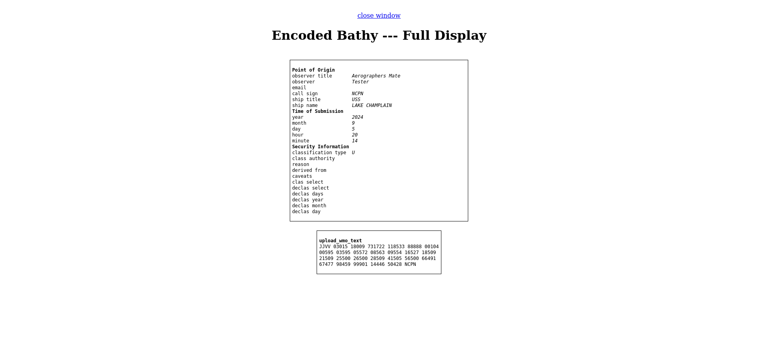

Next, select “Display Encoded Message”, then click the “Process” button. You should see the following;

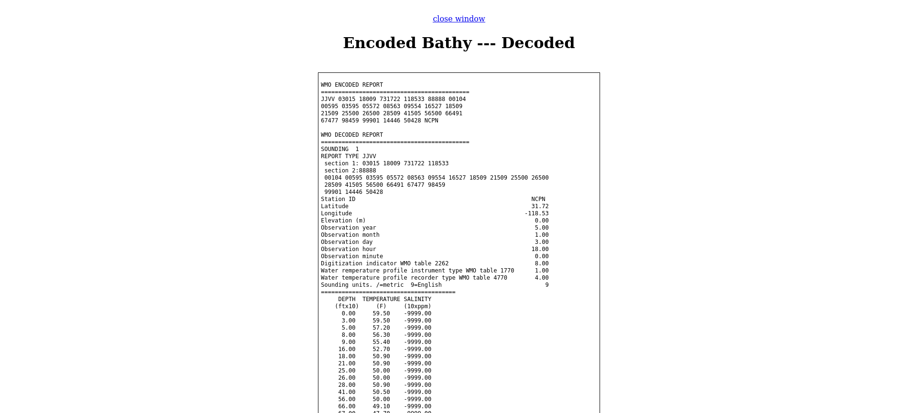

Select “Submit Observation”, then the click “Process” button. You should see the following;

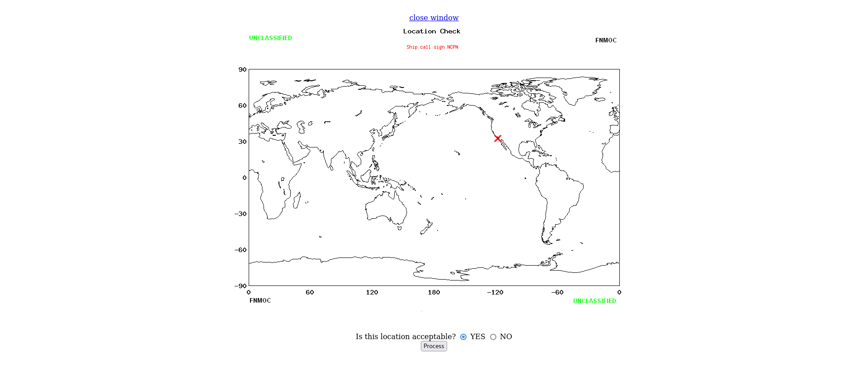

Select “YES” then click the “Process” button. You should see the following;

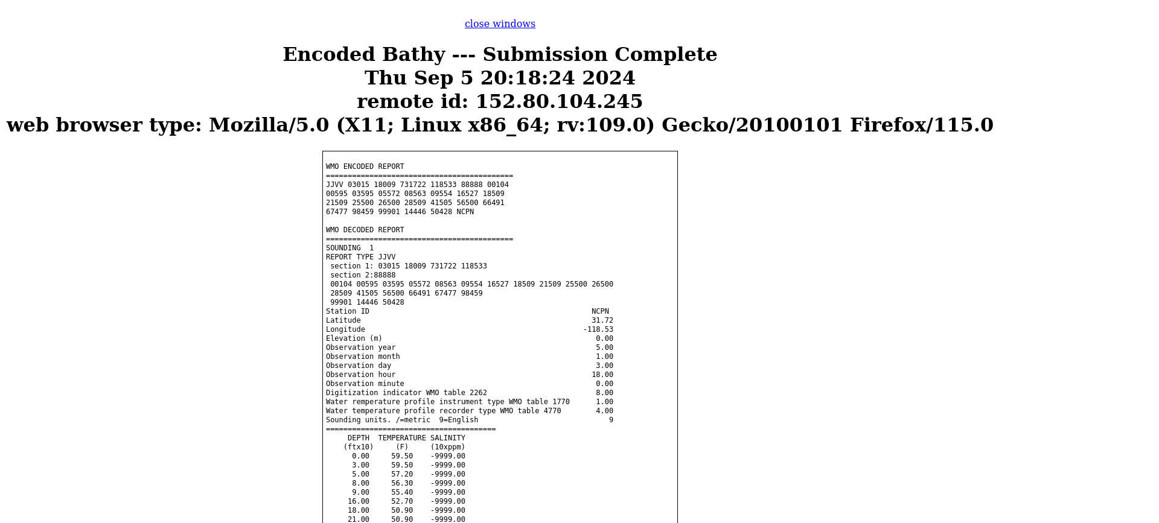

This concludes testing “Encoded Bathy”.

TEST 4) “Encoded TESAC”

Select “Encoded TESAC”, then open file kkyy.txt and place it’s content in the form.

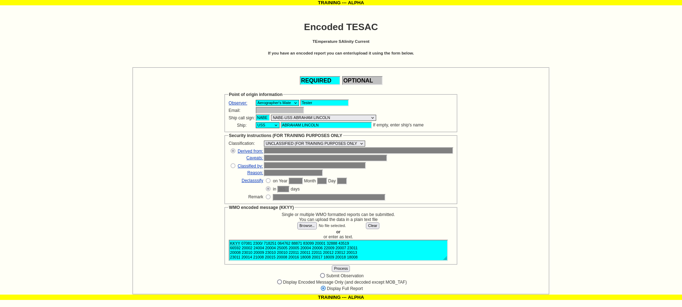

Select “Display Full Report”, then click the “Process” button. You should see the following;

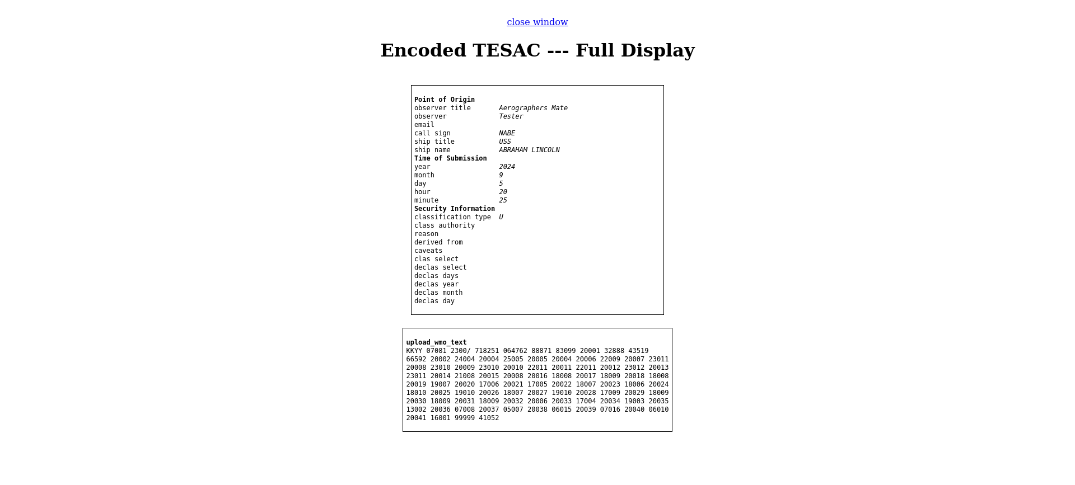

Select “Display Encoded Message”, then click the “Process” button. You should see the following;

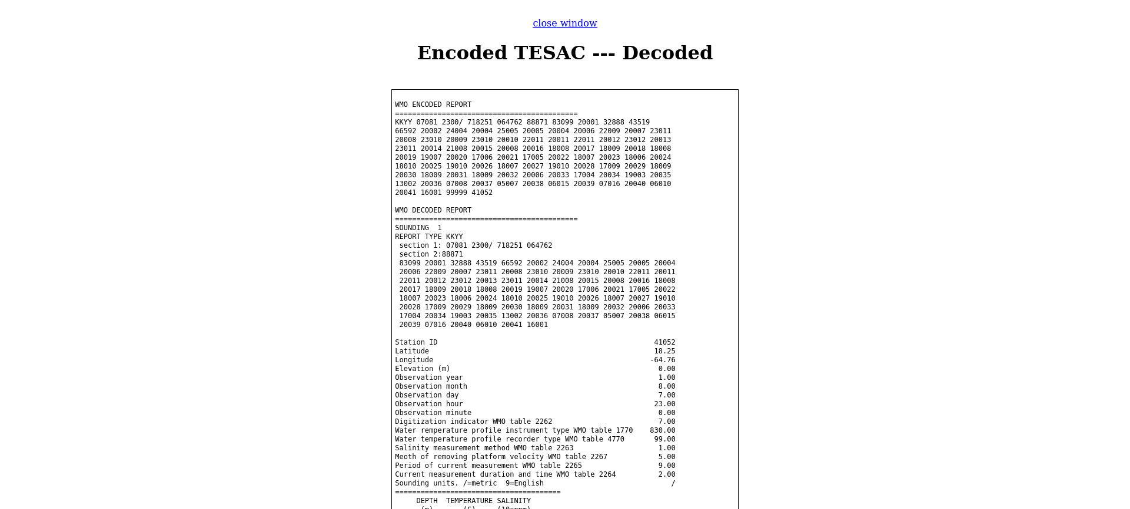

Select “Submit Observation”, then click the “Process” button. You should see the following;

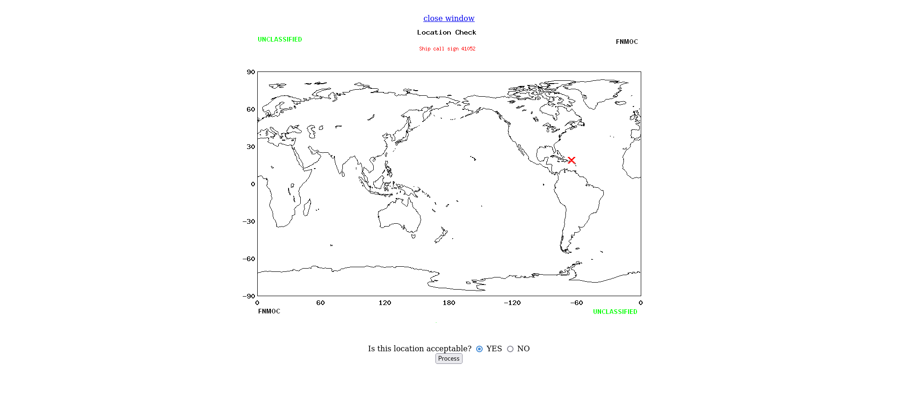

Select “YES”, then click the “Process” button. You should see the following;

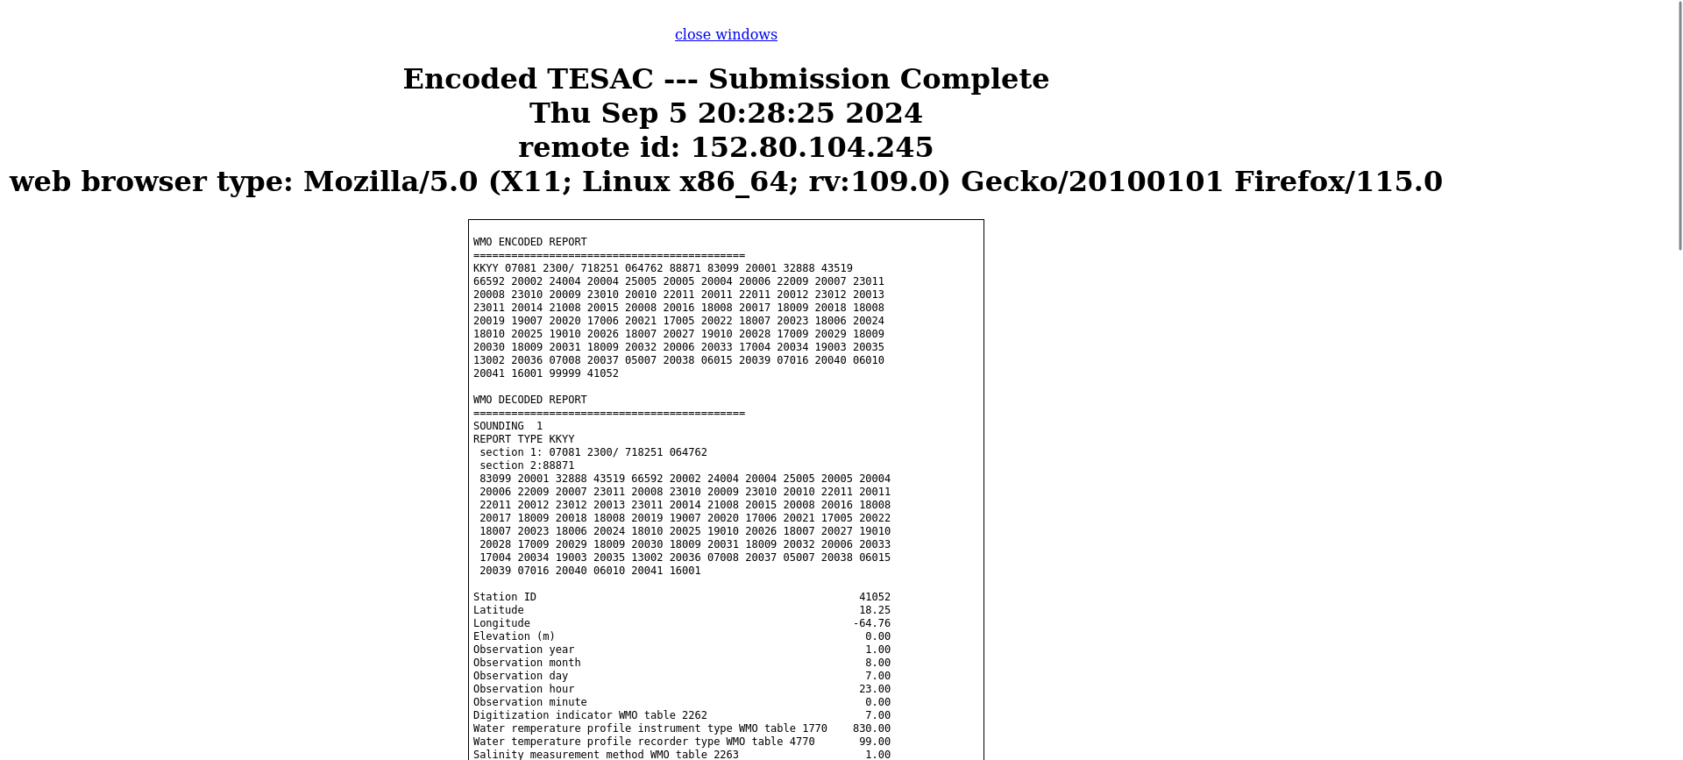

This concludes TEST 4.

TEST 5) “Encoded Surface Weather Observation”

Select “Encoded Surface Weather Observation” from the home page, then open file ooxx_land.txt and place it’s content in the form. Whatever call sign you use, it must be placed at the end of the report.

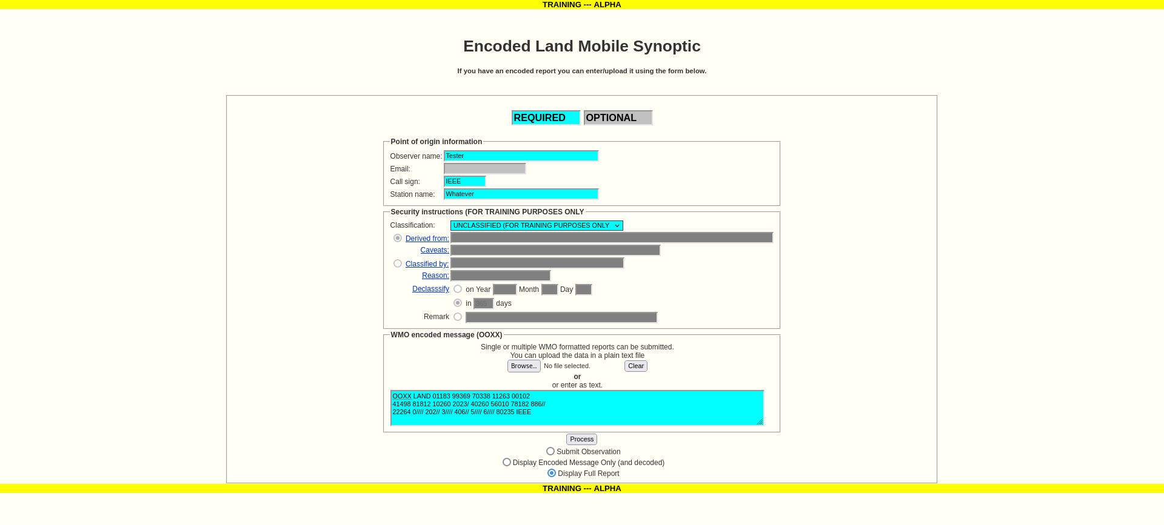

Select “Display Full Report”, then click the “Process” button. You should see the following;

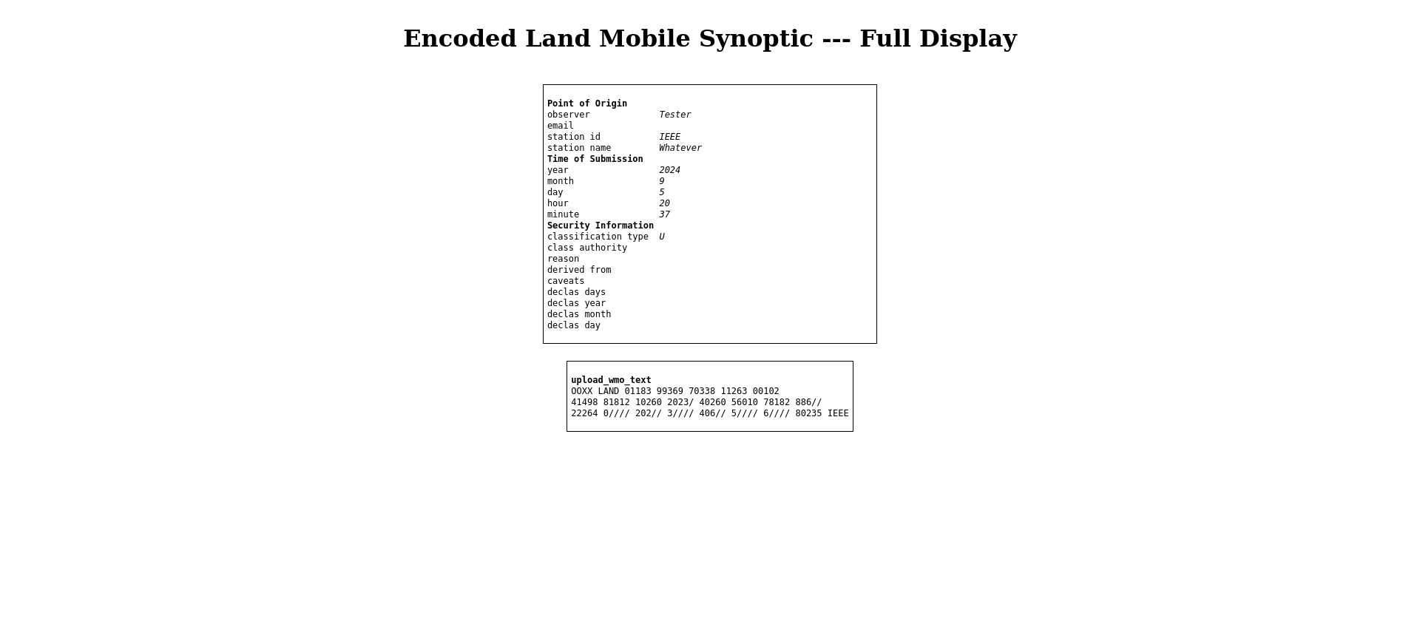

Select “Display Encoded Message”, then click the “Process” button. You should see the following;

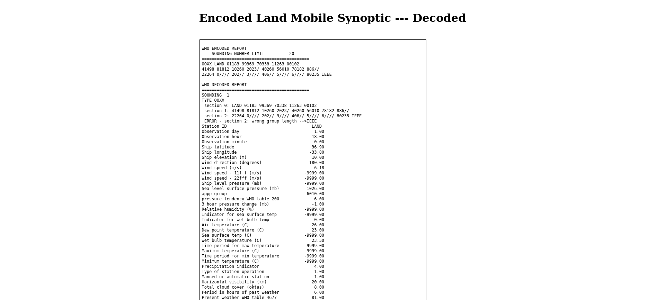

Select “Submit Observation”, then click the “Process” button. You should see the following;

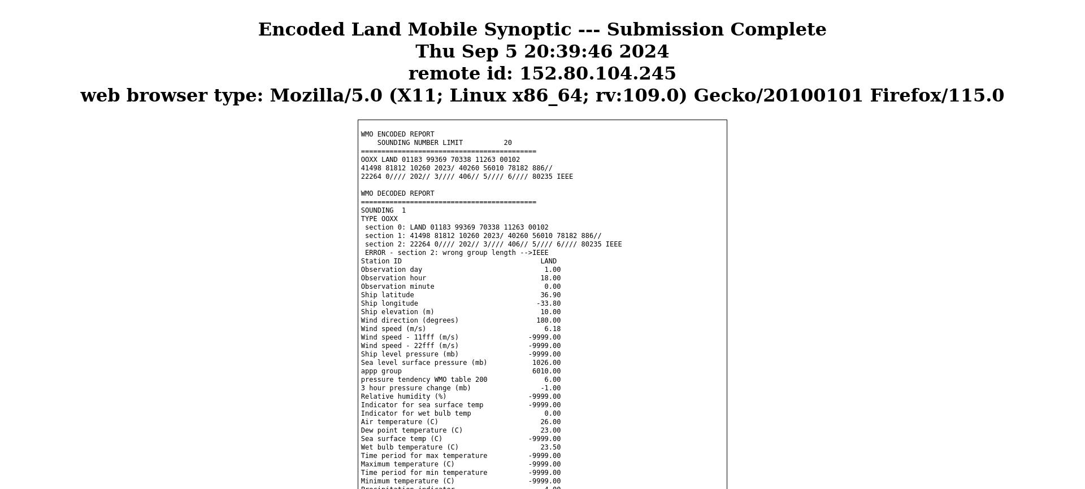

This concludes TEST 5.

TEST 6) “Encoded Upper Air Sounding”

Select “Encoded Upper Air Sounding” from the homepage, then open file iixx_land.txt and place it’s content into the form. The reports are separated by “IIBB LAND” and each report needs to end with the call sign you are utilizing.

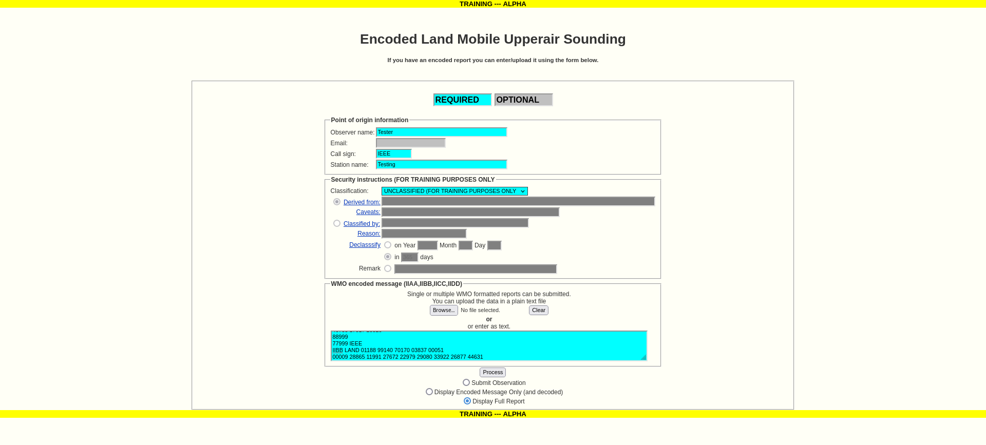

Select “Display Full Report”, then click the “Process” button. You should see the following;

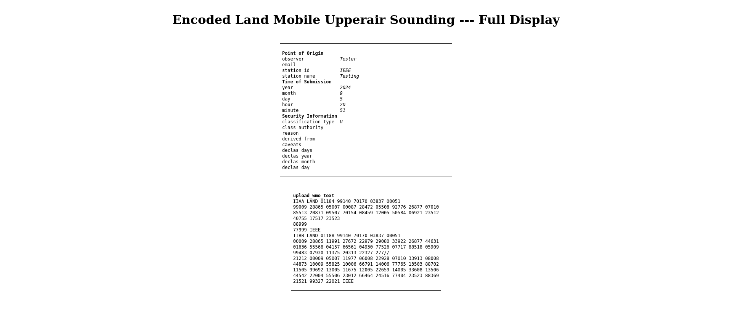

Select “Display Encoded Message”, the click the “Process” button. You should see the following;

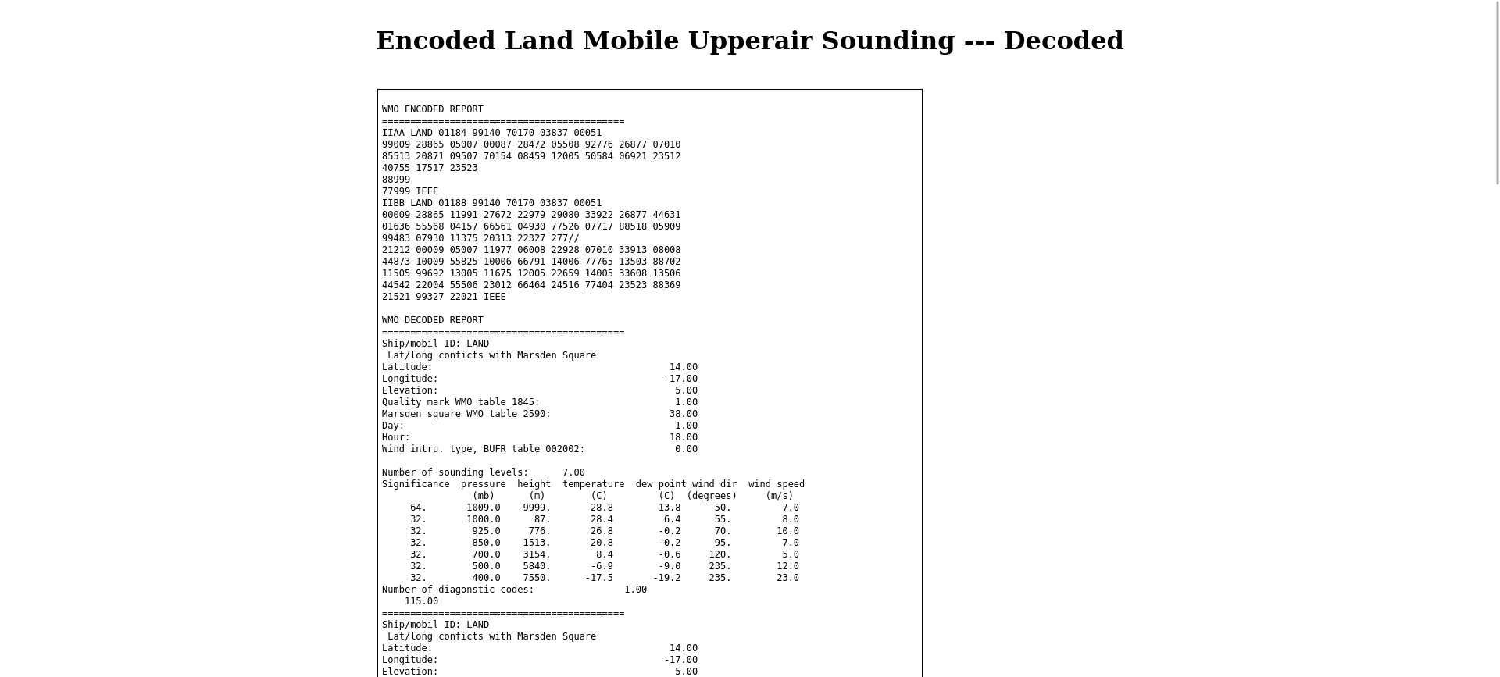

Select “Submit Observation”, then click the “Process” button. You should see the following;

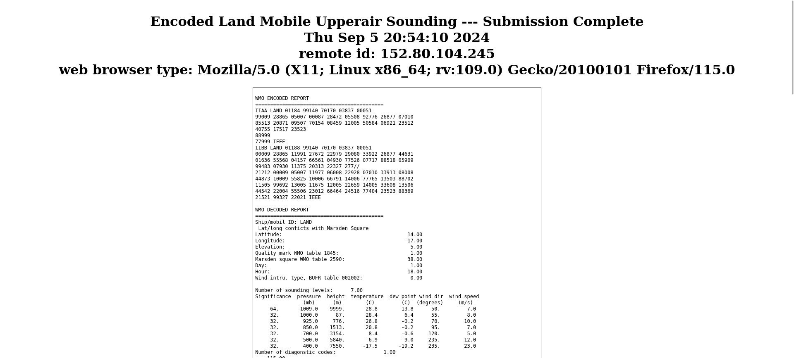

This concludes TEST 6.

TEST 7) “XBT”

Select “XBT”, then open file jjvv_xbt.txt and place one of the reports into the form. Note that the last group in the report is your call sign.

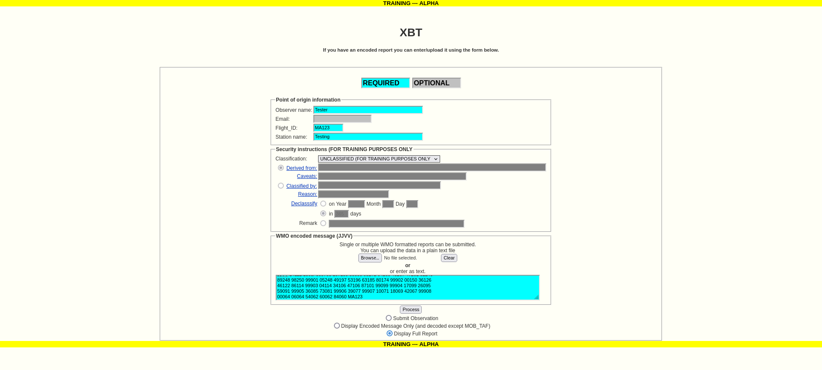

Select “Display Full Report”, then click the “Process” button. You should see the following;

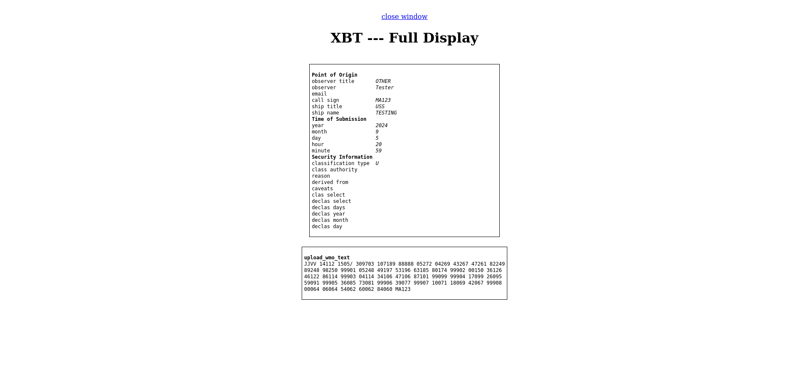

Select “Display Encoded Message”, then click the “Process” button. You should see the following;

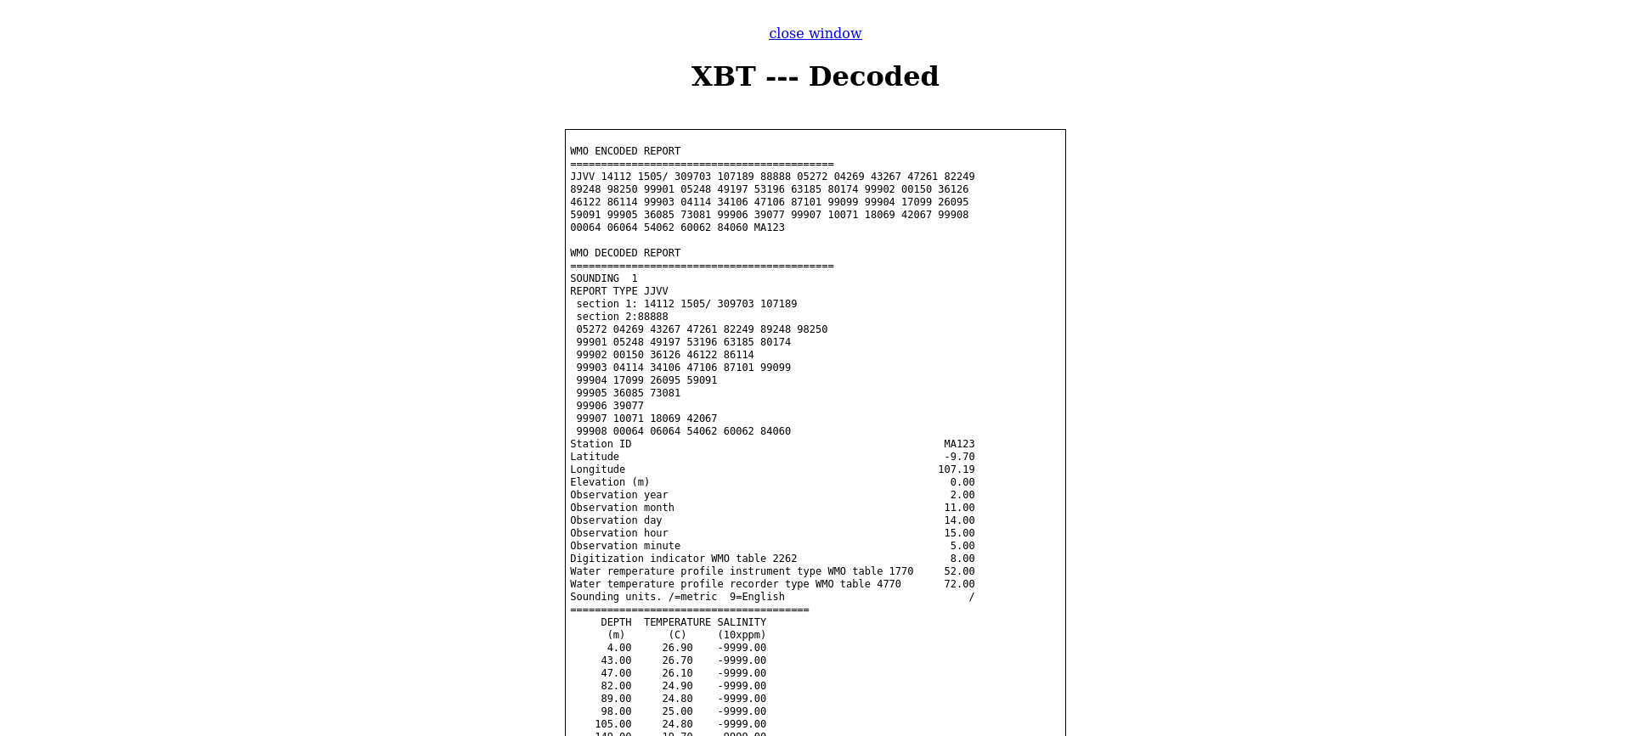

Select “Submit Observation”, then click the “Process” button. You should see the following;

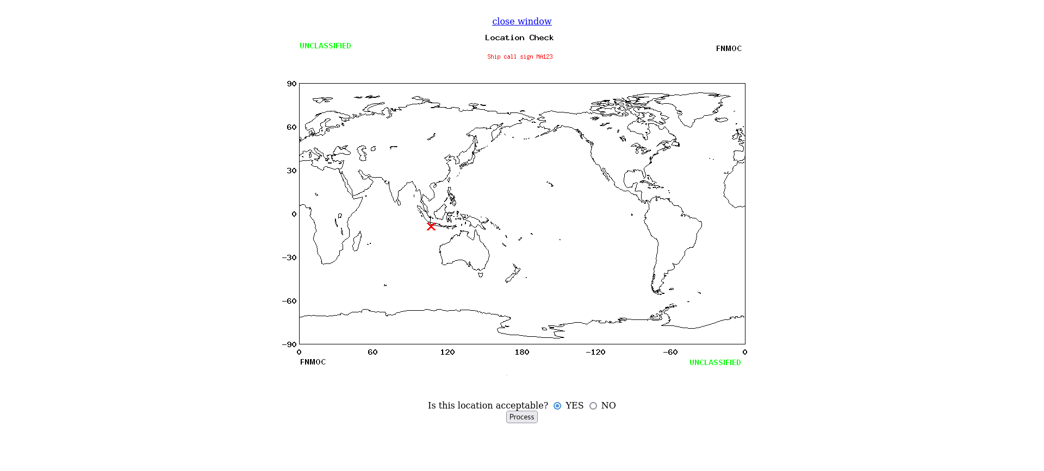

Select “YES”, then click the “Process” button. You should see the following;

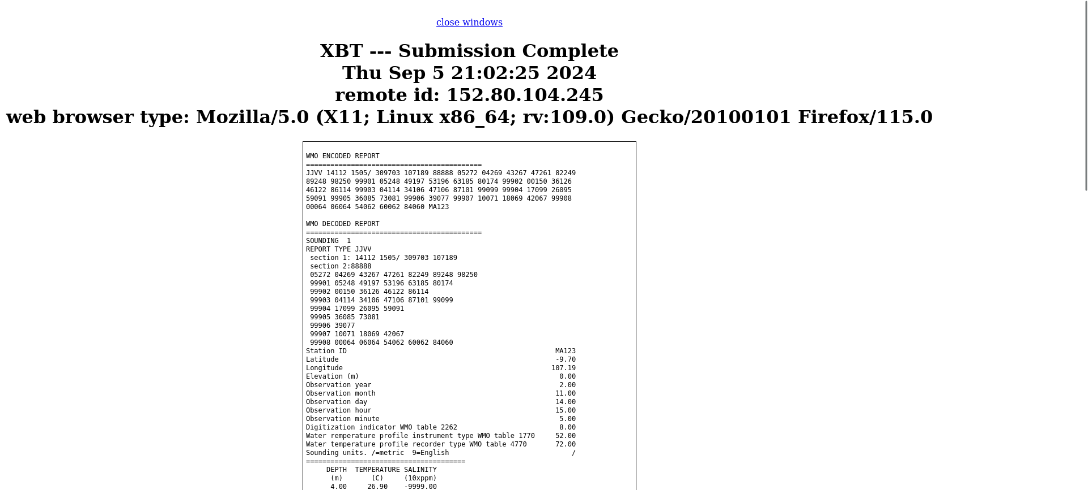

This concludes TEST 7

TEST 8) Link test

Select each link on the homepage to ensure it loads properly.

This concludes TEST 8

BETA testing is complete.

