Quantifying the Visual Mechanisms Underlying the Rod-and-Frame Illusion

Ernestine Brannon

## Analysis

all_task<- cbind(s2r_abs,s2v_abs) %>%   
 select(sid, frame_effect_r, frame_effect_v, frame_size)  
  
  
p_df<- perception_abs %>%  
 ungroup() %>%   
 select(magnitude, sid) %>%   
 rename(sub_1 =sid)  
  
all_task<- cbind(all_task,p_df)  
  
all_task<- all_task %>%   
 select(-sub_1)  
  
all_task<-all_task %>%   
 rename(vv= frame_effect_v,  
 oc = frame_effect_r,  
 perc = magnitude)

### Perception Task: RFI

To determine the change in PSE as a function of frame size, we subtracted the PSE for counterclockwise trials from clockwise trials, and then divided that by half.

~~A negative value indicates that participants PSEs are being biased in the opposite direction of the tilt of the frame.~~

(#tab:percept summary stat table)

*Perception Task*

| Frame Size | Mean | Median | SD | Min | Max |
| --- | --- | --- | --- | --- | --- |
| Small | -2.11 | -2.00 | 1.15 | -6.35 | 0.27 |
| Medium | -1.91 | -1.71 | 1.12 | -6.68 | -0.15 |
| Large | -1.71 | -1.45 | 1.02 | -4.77 | 0.06 |
| Extra Large | -1.55 | -1.33 | 0.99 | -5.80 | 0.50 |

p_mag_anova<- aov(frame_effect_perception ~frame_size, data =perception)  
summary(p_mag_anova)

## Df Sum Sq Mean Sq F value Pr(>F)   
## frame_size 3 14.3 4.759 4.154 0.0066 **  
## Residuals 316 362.0 1.146   
## ---  
## Signif. codes: 0 '***' 0.001 '**' 0.01 '*' 0.05 '.' 0.1 ' ' 1

tukey_p<-tukey_hsd(p_mag_anova)  
apa_table(tukey_p)

(#tab:perc aov frame size effect)

**

| term | group1 | group2 | null.value | estimate | conf.low | conf.high | p.adj | p.adj.signif |
| --- | --- | --- | --- | --- | --- | --- | --- | --- |
| frame_size | 175 | 410 | 0.00 | -0.20 | -0.64 | 0.24 | 0.63 | ns |
| frame_size | 175 | 645 | 0.00 | -0.40 | -0.84 | 0.03 | 0.08 | ns |
| frame_size | 175 | 880 | 0.00 | -0.56 | -1.00 | -0.12 | 0.01 | ** |
| frame_size | 410 | 645 | 0.00 | -0.20 | -0.64 | 0.24 | 0.64 | ns |
| frame_size | 410 | 880 | 0.00 | -0.36 | -0.80 | 0.08 | 0.15 | ns |
| frame_size | 645 | 880 | 0.00 | -0.16 | -0.60 | 0.28 | 0.78 | ns |

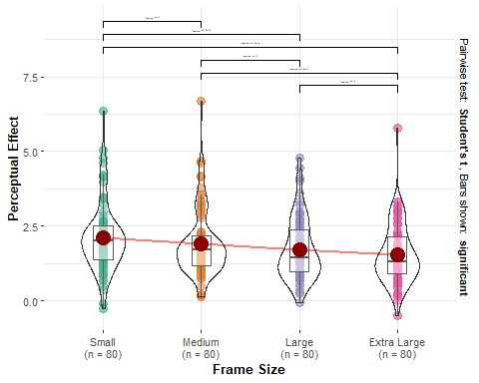

### Saccade-to-Vertical Task: Visuovestibular Effect

The effect of the frames was quantified by subtracting the mean errors for the counterclockwise-tilted frames from those of the clockwise-tilted frames then halving this value to get a measure of the average effect of a single frame (negative values indicated eye movements that deviated in the direction opposite the tilt of the frame).

(#tab:s2v summary stat table)

*Saccade-to-Vertical Task*

| Frame Size | Mean | Median | SD | Min | Max |
| --- | --- | --- | --- | --- | --- |
| Small | 1.47 | 1.31 | 1.63 | -2.77 | 8.74 |
| Medium | 1.23 | 1.01 | 1.75 | -1.84 | 8.34 |
| Large | 1.14 | 1.04 | 1.35 | -1.63 | 5.91 |
| Extra Large | 1.04 | 0.88 | 1.51 | -2.10 | 8.97 |

s2v_ttest_df<-saccade_to_vert_magnitude %>% group_by(FRAME_SIZE_VAL) %>% do(tidy(t.test(.$frame_effect_v)))  
nice_table(s2v_ttest_df)

| FRAME_SIZE_VAL | estimate | statistic | *p* | parameter | Method | Alternative | 95% CI |
| --- | --- | --- | --- | --- | --- | --- | --- |
| 175 | 1.47 | 8.04 | < .001*** | 79.00 | One Sample t-test | two.sided | [1.11, 1.83] |
| 410 | 1.23 | 6.29 | < .001*** | 79.00 | One Sample t-test | two.sided | [0.84, 1.62] |
| 645 | 1.14 | 7.55 | < .001*** | 79.00 | One Sample t-test | two.sided | [0.84, 1.44] |
| 880 | 1.04 | 6.16 | < .001*** | 79.00 | One Sample t-test | two.sided | [0.70, 1.37] |

vv_mag_anova<- aov(frame_effect_v~FRAME_SIZE_VAL, data =saccade_to_vert_magnitude)  
#summary(vv_mag_anova)  
tukey_vv<-tukey_hsd(vv_mag_anova)  
apa_table(tukey_vv)

(#tab:s2v aov frame size effect)

**

| term | group1 | group2 | null.value | estimate | conf.low | conf.high | p.adj | p.adj.signif |
| --- | --- | --- | --- | --- | --- | --- | --- | --- |
| FRAME_SIZE_VAL | 175 | 410 | 0.00 | -0.24 | -0.88 | 0.40 | 0.77 | ns |
| FRAME_SIZE_VAL | 175 | 645 | 0.00 | -0.33 | -0.97 | 0.31 | 0.56 | ns |
| FRAME_SIZE_VAL | 175 | 880 | 0.00 | -0.43 | -1.07 | 0.21 | 0.31 | ns |
| FRAME_SIZE_VAL | 410 | 645 | 0.00 | -0.09 | -0.73 | 0.55 | 0.98 | ns |
| FRAME_SIZE_VAL | 410 | 880 | 0.00 | -0.19 | -0.83 | 0.45 | 0.87 | ns |
| FRAME_SIZE_VAL | 645 | 880 | 0.00 | -0.10 | -0.75 | 0.54 | 0.98 | ns |

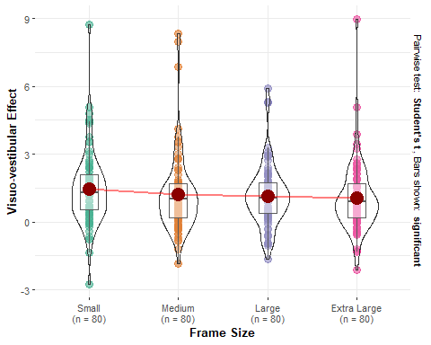

## `geom_smooth()` using formula = 'y ~ x'

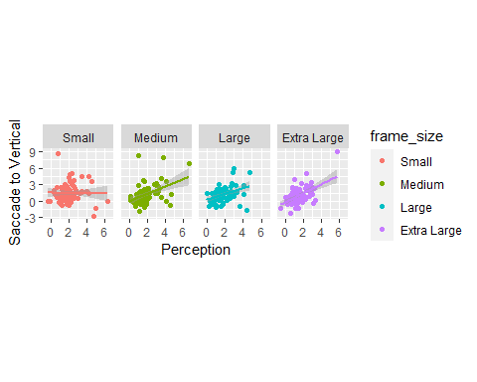

### Saccade to Rod : Orientation Contrast Effect

The effect of the frames was quantified by subtracting the mean errors for the counterclockwise-tilted frames from those of the clockwise-tilted frames then halving this value to get a measure of the average effect of a single frame (negative values indicated eye movements that deviated in the direction opposite the tilt of the frame).

(#tab:s2r summary stat table)

*Saccade-to-Rod Task: Orientation Contrast Effect*

| Frame Size | Mean | Median | SD | Min | Max |
| --- | --- | --- | --- | --- | --- |
| Small | -1.61 | -1.50 | 1.44 | -6.47 | 4.51 |
| Medium | -0.88 | -0.99 | 1.24 | -4.38 | 2.39 |
| Large | -0.62 | -0.58 | 1.35 | -4.01 | 4.02 |
| Extra Large | -0.76 | -0.70 | 1.14 | -4.76 | 2.57 |

| FRAME_SIZE_VAL | estimate | statistic | *p* | parameter | Method | Alternative | 95% CI |
| --- | --- | --- | --- | --- | --- | --- | --- |
| 175 | -1.61 | -9.98 | < .001*** | 79.00 | One Sample t-test | two.sided | [-1.93, -1.29] |
| 410 | -0.88 | -6.36 | < .001*** | 79.00 | One Sample t-test | two.sided | [-1.15, -0.60] |
| 645 | -0.62 | -4.09 | < .001*** | 79.00 | One Sample t-test | two.sided | [-0.92, -0.32] |
| 880 | -0.76 | -5.94 | < .001*** | 79.00 | One Sample t-test | two.sided | [-1.01, -0.50] |

oc_mag_anova<- aov(frame_effect_r~FRAME_SIZE_VAL, data =saccade_to_rod_magnitude)  
summary(oc_mag_anova)

## Df Sum Sq Mean Sq F value Pr(>F)   
## FRAME_SIZE_VAL 3 46.9 15.635 9.284 6.7e-06 ***  
## Residuals 316 532.2 1.684   
## ---  
## Signif. codes: 0 '***' 0.001 '**' 0.01 '*' 0.05 '.' 0.1 ' ' 1

tukey_oc<-tukey_hsd(oc_mag_anova)  
apa_table(tukey_oc)

(#tab:s2r aov frame size effect)

**

| term | group1 | group2 | null.value | estimate | conf.low | conf.high | p.adj | p.adj.signif |
| --- | --- | --- | --- | --- | --- | --- | --- | --- |
| FRAME_SIZE_VAL | 175 | 410 | 0.00 | 0.73 | 0.20 | 1.26 | 0.00 | ** |
| FRAME_SIZE_VAL | 175 | 645 | 0.00 | 0.99 | 0.46 | 1.52 | 0.00 | **** |
| FRAME_SIZE_VAL | 175 | 880 | 0.00 | 0.85 | 0.32 | 1.38 | 0.00 | *** |
| FRAME_SIZE_VAL | 410 | 645 | 0.00 | 0.26 | -0.27 | 0.79 | 0.58 | ns |
| FRAME_SIZE_VAL | 410 | 880 | 0.00 | 0.12 | -0.41 | 0.65 | 0.94 | ns |
| FRAME_SIZE_VAL | 645 | 880 | 0.00 | -0.14 | -0.67 | 0.39 | 0.90 | ns |

## Df Sum Sq Mean Sq F value Pr(>F)   
## FRAME_SIZE_VAL 3 46.9 15.635 9.284 6.7e-06 ***  
## Residuals 316 532.2 1.684   
## ---  
## Signif. codes: 0 '***' 0.001 '**' 0.01 '*' 0.05 '.' 0.1 ' ' 1

(#tab:s2r within graph)

**

| term | group1 | group2 | null.value | estimate | conf.low | conf.high | p.adj | p.adj.signif |
| --- | --- | --- | --- | --- | --- | --- | --- | --- |
| FRAME_SIZE_VAL | Small | Medium | 0.00 | 0.73 | 0.20 | 1.26 | 0.00 | ** |
| FRAME_SIZE_VAL | Small | Large | 0.00 | 0.99 | 0.46 | 1.52 | 0.00 | **** |
| FRAME_SIZE_VAL | Small | Extra Large | 0.00 | 0.85 | 0.32 | 1.38 | 0.00 | *** |
| FRAME_SIZE_VAL | Medium | Large | 0.00 | 0.26 | -0.27 | 0.79 | 0.58 | ns |
| FRAME_SIZE_VAL | Medium | Extra Large | 0.00 | 0.12 | -0.41 | 0.65 | 0.94 | ns |
| FRAME_SIZE_VAL | Large | Extra Large | 0.00 | -0.14 | -0.67 | 0.39 | 0.90 | ns |

## `geom_smooth()` using formula = 'y ~ x'

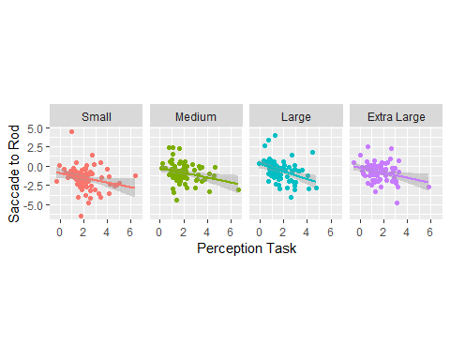

### Combined Saccades and Perception Task Comparison

So far the perceptual and orientation contrast effect were reported as negative numbers, indicating that the perceptual response or saccade erred in the opposite direction of the tilt of the frame. However, it should be noted that for the purpose of making an additive comparison between summed saccade tasks and the perceptual response, we used the inverse value of the OC effect.

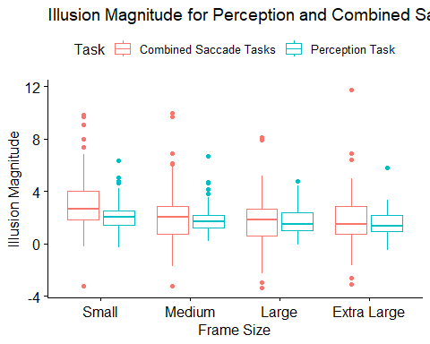

## Effect sizes were labelled following Funder's (2019) recommendations.  
##   
## The Pearson's product-moment correlation between across_frames$perception and  
## across_frames$combined_saccade is positive, statistically significant, and very  
## large (r = 0.43, 95% CI [0.33, 0.51], t(318) = 8.45, p < .001)

## `geom_smooth()` using formula = 'y ~ x'

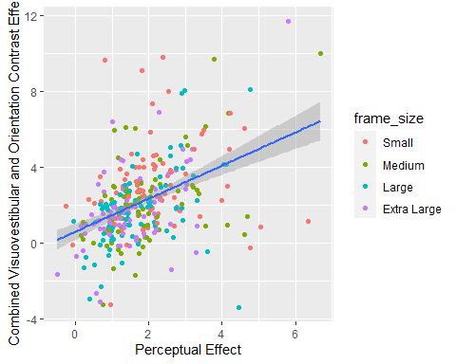

## Effect sizes were labelled following Funder's (2019) recommendations.  
##   
## The Pearson's product-moment correlation between across_frames$perception and  
## across_frames$combined_saccade is positive, statistically significant, and very  
## large (r = 0.43, 95% CI [0.33, 0.51], t(318) = 8.45, p < .001)

## `geom_smooth()` using formula = 'y ~ x'

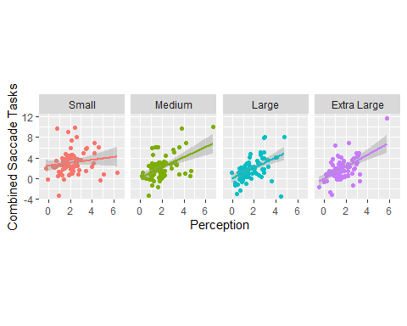

**Perception and Saccade-to-Vertical**

## `geom_smooth()` using formula = 'y ~ x'



**Perception and Saccade-to-Rod**

## `geom_smooth()` using formula = 'y ~ x'



### Model Comparison

For each frame size a hierarchical design was employed using two models: 1) model 1 predicted the overall RFI magnitude (measured by the perception task) from the visuovestibular effect (measured by the saccade-to-vertical task) and 2) model 2 predicted the overall RFI magnitude from visuovestibular effect and the orientation contrast effect (measured by the saccade-to-rod task).

* **Small Frame**

##   
## Call:  
## lm(formula = perc ~ vv, data = df_small)  
##   
## Residuals:  
## Min 1Q Median 3Q Max   
## -2.4004 -0.7165 -0.1283 0.4315 4.2230   
##   
## Coefficients:  
## Estimate Std. Error t value Pr(>|t|)   
## (Intercept) 2.12753 0.17419 12.214 <2e-16 ***  
## vv -0.01199 0.07954 -0.151 0.881   
## ---  
## Signif. codes: 0 '***' 0.001 '**' 0.01 '*' 0.05 '.' 0.1 ' ' 1  
##   
## Residual standard error: 1.155 on 78 degrees of freedom  
## Multiple R-squared: 0.0002913, Adjusted R-squared: -0.01253   
## F-statistic: 0.02273 on 1 and 78 DF, p-value: 0.8805

##   
## Call:  
## lm(formula = perc ~ vv + oc, data = df_small)  
##   
## Residuals:  
## Min 1Q Median 3Q Max   
## -2.4789 -0.6643 -0.1876 0.3187 4.2826   
##   
## Coefficients:  
## Estimate Std. Error t value Pr(>|t|)   
## (Intercept) 1.83034 0.21902 8.357 2.08e-12 ***  
## vv -0.01792 0.07779 -0.230 0.8184   
## oc -0.19003 0.08810 -2.157 0.0341 *   
## ---  
## Signif. codes: 0 '***' 0.001 '**' 0.01 '*' 0.05 '.' 0.1 ' ' 1  
##   
## Residual standard error: 1.129 on 77 degrees of freedom  
## Multiple R-squared: 0.05726, Adjusted R-squared: 0.03277   
## F-statistic: 2.338 on 2 and 77 DF, p-value: 0.1033

## [1] 0.05696534

## Analysis of Variance Table  
##   
## Model 1: perc ~ vv  
## Model 2: perc ~ vv + oc  
## Res.Df RSS Df Sum of Sq F Pr(>F)   
## 1 78 104.12   
## 2 77 98.19 1 5.9331 4.6527 0.03412 *  
## ---  
## Signif. codes: 0 '***' 0.001 '**' 0.01 '*' 0.05 '.' 0.1 ' ' 1

* **Medium Frame**

## [1] 0.0631005

## Analysis of Variance Table  
##   
## Model 1: perc ~ vv  
## Model 2: perc ~ vv + oc  
## Res.Df RSS Df Sum of Sq F Pr(>F)   
## 1 78 80.926   
## 2 77 74.703 1 6.2227 6.4141 0.01336 *  
## ---  
## Signif. codes: 0 '***' 0.001 '**' 0.01 '*' 0.05 '.' 0.1 ' ' 1

* **Large Frame**

## [1] 0.08649254

## Analysis of Variance Table  
##   
## Model 1: perc ~ vv  
## Model 2: perc ~ vv + oc  
## Res.Df RSS Df Sum of Sq F Pr(>F)   
## 1 78 69.863   
## 2 77 62.747 1 7.1162 8.7326 0.004146 **  
## ---  
## Signif. codes: 0 '***' 0.001 '**' 0.01 '*' 0.05 '.' 0.1 ' ' 1

* **Extra Large Frame**

## [1] 0.02668074

## Analysis of Variance Table  
##   
## Model 1: perc ~ vv  
## Model 2: perc ~ vv + oc  
## Res.Df RSS Df Sum of Sq F Pr(>F)   
## 1 78 54.640   
## 2 77 52.586 1 2.0533 3.0066 0.08693 .  
## ---  
## Signif. codes: 0 '***' 0.001 '**' 0.01 '*' 0.05 '.' 0.1 ' ' 1