Information Architecture
The public site has 21 page types under five top-level areas, plus the staff portal at /portal; every page is at most two clicks from the home page.

Sitemap
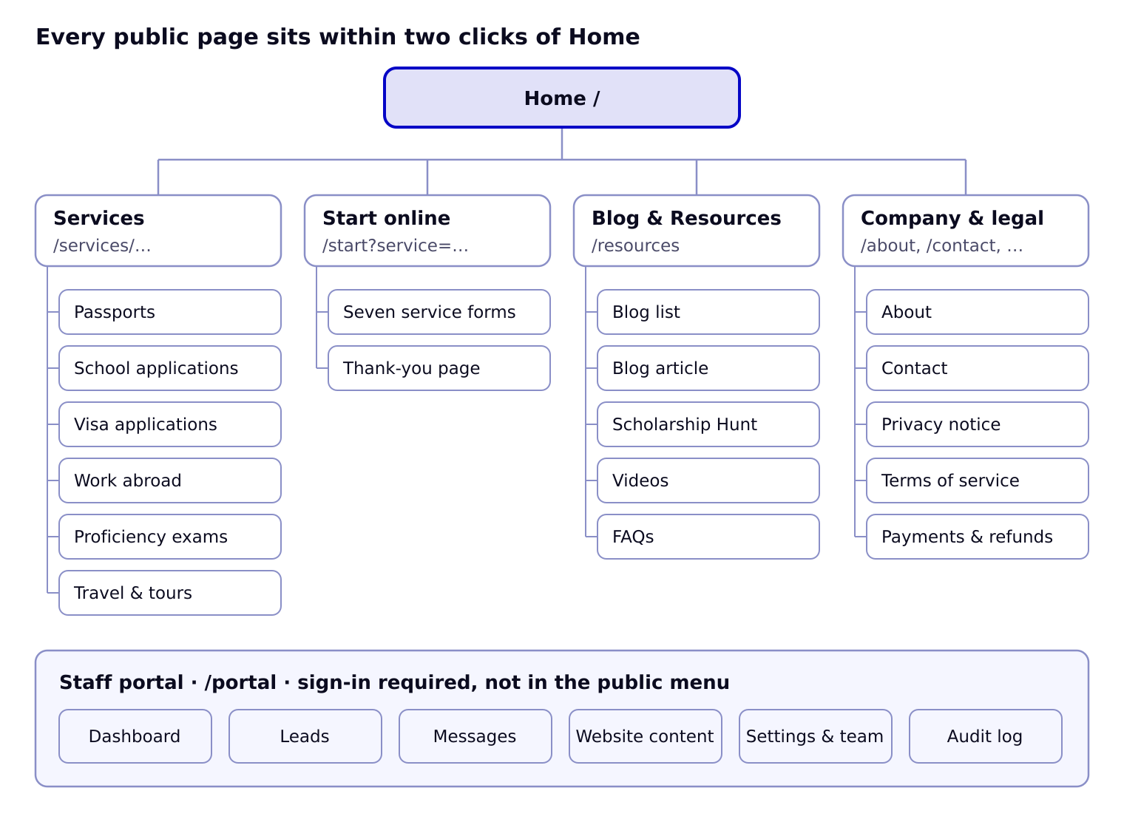
Services, Start online, Blog & Resources and Company pages hang directly off Home; the staff portal is a separate area reached only by signing in.

Pages and URLs
Page | URL | Template | Content from | Primary action
Home | / | Home | Settings, Team, Drives, Testimonials, latest Posts, Scholarships, Videos | Start online
Passports & Birth Certificates | /services/passports | Service | Settings (prices), Drives, FAQs | Start online (passport)
School Applications | /services/school-applications | Service | Programmes, Videos | Start online (school)
Visa Applications | /services/visa-applications | Service | FAQs, Videos | Start online (visa)
Work Abroad | /services/work-abroad | Service | Openings, Programmes | Start online (work)
Proficiency Exams | /services/exams | Service | Settings (prices), FAQs | Start online (exams)
Travel & Tours | /services/travel | Service | Trips | Request a quote
Start online | /start?service={key} | Form | Form definitions, Settings | Save and continue
Thank you | /start/done?ref={ref} | Form | Lead, Settings | Message us now
Blog & Resources | /resources | Hub | latest Posts, Scholarships, Videos | Section cards
Blog | /resources/blog?topic={topic}&page={n} | List | Posts | Read article
Article | /resources/blog/{slug} | Article | Post, Team member | Start online box
Scholarship Hunt | /resources/scholarships?status={status} | List | Scholarships | Official page / Get help
Videos | /resources/videos?platform={platform} | List | Videos | Play
FAQs | /resources/faqs?topic={service} | List | FAQs | WhatsApp us
About | /about | Content | Team, Settings | Start online
Contact | /contact | Content + form | Settings (offices, contacts) | Send message
Privacy notice | /privacy | Legal | Static text from ELC | —
Terms of service | /terms | Legal | Static text from ELC | —
Payments & refunds | /payments | Legal | Static text from ELC | —
Not found | (any) | Error | — | Home, Start online
Staff portal | /portal/… | Portal | Everything | Sign in
Portal routes: /portal (dashboard), /portal/leads, /portal/leads/{id}, /portal/messages, /portal/subscribers, /portal/content/{type} and /portal/content/{type}/{id} for scholarships, posts, videos, programmes, openings, drives, trips, faqs, team, testimonials, /portal/settings/{section}, /portal/audit, /portal/sign-in.

Navigation
- Header: Home · Services (6 links) · Blog & Resources (Blog, Scholarship Hunt, Videos, FAQs) · About · Contact · WhatsApp · Start online. Top bar: phones, hours, LIVE note.
- Footer: CTA bar; Services; Resources; Company (About, Team, Host a passport drive, Partner with us, Internships & NSS, Book the CEO, Contact, Start online); Visit or call; Scholarship Hunt alerts; legal links; no-guarantee line.
- Phone bar (under 820 px): Start online · WhatsApp · Call.
- Breadcrumbs on every page below the home page.
- Portal sidebar: Dashboard · Leads · Messages · Website content (Scholarship Hunt, Blog, Videos, Programmes & openings, Passport drives, Group trips, FAQs, Team, Testimonials) · Settings & team · Audit log.

Redirects from the current site
Old URL | New URL
/index.html | /
/about-us/ | /about
/services/, /services/service-details/ | /services/passports
/projects/, /projects/projects-details/, /project-masonry/, /clients/ | /
/blog/ and old post slugs | /resources/blog
/faqs/ | /resources/faqs
/contact/ | /contact
/team/team-details/ | /about#team
/category/* | /resources/blog

