System Architecture
One Next.js app on Vercel serves the public site, the Start online forms and the staff portal; Supabase holds every record and enforces who can read or change it.

System overview
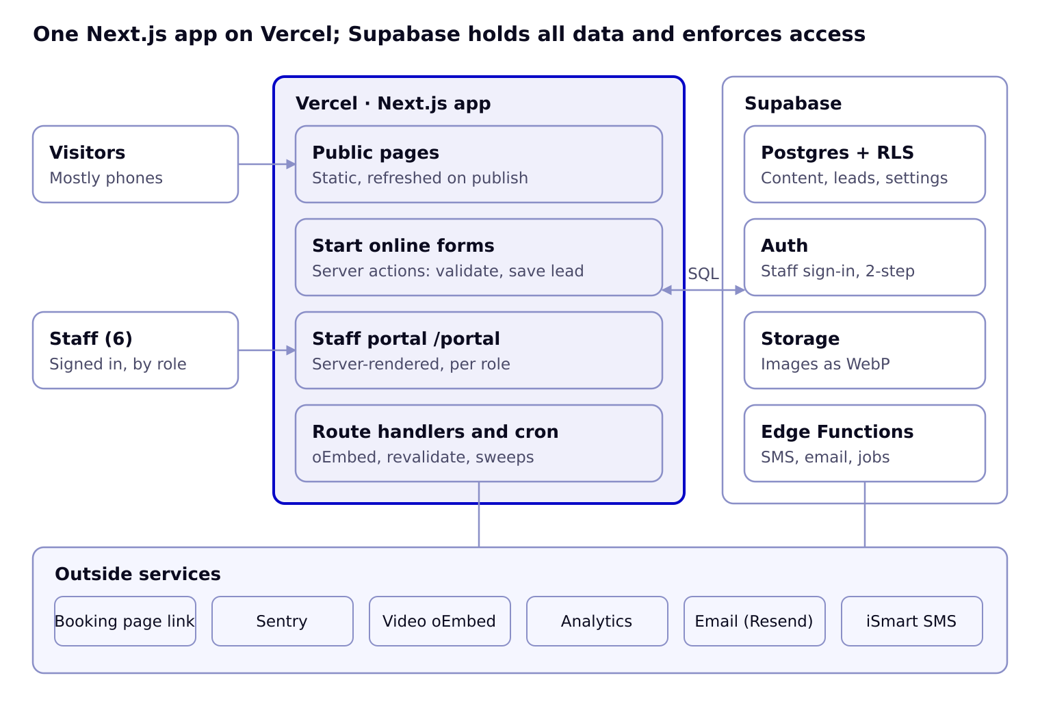
Visitors and staff reach the same Next.js app; it talks to Supabase over SQL with row-level security, and only server code and Edge Functions call the outside services. The booking page is a plain outbound link.

Lead capture flow
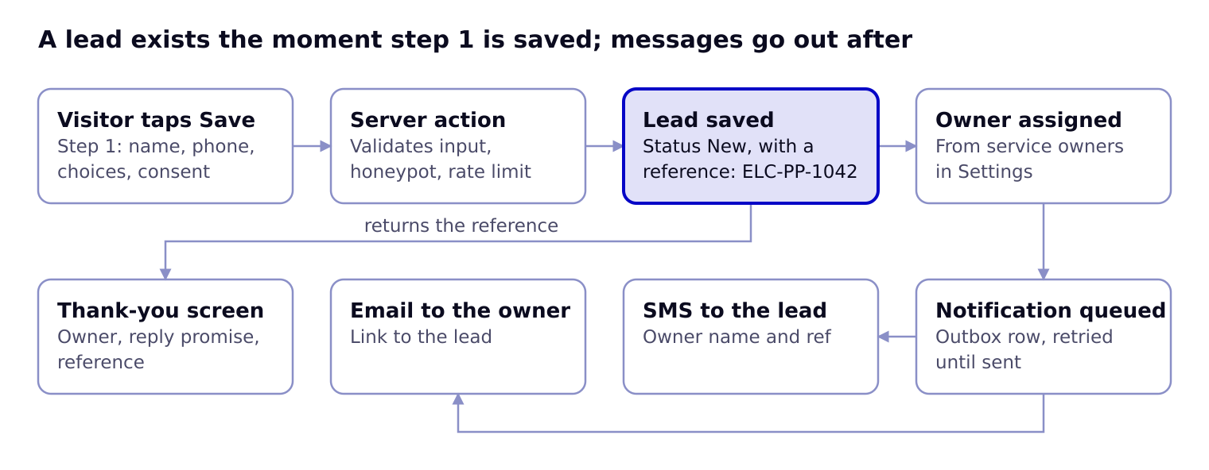
The visitor sees the thank-you screen as soon as the lead is saved; SMS and email go out through an outbox table, so a provider outage delays messages but never loses a lead.

Technology stack
Layer | Choice | Why
Framework | Next.js (App Router), TypeScript, React Server Components | Static pages for speed, server actions for forms, one codebase for site and portal
Styling | Tailwind CSS with ELC design tokens; shadcn/ui primitives (Radix) restyled to the Design System | Accessible primitives, tokens shared with the design system
Forms | React Hook Form + Zod (same schema on client and server) | One source of validation rules per form step
Database | Supabase Postgres with row-level security | Relational data, roles enforced in the database
Auth | Supabase Auth (email magic link or password; TOTP two-step for admins) | Invite-only staff accounts
Storage | Supabase Storage, public bucket for published images, private bucket for drafts | Images resized to WebP on upload
Jobs | Supabase pg_cron + Edge Functions; Vercel Cron for revalidation sweeps | Scholarship status, freshness flags, digests, notification retries
Rich text | Tiptap editor storing JSON; rendered to HTML on the server | Clean, safe blog content
Messaging | iSmart SMS; Resend email | Existing SMS provider; reliable transactional email
Monitoring | Sentry; Vercel Analytics or Plausible; first-party events table | Errors, page analytics, funnel events
Testing | Vitest (units), Playwright (end-to-end), axe-core (accessibility) | Every form tested end to end before release

Repository structure
elc-web/
app/
(site)/ public pages: page.tsx, services/[slug], resources/..., about, contact, start
(portal)/portal/ dashboard, leads, messages, content/[type], settings/[section], audit
api/ oembed, revalidate, cron/*, webhooks/sms
layout.tsx, sitemap.ts, robots.ts, not-found.tsx
components/
ui/ design-system components (Button, Field, Card, Badge, Tabs, Dialog...)
site/ Header, Footer, PhoneBar, ServiceCard, ProgrammeCard, VideoEmbed...
forms/ StartOnlineForm, StepRenderer, field components
portal/ Sidebar, DataTable, LeadPanel, ContentEditor, PublishBar...
lib/
supabase/ server.ts, client.ts, admin.ts (service role, server only)
forms/ form definitions per service + Zod schemas
content/ queries per content type, cache tags
notify/ sms.ts, email.ts
auth/ roles and permission helpers
styles/tokens.css CSS variables generated from the Design System tokens
supabase/
migrations/ SQL: tables, enums, RLS policies, functions, cron jobs
functions/ Edge Functions: send-notifications, scholarship-status, weekly-digest
seed.sql services, settings, team, sample content from the mockups
tests/ unit, e2e (Playwright), a11y

Environments and deployment
Environment | URL | Database | Deploys from
Local | localhost:3000 | Supabase CLI (local Docker) | Developer machine
Preview | per-branch Vercel URL | Supabase staging project | Every pull request
Staging | staging.ernestlinksconsult.com | Supabase staging project | main branch
Production | ernestlinksconsult.com | Supabase production project | Release tag, after staging sign-off
Database changes ship only as SQL migrations in supabase/migrations, applied by CI to staging, then production. Secrets live in Vercel and Supabase environment settings, never in the repo: NEXT_PUBLIC_SUPABASE_URL, NEXT_PUBLIC_SUPABASE_ANON_KEY, SUPABASE_SERVICE_ROLE_KEY (server only), ISMART_API_KEY, RESEND_API_KEY, META_OEMBED_TOKEN, REVALIDATE_SECRET, SENTRY_DSN.

Caching and revalidation
- Public pages are static. Each query is tagged by content type (tag: scholarships, tag: settings).
- Publishing, unpublishing or changing a setting in the portal calls revalidateTag for the affected tags, so changes appear within seconds; a 10-minute fallback revalidation catches anything missed.
- Scholarship status is computed in SQL from opens and deadline, and a nightly job revalidates the scholarship pages after midnight Africa/Accra time.

Security model
- Visitors use the anon key and can only read published rows (RLS) and insert through server actions; they never write tables directly.
- Form submissions run in server actions that validate with Zod, check the honeypot and rate limit, then write with the service role.
- Staff requests carry the user's session; RLS checks staff.role and per-type permissions for every read and write.
- The service-role key exists only in server code and Edge Functions.
- Every change by staff is written to audit_log by database triggers.

