Data Model (ERDs)
Twenty-five Postgres tables in three groups: leads and people, website content, and settings and operations. All use UUID keys and created_at / updated_at timestamps unless noted.

ERD 1: leads and people
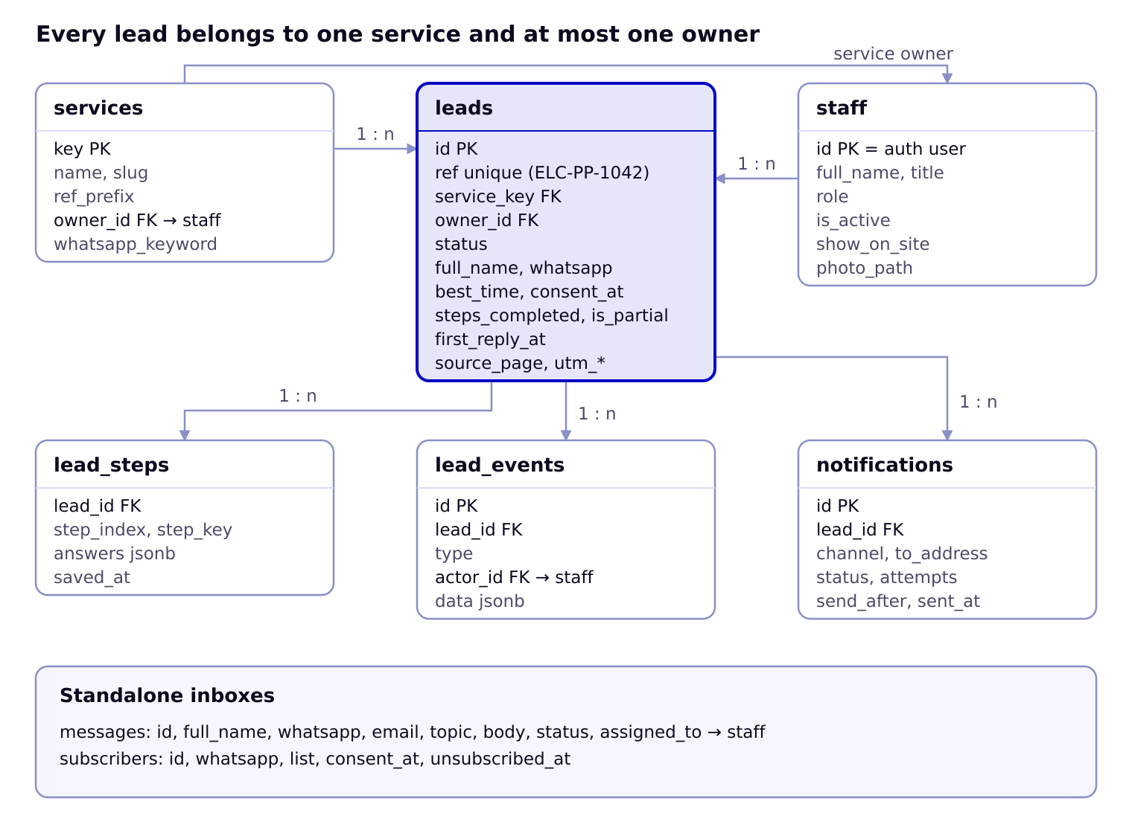
A lead points to its service and its owner; its saved steps, timeline events and outgoing messages each hang off it. Each service also names a default owner in staff.

ERD 2: content, settings and operations
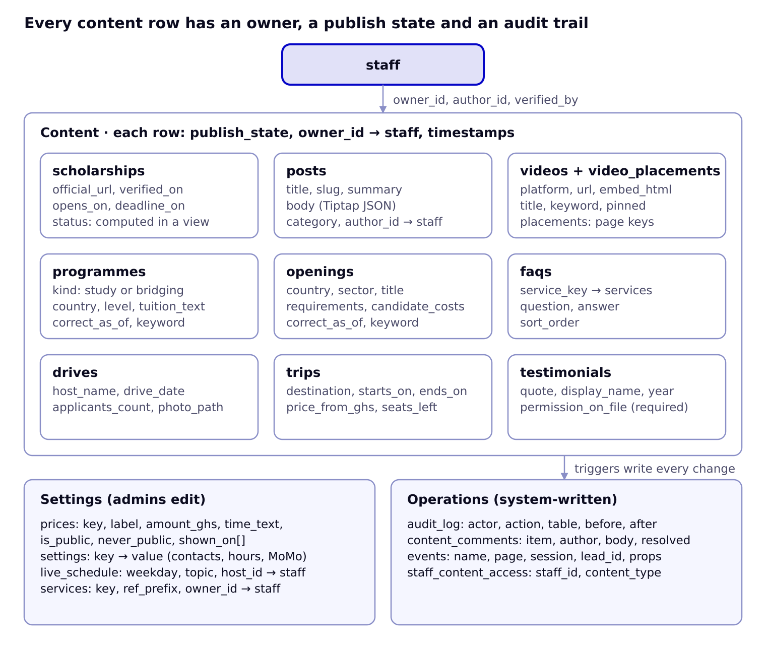
All nine content tables share the same publishing columns and point to staff; settings are admin-only key tables, and database triggers write every staff change to the audit log.

Enums
Enum | Values
staff_role | admin, editor, front_desk
lead_status | new, contacted, started, paid, closed
lead_event_type | created, step_saved, completed, status_changed, assigned, note, sms_sent, email_sent, merged
notify_channel | sms, email
notify_status | pending, sent, failed
publish_state | draft, in_review, published, archived
content_type | scholarship, post, video, programme, opening, drive, trip, faq, testimonial, team
video_platform | tiktok, instagram, facebook, youtube
post_category | passports, school_applications, visas, exams, scholarships, student_stories, work_abroad, travel
programme_kind | study, bridging

Tables
Table | Key columns | Notes
staff | id (= auth.users.id), full_name, title, role, phone, email, is_active, show_on_site, photo_path, bio, sort_order | One row per staff member; drives About page and portal access
staff_content_access | staff_id → staff, content_type | Which content types an editor may edit
services | key (passport, birth, school, visa, work, exams, travel), name, slug, ref_prefix (PP, BC, SA, VS, WA, EX, TR), owner_id → staff, whatsapp_keyword, sort_order | Seeded; owner gets new leads
leads | id, ref (unique, e.g. ELC-PP-1042), service_key → services, full_name, whatsapp, best_time, consent_at, status, owner_id → staff, steps_completed, steps_total, is_partial, form_version, source_page, referrer, utm_source, utm_medium, utm_campaign, heard_from, first_reply_at, closed_reason | Created at step 1; ref from a per-service sequence
lead_steps | lead_id → leads, step_index, step_key, answers (jsonb), saved_at | One row per saved step; answers validated by the step's Zod schema
lead_events | id, lead_id → leads, type, actor_id → staff (null for system), data (jsonb), created_at | Timeline in the lead panel
notifications | id, lead_id → leads (nullable), channel, to_address, template, payload, status, attempts, last_error, send_after, sent_at | Outbox processed by an Edge Function every minute
messages | id, full_name, whatsapp, email, topic, body, consent_at, status (new, handled), assigned_to → staff | General contact form
subscribers | id, whatsapp, list ('scholarship_alerts'), consent_at, unsubscribed_at | Footer alert sign-up
scholarships | id, slug, name, where_text, levels (text[]), covers, official_url, opens_on, deadline_on, deadline_text, verified_on, verified_by → staff, not_pay_to_apply, publish_state, owner_id | Public status comes from the scholarships_public view
posts | id, slug, title, summary, body (Tiptap JSON), body_html, category, author_id → staff, cover_path, cover_alt, seo_title, seo_description, publish_state, published_at, reviewed_by | Blog
videos | id, platform, url, embed_html, thumbnail_url, title, keyword, pinned, publish_state, added_by → staff, published_at | Embed fetched by /api/oembed
video_placements | video_id → videos, page_key (videos, home, school, visa, passports, work, …) | Where each video shows
programmes | id, kind, country, city, level, title, duration_text, tuition_text, keyword, correct_as_of, internal_school_name (never rendered), publish_state, owner_id | Programmes open now; bridging programmes also feed Work Abroad
openings | id, country, sector, title, requirements, candidate_costs, keyword, correct_as_of, publish_state, owner_id | Work abroad openings; review required
drives | id, host_name, drive_date, applicants_count, photo_path, publish_state | Track record cards
trips | id, title, destination, starts_on, ends_on, price_from_ghs, seats_left, photo_path, publish_state | Group trips
faqs | id, service_key → services (null = general), question, answer, sort_order, publish_state | FAQs page, service pages
testimonials | id, display_name, service_key, year, quote, photo_path, permission_on_file, publish_state | Cannot publish unless permission_on_file
content_comments | id, content_type, content_id, author_id → staff, body, resolved | Review comments on any content row
prices | key, label, amount_ghs, time_text, is_public, never_public, shown_on (text[]), updated_by | never_public rows (school application, visa processing) can never be rendered
settings | key, value (jsonb), updated_by | contacts, hours, reply_promise, official_momo, booking_url, offices
live_schedule | weekday (1–5), topic, host_id → staff, starts_at_time | Homepage LIVE strip
audit_log | id (bigserial), actor_id, action, table_name, row_id, before, after, created_at | Written by triggers on every staff change
events | id (bigserial), name, page, session_id, lead_id, props (jsonb), created_at | form_open, step_saved, whatsapp_click, … for the funnel

Access rules (row-level security)
Table group | Anonymous visitor | Front desk | Editor | Admin
Published content (all content tables) | Read rows where publish_state = published | Read | Read | Read
Draft and in-review content | None | None | Read and write for their content types; cannot set published on posts, openings, programmes | All
leads, lead_steps, lead_events | None (insert only through server actions with the service role) | Read all; update status, owner, notes | Read and update leads they own | All
messages, subscribers | None (server actions insert) | Read, update | None | All
prices, settings, live_schedule | Read public values via views | Read | Read | Read and write
staff, staff_content_access | Read show_on_site rows via a view | Read | Read | Read and write
audit_log, events | None | None | None | Read

Key SQL
-- Reference numbers: ELC-PP-1042
create sequence lead_ref_seq start 1000;
create function next_lead_ref(p_service text) returns text language sql as $$
select 'ELC-' || s.ref_prefix || '-' || nextval('lead_ref_seq')
from services s where s.key = p_service;
$$;
-- Public scholarship status computed from dates (Africa/Accra)
create view scholarships_public as
select s.*,
case
when s.deadline_on is not null and s.deadline_on < (now() at time zone 'Africa/Accra')::date then 'closed'
when s.opens_on is not null and s.opens_on > (now() at time zone 'Africa/Accra')::date then 'opening_soon'
else 'open'
end as status
from scholarships s
where s.publish_state = 'published' and s.official_url is not null and s.not_pay_to_apply;
-- Example policy: editors manage only their content types
create policy editors_write_posts on posts for all to authenticated
using (is_admin() or has_content_access('post'))
with check (is_admin() or (has_content_access('post') and publish_state <> 'published'));

Form definitions (in code)
Forms live in lib/forms/{service}.ts so they are versioned with the code; each lead stores form_version.
type Field =
| { kind: 'text' | 'tel' | 'email' | 'date' | 'month' | 'number'; key: string; label: string; required?: boolean; hint?: string }
| { kind: 'select' | 'radio' | 'checkboxes'; key: string; label: string; options: string[]; required?: boolean }
| { kind: 'textarea'; key: string; label: string }
| { kind: 'heading' | 'note'; label: string };
type Step = { key: string; title: string; intro?: string; fields: Field[]; schema: ZodSchema };
type ServiceForm = { service: ServiceKey; version: number; steps: Step[]; later: string[]; nextSteps: string[] };
Step contents follow the Start online mockup: passport (7 steps, from ELC's registration sheet without ID numbers, payment or facilitator fields), birth certificate (6, without the informant's ID number), school applications (5), visa (4), work abroad (3), exams (3), travel (3).

