Research & Restoration Partnership
Landscape Health Intelligence Dashboard
Six Rivers Africa × Ernest Moyo / 7Square Inc.
Project Specification & Geospatial Framework | February 2026 | Preliminary — Not for Distribution

Executive Summary
This document specifies the technical framework for a geospatial Landscape Health Intelligence Dashboard covering Six Rivers Africa's two operational zones in southern Tanzania — the Usangu Game Reserve / Ihefu Wetland and the Nyerere National Park (Selous ecosystem). It is framed explicitly within Six Rivers Africa's Research & Restoration pillar, providing the scientific evidence base needed to guide conservation decisions, measure ecosystem health over time, and communicate impact to stakeholders and funders.
The proposal integrates shapefile demarcation, satellite-derived environmental indicators, and AI-assisted analysis and reporting. A companion Claude AI prompt is provided as a standalone analytical instrument to operationalise the work.

⚠ Spatial Assumptions & Placeholder Boundary Notice
The maps and zone boundary coordinates included in this document are INDICATIVE PLACEHOLDERS only. They have been constructed from:
- Publicly available published descriptions of Usangu Game Reserve, Ihefu Wetland, and Nyerere National Park
- WDPA (Protected Planet) database records and conservation literature available in the public domain
- Press coverage of Six Rivers Africa operations (including references to the Ikoga airstrip location)
- General geographic knowledge of protected area locations in southern and western Tanzania

These boundaries have NOT been verified against:
- Authoritative shapefiles from TANAPA, TAWA, or Six Rivers Africa’s own operational GIS
- Ground-truthed GPS surveys or official protected area demarcations
- The WDPA digital boundary files (which require a separate download)

Action required: Once Six Rivers Africa shares their operational boundary coordinates or shapefiles, all maps, zonal statistics, and alert thresholds in this document and the companion Claude prompt will be updated to reflect verified demarcations. This is the first task in Phase 1 of the project (Month 1). Until then, all spatial outputs should be treated as directionally correct but not survey-accurate.

1. Strategic Alignment with Six Rivers Africa

1.1 Research & Restoration Pillar
Six Rivers Africa's Research & Restoration pillar is centred on enhancing public awareness and accessibility to wildlife population dynamics and biodiversity auditing data, to inform decision-making. The Landscape Health Intelligence Dashboard operationalises this pillar by providing a systematic, reproducible, and transparent evidence platform — converting raw satellite and field data into decision-ready intelligence for conservation managers, local authorities, and international funders.

Six Rivers Africa states:  “Enhancing public awareness and accessibility to wildlife population dynamics and biodiversity auditing data, to inform decision-making.” | This dashboard delivers:  - Continuous, accessible biodiversity & landscape data  - Reproducible, auditable monitoring methodology  - Multi-stakeholder reporting (local authorities + funders)  - Evidence base to inform adaptive management decisions

1.2 Tanzanian-Led, Data-Driven Model
The dashboard is designed to be operated and interpreted by Tanzanian conservation professionals, with outputs structured for presentation to local government authorities (district councils, TANAPA, TAWA) and community leaders. Data pipelines will be documented and transferable, ensuring institutional independence from external technical partners over time.

2. Operational Zones & Spatial Demarcation

2.1 Overview Map — Southern & Western Tanzania
The two operational zones below represent the primary landscapes within which Six Rivers Africa conducts its conservation work. Both zones are demarcated as GIS shapefiles (see Section 4) and serve as the spatial units for all monitoring, analysis, and reporting.

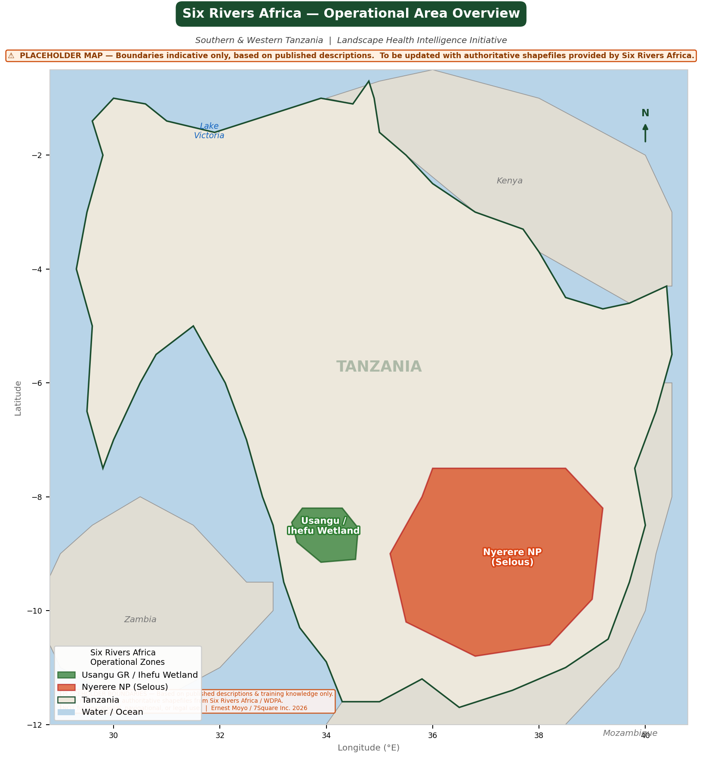
Figure 1: Six Rivers Africa operational zones — southern & western Tanzania

2.2 Zone 1 — Usangu Wetlands & Ihefu Swamp
Full name: Usangu Game Reserve (incorporating Ihefu Wetland)  Region: Mbeya Region, Mbarali District  Approx. area: ~2,500 km² (reserve); ~350 km² (Ihefu swamp core)  Ecosystem: Seasonal floodplain wetland, miombo woodland, grassland  Key rivers: Great Ruaha River, Chimala River  Key species: Elephant, buffalo, hippopotamus, wild dog, lion, tigerfish  Status: Game Reserve — managed by TAWA | Six Rivers base: Ikoga Airstrip (operational hub)  Primary threats: Agricultural encroachment, seasonal water abstraction  WDPA ID: WDPA 20021 (Usangu GR)  Shapefile ref: usangu_game_reserve.shp + ihefu_swamp_core.shp

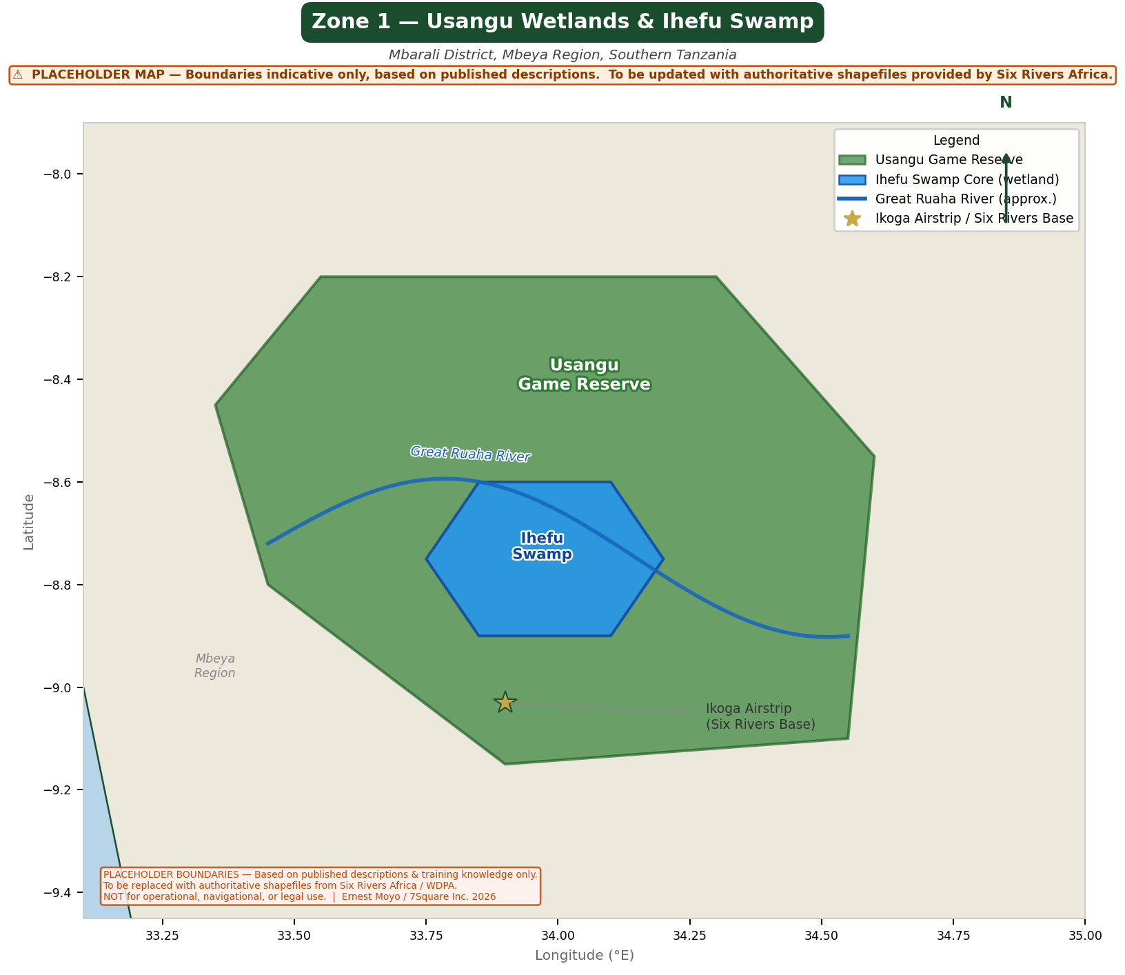
Figure 2: Zone 1 — Usangu Game Reserve and Ihefu Swamp Core, Mbeya Region

2.3 Zone 2 — Nyerere National Park (Selous Ecosystem)
Full name: Nyerere National Park (formerly Selous Game Reserve)  Regions: Morogoro, Lindi, Ruvuma Regions  Approx. area: ~30,893 km² (national park core)  Ecosystem: Miombo woodland, riverine forest, floodplain  Key rivers: Rufiji River, Great Ruaha River, Kilombero River  Key species: Elephant, lion, wild dog, crocodile, hippo, sable antelope  Status: National Park — TANAPA; UNESCO World Heritage Site (1982) | Governance: TANAPA (national park); buffer zone under district councils  Primary threats: Poaching, charcoal production, infrastructure encroachment  WDPA ID: WDPA 1695 (former Selous GR)  Shapefile ref: nyerere_np_boundary.shp

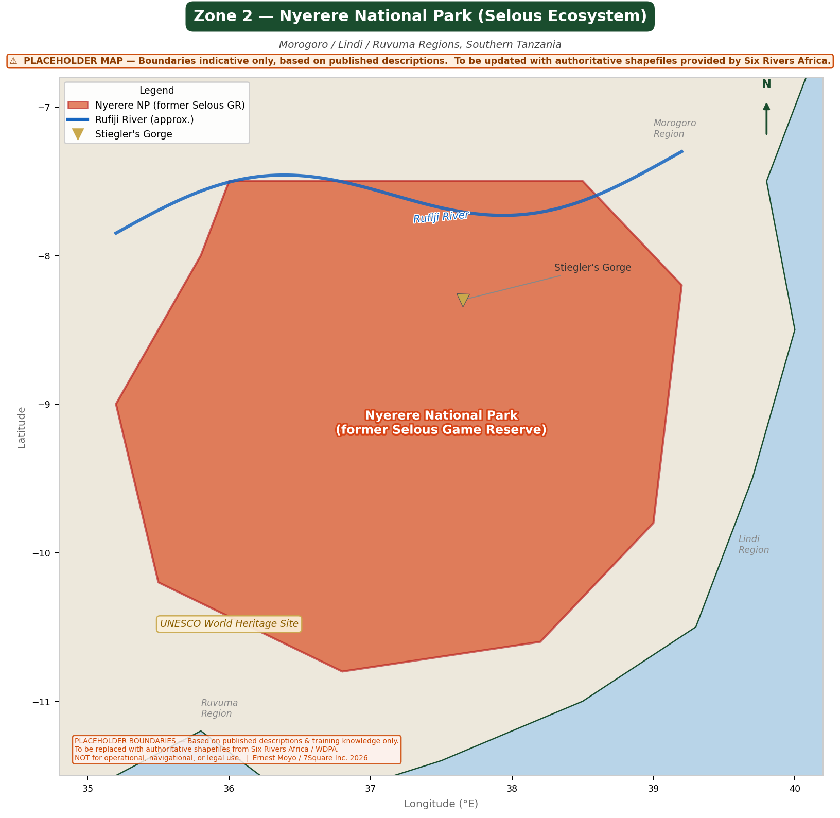
Figure 3: Zone 2 — Nyerere National Park (Selous Ecosystem), Southern Tanzania

3. Dashboard Technical Specification

3.1 Environmental Indicators
The dashboard will track the following satellite-derived landscape health indicators, updated monthly, for each operational zone independently and as a combined Six Rivers Africa landscape:

Indicator | Data Source | Scientific Rationale
NDVI (Vegetation Greenness) | Sentinel-2 / MODIS | Proxy for vegetation productivity, grazing pressure, and habitat quality
EVI (Enhanced Vegetation Index) | MODIS MOD13Q1 | Reduced canopy saturation bias; superior in dense miombo
Land Cover Change | ESA WorldCover / GFC | Detects deforestation, agricultural expansion, wetland shrinkage
Burn Scar Extent | NASA FIRMS / MODIS MCD64 | Fire ecology monitoring; illegal burning detection
Surface Water Dynamics | JRC Global Surface Water | Seasonal inundation tracking; Ihefu swamp extent monitoring
Rainfall Anomaly | CHIRPS v2.0 | Contextualise vegetation signals; drought / flood risk
Land Surface Temperature | MODIS MOD11A2 | Thermal stress on vegetation and wildlife; heat island detection
NDWI (Water Index) | Sentinel-2 | Quantify open water and wetland health in Ihefu / riparian zones

3.2 Dashboard Architecture
The system is built on open-source, maintainable components to ensure long-term operational independence for Six Rivers Africa:

Data Pipeline  Data Pipeline  - Google Earth Engine (GEE): satellite data extraction, index computation  - R / Python: statistical processing, anomaly detection, time-series analysis  - GitHub Actions: automated monthly pipeline execution  - PostGIS / GeoPackage: spatial data storage | Reporting & Visualisation  Reporting & Visualisation  - R Shiny or Quarto dashboard: interactive web interface  - Leaflet.js: interactive mapping layer  - Claude API: automated narrative generation from data outputs  - PDF/HTML reports: automated monthly donor-ready outputs

3.3 Alert & Anomaly Detection
The dashboard will trigger alerts when landscape indicators breach defined thresholds within any operational zone shapefile boundary:
- NDVI decline >15% below 5-year monthly baseline (2+ consecutive pixels, >2 km²) → vegetation stress alert
- Active fire detected within shapefile boundary → immediate burn alert with coordinates
- Forest cover loss >0.5 km² in 30-day window → deforestation event logged
- Surface water area (Ihefu) deviating >25% from seasonal norm → wetland health flag
- Rainfall deficit >40% of CHIRPS 30-year mean for 3+ consecutive decades → drought watch

4. Shapefile Demarcation Framework

4.1 Overview
All spatial analysis will be bounded by and attributed to authoritative GIS shapefiles. These form the analytical units for satellite data extraction (zonal statistics), alert generation, and reporting disaggregation. Shapefiles will be maintained in a version-controlled GeoPackage repository, updated when authoritative boundary revisions are published.

Core Shapefile Register

Shapefile / Layer | Type | CRS | Source / Method
usangu_game_reserve.shp | Polygon | EPSG:4326 | TANAPA / TAWA boundary data; digitised from WDPA
ihefu_swamp_core.shp | Polygon | EPSG:4326 | Wetlands International / Ramsar database
nyerere_np_boundary.shp | Polygon | EPSG:4326 | Protected Planet (WDPA) — IUCN Category II
great_ruaha_river.shp | LineString | EPSG:4326 | HydroSHEDS / GRDC river network
rufiji_river.shp | LineString | EPSG:4326 | HydroSHEDS / GRDC river network
six_rivers_study_zones.shp | Polygon | EPSG:4326 | Composite: both operational zones merged
tz_admin_regions.shp | Polygon | EPSG:4326 | GADM v4.1 — Tanzania regions
tz_protected_areas.shp | Polygon | EPSG:4326 | WDPA / UNEP-WCMC full extract

⚠ PLACEHOLDER BOUNDARIES NOTICE: The coordinates and boundary polygons used in the maps on pages 2–4 of this document are indicative only. They are based on published descriptions of these protected areas (WDPA records, press coverage, and publicly available conservation literature) and are NOT derived from authoritative GIS shapefiles. They should not be used for navigation, legal, or operational purposes. All boundaries will be replaced with verified authoritative shapefiles (WDPA / TANAPA / TAWA / Six Rivers Africa’s own operational maps) as soon as these are shared by Six Rivers Africa. The shapefile register in the table above reflects the target architecture, not the current state.

4.2 Coordinate Reference Systems
Storage CRS: EPSG:4326 (WGS84 geographic) — all shapefiles  Analysis CRS: EPSG:32736 (WGS84 / UTM Zone 36S) — area & distance  GEE export: EPSG:4326 with 30m pixel resolution  Map display: EPSG:3857 (Web Mercator) — dashboard tiles | File format: GeoPackage (.gpkg) primary; Shapefile (.shp) for exchange  Attribute schema: name, zone_id, area_km2, source, wdpa_id, date_updated  Topology rules: No overlaps within layer; gaps allowed between zones  Version control: Git-tracked GeoPackage with semantic versioning

4.3 Shapefile Preparation Workflow
Current status: All boundaries are placeholders pending receipt of authoritative files from Six Rivers Africa. Step 0 below is the prerequisite for all subsequent steps.
- STEP 0 (prerequisite): Obtain verified operational boundary coordinates or shapefiles directly from Six Rivers Africa. All subsequent steps depend on this. Once received, replace all placeholder polygons in the GeoPackage and regenerate maps.
- Download WDPA shapefile for Tanzania (Protected Planet) and clip to study regions as a cross-validation reference
- Cross-validate boundaries against TANAPA / TAWA published maps and aerial imagery
- Generate simplified versions for web display (Douglas-Peucker, tolerance 0.001°)
- Compute zonal statistics masks in GEE using each polygon as an extraction unit
- Store all versions in versioned GeoPackage with provenance metadata
- Annual review: compare against updated WDPA releases and adjust if boundaries revised

5. Deliverables & Timeline
Phase | Deliverable | Timeline | Owner
1 | Shapefile register: both zones demarcated & validated | Month 1 | Ernest Moyo
1 | GEE data pipeline: historical baseline (2018–2025) | Month 1 | Ernest Moyo
1 | Interactive prototype dashboard (single zone) | Month 2 | Ernest Moyo
2 | Full dashboard: both zones, all indicators, alerting | Month 3 | Ernest Moyo
2 | First automated monthly landscape health report | Month 3 | Claude API
2 | Staff training: dashboard interpretation & data query | Month 4 | Ernest Moyo + SRA team
3 | Integration with SRA annual reporting template | Month 5 | Ernest Moyo + SRA team
3 | Community-facing summary brief (Swahili + English) | Month 6 | Ernest Moyo + SRA team

6. Proposed Next Steps
This specification is designed as a working document to be refined through direct engagement with the Six Rivers Africa team. A short scoping call (45–60 minutes) would enable us to:
- Confirm which landscape zone (Usangu or Selous) represents the highest current monitoring priority
- Review existing data assets: any historical field monitoring, previous satellite analyses, or boundary shapefiles already held by SRA
- Agree on the first reporting cycle and audience (internal management vs. donor vs. Tanzanian government)
- Confirm 7Square Inc. engagement model: technical partnership, advisory, or secondment

Contact  Name: Ernest Moyo  Role: Epidemiologist & Data Scientist, NM-AIST | Co-founder, 7Square Inc.  Web: 7squareinc.com  Research: github.com/ernestmoyo | Document Status  Version: v1.0 — Preliminary  Date: February 2026  Audience: Six Rivers Africa Team — Not for Distribution  Review: Pending scoping conversation

Prepared by Ernest Moyo / 7Square Inc. | February 2026 | Confidential — Preliminary Concepts

