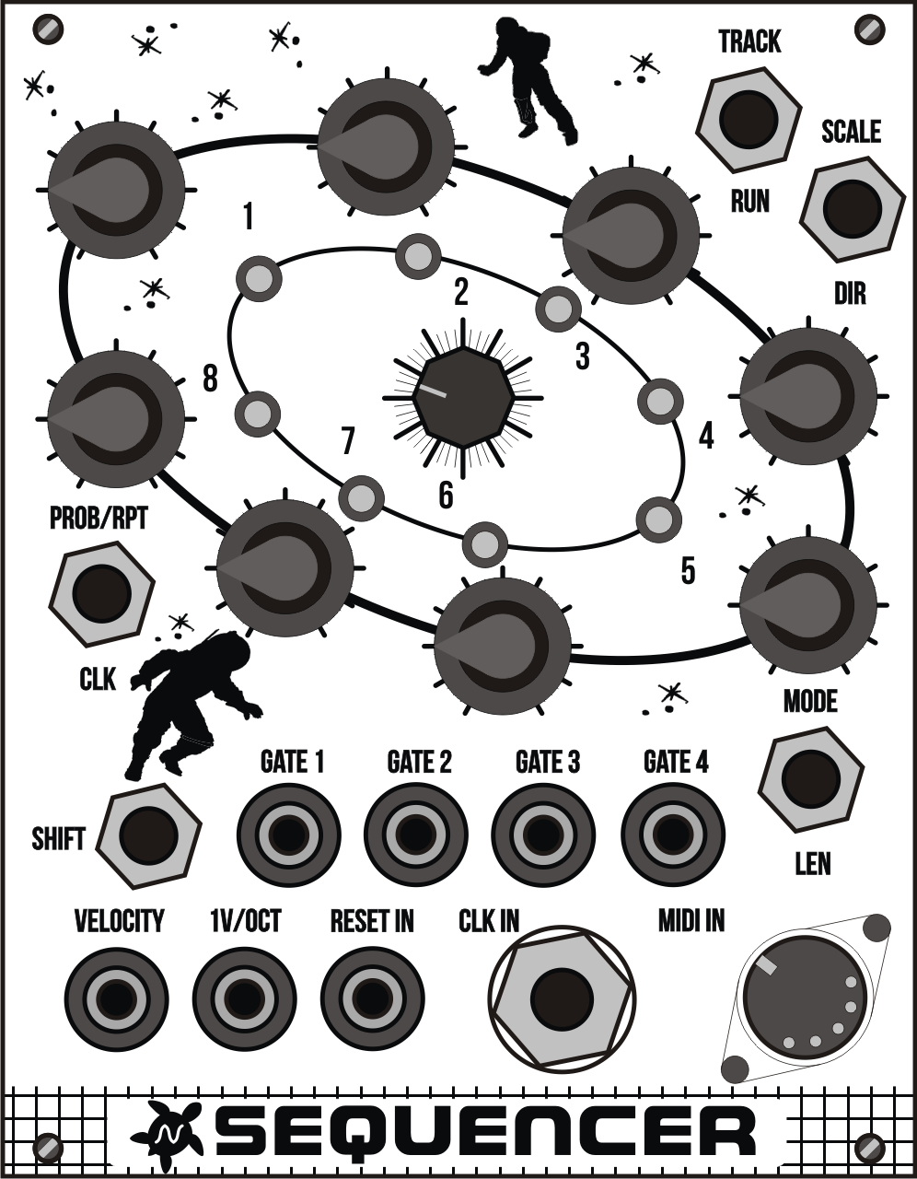

**User’s**

**MANUAL**

*SEQUENCER*

July 2020

**Revision Sheet**

|  |  |  |
| --- | --- | --- |
| **Release No.** | **Date** | **Revision Description** |
| Rev. 0 | 04/07/2020 | User’s Manual First revision |
| Rev. 1 | 19/10/2020 | New Feature: Root note for scale. Voltage table information. |
|  |  |  |
|  |  |  |
|  |  |  |
|  |  |  |
|  |  |  |

**USER'S MANUAL**

**TABLE OF CONTENTS**

Page #

A. GENERAL INFORMATION 1

​ 1.1 Specifications 1

​ 1.2 Description 2

B. GETTING STARTED 1

​ 2.1 Overview 1

​ 2.2 Usage 2

​ 2.3 Configuration 5

​ Clock source selection 5

​ MIDI channel selection 5

​ Reset input behavior selection 5

​ Root note selection 5

​ 2.4 Voltage table for 1v/Oct output 6

**1.0 GENERAL INFORMATION**

# GENERAL INFORMATION

## 1.1 Specifications

* Format: Eurorack
* Dimensions: 20HP, 70mm deep
* Internal and external signals: 0-5V Logic I/O
* Max Current:
  1. +12V: 100mA
  2. -12V: 1mA
  3. +5V: n/a

## 1.2 Description

The Sequencer is a 4-track 8-step sequencer. Each track correlates with it's own sequencer (4 independent sequencers that share the same base clock). Each track has a gate output and track 1 has an extra 1V/OCT output and Velocity output.

Each step of a sequencer can be programmed with Probability and Repeats. An extra feature of Notes exists for track 1 (using 1V/OCT output).

There is also a randomization feature for Probability and Notes. Track parameters for Scales, Sequence Direction (Forward, Reverse, Pendulum and Random), Sequence Length and Clock Division are all accessible and independent for each track.

Features

* 4 Modes:
  + Mode 1: Sequencer with 3 tracks using gate output + 1 track using gate and 1V/OCT output
  + Mode 2: Sequencer with 3 tracks using gate output + 1 track controlled by MIDI input using gate, 1V/OCT and Velocity outputs
  + Mode 3: Sequencer with 3 tracks using gate output + 1 track Arpeggiator controlled by MIDI.
  + Mode 4: Sequencer with 3 tracks using gate output + 1 track in Euclidean mode using gate and 1V/OCT output.
* 8 steps per track.
* Play/Stop Function
* Divide clock per track.
* Adjust sequence length per track.
* Program Notes for Track 1.
* 8 Quantized Scale Options (Micro Tuning, Chromatic, Major, Minor, Blues, Phrygian, Lydian, Dorian Scales)
* Program clock tempo between 30 and 600 bpm.
* 7 Sequencer Direction Modes (Forward, Reverse, Pendulum, Stagger, Skip, Random, Random With Rest)
* CLK IN: Clock input.
* RESET IN: Configure this input to reset sequence to step 1 or hold the current step.
* Probability: Control the probability of a step outputting a gate.
* Repeat: Control the amount of repeats per step.
* 8 leds to indicate current step and options selected.
* 0 to 5 volt Analog CV Output
* 5 volt Gate Output

**2.0 GETTING STARTED**

# GETTING STARTED

## 2.1 Overview

**Buttons:**Use

these combined with

Shift button

to select an option



**Note/Prob knobs:**Use

this knobs to set the

step note in track 1

or prob/rpt for

tracks 2 to 4

**Leds:**Indicate current

Step and options.

**Encoder:**Use

this encoder to set the

base time

**Reset and CLK IN:**

0V – 12V tolerant

**Gate outputs:**Connect

your patch cables

from these outputs

to other module gate,

trigger or CV inputs.

**MIDI INPUT:**

Connect a keyboard

using MIDI and use

the sequencer as a

MIDI to CV converter

**Analog outputs:**

Connect

your patch cables

from these outputs

to other module

CV inputs.

**Leds:** Leds show the active step in the sequence in modes 1 to 3. In Euclidean mode leds mark the steps where a gate event will occur.

**Gate outputs:** These outputs go HI 50% of the step’s time. Each output is managed by a “Track”. There are 4 tracks. Track 1 has 3 outputs: 1V/oct, Velocity and GATE1, Track 2 to 4 have one output each, GATE2, GATE3 and GATE4.

**Clock In:** A clock signal can be connected to this input to control the sequencer BPM. External clock mode must be configured.

**Reset In:** A pulse signal can be connected to this input and allows to reset the sequencer step. There are several modes with different behaviours (back to step 1, hold current step, etc.)

**MIDI IN:** In mode 2 and 3, MIDI input can be used to connect a MIDI keyboard. MIDI channel is configurable from 0 to 8. In mode 2, the analog outputs 1v/oct and Velocity will respond to MIDI key events. In mode 3 (arpeggiator) pressed keys will be arpeggiated using the current BPM (one key per step).

**Velocity output:** In mode 1, 3 and 4 velocity is always 5V. In mode 2, velocity value is controlled by MIDI key pressed event.

**1V/OCT output:** In mode 1 and 4, this output (0V to 5V) is controlled by the step’s knobs and can be different for each step. In mode 2 and 3, the output value will correspond to the MIDI key pressed.

**Encoder:** Encoder allows to change BMP from 30 to 600. In mode 4 can be combined with “Shift” button to change the amount of enabled steps in euclidean mode, and combined with “Dir” to rotate the enabled steps also in euclidean mode.

**Buttons:** These buttons can be used while the sequence is playing to change parameters and select the current track. They can be used also to configure settings in the device.

**Knobs:** Knobs are used to set a parameter for each step. There is one knob for each step.

## 2.2 **Usage**

**Button Shift:** Pressing this button in combination with another, allows the user to select the option notated over to button.

**Button Run:** Press run to start the sequence in all four tracks. Press again to stop it. Sequence will always start at step 1.

**Button Track (Shift+Run):** Press track to see and change the current active track. The parameters affected by the knobs will affect just the current track parameters.

*Usage:* Press Track once. The current track will be displayed on the leds. If led 1 is blinking, then the current track is one. If led 2 is blinking then the current track is two. Press Track again to change the value (1 to 4). For finishing the setting, wait 3 seconds and the leds will display the current step again.

**Button Dir:** Press Dir to see and change the current track direction for the steps.

*Usage:* Press Dir once. The current direction will be displayed on the leds. Press Dir again to change the value (1 to 7). For finishing the setting, wait 3 seconds and the leds will display the current step again.

* #1 Forward - The sequence steps between steps 1 to 8 in order.
* #2 Reverse - The sequence steps between steps 8 to 1 in reverse order.
* #3 Pendulum - The sequence steps between steps 1 to 8 then reverses direction. Steps 1 and 8 are triggered twice to create a 16 step sequence length.
* #4 Stagger - The sequence steps between steps 1 to 8 in order with a 25% chance that the sequence will stagger back 1 step or ahead 2 steps. This creates a sequence that staggers back and forth as it steps between steps. Step 1 may be staggered past on any given cycle.
* #5 Skip - The sequence steps between steps 1 to 8 in order, skipping a subsequent step each cycle. This creates a complex sequence of 56 steps. The first time through step 1 is skipped, the second time through step 2 is skipped, and so on.
* #6 Random 1 - The active step is selected randomly.
* #7 Random 2 - The active step is selected randomly. Includes silence step.

**Button Scale (Shift+Dir):** Press Scale to see and change the scale used to select notes with the knobs (only available for track 1).

*Usage:* Press Scale once. The current scale will be displayed on the leds. Press Scale again to change the value (1 to 8). For finishing the setting, wait 3 seconds and the leds will display the current step again.

* #1 Micro - Fine grained access to note intervals.
* #2 Chromatic - 12 step scale with note intervals at 0, 1, 2, 3, 4, 5, 6, 7, 8, 9, 10, 11.
* #3 Major - 7 step scale with note intervals at 0, 2, 4, 5, 7, 9, 11.
* #4 Minor - 7 steps per octave scale with note intervals at 0, 2, 3, 5, 7, 8, 10.
* #5 Blues - 6 steps per octave scale with note intervals at 0, 3, 5, 6, 7, 10.
* #6 Phrygian - 7 steps per octave scale with note intervals at 0, 1, 3, 5, 7, 8, 10.
* #7 Lydian - 7 steps per octave scale with note intervals at 0, 2, 4, 6, 7, 9, 11.
* #8 Dorian - 7 steps per octave scale with note intervals at 0, 2, 3, 5, 7, 9, 10.

**Button Len:** Press Len to see and change the sequence’s length for the current track.

*Usage:* Press Len once. The current length will be displayed on the leds. Press Len again to change the value (1 to 8). For finishing the setting, wait 3 seconds and the leds will display the current step again.

**Button Clk:** Press Clk to see and change the base clock division for the current track.

*Usage:* Press Clk once. The current clock division will be displayed on the leds. Press Clk again to change the value (one means %1, two means %2, eight means %8). For finishing the setting, wait 3 seconds and the leds will display the current step again.

**Button Mode (Shift+Len):** Press Mode to see and change the current mode for the device.

*Usage:* Press Mode once. The current mode will be displayed on the leds. Press Mode again to change the value (1 to 4). For finishing the setting, wait 3 seconds and the leds will display the current step again.

* #1 Mode 1:
  + Knobs will set Notes for track 1
  + Knobs will set Probability and Repetition for tracks 2 to 4
* #2 Mode 2:
  + Track 1 is disabled. MIDI key events will control Gate1, Velocity and 1V/OCT outputs
  + Knobs will set Probability and Repetition for tracks 2 to 4.
* #3 Mode 3:
  + Arpeggiator mode. Track 1 is disabled. MIDI key events will control Gate1, Velocity and 1V/OCT outputs generating arpeggios.
  + Knobs will set Probability and Repetition for tracks 2 to 4.
* #4 Mode 4:
  + Track 1 is in Euclidean mode. Knobs will set Notes. Use the encoder to change euclidean parameters.
  + Knobs will set Probability and Repetition for tracks 2 to 4.

**Button Prob/Rpt (Shift+Clk):** Press Prob/Rpt to see and select between Probability and Repetitions mode. In probability mode, knobs will set probability for the gate to get HI. In repetitions mode, knobs will set the amount of times a gate goes HI for each step slot time.

*Usage:* Press Prob/rpt once. The current mode will be displayed on the leds. Press the button again to change the value (#1 means Probability mode, #2 means Repetitions mode). For finishing the setting, wait 3 seconds and the leds will display the current step again.

* 1. **Knobs:** Each knob selects a different parameter for each step in a track.
  + For track 1, knobs select the note played through 1V/OCT output in each step.
  + For tracks 2 to 4, knobs select the probability (0% to 100%) for the gate to go HI or the amount of times (repetitions) the gate will go HI (1 to 8)

## 2.3 **Configuration**

### Clock source selection

Press Clk button for 5 seconds. Leds will display the current clock source:

* # 1 Internal
* # 2 External (The sequence will advance when a pulse appears in the CLK input)

Press the button again to change the value (1 or 2). For finishing the setting, wait 3 seconds and the leds will display the current step again.

### MIDI channel selection

Press Run button for 5 seconds. Leds will display the current MIDI channel. (channel 0 is represented by all leds off). Press the button again to change the value (0 to 8). For finishing the setting, wait 3 seconds and the leds will display the current step again.

### Reset input behavior selection

Press Len button for 5 seconds. Leds will display the current Reset input mode:

* # 1: Step go back to step 1 when a reset signal goes high.
* # 2: Sequence will hold the current step while the reset input is high
* # 3: The sequence direction reverses when the incoming reset signal goes high. The sequence returns to normal when the gate goes high a second time. If the direction mode is set to random 1 or random 2, reverse mode enables the sequence to play forward.

Press the button again to change the value (1 to 3). For finishing the setting, wait 3 seconds and the leds will display the current step again.

### **Root note** selection

Press Dir button for 5 seconds. Leds will display the current root note:

|  |  |
| --- | --- |
| **LED Number** | **Note** |
| 1 | C |
| 2 | D |
| 3 | E |
| 4 | F |
| 5 | G |
| 6 | A |
| 7 | B |
| 8 | Means sharp (#). This led will be ON for C, D, F, G and A |

Press the button again to change the value (FROM C to B). For example, if led 4 and 8 are ON, that means F#. For finishing the setting, wait 4 seconds and the leds will display the current step again.

## **2.4 Voltage table for 1v/Oct output**

|  |  |  |
| --- | --- | --- |
| **Key** | **MIDI** | **1v Octave [V]** |
| C2 | 36 | 0,0833 |
| C#2 | 37 | 0,1667 |
| D2 | 38 | 0,25 |
| D#2 | 39 | 0,3333 |
| E2 | 40 | 0,4167 |
| F2 | 41 | 0,5 |
| F#2 | 42 | 0,5833 |
| G2 | 43 | 0,6667 |
| G#2 | 44 | 0,75 |
| A2 | 45 | 0,8333 |
| A#2 | 46 | 0,9167 |
| B2 | 47 | 1 |
| C3 | 48 | 1,0833 |
| C#3 | 49 | 1,1667 |
| D3 | 50 | 1,25 |
| D#3 | 51 | 1,3333 |
| E3 | 52 | 1,4167 |
| F3 | 53 | 1,5 |
| F#3 | 54 | 1,5833 |
| G3 | 55 | 1,6667 |
| G#3 | 56 | 1,75 |
| A3 | 57 | 1,8333 |
| A#3 | 58 | 1,9167 |
| B3 | 59 | 2 |
| C4 | 60 | 2,0833 |
| C#4 | 61 | 2,1667 |
| D4 | 62 | 2,25 |
| D#4 | 63 | 2,3333 |
| E4 | 64 | 2,4167 |
| F4 | 65 | 2,5 |
| F#4 | 66 | 2,5833 |
| G4 | 67 | 2,6667 |
| G#4 | 68 | 2,75 |
| A4 | 69 | 2,8333 |
| A#4 | 70 | 2,9167 |
| B4 | 71 | 3 |
| C5 | 72 | 3,0833 |
| C#5 | 73 | 3,1667 |
| D5 | 74 | 3,25 |
| D#5 | 75 | 3,3333 |
| E5 | 76 | 3,4167 |
| F5 | 77 | 3,5 |
| F#5 | 78 | 3,5833 |
| G5 | 79 | 3,6667 |
| G#5 | 80 | 3,75 |
| A5 | 81 | 3,8333 |
| A#5 | 82 | 3,9167 |
| B5 | 83 | 4 |
| C6 | 84 | 4,0833 |
| C#6 | 85 | 4,1667 |
| D6 | 86 | 4,25 |
| D#6 | 87 | 4,3333 |
| E6 | 88 | 4,4167 |
| F6 | 89 | 4,5 |
| F#6 | 90 | 4,5833 |
| G6 | 91 | 4,6667 |
| G#6 | 92 | 4,75 |
| A6 | 93 | 4,8333 |
| A#6 | 94 | 4,9167 |
| B6 | 95 | 5 |