Computational Investigation of Quantum Tunneling Through Finite Potential Barriers
An independent computational investigation
[Author name] | Generated 2026-10-15 from the project repository

Abstract
This report describes an independent computational investigation of quantum tunneling of a single electron through a one-dimensional finite rectangular potential barrier with 0 < E < V₀. The transmission probability T is computed in two separate ways: from the closed-form expression T = [1 + V₀² sinh²(κa) / (4E(V₀ − E))]⁻¹, and by directly solving the four boundary-matching conditions as a 4×4 complex linear system. The two implementations were compared on a fixed grid of 125 parameter combinations spanning κa from 0.181 to 96.72. The largest absolute difference in T was 5.55×10⁻¹⁶ and the largest relative difference was 1.09×10⁻¹⁴, at the level of double-precision round-off. For fixed V₀ = 5 eV, T decreases monotonically with barrier width and with barrier height, and increases with particle energy, as the closed-form expression requires. Because both methods solve the same equations, their agreement validates the implementation and the algebra; it does not test whether the rectangular-barrier model describes any physical system. No experimental data are used and no novel result is claimed.

1 Introduction
A classical particle with energy E below a potential barrier of height V₀ cannot cross it. A quantum particle can: its wavefunction decays inside the barrier but does not vanish, so there is a nonzero probability of finding the particle on the far side. The finite rectangular barrier is the standard textbook example of this effect [1] and has an exact solution.
The question investigated here is: how does the tunneling probability change with barrier width, barrier height and particle energy, and do an analytic formula and a direct numerical solution of the boundary conditions agree across barriers from thin to very thick? The aim is a reproducible, tested implementation with honestly reported numerical behaviour. This is a re-derivation and numerical verification of well-known results; it is not a novel discovery.
Section 2 gives the theory. Section 3 describes the units, the two implementations, the parameter sweep and the automated tests. Section 4 reports results, Section 5 states limitations, and Section 6 concludes. The Appendix describes the repository so that the report can be rebuilt.

2 Theory

2.1 Schrödinger equation in one dimension
A particle of mass m moves in the potential V(x) = 0 for x < 0, V(x) = V₀ for 0 < x < a, and V(x) = 0 for x > a. The time-independent Schrödinger equation is
−(ħ² / 2m) ψ″(x) + V(x) ψ(x) = E ψ(x) (1)
with ħ the reduced Planck constant. The model is non-relativistic, one-dimensional, and describes a single particle (here an electron) incident from the left with energy 0 < E < V₀.

2.2 Wavefunctions in the three regions
Define the wavenumber outside the barrier and the decay constant inside it:
k = √(2mE) / ħ, κ = √(2m(V₀ − E)) / ħ (2)
The general solution in each region, with unit incident amplitude, is
ψ_{I}(x) = e^{ikx} + r e^{−ikx} (x < 0) (3)
ψ_{II}(x) = A e^{κx} + B e^{−κx} (0 < x < a) (4)
ψ_{III}(x) = t e^{ikx} (x > a) (5)
Region III contains only a transmitted, right-moving wave. The transmission and reflection probabilities are T = |t|² and R = |r|². Because the particle has the same wavenumber on both sides, no velocity factor is needed, and probability conservation requires R + T = 1.

2.3 Boundary conditions
ψ and ψ′ must be continuous at x = 0 and x = a, which gives four linear equations for r, A, B and t:
1 + r = A + B (6)
ik(1 − r) = κ(A − B) (7)
A e^{κa} + B e^{−κa} = t e^{ika} (8)
κ(A e^{κa} − B e^{−κa}) = ik t e^{ika} (9)

2.4 Algebra leading to the transmission probability
Equations (8) and (9) give A and B in terms of t. Adding and subtracting them,
A e^{κa} = (t e^{ika} / 2)(1 + ik/κ), B e^{−κa} = (t e^{ika} / 2)(1 − ik/κ) (10)
Adding (6) to (7) divided by ik eliminates r: 2 = A(1 − iκ/k) + B(1 + iκ/k). Substituting (10), and using (1 + ik/κ)(1 − iκ/k) = 2 − i(κ² − k²)/(kκ) together with its complex conjugate, gives
t e^{ika} = 1 / [cosh(κa) + i ((κ² − k²) / (2kκ)) sinh(κa)] (11)
Taking the squared modulus and using cosh² = 1 + sinh²,
T = |t|² = 1 / [1 + ((κ² + k²)² / (4k²κ²)) sinh²(κa)] (12)
Finally, k² = 2mE/ħ² and κ² = 2m(V₀ − E)/ħ² give κ² + k² = 2mV₀/ħ² and k²κ² = (2m/ħ²)² E(V₀ − E), so
T = [ 1 + V₀² sinh²(κa) / (4E(V₀ − E)) ]⁻¹ (13)

2.5 Limiting cases
- Thin barrier, a → 0: sinh(κa) → 0, so T → 1. A barrier of vanishing width does not reflect.
- Thick barrier, κa ≫ 1: sinh²(κa) ≈ e^{2κa}/4, and the leading 1 in the denominator is negligible, so T ≈ [16E(V₀ − E)/V₀²] e^{−2κa}. T then falls exponentially with width, with log-slope −2κ.

3 Methods

3.1 Units and constants
User-facing inputs are energies in eV and lengths in nm. Internally every calculation is done in SI units (J, m, kg); the conversions live in src/constants.py (ev_to_joule, joule_to_ev, nm_to_m, m_to_nm). The constants follow CODATA 2022 [2]. The Planck constant h = 6.62607015×10⁻³⁴ J s and the elementary charge e = 1.602176634×10⁻¹⁹ C are exact by the SI definition, and ħ = h/2π = 1.05457182×10⁻³⁴ J s is computed rather than typed in. The electron mass is m_{e} = 9.1093837139×10⁻³¹ kg. All values in this paragraph are read from src/constants.py when the report is built.

3.2 Analytic implementation
src/analytic.py implements Eq. (13) as transmission_analytic(E_eV, V0_eV, width_nm). It raises ValueError unless 0 < E < V₀ and the width is non-negative. A direct evaluation of sinh²(κa) overflows in double precision for κa above roughly 356, so the function works in logarithms. Writing x = κa and A₀ = V₀²/(16E(V₀ − E)), the term in the denominator is A₀ e^{2x}(1 − e^{−2x})²; its logarithm is formed as ln A₀ + 2x + 2 ln(−expm1(−2x)), and T = exp(−logaddexp(0, that logarithm)). The exponential e^{2x} is never formed, and T underflows smoothly to 0 for very thick barriers.

3.3 Independent numerical implementation
src/numeric.py does not import src/analytic.py. It builds the four equations (6)–(9) as a 4×4 complex matrix in the unknowns (r, A′, B, t) and solves it with numpy.linalg.solve. The function returns T = |t|² and R = |r|². To keep the matrix well conditioned for thick barriers, the unknown A is rescaled as A′ = A e^{κa}, the amplitude of the growing exponential at x = a. Every matrix entry then contains only e^{−κa} ≤ 1, never e^{+κa}. This is a change of variables, not an approximation.

3.4 Parameter sweep
src/sweeps.py evaluates both methods on a grid fixed in advance and writes results/comparison.csv. The grid is 5 energies × 5 barrier heights × 5 widths = 125 combinations: E ∈ {0.1, 0.5, 1, 2, 4} eV, V₀ ∈ {4.5, 5, 6, 8, 10} eV, and width ∈ {0.05, 0.2, 1, 3, 6} nm. Every combination satisfies 0 < E < V₀. The electron mass is used throughout. The grid was not adjusted after seeing the results. The CSV columns are E_eV, V0_eV, width_nm, kappa_a, T_analytic, T_numeric, abs_error and rel_error, with rel_error = |T_numeric − T_analytic| / T_analytic.

3.5 Automated tests
The repository contains 72 pytest tests (collected with pytest --collect-only). A full run at report-build time gave: 72 passed in 16.83s. Table 1 gives the count per file.
Table 1. Automated tests collected by pytest.
File | Tests | What is checked
tests/test_analytic.py | 18 | T→1 as a→0, monotonic in width, 0≤T≤1, thick-barrier limit, no overflow, ValueError cases
tests/test_app.py | 9 | app helper functions, E≥V0 warning path, multithreaded figure building
tests/test_constants.py | 9 | constants and unit conversions, round trips
tests/test_numeric.py | 33 | R+T=1 within 1e-10, bounds, monotonicity, agreement with analytic on 12 sets
tests/test_plots.py | 1 | all six figure files are created and non-empty
tests/test_sweeps.py | 2 | CSV has ≥100 rows, expected columns, no NaN
Total | 72

4 Results

4.1 Dependence on barrier width
Figure 1 shows T against width for E = 0.5, 1 and 2 eV with V₀ = 5 eV on a logarithmic axis. All three curves start at T = 1 at zero width and, beyond about 0.5 nm, appear as nearly straight lines on the log axis, i.e. T falls roughly exponentially with width. The lower the energy, the lower the curve at a given width. For E = 1 eV, the analytic function gives T = 9.08×10⁻⁵ at 0.5 nm, 3.22×10⁻⁹ at 1 nm, 4.06×10⁻¹⁸ at 2 nm and 5.11×10⁻²⁷ at 3 nm. Between 1 and 2 nm the log-slope of T for E = 1 eV is d ln T/da = −20.49 nm⁻¹ (about 8.90 decades per nm), compared with −2κ = −20.49 nm⁻¹ from the thick-barrier form, where κ = 10.246 nm⁻¹. For E = 0.5 eV the corresponding slope is −21.74 nm⁻¹ (−2κ = −21.74 nm⁻¹), and for E = 2 eV it is −17.75 nm⁻¹ (−2κ = −17.75 nm⁻¹). On the 301-point width grid used in the check, T is strictly decreasing for all three energies.

4.2 Dependence on barrier height
Figure 2 shows T against V₀ for E = 1 eV and a = 1 nm. T decreases monotonically as the barrier gets taller (the check on a 400-point grid found T strictly decreasing): T = 5.31×10⁻² at V₀ = 1.1 eV, 1.42×10⁻⁴ at 2 eV, 3.22×10⁻⁹ at 5 eV and 6.44×10⁻¹⁴ at 10 eV, a drop of 11.9 decades over this range. The curve is steeper at small V₀ and flatter at large V₀: d log₁₀T/dV₀ is −2.86 eV⁻¹ at V₀ = 1.5 eV but −0.89 eV⁻¹ at 8 eV. This is consistent with κ ∝ √(V₀ − E), which grows fastest when V₀ − E is small.
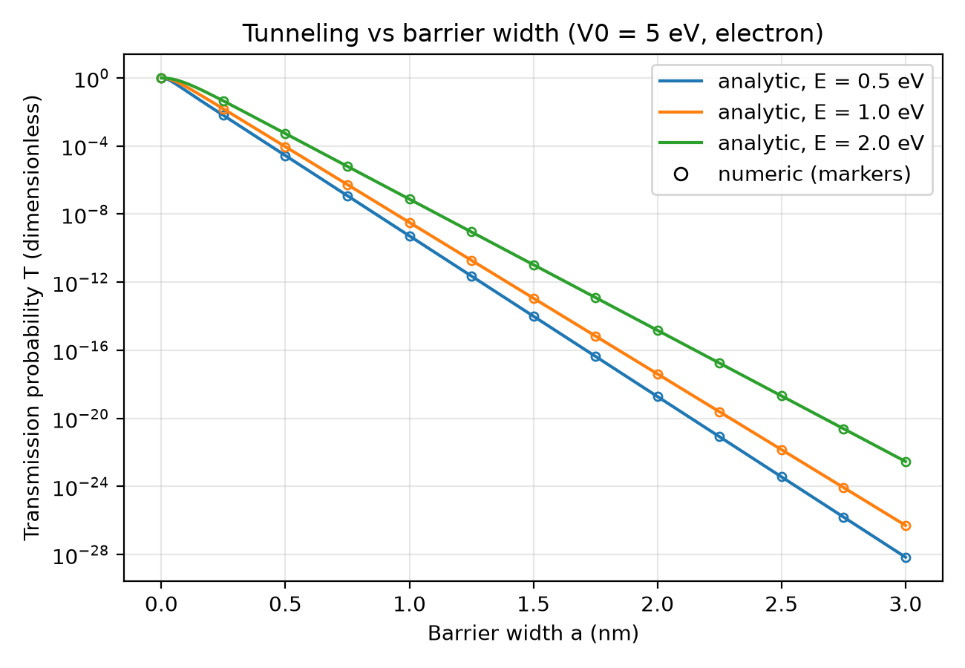  Figure 1. T versus barrier width for E = 0.5, 1 and 2 eV with V₀ = 5 eV (log y-axis). Lines: src/analytic.py. Hollow markers: src/numeric.py at selected widths. | 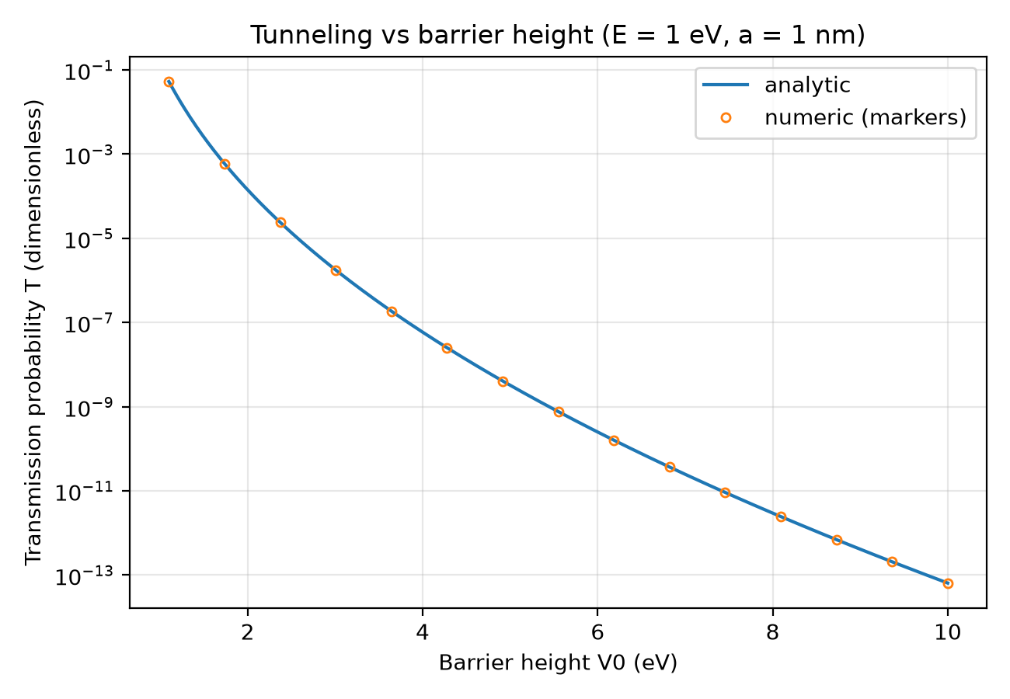  Figure 2. T versus barrier height V₀ for E = 1 eV and a = 1 nm (log y-axis). Line: analytic. Markers: numeric.

4.3 Dependence on particle energy
Figure 3 shows T against E for V₀ = 5 eV and a = 1 nm. T increases monotonically with E (on a 400-point grid, T is strictly increasing): T = 1.99×10⁻¹¹ at E = 0.05 eV, 3.22×10⁻⁹ at 1 eV, 3.68×10⁻⁷ at 2.5 eV and 1.94×10⁻² at 4.95 eV, a gain of 9.0 decades. The curve is steep at both ends and gentler in the middle: d log₁₀T/dE is 5.27 eV⁻¹ at E = 0.1 eV, 1.41 eV⁻¹ at 2.5 eV and 3.31 eV⁻¹ at 4.9 eV. Only energies below the barrier top are computed; the curve is not extended to E ≥ V₀.
Figure 4 combines the width and energy dependence for V₀ = 5 eV. On the plotted grid (E from 0.05 to 4.95 eV, width from 0 to 3 nm) log₁₀T ranges from 0.0 to −30.5. The smallest value is at E = 0.05 eV and a = 3.00 nm. At a = 3 nm, log₁₀T is −3.8 at E = 4.95 eV and −30.5 at E = 0.05 eV. The bands of constant colour rise toward the upper-right of the plot: at higher energy, a wider barrier is needed to reach the same T.
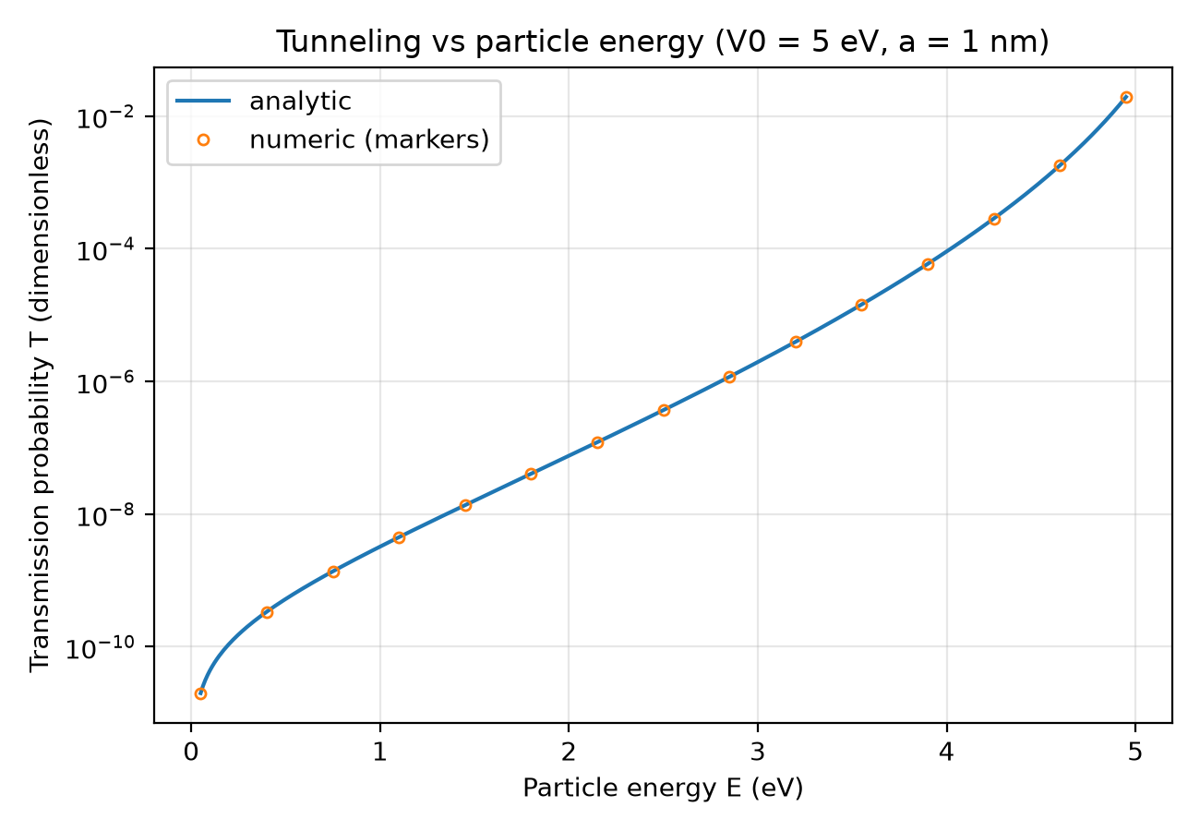  Figure 3. T versus particle energy E for V₀ = 5 eV and a = 1 nm (log y-axis). Line: analytic. Markers: numeric. | 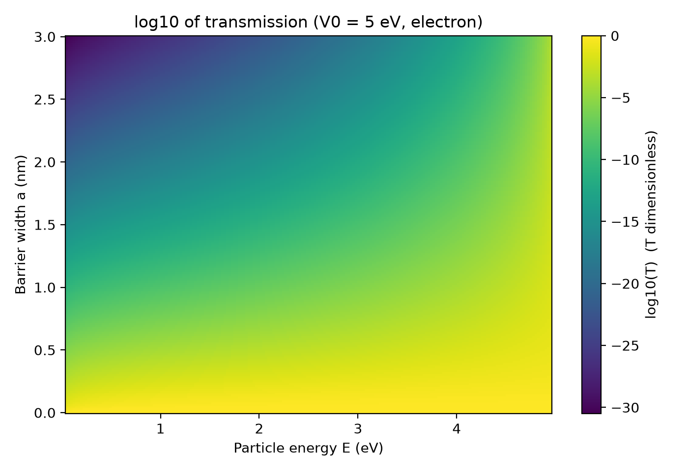  Figure 4. log₁₀(T) versus particle energy and barrier width for V₀ = 5 eV (analytic).

4.4 Thick-barrier approximation
Table 2 compares the exact value from Eq. (13) with the thick-barrier form 16E(V₀ − E)/V₀² · e^{−2κa} for four widths at E = 1 eV and V₀ = 5 eV. The percent difference is (approximate − exact)/exact × 100, evaluated in 60-digit decimal arithmetic because for κa above about 10 it is below double-precision round-off. The approximation overestimates T in every case, and the difference shrinks rapidly as κa grows, as expected from dropping the leading 1 and the e^{−2κa} term in sinh²(κa). Already at κa ≈ 2 the difference is of order one percent.
Table 2. Exact versus thick-barrier transmission.
Case | κa | T exact | T approx. | Difference
E = 1.0 eV, V₀ = 5.0 eV, a = 2.0 nm | 20.49 | 4.060×10⁻¹⁸ | 4.060×10⁻¹⁸ | 8.88×10⁻¹⁷%
E = 1.0 eV, V₀ = 5.0 eV, a = 1.0 nm | 10.25 | 3.224×10⁻⁹ | 3.224×10⁻⁹ | 7.05×10⁻⁸%
E = 1.0 eV, V₀ = 5.0 eV, a = 0.5 nm | 5.12 | 9.085×10⁻⁵ | 9.085×10⁻⁵ | 1.99×10⁻³%
E = 1.0 eV, V₀ = 5.0 eV, a = 0.2 nm | 2.05 | 4.209×10⁻² | 4.249×10⁻² | 9.57×10⁻¹%

4.5 Agreement between the numeric and analytic methods
Table 3 summarises the 125-combination sweep. Energies range from 0.1 to 4 eV, barrier heights from 4.5 to 10 eV, widths from 0.05 to 6 nm, and κa from 0.181 to 96.72. The analytic transmission spans from 1.55×10⁻⁸⁵ to 9.23×10⁻¹ (84.8 decades). On the same grid the numeric solver satisfies |R + T − 1| ≤ 1.11×10⁻¹⁵.
Table 3. Numeric versus analytic transmission over the sweep (results/comparison.csv).
Quantity | Value
Combinations | 125
Max absolute error | 5.55×10⁻¹⁶
Mean absolute error | 4.28×10⁻¹⁷
Max relative error | 1.09×10⁻¹⁴
Mean relative error | 1.87×10⁻¹⁵
Rows with exactly zero absolute error | 5
Largest κa | 96.72

Figure 5 plots T_numeric against T_analytic for all combinations on log-log axes. The points lie on the y = x line over the whole range of T. The worst relative error occurs at E = 0.1 eV, V₀ = 5 eV, a = 6 nm (κa = 68.04), where T_analytic = 2.480×10⁻⁶⁰ and T_numeric = 2.480×10⁻⁶⁰; the relative error is 1.09×10⁻¹⁴ and the absolute error 2.71×10⁻⁷⁴.
Figure 6 shows the absolute and relative errors against κa. The absolute error falls steadily as κa grows, because T itself shrinks over many orders of magnitude. The relative error does not fall. Its median is 4.88×10⁻¹⁶ for κa < 10 (56 rows, maximum 3.87×10⁻¹⁵), 1.42×10⁻¹⁵ for 10 ≤ κa < 50 (48 rows, maximum 7.60×10⁻¹⁵), and 5.30×10⁻¹⁵ for κa ≥ 50 (21 rows, maximum 1.09×10⁻¹⁴). So there is a mild increase in relative error with κa, but it stays near double-precision round-off (smallest nonzero 1.28×10⁻¹⁶, largest 1.09×10⁻¹⁴). The 5 rows with exactly zero absolute error cannot be drawn on a logarithmic axis and are omitted from the figure.
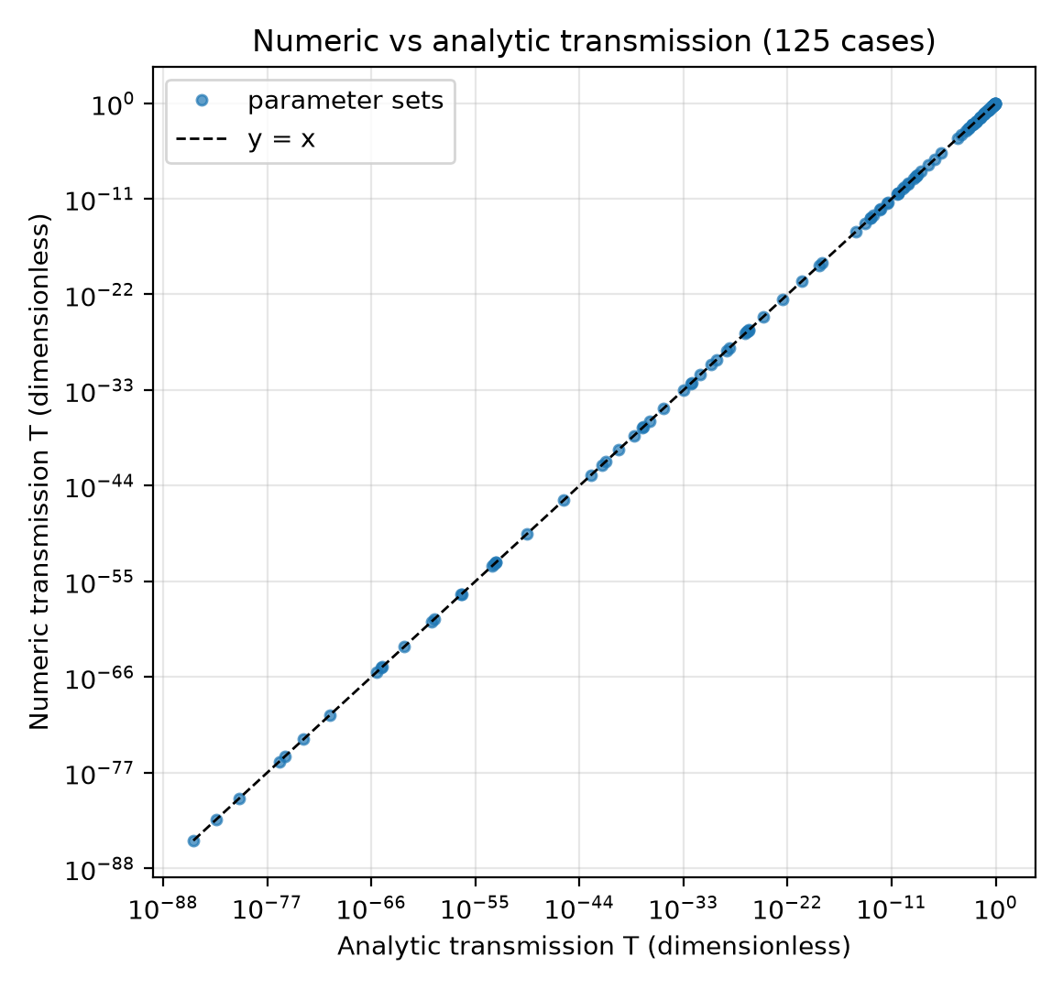  Figure 5. Numeric versus analytic T for the 125 sweep combinations (log-log axes). The dashed line is y = x. | 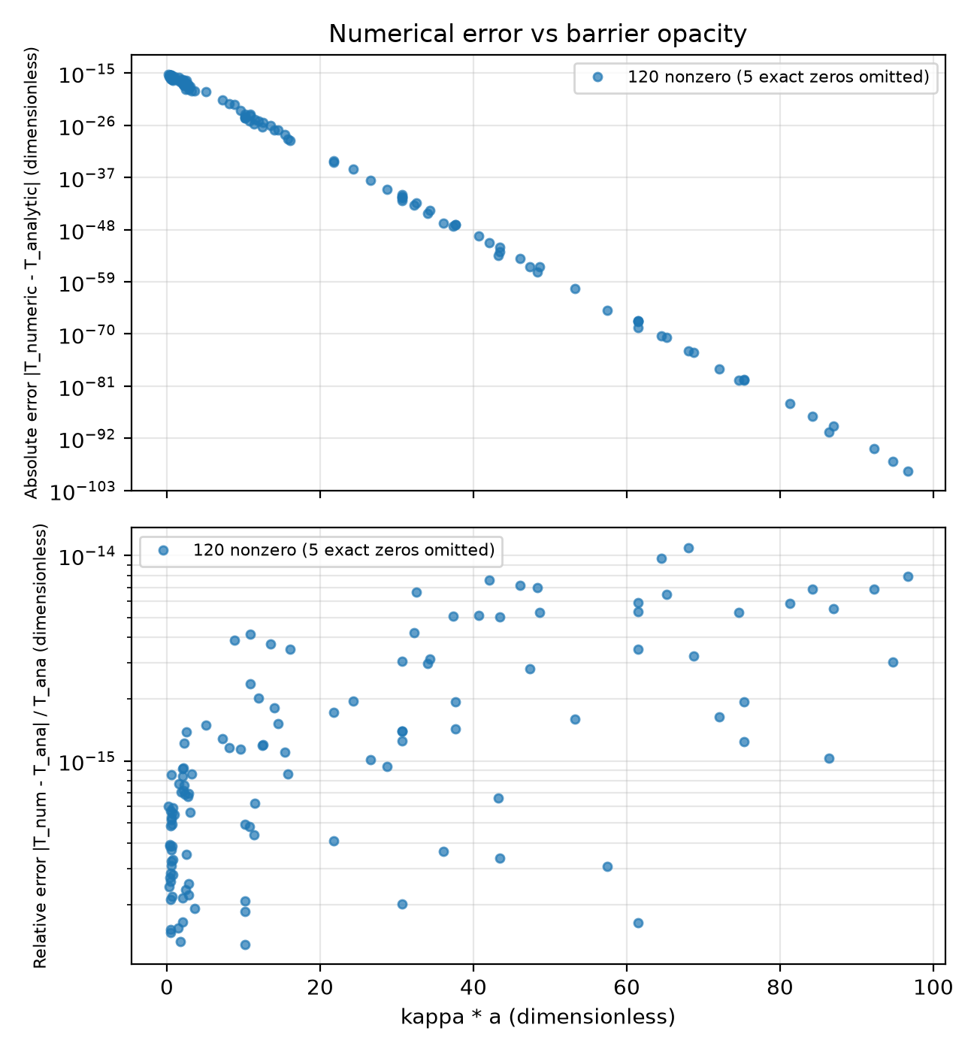  Figure 6. Absolute (top) and relative (bottom) difference between numeric and analytic T versus κa. Exact zeros are omitted (log y-axes).

5 Limitations
- Agreement validates the implementation, not the physics. The numeric and analytic methods solve the same equations (6)–(9) for the same model. Their agreement shows that the algebra in Section 2.4 and both codes are consistent. It does not show that the rectangular-barrier model describes any real system.
- Model scope. The model is one-dimensional, non-relativistic, uses a sharp rectangular barrier, a single electron and plane-wave incidence, and covers only 0 < E < V₀. The cases E = V₀ and E > V₀ use different expressions and are rejected with ValueError.
- No experimental comparison. No measured data were used. The results are properties of the model only.
- Floating-point limits for very thick barriers. For E = 1 eV and V₀ = 5 eV, κ = 10.246 nm⁻¹. T_analytic first returns exactly 0 at a width of about 36.4 nm (κa ≈ 373). The smallest nonzero value just below that is 4.94×10⁻³²⁴, in the subnormal range where double precision has lost significant digits. At κa = 300 the two methods give 6.7850×10⁻²⁶¹ and 6.7850×10⁻²⁶¹; at κa = 360 they give 5.2025×10⁻³¹³ and 5.2025×10⁻³¹³; at κa = 400 they give 0 and 0. The sweep itself reaches only κa = 96.72.
- Sweep coverage. The grid is a fixed 5×5×5 set with E/V₀ ≤ 0.89. It does not probe E very close to V₀, and it contains no variation of the particle mass.
- Known issue in the Streamlit app. Dragging the sliders quickly can start overlapping script reruns in different threads. Matplotlib's mathtext parser is not thread-safe, which previously printed transient ParseFatalException / ParseException errors in the terminal. The app now builds and renders each figure under a lock, and a multithreaded test covers this, but a long interactive session has not been used to confirm that the messages never reappear.

6 Conclusion
For a single electron and a 1D rectangular barrier with 0 < E < V₀, the closed-form transmission probability was derived and implemented, and independently reproduced by a direct 4×4 boundary-matching solve. Over 125 fixed parameter combinations the two agree to a maximum relative difference of 1.09×10⁻¹⁴. For V₀ = 5 eV the computed T decreases with width and with barrier height, and increases with energy, with an approximately exponential dependence on width for thick barriers. These are expected consequences of the closed-form result, and the work should be read as a verified reimplementation of textbook physics. Extensions that would test the physics rather than the implementation include comparison with experimental data, a different numerical method (for example a time-dependent or finite-difference solution), and more realistic barrier shapes.

7 References
[1] D. J. Griffiths and D. F. Schroeter, Introduction to Quantum Mechanics, 3rd ed. (Cambridge University Press, 2018).
[2] E. Tiesinga, P. J. Mohr, D. B. Newell and B. N. Taylor, CODATA recommended values of the fundamental physical constants: 2022 (National Institute of Standards and Technology; https://physics.nist.gov/cuu/Constants/).

Appendix Repository description
The report, the results and the figures can all be rebuilt from the repository. Files that existed when this report was generated are listed in Table 4.
Table 4. Repository contents.
Path | Purpose
app.py | Streamlit app: sliders, T/R metrics, T-versus-width plot, |ψ|² plot
requirements.txt | Pinned Python dependencies
src/constants.py | ħ, h, m_{e}, e; eV↔J and nm↔m conversions
src/analytic.py | transmission_analytic: closed form evaluated in log space
src/numeric.py | transmission_numeric (T, R) and wavefunction_numeric: 4×4 boundary-matching solver
src/sweeps.py | 125-combination comparison; writes results/comparison.csv
src/plots.py | 6 figures to results/figures/
src/make_report.py | Generates this Word document
tests/ | pytest suite (Table 1)
results/comparison.csv | Sweep output used in Section 4.5
results/figures/ | fig1 … fig6 (PNG)
report/quantum_tunneling_report.docx | This report

To rebuild everything from the project root with the project's virtual environment active:
python -m pytest
python -m src.sweeps
python -m src.plots
python -m src.make_report
python -m streamlit run app.py --server.port 8765

Authorship and AI assistance
[ERNIE: describe what you wrote yourself and where AI assisted]

