
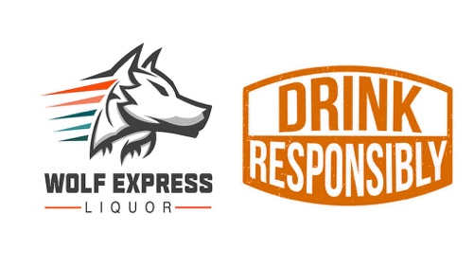
3404 Yale St. Houston, TX 77018 818.447.8545

My Drink Family LLC.
March 20, 2026
Subject: Letter of Interest in Purchasing My Drink Family LLC.

Dear Ernest,

I am writing on behalf of Mercury Imports and Wolf Express Wholesale. Our teams have been closely following the development and subsequent launch of My Drink Family LLC. and we are highly impressed with the exceptional quality and uniqueness of your product line.
As experts in the spirits industry, we have a deep appreciation for fine wines and spirits. Your brands have particularly caught our attention. The evident craftsmanship, the authentic flavor profiles, and your commitment align perfectly with our standards of quality and the premium experiences we aim to provide our customers.
We are excited about My Drink Family LLC. becoming available in the Texas. Considering this, Mercury Imports and Wolf Express Wholesale are eager to establish purchase order agreements with My Drink Family LLC. upon completion of the licensing with TABC. We plan to initiate forward purchase orders for a set minimum of quantity (1 to 2 Pallets) of your brands - as soon as they become available in the state of Texas.
We believe that a partnership with My Drink Family LLC. will greatly enhance our product offerings and resonate well with our commitment to delivering only the best to our clients. We are confident that your brands will be a significant and highly anticipated addition to our selection.

Thank you for considering this proposal. We are looking forward to the possibility of a successful and long-lasting business relationship with My Drink Family LLC.

Yours sincerely,

John Patillo Polo Gutierrez
jp@wolfexpressliquor.com polo@mercury-imports.com
Wolf Express Wholesale Mercury Imports
818.447.8545 832.891.6142

