C:\SourceForge\ScrumTime\ScrumTime\Content\Images\Logos\logo_graph_48x48.png C:\SourceForge\ScrumTime\ScrumTime\Content\Images\Logos\ScrumTimeLogo.png scrum project management tool

User Guide for Release 0.9 Beta 1

Author: Ernie Paschall

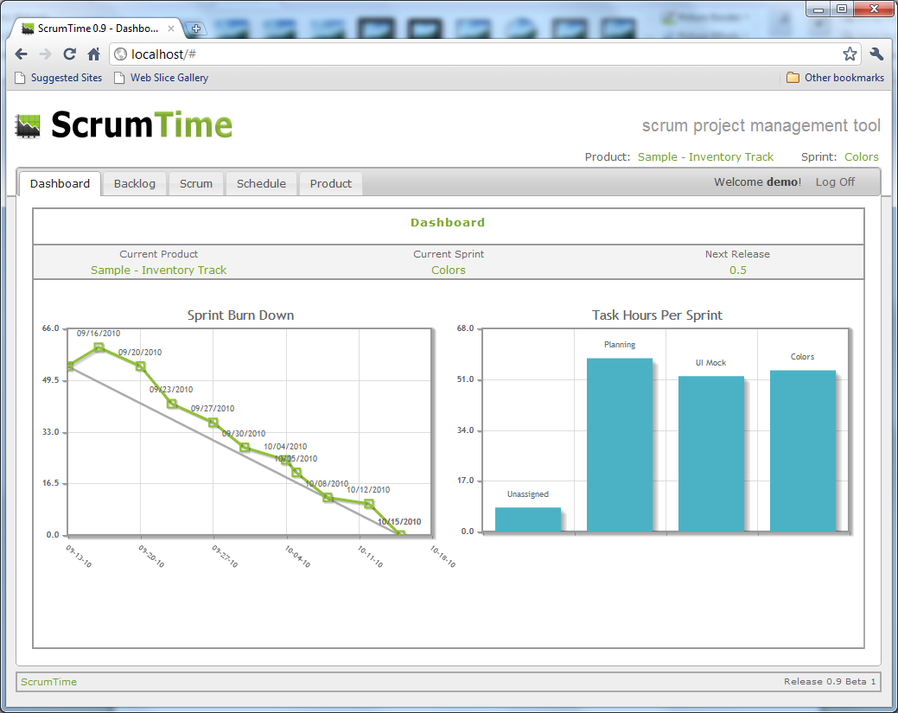

ScrumTime User Guide

User Guide Version 0.9 Draft 1

Table of Contents

[Introduction 3](#_Toc275199015)

[Getting Started 3](#_Toc275199016)

[Downloading and Installing 3](#_Toc275199017)

[The Sample Product 7](#_Toc275199018)

[Daily Use 7](#_Toc275199019)

[Creating a Product 7](#_Toc275199020)

[Adding Stories 9](#_Toc275199021)

[Adding Tasks 10](#_Toc275199022)

[Creating Sprints 11](#_Toc275199023)

[Adding Releases 13](#_Toc275199024)

[Schedule Calendar 15](#_Toc275199025)

[Creating a Scrum 16](#_Toc275199026)

[Dashboard 18](#_Toc275199027)

[Demo Site 19](#_Toc275199028)

[Known Issues 19](#_Toc275199029)

[Beta 2 Priorities 20](#_Toc275199030)

[Release Plan 20](#_Toc275199031)

# Introduction

Scrum is successful when the members of the scrum team become equally responsible for the overall team performance. Therefore, team goals and team status should be clearly visible to each team member at any given time. Ideally, managers and other non-committed members of the team should not need to interrupt a committed team member in order to get status updates. For example, these interruptions can occur as the result of a team member not being able to attend a scrum meeting or is not in the office to view a physical task board. ScrumTime is designed to preserve open communication between all team members regardless of their level of commitment and regardless of their physical location.

ScrumTime 0.9 is an open source project written in C# ASP.NET MVC 2. It contains two MS SQL Express 2008 databases. One database contains the user credential information and the other contains all of the scrum information that is required by the ScrumTime web application.

# Getting Started

## Downloading and Installing

You may download the latest ScrumTime zip web application from <http://scrumtime.org> in the Downloads section on the main screen.

The ScrumTime web application must be hosted within an IIS 7.0+ instance that uses an ASP.NET 4.0 Application Pool. It also requires the installation of the ASP.NET MVC 2 framework. The Microsoft Web Platform Installer is the best way to get ASP.NET 4.0 and the ASP.NET MVC 2 Framework. You can find it at:

<http://www.microsoft.com/web/downloads/platform.aspx>

This installer will allow you to choose many different Microsoft IIS additions, Web Frameworks, and Web Applications. ScrumTime requires only ASP.NET 4.0 and ASP.NET MVC 2 Framework.

Once you have installed ASP.NET 4.0 and the ASP.NET MVC 2 Framework, the recommended installation instructions are as follows:

1. Extract the contents of the ScrumTime web application zip file to c:\WebApplications\ScrumTime or to any other path that you desire.
2. Create an Application Pool named ScrumTime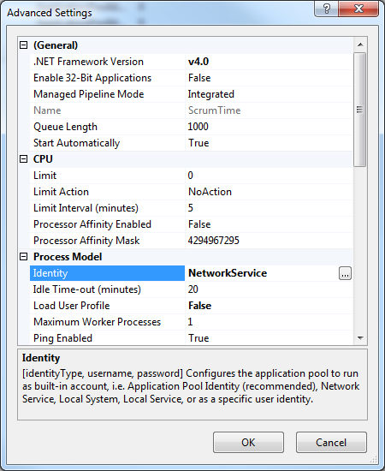
   1. Set the .NET Framework version to v4.0
   2. Process Model - > Identity to NetworkService.
3. Create a new Site called ScrumTime. 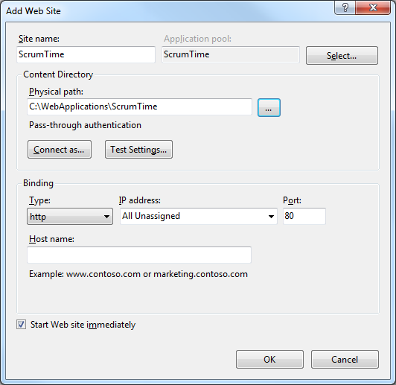
   1. Set the Application Pool to the ScrumTime.
   2. Set the Physical Path to the path that you extracted ScrumTime in step 1.
   3. Choose your web bindings such that they do not conflict with any other Site within the IIS instance. For this document, it is assumed that you have set the port to 80. In most cases, the Default Site is set to 80 so you will want to reset the default to another port.
   4. Start the Site if it has not already started automatically.
4. Navigate to <http://localhost> and you should see the login screen. 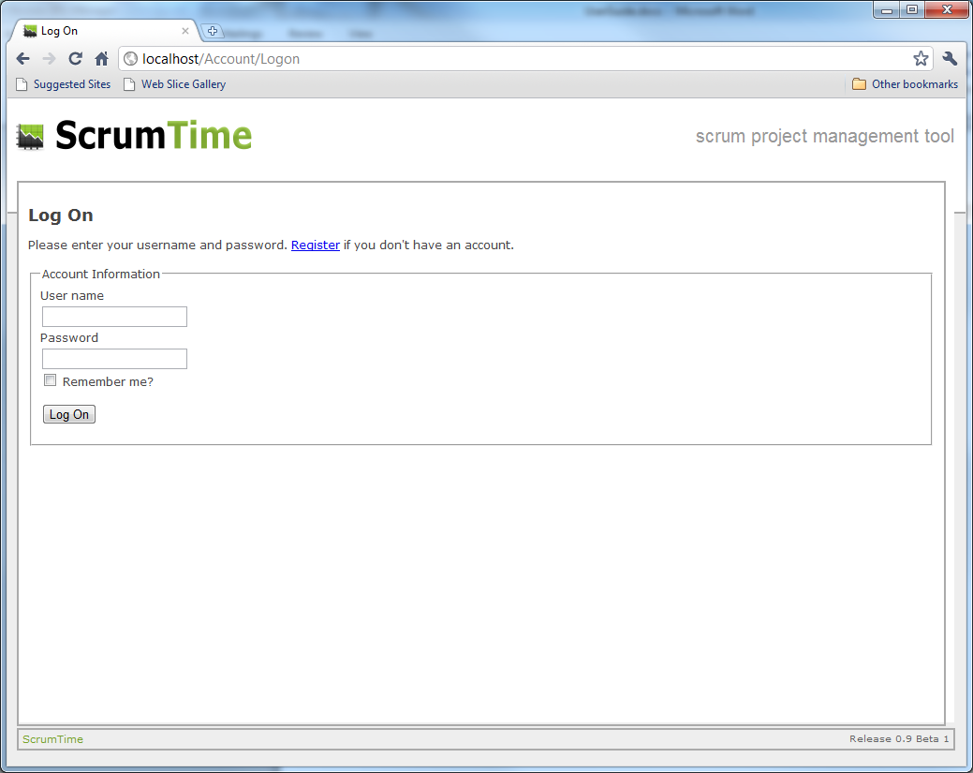
5. You may login with the demo user or register your own account. The demo user credentials are: username: demo

password: demo123

If you get the following error, you need to grant write privilege to the NetworkService user for the folder of which you installed the ScrumTime zip contents.

Failed to generate a user instance of SQL Server due to failure in retrieving the user's local application data path. Please make sure the user has a local user profile on the computer. The connection will be closed.

## The Sample Product

ScrumTime comes with a sample product known as *Sample – Inventory Track*. This provides a fictional product to use while learning the features of ScrumTime. This sample product is required in the current release of ScrumTime so that new users have a default starting product.

# Daily Use

## Creating a Product

The typical use of ScrumTime involves creating your own product by name. What good would a project management tool be without referring to your own product by its name? The Product tab is the place within ScrumTime for creating and managing your products. You may click the Add Product link to create your own product. You will notice that a new row is created that allows you to create a name and a description. For this demonstration, the name is going to be “*User Guide”* and the description is going to be “*A sample for the User Guide”*.

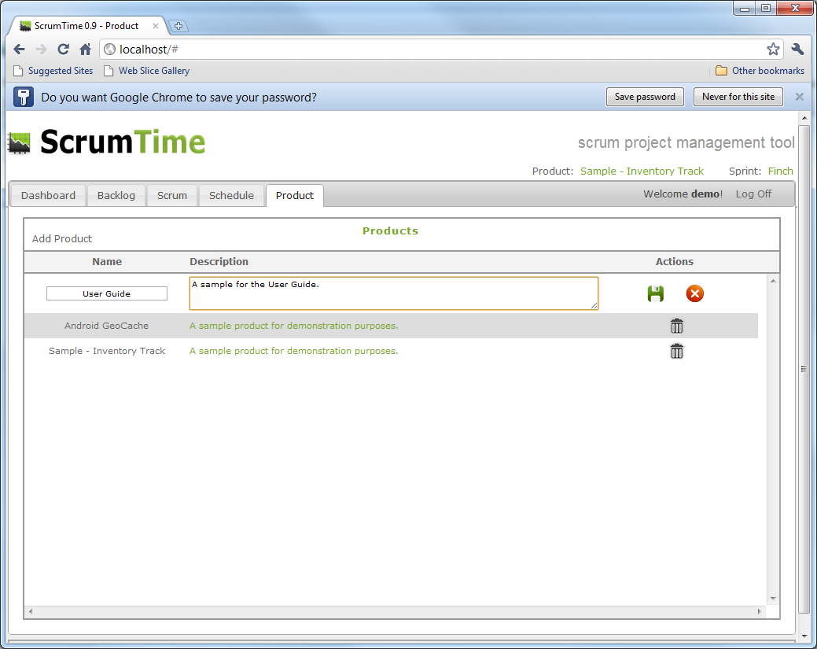

Press the Save icon, Save, in order to commit the product to the database. You will notice that you may now choose the newly created product from the drop-down in the upper right hand corner. This feature determines what the current active product is for your logged in session. 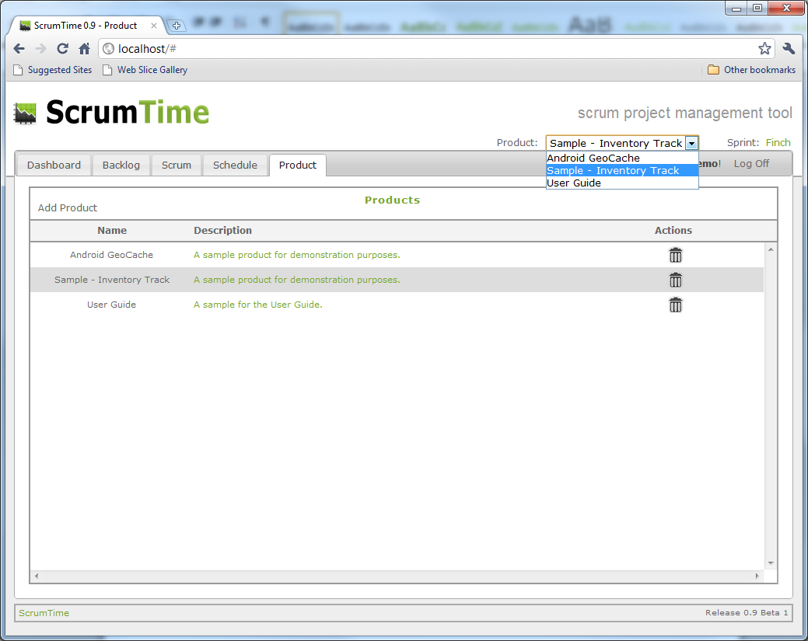

Select your newly created product in order to make it active.

## Adding Stories

In order to add a new story, navigate to the Backlog tab and press the Add Story link.

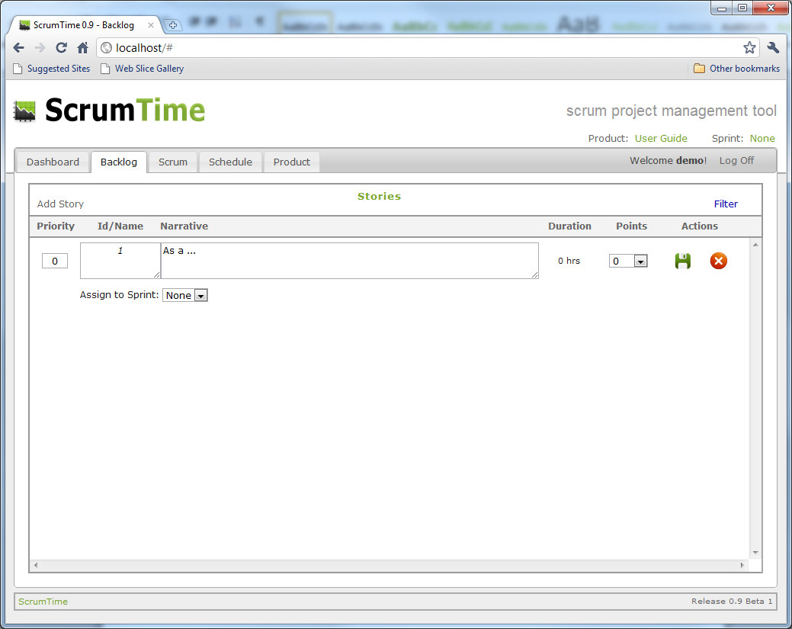

Add as many stories as you like in this section. Again, press the Save icon, Save, in order to commit your changes to the database. You may enter Points for this exercise if you like but it is not required.

In order to edit an existing story, you just need to click on the Priority, Id/Name, Narrative, Duration, or Points to make it editable.

## Adding Tasks

A task may only be added to an existing story. A future version of ScrumTime may allow you to create tasks that are not assigned to stories. Also, tasks currently are not capable of being moved from one story to another. This is another enhancement planned for the future.

To add a task, click on the Task icon, http://localhost/Content/Images/Menu/note_accept.png, under the Actions header for the story that needs new tasks. In the following example, tasks are being added to the “*Create Releases*” story.

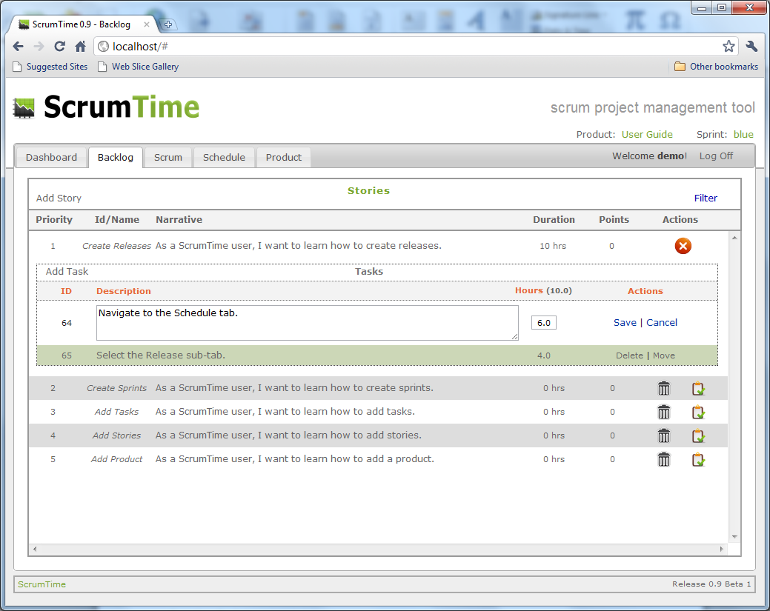

You must press the “*Save*” link in order to commit your changes to the database. Links were used here instead of icons in the interest of conserving screen space.

In order to edit an existing task, you just need to click on the ID, Description, or Hours to make it editable.

## Creating Sprints

The name of a sprint is very subjective. ScrumTime recommends that you keep it relatively short. Some organizations choose a set of related names for their sprint names such as bird types or colors. ScrumTime does not provide a meaning default name in order to encourage the user to create a thoughtful name for each sprint.

While the sprint name is not defaulted by Scrumtime, a thirty day period between the start date and the finish date is defaulted based on the current day. However, there is room for improvement in future releases concerning sprint defaults and feedback from users is always encouraged.

In order to add a new sprint, navigate to the Schedule tab and press the Add Sprint link near the lower left corner of the screen.

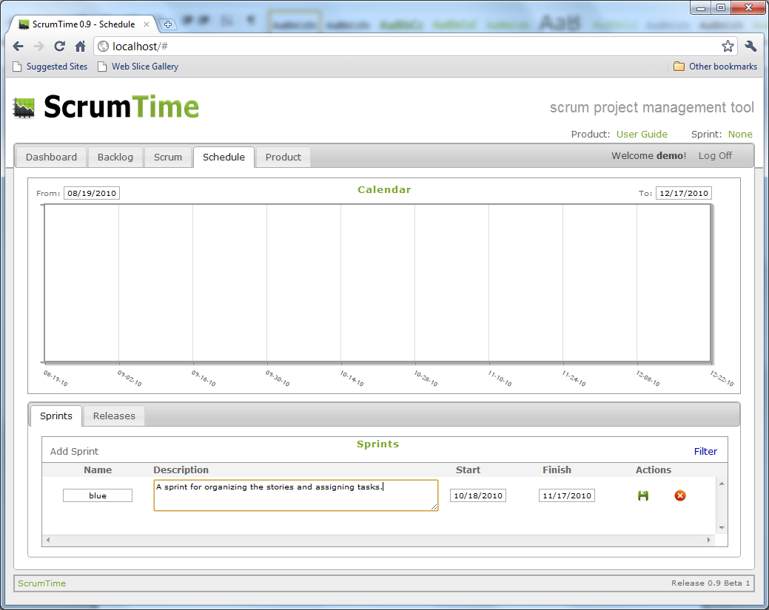

Press the Save icon, Save, in order to commit your changes to the databases. Just after the save is committed, you will notice a new horizontal bar is displayed on the calendar that represents your new sprint. Also, you may now select the active sprint in the upper right corner of the screen as follows:

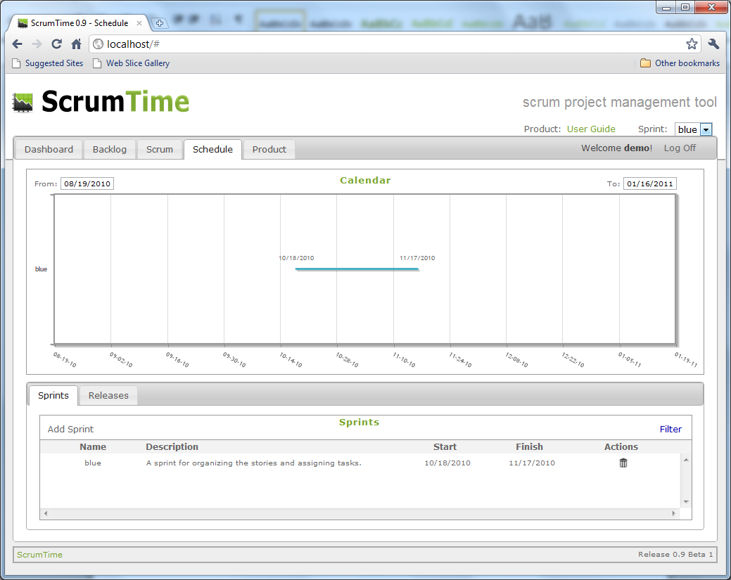

In order to edit an existing sprint, you just need to click on the Name, Description, Start, or Finish to make it editable.

## Adding Releases

The name of a release is typically the release number and any other relevant information. ScrumTime recommends that you keep the release names relatively short. Some examples include:

* 1.0
* 1.0 Beta 1
* 1.0.0.23930
* 1.0 Build 230
* Etc…

To add a new release, navigate to the Schedule tab (if you are not already there) and navigate to the Release sub-tab. There you will find an Add Release link will create an empty release edit row in the release listing. Press the Add Release link and add some relevant release information as follows:

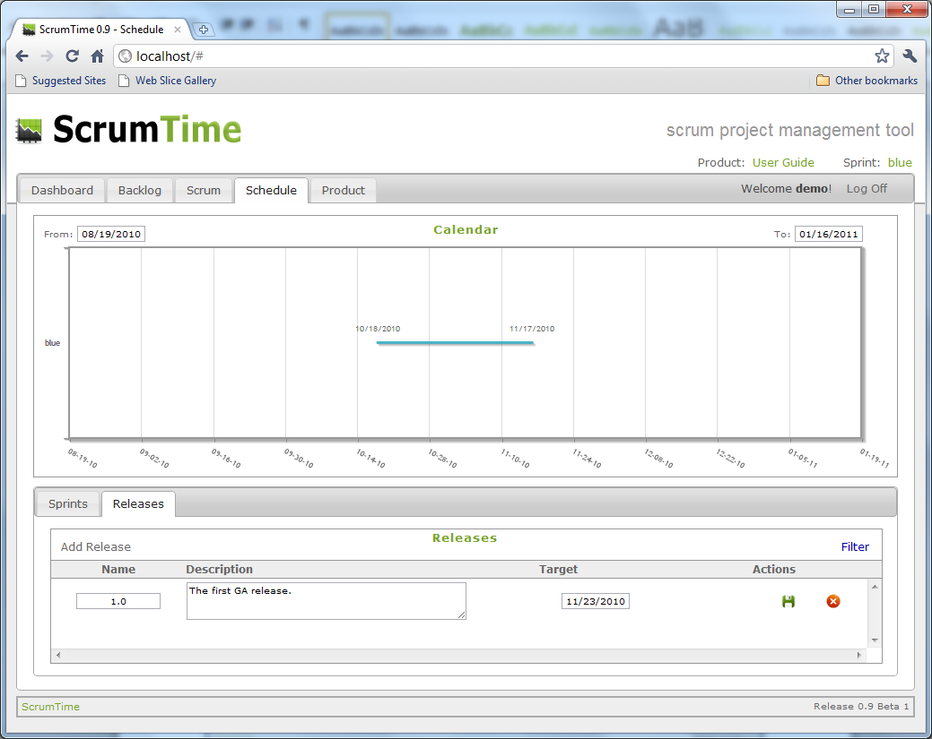

Notice that the target date is set for just after the existing sprint is set to finish. Press the Save icon, Save, in order to commit your changes to the database. You should see a vertical red bar appear in the Calendar representing your newly created release:

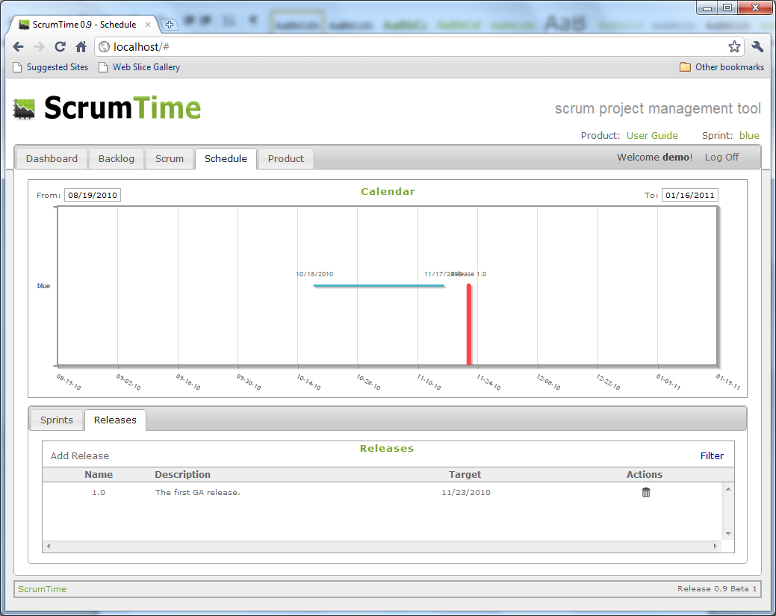

Note: Within the Calendar, the title of the release and the ending date of the sprint may overwrite one another depending on how they are scheduled relative to other sprints in the Calendar. This occurs much more often when you have only one sprint displayed in the Calendar view.

In order to edit an existing release, you just need to click on the Name, Description, or Target to make it editable.

## Schedule Calendar

The Schedule Calendar is found on the Schedule tab. The display contents of the Calendar are controlled by the “From:” and “To:” values that are located respectively to the upper left and right of the Calendar control. The “From:” and “To:” determine the date limits of display for the Calendar control. You may change these to any values while on the Schedule tab. However, your settings will be lost once you click away from the Schedule tab. A future version of ScrumTime may address this shortcoming.

The default values for the “From:” and “To:” are dictated by your currently active sprint. The “From:” value is calculated by subtracting sixty days from the start date of your currently active sprint. The “To:” value is calculated by adding sixty days to the finish date of your currently active sprint. The following depicts the Calendar “From:” and “To:” as being set to custom values in order to see more detail:

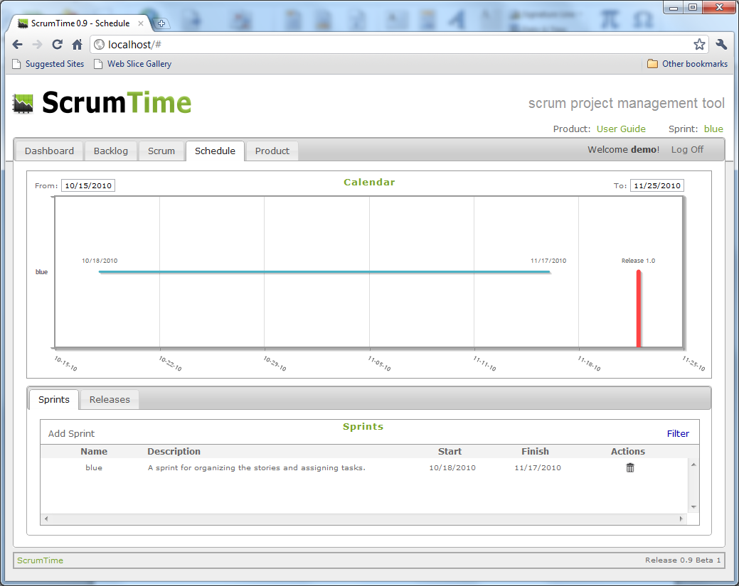

## Creating a Scrum

In order to create a new Scrum, you must first make sure that you have stories that are assigned to your currently active sprint. To do this, navigate to the Backlog tab and click on any existing story. You should see a selection list to right of the “Assign to Sprint:” title. Within the selection list, you should see the sprint name of the sprint that you created before. Select the sprint name as follows:

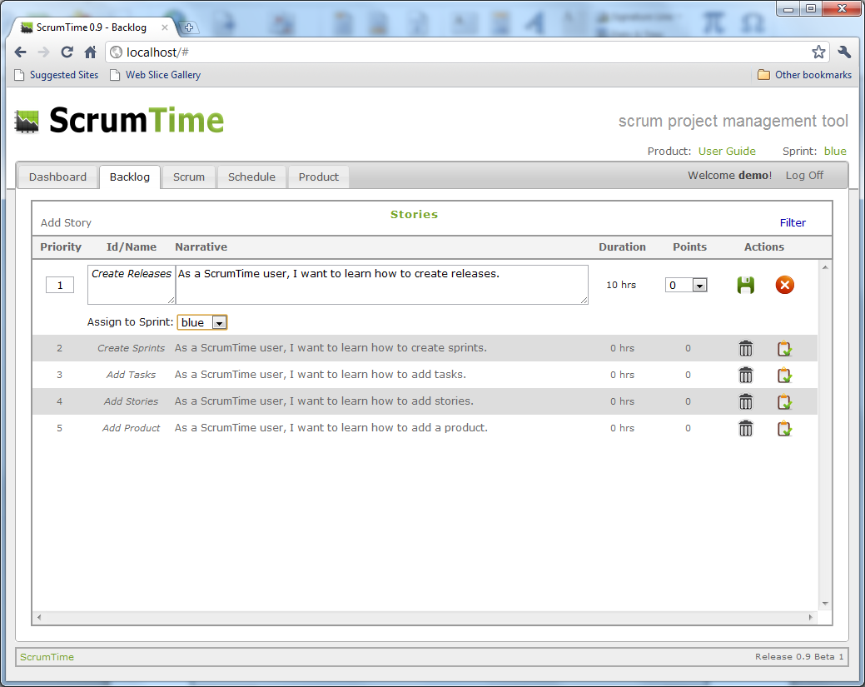

Press the Save icon, Save, in order to commit your changes to the database.

Next, navigate to the Scrum tab and press the Add Scrum link. You should see a pop-up screen that allows you to assign the work to a team member, identify hours completed, and identify hours remaining as follows:

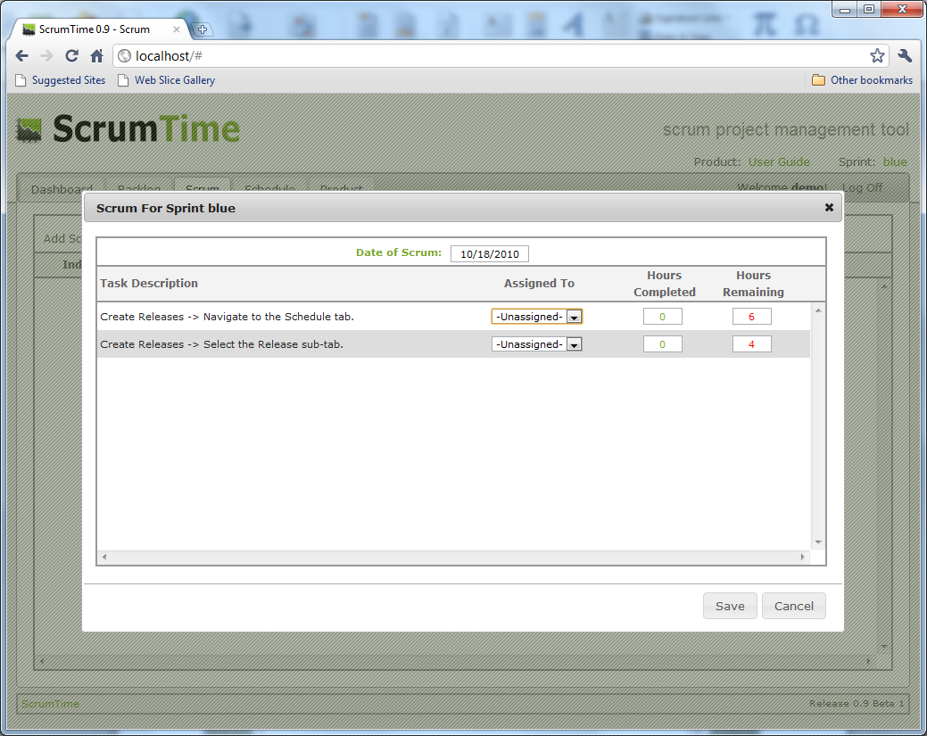

Notice that the “Date of Scrum” defaults to today’s date and the “Hours Remaining” is pulled from the task’s hours. Save the values to the database by pressing the Save button.

Note: Every subsequent scrum for this sprint will pull the “Hours Remaining” values from the previous scrum as defaults. Play with it to see how this works. You may want to view the Sprint Burn-Down chart on the Dashboard tab to get a feel for the way the scrums relate to the sprint.

## Dashboard

The Sprint Burn Down chart shows the hours completed within scrums relative to the perfect completion rate for total task hours for the currently active sprint. The purpose of this chart is to monitor the progress of work being completed relative to the planned schedule.

The Task Hours Per Sprint chart shows the number of task hours that have been assigned to the most recent four sprints relative to the currently active sprint. Also displayed on the chart in the far left, is the total number of task hours that have not been assigned to any sprint. The purpose of this chart is to determine if one sprint has too many task hours assigned to it relative to other sprints.

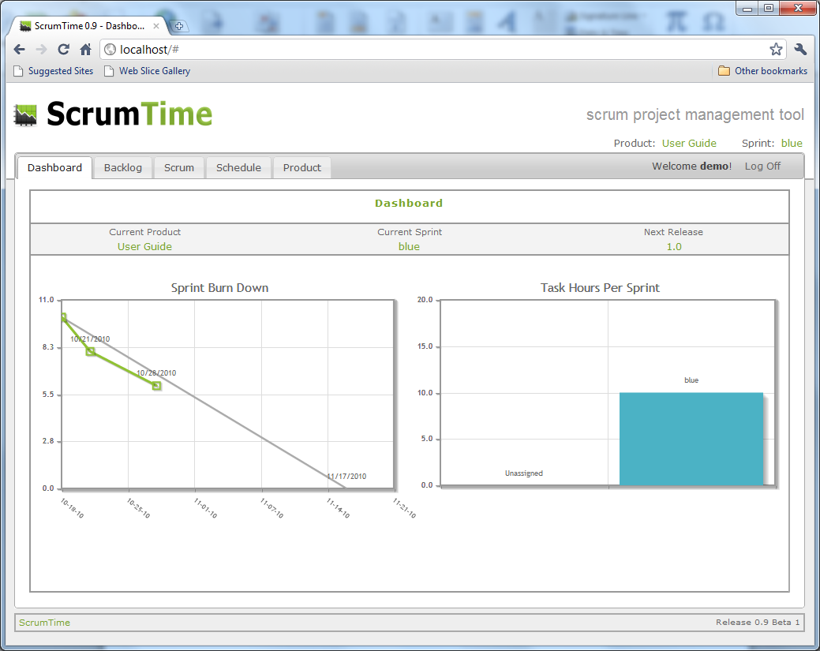

# Demo Site

The demo site was created to demonstrate features for individuals that may not take the time to download the web application.

Disclaimer: The demo site is not always guaranteed to be available and it is not hosted in a secure environment. Every effort will be made to keep the data as close to that of the download as possible.

The demo site may be found at:

<http://demo.scrumtime.com>

Username: demo

Password: demo123

# Known Issues

ScrumTime 0.9 Beta 1

* Backlog priorities being reset when there is more than one product.
  + Classified as a bug.
* Backlog Filter does not work
  + This feature did not make it to the release.
* Sprint Filter does not work
  + This feature did not make it to the release.
* Release Filter does not work
  + This feature did not make it to the release.
* Cannot delete a product
  + This functionality is expected in Beta 2 due to the complexity related to user default settings.
* Cannot view a list of site members
  + This had to do with the complexity of keeping members private on the demo site. Expected in Beta 2.
* Some titles overwrite one another in the Schedule Calendar
* There needs to be a spinning graphic to indicate when the web application is busy with an AJAX request.
  + Expect more of this sort of functionality in Beta 2 or 0.9 GA.

# Beta 2 Priorities

1. Bug Fixes
2. Add story themes so that stories may be grouped according to an overall functionality. This is beneficial in breaking a product down into its constituent pieces. This will impact the filter feature of the Backlog.
3. The Backlog filter will be partially implemented as it will offer filtering on theme and on hours.

# Release Plan

Release 0.9 Beta 2 December, 2010

Release 0.9 GA May be superseded by Release 1.0

Release 1.0 TBD – Depends on 0.9 Beta 1 feedback.