# UI Development Information

Scrumtime

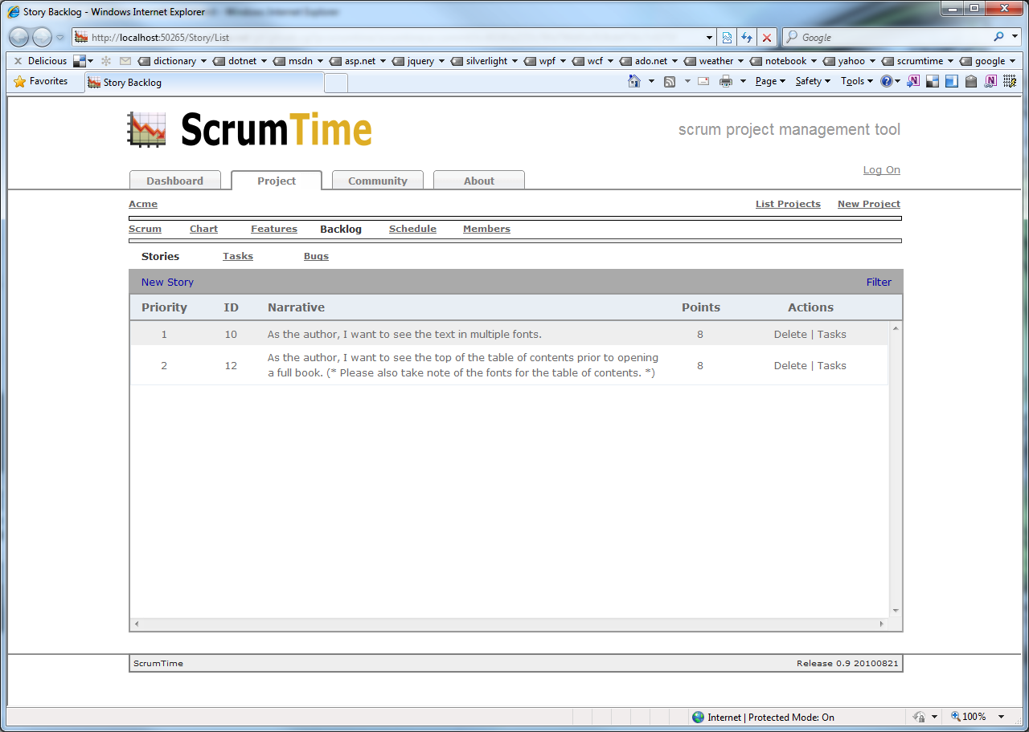

* Each row of the table is referenced by id=”row_X” where X is the one based index of the row.
* Each blue column of the table is referenced by class=”story_X” where X is the one based index of the row.
* The delete link is referenced by id=”delete_X” where X is the one based index of the row.
* The task link is referenced by id=”task_X” where X is the one based index of the row.