M3 – report on improving the website

1. Your web counter would look better underneath your main text with some words saying “You are visitor number 10”

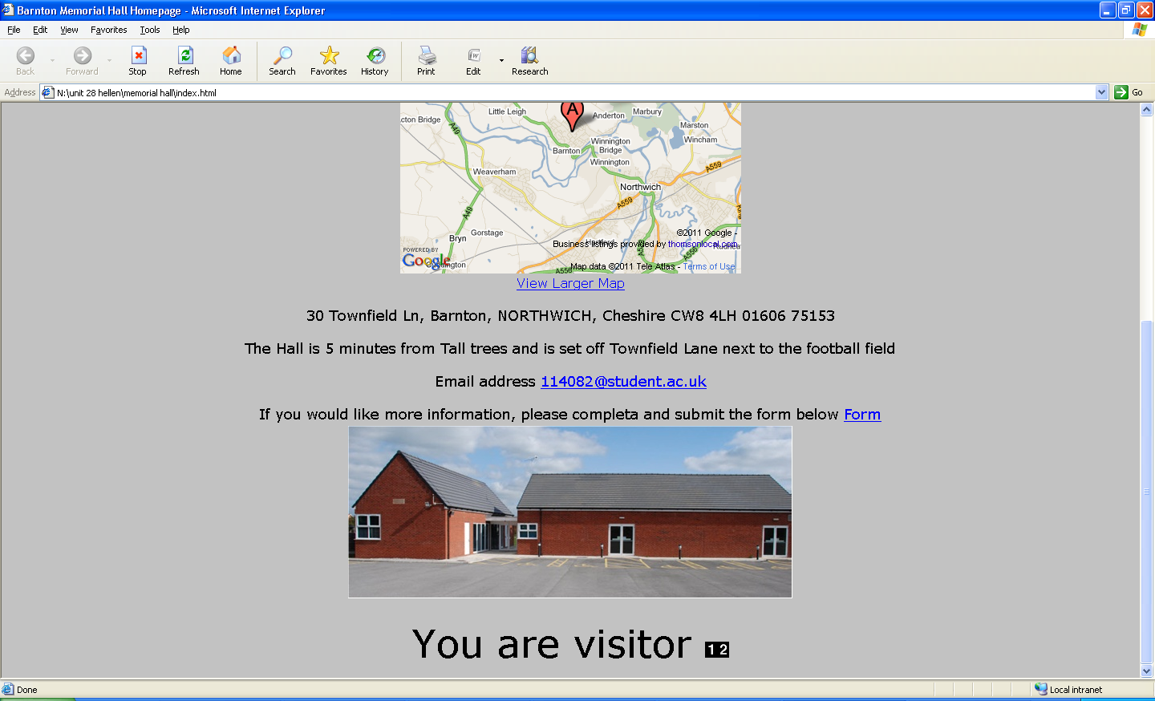

I basically reorganised the location of the web counter and also added a sentence which says “you are visitor”

1. Can you add some instructions to the top of your form saying “If you would like more information, please complete and submit the form below.”

I added the sentence “If you would like more information, please complete and submit the form below” before the webcounter

1. Can you add the directions to the hall on the homepage please?



I just added the directions on the homepage after the address so that the users have some idea on where it is.

1. 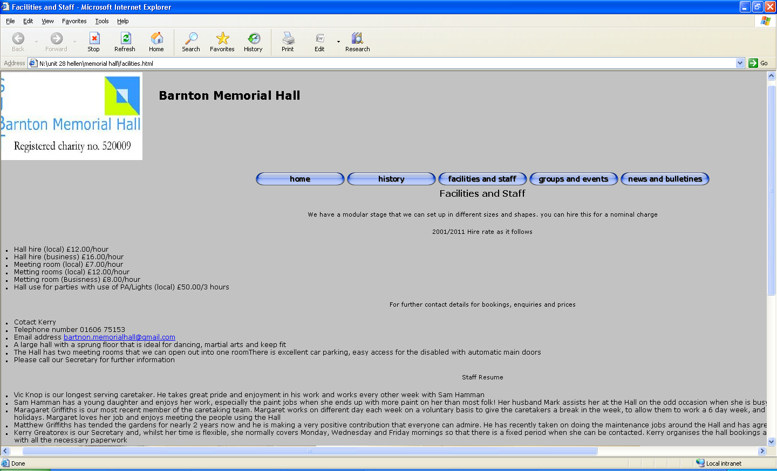You haven’t got much about the facilities on the facilities and staff page, but you got regular users which should be on the groups and events page

I added a few more description about the facilities and staff on the page and also added a few staff pictures

1. Your facilities and staff page could do with some staff pictures