**FILECOIN**

Overview:

Filecoin is the economic **incentive layer** to the peer-to-peer **distributed** Interplanetary File System (IPFS) network for sharing and storing of data.

**Filecoin**, a blockchain built on top of IPFS that enables anyone to become a **storage provider**, allowing web3 users to store personal, web hosting, or enterprise files.

 All Filecoin nodes are IPFS nodes.

It has its own native cryptocurrency, **FIL**, which acts as a payment protocol that connects buyers and sellers of storage in the IPFS ecosystem.

It is often referred to as, in reference to Protocol Labs’ fellow Y Combinator alum: “**Airbnb for cloud storage.**”

As of today, **Filecoin’s** total network storage power has surpassed **15.6 EiB** (exbibyte), or over **18 million TB (terabyte)**.

How Filecoin works:

Filecoin connects two main players:

* **Users** (the customers or individuals in the market that are looking to hire storage)
* **Storage providers** (the miners who are rewarded with FIL for contributing storage to the network)

An **agreement** between a user and a storage provider is called **deals**.

In the Filecoin network, there are two notable types of deals,

* **Storage deal** (occurs when a miner has received data from the client to store)
* **Retrieval deals** (occur when miners extract data from the network)

Once **storage deal** is initiated, storage provider will repeatedly prove to the chain that it is still storing the data per the agreement so that it can collect rewards. If not, the storage provider will be slashed and lose FIL.

Filecoin verifies storage data through its consensus mechanism “**proof of replication” (PoRep)** and ”**proof of spacetime” (PoST).**

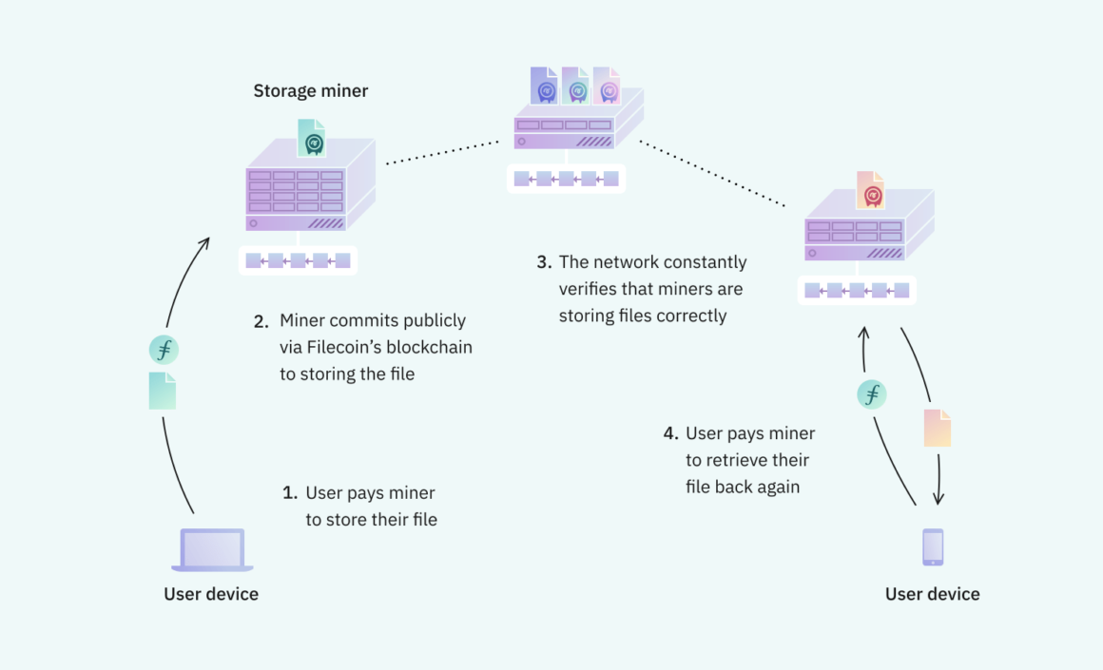

**Storage Fees:**

Fees are paid in FIL by clients after a deal has been reached in exchange for storing data.

**Retrieval Fees:**

FIL retrieval fees are paid to miners when users wish to retrieve their data from the storage. Due to the bandwidth and disk lookup, this process discourages spam transactions.

**Block Rewards:**

FIL is distributed to miners for creating a new block.

**Gas Fees**

Each transaction includes message limits and computation limits that must be paid in **FIL** “gas” fees, like those found on Ethereum.

**Staking/Slashing:**

A miner must stake some FIL coin before they can participate in the network. If miner stores the data as expected, they are **rewarded**.

A miner’s FIL balance is **penalized** if it fails to provide reliable uptimes or acts maliciously against the network.

