Under the supervision of Andrzej Miękina, PhD

Warsaw, 14/05/2019

Numerical Methods (ENUME 2019) – Project Assignment B: Approximation of functions

Ernest Pokropek, 293076

**Table of contents**

1. Introduction
2. Methodology
3. Results
4. Conclusions
5. Bibliography
6. Introduction

Approximation of functions is one of the most important topics covered in whole applied mathematics. It enables to depict the function knowing only some discrete points on the given plane. Here, the method of **least-squares function approximation** is to be discussed.

Least squares function approximation applies the principle of least squares to function approximation, by means of a weighted sum of other functions. The best approximation can be defined as that which minimises the difference between the original function and the approximation; for a least-squares approach the quality of the approximation is measured in terms of the squared differences between the two. Two types of least squares algorithm are to be distinguished: linear and nonlinear, whereas linear version aims at providing a one straight line which passes through most of the points on x-y graph, the nonlinear one aims to follow as closely as it can to the inflections and turns of a given function.

In this particular case, the non-linear approximation shall be performed using **B-spline functions** (called sometimes basis splines). The B-spline function is a spline function that has minimal support with respect to a given degree, smoothness, and domain partition. Any spline function of given degree can be expressed as a linear combination of B-splines of that degree.

1. Methodology

The given function (from which the indicated sequence of its values will be used for approximation) has the following form:

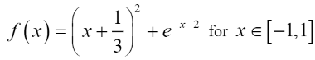

B-splines are given as follows:

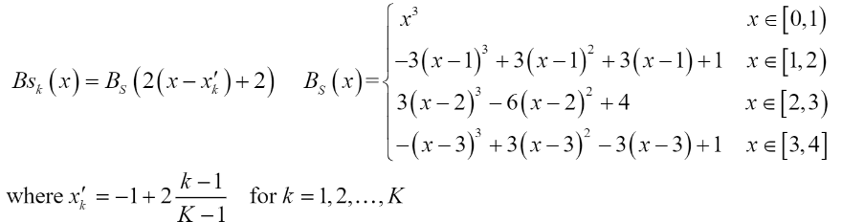

Concerning the vector of parameter p = [p1, … pk] which is sought for, the vector that makes the linear combination of linearly independent functions { φk(x) | k = 1,2,…, K}:

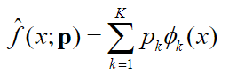

Then, the necessary condition of the minimum has the form:

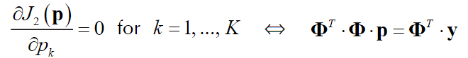

where:

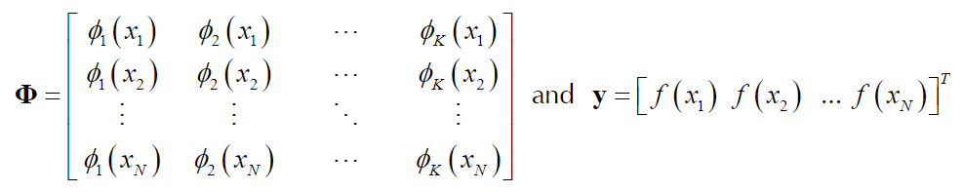

Thus finally, the solution may be presented in following form:



1. Results

The approximated function, nodes and original functions are presented on figures 1-3, with different pairs of parameter N and K (where N is the number of nodes). For every figure of given N, there are 3 changes in parameter K (captions *a*, *b*, and *c*).

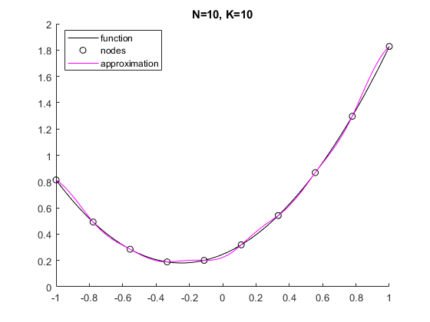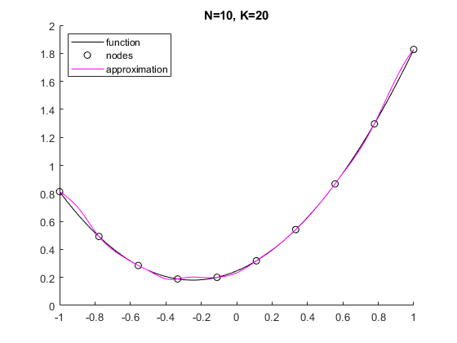

Fig. 1a) Fig. 1b)

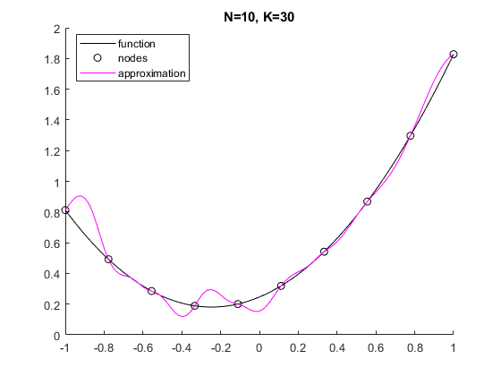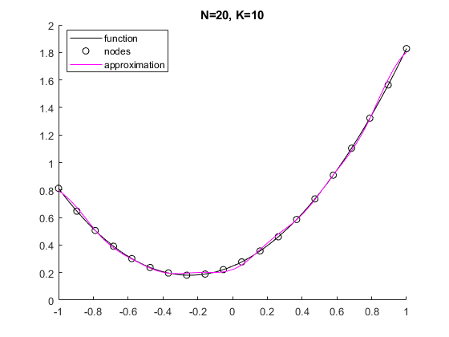

Fig. 1c) Fig. 2a)

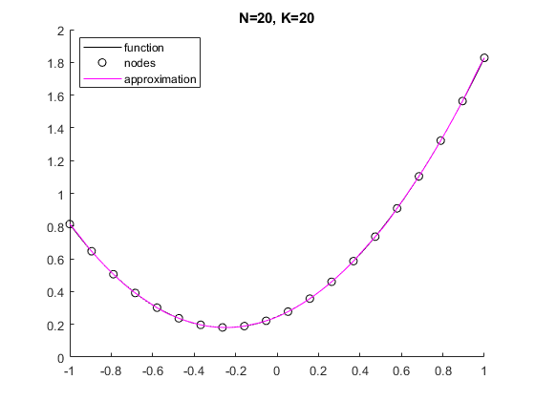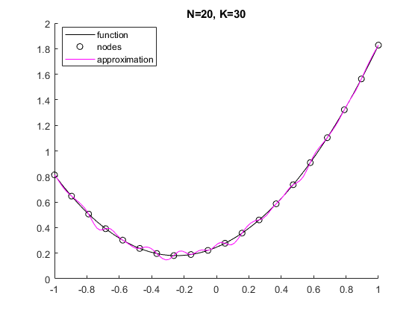

Fig. 2b) Fig. 2c)

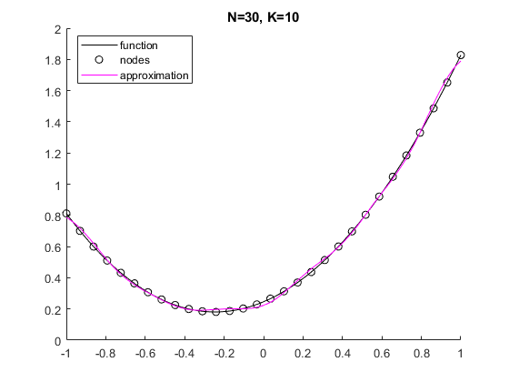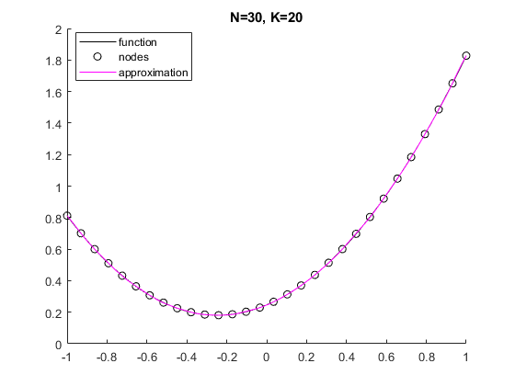

Fig. 3a) Fig. 3b)

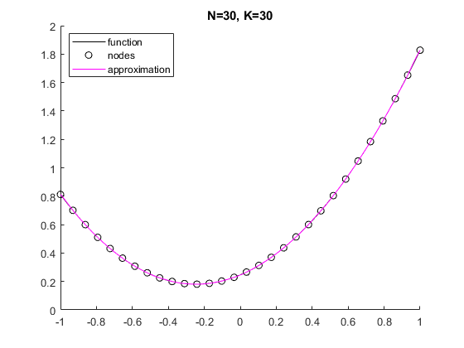

Fig. 3c)

PIERDOLNĄĆ WNIOSKI

Furthermore, the systematic investigation of the dependence of the accuracy of approximation on values N and K was carried, using two following accuracy indicators:

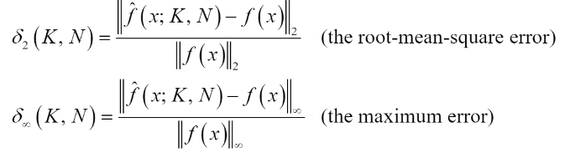

Where f(x; K, N) is an approximating function obtained for N and K. The results of the investigation are presented on figures 2a) and 2b).