ufw-manager-tui
Project Summary
Date: 2026-10-31 | Version: 1.0
Audience: Engineering Team, Architects, Stakeholders

Table of Contents
1. Executive Summary
2. Architecture Overview
2.1 The system in its environment
2.2 Layering
2.3 Design principles
3. Processing Pipeline
3.1 Startup
3.2 The event loop
3.3 The read path
3.4 The change pipeline
3.5 Undo and escalation
4. Core Components
4.1 `core/` — pure logic
4.2 `app.rs` — the state machine
4.3 `backend/` — the operating-system seam
4.4 `ui/` — rendering only
5. API Contracts and Data Schemas
5.1 The `Backend` trait
5.2 Error contract
5.3 Command-line interface
5.4 `config.toml`
5.5 `journal.json`
5.6 `watchdog.json`
5.7 `ufw` invocation contract
6. Infrastructure and Deployment
6.1 Build and distribution
6.2 Runtime topology
6.3 Privilege model
6.4 Files and directories
6.5 Verification status
6.6 Known operational limits
7. Extension Patterns
7.1 Add a new firewall change
7.2 Add a whole-firewall suggestion with a one-key fix
7.3 Add a preset
7.4 Add a tab or screen
7.5 Add a backend implementation
7.6 Add a configuration setting
7.7 Teach the parser a new `ufw status` shape
8. Rules and Anti-Patterns
8.1 Layering rules
8.2 Do
8.3 Don't
8.4 Gotchas
9. Dependencies
10. Code Structure
10.1 Where to start reading

1. Executive Summary
ufw-manager-tui is a full-screen terminal application that makes the Linux ufw firewall usable by people who have never written a firewall rule. It runs on the operator's own machine, reads the firewall through the ufw command-line tool, and writes changes only by invoking ufw itself with an explicit argument vector — it never edits /etc/ufw/* and never invents a second source of truth.
The application is a single Rust Cargo package (ufw-manager-tui 0.2.0, edition 2021, MSRV 1.85) that builds both a library crate, ufw_manager, and one binary, ufw-manager-tui. Internally it is split into four layers — ui/ (rendering with ratatui), app.rs (state machine and the change pipeline), core/ (pure, deterministic logic), and backend/ (all operating-system access behind a Backend trait, with a real ufw implementation and an in-memory mock) — plus the entry point in main.rs and the detached watchdog.rs side effect.
Its distinguishing capabilities are safety-oriented rather than cosmetic: every change is previewed as the exact ufw command, validated with ufw --dry-run, guarded against losing the SSH session that is being typed on, journaled for one-key undo, and — for changes that could cut the connection — protected by a detached watchdog process that reverts the change unless the operator confirms they are still connected. The codebase ships 309 passing tests (261 unit, 48 integration), a clean cargo clippy --all-targets -- -D warnings, and a clean cargo fmt --check, none of which need root or a terminal.

2. Architecture Overview
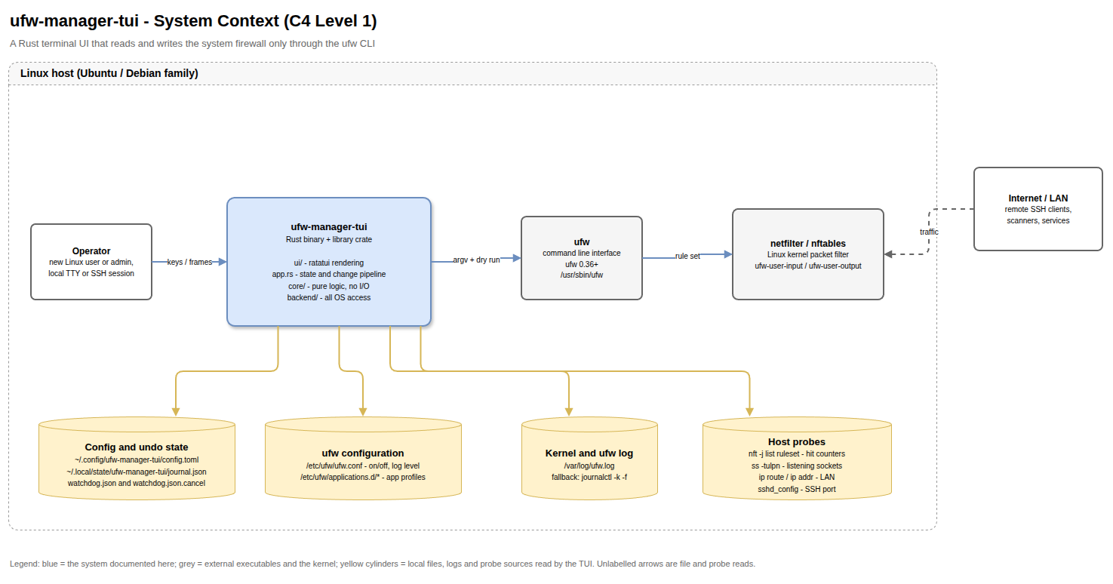
High-Level Architecture

2.1 The system in its environment
ufw-manager-tui sits between the operator and the system firewall. It has exactly one write path (the ufw CLI) and a small number of read paths:
Interaction | Direction | Mechanism
Keystrokes and rendered frames | Operator ↔ app | crossterm events, ratatui drawing on the TTY
Firewall rules and status | app → ufw | ufw status numbered, ufw status verbose, ufw --dry-run …, write subcommands
Firewall on/off and log level without root | app → disk | /etc/ufw/ufw.conf (world-readable)
Application profiles | app → disk | /etc/ufw/applications.d/*
Hit counters | app → nft | nft -j list ruleset, mapped by position in ufw-user-input / ufw-user-output
Blocked packets | app → log | /var/log/ufw.log, falling back to journalctl -k -f
Host facts (LAN, interfaces, SSH port) | app → probes | ip route, ip -o -4 addr, ss, sshd_config, SSH_CONNECTION
User preferences, undo history, watchdog state | app ↔ disk | XDG config and state directories (see §6.4)

2.2 Layering
The layering is enforced by convention and reviewed in .copilot/AGENTS.md. It is the single most important architectural decision in the project, because it is what makes the safety logic testable without root.
Layer | Files | Allowed to do | Must not do
Entry | src/main.rs, src/cli.rs, src/config.rs | Parse arguments, load config, own the terminal, run the event loop | Contain firewall policy
State machine | src/app.rs | Hold all state, dispatch keys, run the change pipeline, call the backend | Render, or construct ufw argument vectors by hand
Pure logic | src/core/* | Parse, build commands, explain, assess risk, simulate, journal, guard | Spawn a process, touch a file, read the environment
OS access | src/backend/* | Spawn processes, read system files, run background log tailing | Decide what to change
Rendering | src/ui/* | Draw &App | Mutate state or call the backend
Side effects | src/watchdog.rs | Spawn and drive the detached revert helper | Contain UI or policy logic

The seam between layers is the Backend trait in src/backend/mod.rs:144. UfwCli implements it against the real machine; MockBackend implements it in memory, which is what --demo uses and what every integration test drives.

2.3 Design principles
1. ufw is the only writer. All writes are ufw invocations with a Vec<String> argument vector passed to Command::args, never a shell string. There is no quoting layer and therefore no shell-injection surface.
2. Nothing is reconstructed from user.rules. Undo replays recorded inverse commands instead of rewriting the rule file, which is the operation that usually corrupts a rule set.
3. Preview before apply. The confirmation dialog shows the command, its plain-English meaning, and the recorded dry-run result.
4. Refuse rather than guess. Unparsable ufw status rows are kept verbatim and read-only so rule numbering stays stable; hit counters that do not align are reported as unavailable (—) rather than invented.
5. Degrade, never fail. A broken config file, an unreadable journal, a missing profile directory, or a missing /etc/hostname all fall back to defaults. The one thing that must never stop working is the ability to see why the firewall is broken.

3. Processing Pipeline
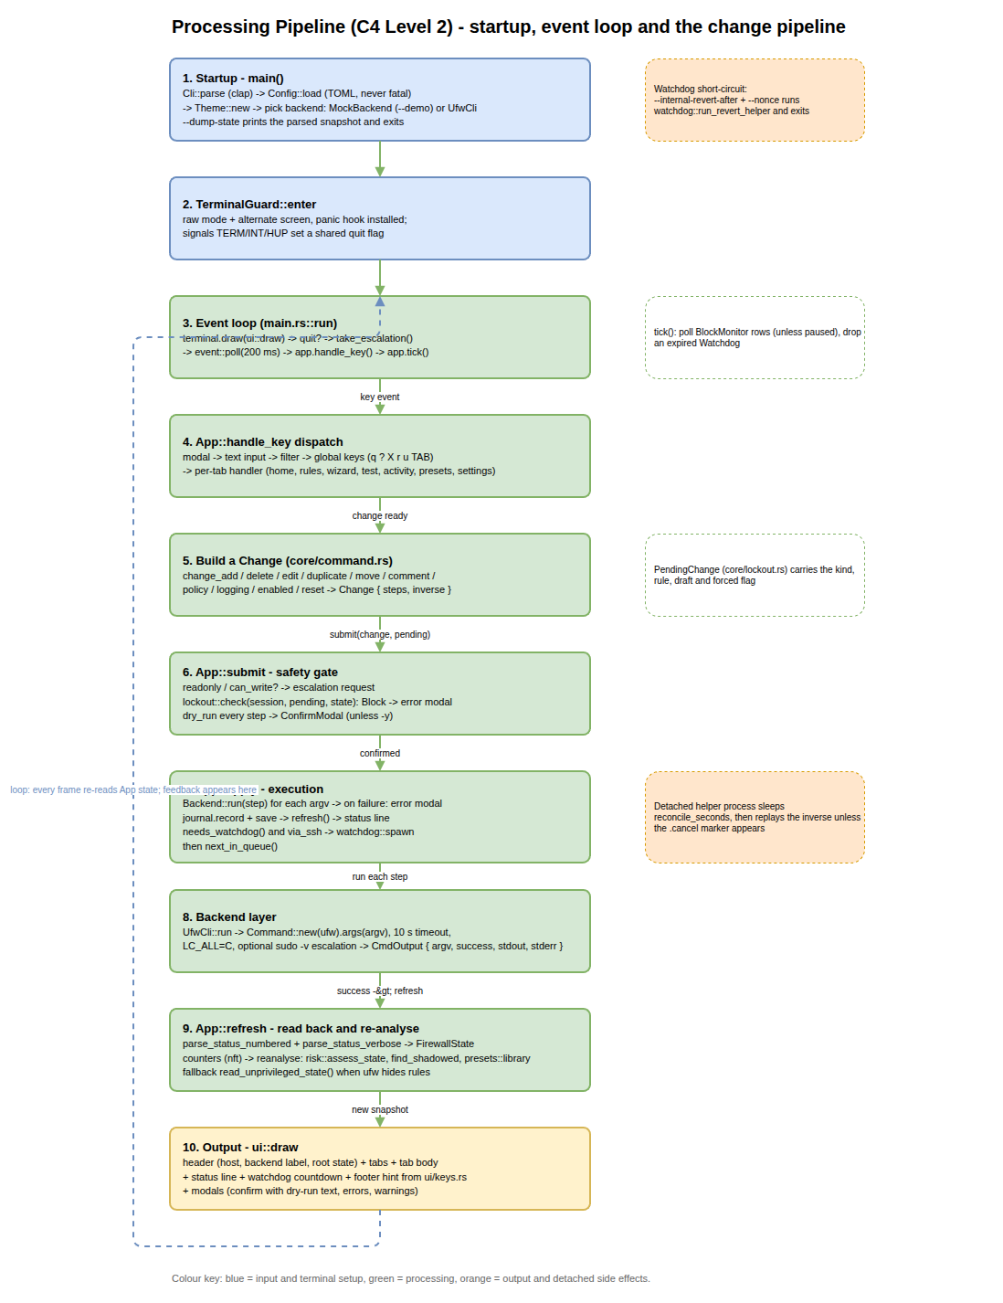
Processing Pipeline

3.1 Startup
1. Cli::parse (clap) reads flags. --internal-revert-after together with --nonce short-circuits into watchdog mode: watchdog::run_revert_helper runs and the process exits with its status.
2. Config::load reads config.toml (or --config <path>). Any read or TOML error yields Config::default().
3. Theme::new resolves the palette from --theme/config plus --no-color and --ascii.
4. The backend is chosen: MockBackend for --demo, otherwise UfwCli::new(readonly, no_escalate). UfwCli probes the machine once at construction (root-ness, LAN, interfaces, SSH port, profiles) so that drawing a frame never spawns a process.
5. --dump-state prints backend label, enabled flag, log level, default policies, rule count and every rule summary, then exits.
6. Otherwise App::new builds the state (reading /etc/hostname and the on-disk journal), calls bootstrap(), and run(app) starts the loop.

3.2 The event loop
main.rs::run owns a TerminalGuard (raw mode + alternate screen, restored on drop, on panic, and on TERM/INT/HUP). Each iteration:
1. terminal.draw(|frame| ui::draw(frame, &app)).
2. Exit when app.should_quit or the signal flag is set.
3. Service a pending Escalation: restore the terminal, run sudo -v through the backend, re-enter raw mode, clear, then App::after_escalation.
4. event::poll(200 ms); on a key event, App::handle_key.
5. App::tick() — refresh activity rows from the block monitor (unless paused) and drop an expired watchdog handle.
Key dispatch order in handle_key is: modal → open text input → open filter → global keys (q, ?, X, Tab, r, u, digits) → the active tab's handler.

3.3 The read path
App::refresh calls Backend::read_state, which runs ufw status numbered and ufw status verbose, parses both with core::parse, and combines them into a FirewallState. Hit counters are read from nft JSON and aligned to ufw rule numbers by position; if alignment fails, HitCounters::unavailable(reason) is returned instead of wrong numbers. reanalyse() then recomputes, purely in memory:
• risk::assess_state — whole-firewall suggestions, worst first;
• risk::find_shadowed — rule pairs where a broad rule hides a narrow one;
• presets::library — the preset cards valid for this context.
When ufw refuses to print rules (not root), refresh falls back to read_unprivileged_state(), which reads only /etc/ufw/ufw.conf, and sets a warning status.

3.4 The change pipeline
Every write goes through App::submit(change, pending) and then App::apply(&change):
Stage | Code | Behaviour on failure
1. Write permission | submit | Read-only or !backend.can_write(): queues an Escalation::Write when escalation is possible, otherwise a warning status. Nothing runs.
2. Lockout guard | lockout::check(session, pending, state) | GuardVerdict::Block opens an error modal explaining what to do instead.
3. Dry run | backend.dry_run for every step | Any non-zero exit opens "ufw rejected this change" and states that nothing was changed.
4. Confirmation | ConfirmModal | Skipped when -y is set or confirm_before_apply = false; the dry run still happens.
5. Execution | backend.run per step | Failures are collected per command and shown verbatim in an error modal; the state is refreshed.
6. Journal | journal.record + Journal::save | Save errors are ignored; the in-memory journal still allows undo.
7. Watchdog | watchdog::spawn when needs_watchdog(change) and the session is over SSH | If the helper cannot start, the change stays applied and the status line says so.
8. Queue | next_in_queue() | The next queued change is submitted through the same pipeline.

needs_watchdog selects the destructive cases: enabling the firewall, changing the default incoming policy, and reset. lockout::check is broader — it also refuses to delete or edit the rule that currently carries the SSH session.

3.5 Undo and escalation
App::undo takes the newest journal entry, wraps its reverse steps/inverse pair in a new Change, and runs that through backend.run. Nothing is undone when the entry has no inverse (for example a reset), when the journal is empty, or in read-only mode.
X (or the first write while unprivileged) raises Escalation::Privileges/Escalation::Write. main.rs leaves raw mode, the backend runs sudo -v, raw mode is restored, and after_escalation(granted, retry) either retries the blocked change or simply makes the rules visible.

4. Core Components
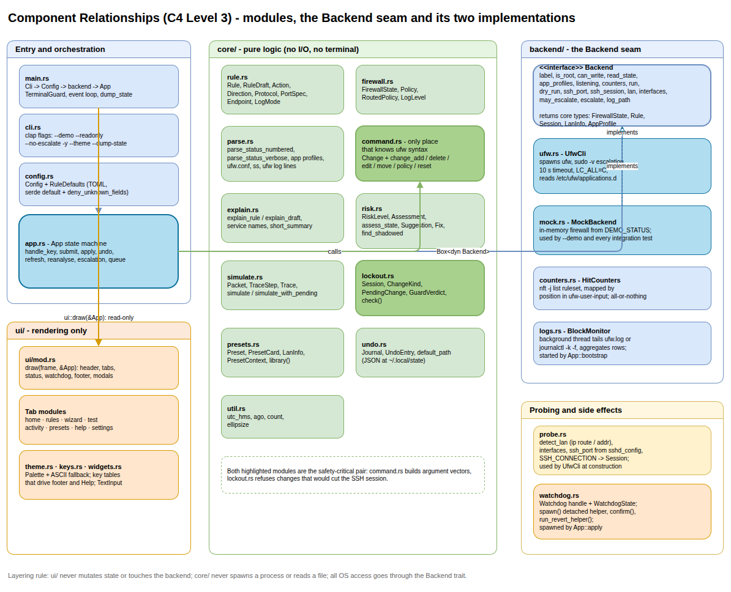
Component Relationships

4.1 `core/` — pure logic
Module | Responsibility | Key public items
rule.rs:1039 | The rule model and its parsers | Rule, RuleDraft, Action, Direction, Protocol, PortRange, PortSpec, Endpoint, LogMode, parse_net
firewall.rs:392 | Whole-firewall snapshot | FirewallState, Policy, RoutedPolicy, LogLevel
parse.rs:273 | Defensive parsers for ufw and host output | ParsedRules, ParsedHeader, AppProfile, Listening, BlockEvent, UfwConf, parse_status_numbered, parse_status_verbose, parse_ufw_log_line
command.rs:34 | The only module that knows ufw syntax | Change, render_command, rule_args, change_add/delete/edit/duplicate/move/comment/policy/logging/enabled/reset, insert_rule, delete_by_number, is_destructive
explain.rs:294 | Plain English for every rule | describe_source, describe_port, explain_rule, explain_draft, short_summary, service_name
risk.rs:485 | Per-rule and whole-firewall risk | RiskLevel, Assessment, assess_rule, Suggestion, Fix, assess_state, find_shadowed, is_sensitive_port
simulate.rs:175 | The packet simulator | Packet, StepOwner, TraceStep, Trace, simulate, simulate_with_pending, matches_rule
lockout.rs:262 | The lockout guard | Session, ChangeKind, PendingChange, GuardVerdict, check
presets.rs:412 | One-key recipes | Preset, PresetCard, PresetContext, LanInfo, library
undo.rs:88 | The undo journal | UndoEntry, Journal (record, last, save, load, default_path)
util.rs | Formatting helpers | utc_hms, hms_from_epoch, ago, count, ellipsize

4.2 `app.rs` — the state machine
App holds every piece of mutable state: the backend, the firewall snapshot, derived analysis (suggestions, shadowed, lan, presets), per-tab cursors, form state (wizard, traffic), the open modal, the change queue, the write flags, escalation, watchdog, and activity_rows. It is constructed once by App::new(backend, AppOptions); AppOptions carries the journal path, yes, readonly, theme, reconcile_seconds, show_counters, confirm_before_apply, the Config, and the config path.
The UI reads App and never writes it, so every rendering test is a pure function of construction plus synthetic key presses.

4.3 `backend/` — the operating-system seam
Module | Responsibility
mod.rs:144 | Backend trait, BackendError, CmdOutput, dry-run argument helper, not-root and not-installed detection
ufw.rs | UfwCli: spawns ufw with a 10 s timeout and LC_ALL=C, caches probe results at construction, handles sudo -v escalation
mock.rs | MockBackend: an in-memory firewall seeded from a realistic captured rule set; used by --demo and all flow tests
counters.rs | HitCounters, parse_nft_rules, align, collect — all-or-nothing mapping of kernel counters to rule numbers
logs.rs | BlockMonitor background thread, BlockRow aggregation, 15-minute retention, clear, clear_source, total
probe.rs | detect_lan, interface enumeration, SSH port discovery, Session from SSH_CONNECTION

4.4 `ui/` — rendering only
ui::draw lays out header (host, backend label, privilege state), tab bar, active tab body, status line, watchdog countdown, footer hints, and modals. The tab modules are home, rules, wizard, test, activity, presets, help, and settings. theme.rs holds the palettes; keys.rs holds the hint tables that generate both the footer and the Help screen, so the two cannot drift; widgets.rs holds TextInput and layout helpers. The UI renders a "terminal too small" message below 40×12 and every screen is tested at that size.

5. API Contracts and Data Schemas

5.1 The `Backend` trait
Every method is synchronous and called from the render thread except where noted.
Method | Signature | Contract
label | fn(&self) -> String | One-line backend description, e.g. ufw 0.36.2 or demo mode.
is_root | fn(&self) -> bool | Whether the process started as root.
can_write | fn(&self) -> bool | false in read-only mode, demo mode, or without privileges.
read_state | fn(&self) -> Result<FirewallState, BackendError> | Runs ufw status numbered + ufw status verbose and combines the parses.
app_profiles | fn(&self) -> Result<Vec<AppProfile>, BackendError> | Application profiles known to ufw.
listening | fn(&self) -> Result<Vec<Listening>, BackendError> | Listening sockets, from ss.
counters | fn(&self, rules: &[Rule]) -> Result<HitCounters, BackendError> | Per-rule packet counts, or an explicitly unavailable set.
run | fn(&self, args: &[String]) -> Result<CmdOutput, BackendError> | Executes one ufw invocation.
dry_run | fn(&self, args: &[String]) -> Result<CmdOutput, BackendError> | Executes the same invocation with --dry-run inserted first.
ssh_port | fn(&self) -> u16 | SSH port in use, default 22.
ssh_session | fn(&self) -> Session | Who is driving and from where.
lan | fn(&self) -> Option<LanInfo> | Detected local network.
interfaces | fn(&self) -> Vec<String> | Interface names for the wizard.
may_escalate | fn(&self) -> bool (defaulted) | Whether sudo escalation is permitted.
escalate | fn(&self) -> bool (defaulted) | Runs sudo -v; returns whether privileges were granted.
log_path | fn(&self) -> Option<PathBuf> (defaulted) | The log file the block monitor should tail, if any.

5.2 Error contract
BackendError carries ufw's own wording wherever possible so the UI can show the real message:
Variant | Meaning
NotRoot(String) | ufw refused because the process is not root.
NotFound | ufw is missing from PATH.
Timeout { seconds } | ufw did not answer inside the timeout (10 s).
Failed { command, stderr } | A command exited non-zero.
Parse(String) | Output could not be understood.
Io(String) | Any other I/O failure.

CmdOutput { argv, success, stdout, stderr } keeps both streams; command() renders the argv as a copy-pasteable command line and message() prefers stderr, falling back to stdout.

5.3 Command-line interface
Flag | Effect
--demo | Run against MockBackend; nothing on the system is read or changed.
--readonly | Never change the firewall.
--no-escalate | Never invoke sudo.
-y, --yes | Skip the confirmation dialog; the dry run still happens.
--no-color | Text risk badges instead of colours.
--ascii | Force ASCII box drawing.
--theme <dark|light|16color|mono> | Override the configured theme.
--config <PATH> | Use a specific config.toml.
--debug-log <PATH> | Accepted for diagnostics; no trace is currently written.
--dump-state | Print the parsed firewall snapshot and exit.
--ufw <PATH> (hidden) | Override the ufw executable; used by tests.
--internal-revert-after <SECONDS>, --nonce <PATH> (hidden) | Enter watchdog mode for the detached helper.

5.4 `config.toml`
Located at <config_dir>/ufw-manager-tui/config.toml. Parsing uses #[serde(default, deny_unknown_fields)], so unknown keys are rejected and missing keys fall back to defaults; a malformed file silently yields the defaults.
Key | Type | Default | Meaning
theme | string | "dark" | dark, light, 16color, mono.
confirm_before_apply | bool | true | Show the confirmation dialog.
show_counters | bool | true | Read per-rule hit counters (needs root).
counters_refresh_secs | u64 | 5 | Persisted setting; counters are currently re-read on every refresh(), so this value has no runtime effect yet.
log_source | string | "auto" | Persisted setting; the block monitor currently auto-detects file versus journalctl, so this value has no runtime effect yet.
reconcile_seconds | u64 | 60 | Watchdog delay; 0 disables it.
ascii_fallback | bool | false | Force ASCII box drawing.
readonly | bool | false | Start read-only even when root.
skip_wizard | bool | false | Start new rules on the Advanced step.
[defaults].action | string | "allow" | Default action for new rules.
[defaults].direction | string | "in" | in, out, or forward.
[defaults].interface | string | "" | Empty means any interface.
[defaults].protocol | string | "any" | any, tcp, udp, icmp, …
[defaults].from_addr / to_addr | string | "" | Empty means any address.
[defaults].logging | string | "off" | off, log, log-all.

5.5 `journal.json`
Path: <state_dir>/ufw-manager-tui/journal.json (core::undo::default_path). The file is a single JSON object:
{
"entries": [
{
"id": 1,
"at": "14:32:07",
"description": "Add rule: Allow TCP port 22 from 192.168.1.0/24",
"forward": [["allow", "22/tcp"]],
"inverse": [["delete", "allow", "22/tcp"]]
}
],
"next_id": 2
}

forward holds the argument vectors that applied the change and inverse the vectors that revert it; the example is abbreviated, and real vectors carry the full rule (allow from 192.168.1.0/24 to any port 22 proto tcp) plus the comment clause when a note exists. Entries are ordered oldest first; undo pops the last. An entry with an empty inverse is displayed in history but cannot be undone.

5.6 `watchdog.json`
Path: <state_dir>/ufw-manager-tui/watchdog.json, with the cancel marker next to it as watchdog.json.cancel.
{
"inverse": [["disable"]],
"description": "Turn the firewall on"
}

The detached helper reads this file, waits reconcile_seconds, polling for the cancel marker every 250 ms, and then runs each inverse vector in order through the configured ufw program. Failed inverse steps are reported on stderr and do not stop the remaining steps.

5.7 `ufw` invocation contract
Purpose | Invocation | Notes
Read rules | ufw status numbered, ufw status verbose | Two subprocesses, parsed defensively.
Read profiles | files in /etc/ufw/applications.d | Read at construction.
Validate a change | ufw --dry-run <args…> | The prefix goes first; every step is validated.
Add | ufw allow <…> / ufw deny <…> / ufw reject <…> / ufw limit <…> | Short form allow 22/tcp used when the rule is a simple port.
Insert at position | ufw insert <N> <…> | Only when position N exists; otherwise a plain append.
Forwarding | ufw route <…> and ufw route insert <N> <…> | ufw route delete N is invalid, so deletion uses plain ufw --force delete N.
Delete | ufw --force delete <N>, or ufw delete <rule args> when undoing an add | Deleting an existing rule uses its number; the inverse of an add deletes by specification instead, because that survives renumbering. Comments are never part of the match.
Comment | ufw <action> … comment '<text>' | Notes are real ufw comments, not a sidecar file.
Policy | ufw default <allow|deny|reject> <incoming|outgoing|routed> | Guarded and watchdog-protected.
Logging | ufw logging <off|low|medium|high|full>
Enable/disable | ufw --force enable / ufw disable | --force replaces ufw's own prompt; enabling is guarded and watchdog-protected.
Reset | ufw --force reset | Destructive; no inverse.

6. Infrastructure and Deployment

6.1 Build and distribution
Aspect | Value
Package | ufw-manager-tui 0.2.0, MIT, repository ernos/ufw-manager-tui
Targets | library ufw_manager (src/lib.rs), binary ufw-manager-tui (src/main.rs)
Toolchain | Rust edition 2021, rust-version = "1.85"
Release profile | lto = true, codegen-units = 1
Install | cargo install ufw-manager-tui, or cargo install --path . from a clone
Runtime requirement | Linux with ufw 0.36+ installed; root for reading and writing rules

There is no Dockerfile, container image, Helm chart, service unit, or CI workflow in the repository. The application is a single binary that is run interactively; verification is local (cargo test, cargo clippy --all-targets -- -D warnings, cargo fmt --check). Editor settings are shared through .editorconfig (4-space indent, LF, final newline) and .vscode/.

6.2 Runtime topology
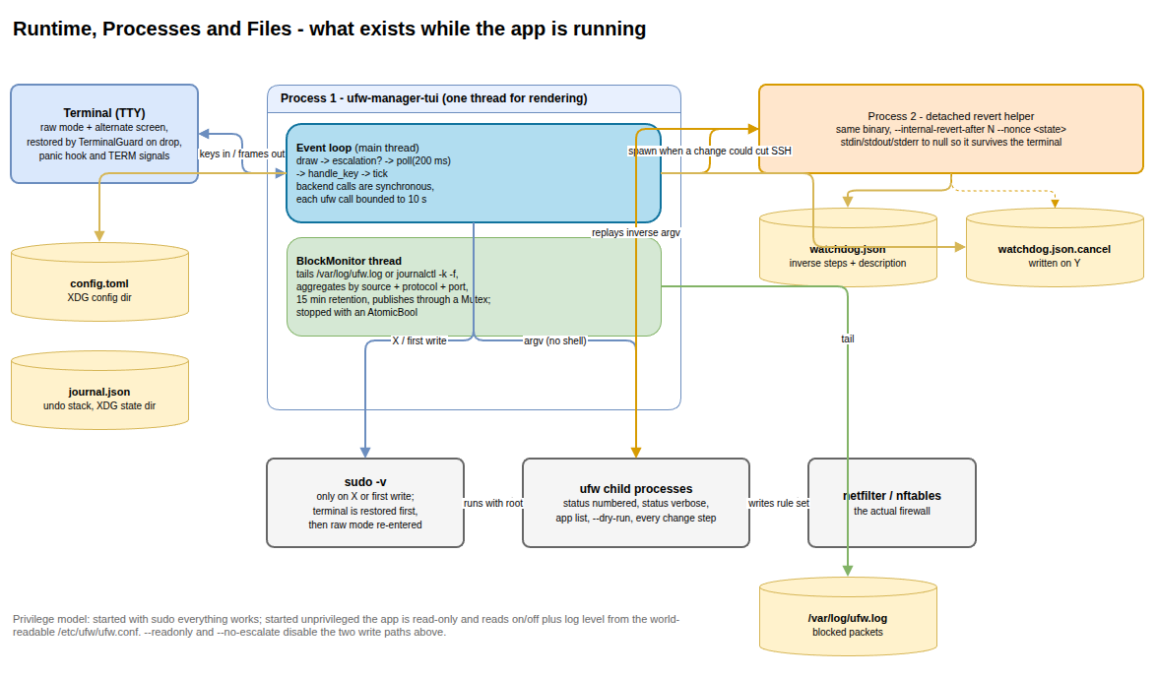
Runtime and Processes
Runtime element | Nature | Lifetime
Event loop | Main thread; synchronous backend calls | Whole session
BlockMonitor | Background thread started by App::bootstrap; publishes rows through a Mutex, stops via an AtomicBool | Whole session
ufw child processes | Spawned per read and per change step, 10 s timeout | Per call
sudo -v | Spawned on demand after the terminal is restored | Until credentials expire
Detached revert helper | Second process of the same binary, stdio redirected to null | reconcile_seconds or until confirmed

There is no async runtime. The only unbounded work (tailing the block log) is isolated on its own thread; everything else is bounded by timeouts so the UI cannot freeze on a hung ufw.

6.3 Privilege model
Situation | Behaviour
Started with sudo | Everything works.
Started unprivileged | Read-only: firewall on/off and log level come from the world-readable /etc/ufw/ufw.conf; the UI states that rules are hidden instead of pretending.
First write while unprivileged | Leaves raw mode, runs sudo -v, retries the change. Disabled by --no-escalate.
--readonly or readonly = true | Never writes, even as root.

6.4 Files and directories
Path | Purpose | Failure behaviour
<config_dir>/ufw-manager-tui/config.toml | User preferences | Missing or malformed → defaults
<state_dir>/ufw-manager-tui/journal.json | Undo history | Unreadable → empty journal
<state_dir>/ufw-manager-tui/watchdog.json + .cancel | Watchdog state and cancel marker | Helper exits with code 1
/etc/ufw/ufw.conf | On/off and log level without root | Field stays default
/etc/ufw/applications.d/* | Application profiles | Empty profile list
/var/log/ufw.log or journalctl -k -f | Blocked traffic | Empty activity list
/etc/hostname | Host name in the header | localhost

6.5 Verification status
Check | Command | Result
Unit tests | cargo test --lib | 261 passed
Flow tests (real App + MockBackend) | cargo test --test app_flow | 39 passed
Real backend against a fake ufw script | cargo test --test backend_ufw | 9 passed
Lints | cargo clippy --all-targets -- -D warnings | Clean
Formatting | cargo fmt --check | Clean

6.6 Known operational limits
• Hit counters map kernel rules to ufw numbers by position; limit rules and application profiles expand into several kernel rules, so misalignment yields — rather than a guess.
• The simulator is a model, not the kernel. It reproduces ufw's built-in rules for loopback, established connections, invalid packets, ICMP echo, DHCP and mDNS, then applies the user rules in order, including forwarded packets and the routed default policy. The UI labels its output as simulated.
• ufw status is text. Rows that cannot be parsed are shown verbatim and left read-only so rule numbers stay consistent.
• SIGKILL can leave the terminal in raw mode; reset recovers it.

7. Extension Patterns

7.1 Add a new firewall change
1. Add a builder in src/core/command.rs:385 that returns Change { description, steps, inverse }. Reuse rule_args and insert_rule; never build argument strings elsewhere.
2. Add a PendingChange with the matching ChangeKind so the lockout guard can judge it, and extend lockout::check if the new kind can cut access.
3. Call app.submit(change, pending) from the relevant key handler; do not call the backend directly from a UI module.
4. If the change can flush the firewall while the session is remote, extend needs_watchdog in src/app.rs:3642.
5. Add argument-vector tests in core/command.rs and a key-press flow test in tests/app_flow.rs.

7.2 Add a whole-firewall suggestion with a one-key fix
1. Push a Suggestion { level, text, fix } in risk::assess_state (src/core/risk.rs:485), ordered by severity.
2. Add the corresponding Fix variant.
3. Handle the new variant in App::apply_suggestion (src/app.rs:1677) by building a Change and calling submit.
4. Cover the boundary conditions in the risk.rs tests.

7.3 Add a preset
1. Add a Preset variant in src/core/presets.rs:109 and its title/explanation.
2. Emit a PresetCard from library(ctx); set blocked with a reason when a precondition (for example a detected LAN or an existing SSH rule) is missing.
3. Provide the Change sequence the preset expands into; the Presets tab only enqueues cards and lets the normal pipeline validate them.

7.4 Add a tab or screen
1. Add the variant to Tab and Tab::ALL in src/app.rs:44 with title and description; the digit shortcut follows from the index.
2. Create src/ui/<name>.rs exporting a draw function that takes &App and a Rect, and dispatch to it from ui::draw.
3. Add a per-tab key handler in impl App and route it from dispatch_tab_key.
4. Add hints in src/ui/keys.rs:122 so the footer and Help screen stay correct.
5. Add a render test at 40×12, 120×40 and larger; keep the "too small" path functional.

7.5 Add a backend implementation
1. Implement Backend for the new type; every method except may_escalate, escalate and log_path is required.
2. Return BackendError variants with the tool's own wording.
3. Wire the selection in main.rs alongside the --demo branch.
4. Reuse the core parsers rather than parsing in the backend; the pure layer holds the format knowledge.
5. Add integration coverage in tests/backend_ufw.rs style, against a scripted fake executable.

7.6 Add a configuration setting
1. Add the field to Config (or RuleDefaults) in src/config.rs:37 with a doc comment and a value in Default.
2. Pass it through AppOptions if the app needs it at startup.
3. Expose it on the Settings tab if it is user-editable, and save with Config::save when the row is committed.
4. Update README.md §10 and keep deny_unknown_fields semantics in mind.

7.7 Teach the parser a new `ufw status` shape
1. Add a fixture-style test in src/core/parse.rs:273 using real captured output.
2. Extend the column detection rather than adding byte offsets; the To column can exceed 26 characters and remove the padding gap.
3. If a row still cannot be understood, leave it in unparsed — never drop it, because rule numbers must stay aligned with ufw delete N.

8. Rules and Anti-Patterns

8.1 Layering rules
Rule | Rationale
core/ must not spawn processes, read files, read the environment, or touch the terminal | Keeps the safety logic unit-testable without root and deterministic against captured output.
ui/ must not mutate App or call the backend | Rendering stays a pure function of state, so tests can assert on frames.
All OS access goes through Backend | Makes --demo, integration tests, and screenshot tests possible.
command.rs is the only place that constructs ufw argument vectors | One place to review for correctness and one place that can be wrong.
app.rs owns all state | A single source of truth prevents divergent copies of the firewall snapshot.

8.2 Do
• Write block doc comments for every function and type, including purpose, typed arguments, concrete return type, and notes on panics, ignored errors, and terminal or escalation behaviour (see docs/DOCUMENTATION.md).
• Update docs/ whenever behaviour, configuration, or a workflow changes.
• Add a key-press flow test in tests/app_flow.rs for new user-visible behaviour, and unit tests in the affected core module.
• Keep the footer hints and Help screen driven from ui/keys.rs tables.
• Keep every screen usable at 40×12.
• Return ufw's own error text to the user instead of paraphrasing it.

8.3 Don't
• Don't shell out with a command string; pass Vec<String> to Command::args.
• Don't edit /etc/ufw/* or rewrite user.rules; undo by replaying inverse commands.
• Don't store notes in a sidecar file; use ufw comments.
• Don't drop or renumber unparsable ufw status rows.
• Don't invent counter values; show — when alignment fails.
• Don't let a config or journal problem abort startup.
• Don't run git commit, git push, or any branch-changing git command while working in the repository (project agent rule).

8.4 Gotchas
• App::new reads /etc/hostname and the journal; failures are ignored by design.
• Config::load never fails and rejects unknown keys.
• read_unprivileged_state() is the fallback when ufw hides rules.
• HitCounters::unavailable(reason) carries the reason shown in the UI.
• The watchdog is spawned only when the session is over SSH, the change is destructive, and an inverse exists.
• ufw insert N requires position N to exist; an edit that removes the last rule must append instead.

9. Dependencies
Direct dependencies are deliberately few: a terminal UI stack, serialization, error handling, and small platform helpers.
Crate | Declared | Resolved | Role
ratatui | 0.30 | 0.30.2 | Widgets, layout, and frame drawing.
crossterm | 0.29 | 0.29.0 | Raw mode, alternate screen, key events, terminal size.
clap | 4 (derive) | 4.6.7 | Command-line parsing and help text.
anyhow | 1 | 1.0.104 | Error propagation at the binary's top level.
thiserror | 2 | 2.0.21 | BackendError derive.
serde | 1 (derive) | 1.0.229 | Config and journal (de)serialization.
serde_json | 1 | 1.0.154 | Journal and watchdog state files; nft JSON input.
toml | 1 | 1.1.8 | config.toml.
ipnet | 2 | 2.12.2 | CIDR parsing for sources, destinations and LAN detection.
directories | 6 | 6.0.0 | XDG config/state/data locations.
signal-hook | 0.4.5 | 0.4.5 | TERM/INT/HUP handling for clean shutdown.

Dev dependencies:
Crate | Declared | Resolved | Role
insta | 1 | 1.49.0 | Snapshot testing for parser output (declared for snapshot review).
tempfile | 3 | 3.27.0 | Temporary directories for journal, config and fake-ufw tests.

Notable transitive crates: unicode-width 0.2.3 and unicode-segmentation (text layout), libc 0.2.191 (signal constants), cassowary (ratatui layout solver). Cargo.lock pins 213 packages in total.

10. Code Structure
ufw-manager-tui/
├── Cargo.toml package metadata, library + binary targets, deps
├── Cargo.lock pinned dependency graph (213 packages)
├── README.md user documentation: install, keys, tabs, safety model
├── CHANGELOG.md release notes, including the 0.1.x → 0.2.0 fixes
├── TODO_KNOWN_BUGS.md outstanding known issues
├── .editorconfig 4-space indent, LF, final newline
├── .copilot/
│ ├── AGENTS.md layering rules, data flow, change pipeline, gotchas
│ └── Architecture_mermaid.md longer architecture notes with Mermaid diagrams
├── docs/
│ ├── SPEC.md product specification (problem, screens, safety model)
│ ├── TESTING.md automated coverage table + manual VM checklist
│ ├── GLOSSARY.md plain-English firewall terms (mirrors the Help tab)
│ ├── DOCUMENTATION.md documentation and commenting style rules
│ ├── project-summary.md this document
│ ├── project-summary.docx Word version of this document
│ └── diagrams/ editable .drawio sources and rendered .png exports
├── screenshots/ tab screenshots used by the README
├── src/
│ ├── main.rs (321) entry point, TerminalGuard, event loop, dump_state
│ ├── lib.rs (7) re-exports the library modules
│ ├── cli.rs (191) clap flags and watchdog-mode detection
│ ├── config.rs (531) Config, RuleDefaults, load/save, defaults
│ ├── app.rs (3915) App state, key dispatch, submit/apply/undo, pipeline
│ ├── watchdog.rs (426) detached revert helper and Watchdog handle
│ ├── core/ pure logic — no I/O, no terminal
│ │ ├── mod.rs (16) module list
│ │ ├── rule.rs (1768) rule model, actions, ports, endpoints, drafts
│ │ ├── firewall.rs (654) FirewallState, policies, log levels
│ │ ├── parse.rs (1590) ufw status/app/ss/log parsers
│ │ ├── command.rs (1598) Change + ufw argument-vector builders
│ │ ├── explain.rs (667) plain-English rule descriptions
│ │ ├── risk.rs (1215) risk levels, assessments, suggestions, shadowing
│ │ ├── simulate.rs (1320) packet simulator and decision traces
│ │ ├── lockout.rs (706) session model and lockout guard
│ │ ├── presets.rs (766) preset catalogue and evaluation
│ │ ├── undo.rs (533) journal, entries, JSON persistence
│ │ └── util.rs (202) time and text helpers
│ ├── backend/ all OS access behind the Backend trait
│ │ ├── mod.rs (481) trait, BackendError, CmdOutput, dry-run helper
│ │ ├── ufw.rs (908) UfwCli: real ufw, sudo, timeouts, profiles
│ │ ├── mock.rs (1065) MockBackend and the demo rule set
│ │ ├── counters.rs (543) HitCounters and nft JSON alignment
│ │ ├── logs.rs (626) BlockMonitor thread and aggregation
│ │ └── probe.rs (440) LAN, interfaces, SSH port, session detection
│ └── ui/ rendering only
│ ├── mod.rs (857) layout, header, tabs, status, modals
│ ├── home.rs (426) firewall status and suggestions
│ ├── rules.rs (510) rule table with risk and hit counts
│ ├── wizard.rs (464) guided rule creation
│ ├── test.rs (382) traffic simulator form and trace
│ ├── activity.rs (197) live blocked traffic and session changes
│ ├── presets.rs (230) preset cards
│ ├── help.rs (128) keys and glossary
│ ├── settings.rs (351) defaults for new rules
│ ├── theme.rs (711) palettes and ASCII fallbacks
│ ├── keys.rs (327) hint tables driving footer and Help
│ └── widgets.rs (455) TextInput and layout helpers
└── tests/
├── app_flow.rs (2168) 39 key-press flows against MockBackend
└── backend_ufw.rs (446) 9 tests of UfwCli against a fake ufw script

10.1 Where to start reading
1. src/main.rs — how a session is assembled and how the loop works.
2. src/app.rs:3149 — submit, apply, undo: the safety model in code.
3. src/core/command.rs:34 — the only module that knows ufw syntax.
4. src/core/lockout.rs:262 — when the app refuses to act.
5. src/backend/ufw.rs — process spawning, timeouts, escalation.
6. tests/app_flow.rs — the behaviour contract, expressed as key presses.

