Reducing Car & Motorcycle Theft, Increasing Recovery Rates while preserving a high level of privacy
Ernst Melias
Abstract

Table of Contents
Overview
The goal of the tool is to add as a preventive measure against car and motorcycle theft. In addition, in the event of theft the goal of the tool is to increase the likelihood that to vehicle will be recovered. Ideally the tool would be placed in an discreet location on the vehicle where its removal would either be difficult or affect the short-term operation of the vehicle. The device would allow the user to track the real-time movement pattern of the vehicle, provide real time position data, allow the user to turn on and turn off tracking at ease, accepts certain voice commands, and features a user a panic mode. In addition, for the vehicles that do unfortunately fall victim to theft attempts the tool will provide analytics warning users of certain patterns that increase theft, certain actions taken by potential thefts, and certain areas that are certain hotspots for theft.
Research
Overall vehicle theft in the United States has been gradually decreasing from 1960 to 2015 with thefts peaking in 1991 with a report 1,661,738* vehicles being reported stolen. A lot of this has been due to coordinated effort between law enforcement and vehicle monitoring and protection groups such as National Insurance Crime Bureau (NICB) , International Association of Auto Theft Investigators (IAATI), International Association of Special Investigation Units (IASIU), and more. In addition, tougher laws and punishments have made a major impact in the reduction of vehicle theft. Lastly, advancements in technology have made traditional forms of vehicle obsolete or at least an extremely difficult task. However, the problem is far from being solved. According to the FBI’s Uniform Crime Report a motor vehicle was stolen in the U.S every 45 seconds in 2015 with at total of 707,758 motor vehicles stolen that year*. The Uniform Crime Report defines a motor vehicle as a self propelled that runs on land surface and not on rails. Examples of motor vehicles include sport utility vehicles, automobiles, trucks, boats, motorcycles, motor scooters, all-terrain vehicles, and snowmobiles. Below we provide further data on vehicle theft:
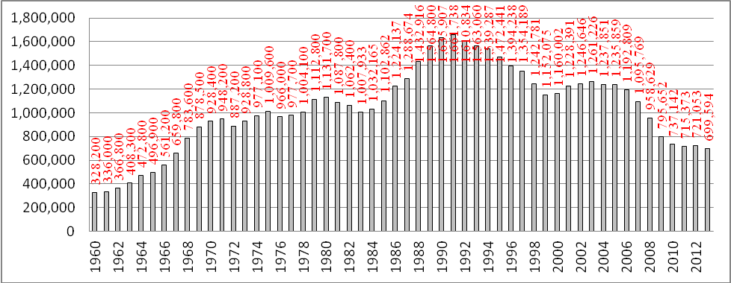
Figure: Vechicle Thefts by year 1960-2013
Source: Vehicle thefts and theft rates: FBI, Uniform Crime Report; prepared by the National Insurance Crime Bureau
Population: U.S. Census Bureau
Registration: Federal Highway Adminstration

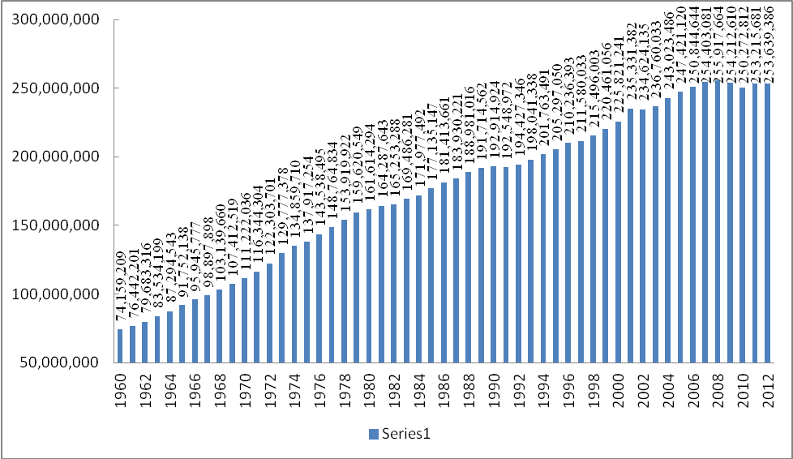
Figure: Vechicle Registration From 1960 to 2012

Source: Vehicle thefts and theft rates: FBI, Uniform Crime Report; prepared by the National Insurance Crime Bureau
Population: U.S. Census Bureau
Registration: Federal Highway Adminstration

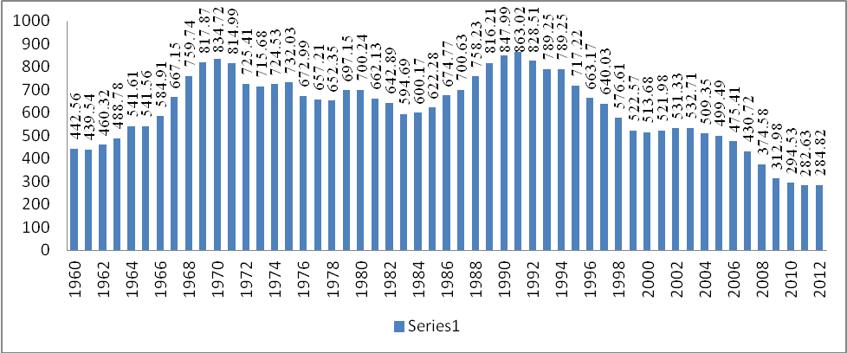
Figure: Vechicle Thefts Per 100k Registration From 1960 2012

Source: Vehicle thefts and theft rates: FBI, Uniform Crime Report; prepared by the National Insurance Crime Bureau
Population: U.S. Census Bureau
Registration: Federal Highway Adminstration

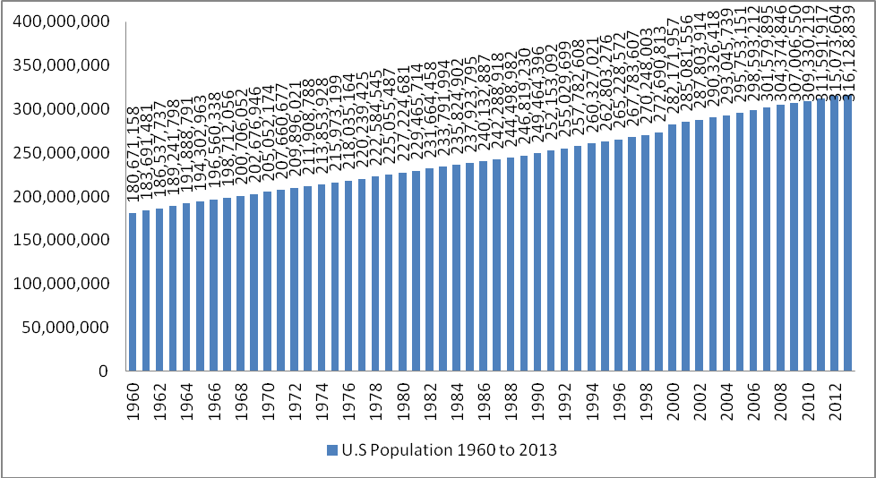
Figure: U.S Population from 1960 to 2013
Source: Vehicle thefts and theft rates: FBI, Uniform Crime Report; prepared by the National Insurance Crime Bureau
Population: U.S. Census Bureau
Registration: Federal Highway Adminstration

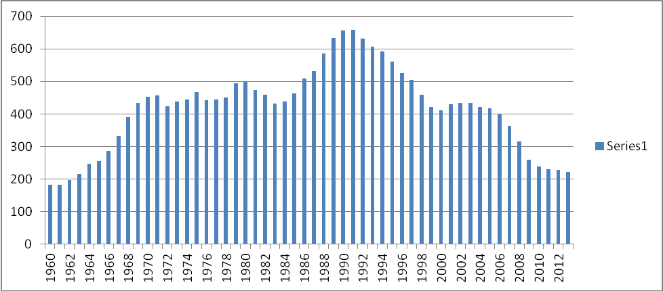
Figure: Vechicle Theft Per 100k Population

Source: Vehicle thefts and theft rates: FBI, Uniform Crime Report; prepared by the National Insurance Crime Bureau
Population: U.S. Census Bureau
Registration: Federal Highway Adminstration

Rank | 1 | 2 | 3 | 4 | 5 | 6 | 7 | 8 | 9 | 10
Year
1960 | California | Illinois | Texas | Michigan | Pennsylvania | Ohio | New Jersey | Massachusetts | Florida | Missouri
 | 53,453 | 35,619 | 15,975 | 14,040 | 13,854 | 13,069 | 11,908 | 10,868 | 9,289 | 7,982
1961 | California | Illinois | Texas | Massachusetts | Michigan | Pennsylvania | New Jersey | Ohio | Florida | Indiana
 | 54,559 | 36,392 | 15,348 | 14,215 | 14,019 | 13,775 | 12,901 | 12,047 | 8,862 | 8,330
1962 | California | Illinois | Texas | Michigan | Massachusetts | Pennsylvania | New Jersey | Ohio | Florida | Indiana
 | 57,555 | 37,710 | 16,986 | 15,933 | 15,668 | 15,510 | 14,641 | 13,781 | 9,187 | 9,154
1963 | California | Illinois | Massachusetts | Michigan | Pennsylvania | Texas | New Jersey | Ohio | Missouri | Indiana
 | 63,717 | 38,854 | 19,099 | 18,328 | 18,205 | 17,744 | 16,826 | 15,045 | 10,401 | 9,996
1964 | California | Illinois | Massachusetts | Pennsylvania | Michigan | Texas | New Jersey | Ohio | Florida | Missouri
 | 75,787 | 42,555 | 24,133 | 21,398 | 21,243 | 21,026 | 18,923 | 18,525 | 11,775 | 11,442
1965 | California | New York* | Illinois | Massachusetts | Michigan | Pennsylvania | Texas | New Jersey | Ohio | Florida
 | 81,773 | 58,452 | 40,438 | 28,533 | 26,591 | 25,504 | 20,195 | 19,924 | 19,459 | 12,062
1966 | California | New York | Illinois | Massachusetts | Michigan | Texas | Pennsylvania | Ohio | New Jersey | Maryland
 | 87,156 | 64,368 | 44,530 | 29,706 | 29,600 | 24,834 | 24,308 | 24,267 | 22,904 | 15,542
1967 | California | New York | Illinois | Massachusetts | Ohio | Michigan | New Jersey | Texas | Pennsylvania | Maryland
 | 97,322 | 83,775 | 45,931 | 36,180 | 34,056 | 33,394 | 29,783 | 28,753 | 27,485 | 18,009
1968 | California | New York | Illinois | Massachusetts | Ohio | Michigan | New Jersey | Texas | Pennsylvania | Maryland
 | 119,444 | 104,877 | 48,400 | 43,853 | 40,270 | 37,601 | 36,700 | 34,170 | 32,796 | 22,729
1969 | California | New York | Illinois | Ohio | Massachusetts | Michigan | Texas | New Jersey | Pennsylvania | Missouri
 | 131,943 | 115,400 | 52,416 | 51,776 | 46,950 | 43,936 | 43,251 | 37,242 | 35,975 | 26,905
1970 | California | New York | Illinois | Ohio | Massachusetts | Texas | Michigan | Pennsylvania | New Jersey | Florida
 | 137,514 | 125,674 | 57,551 | 52,488 | 49,955 | 45,394 | 41,184 | 40,715 | 39,957 | 26,930
1971 | California | New York | Massachusetts | Ohio | Illinois | Michigan | Pennsylvania | Texas | New Jersey | Florida
 | 144,375 | 127,658 | 56,709 | 53,501 | 53,267 | 44,793 | 43,739 | 43,478 | 42,346 | 27,652
1972 | California | New York | Massachusetts | Illinois | Ohio | New Jersey | Michigan | Pennsylvania | Texas | Florida
 | 139,440 | 105,081 | 56,272 | 49,843 | 47,725 | 43,183 | 43,044 | 40,372 | 39,441 | 26,576
1973 | California | New York | Massachusetts | Illinois | Michigan | Pennsylvania | New Jersey | Texas | Ohio | Florida
 | 130,997 | 112,328 | 64,556 | 57,046 | 49,589 | 43,473 | 42,159 | 42,105 | 40,443 | 34,542
1974 | California | New York | Massachusetts | Illinois | Michigan | Texas | Pennsylvania | Ohio | New Jersey | Florida
 | 133,549 | 104,095 | 79,203 | 59,155 | 56,835 | 46,046 | 44,460 | 43,202 | 40,073 | 39,065
1975 | California | New York | Massachusetts | Illinois | Michigan | Texas | Ohio | Pennsylvania | New Jersey | Florida
 | 133,086 | 116,274 | 91,563 | 66,147 | 59,510 | 47,386 | 45,879 | 43,401 | 39,337 | 36,991
1976 | California | New York | Massachusetts | Illinois | Michigan | Texas | Pennsylvania | Ohio | New Jersey | Florida
 | 138,650 | 133,504 | 76,257 | 65,050 | 55,821 | 43,871 | 41,303 | 40,421 | 37,462 | 28,605
1977 | California | New York | Illinois | Massachusetts | Texas | Michigan | Ohio | Pennsylvania | New Jersey | Florida
 | 145,270 | 133,669 | 68,783 | 65,922 | 51,018 | 49,803 | 42,851 | 39,264 | 37,489 | 29,698
1978 | California | New York | Illinois | Massachusetts | Texas | Michigan | Ohio | New Jersey | Pennsylvania | Florida
 | 154,108 | 119,264 | 69,989 | 63,259 | 57,821 | 48,328 | 43,210 | 41,075 | 40,035 | 33,400
1979 | California | New York | Illinois | Texas | Massachusetts | Michigan | New Jersey | Ohio | Pennsylvania | Florida
 | 167,563 | 124,343 | 75,912 | 72,836 | 66,051 | 55,440 | 51,045 | 47,099 | 45,679 | 38,298
1980 | California | New York | Texas | Illinois | Massachusetts | Michigan | New Jersey | Pennsylvania | Ohio | Florida
 | 174,834 | 133,041 | 79,088 | 73,689 | 60,241 | 53,979 | 53,563 | 49,465 | 45,945 | 45,682
1981 | California | New York | Texas | Illinois | Michigan | Massachusetts | New Jersey | Ohio | Florida | Pennsylvania
 | 162,557 | 136,849 | 83,306 | 69,929 | 58,446 | 57,657 | 50,573 | 45,777 | 45,712 | 43,799
1982 | California | New York | Texas | Illinois | Michigan | Massachusetts | New Jersey | Florida | Ohio | Pennsylvania
 | 164,530 | 137,880 | 87,105 | 68,575 | 63,009 | 55,995 | 46,620 | 44,772 | 41,190 | 39,413
1983 | California | New York | Texas | Michigan | Illinois | Massachusetts | New Jersey | Florida | Pennsylvania | Ohio
 | 158,904 | 127,861 | 82,532 | 66,894 | 65,351 | 49,533 | 45,127 | 43,236 | 37,488 | 37,027
1984 | California | New York | Texas | Michigan | Illinois | Massachusetts | Florida | New Jersey | Pennsylvania | Ohio
 | 161,309 | 115,392 | 87,799 | 78,578 | 67,407 | 48,705 | 46,830 | 43,179 | 40,444 | 38,976
1985 | California | New York | Texas | Michigan | Illinois | Florida | Massachusetts | New Jersey | Pennsylvania | Ohio
 | 177,237 | 106,537 | 99,528 | 75,233 | 68,160 | 59,724 | 50,346 | 50,237 | 38,904 | 37,896
1986 | California | Texas | New York | Michigan | Illinois | Florida | New Jersey | Massachusetts | Pennsylvania | Ohio
 | 205,597 | 119,121 | 113,247 | 73,193 | 72,587 | 69,824 | 59,096 | 52,866 | 42,130 | 40,396
1987 | California | New York | Texas | Florida | Michigan | New Jersey | Illinois | Massachusetts | Pennsylvania | Ohio
 | 229,624 | 125,329 | 123,367 | 81,355 | 69,182 | 64,857 | 62,487 | 54,110 | 41,680 | 41,291
1988 | California | New York | Texas | Florida | Illinois | New Jersey | Michigan | Massachusetts | Pennsylvania | Ohio
 | 265,913 | 153,898 | 134,256 | 94,694 | 69,876 | 69,046 | 68,920 | 52,399 | 51,333 | 43,405
1989 | California | New York | Texas | Florida | New Jersey | Illinois | Michigan | Pennsylvania | Massachusetts | Ohio
 | 298,445 | 171,007 | 150,971 | 102,086 | 71,106 | 70,806 | 67,007 | 56,517 | 53,851 | 47,477
1990 | California | New York | Texas | Florida | Illinois | New Jersey | Michigan | Pennsylvania | Massachusetts | Ohio
 | 302,214 | 187,591 | 154,415 | 106,902 | 73,473 | 72,628 | 66,336 | 60,062 | 55,567 | 53,221
1991 | California | New York | Texas | Florida | Illinois | New Jersey | Michigan | Pennsylvania | Massachusetts | Ohio
 | 315,615 | 181,287 | 163,830 | 104,035 | 75,642 | 71,847 | 63,670 | 57,598 | 55,083 | 54,744
1992 | California | New York | Texas | Florida | Illinois | New Jersey | Michigan | Pennsylvania | Ohio | Massachusetts
 | 320,112 | 168,922 | 145,071 | 111,685 | 71,976 | 63,524 | 59,057 | 56,171 | 51,886 | 47,416
1993 | California | New York | Texas | Florida | Illinois | Michigan | New Jersey | Pennsylvania | Massachusetts | Ohio
 | 319,295 | 151,949 | 124,837 | 122,516 | 65,351 | 58,291 | 56,253 | 53,033 | 49,063 | 48,276
1994 | California | New York | Florida | Texas | Illinois | Michigan | Pennsylvania | New Jersey | Ohio | Arizona
 | 308,205 | 128,873 | 127,186 | 110,753 | 66,218 | 62,304 | 54,153 | 52,164 | 47,413 | 43,467
1995 | California | Florida | Texas | New York | Illinois | Michigan | New Jersey | Pennsylvania | Arizona | Ohio
 | 280,479 | 111,320 | 104,923 | 102,596 | 61,874 | 61,639 | 50,184 | 49,817 | 48,830 | 46,261
1996 | California | Texas | Florida | New York | Michigan | Illinois | Pennsylvania | New Jersey | Georgia | Ohio
 | 242,466 | 104,928 | 103,769 | 89,900 | 67,203 | 58,077 | 48,736 | 46,437 | 46,215 | 45,528
1997 | California | Florida | Texas | New York | Michigan | Illinois | Ohio | Georgia | Pennsylvania | Arizona
 | 228,722 | 107,195 | 101,721 | 79,697 | 65,327 | 55,423 | 45,419 | 44,572 | 44,213 | 44,201
1998 | California | Florida | Texas | New York | Michigan | Illinois | Ohio | Pennsylvania | Georgia | Arizona
 | 195,517 | 104,250 | 96,646 | 68,171 | 58,338 | 52,932 | 43,021 | 42,668 | 42,538 | 40,391
1999 | California | Florida | Texas | New York | Michigan | Illinois | Georgia | Pennsylvania | Ohio | Arizona
 | 168,480 | 93,191 | 92,037 | 58,261 | 56,800 | 56,668 | 40,120 | 39,234 | 39,192 | 38,247
2000 | California | Texas | Florida | Michigan | New York | Illinois | Arizona | Ohio | Georgia | Pennsylvania
 | 182,035 | 93,161 | 89,181 | 55,724 | 54,231 | 50,267 | 43,204 | 39,026 | 38,702 | 36,325
2001 | California | Texas | Florida | Michigan | Arizona | Illinois | New York | Ohio | Washington | New Jersey
 | 204,177 | 102,667 | 89,917 | 53,607 | 52,203 | 48,733 | 48,287 | 42,229 | 39,077 | 37,708
2002 | California | Texas | Florida | Arizona | Michigan | New York | Illinois | Ohio | Washington | Georgia
 | 222,364 | 102,680 | 88,516 | 57,668 | 49,723 | 47,366 | 44,812 | 42,767 | 40,493 | 38,036
2003 | California | Texas | Florida | Arizona | Michigan | New York | Georgia | Illinois | Ohio | Washington
 | 241,326 | 98,214 | 81,563 | 56,997 | 53,711 | 45,204 | 43,392 | 41,633 | 41,017 | 40,618
2004 | California | Texas | Florida | Arizona | Michigan | Georgia | Washington | New York | Ohio | Illinois
 | 252,604 | 94,077 | 78,325 | 55,306 | 50,584 | 44,238 | 43,233 | 41,002 | 40,651 | 40,373
2005 | California | Texas | Florida | Arizona | Washington | Michigan | Georgia | Ohio | Illinois | New York
 | 257,543 | 93,423 | 75,303 | 54,905 | 49,287 | 48,275 | 44,477 | 41,471 | 39,373 | 35,736
2006 | California | Texas | Florida | Arizona | Michigan | Washington | Georgia | Ohio | Illinois | New York
 | 243,088 | 95,436 | 76,454 | 56,385 | 50,132 | 45,962 | 44,295 | 37,989 | 37,641 | 32,220
2007 | California | Texas | Florida | Arizona | Georgia | Michigan | Washington | Illinois | Ohio | Maryland
 | 219,385 | 93,977 | 73,634 | 49,867 | 42,532 | 41,935 | 37,690 | 33,887 | 33,785 | 28,393
2008 | California | Texas | Florida | Georgia | Arizona | Michigan | Illinois | Washington | Ohio | North Carolina
 | 192,529 | 85,384 | 63,517 | 39,593 | 38,211 | 35,715 | 32,726 | 28,745 | 28,738 | 26,724
2009 | California | Texas | Florida | Georgia | Michigan | Illinois | Arizona | Washington | Ohio | New York
 | 163,833 | 76,569 | 50,259 | 33,163 | 29,345 | 26,676 | 26,437 | 23,747 | 22,660 | 21,871
2010 | California | Texas | Florida | Georgia | Illinois | Michigan | Washington | Arizona | Ohio | New York
 | 152,524 | 68,023 | 41,462 | 30,305 | 28,796 | 27,353 | 25,729 | 21,508 | 21,118 | 20,433
2011 | California | Texas | Florida | Georgia | Illinois | Michigan | Washington | Ohio | Arizona | New York
 | 146,848 | 63,338 | 39,621 | 29,475 | 28,769 | 25,496 | 24,835 | 21,068 | 19,829 | 19,311
2012 | California | Texas | Florida | Georgia | Washington | Illinois | Michigan | Ohio | Arizona | New York
 | 168,608 | 64,996 | 37,330 | 28,536 | 26,402 | 25,690 | 25,115 | 19,512 | 19,158 | 17,348
2013 | California | Texas | Florida | Washington | Georgia | Michigan | Illinois | Ohio | Arizona | Missouri
 | 165,292 | 64,745 | 34,912 | 28,399 | 26,826 | 24,567 | 20,933 | 19,532 | 17,438 | 16,325

The interesting fact is that every year since 1960 California has been the number 1 state for vechicle thefts.

The NICB reports that in 2014 the most stolen vechicles are:
Rank | Make & Model | Total Stolen in 2014
1 | Honda Accord | 51,290
2 | Honda Civic | 43,936
3 | Ford Pickup (Full Size) | 28,680
4 | Chevrolet Pickup (Full Size) | 23,196
5 | Toyota Camry | 14,605
6 | Dodge Pickup (Full Size) | 11,075
7 | Dodge Caravan | 10,483
8 | Nissan Altima | 9,109
9 | Acura Integra | 6,902
10 | Nissan Maxima | 6,586

Though it is no ideal the recovery rate for stolen cars is about 60%. However, for motorcylces the recovery rate is around 30%*. Similar to cars California has the highest rate for stolen motorcyles by state. For 2014 of the 42,856 motorcylces stolen nationally 6,355 of those thefts occurred in California.

Unlike cars motorcycles are lacking in ant-theft technology which makes them a softer target. In addition, because of their high performance and valuable parts they are a very attractive target for thieves particularly models with street-racing capabilities. Interestingly the NCIB reports that most bike thefts occur during hot months of July, August, and September. Similar to cars California tops the list for the most stolen motorcycles.

Rank | State
1 | California
2 | Florida
3 | Texas
4 | North Carolina
5 | Indiana

Vehicle Anatomy
Though this device can be placed in or attached to anything of value the focus here is finding a great place that is unobtrustive, hard to detect , and makes it diffcult for thieves to remove it from a car or motorcylce.

