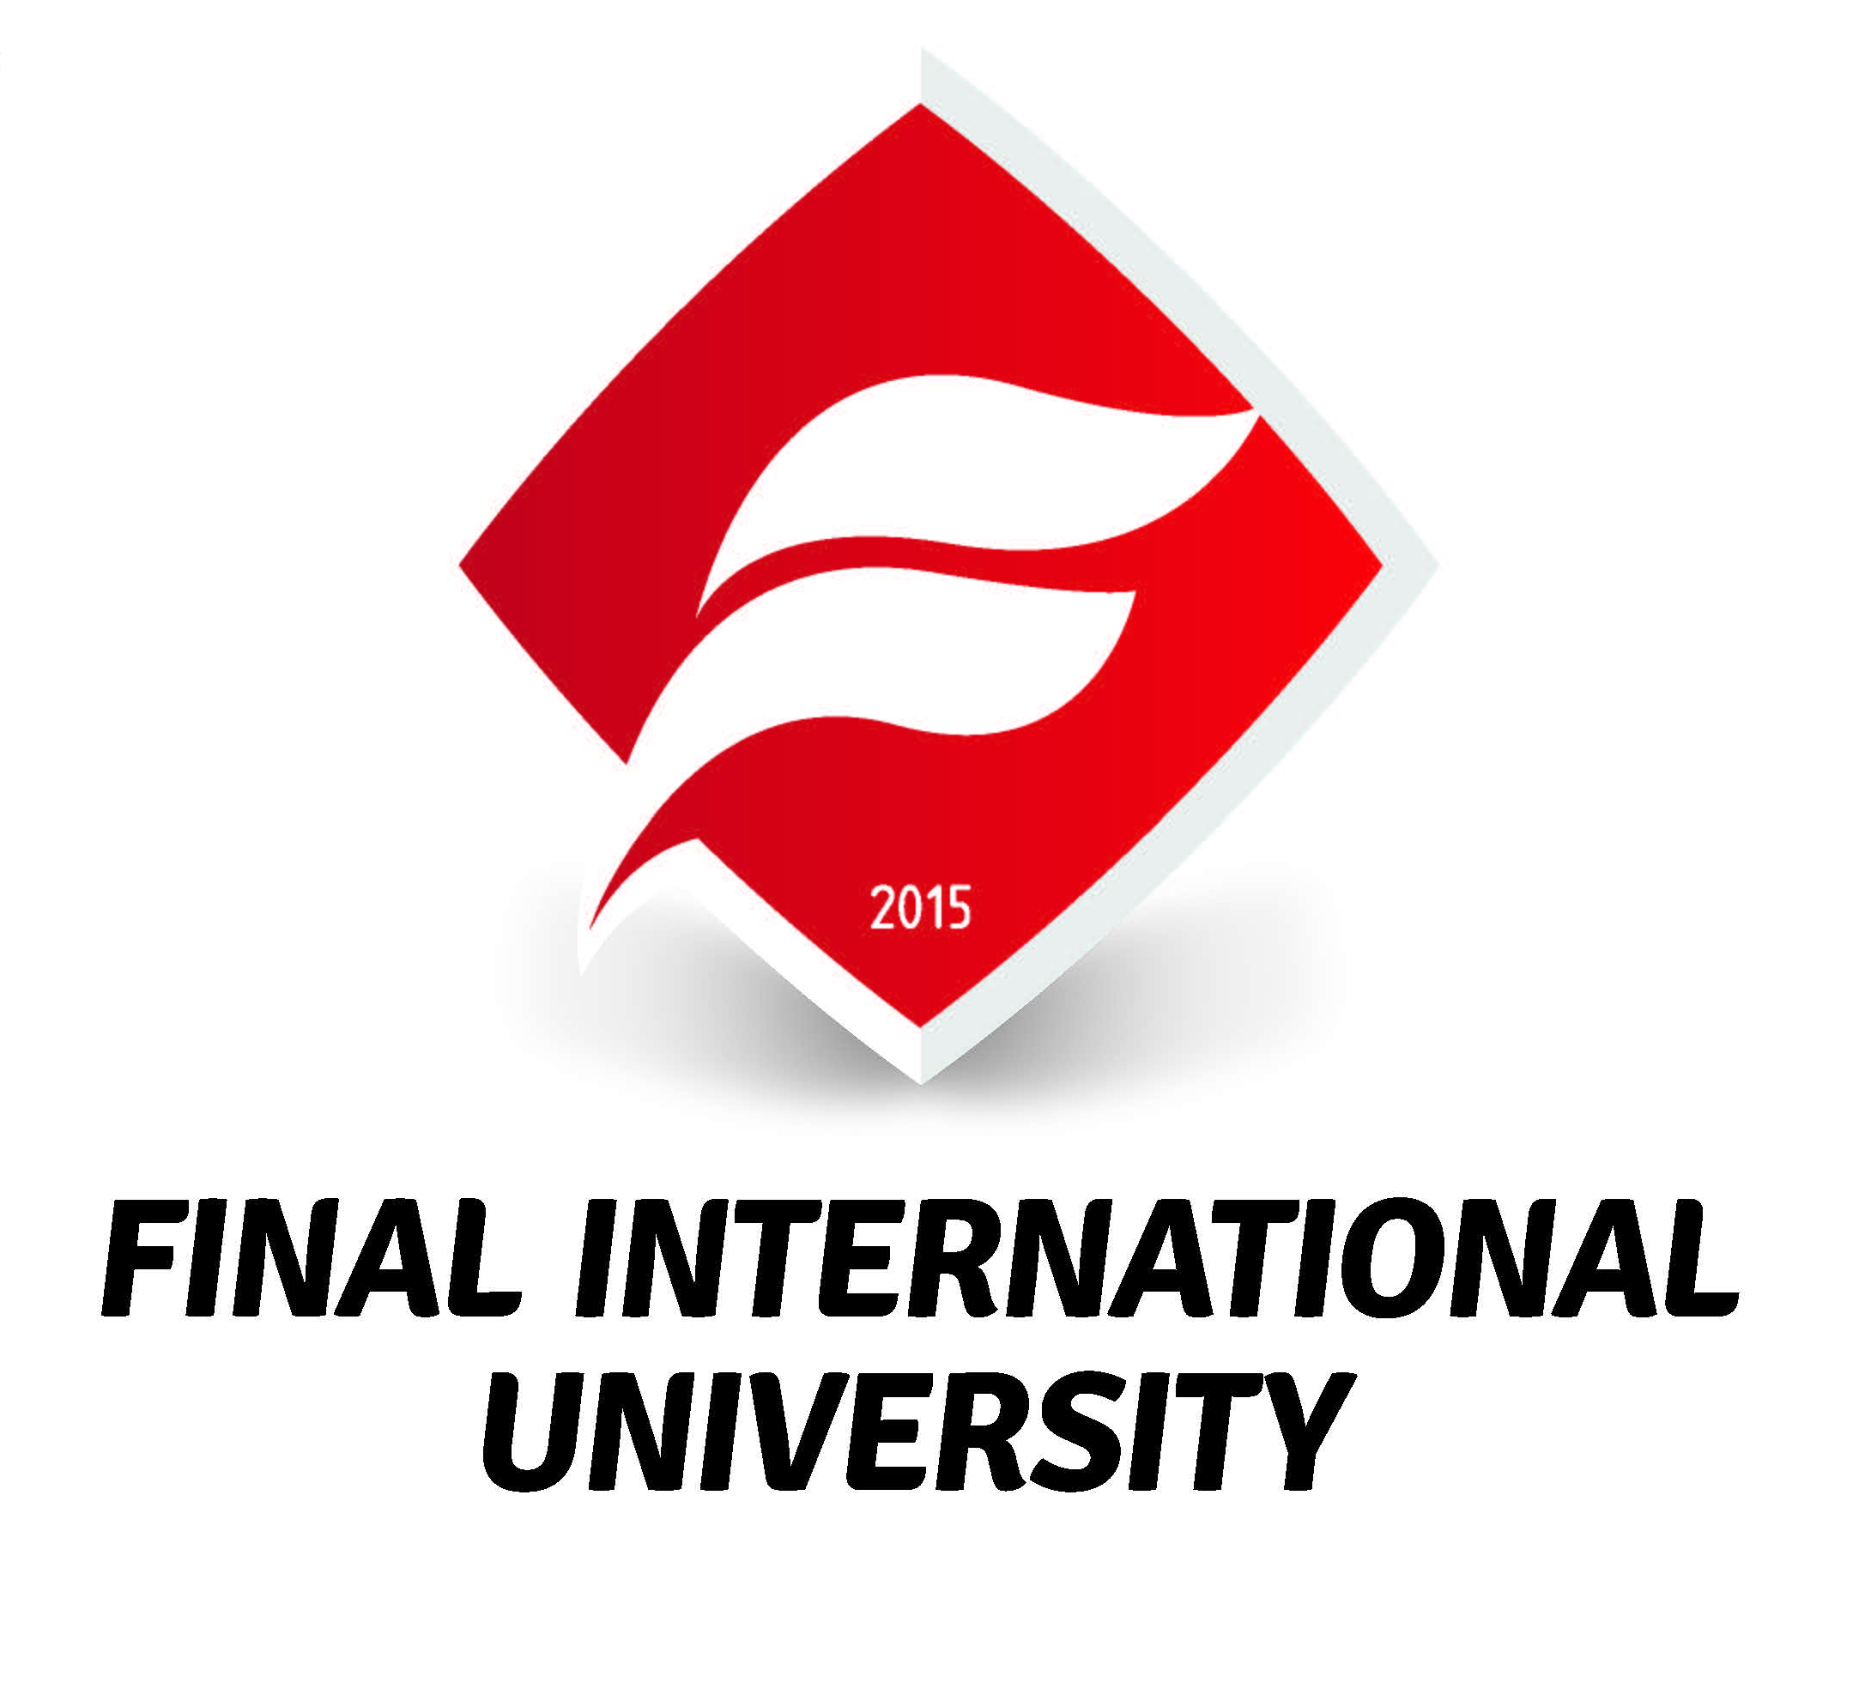

INTERNSHIP LOGBOOK

FACULTY / SCHOOL: FACULTY OF ENGINEERING

STUDENT’S NAME: EREN ÖZCAN ALTIN

STUDENT’S NUMBER: 2003060007

PROGRAM: COMPUTER ENGINEERING SOFTWARE ENGINEERING

ACADEMIC ADVISOR: HASAN ÖZDAL

EMPLOYER SUPERVISOR: IMANE BOUMEDRA

COMPANY: FINAL INTERNATIONAL UNIVERSITY

DATES OF INTERNSHIP: 09/07/2025 – 15/08/2025

Note: At the end of the internship, the logbook should be delivered to the University by the student in a sealed envelope, and a soft copy e-mailed to the academic advisor.

Introduction

The Final International University Internship aims to help you develop the knowledge and skills required for success in the twenty-first century working environment. Through your internship program, and within this logbook, we would like you to reflect on your work experience and in line with our University Learning Outcomes, your progress in improving your:

- Communication skills
- Analytic, critical thinking and problem-solving skills
- Planning, implementing and evaluating skills
- Initiative and autonomy
- Team-work and collaboration skills
- Responsibility and commitment to quality
- Understanding of professional ethics and civic and social responsibilities
- Technological skills.

We hope you enjoy and benefit from your internship experience.

Suggestions for Use

The purpose of the logbook is to record and reflect upon your work experience and the tasks and duties assigned to you by your employer / supervisor.

A well-kept, professionally presented logbook can help you in more ways than one, and may even be a resource you can use during your search for a full-time job. It is a good idea therefore to take notes during your daily training and then write these notes up fully and carefully in the logbook.

You are very welcome to add diagrams, graphs, photographs, drawings, plans and specifications and other supporting material to your logbook.

Report Format

Cover Page Contents:

1. University Name
2. Faculty / School Name
3. Program Name
4. Student Name
5. Student ID Number
6. Academic Supervisor Name
7. Employer Supervisor Name
6. Company Name
7. Dates of Training

Formatting of Text:

1.Table of contents must follow the cover page
2. Pages must be numbered (Bottom – Right).
3. All Margins (Left, Right, Top, Bottom) must be 1 inch.
4. All Headings should be written in ‘Times New Roman’, 12 pts., Bold. Text should be written in ‘Times New Roman’, 12 pts., Regular. Text should be justified.
5. All line spacing must be 1.5 points.

Regulations

The Logbook and Report should be submitted to your advisor by the end of November.

A presentation should be given regarding the experience gained and the work done during the internship by the end of December.

If the required documents are not submitted by the deadline, they cannot be resubmitted until the following academic year.

In the case of a failing grade, the internship will be repeated in full the following summer.

The logbook must be submitted in a sealed and clearly labelled envelope.

The logbooks and internship reports will receive a final grade of either “S” (satisfactory) or “U” (unsatisfactory) Final grades will be entered by the Advisor at the end of the semester.

Report Contents

Part A - Information about the company

- Name and address
- Location
- Size
- The main product(s)/services offered by the organization
- Nature of goals (what is the organization trying to accomplish)
- Major activities (which tasks are performed)
- Organizational Chart (if available)

Part B – Written Reflection

Write a report to describe and analyse what you have learned during your internship experience. Include the following:

- Describe the department(s) in which you were directly involved in. What were your specific jobs, duties and responsibilities within the organization?

- The extent to which you progressed and developed your knowledge and skills with regard to FIU’s Learning Outcomes, and specifically:

- Communication skills
- Analytic, critical thinking and problem solving skills
- Planning, implementing and evaluating skills
- Initiative and autonomy
- Team-work and collaboration skills
- Responsibility and commitment to quality
- Understanding of professional ethics and civic and social responsibilities
- Technological skills.

- In what areas would you now say you are knowledgeable, confident and skilled, and in what areas do you need to progress further?

- Do you feel that this internship has offered you a positive learning experience?

- Additional comments including any further information requested by your Faculty or School

Note: Further information about the length and contents of the report will be provided by your Faculty / School

Part C – The Log

Notes:

- Do not forget to ensure that your Employer-Supervisor signs your log at the end of each working week.
- Use the weekly summary box to make further comments about that week and any issues of particular significance or interest that occurred.

DAILY WORK DESCRIPTION

DAYS  GÜNLER |  | DATE  TARİH |  | DEPARTMENT  BÖLÜM | BRIEF EXPLANATION OF WORK AND COMMENTS  YAPILAN İŞİN KISA AÇIKLAMASI
1 |  | 09.07. 2025 |  | Software Engineering | Reviewed the FIU Student Guidance Request System (SGRS) documentation. Defined the project scope, purpose, and user roles (Student, Admin, Superadmin). Selected the technology stack: React for frontend, Node.js for backend, and MySQL for the database.
2 |  | 10.07. 2025 |  | Software Engineering | Designed the layered architecture (Frontend, Backend, Database). Created an Entity-Relationship (ER) diagram for the database
3 |  | 11.07. 2025 |  | Software Engineering | Installed and configured the MySQL database. Created tables with relationships and applied constraints (max 300 characters for content, max 2MB file size, allowed file types).
4 |  | 14.07. 2025 |  | Software Engineering | Developed basic backend API endpoints using Node.js for request submission, file upload, status update, and request listing. Tested the endpoints using Postman.
5 |  | 15.07. 2025 |  | Software Engineering | Implemented admin-specific APIs for filtering, searching, sorting, and changing request statuses. Added functionality to attach documents to responses.
6 |  | 16.07 2025 |  | Software Engineering | Integrated file upload with type and size validation. Added checks for mandatory file uploads for specific request types.
7 |  | 17.07. 2025 |  | Software Engineering | Developed the notification system to send in-app alerts when a request is submitted, its status changes, or documents are uploaded.
Weekly Summary: |  |  |  |  | During the first week, the project requirements were analyzed, and the system architecture was designed. The database structure and ER diagram were completed, and the backend API core functionalities were implemented. File upload validation and the notification system were also developed.
Signed and dated by Employer-Supervisor as a true and accurate record:

8 |  | 18.07. 2025 |  | Software Engineering | Created the student request form using React with category selection, content input, and file upload fields. Added form validation.
9 |  | 21.07. 2025 |  | Software Engineering | Built the student dashboard to display previous requests, their statuses, and attached admin responses.
10 |  | 22.07. 2025 |  | Software Engineering | Developed the admin panel interface for filtering requests, updating statuses, and adding response attachments.
11 |  | 23.07. 2025 |  | Software Engineering | Integrated 5-language support (Turkish, English, Arabic, Russian, French) with flag icons for selection. Applied translations across the entire application.
12 |  | 25.07. 2025 |  | Software Engineeringv | Implemented login functionality and role-based access control (RBAC) for admins.
13 |  | 26.07. 2025 |  | Software Engineering | Used Bootstrap/Tailwind CSS to make all pages responsive for both desktop and mobile devices.
14 |  | 27.07. 2025 |  | Software Engineering | Enforced HTTPS for secure data transfer. Added file scanning and improved user session management.
Weekly Summary: |  |  |  |  | The frontend request form and student dashboard were developed. The admin panel interface was created, and multi-language support was integrated with flag icons. The system started to take shape with both backend and frontend components working together.
Signed and dated by Employer-Supervisor as a true and accurate record:

15 |  | 28.07. 2025 |  | Software Engineering | Tested all backend API endpoints with Postman. Fixed detected issues and improved API responses.
16 |  | 29.07. 2025 |  | Software Engineering | Tested the frontend on multiple browsers. Fixed minor UI issues.
17 |  | 30. 07. 2025 |  | Software Engineering | Optimized SQL queries and reduced API calls to improve loading speed.
18 |  | 31.07. 2025 |  | Software Engineering | Implemented SLA timers to escalate unresolved requests to higher-level staff.
19 |  | 04.08. 2025 |  | Software Engineering | Added reporting features for admins to view request counts, category distribution, and average resolution times.
20 |  | 05.07. 2025 |  | Software Engineering | Implemented an audit log to track all system actions for accountability.
21 |  | 06.08. 2025 |  | Software Engineering | Reviewed and fixed remaining bugs across the application.
Weekly Summary: |  |  |  |  | Authentication and role-based access control were added. Mobile responsiveness was implemented, and security measures were strengthened. Backend and frontend testing were performed, followed by user acceptance testing and performance optimization.
Signed and dated by Employer-Supervisor as a true and accurate record:

22 |  | 07.08. 2025 |  | Software Engineering | Worked on errors in admin pages and fixed.
23 |  | 08.08. 2025 |  | Software Engineering | Worked on the statistics page for superadmin and department admins
24 |  | 11.08. 2025 |  | Software Engineering | Statistics page for superadmin and department admins completed
25 |  | 12.08. 2025 |  | Software Engineering | Work has been done on a page where Superadmin can block requests from being created on academic calendar holidays.
26 |  | 13.08. 2025 |  | Software Engineering | A page has been completed for superadmin to prevent requests from being created on academic calendar holidays.
27 |  | 14.08. 2025 |  | Software Engineering | Project presentation day
28 |  | 15.08. 2025 |  | Software Engineering | Documentation and report delivery date
Weekly Summary: |  |  |  |  | Most of the project was completed and the presentation was made. The features to be added were determined.
Signed and dated by Employer-Supervisor as a true and accurate record:

29 |  | 18.08. 2025 |  | Software Engineering | Pagination feature added
30 |  | 19.08. 2025 |  | Software Engineering | Improvements were made to project colors
31 |  | 20.08. 2025 |  | Software Engineering | Fixed translation error for the entire project
32 |  | 21.08. 2025 |  | Software Engineering | Project presentation day
33 |  | 22.08. 2025 |  | Software Engineering | Admin notification system errors fixed
34
35
Weekly Summary: |  |  |  |  | The deficiencies on the site have been resolved and all features are now operational.
Signed and dated by Employer-Supervisor as a true and accurate record:

36
37
38
39
40
Weekly Summary:
Signed and dated by Employer-Supervisor as a true and accurate record:

Part D – Self Evaluation Form

Please complete the self-evaluation form below, considering your internship experience, and using the scale below:

1: I did not learn or develop in this area.
2: I learned / developed to a small extent in this area, but not as much as I hoped.
3: I learned / developed satisfactorily in this area.
4: I learned / developed a lot in this area.

N/A: Not possible to assess due to lack of information / applicability.

You may be asked in your jury interview to discuss your answers and give reasons and examples.

SELF-EVALUATION OF STUDENT INTERNSHIP

During the internship, I learned / developed: | 4 | 3 | 2 | 1 | N/A
- Professional responsibility (e.g. attendance, dress, awareness of and adherence to workplace regulations). | X
- Professional ethics and social and civic responsibilities (awareness of ethical and social areas of relevance to the field and to the workplace, and to behavior and conduct in professional life more generally). | X
- Professional autonomy (able to work independently, take initiative, self-organize and generally work well with minimum support and supervision). |  | X
- Time Management Skills (timely task completion, distribution and prioritizing of time, punctuality, etc.) |  | X
- Teamwork Skills (working harmoniously with others, interacting positively and constructively with colleagues etc.) |  | X
- Communication Skills (able to convey ideas and suggestions, understand instructions, respond to questions and instructions in a professional manner). |  | X
- Analytic, critical thinking and problem-solving skills (able to evaluate and respond to day-to-day work related issues and problems with original insights based on evidence and date, and make relevant proposals) | X
- Technical Knowledge and Skills (as relevant to the field in general and the workplace in specific and showing the ability to transfer classroom learning into work environment). |  | X
- Continuous learning and development (desire and interest to learn more about the field, the organization, and develop higher levels of knowledge and skills). | X
- Overall Assessment |  | X

