**Analysis of Global Data on Sustainable Energy**

**Introduction**

This project involves the analysis of a comprehensive dataset on global sustainable energy. The dataset includes various metrics related to renewable energy, access to electricity, and environmental impacts across different countries and regions. The goal of this project is to explore the data, uncover trends, and generate insights that could inform policy decisions and sustainable energy practices globally.

**Dataset Overview**

* **Source**:

The dataset used in this project is [Global Data on Sustainable Energy]

(<https://www.kaggle.com/datasets/anshtanwar/global-data-on-sustainable-energy>)

from Kaggle.

This comprehensive dataset showcases sustainable energy indicators and other useful factors across all countries from 2000 to 2020, vital aspects such as electricity access, renewable energy, carbon emissions, energy intensity, financial flows, and economic growth.

* **Data Dictionary**

|  |  |  |  |  |
| --- | --- | --- | --- | --- |
| **SL NO** | **Field** | **Variable** | **FIELD DESCRIPTION** | **VARIABLE TYPE** |
| 1 | Country | country_name | The name of the country or region for which the data is reported. | object |
| 2 | Year | year | The year for which the data is reported, ranging from 2000 to 2020. | int64 |
| 3 | Access to electricity (% of population) | access_to_electricity_by_population | The percentage of population with access to electricity. | float64 |
| 4 | Access to clean fuels for cooking | access_to_clean_fuels | The percentage of the population with primary reliance on clean fuels. | float64 |
| 5 | Renewable-electricity-generating-capacity-per-capita | renewable_electricity_generating_capacity_per_capita | Installed Renewable energy capacity per person. | float64 |
| 6 | Financial flows to developing countries | financial_flows_to_developing_countries_usd | Aid and assistance from developed countries for clean energy projects. | float64 |
| 7 | Renewable energy share in total final energy consumption | renewable_energy_share_% | Percentage of renewable energy in final energy consumption. | float64 |
| 8 | Electricity from fossil fuels | electricity_from_fossil_fuels | Electricity generated from fossil fuels (coal, oil, gas) in terawatt-hours. | float64 |
| 9 | Electricity from nuclear | electricity_from_nuclear | Electricity generated from nuclear power in terawatt-hours. | float64 |
| 10 | Electricity from renewables | electricity_from_renewables | Electricity generated from renewable sources (hydro, solar, wind, etc.) in terawatt-hours. | float64 |
| 11 | Low-carbon electricity | electricity_from_low_carbon | Percentage of electricity from low-carbon sources (nuclear and renewables). | float64 |
| 12 | Primary energy consumption per capita | primary_energy_consumption_per_capita | Energy consumption per person in kilowatt-hours. | float64 |
| 13 | Energy intensity level of primary energy | energy_intensity_level | Energy use per unit of GDP at purchasing power parity. | float64 |
| 14 | Value_co2_emissions (metric tons per capita) | value_co2_emissions | Carbon dioxide emissions per person in metric tons. | float64 |
| 15 | Renewables | renewables_% | Equivalent primary energy that is derived from renewable sources. | float64 |
| 16 | GDP growth | gdp_growth | Annual GDP growth rate based on constant local currency. | float64 |
| 17 | GDP per capita | gdp_per_capita | Gross domestic product per person. | float64 |
| 18 | Density | population_density | Population density in persons per square kilometer. | object |
| 19 | Land Area | land_area_km^2 | Total land area in square kilometers. | float64 |
| 20 | Latitude | latitude | Latitude of the country's centroid in decimal degrees. | float64 |
| 21 | Longitude | longitude | Longitude of the country's centroid in decimal degrees. | float64 |

* **Problem Statement**

We will use the available data to perform the following

* + 1. Exploratory Data Analysis: Identify the trends or patterns behind our current climate conditions.
    2. Carbon Emission analysis: study CO2 emissions, support climate strategies.
* **Data Preprocessing**

Data Normalization / Cleaning :

* + 1. *#drop all duplicate countries and append them to a list*
    2. df_countries_list = df1['Entity'].drop_duplicates().to_list()
    3. ['Afghanistan', 'Albania', 'Algeria', 'Angola', 'Antigua and Barbuda', 'Argentina', 'Armenia', …..]
    4. Merging columns from another source
* *#reading the 2nd file for country_code and region*
* country_code_df = pd.read_csv('country_codes.csv'
  + 1. Dropped unnecessary columns and retained required columns.
    2. Checked for different country names in new dataset and renamed them accordingly to match the main dataset.
    3. *#renaming countries to match the origin dataset*
* country_code_df = country_code_df.replace('United States of America', 'United States')
* country_code_df = country_code_df.replace('United Kingdom of Great Britain and Northern Ireland', 'United Kingdom')
* country_code_df = country_code_df.replace('Türkiye', 'Turkey')
* country_code_df = country_code_df.replace('Netherlands, Kingdom of the', 'Netherlands')
  + 1. Ran a check to match countries in both datasets and dropping the missing ones.
    2. Created new columns for country_code and region in df1
    3. Looped through df1 and country_code_df. If the country was a match, updated rows with country_code and region into df1.
    4. *Loop through `df` and update `country_code` and `region`*

for index, row in df1.iterrows():

match = valid_countries[valid_countries['name'] == row['Entity']]

if not match.empty:

df1.at[index, 'country_code'] = match['alpha-3'].values[0]

df1.at[index, 'region'] = match['region'].values[0]

* **Identifying the missing values**

pip install plotly

import plotly.express as px

nan_count = df.isna().sum().reset_index()

nan_count.columns = ['Column', 'Missing Values']

fig = px.bar(nan_count,

x='Column', y='Missing Values', labels={'x': 'Columns', 'y': 'Missing Values Count'}, title='Missing Values in Each Column', height=600)

fig. show()

* **Imputing the missing values**

Considerations

* While imputing missing data for certain fields, we will need to use “MEAN” ( Average ) values. However, the MEAN value we calculate should be of that specific entity ( country ) over the years, rather than taking the MEAN value for the entire column.
* The values of each column was grouped by ‘Entity’ (country).
* Using a loop, mean for the column BY country was imputed and missing values were filled.
* However, for two columns namely 'Financial flows to developing countries (US $)' and 'Renewables (% equivalent primary energy)'], the missing values were not replaced by mean. Upon eye-balling, it was noticed that these records belonged to developed countries that were not receiving financial aid, hence we replaced the null values by ‘zero’ rather then mean to prevent our data from being skewed.

*# Specify the columns you want to leave with NaN values*

columns_to_leave = ['Financial flows to developing countries (US $)', 'Renewables (% equivalent primary energy)']

*# Group the DataFrame by 'country'*

grouped = df1.groupby('Entity')

*# Iterate over each column*

for column in df1.columns:

*# Exclude the specified columns*

if column not in columns_to_leave:

*# Check if there are NaNs and if the column is numeric*

if df1[column].isna().any() and df1[column].dtype in [np.float64, np.int64]:

*# Fill NaNs with the mean calculated within each group*

df1[column] = grouped[column].transform(lambda x: x.fillna(x.mean()))

print(df1[column])

grouped = df1.groupby('Entity')

*# Iterate over each column*

for column in df1.columns:

if df1[column].isna().any():

df1[column] = grouped[column].transform(lambda x: x.fillna(0))

Run a final check for missing values

*#final check for missing values*

df1.isna().sum()

* **Entity Relation Diagram**

# **Renaming columns according to ER Diagram**

*#renaming column names*

df1 = df1.rename(columns={'Entity':'country_name', 'Year':'year',

'Access to electricity (% of population)':'access_to_electricity_by_population',

'Access to clean fuels for cooking':'access_to_clean_fuels',

'Renewable-electricity-generating-capacity-per-capita':'renewable_electricity_generating_capacity_per_capita',

'Financial flows to developing countries (US $)':'financial_flows_to_developing_countries_usd',

'Renewable energy share in the total final energy consumption (%)':'renewable_energy_share_%',

'Electricity from fossil fuels (TWh)':'electricity_from_fossil_fuels',

'Electricity from nuclear (TWh)':'electricity_from_nuclear',

'Electricity from renewables (TWh)':'electricity_from_renewables',

'Low-carbon electricity (% electricity)':'electricity_from_low_carbon',

'Primary energy consumption per capita (kWh/person)':'primary_energy_consumption_per_capita',

'Energy intensity level of primary energy (MJ/$2017 PPP GDP)':'energy_intensity_level',

'Value_co2_emissions_kt_by_country':'value_co2_emissions',

'Renewables (% equivalent primary energy)':'renewables_%',

'Density_P/Km2':'population_density',

'Land Area_Km2':'land_area_km^2',

'Latitude':'latitude', 'Longitude':'longitude'})

# **Creating tables using DuckDB**

* Total of 5 tables to be created:
  + Year
  + Countries
  + Environmental
  + Economic
  + Energy
* Subset the dataset for required columns for each table.
* Create an id for each table

Creating indexes for each respective table

#adding in indexes for each table which is to be created.

df1['environmental_id'] = df1.index

df1['energy_id'] = df1.index

df1['economic_id'] = df1.index

df1['country_id'] = df1.index

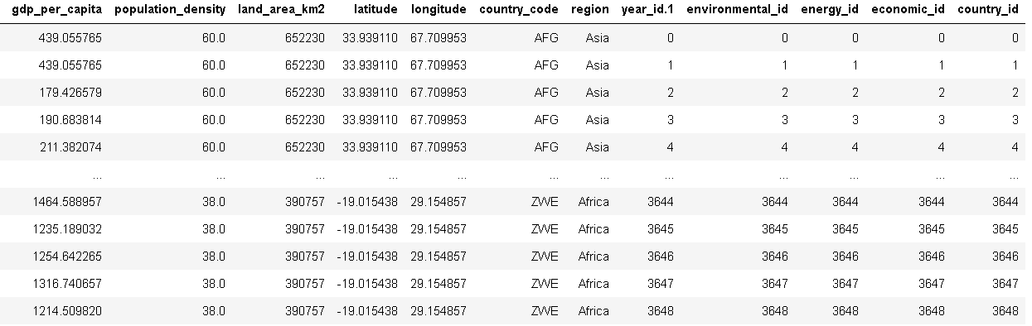

# **Utilizing DuckDB to create a database**

* Install duckdb to be used as a DBMS
* Create tables based off ER Diagram
* Run SQL queries

Creating tables for years, environmental_metrics

#creating tables for years and environmental_metrics with primary key and foreign key allocation

con.sql("CREATE TABLE years (year_id INTEGER PRIMARY KEY, year INTEGER)");

con.sql("CREATE TABLE environmental_metrics (environmental_id INTEGER PRIMARY KEY, year_id INTEGER REFERENCES years(year_id))");

#inserting of data from dataframe

con.sql("INSERT INTO years (SELECT year_id, year FROM df1)")

#adding in the columns for environmental_tables

con.sql("ALTER TABLE environmental_metrics ADD COLUMN value_co2_emissions FLOAT")

con.sql("ALTER TABLE environmental_metrics ADD COLUMN renewables_percent FLOAT")

con.sql("ALTER TABLE environmental_metrics ADD COLUMN primary_energy_consumption_per_capita FLOAT")

con.sql("ALTER TABLE environmental_metrics ADD COLUMN renewable_energy_share_percent FLOAT")

con.sql("ALTER TABLE environmental_metrics ADD COLUMN country_id INTEGER")

con.sql("INSERT INTO environmental_metrics (SELECT environmental_id, year_id, value_co2_emissions, renewables_percent, primary_energy_consumption_per_capita, renewable_energy_share_percent, country_id FROM df1)")

Creating countries table

con.sql("CREATE TABLE countries (country_id INTEGER PRIMARY KEY, country_name TEXT , country_code TEXT, region TEXT, latitude FLOAT, longitude FLOAT, land_area_km2 FLOAT, population_density FLOAT)")

con.sql("INSERT INTO countries (SELECT country_id, country_name, country_code, region, latitude, longitude, land_area_km2, population_density FROM df1)")

con.sql("CREATE TABLE energy_metrics (energy_id INTEGER PRIMARY KEY, year_id INTEGER REFERENCES years(year_id), country_id INTEGER REFERENCES countries(country_id))");

con.sql("ALTER TABLE energy_metrics ADD COLUMN access_to_electricity_by_population FLOAT");

con.sql("ALTER TABLE energy_metrics ADD COLUMN access_to_clean_fuels FLOAT");

con.sql("ALTER TABLE energy_metrics ADD COLUMN electricity_from_fossil_fuels FLOAT");

con.sql("ALTER TABLE energy_metrics ADD COLUMN electricity_from_nuclear FLOAT");

con.sql("ALTER TABLE energy_metrics ADD COLUMN electricity_from_renewables FLOAT");

con.sql("ALTER TABLE energy_metrics ADD COLUMN electricity_from_low_carbon FLOAT");

con.sql("ALTER TABLE energy_metrics ADD COLUMN renewable_electricity_generating_capacity_per_capita FLOAT");

con.sql("INSERT INTO energy_metrics (SELECT energy_id, year_id, country_id, access_to_electricity_by_population, access_to_clean_fuels, electricity_from_fossil_fuels, electricity_from_nuclear, electricity_from_renewables, electricity_from_low_carbon, renewable_electricity_generating_capacity_per_capita FROM df1)");

con.sql("CREATE TABLE economic_metrics (economic_id INTEGER PRIMARY KEY, year_id INTEGER REFERENCES years(year_id), country_id INTEGER REFERENCES countries(country_id))");

con.sql("ALTER TABLE economic_metrics ADD COLUMN financial_flows_to_developing_countries_usd FLOAT");

con.sql("ALTER TABLE economic_metrics ADD COLUMN gdp_growth FLOAT");

con.sql("ALTER TABLE economic_metrics ADD COLUMN gdp_per_capita FLOAT");

con.sql("ALTER TABLE economic_metrics ADD COLUMN energy_intensity_level FLOAT");

con.sql("INSERT INTO economic_metrics (SELECT economic_id, year_id, country_id, financial_flows_to_developing_countries_usd, gdp_growth, gdp_per_capita, energy_intensity_level FROM df1)");

SHOW country_table

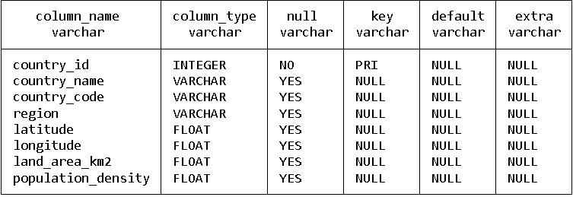

SELECT ALL ROWS FROM COUNTRIES

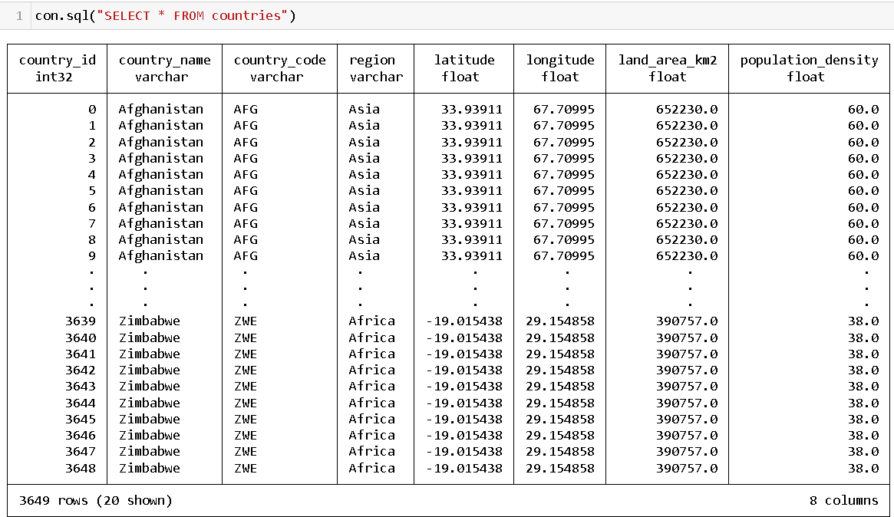

INNER JOINS between countries, years and environmental_metrics

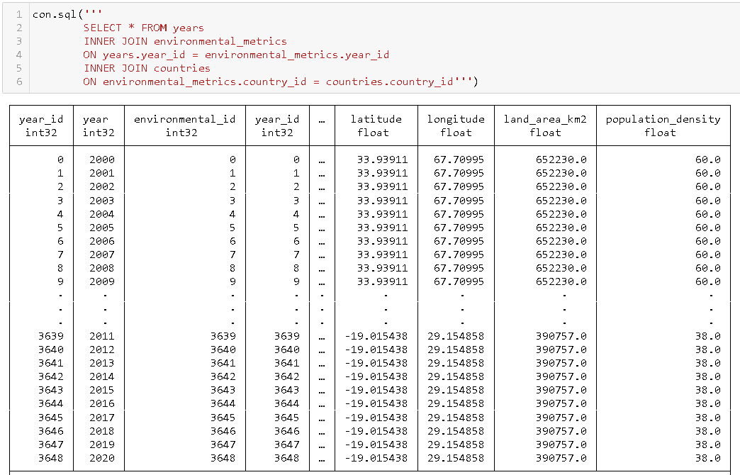

Creating energy_metrics table

con.sql("CREATE TABLE energy_metrics (energy_id INTEGER PRIMARY KEY, year_id INTEGER REFERENCES years(year_id), country_id INTEGER REFERENCES countries(country_id))");

con.sql("ALTER TABLE energy_metrics ADD COLUMN access_to_electricity_by_population FLOAT");

con.sql("ALTER TABLE energy_metrics ADD COLUMN access_to_clean_fuels FLOAT");

con.sql("ALTER TABLE energy_metrics ADD COLUMN electricity_from_fossil_fuels FLOAT");

con.sql("ALTER TABLE energy_metrics ADD COLUMN electricity_from_nuclear FLOAT");

con.sql("ALTER TABLE energy_metrics ADD COLUMN electricity_from_renewables FLOAT");

con.sql("ALTER TABLE energy_metrics ADD COLUMN electricity_from_low_carbon FLOAT");

con.sql("ALTER TABLE energy_metrics ADD COLUMN renewable_electricity_generating_capacity_per_capita FLOAT");

con.sql("INSERT INTO energy_metrics (SELECT energy_id, year_id, country_id, access_to_electricity_by_population, access_to_clean_fuels, electricity_from_fossil_fuels, electricity_from_nuclear, electricity_from_renewables, electricity_from_low_carbon, renewable_electricity_generating_capacity_per_capita FROM df1)");

Creating economics_table

con.sql("CREATE TABLE economic_metrics (economic_id INTEGER PRIMARY KEY, year_id INTEGER REFERENCES years(year_id), country_id INTEGER REFERENCES countries(country_id))");

con.sql("ALTER TABLE economic_metrics ADD COLUMN financial_flows_to_developing_countries_usd FLOAT");

con.sql("ALTER TABLE economic_metrics ADD COLUMN gdp_growth FLOAT");

con.sql("ALTER TABLE economic_metrics ADD COLUMN gdp_per_capita FLOAT");

con.sql("ALTER TABLE economic_metrics ADD COLUMN energy_intensity_level FLOAT");

con.sql("INSERT INTO economic_metrics (SELECT economic_id, year_id, country_id, financial_flows_to_developing_countries_usd, gdp_growth, gdp_per_capita, energy_intensity_level FROM df1)");

# **Conclusion:**

In line with our problem statement, we discovered the trend that less developed regions (economic) and countries tend to have lower greenhouse gas emissions. Over the years, there is an increasing adoption in the use of renewables. Additionally, it is noteworthy that while country such as Iceland have one of the highest energy consumptions in the world, most of its energy production stems from geothermal and hydropower renewable resources. Thus, environmental factors will include policies, working together with other countries, R&D and capitalising on geographical resources (if available).