Cloud Port — Migration Plan by Phase
AltopTradeSupport · Azure hybrid migration · explanation, tasks, and diagrams for each phase
This document lays out the cloud migration in its two strategic phases. For each phase it gives a plain explanation of what the phase achieves, an architecture diagram, and the concrete task checklist. The two phases stack: Phase 1 delivers real cloud benefits on its own and is a valid permanent end state; Phase 2 deepens it on your own schedule.
In a nutshell
Phase 1 — Cloud infrastructure + Proxy (hybrid). Stand up all cloud infrastructure and move the cloud-native majority of the application (~798 of ~1,121 endpoints) into Azure. Routes that depend on PowerWorld, Dayzer, or the on-site \\mars file share stay on-site and are reached through a proxy. No file porting. All work is gated by POCs: a cloud setup, then POC 0 (hybrid + on-site AD), POC 1 (cloud-native apps), POC 1a (the proxy), POC 2 (Onyx hybrid) and POC 3 (async), reaching hybrid Onyx with DNS failover; the rest of the apps then follow Onyx as a multiplier.
Phase 2 — File shim + shrink the proxy. Give the file-bound apps a storage shim and a publish model so each app’s routes leave the proxy one app at a time — starting with Onyx, then the rest — burning the on-site surface down to its irreducible core: PowerWorld, Dayzer, and a few connectivity dependencies.

The decisions this plan is built on
- Compute: Azure Container Apps (serverless) — Django runs unchanged, scale-to-zero, no execution-cap risk.
- Cloud storage (Phase 2): Azure Blob, via a storage shim over 443 — no mount. Cloud code is filesystem-free; one shared per-dataset registry decides what gets saved where, so producer and consumer can’t disagree (no split-brain). Azure Files isn’t the target — under no-mount it’s an antipattern.
- Cross-boundary writes: a publish push, not File Sync. On-site post-processors publish finished datasets to Blob over 443 (bounded, observable latency).
- Authentication: on-site Active Directory in both phases — no Entra migration. The login service runs in the cloud and binds the on-site domain controller over the link (LDAPS 636).
- PowerWorld and Dayzer compute stay on-site in both phases.

The end state at a glance
The target is a hybrid: the bulk of the application runs in Azure behind a single front door, while a small set of specialized components remain on-site and are reached over a private hybrid link. The cloud handles everything it can on its own; it only calls back to the site for the few tasks that genuinely need on-site software or data. The on-site footprint shrinks from “the whole app fleet” to “two compute engines behind APIs.”
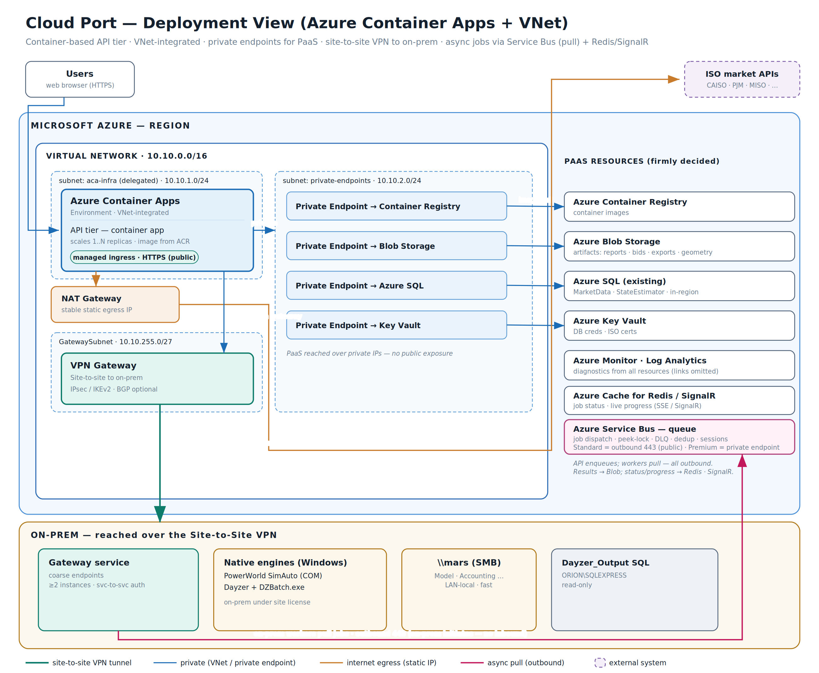
End-state deployment view — Azure Container Apps + VNet, private endpoints for PaaS, and a site-to-site link to the on-site engines. On-site workers pull async jobs outbound; nothing reaches inbound.

Phase 1 — Cloud infrastructure + Proxy (hybrid)

What Phase 1 does
Phase 1 stands up the cloud platform and moves everything that can run in the cloud without touching a file. The mechanism is a single gateway rule: default → cloud, with an explicit on-prem allowlist. Every request goes to the cloud instance unless its route is on a compact allowlist of on-site-dependent patterns, which is proxied down to an on-site instance. The allowlist is feature-level where a feature is uniform and route-level where a feature is mixed.
Because the cloud-native majority (~798 of ~1,121 endpoints; Onyx alone is 131 of 174) is already backed by Azure SQL, this is a large, low-risk win that needs no file porting — the file-bound routes simply stay on-site behind the proxy for now.
All of Phase 1 is gated by proofs of concept: each step proves one risky assumption before the next is built, so the plan front-loads the unknowns — hybrid network reach, on-site authentication, the proxy mechanism — as cheap POCs rather than discovering them late. The sequence is a Cloud Setup, then POC 0 (hybrid VNet + on-site AD over LDAPS), POC 1 (the cloud-native apps, proving the cloud beats the VPN), POC 1a (the proxy as its own config-driven app), POC 2 (Onyx, the first hybrid app), and POC 3 (the async bridge for Onyx’s long runs) — reaching a checkpoint where hybrid Onyx is live and DNS can flip a whole app between cloud and on-site. The remaining apps then follow the proven POC 2 pattern as a multiplier. The diagram below shows the hybrid mechanism all of this builds toward: default → cloud, with an explicit on-prem allowlist.
- The cloud is filesystem-free. No cloud instance resolves a \\mars path — directly or through a shared helper. Anything file-bound is proxied to on-site. Local-disk IPC (e.g. log polling) moves to Redis/SQL so replicas stay stateless.
- Sign-in keeps using on-site Active Directory. The login service runs in the cloud but checks credentials against the on-site domain controller over the link (LDAPS 636); it is cloud-served, not proxied. No new directory, no Entra migration.
- It is reversible by construction. The same image runs in both places, so rolling a route back is a gateway config change — seconds, no redeploy. The on-site instance never went away.
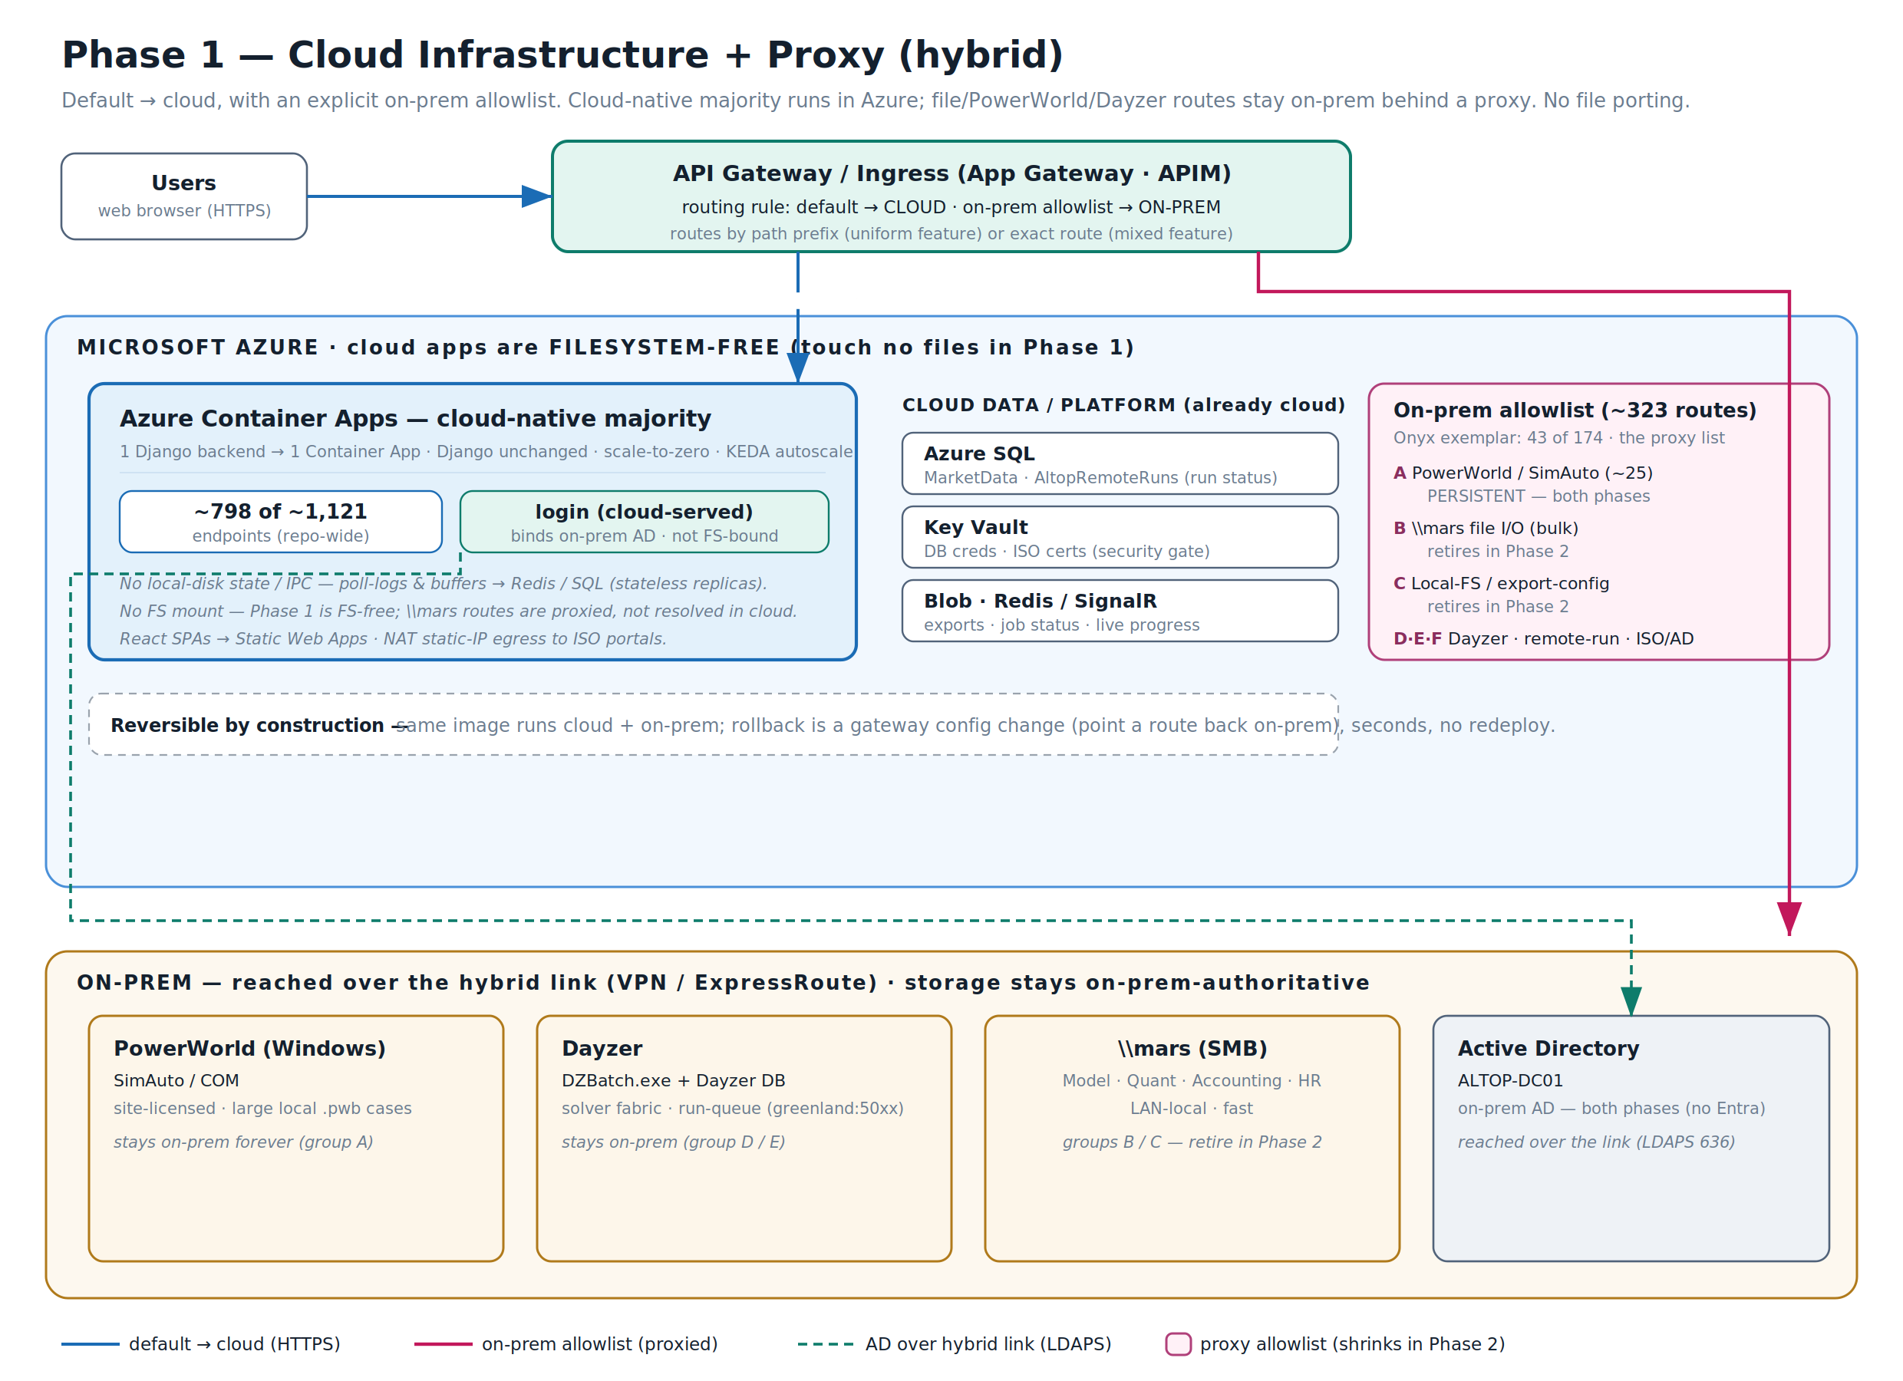
Phase 1 — default → cloud with an explicit on-prem allowlist. The cloud-native majority runs in Container Apps; PowerWorld / Dayzer / \\mars routes are proxied on-site. The allowlist (~323 routes) is also the Phase-2 burndown list.

The async run lifecycle
PowerWorld and Dayzer runs can take minutes, which is longer than a web request should be held open. Phase 1 handles them asynchronously: the on-site job writes its status to Azure SQL (Operations.AltopRemoteRuns), and the cloud front end reads it with a short-poll status endpoint rather than holding a request open. Blocking poll loops are removed so no cloud worker is ever pinned waiting. The diagram below shows the full job round-trip; on-site workers reach outbound to pick up work, so nothing from outside reaches into the network.
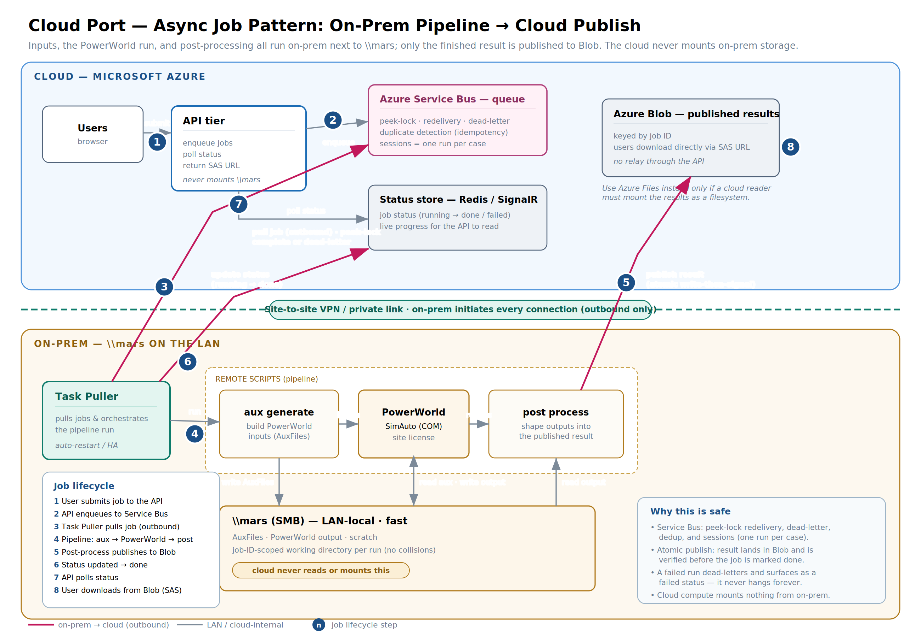
Async job lifecycle — the cloud enqueues a run; on-site workers pull it outbound, run the pipeline, publish the result, and post status. The cloud reads the result and returns it; live progress streams over Redis / SignalR.

Cloud Setup
Build the bulk cloud infrastructure in a throwaway scratch account first, captured as Terraform that ports cleanly to the real corporate account, with tagging rules defined up front. This stands up networking and private DNS — including the cloud↔on-prem switch, so that if the cloud is down a single DNS record flips an app back to on-site — plus the VNet, the Container Apps environment, Key Vault, SQL Server connectivity, and permissions. Building in a scratch account keeps mistakes cheap, and the Terraform (not hand-clicking) is the deliverable that moves to corporate.

POC 0 — Hybrid VNet + on-site AD over LDAPS
The first proof, aimed at the riskiest unknown: that a cloud workload can reach across the hybrid link and authenticate a user against the on-site domain controller over LDAPS. Nothing else in the plan works if this does not, so it is proven before any app is built.

POC 1 — QuickSignals & BalDay in the cloud
Get the two cloud-native apps (QuickSignals and BalDay) running in the cloud and prove the headline benefit — that the cloud path is faster than the VPN — for real users. This POC also introduces duality: the code must know whether it is running in the cloud or on-prem and choose its credential source (and, later, its data source) accordingly. No proxy and no file dependency yet.

POC 1a — The proxy, as its own app
Build the proxy as a standalone container app driven entirely by a config-supplied proxy list, and prove the mechanics before any real app depends on it: HTTPS termination works, and a deploy is nothing more than editing the list. The list lives somewhere with versioning and rollback (e.g. a blob), and a CI/CD pipeline ships both the proxy and list changes. Proving the proxy in isolation means POC 2 only has to add Onyx to a known-good mechanism.

POC 2 — Onyx, the first hybrid app
The first real hybrid app: add Onyx to the proxy list so its cloud-native routes serve from the cloud and its file- and engine-bound routes proxy to on-site. Onyx runs from the same codebase as on-prem — only the packaging differs — and is modified to read its secrets from Key Vault or the environment rather than hardcoded. A CI/CD pipeline builds and ships the cloud Onyx. Long-running async tasks are deliberately deferred to POC 3.

POC 3 — Async bridge for Onyx
Handle Onyx’s long-running tasks without holding a web request open. A task queue that the on-site side can read carries the work; the cloud enqueues, polls for status, and when a job completes the cloud learns it is done and reads the results. This is the trigger-and-completion pattern the ~230s gateway ceiling forces — proven on Onyx before it is relied on elsewhere.

Checkpoint — hybrid Onyx live
Hybrid Onyx is now running in the cloud, and DNS can point users at either the cloud or the on-prem app — full-app failover by a single record change. Every risky unknown is proven; what remains is repetition.

Migrate the remaining apps to the proxy
Repeat the POC 2 pattern for the rest of the backends. Because the mechanism is proven and the code differences are packaging-only, each app is a fraction of POC 2’s effort — enough that a multiplier estimate suffices rather than per-app planning: roughly number of apps × 0.2 × POC 2 hours (≈ 8h per app). The end of this is every hybrid app reachable in the cloud but still file-bound through the proxy — which Phase 2 then unwinds. Itemized tasks live in the companion task tracker (Cloud_Port_Task_Tracker.xlsx).

Phase 2 — File shim + shrink the proxy to its minimum

What Phase 2 does
Phase 2 peels the file-bound apps off the proxy, one dataset at a time, until the on-site surface is just its irreducible core. But before any of that is safe, it is worth being clear about why the file-bound apps are hard to move at all — because that is the problem the rest of the phase is built to fix.

Why the shared drive is hard to move
The usual answers — chatty SMB over the WAN, thousands of hardcoded paths, no clean way to mount it — are real, but they are symptoms. The root cause is simpler and deeper: a bare file share has no contract. A path is not an interface. When code just opens \\mars\… and reads or writes, nothing in the system declares who produces a given dataset and who consumes it — those roles are implicit, discoverable only by grepping for the path across all 38 backends.
That single absence is what makes the drive hard in two different ways:
- Hard to port — you can’t move what you can’t delineate. Migrating a dataset means knowing who writes it, who reads it, and whether the readers can tolerate a new location — and the share answers none of that. Every file is a producer/consumer relationship you must reconstruct by archaeology before you can safely touch it.
- Hard to develop — with no declared producer or consumer, any code can write any path and any other code can depend on it. The dependency graph is invisible, every change risks a silent break, and there is nowhere to add validation, versioning, or a location swap — because there is no seam. The “interface” is a string literal scattered across the codebase.
So the migration work is not really moving bytes; it is writing down the contract that never existed. That is what the storage shim is.

The storage shim — one declared home per dataset
The shim exists to answer exactly one question for every dataset: what gets saved where. It is not a porting convenience — it is how the system avoids split-brain, the state where a producer writes a dataset to one place and a consumer goes looking for it in another.
The mechanism is a shared per-dataset registry. Each dataset is identified by a logical key, not a path; the registry maps that key to a backend and a location, and it is the single source of truth, read by the producer and the consumer alike. The registry is the contract.
- The producer declares the home. It calls store.write_df(df, key) — it names a dataset, never a container or a path. The registry decides where the bytes land.
- The consumer resolves the same entry. It calls store.read_df(key) and reads from wherever that key resolves. Because both sides go through the one registry, they cannot disagree about where a dataset lives.
- Moving a home is one edit. Repointing a dataset from \\mars to Blob is a single registry change that moves the producer and every consumer together — there is never a window where one points at the old place and the other at the new. A contract-test gate refuses to deploy any state where a consumer reads cloud but its producer doesn’t write there, and a current-version pointer in Azure SQL (publish all files of a version, then advance the pointer) keeps the two agreeing on which version as well.
End state: Blob, not a file share
The cloud-authoritative store is Azure Blob. Once you commit to no mount, an Azure Files share buys nothing Blob doesn’t — it only costs more and scales worse — so settling on it would be the antipattern. The cloud-consumed datasets are object-shaped: written once, immutable, versioned, read whole or by range, listed by prefix. The few call sites that look like they need a file share don’t survive scrutiny — directory enumeration becomes store.list() over a prefix, and the one in-place rewriter (AdjMW) is fixed as its dataset migrates. The intermediates that genuinely want file semantics never leave \\mars; their registry home simply stays local://.

With that contract in place, the publish path is simple: on-site post-processors read the \\mars intermediates locally (fast) and publish only the finished result datasets through the shim to Blob over 443. The large, chatty intermediates never cross the WAN; cloud availability is bounded by the upload of a small artifact, with a cloud-then-\\mars fallback that doubles as a rollback alarm.
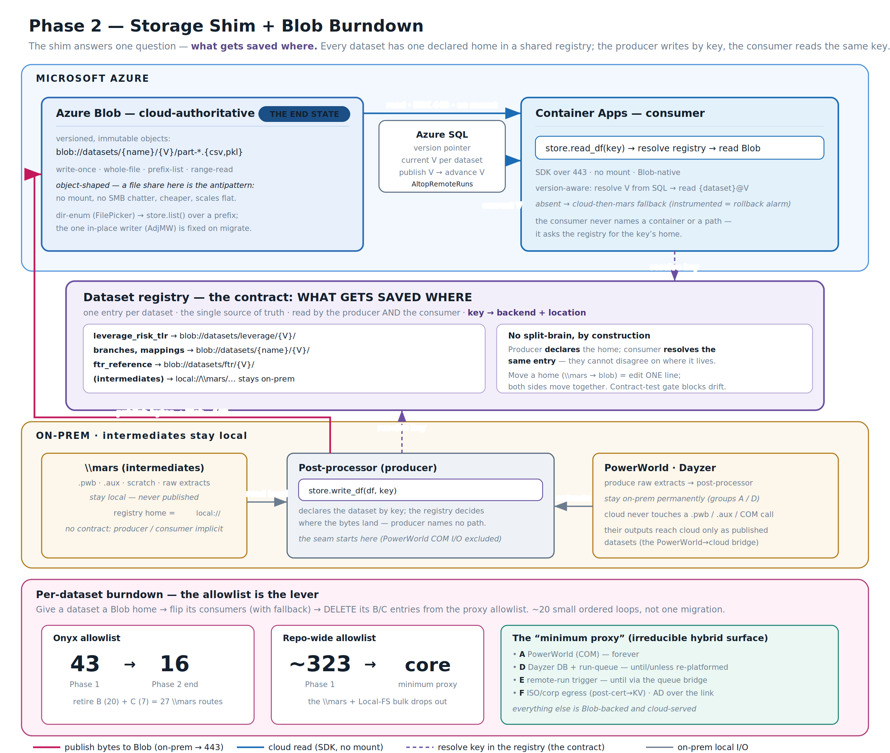
Phase 2 — the shim and its dataset registry decide what gets saved where. Producers declare a dataset’s home by key and publish to Blob over 443; consumers resolve the same key and read Blob (no mount), versioned via an Azure SQL pointer. Blob is the end state; intermediates stay on \\mars. Per dataset, routes leave the allowlist (43 → 16).
The proxy allowlist is the lever and the scoreboard: as each dataset gets a Blob home and its consumers are flipped, that dataset’s routes are deleted from the allowlist. Onyx’s list shrinks from 43 to 16; the repo-wide ~323 collapses to the persistent core.

How Phase 2 proceeds — one app at a time, starting with Onyx
Phase 1 leaves every hybrid app reachable but still pinned to on-site: its data lives on \\mars and the proxy holds its file-bound routes. Phase 2 removes that pin one app at a time. For each app, its data sources are moved from \\mars to Blob through the storage shim; once an app’s data is in the cloud, that app’s routes are deleted from the proxy list and it becomes fully cloud-served. Onyx goes first — it is the proven hybrid app from POC 2 — and establishes the burndown pattern; the rest follow as a multiplier. The proxy shrinks with each app until only the irreducible minimum remains.

The file shim (built once)
The shared machinery every app reuses: a storage shim with a stable interface (read / write / list / open) over pluggable backends, and a per-dataset registry mapping each dataset’s logical key to its home (on-site or Blob) — the single source of truth read by both the producer and the consumer, so they can never disagree about where data lives. Producers can write to the old home, the new home, or both; consumers read the new home with a fallback to the old, instrumented so that a zero-fallback reading proves the cutover is safe. Datasets are versioned with a current-version pointer in Azure SQL, published all-then-advance so a reader never sees a half-written update, and a deploy gate rejects any split-brain config.

Onyx — migrate its data sources (first; establishes the pattern)
Inventory Onyx’s data sources — the datasets it reads and writes on \\mars — then migrate each one through the loop: register its key, have the producer mirror to Blob, verify the cloud copy matches, flip Onyx’s consumers to read cloud with fallback, and once fallbacks hold at zero, drop the fallback. When the last of Onyx’s data sources is on Blob, delete Onyx’s file-bound routes from the proxy list: Onyx is now fully cloud-served, save any PowerWorld / Dayzer compute, which stays on-site by design.

The remaining apps — repeat per app and its data sources (multiplier)
Each remaining app follows Onyx’s pattern: inventory its data sources, migrate each off \\mars to Blob through the shim, then strike that app’s routes from the proxy list. As with the Phase 1 rollout, the proven loop makes each app a fraction of Onyx’s effort, so a multiplier estimate suffices — scaled by each app’s dataset count. The proxy list shrinks app by app until it holds only the minimum-proxy core described below. Itemized tasks live in the companion task tracker (Cloud_Port_Task_Tracker.xlsx).

The end state: the “minimum proxy”
After the burndown and the parallel residual tracks, the proxy allowlist contains only the irreducible hybrid surface — the file-I/O bulk is gone:
- PowerWorld (COM) routes — on-site forever (license, Windows COM, local case data).
- Dayzer DB + run-queue — until/unless Dayzer is re-platformed.
- Remote-run trigger routes — until that compute is reached from cloud via the queue bridge.
- ISO / corp egress — only where certs/egress can’t be made cloud-native (most leave after certs move to Key Vault).
- Active Directory — not in the proxy: login is cloud-served and reaches on-site AD over the link (LDAPS), permanently.
Everything else runs in Azure. Phase 1 gets you the cloud-native majority behind a reversible switch; Phase 2 takes the on-site footprint down to those few engines and connectivity dependencies — as fast or as cautiously as you choose, with a working system at every step.

