Week 10: Using FEAT for second and higher level analysis

This tutorial leads you through three examples of higher-level analysis in FEAT. Higher level analysis is required whenever you have more than one session of data. The following common situations are covered here:

- The multiple sessions are two or more sessions from the same participant on the same day. It is common practice to perform several runs of an experiment on each participant and then average across those runs using a second level fixed effects analysis.

- Another common example of higher level analysis is to run a single session on multiple participants and then look for group level “average” activation on a particular contrast of interest (e.g. visual - auditory) using a second level mixed effects analysis. This kind of second level analysis can be preceded by the within subject kind described above. In that case the group level analysis is the third level of analysis.

- Finally, for a given contrast (e.g. visual - auditory) you might want to ask where in the brain activation differs between two participant groups (e.g. elderly and young).

One sample t test
We have a group of 6 subjects, all of whom performed a single session under the same conditions. The session involved using their right hand to perform several motor tasks (tapping of index finger, sequential tapping of all 5 digits, random tapping of all 5 digits).

The first level analyses for each participant have been performed for you, including the following contrasts:

- index
- sequential
- random
- random - sequential
- sequential - index

We want the mean group effect for each of the above contrasts, taking into account the within-subject fixed effects variances and the between-subject random effect variance. FEAT will run 5 separate second level analyses, one for each of the first level contrasts. In each case, at each voxel FEAT will test the null hypothesis that the mean effect across the group is zero.

The first level analyses are held in 6 different directories in /storage/silver/pym0fm/<your IT login>/fsl_course_data/fmri/ptt, one for each subject. The subject directories are ac at cm df dn eg. Within these are the first-level FEAT directories, which have already been run for you. The FEAT directories are named ??_right.feat, where ?? is the subject initials. (There are also ??_left.feat directories, which are for use later in the workshop)

Each first-level analysis contained 5 contrasts ("index", "sequential", etc.). Thus there are 5 cope images in the stats subdirectory of each first-level .feat directory. The higher-level analysis will be carried out independently on these contrasts, i.e. a second-level analysis of all subjects' first-level "index" contrasts, a separate second-level analysis of all first-level "sequential" contrasts, etc. Each of these second-level analyses will form a separate cope??.feat directory inside a newly-created .gfeat directory.

- cd /storage/silver/pym0fm/<your IT login>/fsl_course_data/fmri/ptt
- Type Feat &
- Change First-level analysis to Higher-level analysis
- Change the Number of inputs to 6 (6 subjects * 1 conditions. It is 1 condition because all subjects did the same thing. If half the subjects had used their toes instead of their fingers you'd have two conditions at the second level. Note that the fact there were 3 different experimental conditions at the first level - index, sequential,and random – is completely irrelevant here)
- Press Select FEAT directories. Select .../ac/ac_right.feat .../at/at_right.feat .../cm/cm_right.feat (etc. up to 6)
- When this is done, in the Output directory enter rightHand. This will result in a second level results directory being created inside the working directory called rightHand.gfeat
- Notice that the FEAT interface now says “Use lower-level cope:” followed by 5 selected tick boxes. These are the 5 contrasts to be carried up from the lower level. If you were only interested in the random–sequential contrast you would deselect all the boxes except 4 here.
- Go to the Stats tab and click on Model setup wizard. Select single group average and click Process. The second level voxelwise design matrix will appear. With this simple design the matrix does not look like much. In fact you have a row for each participant. The first column contains a 1 for all participants, indicating that they are all part of the same group. The second column specifies an EV – every row has a value of 1, which produces the mean activation across the group for each lower level contrast you choose to apply this design matrix to. This will result in the second level PE1 image.
- Now click on Full model setup. You can see the same information here that you just saw in the design matrix. You could edit the design matrix that was set up by the wizard here. For example, if you changed the weighting of inputs 4,5, and 6 to -1, you would now be subtracting the activation of the second half of the sample from that of the first half of the sample. (Don't do this)
- Go to the Post-stats tab and increase the z threshold to 3.0
- Press Go, and wait for the results
- Have a look at the results, satisfying yourself that you can locate the second level group results for each of the first level contrasts
- Note: if you click on the Inputs link you can see a list of the lower level FEAT reports – check you didn't input any ??_left.feat directories by accident!
- Click on one of the Inputs and have a look at the first level analysis – pay particular attention to how the first level design matrix and contrasts were set up. Keep in mind that first level design matrices represent time on the vertical axes (each row is a different TR). In a higher level design matrix the vertical axis is different people (each row is a different person).

Paired t test
The group of 6 subjects used in the one sample t test example above were actually scanned under two different conditions, A (left hand motor function) and B (right hand motor function). Is there a significant A-B paired difference generalisable to the population from which the subjects are drawn? In other words, is brain activation different when using the left hand rather than the right hand?

We want the A-B paired mean difference within a mixed effects model, taking into account the within-subject fixed effects variances and the between-subject random effect variance. This is done as a two-level analysis:

- Level 1: Single-session analyses; there are [6 subjects] * [2 sessions] = 12 first-level FEAT analyses. These have already been done for you.
- Level 2: Between-subject analysis; we input the COPEs from Level 1 (there are 5 contrasts at Level 1 and hence 5 separate second-level analyses), and estimate the paired difference mean for each.

Note that as well as the COPEs, FEAT passes the variance of these COPEs ("varcopes"), and even the uncertainty in the variance of these COPEs ("tdofs" - degrees-of-freedom), between the different levels.

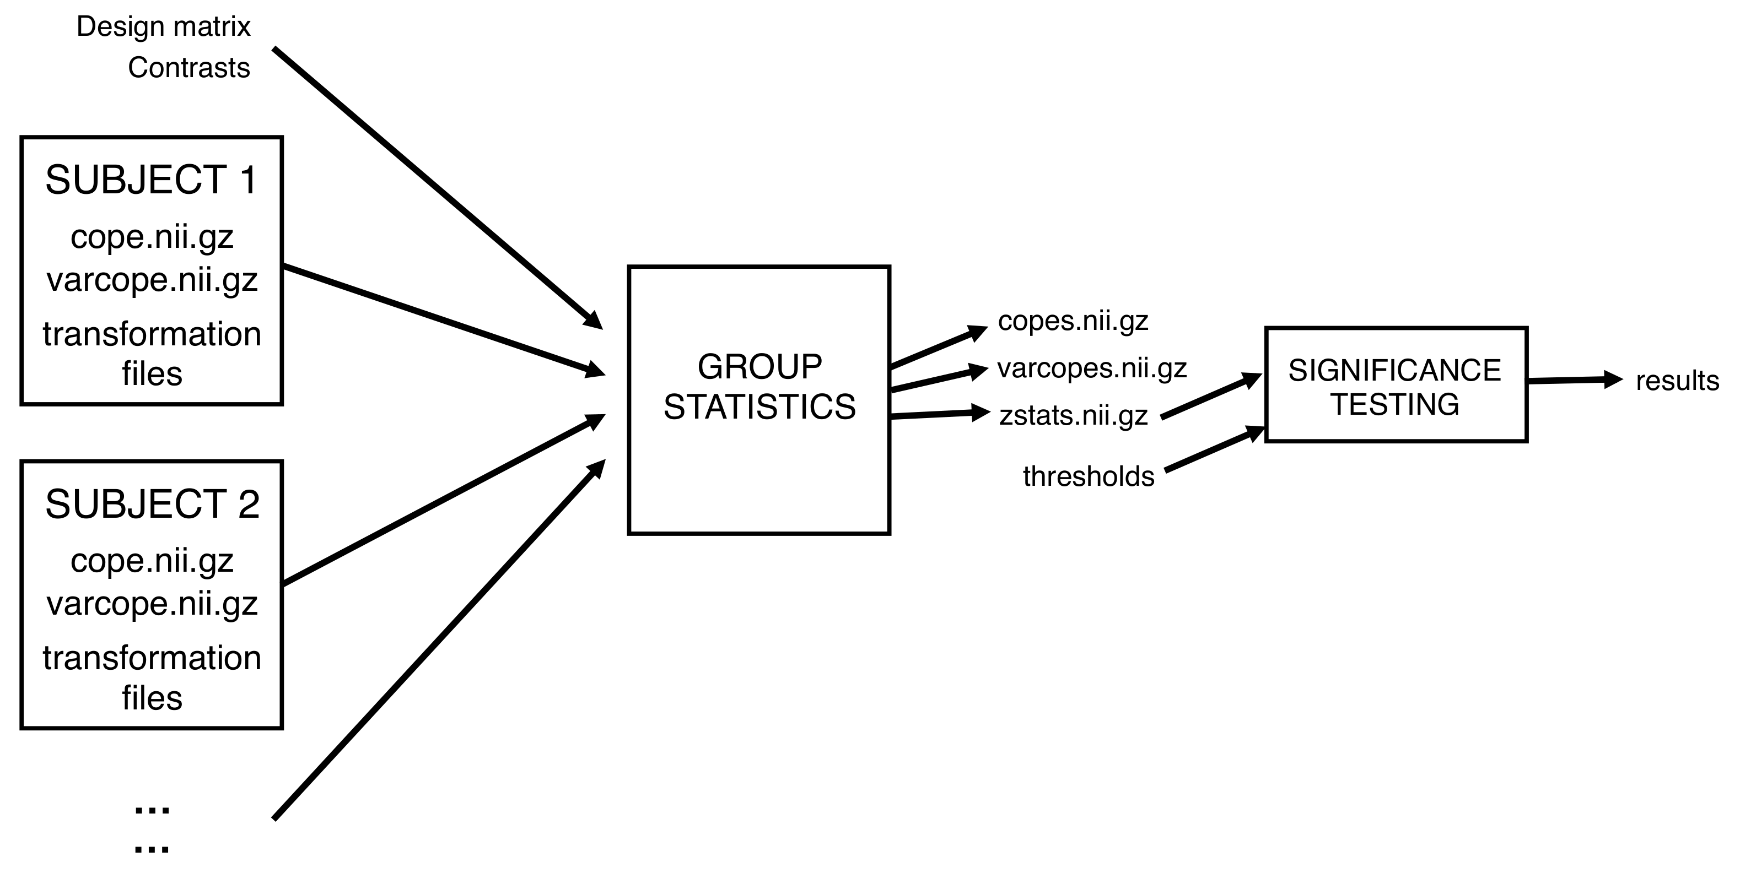

The first level analyses are held in 6 different directories in /storage/silver/pym0fm/<your IT login>/fsl_course_data/fmri/ptt, one for each subject. The subject directories are ac at cm df dn eg. Within these are the first-level FEAT directories, which have already been run for you.

Each first-level analysis contained 5 contrasts ("index", "sequential", etc.). Thus there are 5 COPEs in the stats subdirectory of each first-level .feat directory. The higher-level analysis will be carried out independently on these contrasts, i.e. a second-level analysis of all subjects' first-level "index" contrasts, a separate second-level analysis of all first-level "sequential" contrasts, etc. Each of these second-level analyses will form a separate cope??.feat directory inside a newly-created .gfeat directory.

- cd /storage/silver/pym0fm/<your IT login>/fsl_course_data/fmri/ptt
- Type Feat &
- Change First-level analysis to Higher-level analysis
- Change the Number of inputs to 12 (6 subjects * 2 conditions (LEFT HAND IN SESS 1, RIGHT HAND IN SESS 2)
- Press Select FEAT directories. Now, you need to fill the first level FEAT directories in a sensible order. DO NOT DO IT YET - a shortcut is explained below. You could either put them in order:
../ac/ac_left.feat ../ac/ac_right.feat ../at/at_left.feat (etc.)
or you could enter all the "lefts" first and then all the "rights":
../ac/ac_left.feat ../at/at_left.feat ... ../ac/ac_right.feat (etc.)
We recommend the latter, because this matches the example paired t-test in the FEAT manual, and also matches the way the paired t-test is set up for you if you use the "model setup wizard" (explained below).

Shortcut: Note that you can often avoid having to tediously hand-select each of these first-level FEAT directories separately, using the Paste button. If you press this, a new free-text window comes up, within which you can paste text (in this case the list of first-level FEAT directories) which you can copy, e.g. from a list in a terminal. Press Clear to clear the text window. Then in your terminal, inside the ptt directory, type

ls -d `pwd`/??/??_left.feat ; ls -d `pwd`/??/??_right.feat

This gives you a complete listing of the full pathnames of the FEAT directories in the right order. (The `pwd` part tells the shell to replace what's within the quotes with the result of running the command - in this case, filling out the full pathname of the current directory. The ? characters are expanded by the shell to fit any single character, in alphabetical order, hence all the "left" FEAT directories are listed first, and then all the "right".) You can now highlight this list with the mouse, and paste it into the FEAT free text window with the middle mouse button (not the wheel, the button).

Additional explanation of building path lists in the Terminal:
- To obtain the ` character ` look to the top left of the keyboard.
- `pwd` tells Linux to print the working directory path, and then you concatenate the rest of your path statement to that.
- Passing the -d option to the ls command tells the shell to list directories only.
- The semi-colon ; is interpreted by Linux as if you pressed Enter, so you can use this to string together multiple commands
- To get the list formatted correctly (one path to one line) the Terminal window needs to be narrow. If you have made it wider you will get a two column list (no good)
- Finally, you could have used the * wildcard that matches any number of unspecified characters instead of ?? in this case. * is generally more useful than ?

- Now set the Output directory to /storage/silver/pym0fm/<your IT login>/fsl_course_data/fmri/ptt/ptt_ols.gfeat (no need to type all of it, just ptt_ols)
- Go to the Stats tab and select the Mixed Effects: Simple OLS option – ordinary least squares estimation
- Also, make sure that you deselect the Use automatic outlier de-weighting button. **NOTE**: It is important that you do not miss this step out; otherwise the analysis will not be quick enough to be of use to you in the time that we have available for the practical. Normally, it is recommended that you use one of the more accurate FLAME options, possibly in combination with outlier de-weighting. However, in the interest of speed, in this practical we choose the faster OLS option without outlier de-weighting.
- With this design you can use the Model setup wizard, which provides an easy way of setting up a few simple designs. Select two groups, paired and press Process. You will now see the design matrix that has been created for you. To understand how this is controlled in detail, open the Full model setup.
- Note that the Inputs (1-12) must correspond to the order you entered the first-level FEAT directories. Also note that the first column (labelled Group) corresponds to groupings of inputs that will share the same random effects (RE) variance in this level of the model. Here, we let all subjects have the same random effects variance (i.e. the Group column should be left as all 1s). The participants are all part of the same group because this is a repeated measures design. Here we are assuming that differences between the same person at two different times are small. If you were interested in differences within a participant across time you might set this to 2 groups.
- There are 7 EVs in the design matrix:
- EV 1 models the A-B (left hand-right hand) paired difference
- EVs 2-7 are confounds, which model out each subject's mean (this is what makes the design a paired t test). Notice that EV 2 has values of 1 for both of the rows of the design matrix that refer to participant 1, with zeros elsewhere.
- Click on the Contrasts & F-tests tab. There are two contrasts setup for you by the wizard. EVs 2-7 are confounds of no interest and so do not appear in the contrasts. Hence, the contrasts only involve EV1. Change the Titles to read:
  - left > right
  - right > left
- Press Done.
- The default Post-stats are fine. So you are now ready to run the analysis. Press Go, and wait for the results - this second-level analysis should take about 5 minutes. The web browser that appears monitors the overall progress.
- Higher-level FEAT runs produce .gfeat directories. The top-level web report provides links to the previous level reports, a registration summary page (have a look at this, you may later need to reload the page if you view it before it's completed) and links to the separate higher-level reports.
- LOOK AT YOUR DATA - in particular it is always important to look at the registration summary report page very carefully, to check that all lower-level registrations succeeded. (If any of the lower-level FEATs look like the registration has failed badly, you need to fix this before re-running the higher-level FEAT. The simplest way to do this is to start the FEAT GUI, change Full analysis to Registration only, select the first-level FEAT directory with the problematic registration and change the registration settings. The first thing to try is to reduce the search to No search (assuming that the data is roughly oriented correctly) and/or to change the DOF.)
- NOTE: if you look on poststats -> results for a higher level contrast the “time series report” is now actually a report across participants. Look at the green line labeled “cope partial model fit”. You can easily relate it the 1st column of your second level design matrix. The difference between the full model fit and the partial model fit is attributable to the nuisance regressors.
- If you get spare time at the end of this session, there are two other analyses on this data that are of interest, but the stuff under the next main heading is more important, so do that first :
  - In the FEAT GUI, load in the design.fsf from the .gfeat directory. Change the modelling/estimation method to Mixed Effects: FLAME 1, which is nearly as accurate as full FLAME and nearly as fast as OLS. Change the output directory name to reflect this option. Under the Data tab, deselect all of the lower-level copes except 2 - this tells the group FEAT to only run the second-level analysis on the second of the first-level contrasts, not all 5. After completion (5-10 minutes), compare with the previous OLS results. The FLAME results do look "nicer", as well as there being some new plausible activations that were not previously found.

  - Whilst the above is running, get another analysis ready to run - revert to the OLS option, and change the model to the simpler unpaired t test (use the wizard, and make sure that you understand the EVs and contrasts that the wizard sets up for you), re-run and compare with the paired t-test results. Notice that the group column in full model setup now divides the group in 2. There are no regressors for individual participants means, so the between participants variance will contribute to the error variance. The wizard also sets up contrasts for a group average of group 1 alone and a group average of group 2 alone.

Group difference with multiple sessions for each subject
We have a set of data which consists of two groups: patients and controls. Within each group we have 5 subjects. For each subject we have 3 sessions of the same experiment. Is there a significant difference between the means of the patient group and the control group, which is generalisable to the populations from which the subjects are drawn?

NOTE: In this data set, each level 1 design matrix models two experimental conditions – semantic and visual control. There is just one contrast semantic - visual

We want the mean group difference, across subjects, within a mixed effects model, taking into account the within-subject fixed effects variances and the between-subject random effect variance. This is done in THREE levels:

- Level 1: Within-session analysis (there are [2 groups] * [5 subjects] * [3 sessions] = 30 of these first level FEAT analyses, which have already been done for you)
- Level 2: Between-session analysis (in which we input the data from Level 1, and estimate each subject's mean response across the 3 sessions)
- Level 3: Between-subject analysis (in which we input the data corresponding to the subject means from Level 2, model the between-subject variances and estimate the group mean difference)

Because each subject only has 3 sessions, we do not run a completely separate second-level analysis for each subject - one reason for this is that we would not be able to get a good estimation of the within-subject session-to-session variance with just 3 sessions. Hence we put all the second-level analyses into a single second-level model and perform a fixed effects analysis to get separate estimation of each subject's mean response. See

http://www.fmrib.ox.ac.uk/fslcourse/lectures/practicals/feat3/discussion1.html

for a discussion of the choice of a fixed effects analysis in this case. In effect, all the fixed effects analysis does is combine across the 3 sessions “as if” you had run them continuously and not stopped the scanner between runs.

The first-level analyses are held in the directories /storage/silver/pym0fm/<your IT login>/fsl_course_data/fmri/3lev/patients and /controls.
Within each of these directories is a directory for each subject, containing the three first-level FEAT directories which have already been run for you. So, let's start with the level 2, within-subject analysis
- cd /storage/silver/pym0fm/<your IT login>/fsl_course_data/fmri/3lev
- Type Feat &
- Change First-level analysis to Higher-level analysis.
- Change the Number of inputs to 30 (2 groups * 5 subjects * 3 sessions).
- Press Select FEAT directories. Now, you need to fill the first level FEAT directories in a sensible order: control subject 1 sessions 1, 2, 3 then control subject 2 sessions 1, 2, 3, etc., followed by all the patient sessions. You can use the following command in the terminal to create the list to paste into the Paste window:
- ls -d `pwd`/*/*/*.feat
- REMEMBER THE HIGHLIGHT AND THEN MIDDLE BUTTON LINUX PASTING METHOD
- Set the Output directory to /storage/silver/pym0fm/<your IT login>/fsl_course_data/fmri/3lev/lev2.gfeat
- Go to the Stats tab and select the Fixed-effects option.
- Press Full model setup. Note that the Inputs (1-30) correspond to the order you entered the first-level FEAT directories. As this is a FE analysis the Group column is ignored so leave all these entries as 1.
- We need 10 EVs - one for each subject mean. Change the 0s to 1s appropriately, in such a way that each EV models a different subject mean. If you are not sure that you are doing the correct thing then ensure that your design matrix looks the same as the one shown below.
- We now need to set up the contrasts. We need to pass the 10 parameter estimates (PEs) corresponding to the 10 subject means through to the third level as COPEs. To enable this, we need to have a contrast for each subject mean that just selects that parameter. Use the design matrix shown below for guidance.
- Press Done and ensure that the design matrix is the same as:

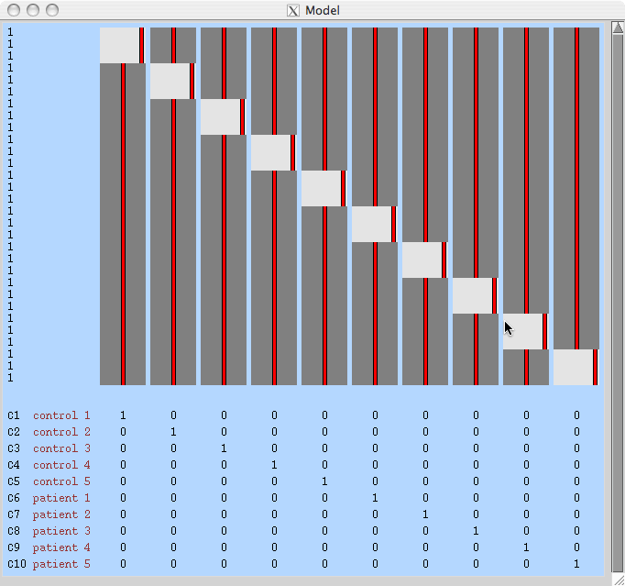

- The default Post-stats are fine (in fact the post-stats don't affect what gets passed up to third-level). So you are now ready to run the second-level analysis. Press Go, wait for the result web pages and then view them carefully.
- We are now ready to setup the third level, between-subject, analysis.
- Type Feat &
- Change First-level analysis to Higher-level analysis
- Change Inputs are lower-level FEAT directories to Inputs are 3D cope images from FEAT directories (the inputs will be the 10 cope images, one for each subject mean, from the second-level analysis).
- Change the Number of inputs to 10 (2 groups * 5 subjects = 10 copes from level 2, each corresponding to a subject mean)
- Press Select cope images and enter the COPEs from the second level in order from 1-10. This ensures that 1-5 correspond to controls and 6-10 correspond to patients. These will be inside the cope1.feat/stats directory which is inside the second-level .gfeat directory that you just created.
  - The relevant command for pasting the list is
  - ls -d `pwd`/lev2.gfeat/cope1.feat/stats/cope?.nii.gz ; ls -d `pwd`/lev2.gfeat/cope1.feat/stats/cope??.nii.gz
  - Can you see why this needs two separate parts, one with a single '?' and one with two?

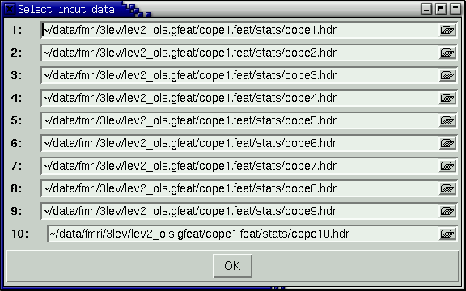

- Set the output directory to lev3.gfeat
- Go to the Stats directory and, again to save time, select the OLS option and deselect the Use automatic outlier de-weighting button. **NOTE**: It is important that you do not miss this step out, otherwise the analysis will not be quick enough to be of use to you in the time that we have available for the practical.
- You can use the wizard to set up a two groups, unpaired analysis (make sure the "Number of subjects in first group" is set appropriately). Note that the Inputs (1-10) correspond to the order you entered the second level COPEs. Here, the control subjects are modelled with one RE variance and the patient subjects with a different RE variance (i.e. Rows 1-5 of the Group column should be 1 and Rows 6-10 should be 2). The two EVs model the different means for the different groups.
- However, instead of this model, let's first try and set it up another way. We still have two EVs, but now one EV represents the overall mean of both groups, and a second EV represents the difference between the two group means. This can be done using EV1 = [1 1 1 1 1 1 1 1 1 1]' and EV2 = [1 1 1 1 1 -1 -1 -1 -1 -1]'. Set up these two EVs.
- Do you think there is anything wrong with setting the design up in this way?
- Press View Design and you will see that there is indeed a problem with setting the design up this way. We have a design matrix that is not "separable" with respect to the random effects variance groupings.
- We are trying to set up a design with different RE variance groupings for the control subjects and patient subjects. However, within each EV, inputs from only one of the variance groups can have non-zero values. We have violated this rule here.
- So, to be able to have these variance groupings we must set up the design using EVs which are separable with respect to the variance groups. For this we need a different EV for each group mean. Re-run the wizard to go back to the recommended unpaired t-test.
- We now have the following contrasts:
- C1: "controls-patients" [1 -1]
- C2: "patients-controls" [-1 1]
- C3: "controls" [1 0]
- C4: "patients" [0 1]
- Go to Post-stats. Reduce the Z threshold to 1.7 (with this artificially small number of subjects the effect is weak!). The other defaults are fine. So you are now ready to run the third-level analysis; press Go.

Outlier Inference
Up to this point in the practical we have run the group analyses with the outlier de-weighting option turned off. In this part of the practical we will look at the output that is generated when outlier de-weighting is performed. Note that outlier de-weighting can be performed for any of the mixed effects analyses, but is not applicable to a fixed effects analysis. In the interest of time, we have provided you with the stripped down results of a group Feat analysis that has been setup and run with outlier de-weighting for you.

The experiment is looking to infer the group mean effect over a group of 18 subjects. The effect of interest is the BOLD response in the feedback phase of a decision making experiment. Move into the group Feat directory corresponding to this lower-level contrast:

cd /storage/silver/pym0fm/<your IT login>/fsl_course_data/fmri/decmak/decmak.gfeat/cope1.feat

Inside the stats directory are the results of the higher level run with outlier inference turned on. Take a look at the files in that directory:

- ls stats

- The prob_outlier1.nii.gz file is a 4D niftii file giving the probability that each subject has outlier data on a voxelwise basis. The global_prob_outlier1.nii.gz file is a 3D niftii file that indicates the size of the outlier population expressed as the proportion of the total number of subjects that are outliers. Note there are versions of these files for each random effects variance group in the analysis. In this case, there was only one variance group. Load the global_prob_outlier1 file into Fslview.

  - fslview stats/global_prob_outlier1.nii.gz

- Use File->Add Standard to load in the MNI standard brain MNI152_T1_2mm_brain. Use File->Add to load in the prob_outlier1 file
- Launch a second, separate, fslview and load the filtered_func_data in the/storage/silver/pym0fm/<your IT login>/fsl_course_data/fmri/decmak/decmak.gfeat directory.
  - Note that the filtered_func_data file is a 4D niftii file of the 18 subjects first-level effect sizes at each voxel, in other words the "data" that gets used to calculate the group average at each voxel.
- Returning to the first fslview select the prob_outlier image and select Tools->Timeseries. Then de-select the prob_outlier image so that it does not get displayed on the spatial map. Do the same for filtered_func_data.
- Navigate around the brain to see where outlier behaviour occurs, and see how this relates to the data in the filtered_func_data timeseries plots and to the probability that each subject has outlier data in the prob_outlier1.nii.gz timeseries plots. Which subject is causing the most outlier behaviour?
- Inside the stats directory is the file zstats1_no_outliers. These are the z-stats resulting from the higher level analysis run with the outlier inference turned off (note that this would not normally be available when you have run outlier inference - it is provided for you here to allow you to make comparisons). Use File->Add to load the z-stats into Fslview for the analyses with
  - /storage/silver/pym0fm/<your IT login>/fsl_course_data/fmri/decmak/decmak.gfeat/stats/zstat1

- and without outlier deweighting
  - /storage/silver/pym0fm/<your IT login>/fsl_course_data/fmri/decmak/decmak.gfeat/stats/zstat1_no_outliers).
- Take a look at how the zstats are changed when there are outliers detected.

This is the end of the Multi-level FEAT practical. In the third part of this practical where you compared patients with controls, when you checked the second-level analysis results, did you notice that one or more of the first-level registrations (that we had already run for you) had failed? If not, you need to LOOK AT YOUR DATA!!

