Open-GL Windows Setup

v1.0

# Preface

This document explains how to setup a basic Open-GL application on Windows using Visual Studios. Note that this document uses Visual Studio 2017.

Note that the test code came from <http://www.opengl-tutorial.org/> tutorial 2.

# Download

1. Checkout the source in GitHub.

# Setup

The following details the steps to create a basic Open-GL application using Visual Studios.

## Initial Setup

1. Download all relevant files. Note that the tested version of each library is already included. To get the latest version of each library, follow each link and download the appropriate file. After each download is finished, unzip the files. Make sure to save each file in a location where you can find it.
   1. <http://glew.sourceforge.net/> (Note: Select the Windows binary)
   2. <http://www.glfw.org/>
   3. <https://github.com/g-truc/glm/tags> (Download the latest version)
2. Open Visual Studio and create a new project (Ctrl + Shift + N). Under Visual C++, create an empty project. Name it ogl-setup.

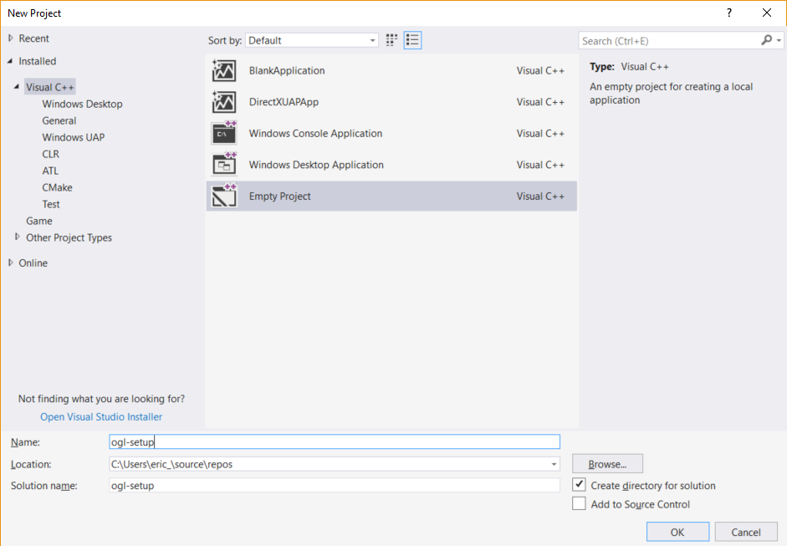

## Add Source Files

From the download repositories, add the files to Visual Studios.

1. Right click Source Files in the Solution Explorer. Under Add, select Existing Item.

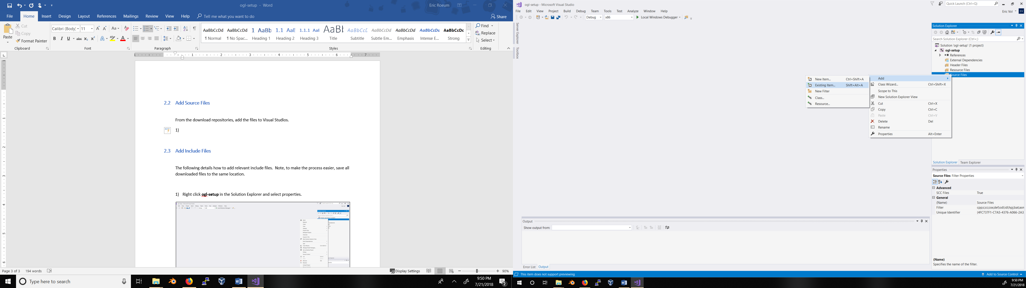

1. Find where you downloaded this repository and add main.cpp.

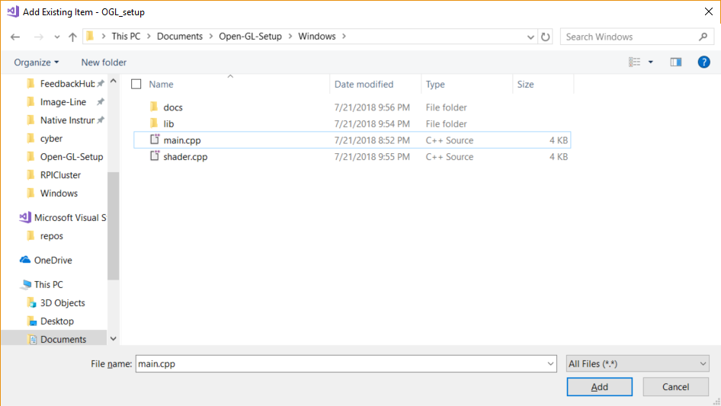

1. Repeat the same process for shader.cpp
2. Go into the file directory of the visual studo application and add SimpleFragmentShader.fragmentshader, and SimpleVertexShader.vertexshader.

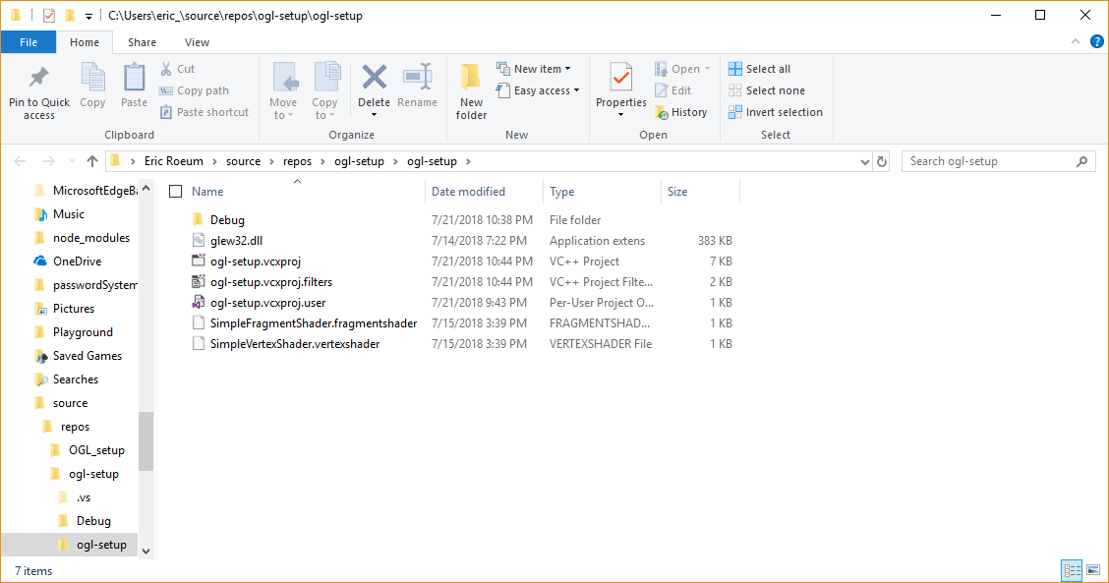

## Add Include Paths

The following details how to add relevant include files. Note, to make the process easier, save all downloaded files to the same location.

1. Right click **ogl-setup** in the Solution Explorer and select properties.

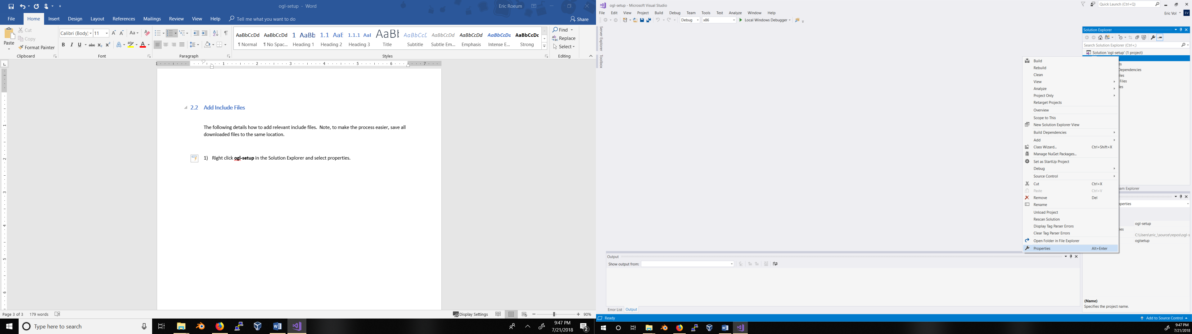

1. Under C/C++, select General.

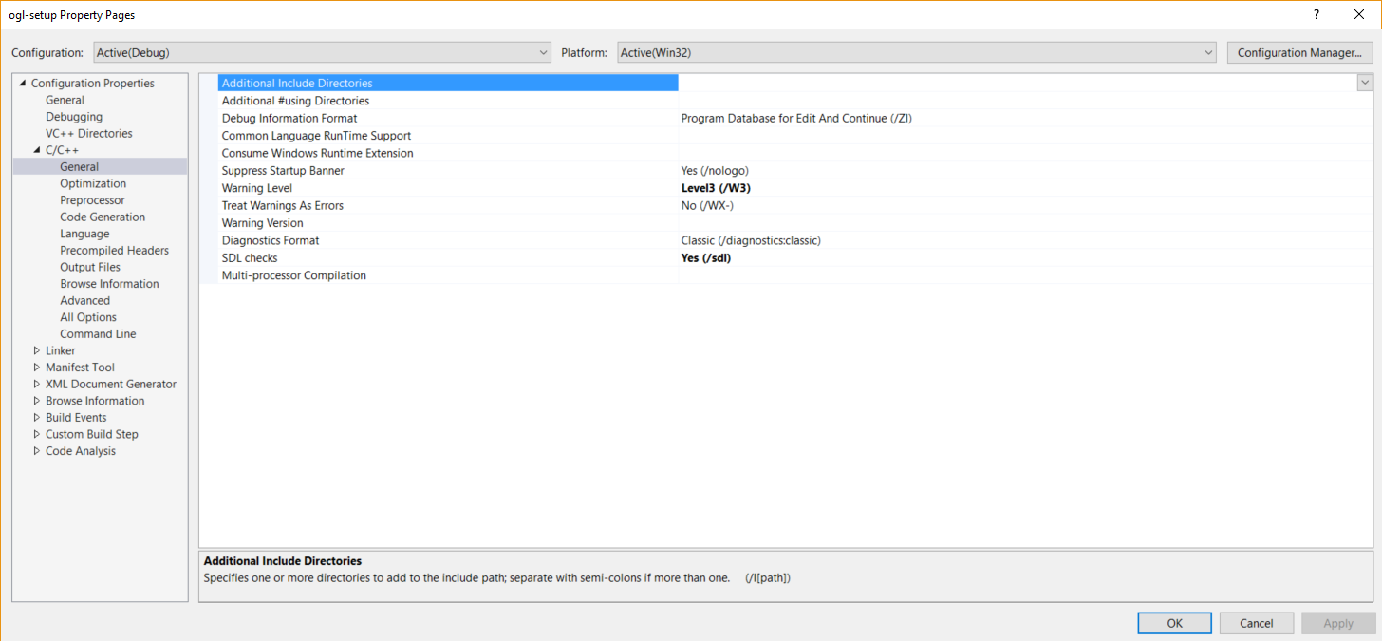

1. Under the Additional Include Directories field, try to type something. A down arrow should appear on the right. Select that arrow and click on Edit.

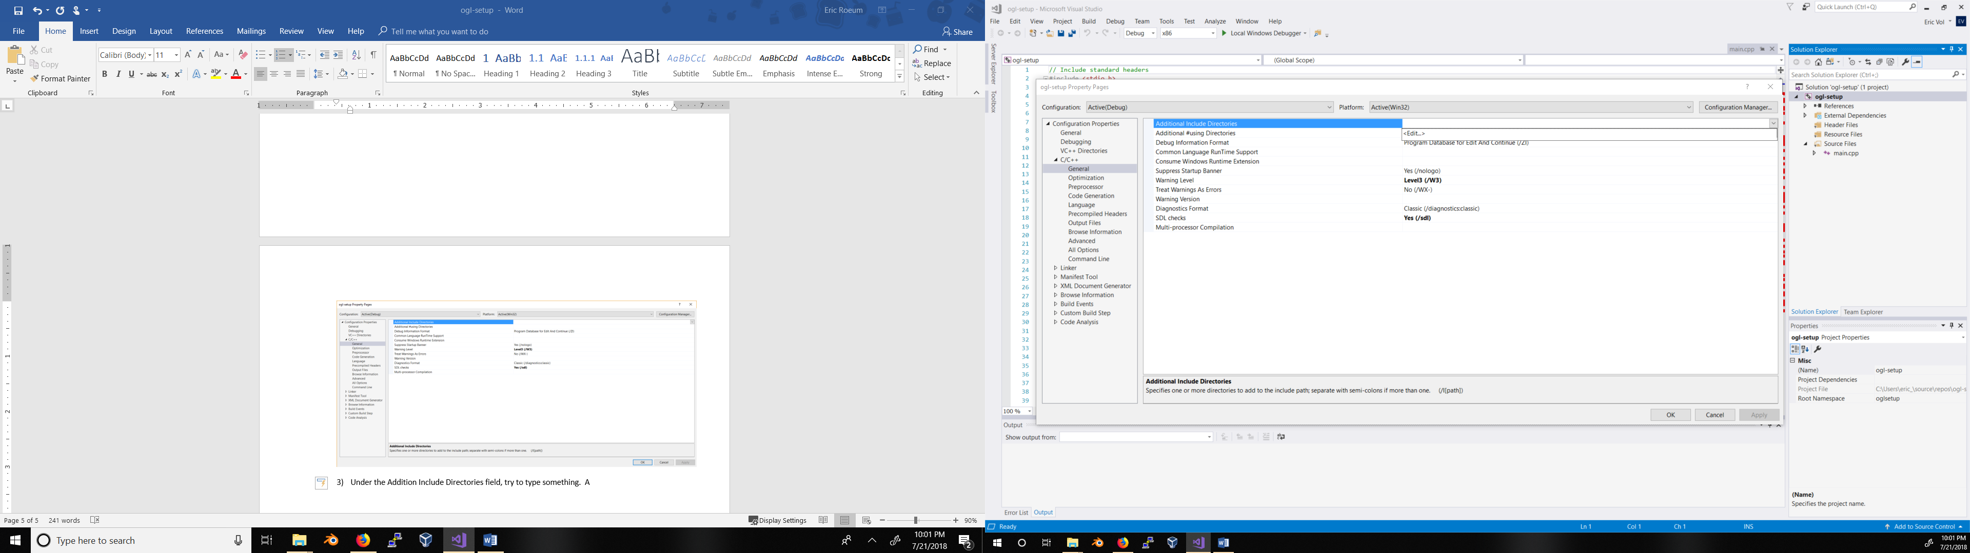

1. Click on the folder icon and add each location of the include directories. After all paths were added, it should look like:

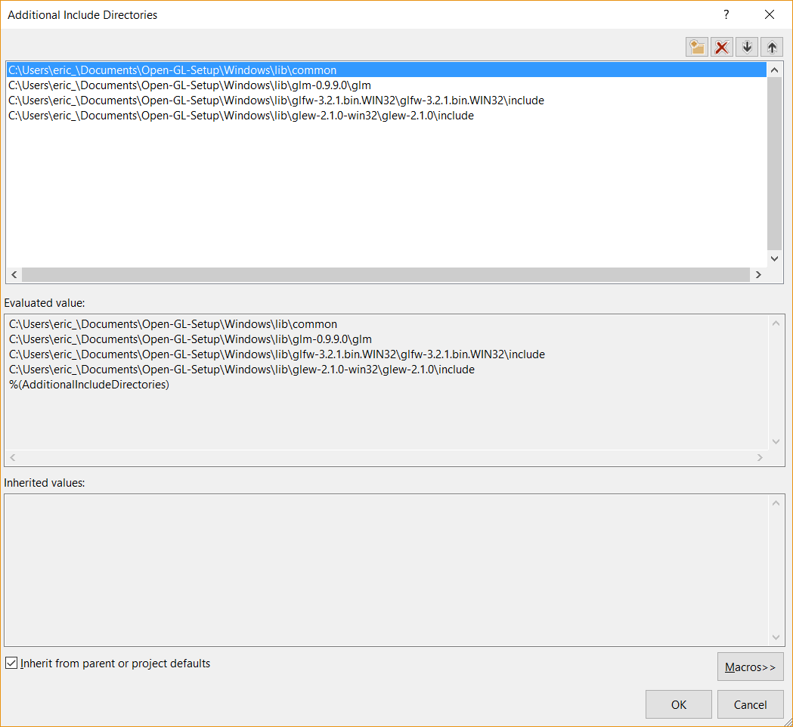

## Add Libraries

1. Add the glew32.dll files to the directory. These can be found in the glew directory.

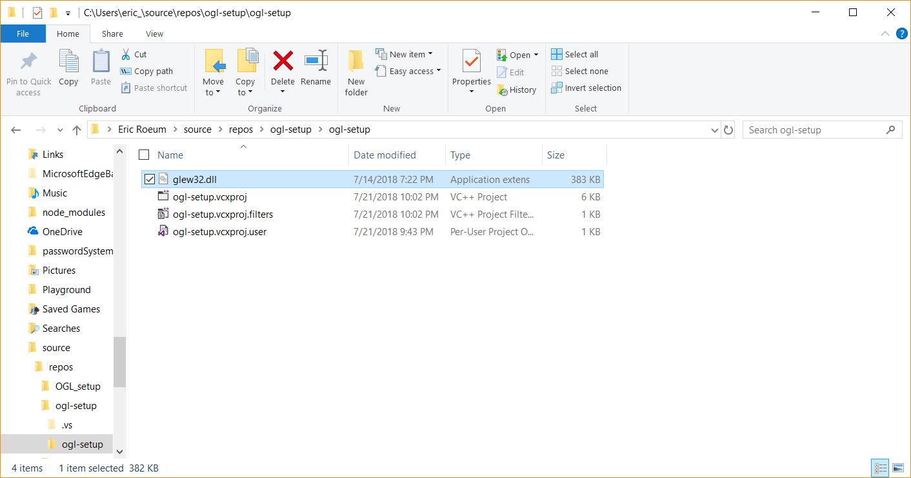

1. Right click **ogl-setup** in the Solution Explorer and select properties.



1. Under Linder, select Input.

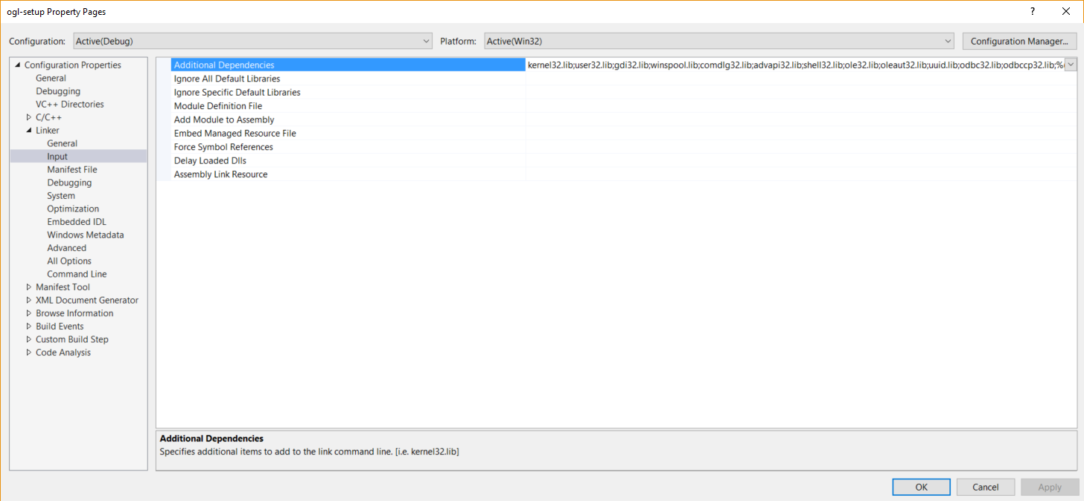

1. Select Additional Dependencies and select the down arrow when you select try to edit the field.

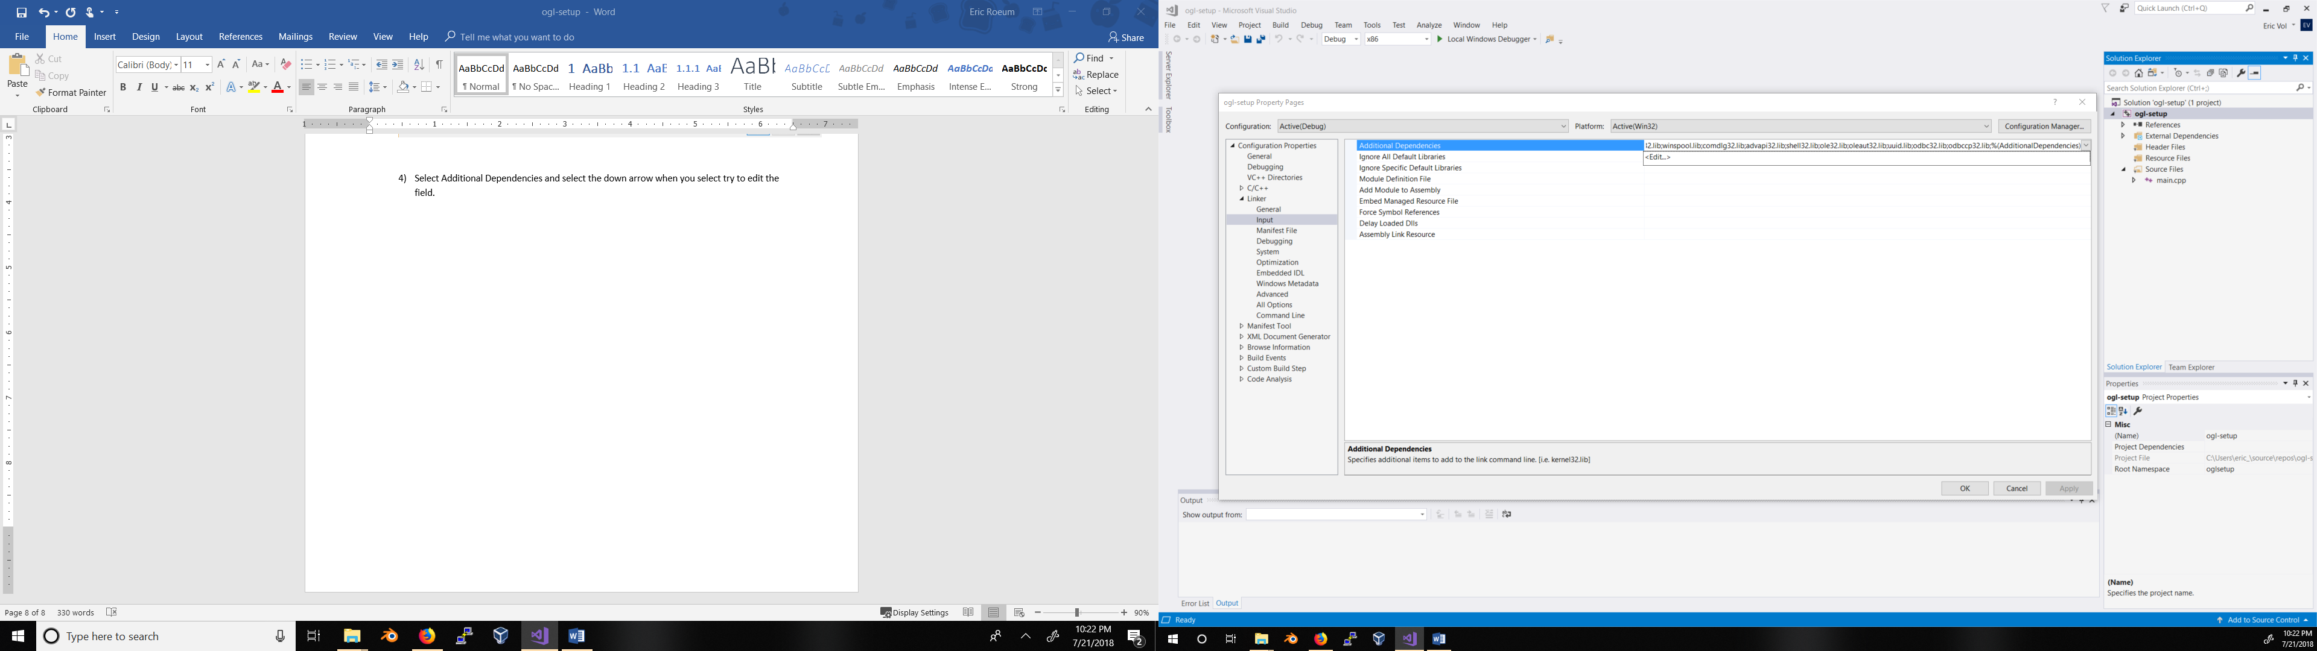

1. Type in:
   * glew32.lib
   * opengl32.lib
   * glfw3.lib
   * glfw3dll.lib

## Add Library Paths

1. Right click **ogl-setup** in the Solution Explorer and select properties.



1. Under Linker, select General.

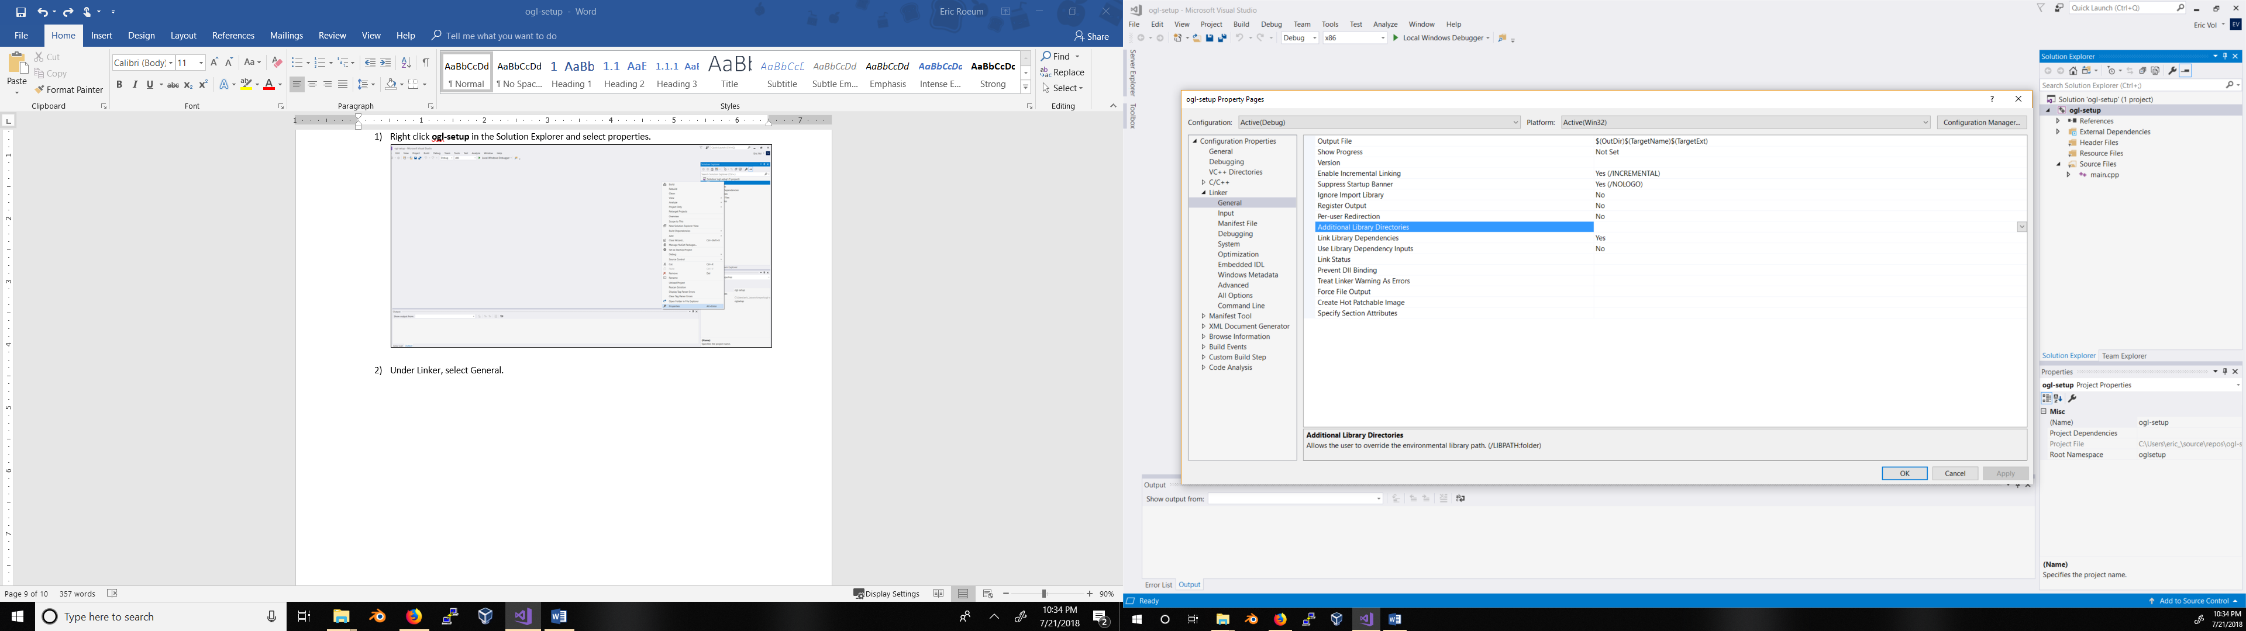

1. Add the paths to each library. The end result should look like the following:

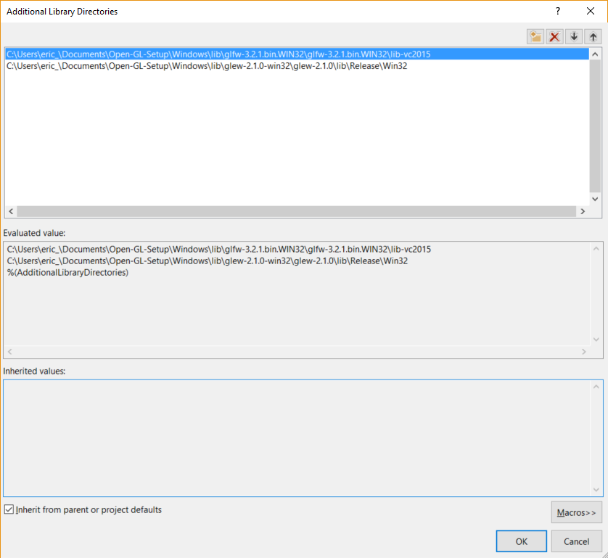

# Run the program

Select Local Windows Debugger. A red triangle should show up.

