Duc Phu Pham

Database Project

**Database Description**

This ER diagram show the process of renting a car as well as showing the connecting between these entities. We have the Customer entity, each identify by its unique Customer_id, this entity contains the customer address, phone number, DOB, name, and driver’s license number.

Next, we have the Reservation entity, this entity is created whenever a customer make a reservation. Each reservation is identified by its unique Rnumber, it also include Customer_id, rental begin date, and rental end date.

Each reservation will contain the information of a specific car that has been reserved, each car will have a make, model, year, price, and a unique vin number. Each car also has an insurance, each insurance has a type and a unique insurance number. There is also location, which is to identify where any car is at. Each location has an address, current stock car, and a unique location_id.

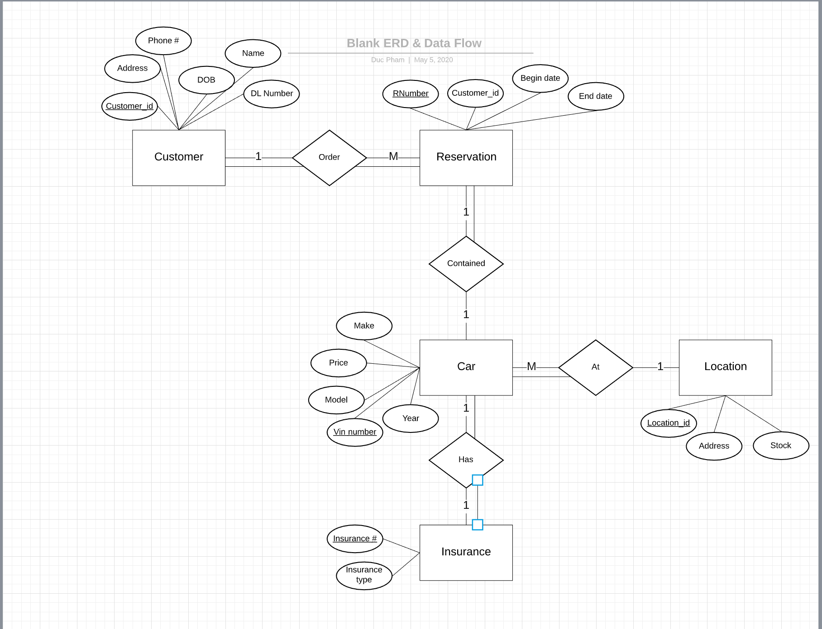

**List of Schemas:**

CUSTOMER(Customer_id, Address, Phone, DOB, Name, DL Number)

RESERVATION(Rnumber, Customer_id, Begin date, End date)

CAR(Vin_number, Make, Model, Year, Price)

LOCATION(Location_id, Address, Stock)

INSURANCE(Insurance #, Insurance Type)

Foreign Keys:

RESERVATION.Customer_id -> CUSTOMER.Customer_id

**SQL Code:**

CREATE TABLE Customer

(

Customer_id number(9) not null,

Address varchar2(60) not null,

Phone varchar2(16) not null,

DOB varchar2(10) not null,

Name varchar2(50) not null,

DLNumber varchar2(15) not null,

primary key (Customer_id)

);

CREATE TABLE Resevation

(

Rnumber number(10) not null,

Customer_id number(9) not null,

BeginDate varchar2(11) not null,

EndDate varchar2(11) not null,

primary key (Rnumber)

foreign key (Customer_id)

);

CREATE TABLE Car

(

Vin_number varchar2(17) not null,

Make varchar2(25) not null,

Model varchar2(25) not null,

Year number(4) not null,

Price number(8) not null,

Primary key (Vin_number)

);

CREATE TABLE Location

(

Location_id varchar2(5) not null,

Address varchar2(60) not null,

Stock number(5) not null,

Primary key (Location_id)

);

CREATE TABLE Insurance

(

InsuranceNum varchar2(18) not null,

InsuranceType varchar2(30) not null

Primary key (InsuranceNum)

);

INSERT INTO Customer VALUES (111111111, “1 Edge Dr, 10000”, 5011111111, “01/01/1991”, “Lake Jun”, “13335777343”);

INSERT INTO Customer VALUES (222222222, “2 London Dr, 20000”, 5012222222, “02/02/1992”, “John Smith”, “a1n399830dn”);

INSERT INTO Customer VALUES (333333333, “3 Layla Dr, 30000”, 5013333333, “03/03/1993”, “Tom Land”, “99830287678”);

INSERT INTO Customer VALUES (444444444, “4 Dome Dr, 40000”, 5014444444, “04/04/1994”, “Lance Hopkin”, “009289038145”);

INSERT INTO Reservation VALUES (0000000001, 111111111, ”03/13/2020”, ”03/17/2020”);

INSERT INTO Reservation VALUES (0000000002, 222222222, “12/22/2019”, ”12/30/2019”);

INSERT INTO Reservation VALUES (0000000003, 333333333, “05/05/2020”, “05/15/2020”);

INSERT INTO Car VALUES (“3k2094j8910228371”, “Volkswagen”, “GTI”, 2019, 80);

INSERT INTO Car VALUES (“980C7D676152J3859”, “Ford”, “Malibu”, 2018, 50);

INSERT INTO Car VALUES (“9890DC6256331SG1”, “Fiat”, “F50”, 2018, 45);

INSERT INTO Location VALUES (“AR123”, “5 Chenal Parkway, 72201”, 12);

INSERT INTO Location VALUES (“TX333”, “10 Hutchinson Rd, 66091”, 34);

INSERT INTO Location VALUES (“NV220”, “8 Aurora Lane, 33291”, 160);

INSERT INTO Insurance VALUES (“JF7283HD91334”, “Silver”);

INSERT INTO Insurance VALUES (“738DDBW7193D”, “Gold”);

INSERT INTO Insurance VALUES (“28DJAS88370DQ”, “Platinum”);

**Queries**

SELECT Price

FROM Car

WHERE Make = “Ford”;

Result : 50

SELECT *

FROM Customer

WHERE Customer_id = 222222222;

Result : 222222222, 2 London Dr, 20000, 5012222222, 02/02/1992, John Smith, a1n399830dn

SELECT Rnumber

FROM Reservation

WHERE EndDate LIKE ‘%2020’;

Result : 0000000001

0000000003

SELECT Location_id

FROM Location

WHERE Stock < 100;

Result : AR123

TX333

SELECT BeginDate, EndDate

FROM Customer, Reservation

Where Customer_id = 333333333;

Result: 05/05/2020, 05/15/2020

SELECT Rnumber

FROM Reservation

WHERE NOT (Customer_id = 111111111);

Result: 0000000002

0000000003

SELECT Name, Rnumber, BeginDate, EndDate

FROM Customer, Reservation

WHERE Customer_id = Customer_id;

Result : Lake Jun, 0000000001, 03/13/2020, 03/17/2020

John Smith, 0000000002, 12/22/2019, 12/30/2019

Tom Land, 0000000003, 05/05/2020, 05/15/2020

CREATE PROCEDURE GetAllRes()

BEGIN

SELECT * FROM Reservation;

END

Result : Output everything from Reservation