Replacing bonds in a Swiss portfolio — a structured thesis (VZ AP5, 2008–2026)
Table of Contents

Replacing bonds in a Swiss portfolio — a structured thesis

VZ AP5 mandate · CHF, monthly total return, net of fees · February 2008 – June 2026
Structured version of the empirical thesis. It is built to be read top to bottom: what we ask, the raw material, the exact portfolios we test, then the results one step at a time — first replacing bonds with one alternative, then with a mix, then with an optimised allocation. Every number comes from the reproducible pipeline (analysis/results_manifest.json, analysis/*.csv).

1. Goal and approach
Goal (one sentence). Find out whether the 42% in bonds of the Swiss VZ AP5 mandate can be replaced by other investable assets, and at what cost in risk — over the full 2008–2026 sample and across interest-rate regimes.
We answer in three clear steps, from simplest to most advanced:
- Step A — one alternative at a time. Replace the bonds with a single alternative (gold only, high yield only, …) and see what each one does on its own.
- Step B — a mix. Replace the bonds with a basket of alternatives, and justify which alternatives and what weights from Step A.
- Step C — an optimised allocation. Let an optimiser choose the "best" weights in-sample, as a descriptive upper bound.
Everything is compared to the AP5 benchmark (bonds untouched) on the same four things: return, volatility, worst loss (drawdown), and extreme loss (CVaR), plus the Sharpe ratio (return per unit of risk, measured as excess over CHF cash).
The three questions behind these steps: (Q1) does replacing bonds change return? (Q2) does it change downside risk? (Q3) does the answer depend on the rate regime?

2. The building blocks (2008-02 → 2026-06, CHF, per asset)
Before combining anything, here is each asset on its own — the raw material. Sharpe is excess over CHF cash.
Asset (proxy) | CAGR | Vol | Sharpe | MaxDD
Swiss equity (SPI) | 6.6% | 12.6% | 0.57 | −38%
World equity (MSCI World) | 8.6% | 18.7% | 0.53 | −42%
Real estate (SXI) | 6.1% | 7.7% | 0.80 | −19%
Swiss bonds (broad) | 1.8% | 3.6% | 0.50 | −16%
Swiss bonds (1–5y) | 1.1% | 1.7% | 0.66 | −7%
World bonds (hedged, broad) | 1.1% | 3.5% | 0.30 | −18%
World bonds (hedged, 1–5y) | 0.6% | 1.8% | 0.31 | −9%
Gold (CHF) | 6.1% | 16.4% | 0.44 | −38%
High yield (HYG, hedged) | 3.9% | 10.3% | 0.41 | −29%
EM debt (EMB, hedged) | 3.3% | 11.5% | 0.33 | −28%
Infrastructure (IGF) | 4.0% | 14.8% | 0.34 | −45%
Managed futures (RYMFX) | −0.8% | 13.8% | 0.01 | −47%
Commodities (DBC) | −1.6% | 18.9% | 0.00 | −76%
Cash (SNB path) | 0.1% | 0.0% | — | −5%
What this already tells us. The bonds did little over 2008–2026 (0.6%–1.8%/yr) — the problem the thesis is about. Among the candidate replacements, gold has the best stand-alone return (6.1%) but is volatile; commodities and managed futures actually lost money over this sample; high yield and EM debt sit in between. No single alternative is an obvious drop-in for bonds.

3. The portfolios we test (the map)
This is the full list of what is replaced, by what, and by how much. Bonds are replaced in 10% steps (0%, 10%, …, 100%); "0%" is always the AP5 benchmark.
ID | What is replaced | Replaced by | How much
B0 | nothing (benchmark) | — (AP5 as-is) | 0%
A·gold | bonds | gold only | 0→100%
A·hy | bonds | high yield only | 0→100%
A·em | bonds | EM debt only | 0→100%
A·infra | bonds | infrastructure only | 0→100%
A·cta | bonds | managed futures only | 0→100%
A·comm | bonds | commodities only | 0→100%
B·equal | bonds | equal-weight mix of the 6 above | 0→100%
B·curated | bonds | curated mix: HY 35 / EM 30 / gold 20 / infra 15 | 0→100%
C·max-Sharpe | bonds + sleeve | optimiser picks the weights (in-sample) | optimiser
C·min-risk | bonds + sleeve | optimiser picks the weights (in-sample) | optimiser
The equity/real-estate/cash core (58%) is always held fixed; only the 42% in bonds is touched.

4. Step A — replace bonds with ONE alternative at a time
Replace 100% of the bonds with a single alternative (analysis/single_alt_full_replacement.csv). Sorted best to worst by Sharpe:
100% of bonds → | CAGR | Vol | Sharpe | MaxDD | CVaR95
Gold only | 5.9% | 10.4% | 0.60 | −21% | −6.8%
Curated mix (for reference) | 4.9% | 10.0% | 0.52 | −28% | −7.0%
AP5 benchmark (0% replaced) | 3.6% | 7.7% | 0.48 | −20% | −5.2%
High yield only | 4.6% | 10.3% | 0.48 | −31% | −7.3%
EM debt only | 4.4% | 10.3% | 0.47 | −26% | −7.3%
Equal-weight mix (for reference) | 4.3% | 10.1% | 0.46 | −28% | −7.1%
Infrastructure only | 4.6% | 12.8% | 0.41 | −39% | −9.4%
Managed futures only | 2.9% | 10.2% | 0.32 | −26% | −6.3%
Commodities only | 2.4% | 13.1% | 0.24 | −39% | −9.7%
Reading this table (the key result of Step A):
- Only gold, on its own, clearly beats the benchmark on risk-adjusted return (Sharpe 0.60 vs 0.48), and it does so without a deeper worst-loss (−21% vs −20%). Every other single alternative is equal to or worse than simply keeping the bonds.
- High yield and EM debt roughly match the benchmark's Sharpe but with much deeper drawdowns (−31% / −26% vs −20%): more return, more risk, no free lunch.
- Commodities and managed futures are the worst: they lost money over the sample and drag any portfolio down.
- Honesty note on gold: the 0.60 Sharpe is a single, concentrated bet — 42% of the portfolio in one asset over a sample (2008–2026) in which gold did unusually well, and gold pays no income (unlike bonds' carry). It is a strong historical result, not a safe recommendation to hold 42% gold.

5. Step B — replace bonds with a MIX (and why this mix)
A single asset is fragile (all eggs in one basket, especially gold). So we diversify across several alternatives. Step A tells us exactly how to build the mix:
- Equal-weight mix of all six (the naïve choice). Result: Sharpe 0.46 — slightly worse than the benchmark. Why? Because it gives equal weight to commodities and managed futures, the two that lost money. A naïve equal mix is not good enough — this is an important, honest finding.
- Curated mix — drop the losers, keep the workers. Remove commodities and managed futures; keep the income assets (high yield, EM debt) and the diversifier (gold), plus a little infrastructure: HY 35% / EM 30% / gold 20% / infra 15%. Result: Sharpe 0.52 — better than both the equal mix and the benchmark.
Mix (100% of bonds replaced) | CAGR | Vol | Sharpe | MaxDD | CVaR95
Equal-weight (all 6) | 4.3% | 10.1% | 0.46 | −28% | −7.1%
Curated (HY/EM/gold/infra) | 4.9% | 10.0% | 0.52 | −28% | −7.0%
Justification of the curated weights. The composition is not arbitrary: it is read directly off Step A. High yield and EM debt are the two income assets that best reproduce what bonds do (carry), so they get the largest weights (35% + 30%). Gold is the one asset that improved risk-adjusted return on its own, so it earns a meaningful 20% as the crisis diversifier. Infrastructure adds a little real-asset inflation exposure (15%). Commodities and managed futures are excluded because Step A shows they only added risk and lost money.
Important caveat. The curated mix is chosen after seeing the full-sample results, so it is exploratory, not a promise it would have been picked in advance. It should be validated out-of-sample before real use. It illustrates that instrument selection matters, not that this exact basket is optimal.

6. Step C — an optimised (advanced) allocation
Finally, let an optimiser choose the 42% weights to maximise in-sample Sharpe (or minimise risk), across bonds and the six alternatives, with realistic caps (appendix_optimisation_*.csv). These weights see the whole history, so they are an optimistic upper bound, not an implementable recommendation.
Optimised (in-sample) | CAGR | Vol | Sharpe | MaxDD | What it chose
Max-Sharpe | 4.4% | 8.1% | 0.56 | −18% | ~30% Swiss bonds + 12% gold (keeps most bonds!)
Min-variance / Min-CVaR | 3.3% | 7.5% | 0.46 | −21% | 42% short world bonds (all bonds)
The most important lesson of Step C. Even the optimiser, free to remove bonds entirely, keeps a large bond allocation and only adds a little gold. It never chooses to replace bonds wholesale. This is the same message as Steps A and B, now from an entirely different method: the best historical portfolio is bonds plus a modest gold sleeve, not bonds replaced by alternatives.

7. Does the answer depend on the rate regime? (Q3)
Splitting 2008–2026 into four SNB regimes (analysis/regime_*.csv), the net return of replacement depends heavily on what bonds were doing:
Regime | AP5 | 100% replaced (equal mix) | Reading
R1 2008–14 low-positive rates | 3.7% | 2.8% | bonds strong → replacement costs
R2 2015–22 negative rates | 3.4% | 5.1% | bonds ≈ 0 → replacement helps
R3 2022–24 hikes | −0.2% | −1.6% | everything fell → replacement costs
R4 2024–26 easing | 6.5% | 10.7% | risk assets rally → replacement helps
Replacement pays when bonds are weak and costs when bonds are strong — it is a bet on the regime, not a free improvement.

8. Robustness and crises (brief)
- The conclusion holds across rebalancing bands (±5–20%), transaction costs (0–50 bps), the hedging assumption, the sample window, and whether bands are monitored per-asset or per-category (analysis/robustness_*.csv).
- A bootstrap (3,000 re-runs) shows no replacement level gives a Sharpe gain distinguishable from zero, while extreme loss (CVaR) gets worse with ≈99–100% probability as you replace more.
- Two crises point opposite ways: in 2020 (COVID) replacement hurt (bonds protected); in 2022 (rate shock) replacement helped (bonds and equities fell together). Replacement changes which crisis you are exposed to; it does not remove crisis risk.

9. Main result and recommendation
Replacing bonds raises return but also raises volatility and extreme loss, without a reliable improvement in risk-adjusted performance. It is a change in the portfolio's risk budget, not the discovery of a better asset than bonds.
Concretely, from the three steps:
- Step A: on its own, only gold improved risk-adjusted return; the rest matched or worsened the benchmark, and two alternatives lost money.
- Step B: a naïve equal mix is worse than keeping bonds; a curated mix helps, but only as an ex-post illustration that selection matters.
- Step C: even a free optimiser keeps most of the bonds and only adds a little gold.
Recommendation.
- Do not replace bonds wholesale. It reliably worsens downside without a reliable Sharpe gain.
- If any replacement is made, keep it partial and treat it as a risk-budget decision (more return accepted in exchange for more downside), not an optimisation.
- The single most useful addition historically is a modest gold allocation alongside bonds — not instead of them — but this is one concentrated bet on one favourable sample and must be stress-tested before use.
- Keep the bond structure (Swiss + world, broad + short-duration): they behave differently by regime and are not redundant.

What remains (the author's work)
The empirical analysis (data, portfolios, results, robustness) is complete and reproducible. The remaining work is the written dissertation — literature review, theoretical framework, references, and the discussion/conclusion prose — which is the student's to write.
\newpage

Figures
Figure 1 — Cumulative CHF total return, net of fees (2008–2026).
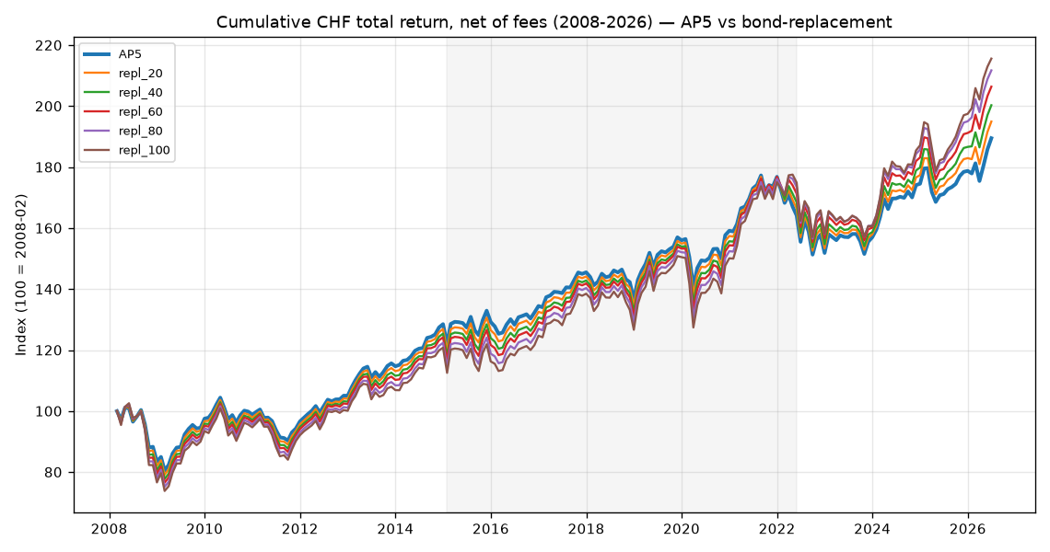
Figure 2 — Validation: reconstructed AP5 vs the real VZ VVIA track record.
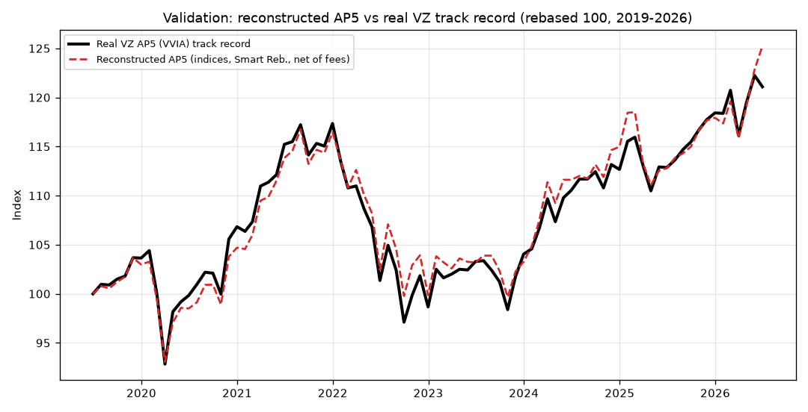
Figure 3 — Annualised return by SNB rate regime.
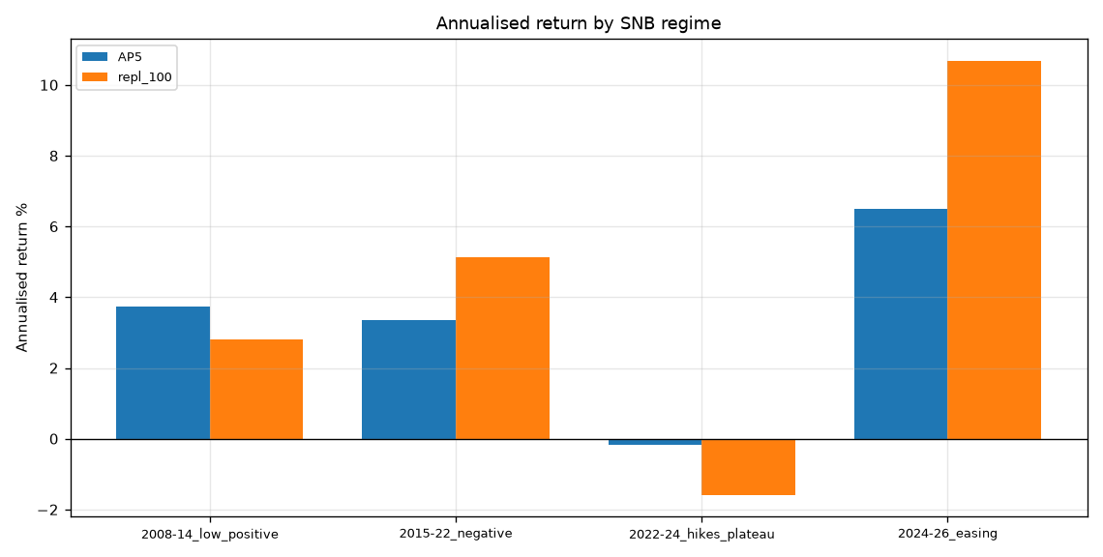
Figure 4 — Bond-sleeve behaviour by rate regime.
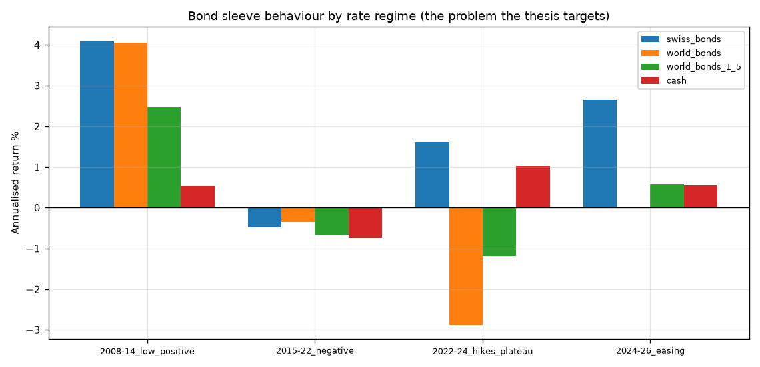
Figure 5 — Monthly return correlations (2008–2026).
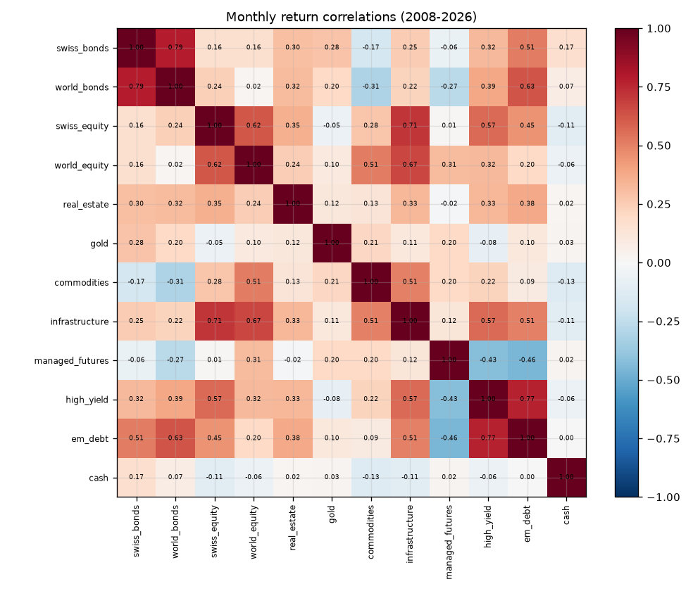
Figure 6 — Rolling 24-month equity–bond correlation.
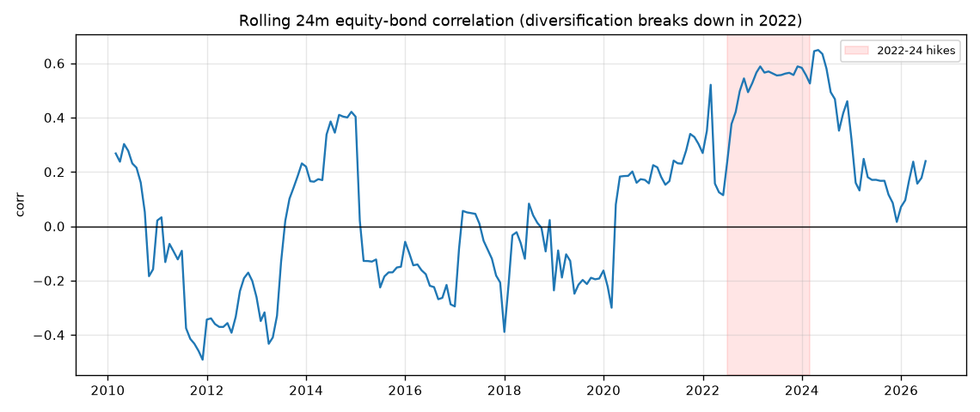
Figure 7 — Bootstrap ΔSharpe vs AP5 (CI straddles zero) and P(worse drawdown).
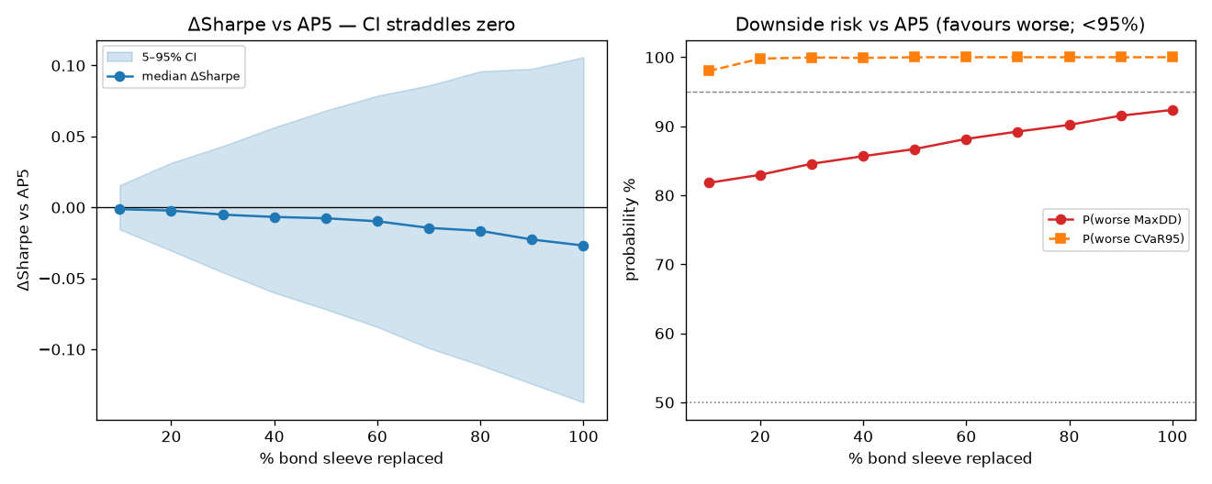
Figure 8 — Curated vs naïve replacement basket — ex-post (100% replaced).
