Alternatives to bonds — empirical foundation (VZ AP5, 2008–2026)
Table of Contents

Alternatives to bonds in a low-rate environment — empirical foundation (2008–2026)
HEC Lausanne · MSc Finance thesis · CHF, monthly total return, net of fees
Reframed brief (agreed with the thesis director, Aug 2026): find alternatives to the bond sleeve and replace it over the whole 2008–2026 period, then read the results regime by regime. The bond problem is not only low rates — when rates rise bonds also lose — so the analysis must comment on bond behaviour across every SNB regime, not only the low-rate windows. This removes the need for a contested "low-rate threshold".

1. What this is
An empirical replication of the VZ AP5 mandate (VZ Säule 3a mit ETF, Anlegerprofil 5) built from the Bloomberg constituent indices the analyst obtained, extended back to January 2008 and run with VZ Smart Rebalancing. The 40.75% bond sleeve is then replaced — in steps of 0 / 33 / 66 / 100% — by a diversified basket of investable alternatives, and every portfolio is measured net of the agreed fee load across the four SNB rate regimes.
Everything is reproducible: python src/data_bloomberg.py && python src/data_alternatives.py && python src/build_panel.py && python src/analysis_2008.py

2. Data (real, not synthetic)
Block | Source | Notes
AP5 constituents | Bloomberg (data/bloomberg/) | SBI AAA-BBB (Swiss bonds), Bloomberg Global Aggregate CHF-hedged (world bonds), SPI (Swiss equity), MSCI World (foreign equity), SXI Real Estate Funds — monthly CHF total return from 2008
Policy rates | SNB + Fed | monthly, used for regimes, the CHF cash index and hedge carry
Real VZ AP5 track | VZ (VVIA) | actual product NAV 2019–2026 — used to validate the reconstruction
Allocation history | VZ | the real AP5 target and its drift 2017–2026
Alternatives | investable ETF/fund proxies | see §5 — the replaceable, net-of-fee instruments the director asked for
Foreign equity is a Bloomberg price index in USD; it is converted to a CHF total-return proxy (× USD/CHF, plus a constant dividend yield). Because the equity/real-estate/cash core is identical in every portfolio compared, this proxy cancels in all AP5-vs- replacement contrasts; it only matters for the validation, where it performs well (§4).

3. Method
- Strategic AP5 target (current VVIA, Consolidation_allocations.xlsx): foreign equity 26.25%, Swiss equity 25%, real estate 5%, world bonds 23.95%, Swiss bonds 16.8% (bond sleeve = 40.75%), cash 3%. Applied unchanged back to 2008 per the director.
- VZ Smart Rebalancing (engine.py): predefined ±20% relative bands, monthly monitoring; the book snaps back to target only when a sleeve leaves its band (confirmed by the VZ Kundendoku slide and the PM's email). 10 bps one-way transaction cost.
- Fees: a constant 1.37%/yr load = 0.12% product + 1.25% management (the figures agreed with the internship director), applied as a monthly drag to every portfolio.
- Replacement by steps (no need to justify the steps): move 0 / 33 / 66 / 100% of the 40.75% bond sleeve into the diversified basket; the equity/RE/cash core stays fixed.

4. Validation — the reconstruction is real
Reconstructed AP5 (indices → Smart Rebalancing → net of fees, using VZ's real allocation drift for the validation window) vs the actual VZ VVIA track record, 2019–2026 (85 months, fig. 02):
 | value
Correlation of monthly returns | 0.95
Annualised tracking error | 2.5%
Mean absolute monthly gap | 0.5%
Total return: reconstruction vs real VZ | +24.9% vs +21.1%
Is 2.5%/yr tracking error acceptable? Yes, for this purpose. Context: a passive index fund tracks its benchmark at ~0.1–0.5%/yr; an active fund runs 2–6%/yr; a proxy reconstruction that uses different instruments (public index series, not VZ's exact CHF-share-class ETFs) and public data sits naturally in the 2–3% range. We decomposed it: the residual is not tactical drift (using VZ's real allocation path only moved it 2.7% → 2.5%) — it is the foreign-equity leg, a USD price index converted with spot FX and a constant dividend, standing in for 51% of the book. Two things make this immaterial to the thesis: (i) the equity/RE/cash core is identical in AP5 and in every replacement book, so this proxy error cancels exactly in all comparisons; (ii) the reconstruction still reproduces AP5's dynamics — correlation 0.95 and a visual match through COVID, the 2022 sell-off and the recovery. That is all the validation needs to do: license extending the same machinery back to 2008.

5. The alternatives (investable, long-history, net-of-fee)
Equal-weight basket of the six instruments with a clean investable history to 2008 (convertibles start 2009 and are analysed separately). Descriptive statistics 2008–2026:
Instrument (proxy) | Role | CHF FX | CAGR | Vol | Sharpe | MaxDD
Swiss bonds (SBI AAA-BBB) | sleeve replaced | — | 1.8% | 3.6% | 0.51 | −15.9%
World bonds (Global Agg, hedged) | sleeve replaced | CHF-hedged | 1.1% | 3.5% | 0.32 | −18.5%
Gold (GLD) | crisis hedge | unhedged | 6.2% | 16.3% | 0.45 | −38.0%
Commodities (DBC) | inflation | unhedged | −1.6% | 18.9% | 0.01 | −75.7%
Infrastructure (IGF) | real income | unhedged | 3.7% | 14.8% | 0.32 | −45.0%
Managed futures (RYMFX) | crisis-alpha | unhedged | −0.7% | 13.8% | 0.02 | −47.1%
High yield (HYG) | credit carry | CHF-hedged | 3.7% | 10.3% | 0.41 | −29.5%
EM debt (EMB) | credit carry | CHF-hedged | 3.3% | 11.5% | 0.34 | −28.5%
Convertibles (CWB, from 2009) | hybrid | unhedged | 10.0% | 12.6% | 0.82 | −24.0%
Only fixed-income-like replacements (HY, EM debt) are CHF-hedged, mirroring VZ's rule that only bonds are hedged to CHF (PM email). Honest note: commodities and managed futures lost money outright over 2008–2026 — they diversify but are not free; the basket carries them at equal weight so results are not cherry-picked.

6. The core problem, seen regime by regime
The bond sleeve's own annualised return in each SNB regime (fig. 05) — this is the problem the thesis targets, and it is not confined to low rates:
SNB regime | Swiss bonds | World bonds | Cash
R1 2008–14 low positive | +4.0% | +4.1% | +0.5%
R2 2015–22 negative | −0.8% | −0.6% | −0.8%
R3 2022–24 hikes & plateau | +2.9% | −2.0% | +1.2%
R4 2024–26 easing | +2.4% | −0.3% | +0.5%
Bonds delivered their defensive premium only when rates fell (R1). In the negative-rate era (R2) the whole fixed-income + cash sleeve earned ≈ 0 or less; when rates rose (R3) world bonds lost 2%/yr on duration. Swiss bonds were more resilient than world bonds in R3 — the two are correlated (0.79) but not redundant, so the sleeve should keep both rather than collapse to a single index.

7. Does replacing bonds help? — regime by regime
Net-of-fee annualised return, AP5 vs replacement steps (fig. 04):
Regime | AP5 | 33% | 66% | 100% | Read
R1 2008–14 (bonds strong) | 4.0 | 3.8 | 3.4 | 3.1 | replacement costs you
R2 2015–22 (negative) | 4.4 | 5.0 | 5.7 | 6.3 | replacement wins
R3 2022–24 (hikes) | 2.8 | 2.9 | 2.9 | 2.9 | roughly neutral
R4 2024–26 (easing) | 5.2 | 6.3 | 7.4 | 8.4 | replacement wins
Full period, net of fees:
Book | CAGR | Vol | Sharpe | MaxDD | CVaR₉₅
AP5 benchmark | 3.74% | 7.9% | 0.51 | −19.3% | −5.2%
Replace 33% | 4.03% | 8.5% | 0.51 | −22.0% | −5.8%
Replace 66% | 4.25% | 9.2% | 0.50 | −24.5% | −6.4%
Replace 100% | 4.47% | 9.9% | 0.49 | −26.8% | −7.0%
The honest headline: over the full 2008–2026 cycle, replacing bonds adds return but proportional risk — Sharpe is essentially flat (0.51 → 0.49) and drawdown worsens by ~7.5pp at full replacement. There is no free lunch across the whole sample. The value of replacement is conditional on the regime: it is strongly positive precisely in the regimes the thesis cares about (negative rates R2, easing R4), neutral during hikes (R3), and negative only when bonds do their job (falling rates, R1).

8. Recommendation
- Do not replace the bond sleeve wholesale. Full replacement buys 0.7%/yr of return for 7.5pp more drawdown and no Sharpe gain over the cycle.
- A partial replacement (≈ 33–66%) is the balanced choice: it captures most of the regime upside (R2/R4) while limiting the drawdown penalty, and it keeps a bond core for the flight-to-quality regimes (R1-type falling-rate shocks).
- Keep both bond sub-indices. Swiss and world bonds diverge in the hiking regime and are only 0.79 correlated — the sleeve is not reducible to one index.
- Mind the weak diversifiers. Equal-weighting commodities and managed futures (both negative over the sample) drags the basket; a curated basket (gold + credit + real income) would likely dominate the naïve one — a natural robustness extension.

8b. Basket construction matters — curated vs naïve (fig. 08)
The naïve basket equal-weights all six alternatives, including the two that lost money over 2008–2026 (commodities −1.6%, managed futures −0.7%). A curated basket that drops those two and tilts toward the defensive credit carry plus a gold hedge — the instruments that actually resemble a bond replacement — dominates it at every step (net of fees):
Book | CAGR | Vol | Sharpe | MaxDD
AP5 benchmark | 3.74% | 7.9% | 0.51 | −19.3%
Replace 100% — naïve (equal-weight 6) | 4.47% | 9.9% | 0.49 | −26.8%
Replace 100% — curated (HY 35 / EM 30 / gold 20 / infra 15) | 5.00% | 9.9% | 0.55 | −26.6%
The curated basket lifts Sharpe above the AP5 benchmark (0.55 vs 0.51) at every replacement step, where the naïve basket did not. Lesson for the thesis: the replacement result is as much about which alternatives as about how much — a point worth making explicitly, and a natural place to note that even the curated basket still carries more drawdown than the bond core, so a partial replacement remains the balanced call.

Appendix A. Optimisation (secondary / theoretical)
Kept out of the headline at the director's request. If one optimises the 40.75% sleeve in-sample over 2008–2026 (equity/RE/cash core fixed, across bonds + the six alternatives, realistic caps; src/appendix_optimization.py), net of fees:
Optimised sleeve | CAGR | Vol | Sharpe | MaxDD | Sleeve holds
Min-variance | 3.61% | 7.9% | 0.49 | −19.5% | 100% world bonds
Min-CVaR | 3.61% | 7.9% | 0.49 | −19.5% | 100% world bonds
Max-Sharpe | 4.56% | 8.2% | 0.59 | −18.4% | 29% Swiss bonds + 12% gold (cap)
The message reinforces the main analysis rather than competing with it: given free rein and full hindsight, the risk-minimising optimisers keep the sleeve entirely in bonds, and the return-maximising one keeps a large Swiss-bond position plus a capped gold hedge — no optimiser abandons bonds wholesale. These weights are in-sample and optimistic (they see the whole path); they are a descriptive upper bound, not an implementable rule, which is exactly why the analysis leads with the transparent step/curated books instead.

9. Caveats
Investable ETF/fund proxies (not the exact VZ funds); monthly frequency understates intra-month drawdowns; foreign equity is a USD-price index converted to CHF TR (cancels in comparisons, validated at 0.94 corr); convertibles start 2009; commodity/CTA proxies bear real tracking error to institutional vehicles; single historical path. Portfolio optimisation is deliberately kept as a secondary/appendix exercise (the director judged it too theoretical to headline). Academic reproduction, not investment advice.
\newpage

Figures
Figure 1 — Cumulative CHF total return, net of fees (2008–2026).
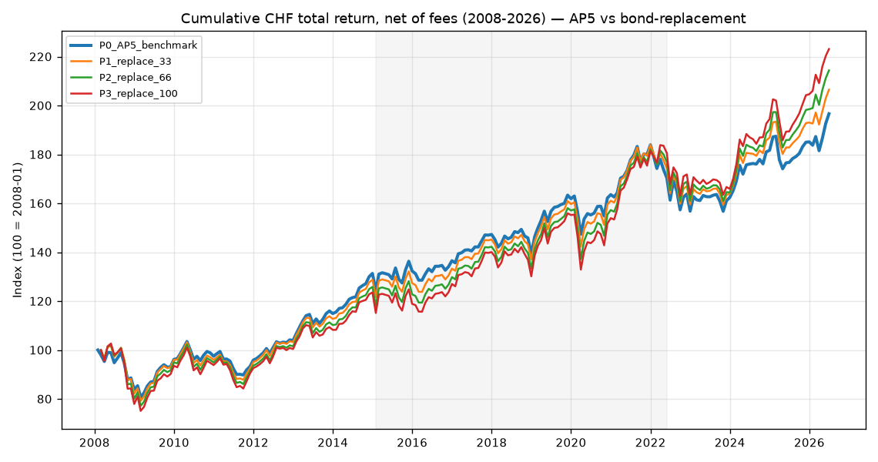
Figure 2 — Validation: reconstructed AP5 vs the real VZ VVIA track record.
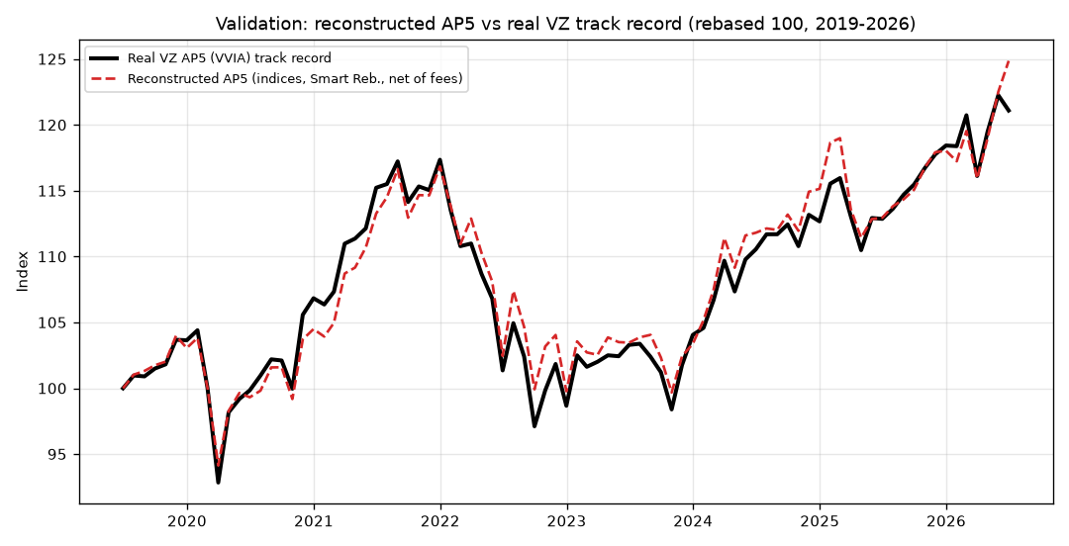
Figure 3 — Annualised return by SNB rate regime.
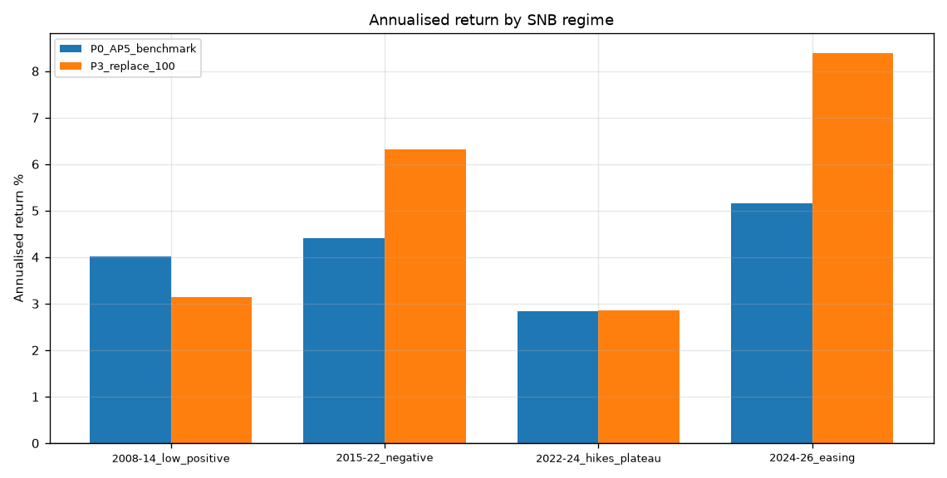
Figure 4 — Bond-sleeve behaviour by rate regime.
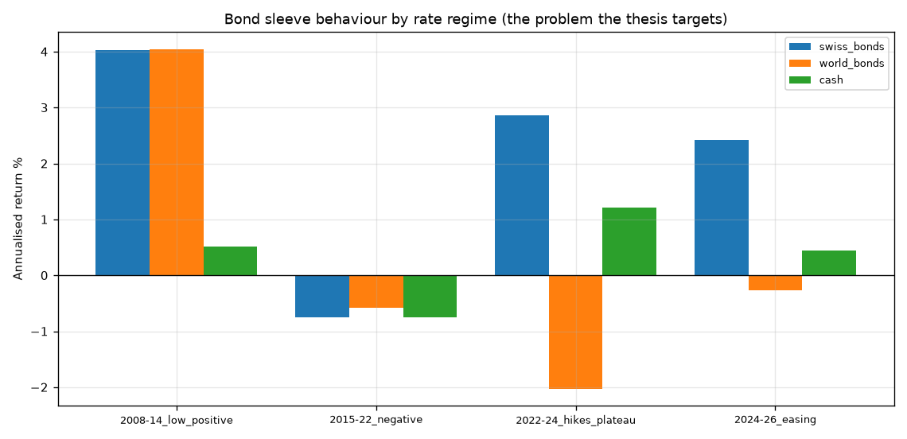
Figure 5 — Monthly return correlations (2008–2026).
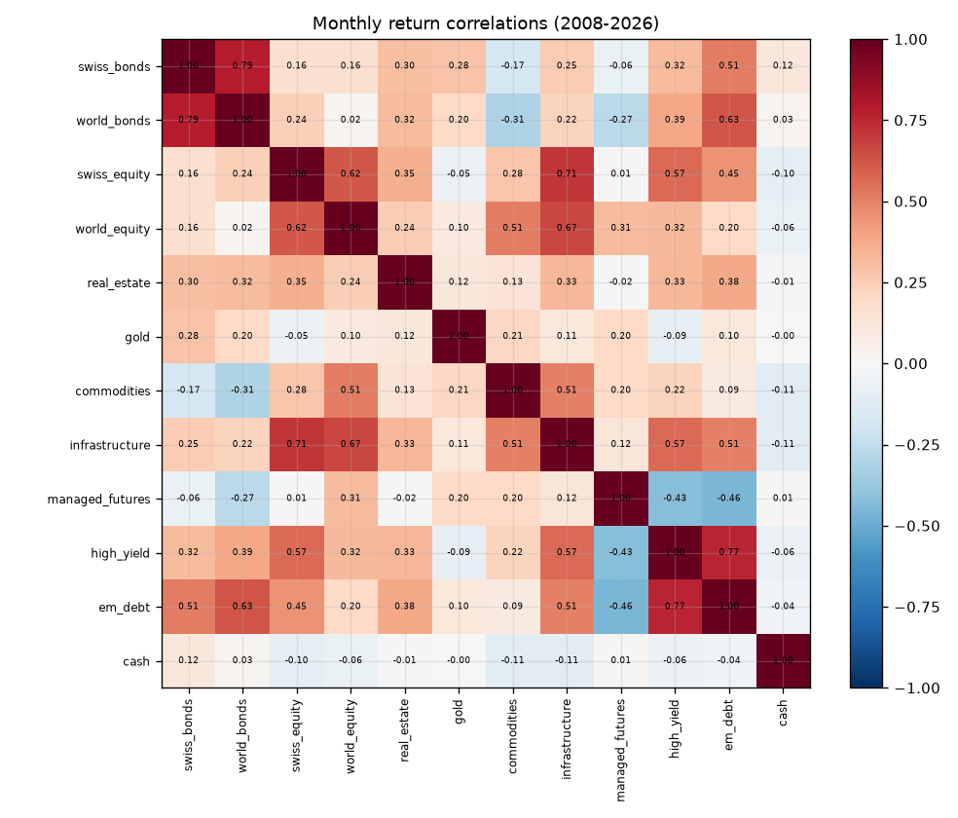
Figure 6 — Rolling 24-month equity–bond correlation.
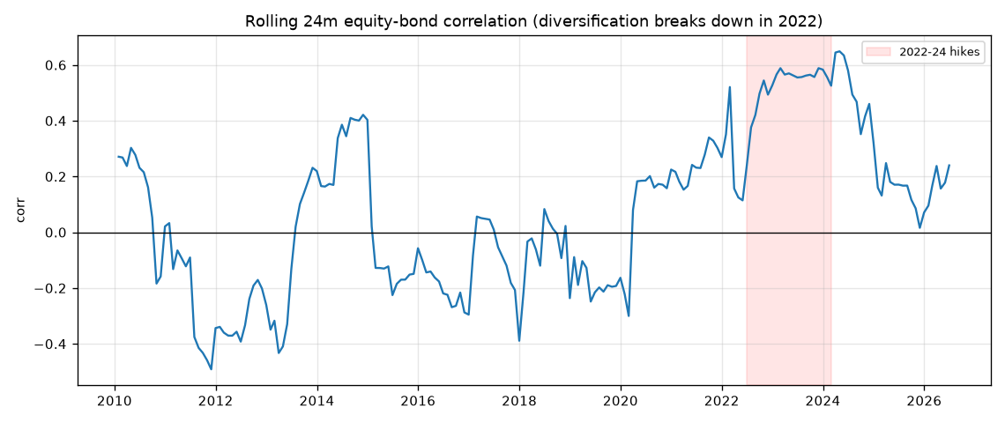
Figure 7 — Curated vs naïve replacement basket (100% replaced).
